BISHOP'S UNIVERSITY
Application for Promotion to Full Professor

Rachid Hedjam, PhD
Associate Professor, Department of Computer Science

Teaching and student learning · Research and scholarship · Leadership and academic service

Promotion dossier
Application cycle: 2026-2027 Submission date: 10/29/2025

rhedjam@ubishops.ca · Sherbrooke, Quebec, Canada

Contents
Reading the dossier 4
Dossier at a glance 4
Scholarly outputs at a glance 4
How to navigate the application 4
Application letter 5
1. Case for promotion 7
1.1 Overview of academic contribution 7
1.2 Academic trajectory and review context 8
2. Teaching and student learning 10
2.1 Teaching philosophy 10
2.2 Highlight teaching effectiveness 11
2.3 Apply disciplinary knowledge 12
2.4 Curriculum and teaching quality and innovation 13
2.5 Promote and support student learning 14
2.6 Leadership recognition and scholarship in learning and teaching 15
3. Research and scholarship 16
3.1 Research vision and development 16
3.2. Research trajectory: from data representation to federated meta-unsupervised learning 17
3.3 Recognition and professional standing 18
3.4 Funding and the research environment 18
4. Supervision and researcher development 20
4.1 A research training environment at several levels 20
4.2 Progression and student outcomes 20
4.3 Undergraduate and visiting research opportunities 20
4.4 Mentoring practice and attribution 21
5. Leadership and academic service 22
5.1 Institutional leadership 22
5.2 Professional service and knowledge exchange 22
6. Future contribution and closing statement 24
6.1 Priorities for the next stage 24
Appendix A. Academic curriculum vitae 25
A1. Education and postdoctoral training 25
A2. Appointments and professional experience 25
A3. Research interests 26
A4. Awards and honors 26
A5. Research funding and project coordination 27
A6. Scholarly outputs 28
A7. Affiliations and collaborations 33
A8. Invited contributions and scholarly service 33
A9. Research resources and reported impact 34
10. Selected supervision records 35
A11. Teaching and curriculum 36
A12. Institutional and community service 38
Appendix B. Teaching evidence 40
B1. Course inventory and evaluation reports 40
B2. Course materials and curriculum development 42
B2.1. Syllabus 42
B2.2. Selected Lecture Materials (cross-liste course) 50
B3. Assessment and reflective practice 55
B4. Awards and peer evidence 57
B5. Peer reviews of teaching 60
B6. Professional development and literature 60
B7. Student accomplishments and educational mentorship 60
B8. Teaching leadership, mentorship, and knowledge mobilization 64
Appendix C. Research evidence 65
C1. Selected outputs and my contribution 65
C3. Impact and reusable resources 66
C3.1 Shared software and datasets 66
C3.2 Awards and external evaluations 67
Appendix D. Supervision and trainee outcomes 69
D1. Authoritative trainee roster 69
D2. Selected outcome statements 71
Appendix E. Service and external engagement evidence 74
E1. Institutional and professional service record 74
E2. Scholarly recognition and conference roles 76
E3. Outreach and knowledge exchange 78

Reading the dossier
The main application (Sections 1–6) explains the significance of my record. Appendix A contains the complete curriculum vitae. Appendices B–F organize the supporting evidence referenced by code in the main text (for example, B2, C1, D1) so that each claim can be checked against its source.

Dossier at a glance
My application brings together teaching, scholarship, research training, and service at Bishop's University, read alongside the record I built over six years at Sultan Qaboos University before joining Bishop's. The narrative in Sections 1–6 explains the significance of this work; the CV in Appendix A records it in detail; the evidence appendices (B–F) support its assessment.

Scholarly outputs at a glance
Category | Count | Entry references
Journal articles | 38 | J01–J38
Conference contributions | 36 | C01–C36
Book chapters | 1 | BC01
Preprints (not counted above) | 1 | PP01
Patent disclosure (filing status to confirm) | 1 | P01

How to navigate the application
- The letter and Section 1 introduce the case; Sections 2–5 develop it by evaluation area.
- Section 6 sets out my forward plan and closes the application.
- Appendix A is the full CV; Appendices B–F hold the supporting evidence log.

Application letter
October 29, 2026
Chair of the Evaluation Committee
Bishop's University

Dear Members of the Evaluation Committee,
Please find enclosed my application for promotion from Associate Professor to Full Professor in the Department of Computer Science. I was promoted to Associate Professor at Bishop’s in July 2026, and I submit this application at the Committee’s invitation, for the current cycle. Before joining Bishop’s, I served for six years as Assistant and then Associate Professor at Sultan Qaboos University (SQU), Oman (2017–2023). In accordance with Article 7.06 g) of the Faculty Collective Agreement, I respectfully ask that my research, teaching and service from those six years be included in the assessment. The supporting evidence is attached in the appendices.
Teaching is central to my work. At Bishop's I have taught and developed courses spanning programming, databases, artificial intelligence, neural networks, data visualization, and natural language processing, at both the undergraduate and graduate levels. The 2026 Excellence in Teaching Award at Bishop's (Appendix B4) recognizes this work; my earlier teaching at SQU included full curriculum development for a new MSc in Data Science and recognition as Distinguished Academician (Best Teacher), College of Science, for 2020–2021 (Appendix B4).
My research asks how useful, interpretable structure can be learned from complex data, particularly when labels are scarce. It connects matrix factorization, manifold learning, and meta-unsupervised learning with applications in medical data analysis, remote sensing, and most recently privacy-preserving federated learning. My 38 journal articles and 36 refereed conference papers include work in Pattern Recognition, IEEE Transactions on Image Processing, IEEE Transactions on Geoscience and Remote Sensing, Knowledge-Based Systems, and Expert Systems with Applications. This program is currently supported by an NSERC Discovery Development Grant, a Mitacs Accelerate award, a CFI John R. Evans Leaders Fund award as co-PI, and three Bishop's Research and Creative Activity Grants.
Graduate and undergraduate supervision connects this research to student development. My record includes postdoctoral, doctoral, master’s and undergraduate supervision across institutions in Canada, Oman, Algeria and Qatar. My students have won two Best Conference Student Paper Awards in 2025 at Bishop’s, and at Sultan Qaboos University a Best Supervised MSc Thesis award (2020) and two Best Published Paper awards (2023 and 2024). My role as Head of the AI Track at AMI-Lab and my 2026 adjunct appointments at the Université de Sherbrooke and UQO extend the collaborative environment available for this training.
I have also contributed through departmental leadership, University committees, scholarly assessment, conference organization, and outreach. At Bishop’s, this includes serving as Interim Chair in Fall 2024, membership of the Task Force on Generative AI, and representation on the Senate Teaching and Learning Centre Initiative Committee. At Sultan Qaboos University (2017–2023), I chaired the Course Files Committee, the Publicity Committee and two research groups (Artificial Intelligence & Machine Learning; Data Science and its Applications), served on the quality assurance and postgraduate studies committees, and held brief Interim Chair responsibilities.
The enclosed narrative, CV, and evidence register set out the basis for my request. I would welcome the opportunity to discuss this dossier and my plans for continued contribution to Bishop's University.

Sincerely,
Rachid Hedjam, PhD
Associate Professor, Department of Computer Science

1. Case for promotion

1.1 Overview of academic contribution
My case rests on a connected record of academic contribution across three countries and eighteen years. I teach the foundations and methods students need to work with data; I develop research on how data can be represented and interpreted; and I use supervision and collaboration to bring students into that research. Service and academic leadership sustain the environment in which these activities take place. This application was brought forward in the current cycle at the Evaluation Committee's own invitation, in recognition of the continuity between my SQU and Bishop's records; Section 1.2 sets out that continuity and the review interval it implies.

1.1.1 Teaching and curriculum
My teaching has been recognized by the 2026 Excellence in Teaching Award at Bishop’s and by the Distinguished Academician (Best Teacher) award of the College of Science at Sultan Qaboos University (2020–2021); both certificates are in Appendix B4. My teaching record also includes developing CS219 (Python for CS and non-CS students) and CS446 (Intelligent Systems and Neural Networks) from scratch, and revising CS316 (Introduction to AI), CS503 (Data Visualization), CS307 (Databases), and CS504 (Programming Languages for Data Science). These contributions broaden access to computing for students outside the discipline while building a clearer path into advanced study for those within it. Supporting evidence is in Appendix B.

1.1.2 Research and scholarly development
My research is in artificial intelligence, mainly representation learning and unsupervised learning, with applications to healthcare, remote sensing and cybersecurity. I publish in highly ranked venues, including ACM Multimedia, UAI and AISTATS (A* and A ranks. Source CORE 2026) and Q1 with high factor impact journals such as IEEE Transaction in Image Processing, IEEE Transaction if Remote Sensing, Pattern Recognition and Expert Systems with Applications. Appendix C identifies the supporting evidence.

1.1.3 Research training and collaboration
My supervision spans several stages of research training across several institutions. At Bishop's, trainee topics include meta-unsupervised learning, seizure detection, medical report summarization, methane detection, and anomaly detection. My wider collaboration network, in Canada, Oman, Algeria, China, Italy, and Qatar, extends this training into joint work on medical data analysis and learning methods. Appendix D provides the full trainee roster.

1.1.4 Service and institutional contribution
My service combines Bishop's responsibilities with contributions to the wider discipline: Interim Chair, University committee work on teaching and generative AI, membership of the “Conseil scientifique de Calcul Québec”, scholarly assessment, editorial activity, and conference organization. Appendix E documents the work performed and its results.

1.1.5 The significance of the combined record
The contribution I bring to Bishop's is the ability to connect a broad teaching portfolio with an active research environment: courses introduce students to the subject, supervised projects give them a chance to investigate open questions, and collaborations extend the expertise and settings available for that work. My forward plan (Section 6) is to deepen these connections through carefully scoped research projects, stronger documentation of student learning, and sustained scholarly output.

1.2 Academic trajectory and review context

1.2.1 Development of an independent academic profile
My training in computer science and engineering established a foundation in clustering, image processing, and data representation. My master's research at the Université de Montréal examined graph-based Markovian clustering for image segmentation. My doctoral work at ÉTS (University of Quebec), completed with highest honor and funded by an FRQNT scholarship, addressed visual image processing in different representation spaces for documentary heritage preservation. A postdoctoral fellowship at McGill University (2013–2017), also FRQNT-funded, extended this work into machine learning, optimization, and multidimensional data analysis.
At Sultan Qaboos University, where I held faculty appointments from 2017 to 2023 — Assistant Professor (2017–2020) and then Associate Professor (2021–2023) — I built a teaching and research program in artificial intelligence, machine learning, and data science. My responsibilities there included graduate supervision, research funding as PI and co-PI, full curriculum development for a new MSc program, research group leadership (as chairperson of two research groups), and departmental committee service. This record is directly relevant background to the program I have continued at Bishop's, and is the basis for my request, under Article 7.06 g), that it be weighted equally with my Bishop's record.

1.2.2 Contributions since joining Bishop's
Since 2023, my work at Bishop's has combined teaching across several levels with the development of a research program in meta-unsupervised learning and applied AI. The record includes three Bishop's Research and Creative Activity Grants, an NSERC Discovery Development Grant, a Mitacs Accelerate award, and a co-PI role in a CFI John R. Evans Leaders Fund award. It also includes student co-authored publications, undergraduate research opportunities, curriculum development, and departmental service.
My appointment as Head of the AI Track at AMI-Lab (Research Centre on Aging, Université de Sherbrooke) began in January 2024. Adjunct appointments at UQO and the Université de Sherbrooke followed in 2026. These affiliations connect my work at Bishop's with complementary research and graduate-training environments and should be read alongside (not folded into) the specific supervision and collaboration records in Sections 3 and 4.

1.2.3 Chronology and evaluation record
Period | Career context | Role in this application
Before 2017 | Graduate training and postdoctoral research (Université de Montréal, ÉTS, McGill) | Foundations and selected earlier contributions
2017–2023 | Assistant then Associate Professor at Sultan Qaboos University | Independent teaching, scholarship, supervision, and service
2023 – Jan. 2026 | Assistant Professor at Bishop's | Development of the Bishop's teaching and research program
January 2026 onward | Associate Professor at Bishop's | Current appointment and subsequent achievements

2. Teaching and student learning
My teaching contribution is presented through my philosophy and the five evaluation elements identified by the Committee. The detailed course record is in Appendix A11; teaching evidence is organized in Appendix B.

2.1 Teaching philosophy

2.1.1 What I aim to do
My aim is to help students understand why a method works, when it is appropriate, and what its limitations are. In computing and AI, obtaining output is only part of learning: students also need to explain their choices, interpret results, and recognize when a method does not answer the question they are investigating. My teaching ranges from introductory programming, where programming is a practical way to reason about information for students taking computing as part of a broader education, to advanced AI and data analysis, where mathematical understanding, algorithmic reasoning, and careful evaluation matter more.

2.1.2 Why I take this approach
I connect concepts, implementation, and interpretation because students need all three to use computing responsibly: a working program can conceal weak understanding, and an explanation without practical application can leave students unable to use what they have learned. My assessment principles accordingly emphasize reasoning as well as implementation, with clear expectations and opportunities to learn from feedback, which is reflected in the project-based design of CS446, CS307, CS316, and CS504.

2.1.3 Why I consider the approach effective
I consider the approach effective when students can explain a method in their own words, justify their choices, apply it to a new problem, and identify limitations in their results. My 2026 Excellence in Teaching Award and the student research accomplishments in Section 2.2.4 are relevant indicators, but they do not by themselves establish the effect of anyone teaching practice; that connection is substantiated through the evaluation record in Section 2.2.2 and Appendix B1.
A concrete illustration is the Honor’s project on deep learning for object detection, completed in 2025. The student first met this material in CS446 (Intelligent Systems and Neural Networks), Fall 2023, a course I developed around project-based work with real datasets. Their experience in the course motivated them to undertake an Honor’s project in the area, which I supervised through problem formulation, implementation, evaluation, and writing of a neural-network object-detection system. They had no prior experience training neural networks; by the end she had built and evaluated an object-detection model on her own. This is a single example rather than proof of general effect, but it connects the course-level aim in Section 2.1.1, that students understand and justify their methods rather than only run them, to a sustained piece of independent work. She subsequently completed a computer vision and machine learning internship at an autonomous-systems company (USA) and began an MSc at York University. Supporting records are in Appendix B7.1.

2.2 Highlight teaching effectiveness

2.2.1 Preparation and effective course delivery
My Bishop's teaching record spans data visualization, programming for data science, image processing, databases, general computing, introductory AI, and neural networks. I developed CS219 around Python for students from computer science and other disciplines; developed CS446 in intelligent systems and neural networks; and developed CS320 and CS520 around natural language processing and large language models. These contributions support both access to computing and progression into advanced study. The course inventory in Appendix B1 records, for each offering, the course and term and the student evaluation scores, compared with the institutional average at Bishop’s and with the department and college averages at SQU. The resource portfolio in Appendix B2 connects selected syllabi and assessments with the learning outcomes they address.
My lectures follow a consistent structure, which I use in e.g., CS405/CS505. I begin by asking students to recall briefly what we covered in the previous lecture, which refreshes the material and shows me what has stuck. I then present a new problem situation and give students two to three minutes to think about a possible solution. When a student offers a tentative answer, I invite the class to comment on it, so that students practice evaluating reasoning, not only producing answers. Only then do I state the lecture's objectives and outline. From there I formalize the problem mathematically and introduce the tool best suited to solving it. I also present the main alternatives, explain why I favor the first tool, and discuss the strengths and limitations of each. Finally, I show how the chosen method is implemented algorithmically, followed by a short program that solves the problem, so students see the path from the problem to mathematics to working code. Sometimes when students appear lost, I return to the previous step and re-explain it with a different example before moving on. Some selected slides in Appendix B2 (a selection, not the complete set) illustrate the structure described above of my cross-listed course CS405/CS505 given in Fall 2026 are shown in Appendix B2.

2.2.2 Student feedback and changes to practice
Bishop's course evaluations since Fall 2023 (Appendix B1) place my overall score above the institutional average in six of eight evaluated course offerings (CS504 in Fall 2023; CS503 in Winter 2024 and Winter 2025; CS219 in Winter 2025; CS307 and CS316 in Fall 2025). Two offerings fell slightly below: CS446 in Winter 2025 and, CS462/CS562 in Winter 2024 my first cross-listed BSc/MSc course. In that course students rated the instructor (3.38) lower than the course content (4.03), which suggests the problem was my delivery rather than the material: I had not yet found a pace and level of explanation that served both groups, and I did not keep the class well in hand. I have not taught CS462/CS562 since, so I applied the lesson to CS405/CS505 (Fall 2026) by structuring each lecture so that both levels are served and marking where each group should concentrate, as the slides in Appendix B2 show. Because that course is in its first term, I cannot yet show evaluation evidence of improvement and will report it when available. If I teach CS462/CS562 again, I will use the same approach. Winter 2026 was not evaluated because too few students completed the survey.

2.2.3 Peer review of teaching
No formal peer review of my teaching has been conducted. The evidence of my teaching quality is therefore the official student evaluations since Fall 2023 (Appendix B1), the dated lecture materials and code (B2), and the documented response to my lowest-rated course (Section 2.2.2).

2.2.4 Supervision and student accomplishments
Supervision is also part of my teaching contribution. At Bishop's, examples include a completed honor’s project on object detection, a completed USRA project on EEG preprocessing, and master's projects in meta-unsupervised learning, seizure detection, medical report summarization, and anomaly detection. The completed Bishop's master's project on meta-unsupervised learning led to a co-authored paper at Canadian AI 2025 (C10), and two of my students won Best Conference Student Paper Awards in 2025 — one at the 38th Canadian AI Conference and one at IEEE BDDM (Appendix D.2). Section 4 and Appendix D provide the full supervision record; Appendix B7 should document each student's starting point, my guidance, and their own contribution alongside these outcomes.
Both award-winning papers began as project-track Master’s work. In both cases I encouraged the student to move from the project track to the thesis track once their work showed a result worth developing into a full research paper, although publication is not required of MSc students. I supervised them through that additional work, and both went on to publish and to win a best paper award. The papers and award notices are in Appendices D2 and B7.
At Sultan Qaboos University (2017–2023), some students I supervised also reached recognized outcomes. An MSc thesis I supervised received the Best Supervised MSc Thesis award of the College of Science in 2020, and the student published the work with me at the IEEE ICIoT 2020 conference (C15, Appendix A6.2). Two PhD students I supervised won the Best Published Paper award of Sultan Qaboos University, in 2023 and in 2024 (Appendix D2). I also supervised a BSc final-year project and recommended the student for a full scholarship to an MSc at Aalto University, which she received; we later published a paper together at ACM Multimedia 2025, an A*-ranked ACM conference (source: ICORE 2026). Together with the Bishop's examples above, these outcomes are documented in Section 4 and Appendices B7 and D2.

2.3 Apply disciplinary knowledge

2.3.1 Maintaining and interpreting disciplinary knowledge
My research in representation learning, AI, image analysis, and medical data analysis informs the questions I bring into teaching, limited labels, uncertain predictions, representation choices, and interpretation. I aim to translate disciplinary material into explanations and tasks appropriate to students' preparation rather than assume that research expertise alone ensures effective teaching. Recorded examples include adding Bayesian learning to CS316, map and network visualization to CS503, and new practical topics to CS504.

2.3.2 Teaching strategies and new resources
My approach moves from the question a method addresses its assumptions, operation, and evaluation, connecting mathematical ideas with examples students can inspect and implement. CS219 and CS320 provide accessible entry points for students from varied backgrounds, while CS505 and CS520 provide room for deeper analysis for students progressing further.
For instance, in Fall 2026 I taught CS405/CS505, a cross-listed course taken by both BSc and MSc students. The selected slides in Appendix B2 (a selection, not the complete set) illustrate the flow of my lectures and how I serve two levels of students in the same room: the slides mark which material is core for everyone and where each group should concentrate, with BSc students focusing on e.g., concepts and implementation and MSc students on e.g., mathematical formalization and analysis. As the course is in its first term, there are no student evaluations yet; I will report them, and any changes I make in response, in future updates to this dossier.

2.3.3 Professional development and engagement with literature
In September 2021 I attended the workshop “Active learning: the key to student learning”, led by Prof. Grahame Bilbow (Grange Education), at Sultan Qaboos University on 23 September 2021, Appendix B6. The idea I kept was to begin with a short recall of the previous lecture and to give students quick chances to test their understanding during class. I apply it at Bishop’s through the structure of my lectures: students first recall the previous lecture, then work for two or three minutes on a new problem before I present the method (Section 2.2.1; slides in Appendix B2). Unsolicited student comments are consistent with this approach: one student described the classes as “lively and informative” (CS307, Fall 2025), and another credited the weekly assignments with “a great hands-on learning experience” and a stronger ability to choose a suitable algorithm for a problem (CS504, CS503 and CS462/CS562, 2023–24; Appendix B1).

2.4 Curriculum and teaching quality and innovation

2.4.1 Course design and curriculum renewal
Course | Documented contribution | Educational purpose
CS219 | Developed a Python-based course for CS and non-CS students | Accessible foundation in computing
CS446 | Developed Intelligent Systems and Neural Networks | Build advanced study in intelligent systems
CS316 | Added Bayesian learning topics | Strengthen reasoning about uncertainty
CS503 | Added map and network data visualization | Broaden representation and interpretation of data
CS504 | Introducing practical data-science topics | Connect programming with data-science tasks
CS307 | Changed the textbook | Update the course resource base
CS320 / CS520 | Developed NLP and Large Language Models offerings | Keep graduate curriculum current with the field

At Sultan Qaboos University, I developed Programming for Data Science for a new MSc program and co-developed Machine Learning I, Machine Learning II, and Ethics for Data Science and Machine Learning for the same program. I also developed Pattern Recognition and Applications for a new BSc program and revised courses in pattern recognition, advanced AI, and intelligent systems, with earlier contributions to introductory computer science including Python, robot programming, and textbook selection.

2.4.2 Collaboration and evaluation of innovation
Between 2019 and 2022, I worked with colleagues at Sultan Qaboos University to design a new MSc program in Artificial Intelligence and Data Science. My role was to investigate the requirements for the program by reviewing comparable programs in other universities. The program team then developed its courses. I developed Programming for Data Science, and I co-developed Machine Learning I, Machine Learning II, and Ethics for Data Science and Machine Learning with colleagues. The program was launched in 2022. Appendix A11 lists each course and shows whether I developed it independently, co-developed it, or revised it, with dates and my responsibilities.

2.5 Promote and support student learning

2.5.1 Engagement and support for varied preparation
Teaching at two institutions, and teaching Python to students across disciplines, informs my attention to varied preparation. CS219 was designed specifically to give students without a computer science background an accessible route into programming, and I have provided flexible exam scheduling and assignment deadlines to students with family responsibilities.

2.5.2 Assessment and skill development
My assessment principles are to make expectations clear and evaluate understanding as well as implementation. A useful assessment should reveal whether a student can explain a method, justify a decision, and interpret evidence; for advanced projects I value a clear problem statement, appropriate comparisons, and an honest discussion of limitations.
[Insert actual teaching and assessment resources in B3: task instructions, rubric or marking scheme, feedback examples, and appropriately anonymized student work where permitted.]
Better to wait for exam on 22

2.5.3 Reflection on learning and teaching quality
I support academic integrity and the responsible use of generative AI in my courses; the specific instructions or assessment design used should be documented here once confirmed for the course in question. I also contributed to the broader institutional conversation on this topic as a co-organizer of the 'AI's Impact on Teaching' session at Bishop's Academic Year Launch (October 2025) and as a member of the Task Force on Generative AI. See Syllabus CS320, Appendix B2.1.

2.6 Leadership recognition and scholarship in learning and teaching

2.6.1 Recognition and speaking invitations
My record includes the 2026 Excellence in Teaching Award at Bishop's and the Distinguished Academician recognition for Best Teacher, College of Science, Sultan Qaboos University, 2020–2021 (Appendix 4). My invited lectures and keynotes (Appendix A8, Appendix E2) are disciplinary rather than teaching-focused; where an invitation specifically concerns teaching or learning, I note that focus explicitly rather than presenting a disciplinary invitation as evidence of teaching scholarship.

2.6.2 Leadership and mentorship
My recorded Bishop's responsibilities include representation on the Senate Teaching and Learning Centre Initiative Committee and membership of the Task Force on Generative AI. I have also informally mentored junior colleagues through my role as Interim Chair, Computer Science Department (SQU), in Fall 2021.

2.6.3 Knowledge mobilization and scholarship of teaching
I have no publication specifically on learning and teaching, distinct from the disciplinary research record in Section 3; this is the thinnest element in my teaching case relative to the Committee's framework, and I note it here as an area for future development (Section 6) rather than overstating existing activity.

3. Research and scholarship

3.1 Research vision and development

3.1.1 A continuing question across different applications
The central question in my research is how to learn useful and interpretable structure from complex data. My early work addressed this through image segmentation, document restoration, and multispectral analysis; later work extended it to remote sensing, matrix factorization, clustering, manifold learning, and medical data analysis. My recent work on meta-unsupervised and federated learning addresses how learning methods can adapt across tasks and data settings. These topics are connected by a shared interest in representations: what information a method preserves, how that information supports learning, and whether a user can interpret the resulting structure.

3.1.2 Three linked directions
The first direction concerns representation and unsupervised learning, including nonnegative matrix factorization, clustering, dimensionality reduction, and meta-unsupervised learning. The second concerns learning from complex observations, including images, multimodal signals, and graph representations. The third concerns the conditions under which learning is useful in practice: limited labels, anomaly detection, medical interpretation, and privacy-preserving collaboration.

3.1.3 Research independence and collaborative work
I have first-authored publications, I have been Principal Investigator on funded projects at both Bishop’s and Sultan Qaboos University (SQU). At Bishop’s, my PI grants are NSERC / Mitacs / Research and Creative Activity. At SQU, I was PI of many projects incdung histology cancer detection (2022–2024) and smart in-line intrusion detection (2019–2021). I was also Co-PI or Co-I on four others (Section 3.5).
My collaborations include:
- AMI-Lab, Université de Sherbrooke (Prof. Bessam Abdulrazak)
- LARIVIA, Université du Québec en Outaouais (Prof. Mohand Saïd Allili)
- University of Trento, Italy (Prof. Farid Melgani)
- Aalto University, Finland (Prof. Laaksonen)
- Ocean University of China (Prof. Guoqiang Zhong)
- Hamad Bin Khalifa University, Qatar (Prof. Samir Brahim Belhaouari)
- Ouargla University, Algeria (Profs Mohammed Lamine Kherfi and Dr. Oussama Ayadi)

These partners bring medical, remote sensing and methodological expertise that complement mine.

I also supervise students at several levels. Their work has led to joint papers and awards (Section 2.2.4; Appendix D).

3.1.4 Quality and significance of the record
My record includes 38 peer-reviewed journal articles, 36 refereed conference papers and one book chapter. Of the journal articles, 27 are in Q1 journals, 7 in Q2, 2 in Q3, and 1in an emerging journal. Several conference papers appear at top-ranked venues:
- Conference on Uncertainty in Artificial Intelligence (UAI): CORE A*
- International Conference on Artificial Intelligence and Statistics (AISTATS): CORE A*
- ACM Multimedia: CORE A*
- International Conference on Document Analysis and Recognition (ICDAR): CORE A
- Canadian AI Conference: CORE B, with a recent Best Paper award
The full publication list is in the CV (Appendix A, Appendix C). I will explain my main contributions in Section 3.2.

3.2. Research trajectory: from data representation to federated meta-unsupervised learning
My research has followed one question: how can a machine learn useful structures from data when labels are few and the data is spread across places that cannot share it? Each stage below leads to the next.
3.2.1 Representation and structure (2013–2021)
My early work studied how the way an image is represented affects what can be recovered from it: historical document restoration (Pattern Recognition, 2013; J36) and color-to-gray conversion (IEEE Transactions on Image Processing, 2015; J35). I also shared resources for other researchers (SMADI, LC2G, and the multispectral text extraction competition at ICDAR 2015). I then moved to non-negative matrix factorization (NMF). My paper, “NMF with feature relationship preservation penalty term for clustering problems” (Pattern Recognition, 2021; J20), shows that a representation must keep the structure of the data if it is to be useful for learning. This idea is the basis of my later work. This work won the IEEE Oman Section Best Paper Award (IEEE Region 8) in 2021. Appendix C3.
3.2.2 Learning with few labels, and on medical data
Next, I worked on learning when labelled examples are scarce. Examples are change detection in remote sensing (IEEE TGRS, 2016; J34, IEEE JSTARS, 2020; J26). I applied the same ideas to medical data with collaborators: histopathology images, Alzheimer’s-related modelling, sleep-stage analysis (J01, J08), seizure detection (C04, C01) and medical report summarization (C02). Two lessons from this work shaped my current program. Medical data has few labels. And it is sensitive, so it often cannot be pooled in one place.
3.2.3 Meta-unsupervised learning (2025)
I then asked how representation learning can work across many tasks instead of one. With my MSc student A. Khan, M. Allaoui and G. Zhong, I published “Meta-Unsupervised Representation Learning: A New Approach to Factorization and Interpretability” (Canadian AI, 2025; C10). It grew from a completed master’s project at Bishop’s. In parallel, my work on manifold learning and visualization (J10, J09, J07, J05) and on graph and anomaly methods (AISTATS 2026, C06; UAI 2026, C03) extends representation learning to embeddings, distributions and graphs.
3.2.4 Federated meta-unsupervised learning: the emerging program
My current program joins the two threads above: learning across tasks (meta-unsupervised learning) and learning across separate data holders without sharing their data (federated learning). The aim is privacy-preserving federated AI for healthcare, where data stays at each hospital or site. Early outputs are the preprint “FIRMA: FIbonacci Ring Model Aggregation for Privacy-preserving Federated Learning” (arXiv, 2026; PP01) and a submitted patent disclosure, Fed-Z-NMF (P01). They are not peer-reviewed publications or granted patents. The program is supported by my NSERC Discovery Development Grant, CFI / Mitacs / Research and Creative Activity Grants (Section 3.5), and it trains graduate students at Bishop’s (Appendix D).
3.2.5 Shared research resources and external use
I have shared my work as resources that others can use: the benchmark datasets SMADI and LC2G, the corrC2G algorithm (MathWorks File Exchange), and the MDSI image quality algorithm, which ranked first among 50 algorithms in an independent comparison (Appendix A9). Dated evidence of availability and use is in Appendix C3.

3.3 Recognition and professional standing
My record includes invited keynote and expert lectures in Algeria and Oman, and visiting appointments in Italy and Canada. Most recent are a May 2026 keynote at COSI’26. I am an IEEE Senior Member and an associate editor of the Journal on Image and Video Processing. I also hold awards for co-authored research and student work (Appendix A4; A8, E2; B4).

3.4 Funding and the research environment
My funding record combines support for methodological research, applied collaboration, institutional research development, and infrastructure. The table below reports the role, amount, and period as recorded in my CV.
Award or project | Role | Amount | Period
NSERC DDG — meta-unsupervised learning and low-rank representation | PI | $44,000 CAD | 2025–2027
Mitacs Accelerate — edge-based methane detection | PI | $120,000 CAD | 2025–2027
CFI John R. Evans Leaders Fund | Co-PI | $191,399 CAD | 2026–
Bishop's Research and Creative Activity Grant — meta-unsupervised learning | PI | $9,000 CAD | 2025–2026
Bishop's Research and Creative Activity Grant — bridging the gap to human intelligence | PI | $9,000 CAD | 2024–2025
Bishop's Research and Creative Activity Grant — Cross-task progressive meta-learning | PI | $9,000 CAD | 2023–2024
Bishop's University funding — meta-unsupervised learning | PI | $7,000 CAD | 2023–
SQU (His Majesty the Sultan of Oman grant) — automatic extraction of cancer-registry data from electronic medical records using NLP and ML ensembles | Co-PI | 39,700 OMR (~$130,000 CAD) | 2022–2024
SQU — matrix factorization and deep learning for cancer detection from histology images | PI | 2,450 OMR (~$8,000 CAD) | 2022–2024
SQU — AI framework for analysis, categorization and retrieval of student research projects | Co-PI | 2,300 OMR (~$7,600 CAD) | 2022–2024
SQU — high-performance computing for machine-learning intrusion detection based on NMF | Co-PI | 1,600 OMR (~$5,400 CAD) | 2022–2024
SQU — toward smart in-line intrusion detection systems | PI | 2,350 OMR (~$7,800 CAD) | 2019–2021
SQU — requirement engineering framework for S-commerce platforms | Co-I | 3,250 OMR (~$10,800 CAD) | 2020–2021

3.4.1 How funding supports the program
The NSERC and Bishop's awards support the development of a coherent research direction in autonomous and interpretable learning. The Mitacs project provides a setting in which AI methods can be investigated with an applied environmental objective. The CFI award concerns shared research infrastructure. My earlier SQU record includes PI support for matrix factorization and cancer detection, a project on intrusion detection, and co-investigator roles in work on medical records, machine-learning infrastructure, and analysis of student research projects; my postdoctoral and doctoral FRQNT awards are listed separately in Appendix A so that training support is not confused with faculty research funding.

3.4.2 Stewardship and outcomes
My NSERC Discovery Development Grant is used to support 1 MSc student at Bishop’s University, 2025-202. The student won the best conference paper at Canada AI 2025 Conference, Calgary, Canada. The same grant will be continued to support a PhD student at University of Sherbrooke. 2027 Jan. The Mitacs Accelerate project supports 1 postdoc, 2 MSc and 1 BSc trainees working with Pergamon Perceptive Technology, Montreal on edge-based methane detection. As Co-PI of the CFI John R. Evans Leaders Fund award, I share responsibility for GPU and Drone equipped with Multispectral camera for remote sensing, which will be used for environment monitoring from 2027. At SQU, my PI grants supported many PhD and MSc students. Award letters and trainee records are in Appendix C3.

4. Supervision and researcher development

4.1 A research training environment at several levels
My supervision includes postdoctoral, doctoral, master's, and undergraduate work. The value of this activity lies in developing researchers who can formulate a question, choose and evaluate methods, communicate findings, and work with others; I aim to make research training an active connection between teaching and scholarship. At Bishop's, my master's projects include meta-unsupervised learning with nonnegative matrix factorization and autoencoders, seizure detection using EEG and graph neural networks, medical report summarization, methane detection, lightweight AI, and anomaly detection in banking, giving students access to both methodological problems and applications with identifiable users.

4.2 Progression and student outcomes
Publication is not required of master’s students, but several of my master’s and doctoral students have published their work, and some have received awards.
At Bishop’s, my students received two Best Conference Student Paper Awards in 2025, one at the Canadian AI conference and one at IEEE BDDM. The award letters are linked in Appendix D2.
At Sultan Qaboos University (SQU), my students were also recognized:
- An MSc student I supervised received the Best Supervised MSc Thesis award in 2020 and published the work at an international conference.
- Two PhD students received the SQU Best Published Paper award, in 2023 and 2024 [confirm my role: supervisor or co-author].
- A BSc student whose final-year project I supervised received a full scholarship for an MSc at Aalto University, after my recommendation. We later published a paper at ACM Multimedia, 2025. C08, Appendix A6.5.
At other institutions, I co-supervised doctoral and master’s students at Université de Sherbrooke, UQO, ESI Algeria, University of Ghardaïa, University of Ouargla and Hamad Bin Khalifa University. Degree completions and later positions are documented where confirmed.

4.3 Undergraduate and visiting research opportunities
Bishop's examples include a completed honors project on object detection and a completed USRA project on EEG preprocessing in 2024, and a completed Mitacs Globalink Research Internship in 2026 (BSc from ENIS Tunisia). Two further 2026 Mitacs Globalink Research Awards (a PhD and an MSc visitor from Algeria) are classified by their actual degree level as graduate visitors, rather than folded into undergraduate totals. See Appendix A10 for more information about undergrad and grad student supervision. See Appendix D2 for a sample of Mitacs ward notice.

4.4 Mentoring practice and attribution
A clear example of how my mentoring leads to research outcomes is the 2025 cohort of master’s students whose papers received Best Conference Student Paper Awards at the 38th Canadian AI Conference and at IEEE BDDM 2025 (Appendix D2). Bishop’s does not require MSc students to publish, but I encouraged them to, and I took on the extra supervision this needed. I helped each student treat the work as a question to defend before other researchers, not only as a deliverable to submit. I helped them turn it into a full paper, and guided them through submission, review and presentation. Both awards are the result of the students’ own work and presentation. My part was to guide the question, the writing and the submission.
The following table counts the 48 trainees I supervised (and co-supervised).
Level | Supervisor | Co-supervisor | Completed | In progress / planned | Total
Postdoctoral | 1 | 0 | 0 | 1 | 1
Doctoral | 3 | 11 | 4 | 10 | 14
Master's | 14 | 6 | 13 | 7 | 20
Undergraduate | 12 | 1 | 11 | 2 | 13

5. Leadership and academic service

5.1 Institutional leadership

5.1.1 Service at Bishop's University
My service at Bishop's includes 1) Interim Chair in Fall 2024, 2) representation for Natural Sciences and Mathematics on the Senate Teaching and Learning Centre Initiative Committee, and 3) membership of the Task Force on Generative AI from 2024. These roles connect departmental operation with questions about teaching and the use of emerging technology in the University (Appendix A12).

5.1.2 Building research connections
Since January 2024, I have been Head of the AI Track at AMI-Lab (Research Centre on Aging, Université de Sherbrooke). I have also held adjunct professor appointments at UQO since January 2026 and at the Université de Sherbrooke since June 2026. These roles link my AI expertise with research on aging and related applications, and with graduate training outside Bishop’s. The joint publications and supervision in Sections 3 and 4 come from these relationships. I am a member and co-founder of BRAIN (Bishop’s Centre for Research in AI & Innovation), which is under construction.

5.1.3 Earlier leadership and institutional experience
At Sultan Qaboos University, I chaired the Course Files Committee and the Publicity Committee, served on committees relating to quality assurance, postgraduate studies, student advising, programming, and technical staff training, and held brief Interim Chair responsibilities. I also chaired two research groups (Artificial Intelligence & Machine Learning, and Data Science and its Applications) in the Department of Computer Science. These roles provide background to my capacity to contribute to departmental and institutional work at Bishop's.

5.1.4 Evidence of contribution
As a member of the Task Force on Generative AI (since 2024), I initiated the idea of surveying Bishop’s members (librarian, IT, faculty and students) on how they use generative AI in teaching and IT service. I played an important role in the statistical analysis of the survey. Its results helped the Task Force to draw up guidelines for the use of generative AI at Bishop’s. The Task Force built on the survey in several rounds of meetings and discussions. As a result, generative AI has become one of the main sessions of the Bishop’s Academic Year Launch, which is held at the beginning of September each year. In September 2025, I co-organized the session “Artificial Intelligence and Bishop’s Mission, Vision and Values: Can they co-exist?”. See Appendix E1.

5.2 Professional service and knowledge exchange

5.2.1 Scholarly assessment and disciplinary service
My disciplinary service includes an associate editorship at the Journal on Image and Video Processing, participation in an NSERC evaluation committee for DG application Program evaluation, and membership of the “Conseil scientifique de Calcul Québec” from 2024. I also review regularly for journals and conferences in image processing, pattern recognition, machine learning, and remote sensing, including Pattern Recognition, IEEE Transactions on Image Processing, Neurocomputing, and Digital Signal Processing. I was named an Outstanding Reviewer at the British Machine Vision Conference (BMVC) in 2024 (Appendix E2). I served as an external reviewer of the MSc program in Computer Science at the University of Ouargla, Algeria (2022), for which the department issued a certificate (Appendix E1.2).
I am a member of the Canadian Artificial Intelligence Association (CAIAC) since 2025 and of the IEEE Computer Society since 2014, and I have been a member of the IEEE Geoscience and Remote Sensing Society, since 2019, where I also co-founded the Oman Section Chapter 29, Region8. See Appendix E2.6.

5.2.2 Conferences and academic communities
My conference service includes chairing the Vision and Multimodal Systems session at Canadian AI 2025 and serving as Awards Chair for M2GARSS 2024. Earlier contributions include further session chair roles at M2GARSS (2020, 2022), organization of the first international forum on remote sensing and machine learning in Oman (2018), I coordinate the multispectral document analysis contest reported at ICDAR 2015. I am also a co-founder of the IEEE GRSS Chapter in Oman. See Appendix E2. In 2024, I chaired the organizing committee of the first edition of the LINKS workshop (Linking Innovation, Networking and Knowledge Sharing) at CERIST, Algeria (Appendix E2).

5.2.3 Outreach and recruitment
At Bishop's, my outreach includes participation in the Rooted in the Townships Career Fair (April 2025, Appendix E3.1), a recruitment visits to Collège de Bois-de-Boulogne (February 2025), and departmental ambassador activities at universities in Algeria (December 2025). These activities bring academic expertise to prospective students and external communities; any subsequent enrolment or partnership outcomes are documented separately rather than assumed.

5.2.4 Professional consultation and public communication
My consultation experience includes work with PreScouter (USA), DeepMinds (Appendix A12, E3.2) an analysis of electricity-consumption anomalies for Mazoon Electricity Company (Oman), and a collaboration between SQU and Clarivate on the AI technology landscape. This work connects research expertise with questions raised by organizations outside the University, described here in non-confidential terms. Earlier public communication includes a documentary appearance on multispectral analysis of historical manuscripts and coverage of the 2018 Oman remote-sensing forum, retained as career context and dated accordingly.

6. Future contribution

6.1 Priorities for the next stage
My next stage of work will deepen the connection between teaching, research, and student development. The priorities below are proposed directions; their scale will depend on student demand, available resources, approvals, and successful funding applications.

6.1.1 Teaching and student projects
I plan to develop a clearer progression from foundational computing and AI courses to supervised projects with a manageable scope, a clear question, appropriate data, and assessment that requires students to explain their reasoning. I also plan to strengthen my evidence of teaching effectiveness. I will document course revisions, review student feedback in context, and collect examples of assessed learning, including a documented response to the CS462/562 evaluation result noted in Section 2.2.2. I have developed the Natural Language Processing (CS320) and Large Language Models (CS520) courses I’m teaching for the first time in Fall 2026. I will revise them after their first offerings, using student feedback and assessment results if needed.

6.1.2 Research and supervision
My research priorities are to consolidate the meta-unsupervised learning program, develop work on representations and anomaly detection, and investigate privacy-preserving learning for distributed data. Medical and physiological data remain an important application direction through existing collaborations. For supervision, I plan to use clearly defined milestones, realistic project scope, and explicit contribution records, while seeking opportunities for students to present, publish, and collaborate.

6.1.3 Institutional contribution and collaboration
I intend to support interdisciplinary projects where computing expertise can help colleagues investigate a substantive question, and to help translate such problems into feasible student projects. Establishing BRAIN as a recognized research center, through a formal Senate proposal, is a near-term priority that would consolidate AI research capacity and graduate training at Bishop's.
Horizon | Proposed priority | Evidence of progress
Next 12 months | Consolidate course evidence and current funded research | Updated teaching portfolio; project milestones; trainee progress
Years 2–3 | Develop collaborative student projects and research outputs | Completed projects; publications; documented partner feedback
Years 3–5 | Sustain a coherent AI research and training environment | Funding outcomes; completed degrees; curriculum and service contributions

Appendix A. Academic curriculum vitae

Rachid Hedjam, PhD
Associate Professor, Department of Computer Science, Bishop's University
rhedjam@ubishops.ca · 2600 College Street, Sherbrooke, Quebec, Canada J1M 1Z7.

A1. Education and postdoctoral training
- 2013–2017 — Postdoctoral Fellow, McGill University, Montreal, Canada — Machine Learning and Optimization with Application to Multidimensional Data Analysis
- 2009–2013 — PhD in Engineering (highest honor), ÉTS, University of Quebec, Montreal — Dissertation: Visual Image Processing in Various Representation Spaces for Heritage Documentary Preservation
- 2005–2009 — MSc in Computer Science (highest honor), Université de Montréal — Dissertation: A Hierarchical Graph-based Markovian Clustering Approach for the Unsupervised Segmentation of Textured Color Images
- 1999 — BSc in Computer Science (highest honor), University of Setif, Algeria — Dissertation: Echo Fix Detection in Meteorological RADAR Images

A2. Appointments and professional experience
Dates | Position | Institution
01/2026 – present | Associate Professor | Bishop's University, Canada
06/2026 – present | Adjunct Professor | Université de Sherbrooke, Canada
01/2026 – present | Adjunct Professor | University of Quebec at Outaouais (UQO), Canada
2023 – 2026 | Assistant Professor | Bishop's University, Canada
01/2024 – present | Head, AI Track | AMI-Lab / Research Centre on Aging, Université de Sherbrooke
2021 – 2023 | Associate Professor | Sultan Qaboos University (SQU), Oman
2021 – present | Consultant, Data Scientist | PreScouter, USA
2020 – present | Consultant, Data Science | Sultan Qaboos University (SQU), Oman
08/2017 – 2020 | Assistant Professor | Sultan Qaboos University (SQU), Oman
2014 – 2017 | Postdoctoral Researcher | Applied Remote Sensing Laboratory, McGill University
2014 – 2017 | Data Scientist and Project Coordinator | Synchromedia Laboratory, ÉTS, University of Quebec
2011 – 2015 | Laboratory Instructor | Synchromedia Laboratory, ÉTS, University of Quebec
Summer 2019 | Research Visit | SRP Laboratory, University of Trento, Italy
Summer 2018 | Research Visit | DIRO Laboratory, Université de Montréal

A3. Research interests
Core areas: Artificial Intelligence, Machine Learning, Deep Learning, Data Science, Computer Vision and Image Processing, Remote Sensing Image Analysis, Data Mining, Document Image Analysis.
Applications:
- Data classification / categorization
- Data clustering
- Data discovery / mining
- Dimensionality reduction and feature selection
- Biomedical image analysis (e.g., breast-cancer detection from histology images)
- Change detection in remote sensing
- Anomaly detection (e.g., change detection, network intrusion detection)
- Digital humanities (historical data analysis)

A4. Awards and honors
- [AW01] Excellence in Teaching Award, Bishop's University, 2026 (Appendix B4).
- [AW02] Best Conference Student Paper Award (MSc student), 38th Canadian AI Conference, 2025 (Appendix B4).
- [AW03] Best Conference Student Paper Award (MSc student), IEEE BDDM 2025 (Appendix B4)..
- [AW04] Best Published Paper (co-author), Sultan Qaboos University, Oman, 2024 (Appendix B4)..
- [AW05] Best Published Paper (co-author), Sultan Qaboos University, Oman, 2023 (Appendix B4)..
- [AW06] IEEE Oman Best Paper Award (Region 8, Oman Section), 2021 (Appendix B4).
- [AW07] Distinguished Academician (Best Teacher), College of Science, Sultan Qaboos University, 2020–2021 (Appendix B4).
- [AW08] Best Supervised MSc Thesis, College of Science, Sultan Qaboos University, 2020.
- [AW09] Best Conference Oral Paper, “Hyperspectral Band Selection Based on Graph Clustering,” ISSPA'12, Montreal ($200).
- [AW10] First Rank, International Competition on Quantitative Evaluation of Binarization Algorithms of Images of Historical Documents with Bleeding Noise, ICFHR'10, India, 2010.
- [AW11] Outstanding Service Award, ISSPA'12 International Conference, Montreal, 2012.
- [AW12] Runner-up, Excellence Award for Best PhD Thesis, ÉTS, University of Quebec.

A5. Research funding and project coordination
Ongoing funding
- PI — Advancing Autonomous Learning Toward More Interpretable Insights with Meta-unsupervised Learning and Deep Low-Rank Data Representation. $44,000 CAD, 2025–2027, NSERC (DDG).
- Co-PI — John R. Evans Leaders Fund (full funding). $191,399 CAD, CFI.
- PI — Edge-based AI Methane Gas Leak Detection, Prediction and Monitoring for Cleaner Environment. $120,000 CAD, 2025–2027, Mitacs Accelerate.
- PI — Meta-Unsupervised Learning. $9,000 CAD, 2025–2026, Research and Creative Activity Grant, Bishop's University.
- PI — Meta-Unsupervised Learning: Bridging the Gap to Human Intelligence. $9,000 CAD, 2024–2025, Research and Creative Activity Grant, Bishop's University.
- PI — Meta-unsupervised Learning. $7,000 CAD, 2023– , Bishop's University.
- Co-PI — Automatic Extraction and Collection of Data from EMRs for the Cancer Registry using NLP and ML Ensembles (PI: Dr. Abdul Rahmane Abdusalam). 39,700 OMR (~$130,000 CAD), 2022–2024, His Majesty the Sultan of Oman.
- PI — Matrix Factorization and Deep Learning for Cancer Detection from Histology Images. 2,450 OMR (~$8,000 CAD), 2022–2024, Sultan Qaboos University.
- Co-PI — An AI Framework for Automatic Analysis, Categorization, and Retrieval of Student Research Projects at SQU (PI: Ms. Fatma Al Raisi). 2,300 OMR (~$7,600 CAD), 2022–2024, Sultan Qaboos University.
- Co-PI — High-Performance Computing for Machine Learning Intrusion Detection Based on NMF (PI: Prof. Abderezak Touzene). 1,600 OMR (~$5,400 CAD), 2022–2024, Sultan Qaboos University.
Completed funding
- PI — Cross-task progressive meta-learning: A new paradigm of Deep Learning. $9,000 CAD, 2024–2025, Research and Creative Activity Grant, Bishop's University. [Confirm against the two awards above — possible duplicate title.]
- PI — Toward Smart In-line Intrusion Detection Systems. 2,350 OMR (~$7,800 CAD), 2019–2021, Sultan Qaboos University.
- Co-I — A Requirement Engineering Framework for S-Commerce Platforms (PI: Prof. Youcef Baghdadi). 3,250 OMR (~$10,800 CAD), 2020–2021, Sultan Qaboos University.
As large-scale project coordinator (Synchromedia team, ÉTS)
- Coordinator (Team 9), IOW — The Indian Ocean World: The Making of the First Global Economy in the Context of Human-Environment Interaction.
- Coordinator, DiDC — Global Currents: Cultures of Literary Networks, 1050–1900.
- Coordinator, Digital Restoration of the Qatari Documentary Heritage.
As postdoctoral fellow and PhD student
- PI — Machine Learning and Optimization with Application to Multidimensional Data Analysis. $70,000 CAD, 2015–2017, FRQNT.
- PI — Visual Image Processing in Various Representation Spaces for Documentary Heritage Preservation (PhD Scholarship). $20,000 CAD/yr, 2011–2013, FRQNT.
- Scholarship for Excellence, one-shot $5,000 CAD, 2012, ÉTS, University of Quebec.

A6. Scholarly outputs

A6.1 Patent entries (1)
[P01] Hedjam R., Belhaouari S., Abdulrazak B. Fed-Z-NMF. Submitted through Hamed Bin Khalifa University Research Office, 2026.

A6.2 Journal articles (38)
- [J01] Tujyinama I, Abdulrazak B, Hedjam R. SApneaNet: Adaptive Squeeze-and-Excitation-Based CNN–Transformer Network with AGFF for Sleep Apnea Event Detection Using ECG Images Under IoMT. Sensors. 2026;26(18):5936.
- [J02] Sui H, Chen Z, Qu J, Zhong G, Hedjam R, Li S, Li M, Yao L. End-to-End Domain Adaptation Network for Cross-Domain Image Retrieval. Cognitive Computation. 2026;18(1):42. [Confirm online publication/acceptance status.]
- [J03] Guo Q, Wang H, Hedjam R, Sun J, Chen Y, Dong J, Zhong G, Xiang W. Progressively unfreezing perceptual GAN. Multimedia Systems. 2026;32(6):379.
- [J04] Zhao B, Guo Q, Wang X, Hedjam R, Zhong G. MA2MB: Multi-agent mutual-advising model-based reinforcement learning for pursuit and evasion games. Robotics and Autonomous Systems. 2026.
- [J05] Nassar S, Hedjam R, Brahim Belhaouari S. Hybrid Wasserstein Distance: An Approximation for Optimal Transport Distances. Computation. 2026;14(3):57.
- [J06] Liu X, Qin X, Li S, Zhang F, Hedjam R, Zhong G. Progressively attentional architecture search. Neurocomputing. 2026.
- [J07] Nassar S, Hedjam R, Belhaouari SB. Novel Loss Functions for Improved Data Visualization in t-SNE. Machine Learning and Knowledge Extraction. 2026;8(2):47.
- [J08] Tujyinama I, Abdulrazak B, Hedjam R. Multimodal hybrid CNN-Transformer with attention mechanism for sleep stages and disorders classification using bio-signal images. Signals. 2026;7(1):4.
- [J09] Allaoui M, Hedjam R, Bouanane K, Allili MS, Kherfi ML, Belhaouari SB. Exploring Non-Negativity for Improved Manifold Embedding: Application to t-SNE. Knowledge-Based Systems. 2025.
- [J10] Allaoui M, Belhaouari SB, Hedjam R, Bouanane K, Kherfi ML. t-SNE-PSO: Optimizing t-SNE using particle swarm optimization. Expert Systems with Applications. 2025.
- [J11] Zhai X, Li S, Zhong G, Li T, Zhang F, Hedjam R. Generative neural architecture search. Neurocomputing. 2025.
- [J12] Bazine O, Rai O, Aiadi O, Hedjam R, Khaldi B, Zhong G. Convolutional Cross-Modal Autoencoder-Based Few-Shot Learning for Data Augmentation with Application to Alzheimer Dementia Diagnosis. Cognitive Computation. 2025;17(1):34.
- [J13] Farfour M, Hedjam R, Foster D, Gaci S. Machine Learning and Seismic Attributes for Petroleum Prospect Generation and Evaluation. Interpretation. 2025;13(4):T805-15.
- [J14] Bouanane K, Dokkar B, Allaoui M, Meddour B, Kherfi ML, Hedjam R. Behaviors of First-Order Optimizers in the Context of Sparse Data and Sparse Models. Digital Signal Processing. 2024.
- [J15] Karuppasamy A, Abdesselam A, Hedjam R, Al-Bahri M. Feed-forward networks using logistic regression and SVM for whole-slide breast cancer histopathology image classification. Intelligence-Based Medicine. 2024;9:100126.
- [J16] Al Sawafi Y, Touzene A, Hedjam R. Hybrid deep learning-based intrusion detection system for RPL IoT networks. Journal of Sensor and Actuator Networks. 2023;12(2):21.
- [J17] Alshohoumi F, Al-Hamdani A, Hedjam R, AlAbdulsalam A, Al Zaabi A. A Review of Radiomics in Predicting Therapeutic Response in Colorectal Liver Metastases. Healthcare. 2022;10(10):2075.
- [J18] Slimani Y, Hedjam R. A Hybrid Metaheuristic and Deep Learning Approach for Change Detection in Remote Sensing Data. Engineering, Technology & Applied Science Research. 2022;12(5):9351-6.
- [J19] Jalali SM, Ahmadian M, Ahmadian S, Hedjam R, Khosravi A, Nahavandi S. X-ray image based COVID-19 detection using evolutionary deep learning approach. Expert Systems with Applications. 2022.
- [J20] Hedjam R, Abdesselam A, Melgani F. NMF with feature relationship preservation penalty term for clustering problems. Pattern Recognition. 2021;112:107814.
- [J21] Khan I, Luo Z, Shaikh AK, Hedjam R. Ensemble clustering using extended fuzzy k-means for cancer data analysis. Expert Systems with Applications. 2021;172:114622.
- [J22] Li Q, Zhong G, Xie C, Hedjam R. Weak edge identification network for ocean front detection. IEEE Geoscience and Remote Sensing Letters. 2021.
- [J23] Douak F, Ghoggali N, Hedjam R, Mekhalfi ML, Benoudjit N, Melgani F. Genetic robust kernel sample selection for chemometric data analysis. Journal of Chemometrics. 2021.
- [J24] Al-Anqoudi Y, Al-Hamdani A, Al-Badawi M, Hedjam R. Using Machine Learning in Business Process Re-Engineering. Big Data and Cognitive Computing. 2021;5(4):61.
- [J25] Abdessalem A, Zidoum H, Zadjali F, Hedjam R, Al-Ansari A, Bayoumi R, Al-Yahyaee S, Hassan M, Albarwani S. Estimate of the HOMA-IR Cut-off Value Identifying Subjects at Risk of Insulin Resistance using a Machine Learning Approach. SQU Medical Journal. 2021.
- [J26] Hedjam R, Abdesselam A, Melgani F. Change Detection in Unlabeled Optical Remote Sensing Data Using Siamese CNN. IEEE JSTARS. 2020;13:4178-87.
- [J27] Rahiche A, Hedjam R, Al-maadeed S, Cheriet M. Historical documents dating using multispectral imaging and ordinal classification. Journal of Cultural Heritage. 2020;45:71-80.
- [J28] Zhong G, Wang H, Liu B, Jiao W, Fan Z, Miao H, Hedjam R. Trace-Norm Regularized Multi-Task Learning for Sea State Bias Estimation. Journal of Ocean University of China. 2020;19(6):1292-8.
- [J29] Sehad A, Chibani Y, Hedjam R, Cheriet M. Gabor filter-based texture for ancient degraded document image binarization. Pattern Analysis and Applications. 2019;22(1):1-22.
- [J30] Zaibet L, Gibreel T, Akhzami S, Hedjam R, Boughanmi H. A research-innovation model to foster university-industry links. Asian Journal of Empirical Research. 2019;11(9):321-36.
- [J31] Nafchi HZ, Shahkolaei A, Hedjam R, Cheriet M. CorrC2G: Color to gray conversion by correlation. IEEE Signal Processing Letters. 2017;24(11):1651-1655.
- [J32] Nafchi HZ, Shahkolaei A, Hedjam R, Cheriet M. MUG: A parameterless no-reference JPEG quality evaluator robust to block size and misalignment. IEEE Signal Processing Letters. 2016;23(11):1577-81.
- [J33] Nafchi HZ, Shahkolaei A, Hedjam R, Cheriet M. Mean deviation similarity index: Efficient and reliable full-reference image quality evaluator. IEEE Access. 2016;4:5579-90.
- [J34] Hedjam R, Kalacska M, Mignotte M, Nafchi HZ, Cheriet M. Iterative classifiers combination model for change detection in remote sensing imagery. IEEE Transactions on Geoscience and Remote Sensing. 2016;54(12):6997-7008.
- [J35] Hedjam R, Nafchi HZ, Kalacska M, Cheriet M. Influence of color-to-gray conversion on the performance of document image binarization. IEEE Transactions on Image Processing. 2015;24(11):3637-3651.
- [J36] Hedjam R, Cheriet M. Historical document image restoration using multispectral imaging system. Pattern Recognition. 2013;46(8):2297-2312.
- [J37] Cheriet M, Moghaddam RF, Hedjam R. A learning framework for the optimization and automation of document binarization methods. Computer Vision and Image Understanding. 2013;117(3):269-80.
- [J38] Hedjam R, Moghaddam RF, Cheriet M. A spatially adaptive statistical method for the binarization of historical manuscripts and degraded document images. Pattern Recognition. 2011;44(9):2184-96.

A6.3 Preprints (1)
- [PP01] Hedjam R. FIRMA: FIbonacci Ring Model Aggregation for Privacy-preserving Federated Learning. arXiv:2605.22898, 21 May 2026.

A6.4 Book chapters (1)
- [BC01] Jalali SM, Hedjam R, Khosravi A, Heidari AA, Mirjalili S, Nahavandi S. Autonomous Robot Navigation using Moth Flame-based Neuroevolution. In Evolutionary Machine Learning Techniques, 2020, pp. 67–83. Springer, Singapore.

A6.5 Conference contributions
- [C01] Cao W, Hedjam R, Abdulrazak B, Zhu JP. Poly-WaveGC: A Generalized Spectral Wavelet Graph Convolution Network. 39th Canadian AI Conference, 2026.
- [C02] Torabizadeh K, Hedjam R, Allaoui M, Abdulrazak B. Cluster-Aware Retrieval-Augmented Generation with Hybrid Retrieval for Faithful Medical Report Summarization. 39th Canadian AI Conference, 2026.
- [C03] Allaoui M, Hedjam R, Allili MS, Zhong G. PCU: Perturbation-Calibrated Uncertainty for Unsupervised Anomaly Detection. UAI 2026.
- [C04] Cao W, Hedjam R, Abdulrazak B, Zhu JP. A Hierarchical Wavelet Bispectrum Framework for Automated Seizure Detection. IEEE BDDM 2025.
- [C05] Uwamahoro H, Allaoui M, Hedjam R, Abdulrazak B. AI-assisted Visual Interpretation of Unsupervised Stress States from Heart Rate Variability Signals. HCI 2026 (accepted).
- [C06] Allaoui M, Hedjam R, Gupta S. TAS-EGNN: Task-Aware Spectral Ego-Graphs for Efficient GNNs-Based Classification. AISTATS 2026 (accepted).
- [C07] Nassar S, Hedjam R, Belhaouari S. Hybrid Merging Projection Wasserstein Distance for Semantics-Aware Optimal Transport. ISCMI 2025.
- [C08] Riahi I, Radman A, Guo Z, Hedjam R, Laaksonen J. Valor32k-AVQA v2.0: Open-Ended Audio-Visual Question Answering Dataset and Benchmark. ACM Multimedia 2025.
- [C09] Wang X, Lu D, Dong J, Hedjam R, Zhong G. SADN: Saliency-Based Attention Discrimination Network for Deepfake Detection. PRCV 2025.
- [C10] Khan A, Hedjam R, Allaoui M, Zhong G. Meta-Unsupervised Representation Learning: A New Approach to Factorization and Interpretability. Canadian AI 2025.
- [C11] Torabizadeh K, Hedjam R, Allaoui M, Abdulrazak B. Embedding-Enhanced Patient Clustering for Customized Medical Report Summarization using LLMs. ACDSA 2025.
- [C12] Uwamahoro H, Allaoui M, Hedjam R, Abdulrazak B. Hybrid Embedding and Clustering techniques for Enhanced Stress Detection. ACDSA 2025.
- [C13] Allaoui M, Kherfi ML, Hedjam R, Belhaouari SB. Exploring Manifold Embedding Techniques for Enhanced Clustering Efficiency. ACDSA 2025.
- [C14] Qu S, Hedjam R, Wang Z, Gu Y, Lia H, Zhonga G. SW-CAM: Class Activation Map with Feature Map Selection and Weight Modification. CVIPPR 2024.
- [C15] Alsaadi HS, Hedjam R, Touzene A, Abdessalem A. Fast Binary Network Intrusion Detection based on Matched Filter Optimization. ICIoT 2020.
- [C16] Slimani Y, Hedjam R. Which CNN Layer For Which Change? M2GARSS 2020.
- [C17] Jalali SM, Khosravi A, Kebria PM, Hedjam R, Nahavandi S. Autonomous robot navigation system using the evolutionary multi-verse optimizer algorithm. IEEE SMC 2019.
- [C18] Hedjam R, Abdesselam A, Melgani F. Change detection from unlabeled remote sensing images using siamese ANN. IGARSS 2019.
- [C19] Karuppasamy A, Abdessalem A, Hedjam R, Zidoum HM. Investigating Existing Techniques for Designing Convolutional Neural Network Filters. ICCCNT 2019.
- [C20] Abuelwafa S, Mhiri M, Hedjam R, Zhalehpour S, Piper A, Wellmon C, Cheriet M. Feature learning for footnote-based document image classification. ICIAR 2017.
- [C21] C. Riekstin, R. Hedjam, T. Dandrest and M. Cheriet. Statistical-based method to determine the best hour of the day regarding GHG emissions for a smart home appliance. 2017 IEEE SmartWorld, Ubiquitous Intelligence & Computing, Advanced & Trusted Computed, Scalable Computing & Communications, Cloud & Big Data Computing, Internet of People and Smart City Innovation (SmartWorld/SCALCOM/UIC/ATC/CBDCom/IOP/SCI), San Francisco, CA, 2017, IEEE
- [C22] Rachid Hedjam, Margaret Kalacska, Soumaya S. Ali Al-ma’adeed, and Mohamed Cheriet. Old manuscript analysis: beyond the visible. The 2nd conference on natural science and technology in manuscript analysis, Hamburg, 2016, 29 April - 1 March.
- [C23] Rachid Hedjam, Margaret Kalacska, Soumaya S. Ali Al-ma’adeed, and Mohamed Cheriet. Visual Linterary Topology. The 2nd conference on natural science and technology in manuscript analysis, 65-67, Hamburg, 85-87, 2016, 29 April - 1 March.
- [C24] Sehad A, Chibani Y, Hedjam R, Cheriet M. LBP-based degraded document image binarization. In2015 International Conference on Image Processing Theory, Tools and Applications (IPTA) 2015 Nov 10 (pp. 213-217). IEEE.
- [C25] R. Hedjam, H. Z. Nafchi, R. F. Moghaddam, M. Kalacska and M. Cheriet. ICDAR 2015 contest on MultiSpectral Text Extraction (MS-TEx 2015). 2015 13th International Conference on Document Analysis and Recognition (ICDAR), Nancy (France), 2015, pp. 1181-1185, IEEE.
- [C26] Hedjam R, Cheriet M, Kalacska M. Constrained energy maximization and self-referencing method for invisible ink detection from multispectral historical document images. In 2014 22nd International Conference on Pattern Recognition 2014 Aug 24 (pp. 3026-3031). IEEE.
- [C27] Cheriet M, Moghaddam RF, Hedjam R. Visual language processing (VLP) of ancient manuscripts: Converting collections to windows on the past. In 2013 7th IEEE GCC Conference and Exhibition (GCC) 2013 Nov 17 (pp. 407-412). IEEE.
- [C28] Hedjam R, Cheriet M. Ground-truth estimation in multispectral representation space: Application to degraded document image binarization. In 2013 12th International Conference on Document Analysis and Recognition 2013 Aug 25 (pp. 190-194). IEEE.
- [C29] Hedjam R, Cheriet M. Hyperspectral band selection based on graph clustering. In 2012 11th International Conference on Information Science, Signal Processing and their Applications (ISSPA) 2012 Jul 2 (pp. 813-817). IEEE.
- [C30] Abboud T, Hedjam R, Noumeir R, Berinstain A. Segmentation of imaged plants captured by a fluorescent imaging system. In 2012 25th IEEE Canadian Conference on Electrical and Computer Engineering (CCECE) 2012 Apr 29 (pp. 1-4). IEEE.
- [C31] Hedjam R, Cheriet M. Novel data representation for text extraction from multispectral historical document images. In 2011 International Conference on Document Analysis and Recognition 2011 Sep 18 (pp. 172-176). IEEE.
- [C32] Hedjam R, Cheriet M. Combining statistical and geometrical classifiers for text extraction in multispectral document images. In Proceedings of the 2011 Workshop on Historical Document Imaging and Processing 2011 Sep 16 (pp. 98-105).
- [C33] Hedjam R, Moghaddam RF, Cheriet M. Text extraction from degraded document images. In 2010 2nd European Workshop on Visual Information Processing (EUVIP) 2010 Jul 5 (pp. 247-252). IEEE.
- [C34] Hedjam R, Cheriet M. Segmentation-based document image denoising. In 2010 2nd European Workshop on Visual Information Processing (EUVIP) 2010 Jul 5 (pp. 61-65). IEEE.
- [C35] Hedjam R, Moghaddam RF, Cheriet M. Markovian clustering for the non-local means image denoising. In 2009 16th IEEE International Conference on Image Processing (ICIP) 2009 Nov 7 (pp. 3877-3880). IEEE.
- [C36] Hedjam R, Mignotte M. A hierarchical graph-based Markovian clustering approach for the unsupervised segmentation of textured color images. In 2009 16th IEEE International Conference on Image Processing (ICIP) 2009 Nov 7 (pp. 1365-1368). IEEE.

A6.6 Technical reports and other outputs (4)
- [TR01] Farrahi Moghaddam R, Chen S, Hedjam R, Cheriet M. A maximal-information color to gray conversion method for document images. arXiv:1306.6058.
- [TR02] Ziaei Nafchi H, Hedjam R, Shahkolaei A, Cheriet M. Deviation Based Pooling Strategies for Full Reference Image Quality Assessment. arXiv:1504.06786.
- [TR03] Ziaei Nafchi H, Shahkolaei A, Hedjam R, Cheriet M. Mean Deviation Similarity Index. arXiv:1608.07433.
- [TR04] Cheriet M, Hedjam R, Farrahi Moghaddam R. Computer-Aided Preservation and Understanding of Ancient Islamic Manuscripts Heritage. Keynote, Taibah University conference, KSA, December 2013.

A7. Affiliations and collaborations
Membership of professional societies
- Member, CAIAC (since 2025)
- Member, IEEE Computer Society (since 2017), Appendix E2.6
- Member, IEEE GRS Oman Section (since 2018)
- IEEE Young Professional, Appendix E2.6
- Associate Editor, Journal on Image and Video Processing, Springer Nature, Appendix E1.2.
Membership of scholarship committees and research groups
- Member and Head of the AI Track, AMI-Lab (Centre for Research on Aging), Université de Sherbrooke, Appendix E1.3.
- Member and co-founder, BRAIN — Bishop's Centre for Research in AI & Innovation (under construction)
- Chairperson, Artificial Intelligence & Machine Learning Research Group, DCS, SQU
- Member, Artificial Intelligence for Remote Sensing Research Group, SQU
- Chairperson, Data Science and its Applications Research Group, DCS, SQU
International collaborations
- Canada — Dr. Mohand Saïd Allili, UQO
- Canada — Prof. Bessam Abdulrazak, Université de Sherbrooke
- Canada — Dr. M. Mignotte, DIRO, Université de Montréal
- Italy — Prof. F. Melgani, University of Trento
- China — Dr. Guoqiang Zhong, Ocean University of China
- Algeria — Prof. Mohammed Lamine Kherfi, University of Ouargla
- Oman — Dr. Abdelhamid Abdesselam, SQU

A8. Invited contributions and scholarly service
Keynote speeches and expert lectures (selected)
- Outstanding Reviewer, BMVC 2024. Appendix E2.4.
- Keynote, “Optimizing Low Dimensional Structure, Theory and Methods In Manifold Learning”. The 18th Conference on Optimization and Information Systems, May 12-14, 2026, Batna 2 University, Batna, Algeria
- https://conference.univ-batna2.dz/cosi2026/people)
- Lecture, “Manifold Learning and Dimensionality Reduction,” ENSIA, Algeria, May 2026.
- Keynote, “AI: Advancement, Challenges and Ethics,” University of Medea, Algeria, Dec. 2025.
- Keynote, “AI: Advancement, Challenges and Ethics,” University of Batna 2, Algeria, May 2025.
- Keynote, LINKS'24 Workshop, CERIST, Algiers, Algeria, Dec. 2024.
- https://links.cerist.dz/index.php/speakers/
- Expert lecturer, 4th IEEE Algerian Geoscience and Remote Sensing Summer School, Constantine, 2021.
- Keynote, International Symposium for Telemedicine and AI in Medicine, SQU, Oman, Feb. 2020.
- Expert lecturer, 3rd IEEE Algerian Geoscience and Remote Sensing Summer School, Djelfa, 2019. Appendix E2.2.
- Keynote, International Forum on Remote Sensing and Space Technologies, SQU, Oman, Oct. 2019.
- Keynote, International Forum for Remote Sensing in the Era of Machine Learning, SQU, Oman, Oct. 2018.
- Expert lecturer, Training Days on Pattern Recognition and Image Processing, Ouargla, Algeria, 2015.

Session chair and awards chair. Appendix E2.
- 2025: Chair, Vision and Multimodal Systems session, 38th Canadian AI Conference.
- 2024: Awards Chair, M2GARSS, Oran, Algeria.
- 2022: Chair, Change Detection session, M2GARSS (virtual).
- 2020: Chair, Deep Learning II session, M2GARSS, Tunis, Tunisia.
Conference, forum, and chapter organization. Appendix E2.
- Co-founder, IEEE GRSS Chapter in Oman.
- Chair of the organizing committee, LINKS’24 (Linking Innovation, Networking and Knowledge Sharing), first edition, CERIST, Algiers, Algeria, December 17, 2024.
- https://links.cerist.dz/index.php/speakers/
- Co-organizer, First International Forum on Remote Sensing and Machine Learning in Oman, 2018.
- Organizer, international contest on analysis of historical document images using multispectral imaging (ICDAR 2015).
- Coordinator, Poster session, ISSPA'12, Montreal, 2012.

Thesis examination
Institution | Recorded roles
Université de Sherbrooke | PhD (1), external examiner
Bishop's University | MSc examiner (7); MSc chair (6)
Sultan Qaboos University | PhD (3) and MSc (9), examiner or chair

A9. Research resources and reported impact
- Conference paper on hyperspectral band selection (ISSPA'12) won a Best Conference Paper award.
- Image quality assessment algorithm (MDSI) ranked first among 50 algorithms in a comprehensive study (MDPI Remote Sensing, 12(15), 2349). Appendix C3.1.
- Collaborative conference work involving the Canadian Space Agency. C30 Appendix A6.5.
- Students' MSc project led to the Best MSc Thesis award, College of Science, SQU, 2020. C15 Appendix A6.5.
- Benchmark dataset SMADI for Computer Vision for Documentary Heritage Preservation, freely available. Appendix C3.1.
- Benchmark dataset and algorithm LC2G for multispectral imaging analysis of historical documents. Appendix C3.1.
- Algorithm corrC2G implemented and published on the MathWorks File Exchange. Appendix C3.1.
- Algorithms won first place in the International Quantitative Evaluation of Binarization Algorithms (ICFHR'10, Kolkata, India). J38 Appendix A6.2.

10. Selected supervision records
Full detail, with role (S = Supervisor, Co-S = Co-Supervisor) and status (C = Completed, IP = In Progress), is in Appendix D. Highlights:
Postdoctoral
- Bishop's University, 2025 — Graph Neural Network and Manifold Learning for Anomaly Detection (S, IP).
PhD (selected)
- Université de Sherbrooke, 2026 (planned) — Privacy Preservation in the Context of Federated Learning (S).
- UQO, 2025 — Manifold Learning and GNN for Anomaly Detection (Co-S, IP).
- ESI Algeria, 2025 — Leveraging Deep Learning and Multimodal Data Fusion for Early Detection of Alzheimer's Disease (Co-S, IP).
- University of Ghardaïa, Algeria, 2025 — Advancing Explainable AI for Medical Imaging (Co-S, IP).
- University of Ouargla, Algeria, 2025 — Few-Shot Learning & Diffusion Models in Alzheimer's Prediction (Co-S, IP).
- Université de Sherbrooke, 2022 — Automated Detection of Sleep Stages and Disorder Patterns in Older Adults Using IoT and Deep Learning (S, IP).
- Hamad Bin Khalifa University, Qatar, 2022 — Optimizing Dimensionality Reduction through Enhanced Cluster and Optimization (Co-S, C).
- Sultan Qaboos University, 2018 — Convolutional Neural Network Filter Learning for Histopathological Image Classification (S, C).
Master's (selected)
- Bishop's University, 2025 — Meta-Unsupervised Learning: Application to Autoencoders (S, IP).
- Bishop's University, 2025 — Lightweight AI on the Edge (S, IP).
- Université de Sherbrooke, 2024 — Uncovering Stress Patterns Through Embedding and Clustering Techniques (Co-S, C).
- Bishop's University, 2024 — Detection and Classification of Seizures using Graph Neural Networks Leveraging EEG Data (S, IP).
- Bishop's University, 2024 — AI-based Methane Gas Detection and Prediction (S, IP).
- Bishop's University, 2024 — Meta-Unsupervised Learning: Application to Non-Negative Matrix Factorization (S, C).
- Sultan Qaboos University, 2018 — Fast Binary Network Intrusion Detection based on Matched Filter Optimization (Best MSc Thesis, 2020) (S, C).
Undergraduate
- Bishop's University — Honours project (2024): Deep Learning for Object Detection (C).
- Bishop's University — USRA (2024): EEG Data Pre-processing with Data Analysis Techniques (C).
- Bishop's University — Mitacs Globalink Research Internship (2026): BSc student from Tunisia (C).
- ESI Algeria — Final Year Project (2024): Deep Learning for Smart Agriculture — Wheat Disease Detection and Classification (2 students, Co-S, C).
- Sultan Qaboos University — Seven Final Year Projects (2017–2023) (S, C).
Graduate research visitors
- Bishop's University — Mitacs Globalink Research Award (2026): PhD student from Algeria (IP).
- Bishop's University — Mitacs Globalink Research Award (2026): MSc student from Algeria (IP).

A11. Teaching and curriculum
Experience teaching Computer Science at the undergraduate and graduate levels at ÉTS (Lab Instructor), Sultan Qaboos University, and Bishop's University.
5.2.1. Course Delivery Record (in last 5 years)

At Bishop's University
2026 –––––
Fall 2026:
- BSc – CS320 –– Natural Language Processing
- MSc/BSc – CS405 / CS505 (Cross-listed) – Data Mining
Summer 2026:
- MSc – CS590 –– Capstone Project
Winter 26:
- BSc – CS219 -- General Topics in Computer Science: a Python approach
- MSc – CS540 -- Programming Languages for Data Science
2025 –––––
Fall 2025:
- BSc – CS307 –– Data Bases
- BSc – CS3037L –– Lab for Data Bases
- BSc – CS316 –– Introduction to AI
Summer 2025:
- MSc – CS590 –– Capstone Project
Winter 2025:
- BSc – CS219 –– General Topics in Computer Science: a Python approach
- MSc – CS446 –– Intelligent Systems and Neural Networks
- MSc – CS503 –– Data Visualization
2024 –––––
Fall 2024:
- BSc – CS316 –– Introduction to AI
- MSc – CS504 –– Programming Languages for Data Science
Winter 2024:
- BSc – CS462 –– Image Processing
- MSc – CS503 –– Data Visualization
2023 –––––
Fall 2023:
- CS504 – Programming Languages for Data Science

At Sultan Qaboos University (SQU), Oman
2022 –––––
Spring 2022:
- BSc – COMP3600 –– Introduction to AI
2021 –––––
Fall 2021:
- BSc – COMP2102 –– Problem Solving
- MSc – COMP6113 –– Advanced AI
Spring 2021:
- BSc – COMP2102 –– Problem Solving
- BSc – COMP4601 –– Intelligent Systems
Short courses
- “Pattern Recognition and Computer Vision,” University of Ouargla, Algeria, 2015.
- “Artificial Neural Network-based Learning with Application to Remote Sensing Data Classification,” 4th IEEE GRS Summer School, Constantine, Algeria, 2021.
- “Machine Learning and Computer Vision,” 3rd IEEE GRS Summer School, Djelfa, Algeria, 2019.
Curriculum development — Bishop's University
- CS219: developed new course teaching Python for CS and non-CS students.
- CS446: developed new course for CS students.
- CS316: introduced new topics on Bayesian learning.
- CS307: changed textbook.
- CS503: introduced map and network data visualization.
- CS504: introduced new practical topics.
- CS320: Natural Language Processing.
- CS520: Large Language Models.
- CS405/CS505 cross-listed, BSc/MSc.
Curriculum development — Sultan Qaboos University
- COMP6601 Programming for Data Science: developed for new MSc program.
- COMP6602/COMP6603 Machine Learning I/II: co-developed for new MSc program.
- COMP6611 Ethics for Data Science and Machine Learning: co-developed for new MSc program.
- COMP5602 Pattern Recognition and Applications: developed for new BSc program.
- COMP6125 Pattern Recognition: updated topics and textbook.
- COMP6113 Advanced AI: added chapters on search, optimization, and evolutionary algorithms.
- COMP3600 Intro to Intelligent Systems: added Bayesian networks, genetic algorithms, swarm optimization.
- COMP2101 Intro to Computer Science: updated programming language to Python; added robot-programming chapter; co-proposed new textbook.

A12. Institutional and community service
Institutional service. Appendix E1.
- Interim Chair (Fall 2024), Bishop's University.
- NSM Representative, Senate Teaching and Learning Centre Initiative Committee, Bishop's University.
- Member, APBU, Bishop's University.
- Member, Task Force on Generative AI Committee (2024–), Bishop's University.
- Interim Chair (one week, Summer 2020 and Summer 2021), Sultan Qaboos University.
- Chair, Course Files Committee (2017–2020), SQU.
- Member, Quality Assurance and Academic Accreditation (2017–2020), SQU.
- Member, Postgraduate Studies Committee (2017–2020), SQU.
- Chair, Publicity Committee (2020), SQU.
- Member, Programming Focus Group (2017–2020), SQU.
- Member, Computer Application Focus Group (2017–2020), SQU.
- Member, Perspective College Committee (created Jan. 2021), SQU.
- Member, Technical Staff Training Committee (2017–2018), SQU.
- Member, Student Advising Committee (2017–2018), SQU.
- Member, Choice of Major Committee (2018–2019), SQU.
Membership. Appendix E1.
- Member, NSERC Evaluation Committee for DG Program evaluation.
- Member, Conseil Scientifique, Calcul Québec (2024–).
Technical program committee and reviewing. Appendix E2.
- TPC / session roles: Canadian AI 2025, M2GARSS (2020, 2022, 2024), ISPR 2025, MedPRAI'21, UVS-Oman 2019 & 2021, ICDAR'15, HIP 2015, ISSPA'12.
- Journal/conference reviewing: BMVC, Pattern Recognition (Elsevier), IEEE Trans. on Image Processing, Neurocomputing, Int. J. of Machine Learning and Cybernetics, Int. J. of Remote Sensing, Digital Signal Processing, IJDAR, and others.
- External reviewer, MSc program in Computer Science, University of Ouargla, Algeria (2022), Appendix E1.2.
Public engagement. Appendix E3.
- Panelist, Rooted in the Townships Career Fair, Bishop's University (April 2025).
- Departmental Ambassador to Algeria (Universities of Médéa and Sétif, December 2025).
- Recruitment visit, Collège de Bois-de-Boulogne, Montreal (February 2025).
Media appearances
- Oman TV: broadcast of the 1st Forum on Remote Sensing and Machine Learning in Oman (October 2018).
- Al-Jazeera documentary (“Asdekaa al-Arab” series, March 2012), with Prof. Robert Wisnovsky (McGill): multispectral imaging for historical documentary heritage analysis.
Industry consultation
- Data Science Consultant, PreScouter Inc. (USA).
- Consultations with DeepMinds (UAE). https://deepminds.me/people
- “Exploring the anomalies of the electricity consumption readings of the customers of Mazoon Electricity Company, Oman” (SQU, 2021).
- “AI Technology Landscape in Oman” — SQU/Clarivate collaboration.

Appendix B. Teaching evidence

B1. Course inventory and evaluation reports
Bishop's University evaluations (scale out of 5):
Course / Term | Overall (Ind.) | Overall (Inst.) | Instructor (Ind.) | Instructor (Inst.) | Course (Ind.) | Course (Inst.)
CS504 / Fall 2023 | 4.44 | 4.03 | 4.39 | 4.20 | 4.49 | 4.24
CS503 / Winter 2024 | 4.56 | 4.10 | 4.60 | 4.27 | 4.69 | 4.31
CS562 / Winter 2024 | 3.25 | 4.10 | 3.38 | 4.27 | 4.03 | 4.31
CS219 / Winter 2025 | 4.21 | 4.10 | 4.32 | 4.25 | 4.30 | 4.30
CS446 / Winter 2025 | 3.79 | 4.10 | 3.93 | 4.28 | 4.28 | 4.30
CS503 / Winter 2025 | 4.74 | 4.10 | 4.59 | 4.25 | 4.71 | 4.30
CS307 / Fall 2025 | 4.31 | 4.05 | 4.18 | 4.23 | 4.54 | 4.28
CS316 / Fall 2025 | 4.13 | 4.05 | 4.15 | 4.23 | 4.39 | 4.28
Average, 8 course offerings (excl. lab) | 4.18 | 4.08 | 4.19 | 4.25 | 4.43 | 4.29
CS307L (lab) / Fall 2025 | 4.67 | 4.38 | - | - | - | -
Winter 2026: not evaluated, because too few students completed the survey.
Sultan Qaboos University evaluations (scale out of 4):
Course | Term | Instructor | Overall | N | Course Avg. | Dept. Avg. | College Avg.
COMP2102 | Fall 2021 | 3.51 | 3.41 | 16 | 3.41 | 3.31 | 3.23
COMP2102 | Spring 2021 | 3.31 | 3.26 | 13 | 3.26 | 3.35 | 3.04
COMP4601 | Spring 2021 | 2.51 | 2.33 | 13 | 2.33 | 3.35 | 3.04
COMP6113 | Fall 2019 | 3.75 | 3.73 | 9 | 3.73 | 3.28 | 3.25
COMP2101 | Fall 2019 | 3.43 | 3.39 | 26 | 3.49 | 3.28 | 3.25
COMP4601 | Spring 2019 | 3.19 | 3.04 | 26 | 3.04 | 3.30 | 3.27
COMP2101 | Fall 2018 | 3.75 | 3.39 | 28 | 3.44 | 3.38 | 3.30
COMP4601 | Fall 2018 | 3.80 | 3.67 | 20 | 3.67 | 3.38 | 3.30
COMP6125 | Spring 2018 | 3.67 | 3.53 | 10 | 3.53 | 3.40 | 3.30
COMP2101 | Spring 2018 | 3.83 | 3.78 | 13 | 3.24 | 3.40 | 3.30
COMP3202 | Fall 2017 | 3.33 | 3.22 | 16 | 3.22 | 3.29 | 3.25
COMP2101 | Fall 2017 | 3.60 | 3.63 | 25 | 3.49 | 3.29 | 3.25
COMP3600/COMP6113 (Spring 2022) and several 2020 offerings have no recorded survey (not performed, low enrolment, or COVID-19 disruption) and are omitted rather than shown as zero.

Unsolicited student feedback
Two unsolicited emails from students are attached after this entry. Excerpts are short and anonymized; the originals are on file.
- CS307, Fall 2025 — email received 11/27/2025 from one student: "You always kept the classes lively and informative. You not only focused on course material but also general life advice to help us succeed in the current world." [Personal sentence redacted in the attached copy.]
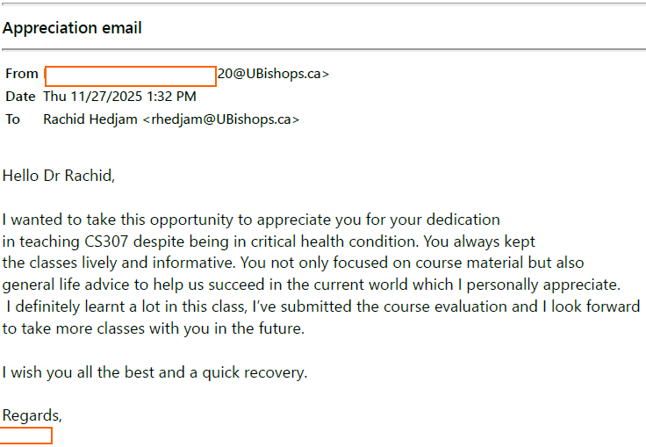
- CS504 (Fall 2023), CS503 and CS462/CS562 (Winter 2024) — email received on 4/6/2025 from a Master's student: "Your classes and assignments definitely have increased my in-depth knowledge in the field"; "your weekly assignments have allowed me to progress in my understanding of the subject with a great hands-on learning experience"; and, on the choice of algorithm, "how to tackle any problem with a suitable algorithm and why it's very important to visualize any dataset". These comments are one student's view and are offered alongside, not in place of, the official evaluations above.
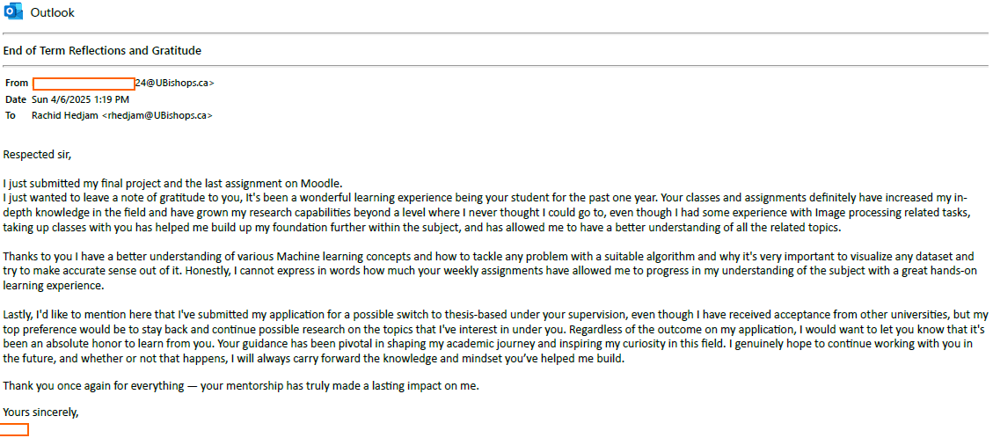

B2. Course materials and curriculum development

B2.1. Syllabus
See next pages

BISHOP'S UNIVERSITY
Department of Computer Science

COURSE SYLLABUS
CS 320 — Natural Language Processing (NLP)

Course Code: | CS 320
Credits: | 3 credits
Level: | 320 — Intermediate Undergraduate
Intended Audience: | BSc Computer Science and BSc Business/IT (BAIT)
Prerequisites: | CS304
Term:
Instructor: | Rachid Hedjam
Office Hours: | Online/Office- upon request
Contact: | rhedjam@ubishops.ca

1. Course Description
Language is the primary medium through which humans communicate, reason, and record knowledge. Natural Language Processing (NLP) is the subfield of Computer Science and Artificial Intelligence concerned with enabling computers to understand, process, and generate human language. From search engines and spam filters to machine translation and intelligent assistants, NLP underlies a broad range of technologies that shape modern business and daily life.
CS320 provides a rigorous yet accessible introduction to the core concepts, algorithms, and practical tools of NLP. The course is designed for a mixed audience of Computer Science (BSc CS) and Business/Information Technology (BSc BAIT) students at the third-year undergraduate level. Mathematical content is presented at a moderate level: formal notation is used where appropriate, but every formula is accompanied by a plain-language explanation, and no result is expected to be derived from first principles. The emphasis is on conceptual understanding and practical application.
The course follows the classical NLP pipeline — from raw text to intelligent applications — progressing from statistical foundations through neural sequence models. It stops deliberately before the Transformer architecture, which is the entry point of CS 520 level (Large Language Models). Students who complete CS320 will have the background necessary to understand and critically evaluate modern language technology, including the limitations and ethical concerns it raises.

Scope
This course covers: text preprocessing, statistical language models, vector space representations, word embeddings, text classification, sequence labeling, syntactic parsing, recurrent neural networks, the encoder-decoder framework with attention, and NLP ethics.

This course does not cover (reserved for CS 520): Transformer architectures, BERT, GPT and other large language models, fine-tuning, prompt engineering, and retrieval-augmented generation.

2. Learning Outcomes
Upon successful completion of CS320, students will be able to:

Knowledge and Understanding
- Explain the main challenges of NLP and the role of the different levels of linguistic analysis.
- Describe statistical n-gram language models and the need for smoothing.
- Distinguish sparse and dense text representations and justify their use.
- Explain the evolution from RNNs/LSTMs to attention-based models.

Skills and Application
- Build a complete text preprocessing pipeline using Python, NLTK and/or spaCy.
- Implement and evaluate classical text classifiers on real datasets.
- Apply pre-trained word embeddings for similarity and analogy tasks.
- Design, implement and present a small NLP project.

Professional and Ethical Awareness
- Identify sources of bias in NLP systems and discuss ethical and regulatory considerations (including relevant Canadian frameworks).

Prerequisites and Assumed Background
The course assumes the following background. Students who are missing any item should complete the suggested preparation before Week 3.

Topic | Required level | Where it is needed
Python programming | Comfortable with loops, functions, lists, dicts | All weeks with coding (Weeks 2–12)
Probability and statistics | Basic: P(A), P(A|B), concept of expectation | Weeks 3–4 (n-grams, perplexity)
Linear algebra | Vectors and dot products (one lecture review is sufficient) | Weeks 5–6 (TF-IDF, embeddings)
Machine learning concepts | Not required — introduced in Week 10 | Module 5
Linguistics | Not required — introduced in Week 1 | Entire course

3. Course Schedule
The table below summarizes the topic, core content, tools, and assessments for each of the twelve weeks. The course is organized into six thematic modules. Module headers (shaded rows) indicate thematic transitions; they do not correspond to separate class meetings.

Note on mathematical content: Formulae are introduced where necessary to ensure rigor, but are always accompanied by a plain-language explanation. Students are expected to understand and apply formulas, not derive them.

Wk | Topic | Key Concepts & Content | Tools | Notes
MODULE 1 — Foundations and Text Processing
1 | Introduction to NLP | What is NLP and why does it matter?  Applications: autocomplete, translation, voice assistants.  Linguistic levels: morphology, syntax, semantics, pragmatics.  Sources of ambiguity: lexical, structural, referential.  Brief history: rule-based → statistical → neural. No maths this week. | Discussion only
2 | Text Preprocessing | Tokenization and sentence segmentation.  Lowercasing, punctuation removal, stopwords.  Stemming vs. lemmatization — when to use each.  Regular expressions: character classes, counters, basic patterns.  Complete preprocessing pipeline in Python. | Python  NLTK  spaCy
MODULE 2 — Statistical Language Models
3 | N-gram Language Models | Why language models? Probability review: joint, conditional, independence (15 min).  Chain rule. Markov assumption — why not use full history.  Unigram, bigram, trigram models. MLE: counting and normalizing.  Sentence probability by hand. Log probabilities. | Python  NLTK (MLE)  Jupyter
4 | Smoothing and Evaluation | Sparsity: why MLE fails at test time. Laplace add-1 smoothing.  Interpolation: mixing n-gram orders. Kneser-Ney: mention only.  Train / dev / test splits. Perplexity: formula and interpretation. Data contamination. | Python  NLTK (Laplace)  Jupyter | Assignment 1 released.
MODULE 3 — Text Representations
5 | Bag-of-Words and TF-IDF | From tokens to numbers. Vocabulary and document-term matrix.  Bag-of-Words: construction and limits.  TF-IDF weighting: formula and worked example.  Cosine similarity for document comparison.  TF-IDF as a feature vector for classification — bridge to Module 4. | Python  scikit-learn  pandas | Assignment 1 due.
6 | Midterm 1 | Full 1 h 30 min in-class exam. Covers Modules 1–2 and the representation foundations of Module 3 (Weeks 1–5). | —
MODULE 4 — Core NLP Tasks
7 | Text Classification | Classification as a task.  Feature vectors from TF-IDF: how scikit-learn pipelines connect TfidfVectorizer to a classifier.  Naive Bayes: one numerical example, no derivation.  Logistic regression for text. Feature engineering: unigrams, bigrams.  Precision, recall, F1, confusion matrix. Sentiment analysis case study. | Python  scikit-learn  NLTK | Assignment 2 released.
8 | Sequence Labelling, NER, and Parsing | POS tagging: what tags are and why they matter. IOB tagging scheme.  Named Entity Recognition: persons, orgs, locations, dates.  HMMs: state diagram — conceptual only. spaCy NER in practice. Error analysis.  Syntax: constituency and dependency parsing — intuition and spaCy demo.  Context-free grammars: conceptual only. | Python  spaCy | Assignment 2 due.
9 | Midterm 2 | Full 1 h 30 min in-class exam. Covers Modules 3–4 (Weeks 5–8): TF-IDF, text classification, sequence labelling, NER, parsing. | —
MODULE 5 — Introduction to Neural NLP
10 | Neural Networks for Text | Why TF-IDF falls short for neural models: sparse, no semantics.  Word embeddings — introduced at the point of need:  Distributional hypothesis. Pre-trained GloVe / Word2Vec vectors.  Vector arithmetic: king − man + woman ≈ queen (brief demo).  Feedforward network: neurons, layers, activation — visual intuition only.  Training: loss, gradient descent intuition, backprop in one sentence.  Text classifier in Keras using an Embedding layer + dense layers. | Python  Keras  Gensim  GloVe | Assignment 3 released.
11 | Recurrent Neural Networks | Why fixed-window models struggle with long-range context. Hidden state idea.  RNN: one forward pass walkthrough. Vanishing gradient: intuition only.  LSTM and GRU as solutions — no derivation. LSTM text classifier in Keras.  Transformers preview: 2 slides — pointer to CS 400/500. | Python  Keras (LSTM)
MODULE 6 — Applications and Ethics
12 | Applied NLP and Ethics | Application survey: information retrieval, question answering, summarization, dialogue systems.  Bias in NLP: how it enters through data, embeddings, and labels.  Fairness metrics (conceptual). Responsible deployment: documentation, auditing, human oversight.  Canadian regulatory context: PIPEDA, Algorithmic Impact Assessment.  Course wrap-up: what CS 400 and CS 500 cover. Word embeddings → contextual embeddings → BERT → LLMs. | Discussion  Demo | Connect bias examples to tools already used Assignment 3 due.

4. Assessment and Grading

4.1 Assessment Components
Item | Weight | Released | Due | Covers
Assignment 1 — Preprocessing & N-gram Models | 10 % | Week 4 | Week 5 | Weeks 1–4
Midterm Exam (full class, Week 6) | 25 % | — | –– | Weeks 1–5
Assignment 2 — Representations & Classification | 15 % | Week 7 | Week 8 | Weeks 5–7
Midterm Exam (full class, Week 9) | 25 % | — | –– | Weeks 6–8
Assignment 3 — Neural NLP | 20 % | Week 10 | Week 12 | Weeks 7–11
Participation | 5 % | — | Ongoing | Full course

4.3 Policies
Late submissions: A penalty of 10 % per calendar day will be applied to late assignments, up to a maximum of three days. Assignments submitted more than three days late will receive a grade of zero. Extensions may be granted if requested in writing before the original deadline.

Missed midterm: A student who misses the midterm examination due to a documented medical or family emergency should contact the instructor within 48 hours. A make-up examination or grade reallocation will be arranged at the instructor's discretion.

5. Required and Recommended References

- Jurafsky, D., & Martin, J. H. (2024). Speech and Language Processing (3rd ed. draft). Available free of charge at: https://web.stanford.edu/~jurafsky/slp3/
- Howard, J., & Gugger, S. (2020). Practical Deep Learning for Coders. fast.ai. Available free of charge at: https://course.fast.ai

Students are not required to purchase any textbook. All required readings are freely available online or will be posted on Moodle.

This resource is particularly recommended for BAIT students and for students who find the mathematical presentation of Jurafsky and Martin challenging. The fast.ai course is designed from the outset for practitioners without a strong mathematical background: it is code-first, application-first, and explicitly avoids unnecessary formalism.

The two references are complementary: Jurafsky and Martin provides the theoretical rigour required for a university course, while fast.ai provides an alternative entry point for students who prefer to see working code before formal definitions. Students are encouraged to consult whichever resource aids their understanding; both are acceptable as secondary citations in assignments and the final project report

6. Course Policies

6.1 Academic Integrity
All work submitted for evaluation must be the student's own. Collaboration is encouraged for conceptual understanding, but all code, written analyses, and reports must be produced independently, unless explicit pair work is authorized.

Use of generative AI tools (e.g., ChatGPT, GitHub Copilot) must be disclosed in any submission. Undisclosed use of AI-generated content constitutes academic dishonesty under the Bishop's University Academic Integrity Policy. Students are responsible for familiarizing themselves with that policy.

Plagiarism detection software may be used to verify originality. Suspected violations will be reported to the Academic Integrity Committee.

6.2 Accessibility and Accommodation
Bishop's University is committed to providing equitable access to education for all students. Students with documented disabilities or other circumstances requiring accommodation should contact the SAS Office and provide official documentation. Students are encouraged to notify the instructor of their accommodation plan within the first two weeks of the term so that appropriate arrangements can be made in a timely manner.

6.3 Attendance
Regular attendance at lectures sessions is expected. Lecture slides and any supplementary materials will be posted on Moodle; however, in-class discussion, worked examples, and live coding demonstrations are integral parts of the learning experience and will not be recorded. Students who miss a class are responsible for obtaining notes from a classmate and reviewing posted materials.

6.4 Communication and Office Hours
The instructor will respond to email enquiries within two business days. For questions of general interest, students are strongly encouraged to use the course discussion forum on Moodle; answers provided there benefit all students. Office hours will be posted on Moodle at the beginning of the term. Students requiring assistance outside of office hours may arrange an appointment by email.

6.5 Inclusive Learning Environment
This course is designed to be accessible to both Computer Science and BAIT students. Each group brings different strengths: CS students may have stronger programming and mathematical foundations, while BAIT students may have stronger domain knowledge in business applications of technology. These differences are a resource, not a barrier. Questions are always welcome, and no level of question is considered too basic. Students are expected to treat their peers with respect and professionalism.

7. Required Tools and Resources

7.1 Software
All software used in this course is freely available. A detailed installation guide and a configuration-verification notebook will be distributed via Moodle in the first week.

Python 3.10 or later | https://www.python.org
Jupyter Notebooks (via Anaconda) | https://www.anaconda.com
NLTK | https://www.nltk.org
spaCy | https://spacy.io
scikit-learn | https://scikit-learn.org
Gensim | https://radimrehurek.com/gensim/
Keras (part of TensorFlow) | https://keras.io
pandas, NumPy, matplotlib | Included in Anaconda distribution

Students who encounter difficulty installing the software locally may use Google Colaboratory (https://colab.research.google.com), a free cloud-based Jupyter environment that requires only a Google account. All assignment notebooks are tested to run on both local installations and Google Colab.

7.2 Course Platform
All course materials — slides, assignment notebooks, announcements, grades, and the discussion forum — are hosted on Bishop's University Moodle. Students must check Moodle regularly.

This syllabus is subject to revision. Any modifications will be announced on Moodle with a minimum of one week's notice. The instructor reserves the right to adjust the pace and content of individual lectures to better serve the learning needs of the class.

B2.2. Selected Lecture Materials (e.g., cross-liste course)
The following slides are selected slides (not all) from my CS405/CS505 course, which is cross-liste for both undergraduate (BSc) and graduate (MSc) students. They illustrate the flow and structure of my lectures and demonstrate how I adapt my teaching to accommodate students at two academic levels. I clearly indicate which topics and concepts require greater attention and deeper understanding from each group, allowing me to address their different learning needs within the same course.
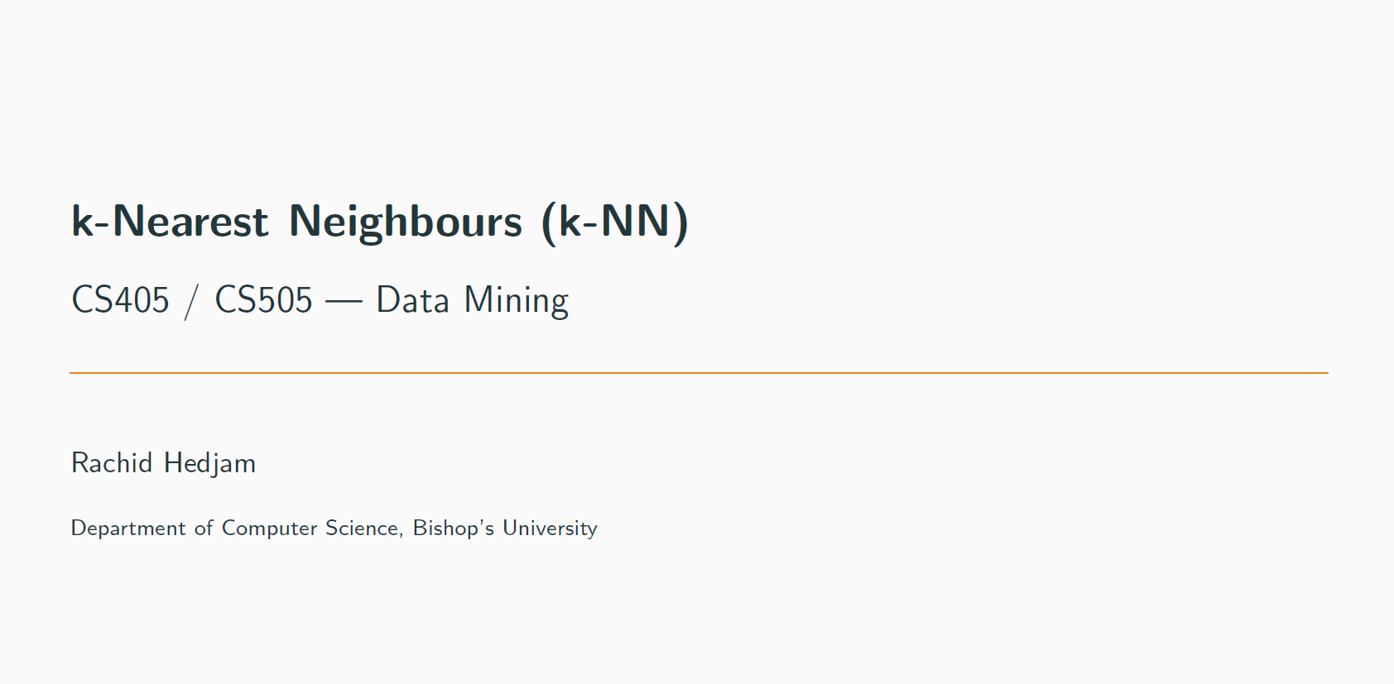
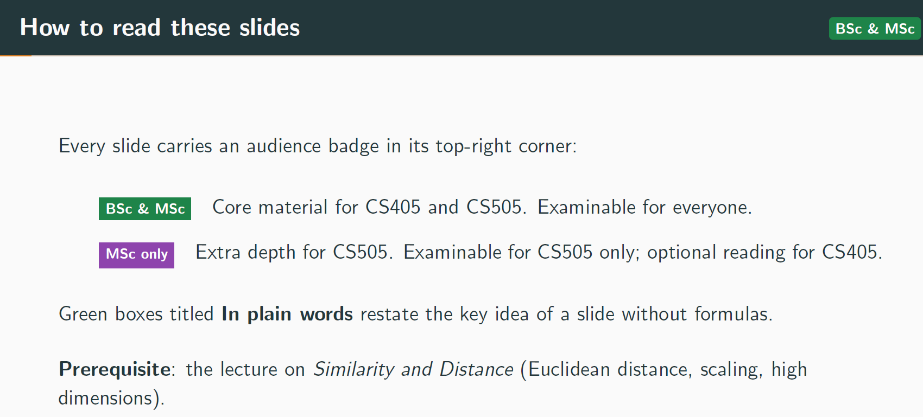
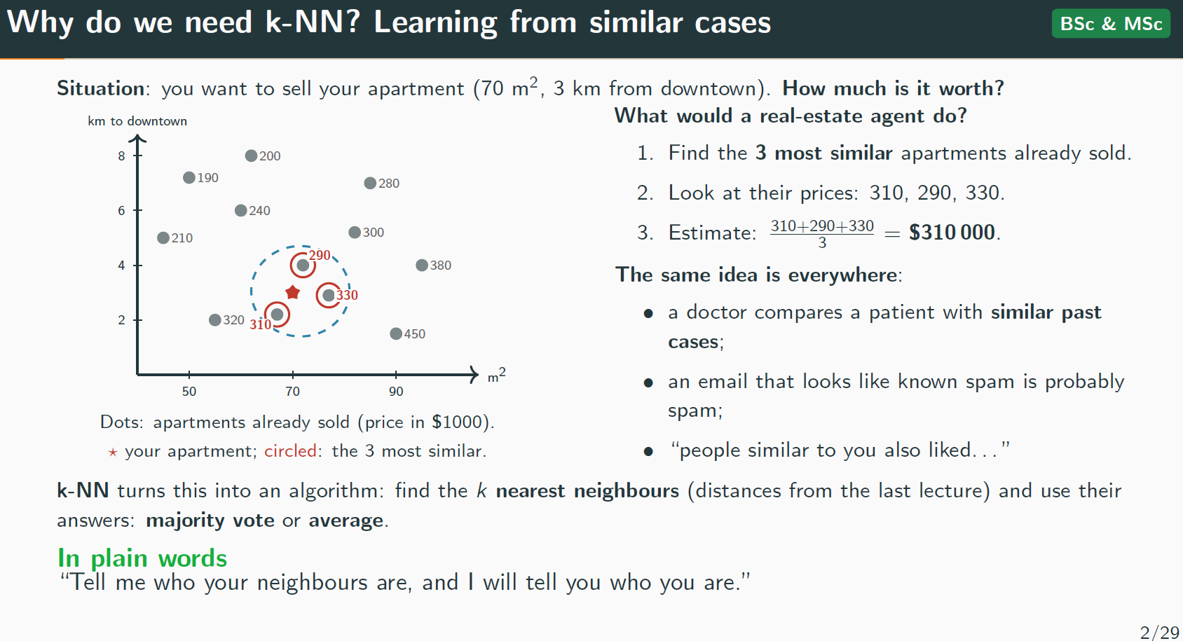
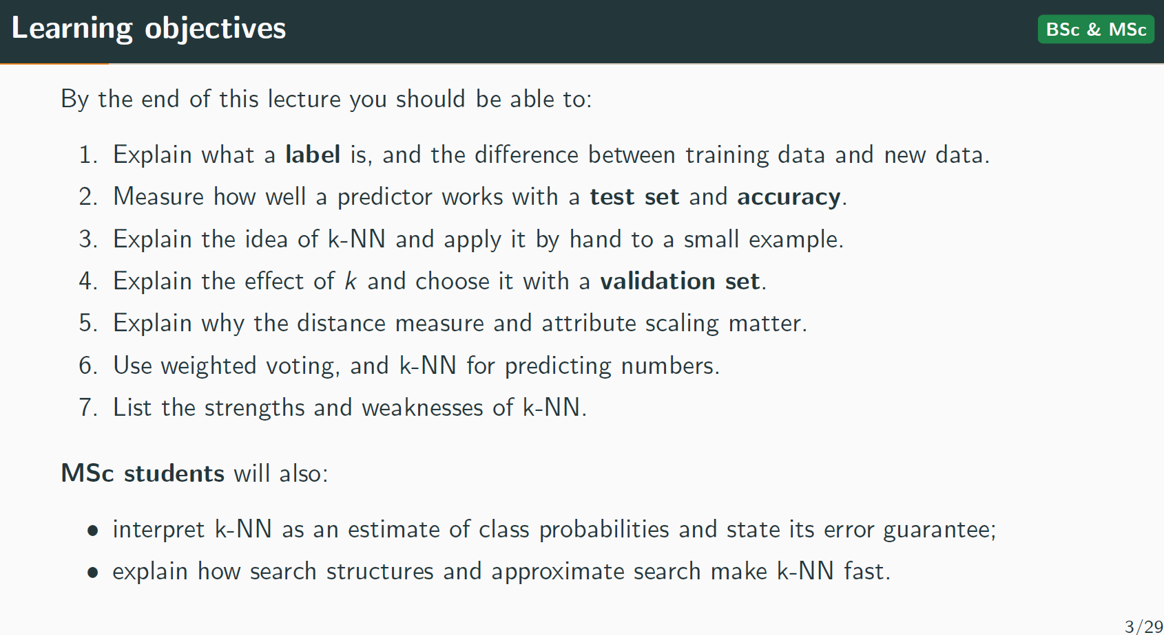
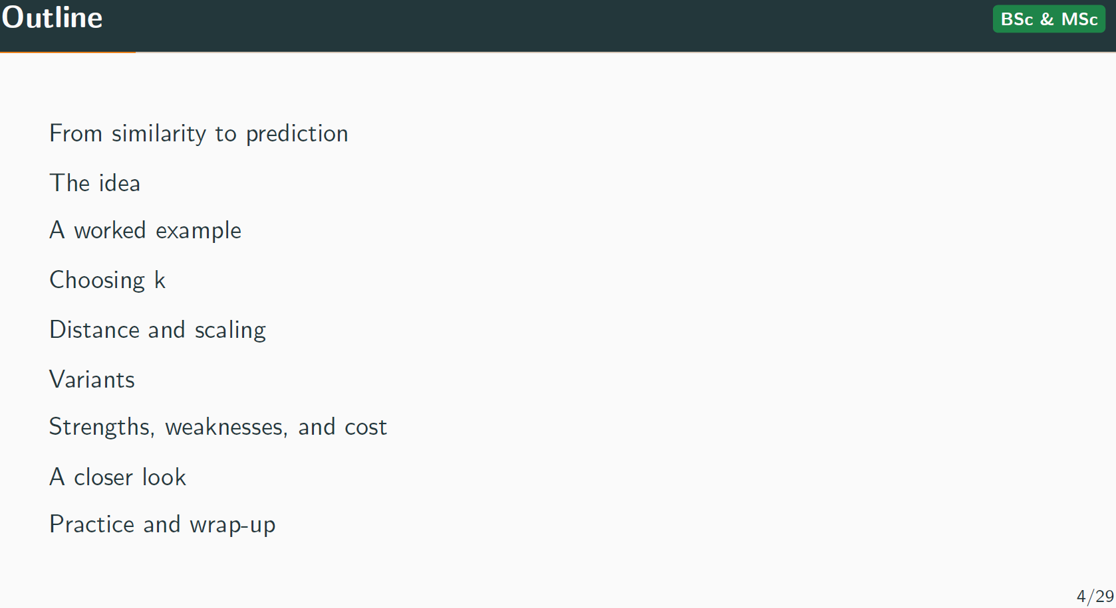
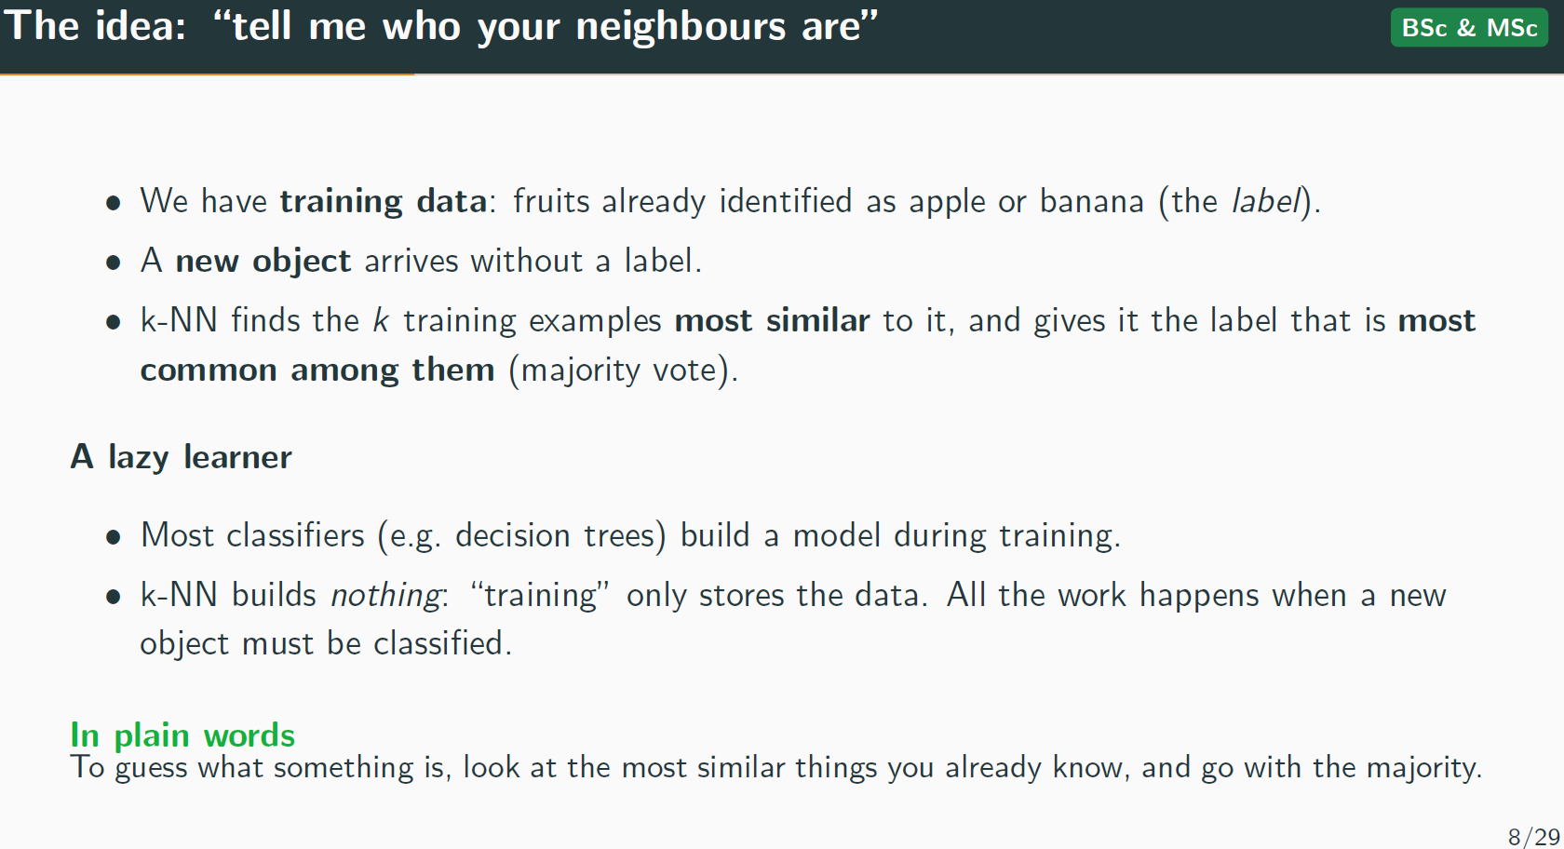
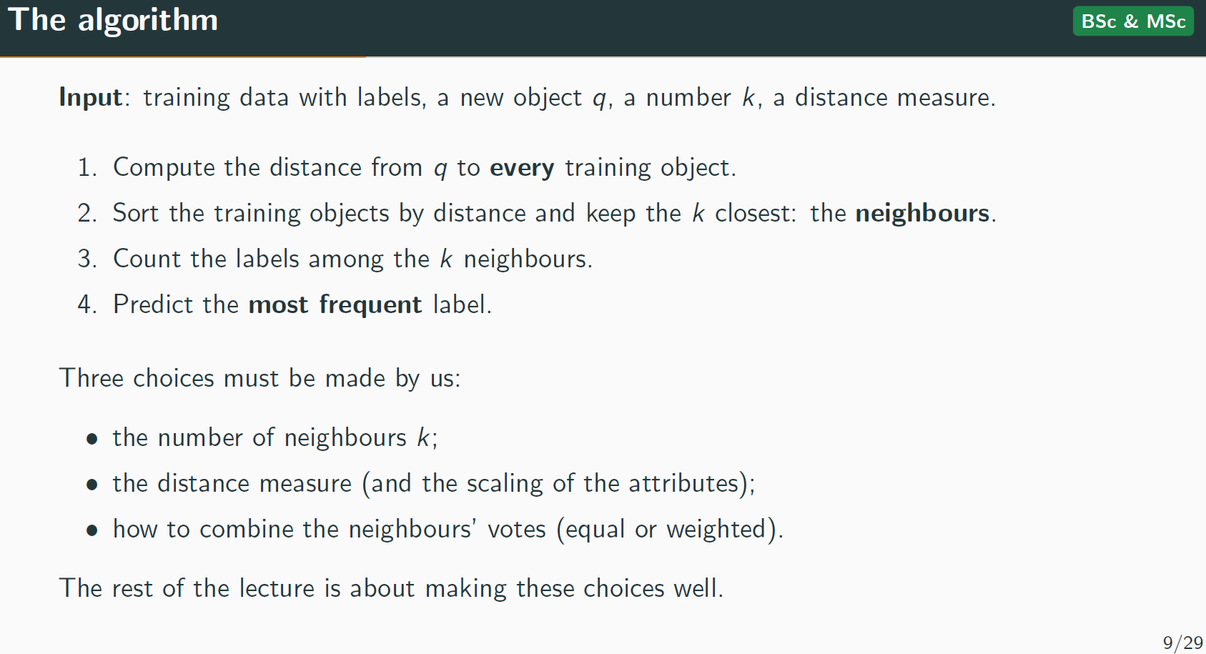
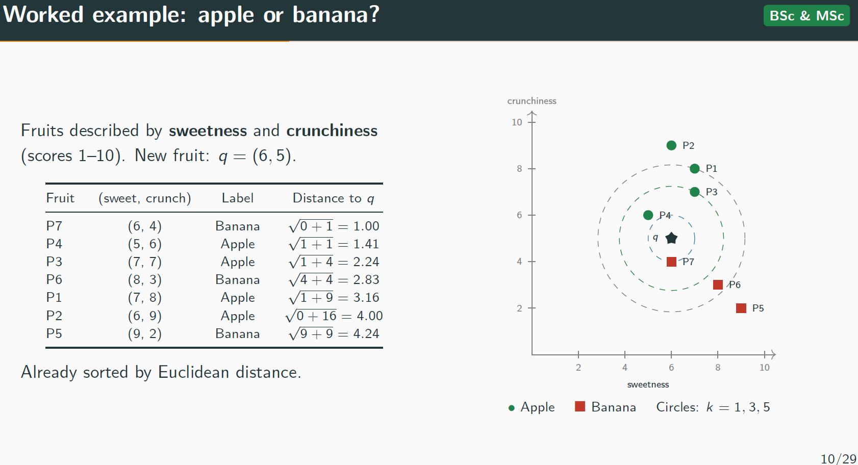
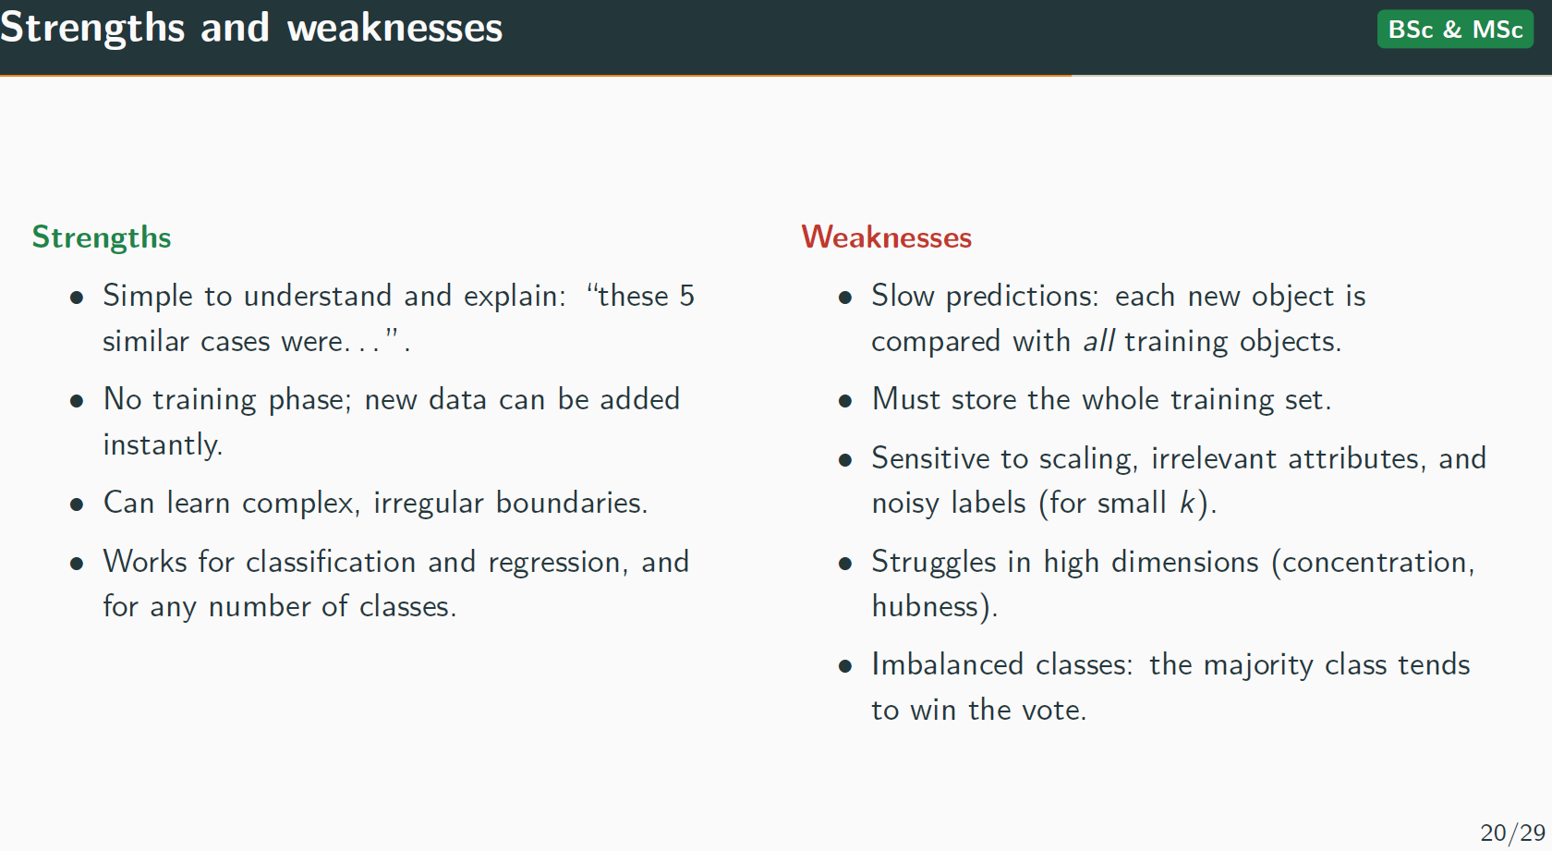
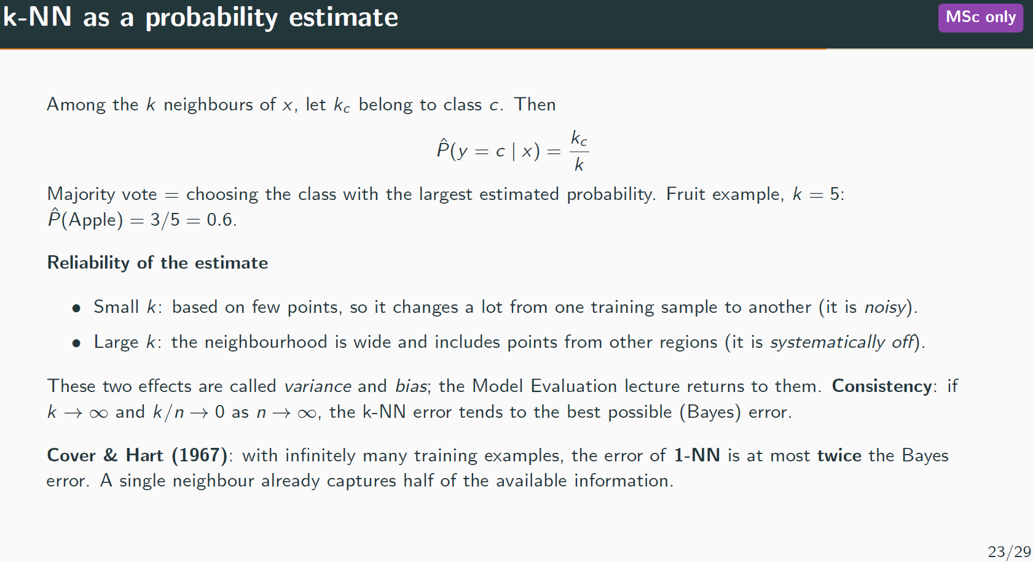
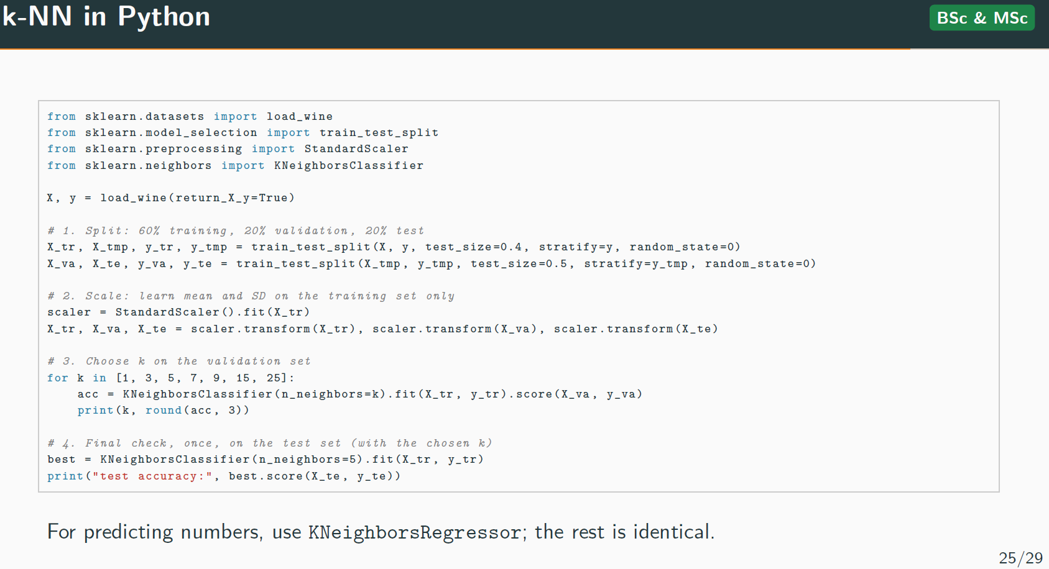
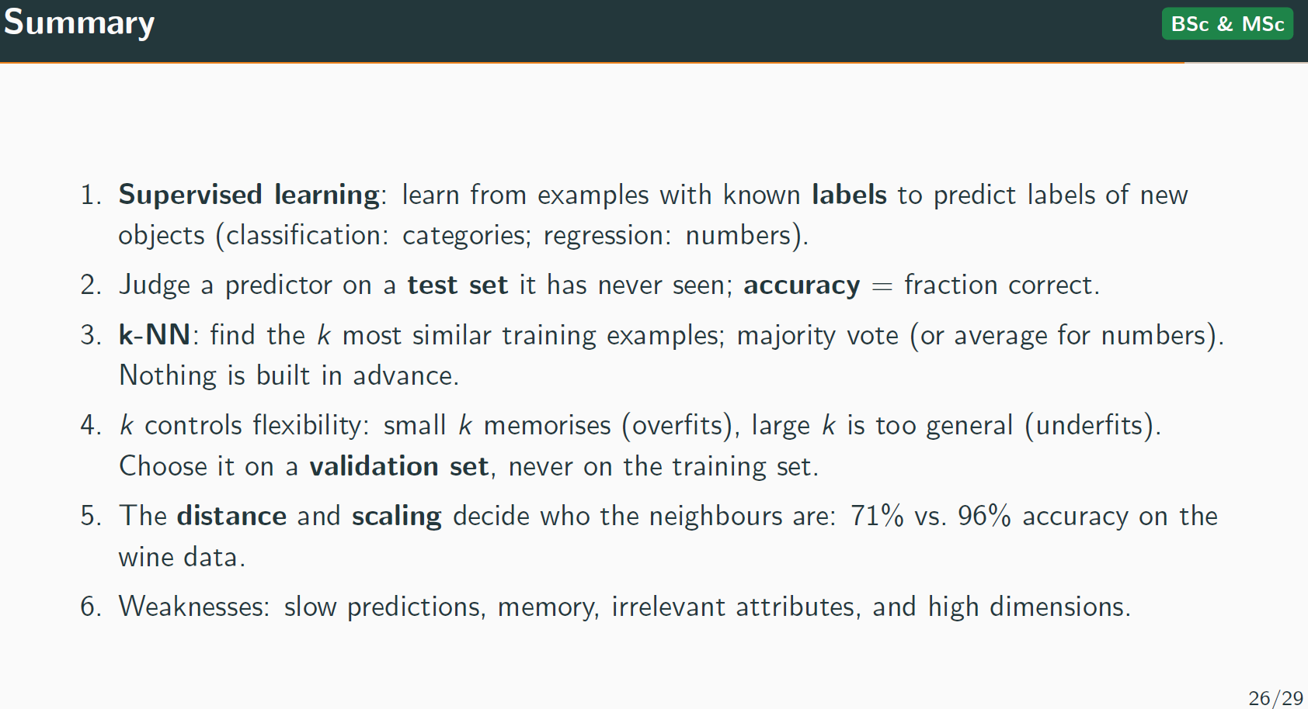
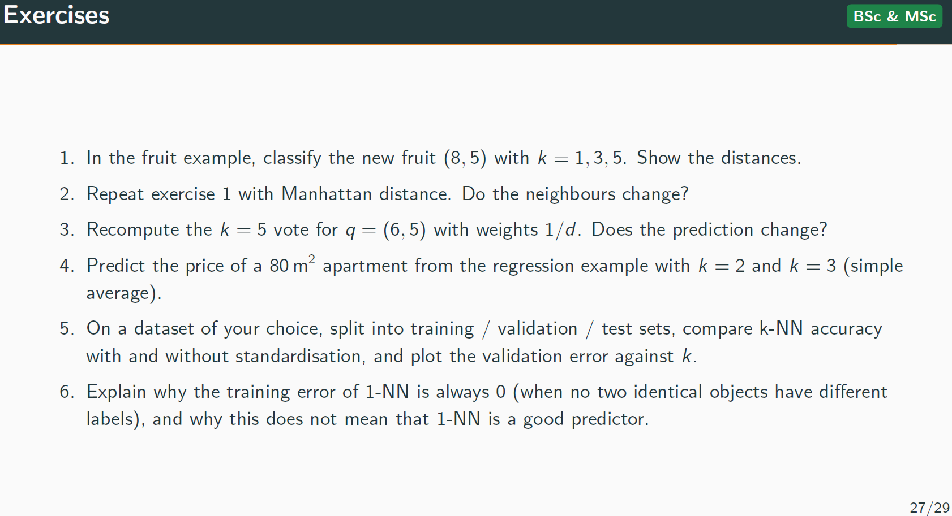
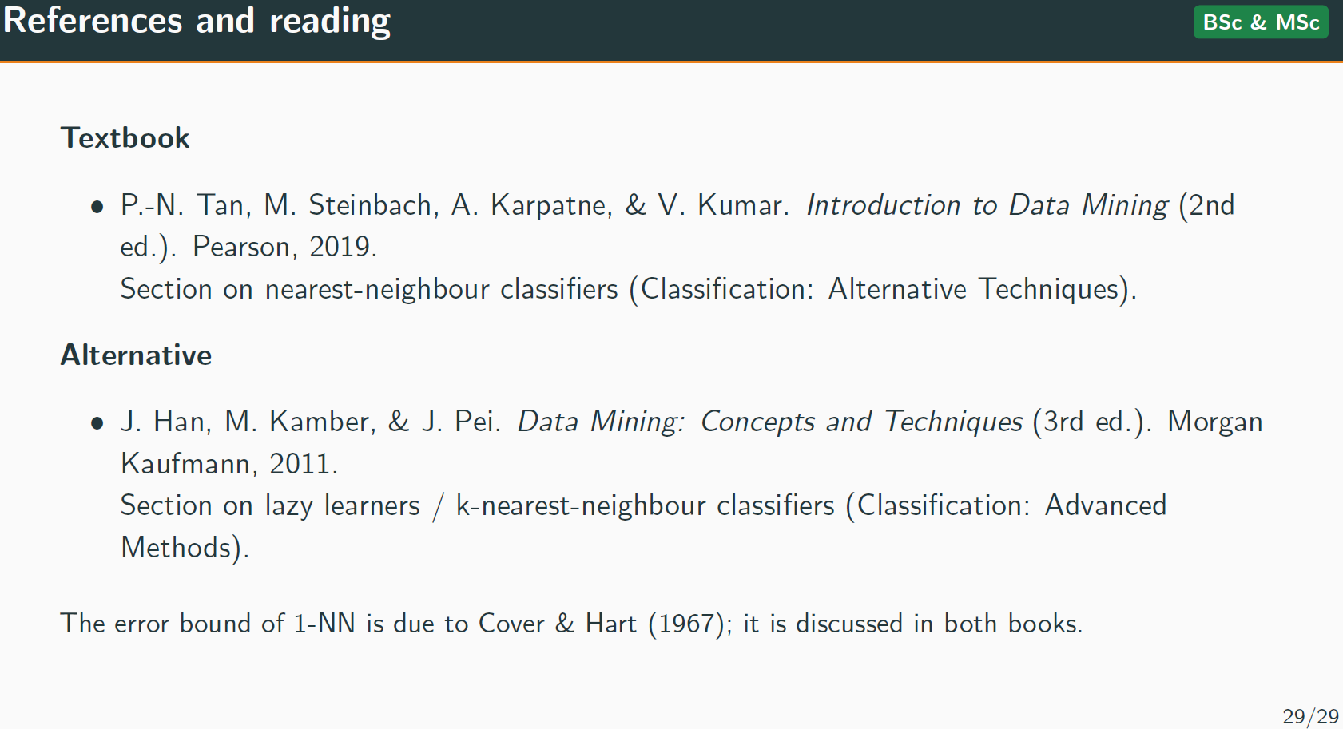

B3. Assessment and reflective practice
For a representative assessment in each priority course: task instructions, rubric or marking scheme, relevant learning outcomes, and a brief account of feedback given. Anonymize any student work used, with permission secured. Structure one reflective example as context, change, evidence, interpretation, and next step — starting from the CS562 (Winter 2024) result flagged in Section 2.2.2.

Wait for exam

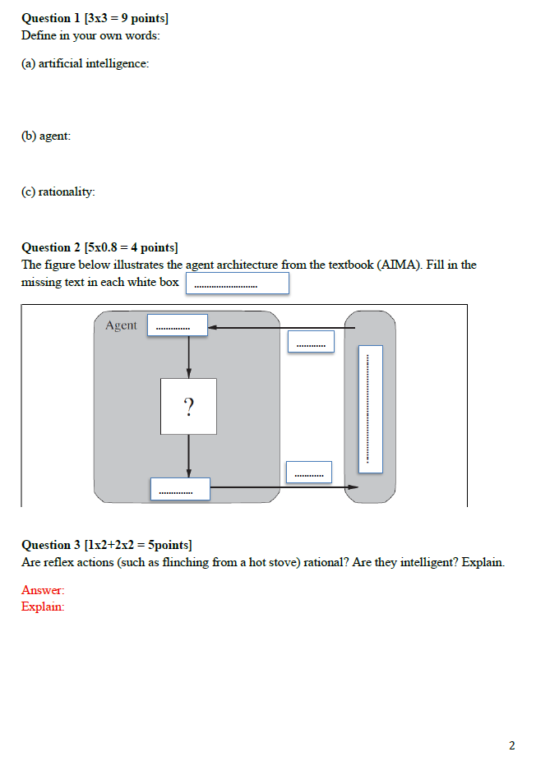

B4. Awards and peer evidence
- Bishop's Excellence in Teaching Award notice (2026)
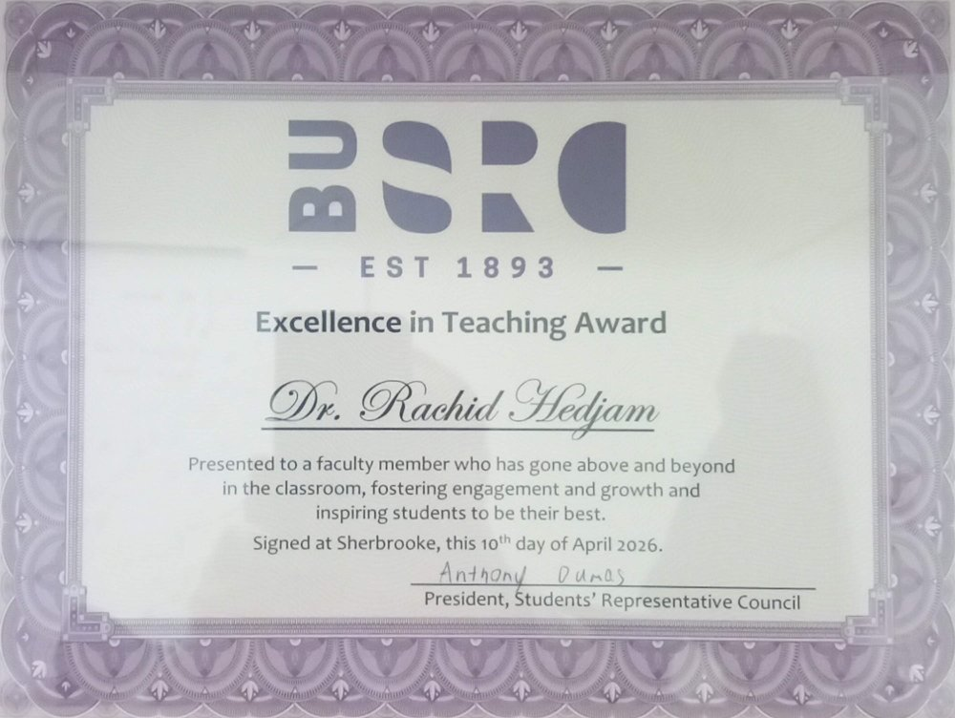

- SQU Distinguished Academician citation (2020–2021).
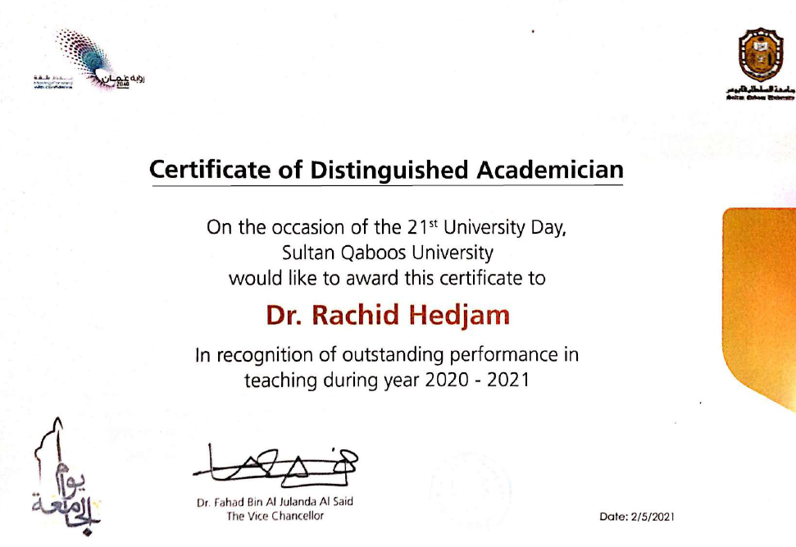

- Teaching appreciation from SQU Vice-Chancellor
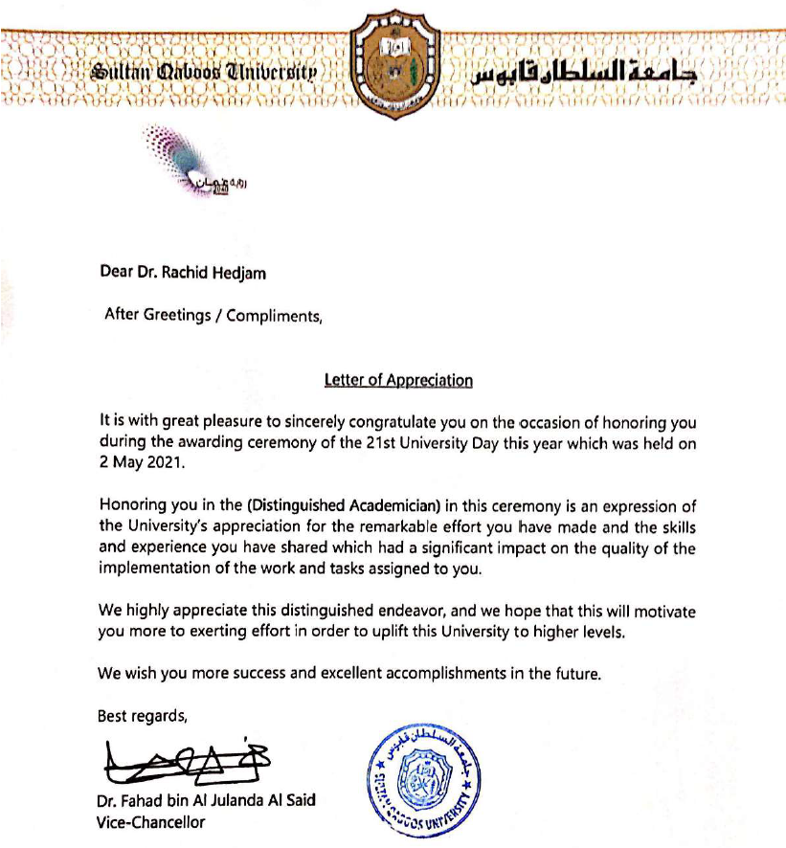

- SQU Teaching evaluation and Comment from SQU Department of Computer Science Chair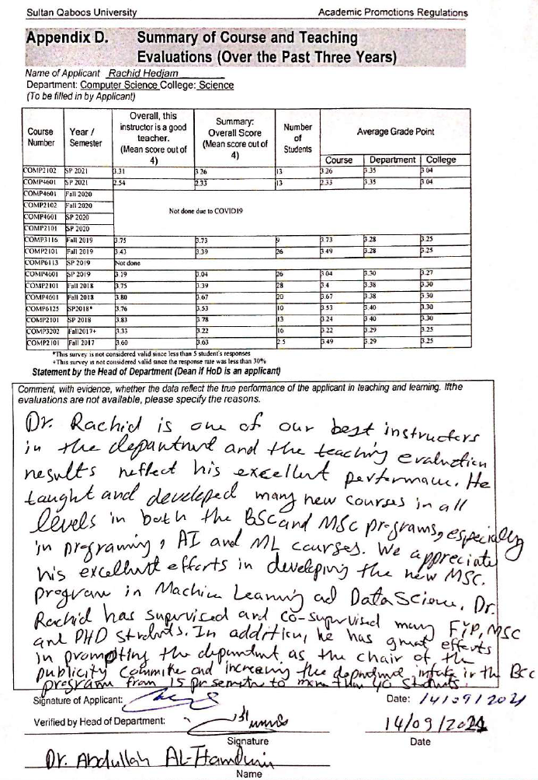

B5. Peer reviews of teaching
I have not yet had a formal peer review of my teaching at Bishop’s, and I plan to request one in the coming year. In the meantime, the following items give independent evidence of the quality of my teaching:
- Student evaluations (Appendix B1): the course evaluation reports for the courses I have taught.
- Teaching awards (Appendix B4): the Excellence in Teaching Award (2026) and the Distinguished Academician (Best Teacher) recognition at SQU (2020–2021).
- Student accomplishments (Appendix B7): awards and publications by students I have supervised or taught.
- Peer engagement on teaching (Appendices B8, E2): my role in the Task Force on Generative AI, including the annual workshop at the Academic Year Launch, and my invited lecture on teaching and learning.
- External academic review: my role as external reviewer of an MSc program at Ouargla University, confirmed by a certificate (Appendix E1.2).
- Professional development (Appendix B6): my certificate of participation in the active learning lecture.

B6. Professional development and literature
- Certificate of participation, workshop ‘Active learning: the key to student learning’, led by Prof. Grahame Bilbow (Grange Education), Sultan Qaboos University, 23 September 2021.
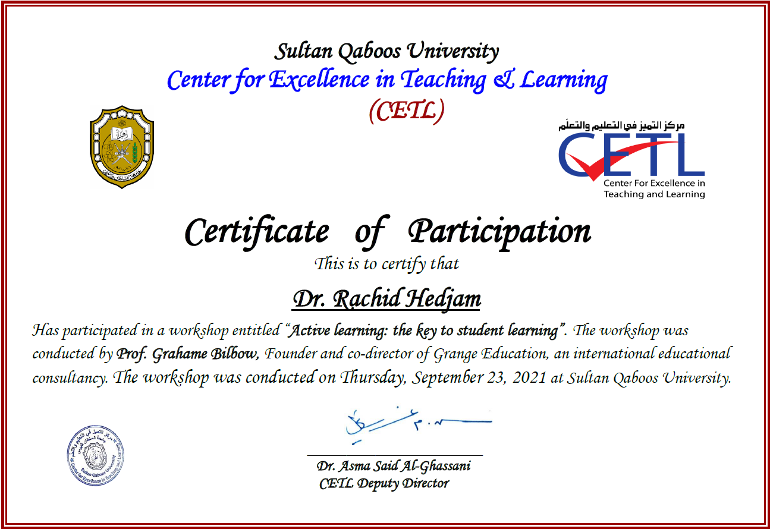

B7. Student accomplishments and educational mentorship
This appendix gives examples of students I supervised and what they achieved. For each student, I give who the student is, the degree or project, the dates, my role, where the student started and what they wanted to learn, how I helped, what the student did on their own, and the result (a thesis, a paper, an award, a presentation, or the next step in their studies). Award letters are in Appendix D2.
B7.1. — CS446 to Honours project (referenced in Section 2.1.3)
- Student and role: A BSc Honours student, Computer Science, Bishop’s; 2024. I was her supervisor.
- Starting point and learning goal: She completed CS446, Intelligent Systems and Neural Networks, in Fall 2023. She had not studied neural networks or the mathematics and programming behind them before. She wanted to learn them in depth and was highly motivated.
- Guidance I provided: I supervised the project from problem formulation through implementation, evaluation and writing. We meet weekly, in my office and online, and I gave feedback on her progress each time. I taught her to implement neural networks step by step, from simple to advanced models, despite the limited computing power she had. We covered many aspects of neural networks, with applications ranging from simple tasks to object detection.
- Student’s own contribution: Over two semesters she implemented many algorithms and tested several object detection methods in different conditions, with a focus on the YOLO approach.
- Accomplishment: She completed the Honours project “Deep Learning for Object Detection” (2024). She then did an internship in computer vision and machine learning at Near Earth Autonomy (Pittsburgh, USA), May 2025 to August 2026, and started an MSc at York University (In progress). I list these as what came next, not as caused by the project.
- Supporting record: The Honor’s report. See some selected pages in next few pages.

B7.2. — MSc student, CS504/CS503/CS462-CS562 (2023-24)
- Student and role: An MSc student in Computer Science, Bishop’s (2023–2025). I was his thesis supervisor, and I also taught him in CS504 (Fall 2023), CS503 and CS462/CS562 (Winter 2024).
- Starting point and learning goal: He was strong in coding, but his mathematical background was limited for machine learning and AI. He enrolled in three of my graduate courses before starting his thesis.
- Guidance I provided: I supervised his thesis on meta-learning for unsupervised learning; a topic usually applied to supervised learning. He built skills in supervised and unsupervised learning and in evolutionary algorithms (genetic algorithms, particle swarm optimization). I also hired him as a research assistant on my AI research project, where he worked on both the theory and the experiments.
- Student’s own contribution: He wrote the code, ran the experiments and wrote the thesis. Some of the results were presented at Bishop’s Research Week (March 2024).
- Accomplishment: His thesis led to a paper at the 38th Canadian Conference on Artificial Intelligence (Calgary, 26–29 May 2025), which won the Best Student Paper Award. He was later admitted to a PhD program with a scholarship from the Quantum institute at University of Sherbrooke.
- Supporting record: The paper and award letter (Appendix D2); the thesis; the Research Week program. Conference paper C10, Appendix A6.

B7.3. — SQU MSc student: network intrusion detection (2020)
- Student and role: An MSc student in Computer Science, Sultan Qaboos University; completed in 2020. I was her thesis supervisor.
- Starting point and learning goal: She had no background in AI for fraud detection. Her interest began with a homework assignment in my Machine Learning course, and she then asked me to supervise a master’s thesis on the topic.
- Guidance I provided: I supervised a thesis on fast binary network intrusion detection using matched filter optimization. We met weekly and worked closely together at every stage of the project.
- Student's own contribution: She designed the initial method, which we then improved together over successive meetings.
- Accomplishment: The thesis received the Best Supervised MSc Thesis award of the College of Science, SQU, in 2020. The work was published with me at the IEEE ICIoT 2020 conference (C15, Appendix A6.5).
- Supporting record: The award certificate (Appendix D2, I couldn’t get form the student); the paper (C15, Appendix A6.5).

B7.4. SQU BSc student: final-year project to MSc scholarship
- Student and role: A BSc student in Computer Science, Sultan Qaboos University; final-year project [year]. I was her supervisor.
- Starting point and learning goal: She has a little information about AI for medical image analysis. However, she was very curious. She was the best student at SQU in 2022.
- Guidance I provided: I supervised the final-year project [Deep Learning for Alzheimer’s Disease Detection from CT Images] and recommended her for a full scholarship to an MSc at Aalto University. I provided a very supportive recommendation letter.
- Student's own contribution: She implemented a DL model for Alzheimer’s Disease Detection.
- Accomplishment: She received the full scholarship and began an MSc at Aalto University. We later published a paper together at ACM Multimedia Conference. A-ranked ACM conference [source: CORE].
- Supporting record:
  - Conference paper, C08, Appendix A6.5
  - Final Year Project: https://github.com/inesriahi/web-application-for-ich-detection-from-ct-scans

B7.5. SQU PhD students: best research paper awards
Two PhD students I supervised at SQU won the Best Published Paper award of Sultan Qaboos University, in 2023 and in 2024 (AW05, AW04). Appendix D2.

Some slides from the Honor’s report are shown here:

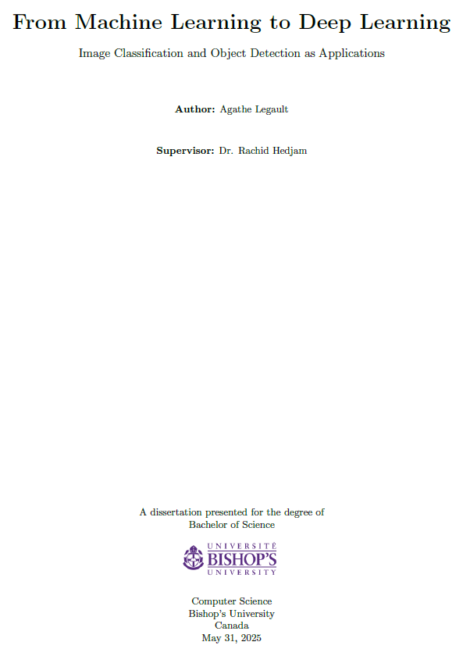
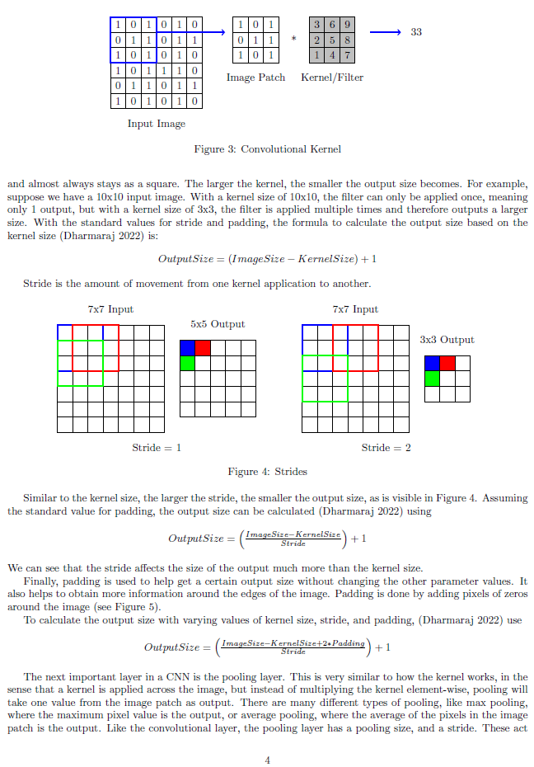

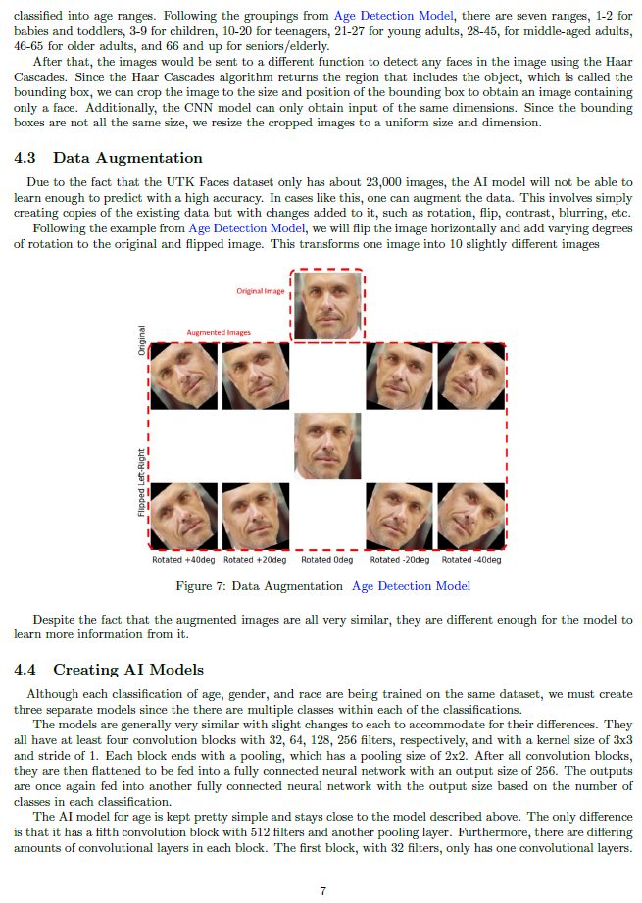

.

B8. Teaching leadership, mentorship, and knowledge mobilization
B8.1 Generative AI in teaching, Bishop’s University
- Activity and date: Member of the Task Force on Generative AI. I initiated the idea of surveying Bishop’s faculty about GenAI in teaching. The survey led to an annual workshop, and GenAI is now an important session within the Bishop’s Academic Year Launch held at the start of each academic year.
- My role: Initiator of the survey. I carried out the statistical analysis of the results, which helped the Task Force draft guidelines for the use of GenAI at Bishop’s. I co-organized the session “AI’s Impact on Teaching” during Launch Week, 25–29 August 2025.
- Audience: Bishop’s faculty.
- Need addressed: Faculty needed shared guidance on using GenAI in teaching and assessment.
- Output and use: Survey results, guidelines, and an annual workshop that is now part of the Academic Year Launch.
- Evidence: Appendix E1.1.
B8.32 Curriculum and course-quality leadership, Sultan Qaboos University
- Activity: At SQU I led the development of a full curriculum for a new MSc in Data Science. I also chaired the Course Files Committee and served on the Learning Centre Initiative Committee and the quality and postgraduate studies committees.
- Need addressed: a new graduate program and consistent course documentation.
- Evidence: No evidence is available.
B8.4 Community and student outreach
- Activity and date: I took part in the Townshippers’ Association career fair, April 14, 2025
- Role and audience: Participant presenting to students or community members from high schools in Township.
- Evidence: thank-you letter from the manager of the ERCC, Townshippers’ Association. Appendix E3.1.
B8.5 Mentorship of students
My supervision and mentoring, including student awards and publications, are documented in Appendix B7 and Appendix D.

Appendix C. Research evidence

C1. Selected outputs and my contribution
These are some outputs selected for the research case. For each, I give the reference, the venue and its rank, my role, the question it addresses, what I contributed myself, and the result and recognition. Where I am not the first author, I state the roles of my students, my postdoctoral researcher and the co-authors.
J20. Appendix A6.2
Venue and rank: Pattern Recognition, [Q1, IF 8.8].
My role: first author
Question and importance: How the structure kept in a data representation affects clustering. [one more sentence]
My contribution: Idea initiation, Model conception, Experimentation. The co-authors, criticism, result validation and proofread the paper
Result and recognition: Best Paper Award, IEEE Oman Section. Appendix C3.2.

C10. Appendix A6.5
Venue and rank: Canadian AI 2025, CORE B
My role: supervisor of the first author (MSc student); M. Allaoui, my postdoctoral researcher, is a co-author
Question and importance: Learning representations across tasks, not for one task only.
My contribution: Supervision. Ask the research question. The other co-authors address it and develop the method.
Result and recognition: The first meta unsupervised algorithm published. Best Conference Student Paper Award. Appendix D2.

J10 and J09. Appendix A6.2.
Venue and rank: Expert Systems with Applications [Q1, IF 9.4]; Knowledge-Based Systems [Q1, IF 8.0].
My role: third author of J10 and second author of J09; the first author of both is my postdoctoral researcher, M. Allaoui
Question and importance: How to improve low-dimensional embeddings used for visualization.
My contribution: Supervision. Improve the formal model, validate experiments and proofread the paper supervision. The 1st author initiates the idea and develop it, the author co-authors contribute in all steps.
Result and recognition: Good number of citations.

J26. Appendix A6.2.
Venue and rank: IEEE JSTARS [Q1, IF 6.3].
My role: first author.
Question and importance: Detecting meaningful change in satellite images when no labelled examples exist.
My contribution: Initiation and end-to-end development of the idea. The other co-author contributed to all steps.

J01 and J08. Appendix A6.2.
Venue and rank: Sensors [Q1, IF 4]; Signals [Q1, IF 2.9].
My role: last author and supervisor; the first author is my PhD student; the 3rd co-author is a co-supervisor.
Question and importance: Detecting sleep apnea and classifying sleep stages from physiological signals.
My contribution: Help in designing a valid prediction model.
Result and recognition: Achieved state of the art in sleep stage and disorder detection.

C03 and C06. Appendix A6.5.
Venue and rank: UAI’26, CORE A*; AISTATS’26, CORE A*
My role: Supervisor and second author of both; the first author of both is my postdoctoral researcher.
Question and importance: reliable anomaly decisions, and efficient graph neural networks for classification.
My contribution: Help in refining the problem formulation and validating experiments.
Result and recognition: Achieved the state of the art on many benchmark datasets.

Earlier work (J34, J35, J36, Appendix A6.2)
IEEE TGRS 2016 (J34), IEEE TIP 2015 (J35) and Pattern Recognition 2013 (J36) show the early direction of my research on image representation, change detection and historical documents, and are the source of the shared resources in Appendix C3. My role: first author of most of them.

C3. Impact and reusable resources
This appendix lists the software and datasets I have shared with other researchers, and the independent recognition of my work. Each entry gives my role, the link, evidence of use with the date it was recorded, and the related publication.

C3.1 Shared software and datasets
- SMADI: Synchromedia Multispectral Ancient Document Images Dataset
- My role: Collected the database
- Related publication: J36, Appendix 6.2
- Link: https://tc11.cvc.uab.es/datasets/SMADI_1
- CorrC2G: color-to-gray conversion by correlation
- My role: Co-author of the method
- Related publication: J31, Appendix 6.2.
- Link: https://www.mathworks.com/matlabcentral/fileexchange/64628-corrc2g-color-to-gray-conversion-by-correlation
- MDSI: mean deviation similarity index (image quality)
- My role: Co-author of the method
- Related publication: J33, Appendix 6.2.
- Link:https://www.mathworks.com/matlabcentral/fileexchange/59809-mdsi-ref-dist-combmethod?s_tid=srchtitle_support_results_1_MDSI
- LC2G: algorithm and benchmark dataset for multispectral analysis of historical documents
- My role: Developer
- Related publication: J35, Appendix 6.2.
- Link: synchromedia.ca/LC2G/index2.html

- Grid-based modeling of images
- My role: Developer
- Related publication: J37, Appendix 6.2.
- Link: https://www.mathworks.com/matlabcentral/fileexchange/27808-grid-based-modeling-of-images?s_tid=answers_rc2-3_p6_undefined

C3.2 Awards and external evaluations
- MDSI. Ranked first among 50 algorithms in an independent comparison (as reviewed in MDPI Remote Sensing, 12(15), 2349).
- Binarization algorithms. First place in the International Quantitative Evaluation of Binarization Algorithms, ICFHR’10, Kolkata, India.
- Best paper. IEEE Oman Section Best Paper Award (IEEE Region 8), 2021, for J20 Appendix A6.2. See the following certificate.

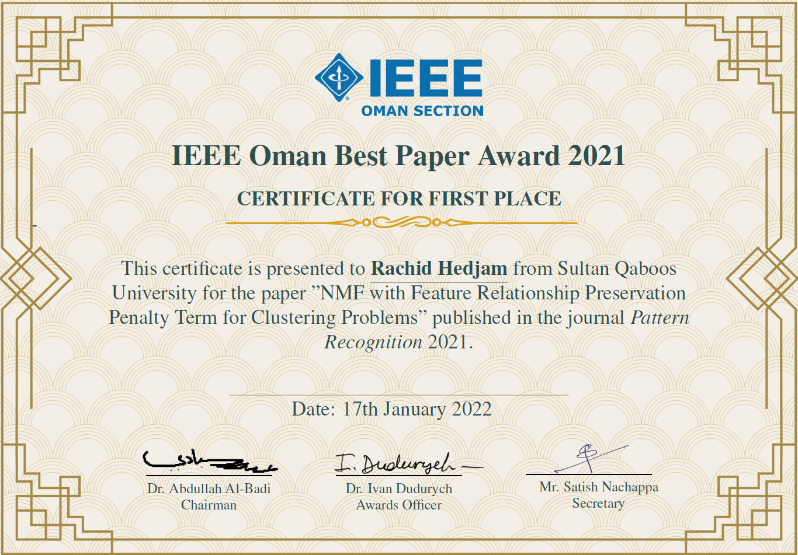

Appendix D. Supervision and trainee outcomes

D1. Authoritative trainee roster
Acronyms: BU : Bishop's University; UdS : Université de Sherbrooke; UQO : Université du Québec en Outaouais; ESI : École Supérieure d'Informatique, Algeria; HBKU : Hamad Bin Khalifa University, Qatar; SQU : Sultan Qaboos University, Oman; UG : University Ghardaya, Algeria; UO : University Ouargla, Algeria; FYP : Final Year Project; USRA : Undergraduate Student Research Award; GRA : Globalink Research Award; GRI : Globalink Research Internship. S : Supervisor; Co-S : Co-Supervisor; C : Completed; IP : In Progress.

D1.1 PhD supervision (14)
Inst. | Start | Title | Role | Status
UdS | 2026 | Privacy Preservation in The Context of Federated Learning | S | Planned
UQO | 2025 | Manifold Learning for Anomaly Detection | Co-S | IP
ESI | 2025 | Leveraging Deep Learning and Multimodal Data Fusion for Early Detection of Alzheimer's Disease | Co-S | IP
UG | 2025 | Advancing Explainable AI for Medical Imaging | Co-S | IP
UG | 2025 | Multimodal Data Fusion for Alzheimer's Disease Prediction | Co-S | IP
UO | 2025 | Few-Shot Learning & Diffusion Models in Alzheimer's Prediction | Co-S | IP
UO | 2025 | Efficient Multimodal LLMs for Low-Resource Medical Diagnosis | Co-S | IP
UdS | 2022 | Automated Detection of Sleep Stages and Disorder Patterns in Older Adults Using IoT and Deep Learning | Co-S | IP
HBKU | 2026 | Lightweight AI | Co-S | IP
HBKU | 2022 | Optimizing Dimensionality Reduction through Enhanced Cluster and Optimization | Co-S | C
HBKU | 2022 | Improving Video Classification through Summarization Techniques | Co-S | C
SQU | 2018-2022 | Convolutional Neural Network Filter Learning for Histopathological Image Classification | S | C
SQU | 2018-2023 | Using machine learning in business process re-engineering | S | C
SQU | 2022-206 | Few-Shot Learning For Breast Cancer Detection from Histological Image | Co-S | IP

D1.2 Master's supervision (20)
Inst. | Start | Title | Role | Status
BU | 2025 | Meta-Unsupervised Learning: Application to Autoencoders | S | IP
BU | 2025 | Lightweight AI on the Edge | S | IP
UdS | 2024 | Uncovering Stress Patterns Through Embedding and Clustering Techniques | Co-S | IP
BU | 2024 | Detection and Classification of Seizures using Graph Neural Networks Leveraging EEG Data | S | IP
BU | 2024 | AI-based Methane Gas Detection and Prediction | S | IP
BU | 2024 | Embedding-Enhanced Patient Clustering for Customized Medical Report Summarization using LLMs | S | IP
BU | 2024 | AI-based Anomaly Detection in Banking Systems | S | IP
BU | 2024 | Meta-Unsupervised Learning: Application to Non-Negative Matrix Factorization | S | C
UO | 2023 | Few Shot Learning For Alzheimer Disease Prediction | Co-S | C
SQU | 2022 | Few-shot Learning for Car Damage Prediction | S | C
SQU | 2022 | Evolutionary Piecemeal Approach for Face Classification | S | C
SQU | 2020 | OneVsOne Deep Learning Classification for Cancer Detection from Histology Images | S | C
SQU | 2019 | Piecemeal Approach for Face Clustering and Recognition | S | C
SQU | 2019 | Decision Boundary Adaptive Classification: Application to NID | S | C
SQU | 2019 | Non-Negative Matrix Factorization for Clustering Problems, and its Relationship to Autoencoders | Co-S | C
SQU | 2019 | Genetic Algorithm for Load Shifting Optimization in Smart Grid | Co-S | C
SQU | 2018 | Fast Binary Network Intrusion Detection based on Matched Filter Optimization (Best MSc Thesis 2020) | S | C
SQU | 2018 | Image Patch Classification for Feature Learning with Application to Change Detection in Remote Sensing | S | C
SQU | 2018 | IoT Anomaly Detection using Machine Learning | Co-S | C
SQU | 2018 | Framework for Assessment of Requirement Engineering Approaches Applied to Software Product Lines | Co-S | C

D1.3 Undergraduate supervision (13)
Inst. | Type | Start | Title | Role | Status
BU | Honors | 2024 | Deep Learning for Object Detection | S | C
BU | USRA | 2024 | EEG Data Pre-processing with Data Analysis Techniques | S | C
BU | GRI | 2026 | Undergraduate Mitacs Globalink Research Internship (BSc Student from Tunisia) | S | C
BU | GRA | 2026 | Undergraduate Mitacs Globalink Research Award (PhD Student from Algeria) | S | IP
BU | GRA | 2026 | Undergraduate Mitacs Globalink Research Award (MSc Student from Algeria) | S | IP
ESI | FYP | 2024 | Deep Learning for Smart Agriculture – Wheat Disease Detection and Classification | Co-S | C
SQU | FYP | 2017-2023 | Seven (7) Projects in Total | S | C

D2. Selected outcome statements
- Canadian AI student paper award, 2025 (AW02), C10, Appendix A6.5. See next page for the award.
- IEEE BDDM student paper award, 2025 (AW03), C04, Appendix A6.5. See next page for the award.
- SQU Best MSc Thesis, 2020. C15 Appendix A6.5.
- SQU Best Published Paper, 2023 (AW05). See next page for the award.
- SQU Best Published Paper, 2024 (AW04). See next page for the award.
- Bishop's honors and USRA projects, 2024.
- Mitacs Globalink Research Internship, 2026. Appendix A10 for full information.
- Mitacs Globalink Research Award, 2026. Appendix A10 for full information.

Below are some award notices
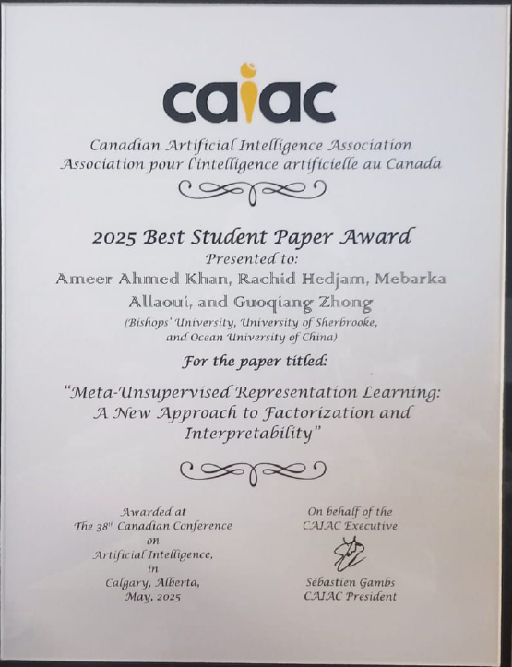 | 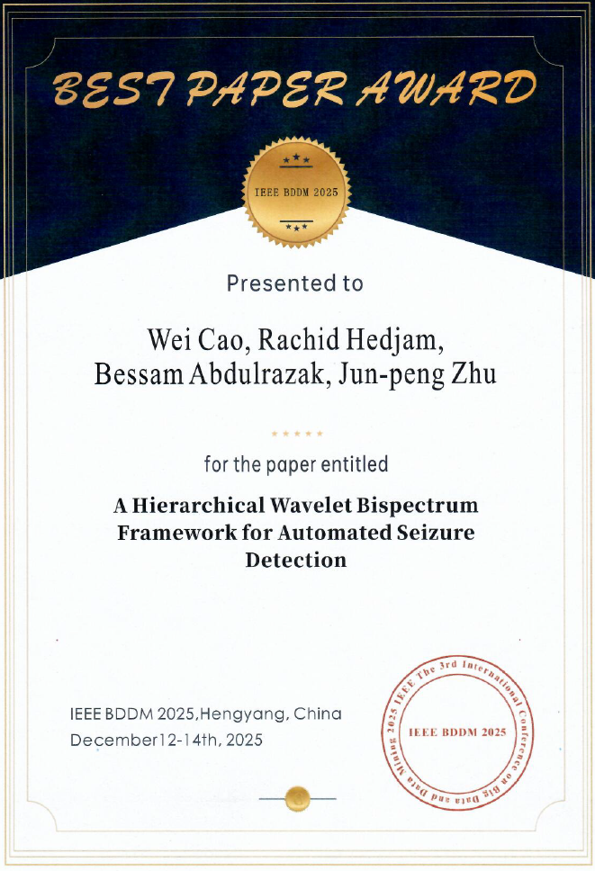

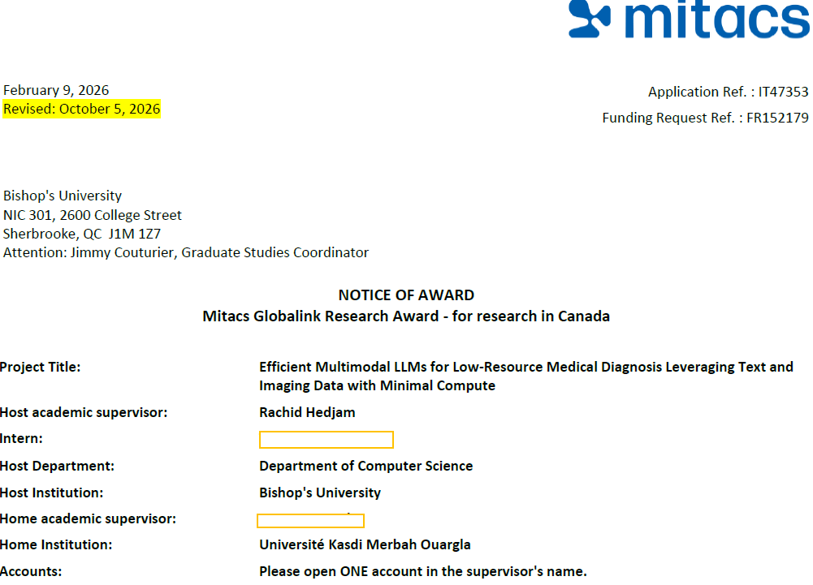

Appendix E. Service and external engagement evidence

E1. Institutional and professional service record

E1.1 Service at Bishop’s University
- Interim Chair, Computer Science, Fall 2024
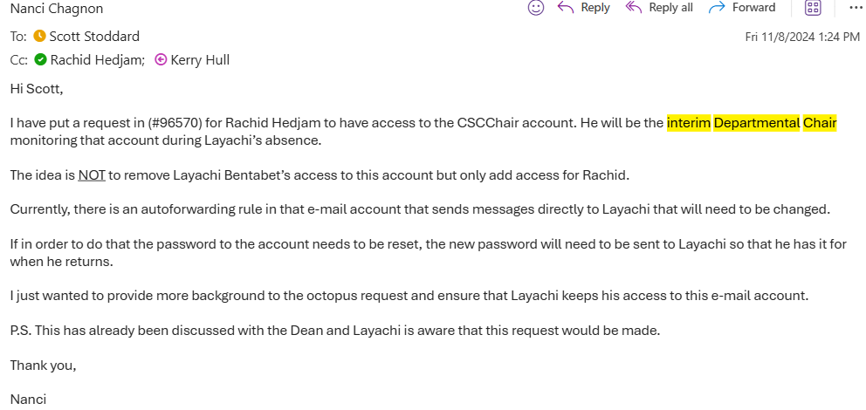
- NSM representative on the Senate Teaching and Learning Centre Initiative Committee
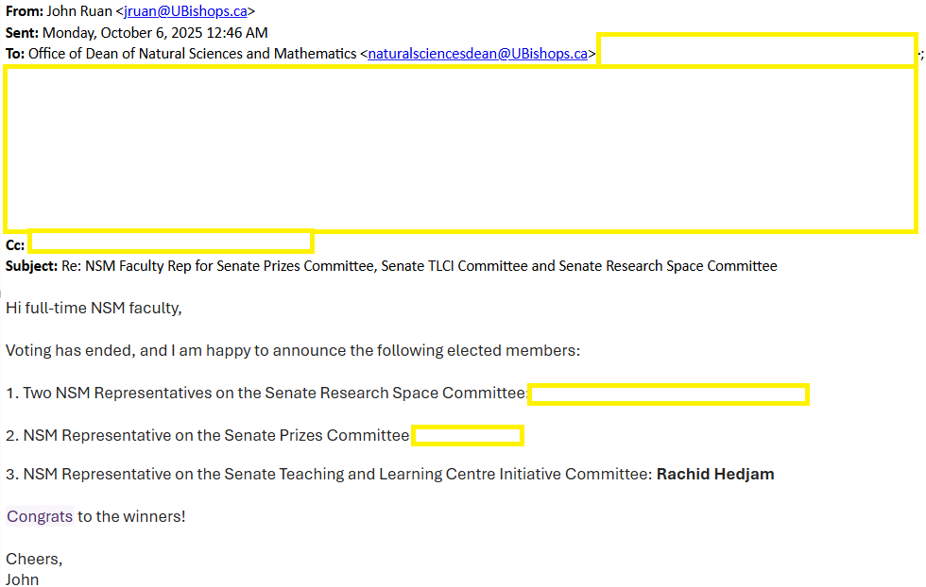

- Member, Task Force on Generative AI (2024–), with the survey analysis and the workshop at Launch Week (August 25–29, 2025). The following screenshot presents the program of a workshop on the use of Artificial Intelligence (AI) in Teaching and Education, held as part of the 2025–2026 Academic Year Launch Week.
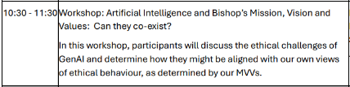

E1.2 Service to the discipline and other universities
- Associate editor, Journal on Image and Video Processing
  - https://link.springer.com/journal/13640/editorial-board
- Member, Conseil scientifique, Calcul Québec (2025–)

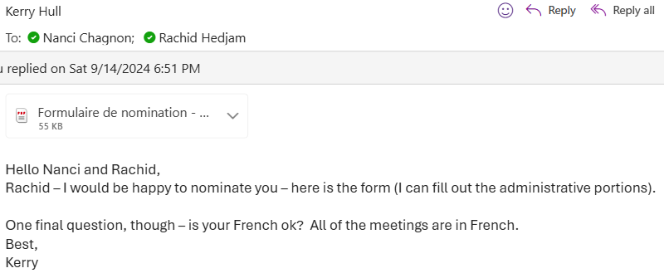

- External reviewer, MSc program in Computer Science, University of Ouargla (2022)

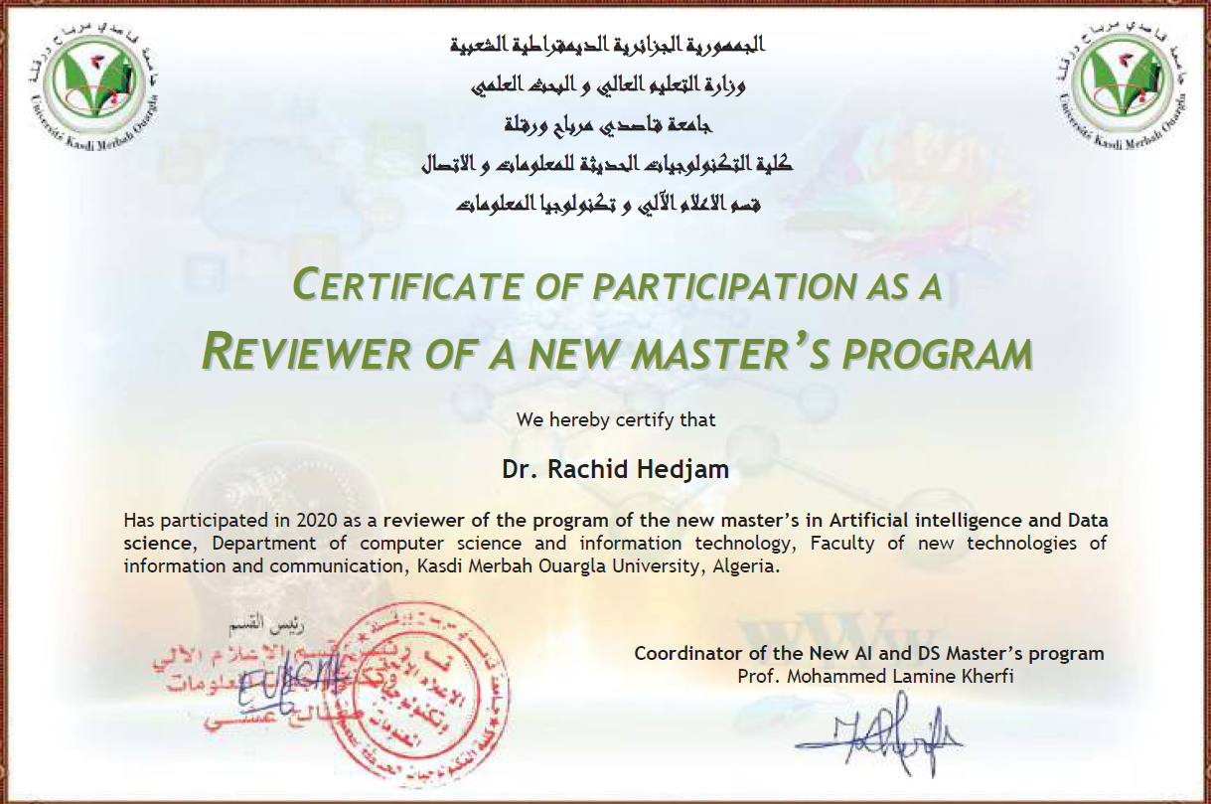

E1.3 Research leadership
- AMI-Lab, Head of AI Track
  - https://ami-lab.ca/en/team/

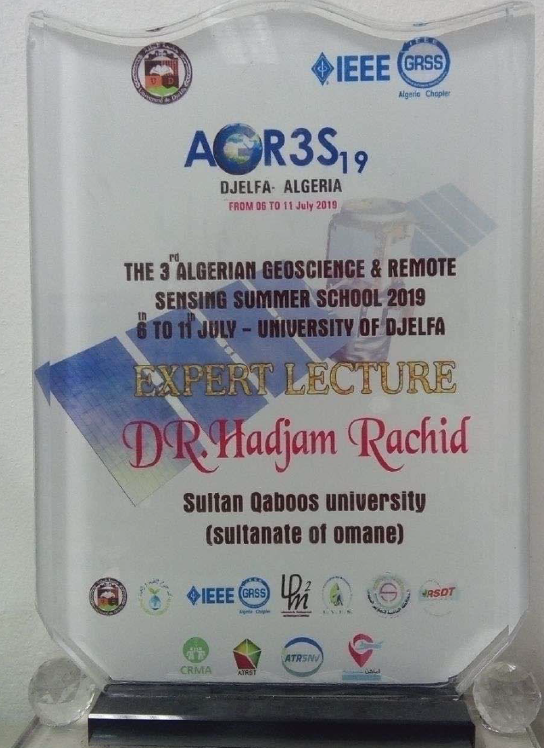
E2. Scholarly recognition and conference roles
Attached below are some supporting documents providing evidence of selected roles listed in Appendix A8.
E2.1 Keynote and invited talks
- Keynote invitation at a conference COSI’26, Batna, Algeria (other keynotes invitations are shown in Appendix A8 above.
  - https://conference.univ-batna2.dz/cosi2026/people

E2.2 Invited lectures on teaching and learning
- Summer school organized by IEEE GRS 2019, Djelfa, Algeria.
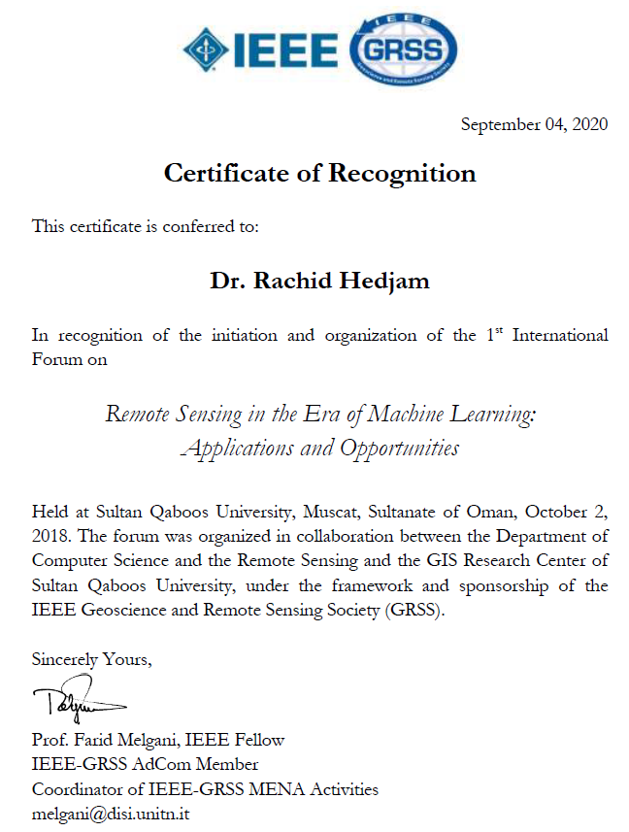
E2.3 Research event organization
- Organization of the 1st International forum on Remote sensing in the era of Machine learning, 2020
- Organization of the 1st international context on Multispectral Document Image Analysis, (MS-TEx), ICDAR’15. C25 Appendix A6.5. ICDAR is leading conference in Document Machine Intelligence.
  - https://iapr.org/archives/icdar2015/index.html%3Fp=254.html
- LINKS’24, first edition: program or call for participation naming me as chair of the organizing committee.
  - https://links.cerist.dz/index.php/comite/

E2.4 Reviewer recognition
- Recognized as an Outstanding Reviewer at BMVC 2024 for the quality of my peer-review contributions. BMVC is a leading international conference in computer vision, ranked A by CORE.
  - https://bmvc2024.org/people/reviewers/
E2.5 Session chairing
- Canada AI: https://www.caiac.ca/en/conferences/canadianai-2025/program
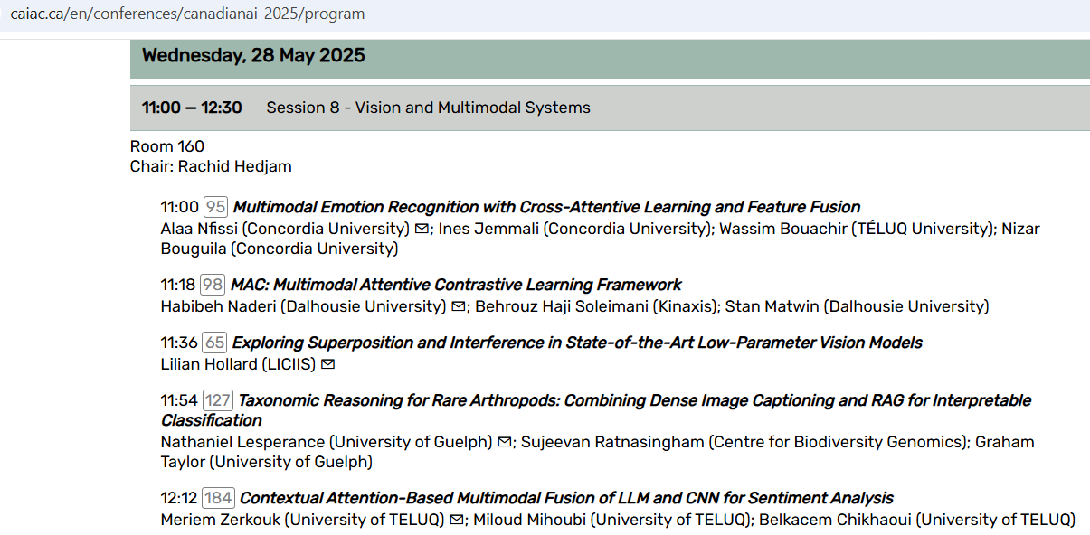
- M2GARSS 2024: https://2024.m2garss.org/organizing_committee.php
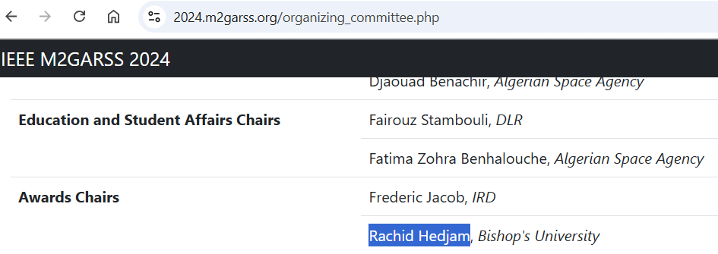
- M2GARSS 2022: https://2022.m2garss.org/view_session.php?SessionID=1012
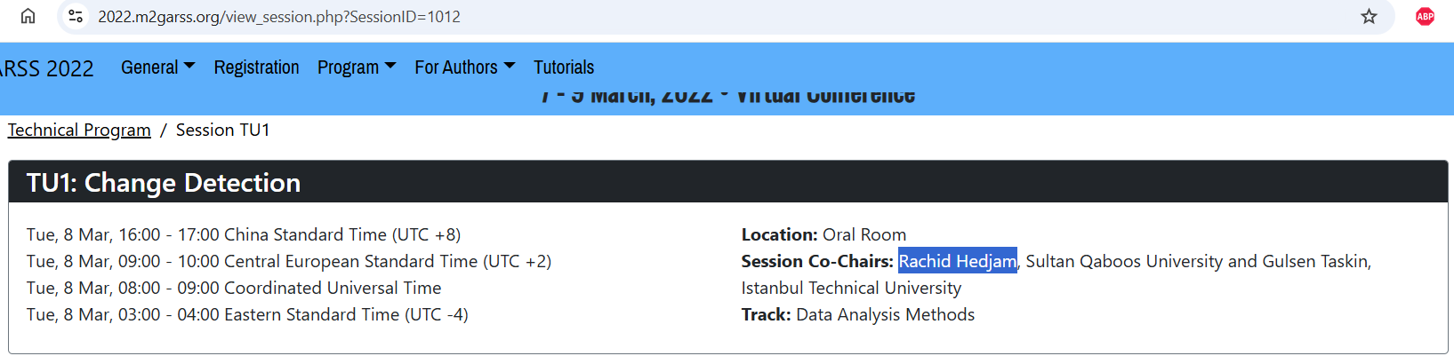

E2.6 Professional standing and memberships (IEEE)
- Senior Member IEEE, December 2026.
- Member IEEE, 2014-2026.
- Member IEEE Geoscience and Remote Sensing Society.

E3. Outreach and knowledge exchange
For the career fair, recruitment visit, and departmental ambassador activities (Section 5.2.3): include the event or visit record and the purpose, contribution, and any confirmed follow-up, classifying Collège de Bois-de-Boulogne accurately rather than automatically as a secondary-school visit.
E3.1 Letter of thanks from the manager of the Townshippers’ Association, April 14, 2025
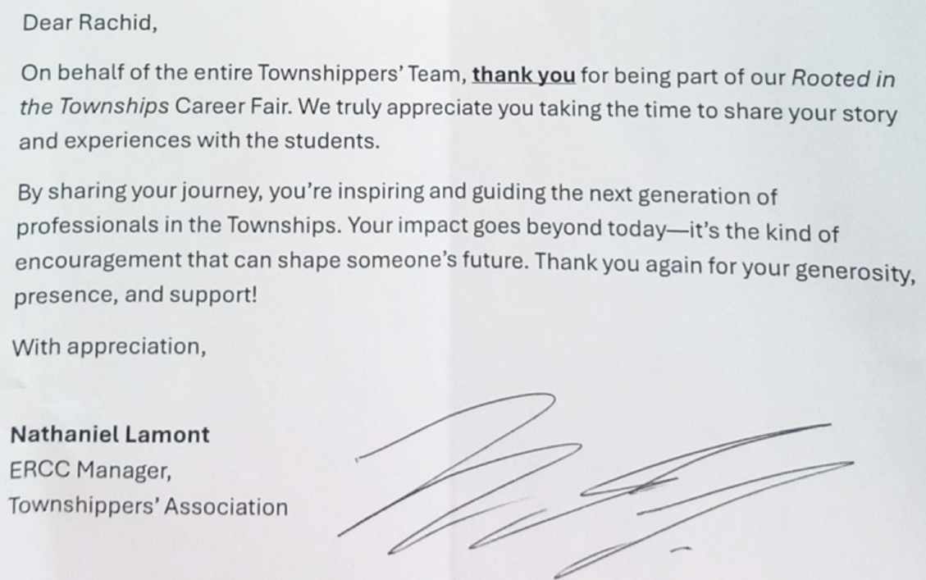
E3.2. Consultancy
- DeepMinds (UAE) and Prescouter (USA)
- https://deepminds.me/people

