determine which features are **discriminative:**

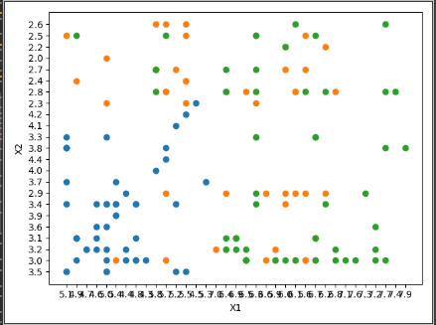

X1-X2 its not discriminative

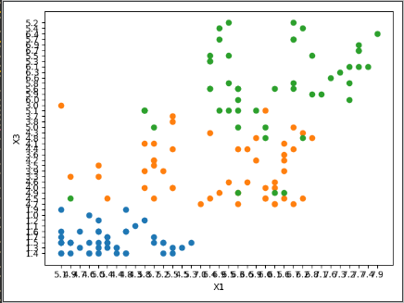

X1-X3 its discriminative we can draw line between blue and orange class to classify the most of samples truly

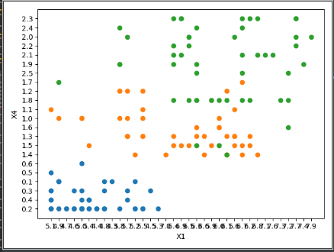

X1-X4 we can do the same so its discriminative , maybe the orange and green we cannot classify them form those feature

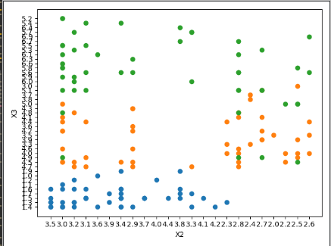

X2-X3 its discriminative we can classify at least two classes from here

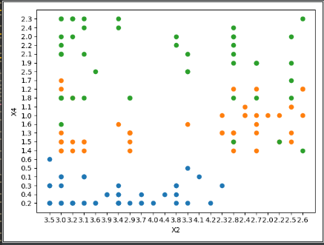

X2-X4 its discriminative for blue class as we can classify it right

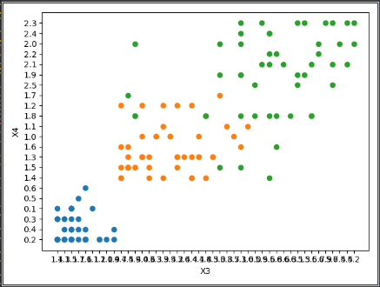

X3-X4 its discriminative features so we can classify blue from other classes easily but the we cant do it for orange and green

As a note for all relation between features its clear that the blue class easy to classify from other classes in most features

Gui

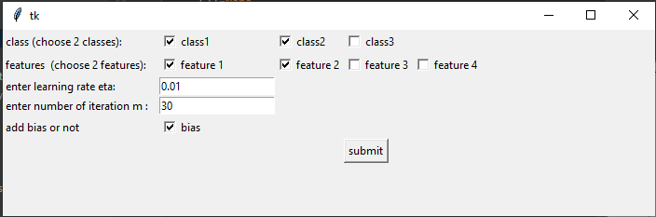

As in the image :  
n= 0.01  
m=30  
class 1 – class 2   
feature 1- feature 2  
bias checked

The output for the values in above its like that

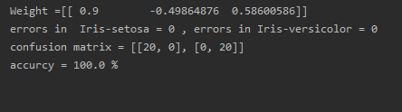

And the line to fit the data :

