|  |  |
| --- | --- |
| Faculty of Computer & Information Sciences  Ain Shams University  Subject: CHW-362Computer Architecture & Org.  Instructors: Dr. Heba Khaled & Dr. Karim Emara  Year: 3rd year undergraduate  Academic year: 2nd term 2019-2020 |  |

**Practical Project**

**MIPS Pipelined Emulator – Version ( 2)**

**تحذير هام: علي الطالب عدم كتابة اسمه أو كتابة اي شيء يدل علي شخصيته**

**Task2 Report:**

You must write a report for the implemented emulator describing the following:

1. Brief description of your implementation and how the code is organized.

* **Instruction class contain the main data of instruction.**

public class Instruction_Line

{

public string op_code;

public string reg_source;

public string reg_ttt_source2;

public string reg_destenation;

public string shift_amount;

public string funct;

public string id;

public string instr11_15;

public string instr16_20;

public string address_I_type16;

public string ALU_result;

public string instruction_line_;

public Instruction_Line(string instruction_line, string instruction_id)

{

instruction_line_ = instruction_line;

op_code = "";

reg_source = "";

reg_ttt_source2 = "";

reg_destenation = "";

shift_amount = "";

funct = "";

instr11_15 = "";

address_I_type16 = "";

ALU_result = "";

int bit_position = 0;

id = instruction_id;

for (int i = instruction_line.Length - 1; i > instruction_line.Length - 16; i--)

{

address_I_type16 = instruction_line[i] + address_I_type16;

}

for (int i = instruction_line.Length - 12; i > instruction_line.Length - 17; i--)

{

instr11_15 = instruction_line[i] + instr11_15;

}

for (int i = bit_position; i < bit_position + 6; i++)

{

op_code += instruction_line[i];

}

bit_position += 6;

for (int i = bit_position; i < bit_position + 5; i++)

{

reg_source += instruction_line[i];

}

bit_position += 5;

for (int i = bit_position; i < bit_position + 5; i++)

{

reg_ttt_source2 += instruction_line[i];

}

bit_position += 5;

for (int i = bit_position; i < bit_position + 5; i++)

{

reg_destenation += instruction_line[i];

}

bit_position += 5;

for (int i = bit_position; i < bit_position + 5; i++)

{

shift_amount += instruction_line[i];

}

bit_position += 5;

for (int i = bit_position; i < bit_position + 6; i++)

{

funct += instruction_line[i];

}

bit_position += 6;

instr16_20 = reg_ttt_source2;

}

}

* **The main data structure in the code id queue of instruction.**

Queue<Instruction_Line>[] process_pipeline = new Queue<Instruction_Line>[6];

* **MIPS Register**

int[] Registers__MIPS;

* **Initialize component (when load form)**

public Form1()

{

InitializeComponent();

//initialize Component "instruction lines"

initialize_component();

}

* **Global variables**

String iiiInstruction_line111, iiiInstruction_line222, iiiInstruction_line333, iiiInstruction_line444;

String iiiInstruction_line555, iiiInstruction_line666, iiiInstruction_line777, iiiInstruction_line888, iiiInstruction_line999;

String iiiInstruction_line000;

string[] instruction_line_arr1;

string[] instruction_line_arr2;

string[] instruction_line_arr3;

string[] instruction_line_arr4;

string[] instruction_line_arr5;

string[] instruction_line_arr6;

string[] instruction_line_arr7;

string[] instruction_line_arr8;

string[] instruction_line_arr9;

string program_counter_code = "1000";

string read_data111 = "";

string read_data222 = "";

string read_register111 = "";

string read_registe222 = "";

string write_data = "";

string write_register = "";

int number_of_cycle = 0;

string sign_extention = "";

string instruction_line_ = "";

string instr_00_t0_15 = "";

string instr_11_t0_15 = "";

string instr_16_t0_20 = "";

string ALU_Output = "";

string ALU_mux_input0 = "";

string reg_dist_MUX_Output = "";

string Address_mem_WR = ""; //23

string read_data25 = ""; //25

string IFetch_IDecode = "";

string IDecode_IExecute = "";

string Memory_write_back = "";

string key = "";

string value = "";

* **Function initialize_componemt() to initialize Register__MIPS array and the instructions.**

void initialize_component()

{

Registers__MIPS = new int[32];

iiiInstruction_line111 = "1000: 00000000 11000000 00101000 00100101";

iiiInstruction_line222 = "1004: 00000000 01100100 00010000 00100000";

iiiInstruction_line333 = "1008: 00000001 00000110 00111000 00100010";

iiiInstruction_line444 = "1012: 10101111 11000101 00000000 00000010";

iiiInstruction_line555 = "1016: 00000000 10100000 00110000 00100100";

iiiInstruction_line666 = "0000: 00000000 00000000 00000000 00000000";

iiiInstruction_line777 = "0000: 00000000 00000000 00000000 00000000";

iiiInstruction_line888 = "0000: 00000000 00000000 00000000 00000000";

iiiInstruction_line999 = "0000: 00000000 00000000 00000000 00000000";

iiiInstruction_line000 = "0000: 00000000 00000000 00000000 00000000";

Split_instructions();

Set_Instruction_in_class();

Draw_Instruction_text();

}

* **Function Draw_instructions_text()**

void Draw_Instruction_text() //for start form only

{

string Instruction_text = "1000: 00000000 11000000 00101000 00100101@1004: 00000000 01100100 00010000 00100000@1008: 00000001 00000110 00111000 00100010@1012: 10101111 11000101 00000000 00000010@1016: 00000000 10100000 00110000 00100100@";

Instruction_text = Instruction_text.Replace("@", System.Environment.NewLine);

txt_user_code.Text = Instruction_text;

}

* **Function Split_instructions()**

void Split_instructions()

{

instruction_line_arr1 = iiiInstruction_line111.Split(' ');

instruction_line_arr1[0] =instruction_line_arr1[0].Remove(instruction_line_arr1[0].Length - 1); //

instruction_line_arr2 = iiiInstruction_line222.Split(' ');

instruction_line_arr2[0] = instruction_line_arr2[0].Remove(instruction_line_arr2[0].Length - 1); //

instruction_line_arr3 = iiiInstruction_line333.Split(' ');

instruction_line_arr3[0] = instruction_line_arr3[0].Remove(instruction_line_arr3[0].Length - 1); //

instruction_line_arr4 = iiiInstruction_line444.Split(' ');

instruction_line_arr4[0] = instruction_line_arr4[0].Remove(instruction_line_arr4[0].Length - 1); //

instruction_line_arr5 = iiiInstruction_line555.Split(' ');

instruction_line_arr5[0] = instruction_line_arr5[0].Remove(instruction_line_arr5[0].Length - 1); //

instruction_line_arr6 = iiiInstruction_line666.Split(' ');

instruction_line_arr6[0] = instruction_line_arr6[0].Remove(instruction_line_arr6[0].Length - 1); //

instruction_line_arr7 = iiiInstruction_line777.Split(' ');

instruction_line_arr7[0] = instruction_line_arr7[0].Remove(instruction_line_arr7[0].Length - 1); //

instruction_line_arr8 = iiiInstruction_line888.Split(' ');

instruction_line_arr8[0] = instruction_line_arr8[0].Remove(instruction_line_arr8[0].Length - 1); //

instruction_line_arr9 = iiiInstruction_line999.Split(' ');

instruction_line_arr9[0] = instruction_line_arr9[0].Remove(instruction_line_arr9[0].Length - 1); //

}

* **Functions Set_instruction_in_class()**

void Set_Instruction_in_class()

{

string instruction_line_str1 = "";

string instruction_line_str2 = "";

string instruction_line_str3 = "";

string instruction_line_str4 = "";

string instruction_line_str5 = "";

Instruction_Line[] Instr_line = new Instruction_Line[5];

for (int i = 1; i < 5; i++)

{

instruction_line_str1 += instruction_line_arr1[i];

instruction_line_str2 += instruction_line_arr2[i];

instruction_line_str3 += instruction_line_arr3[i];

instruction_line_str4 += instruction_line_arr4[i];

instruction_line_str5 += instruction_line_arr5[i];

}

Instr_line[0] = new Instruction_Line(instruction_line_str1,instruction_line_arr1[0]);

Instr_line[1] = new Instruction_Line(instruction_line_str2, instruction_line_arr2[0]);

Instr_line[2] = new Instruction_Line(instruction_line_str3, instruction_line_arr3[0]);

Instr_line[3] = new Instruction_Line(instruction_line_str4, instruction_line_arr4[0]);

Instr_line[4] = new Instruction_Line(instruction_line_str5, instruction_line_arr5[0]);

process_pipeline[5] = new Queue<Instruction_Line>();

for (int i = 0; i < 5; i++)

{

process_pipeline[i] = new Queue<Instruction_Line>();

process_pipeline[0].Enqueue(Instr_line[i]);

}

for (int i = 0; i < 32; i++)

{

if (i == 0)

{

Registers__MIPS[i] = i;

}

else

Registers__MIPS[i] = i + 100;

}

}

* **initialize_button()**

private void btn_initialize_Click(object sender, EventArgs e)

{

dgv_mips_register.Rows.Clear();

Restart();

Set_instructions_txt();

for (int i = 0; i < Registers__MIPS.Count(); i++)

{

if (i == 0)

dgv_mips_register.Rows.Add("$" + i.ToString(), 0);

else

dgv_mips_register.Rows.Add("$" + i.ToString(), Registers__MIPS[i]);

}

}

* **Functions Set_instruction_in_class()**

private void btn_run_cycle_Click(object sender, EventArgs e)

{

for (int i = 4; i >= 0; i--)

{

if (process_pipeline[i].Count == 0)

{

if (i == 1 && instr_11_t0_15 != "")

{

instr_00_t0_15 = "";

instr_11_t0_15 = "";

instr_16_t0_20 = "";

}

if (i == 2 && number_of_cycle == 7)

{

Reset_varibles();

}

if (i == 1)

{

read_data111 = "";

read_data222 = "";

read_register111 = "";

read_registe222 = "";

}

continue;

}

int next = i + 1;

Instruction_Line current_instruction = process_pipeline[i].Dequeue();

if (i == 0)

instruction_line_ = Fetch_pipeline(current_instruction);

if (i == 1)

{

current_instruction = Decode_pipeline(current_instruction);

instr_11_t0_15 = Convert.ToInt32(current_instruction.instr11_15, 2).ToString();

instr_00_t0_15 = Convert.ToInt32(current_instruction.address_I_type16, 2).ToString();

instr_16_t0_20 = Convert.ToInt32(current_instruction.instr16_20, 2).ToString();

}

if (i == 2)

{

current_instruction = Execute_pipeline(current_instruction);

ALU_Output = current_instruction.ALU_result;

ALU_mux_input0 = read_data222;

reg_dist_MUX_Output = instr_11_t0_15;

}

if (next == 5)

{

write_data = current_instruction.ALU_result;

Address_mem_WR = current_instruction.ALU_result;

if (current_instruction.instr11_15 != "")

write_register = Convert.ToInt32(current_instruction.instr11_15, 2).ToString();

}

else

process_pipeline[next].Enqueue(current_instruction);

}

dgv_pipline.Rows.Clear();

dgv_pipline.Rows.Add("pc_counter", program_counter_code);

dgv_pipline.Rows.Add("Current_instruction", instruction_line_);

dgv_pipline.Rows.Add("read_Reg1", read_register111);

dgv_pipline.Rows.Add("read_Reg2", read_registe222);

dgv_pipline.Rows.Add("read_Data1", read_data111);

dgv_pipline.Rows.Add("read_Data2", read_data222);

dgv_pipline.Rows.Add("instr from 11:15 bits", instr_11_t0_15);

dgv_pipline.Rows.Add("instr from 00:15 bits", instr_00_t0_15);

dgv_pipline.Rows.Add("instr from 16:20 bits", instr_16_t0_20);

dgv_pipline.Rows.Add("ALU Output", ALU_Output);

dgv_pipline.Rows.Add("ALU mux input 0", ALU_mux_input0);

dgv_pipline.Rows.Add("reg dist MUX Output", reg_dist_MUX_Output);

dgv_pipline.Rows.Add("write data", write_data);

dgv_pipline.Rows.Add("write register", write_register);

if (number_of_cycle == 7)

{

dgv_memory_data.Rows.Add(key, value);

}

number_of_cycle++;

MessageBox.Show("the Cycle Number " + number_of_cycle.ToString());

}

* **fetch()**

public string Fetch_pipeline(Instruction_Line instruction)

{

int program_counter_code_int = int.Parse(program_counter_code) + 4;

program_counter_code = program_counter_code_int.ToString();

string current_instructions = instruction.instruction_line_;

return current_instructions;

}

public Instruction_Line Decode_pipeline(Instruction_Line instruction)

{

string[] function_code = { "100101", "100000", "100010", "101011", "100100" };

//or --> [0]

if (instruction.funct == function_code[0])

{

int rs = Convert.ToInt32(instruction.reg_source, 2);

int rt = Convert.ToInt32(instruction.reg_ttt_source2, 2);

instruction.reg_destenation = (rs | rt).ToString();

read_register111 = rs.ToString();

read_registe222 = rt.ToString();

read_data111 = Registers__MIPS[rs].ToString(); //rs

read_data222 = Registers__MIPS[rt].ToString(); //rt

}

//add -->[1]

else if (instruction.funct == function_code[1])

{

int rs = Convert.ToInt32(instruction.reg_source, 2);

int rt = Convert.ToInt32(instruction.reg_ttt_source2, 2);

instruction.reg_destenation = (rs + rt).ToString();

read_register111 = rs.ToString();

read_registe222 = rt.ToString();

read_data111 = Registers__MIPS[rs].ToString();

read_data222 = Registers__MIPS[rt].ToString();

}

//sub -->[2]

else if (instruction.funct == function_code[2])

{

int rs = Convert.ToInt32(instruction.reg_source, 2);

int rt = Convert.ToInt32(instruction.reg_ttt_source2, 2);

instruction.reg_destenation = (rs - rt).ToString();

read_register111 = rs.ToString();

read_registe222 = rt.ToString();

read_data111 = Registers__MIPS[rs].ToString();

read_data222 = Registers__MIPS[rt].ToString();

}

//store -->[3]

else if (instruction.op_code == function_code[3])

{

int rs = Convert.ToInt32(instruction.reg_source, 2);

int rt = Convert.ToInt32(instruction.reg_ttt_source2, 2);

read_register111 = rs.ToString();

read_registe222 = rt.ToString();

read_data111 = Registers__MIPS[rs].ToString();

read_data222 = Registers__MIPS[rt].ToString();

sign_extention = (Convert.ToInt32(instruction.address_I_type16, 2)).ToString();

}

//and -->[4]

else if (instruction.funct == function_code[4])

{

int rs = Convert.ToInt32(instruction.reg_source, 2);

int rt = Convert.ToInt32(instruction.reg_ttt_source2, 2);

instruction.reg_destenation = (rs & rt).ToString();

read_register111 = rs.ToString();

read_registe222 = rt.ToString();

read_data111 = Registers__MIPS[rs].ToString();

read_data222 = Registers__MIPS[rt].ToString();

}

else

instruction.instr11_15 = "";

return instruction;

}

public Instruction_Line Execute_pipeline(Instruction_Line instruction)

{

//or

if (instruction.funct == "100101")

{

int data1 = int.Parse(read_data111);

int data2 = int.Parse(read_data222);

instruction.ALU_result = (data1 | data2).ToString();

}

//add

else if (instruction.funct == "100000")

{

int data1 = int.Parse(read_data111);

int data2 = int.Parse(read_data222);

instruction.ALU_result = (data1 + data2).ToString();

}

//sub

else if (instruction.funct == "100010")

{

int data1 = int.Parse(read_data111);

int data2 = int.Parse(read_data222);

instruction.ALU_result = (data1 - data2).ToString();

}

else if (instruction.op_code == "101011")

{

int data1 = int.Parse(read_data111);

instruction.ALU_result = (int.Parse(sign_extention) + data1).ToString();

key = instruction.ALU_result;

value = Registers__MIPS[6].ToString();

}

else if (instruction.funct == "100100")

{

int data1 = int.Parse(read_data111);

int data2 = int.Parse(read_data222);

instruction.ALU_result = (data1 & data2).ToString();

}

return instruction;

}

1. High-level pseudo-code or flowchart for “Run 1 cycle” function.

Fetch_pipeline()

return current_instructions_str

Decode_pipeline(Instruction_Line instruction)

function_code = { "100101", "100000", "100010", "101011", "100100" };

if instruction.funct = function_code of or instructions :

calculte read_data1

calculte read_data2

else if instruction.funct = function_code of add instructions :

calculte read_data1

calculte read_data2

else if instruction.funct = function_code of sub instructions :

calculte read_data1

calculte read_data2

else if instruction.funct = function_code of store instructions :

calculte read_data1

calculte read_data2

calculate sign_extention

else if instruction.funct = function_code of and instructions :

calculte read_data1

calculte read_data2

update all changes in the smae object of instructions and return it

Run one cycle()

for 4 down to 1:

if pipline[i].count = 0:

if i = 1 and bits from 11 to 15 != null:

reset bits

if i = 2:

reset component

continue;

deque pipeline in current_instructions

if i = 0:

instruction_str = fitch_pipline()

if i = 1:

current_instructions = Decode_pipeline()

if i = 2:

current_instructions = Execute_pipeline()

if next = 5 :

apply memory_datapipline

clear datagridview

display current cycle

if number_of_cycle = 7

diplay (key, value)

number_of_cycle ++

Execute_pipeline(Instruction_Line instruction)

function_code = { "100101", "100000", "100010", "101011", "100100" };

if instruction.funct = function_code of or instructions :

ALU_result = data1 | data2

else if instruction.funct = function_code of add instructions :

ALU_result = data1 + data2

else if instruction.funct = function_code of sub instructions :

ALU_result = data1 - data2

else if instruction.funct = function_code of store instructions :

key = instruction.ALU_result;

value = Registers__MIPS[6]

else if instruction.funct = function_code of and instructions :

ALU_result = data1 & data2

update all changes in the same object of instructions and return it

1. Any assumptions not mentioned in the task description (if any)

Code run only in 5 instructions to complete 9 cycles.

1. A user guide explaining how to use the emulator

When start you can use the default instruction in textbox “user code” **OR** enter you own instruction but **only 5 instructions.** Run cycle button for next cycle.

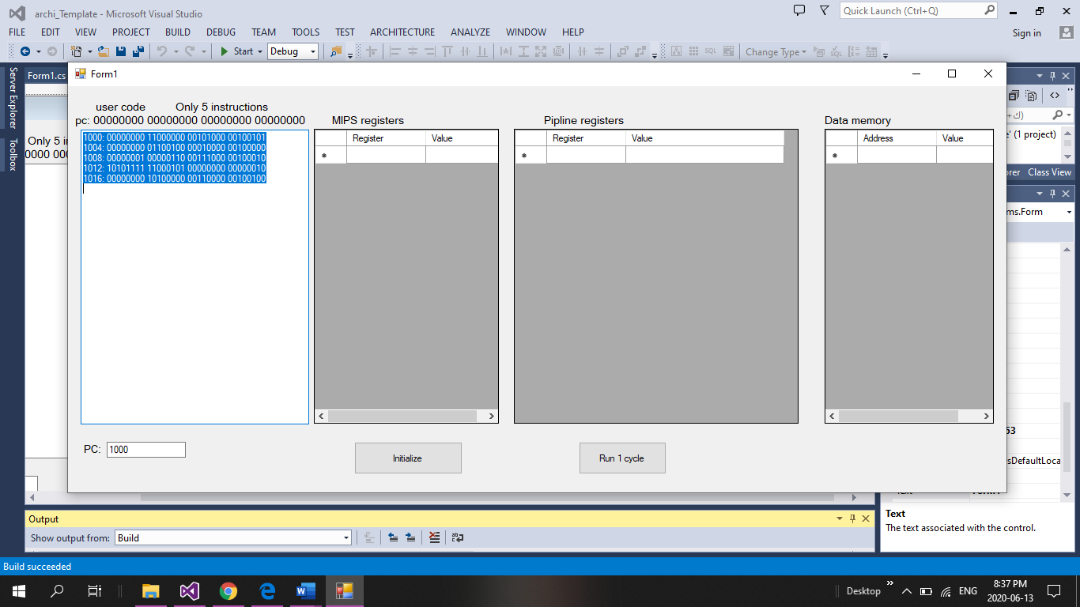

**Use the default instructions**

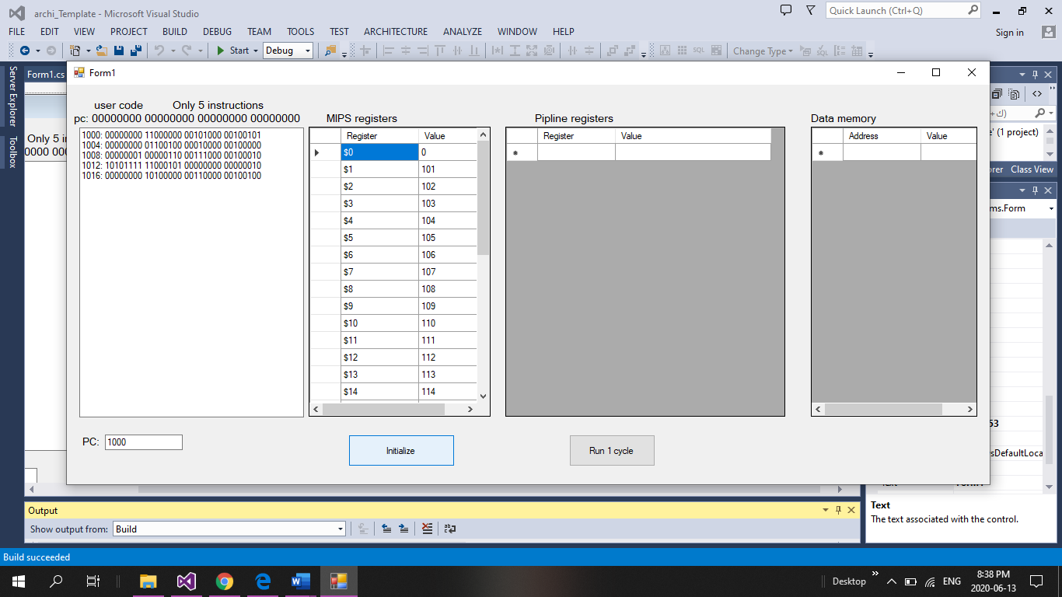

**Click initialize for initialize MIPS registers**

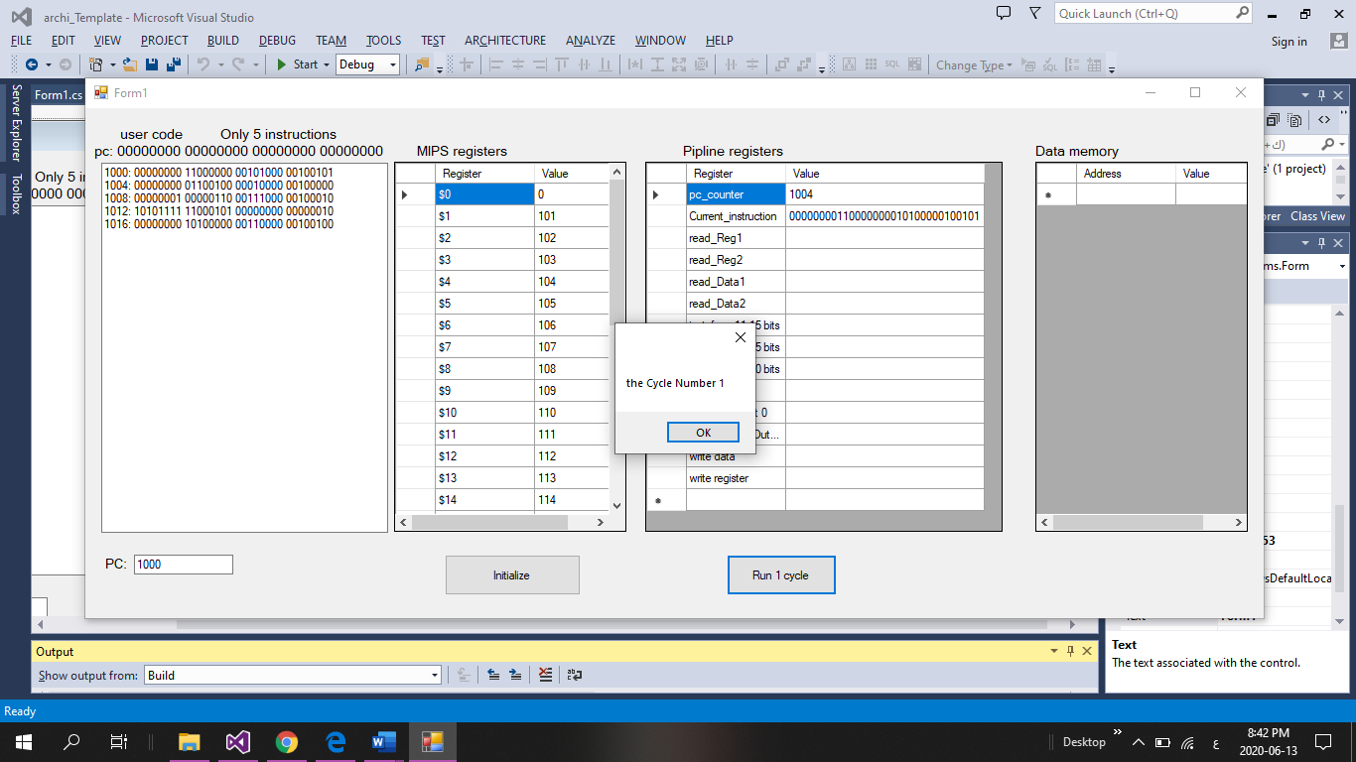

**Click run 1 cycle for execute cycle by cycle**

1. Screenshots of emulating the MIPS code given in Task 1, one screenshot per clock cycle for 9 clock cycles



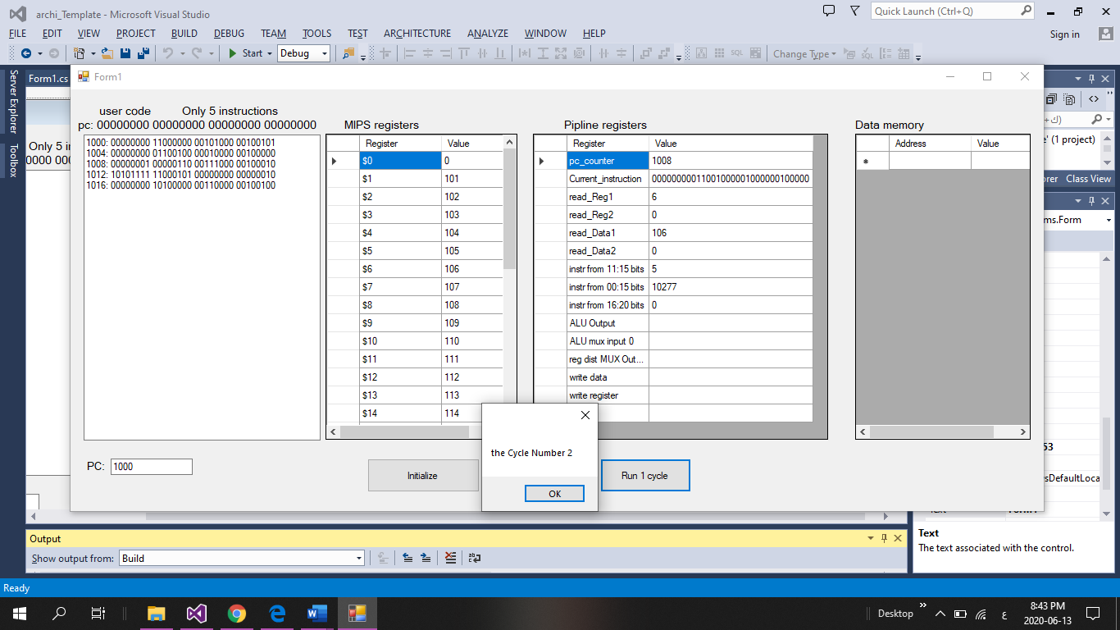

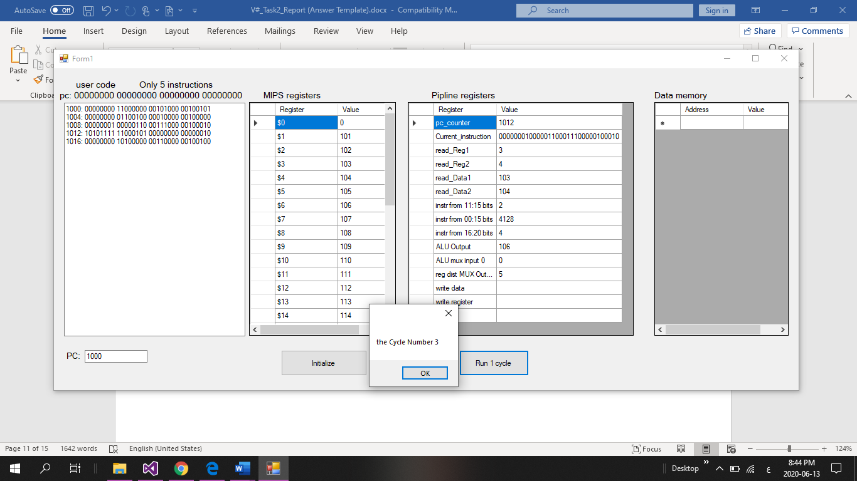

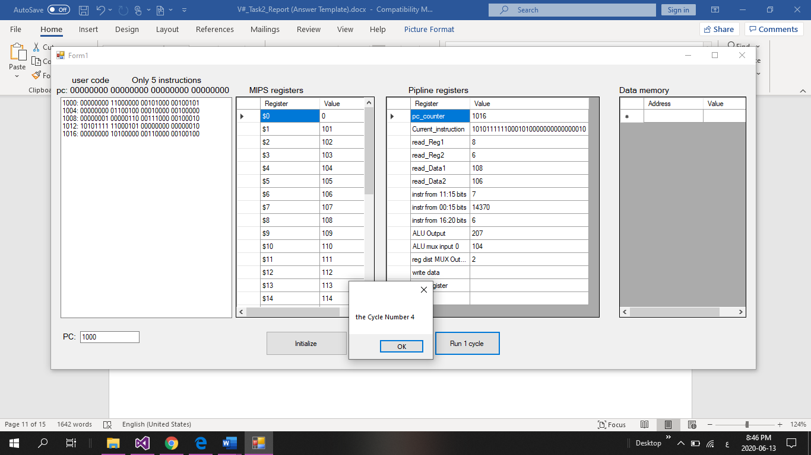

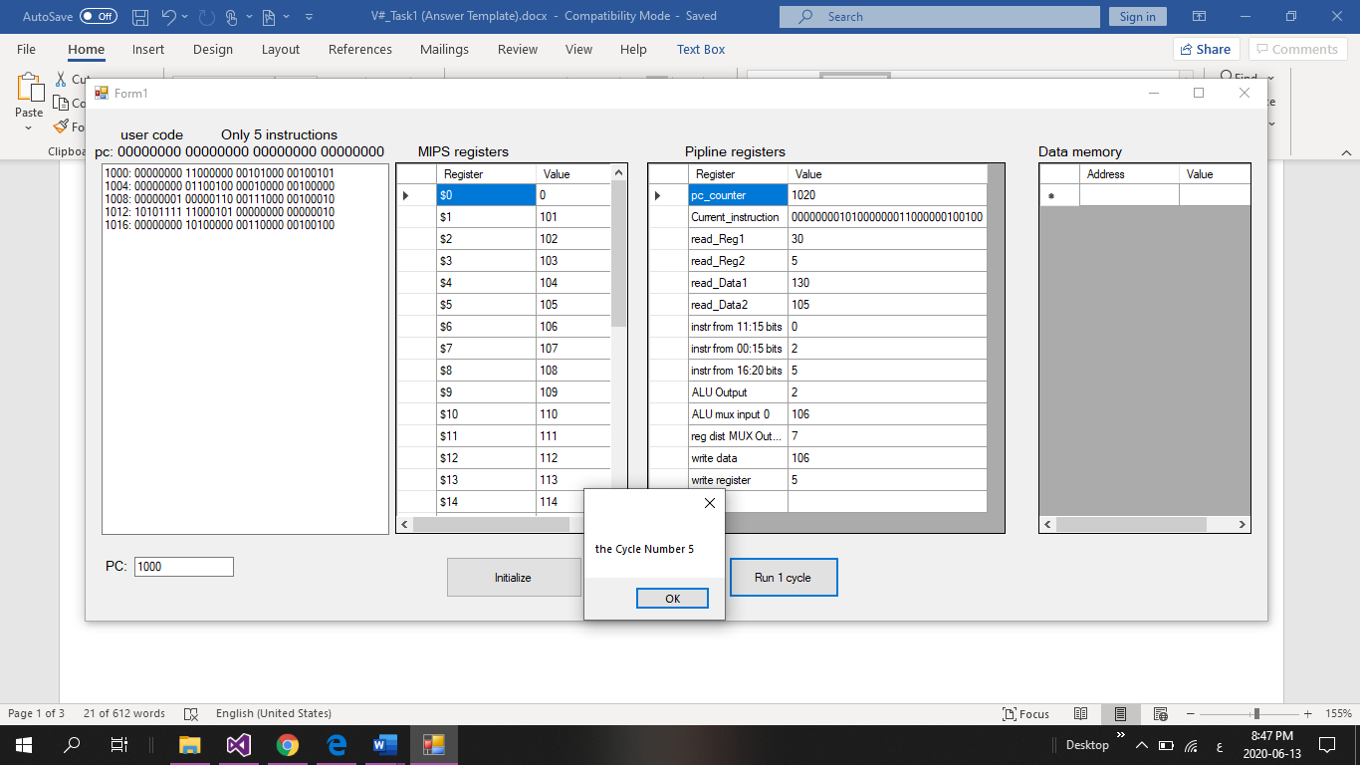

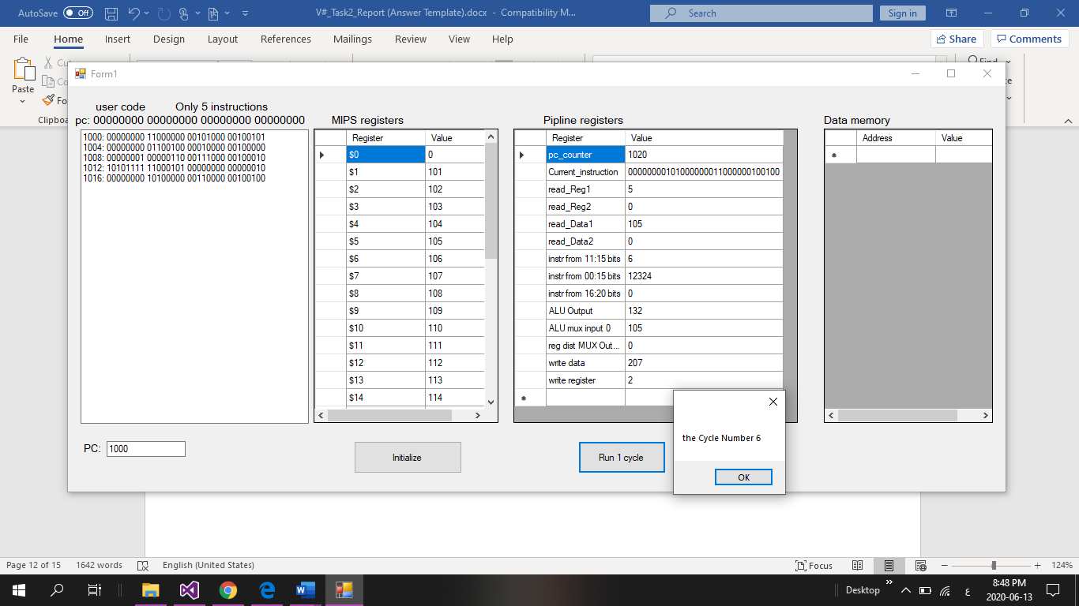

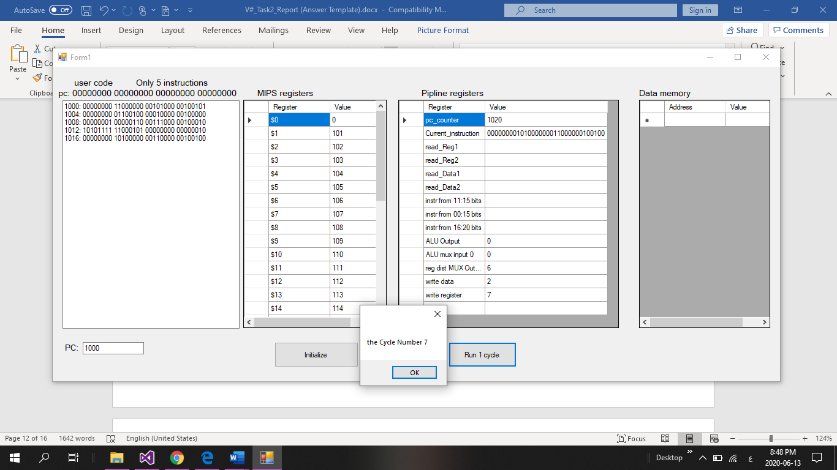

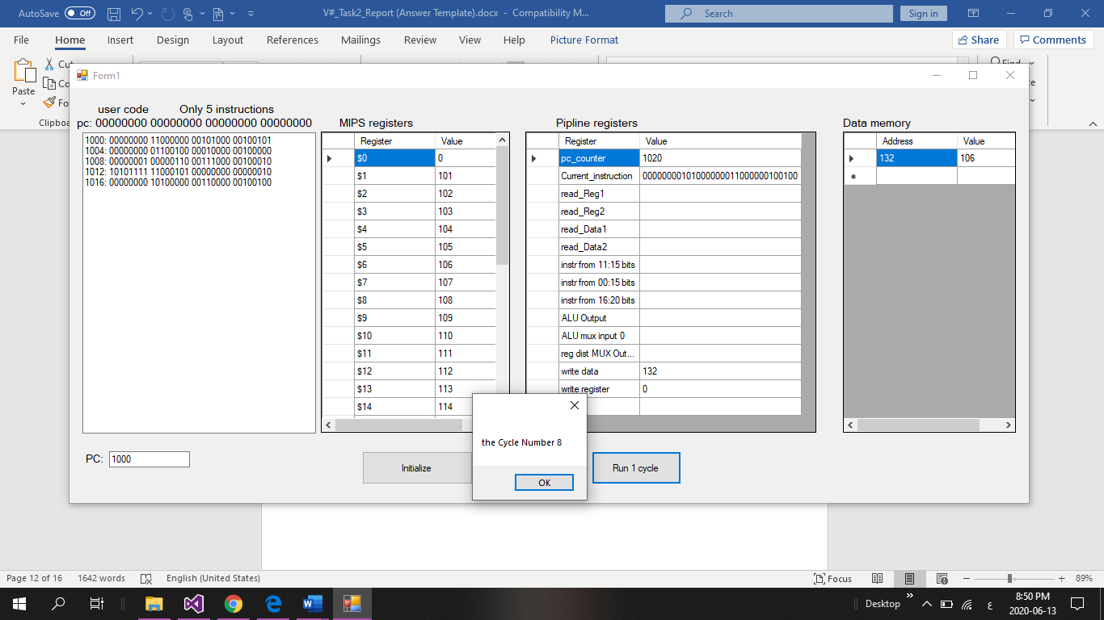

1. Screenshots of emulating another MIPS code from your choice, one screenshot per clock cycle for 9 clock cycles

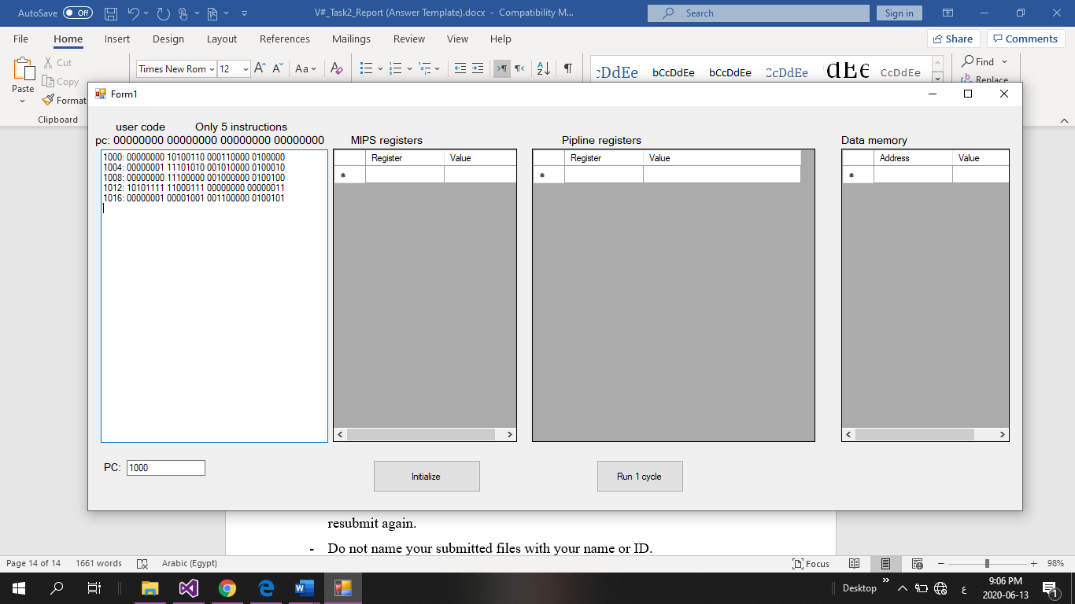

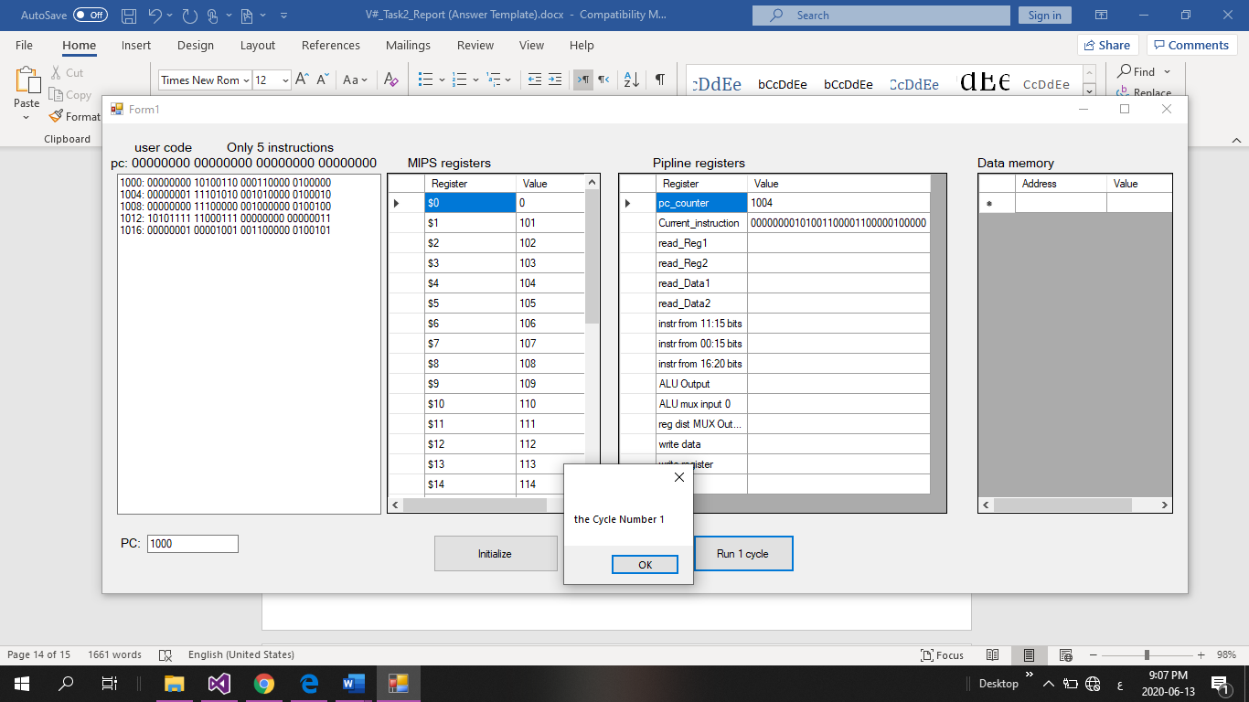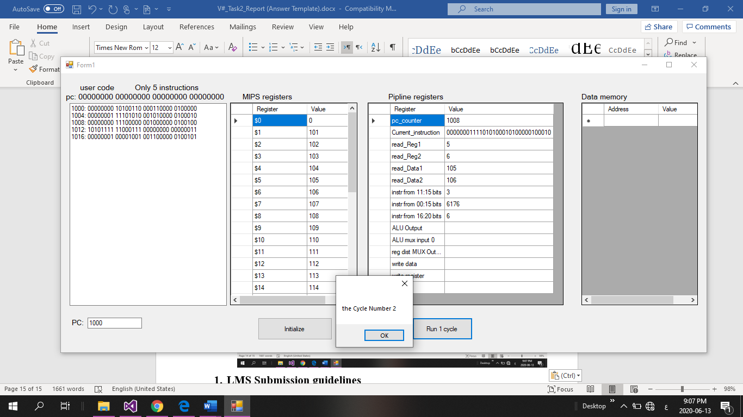

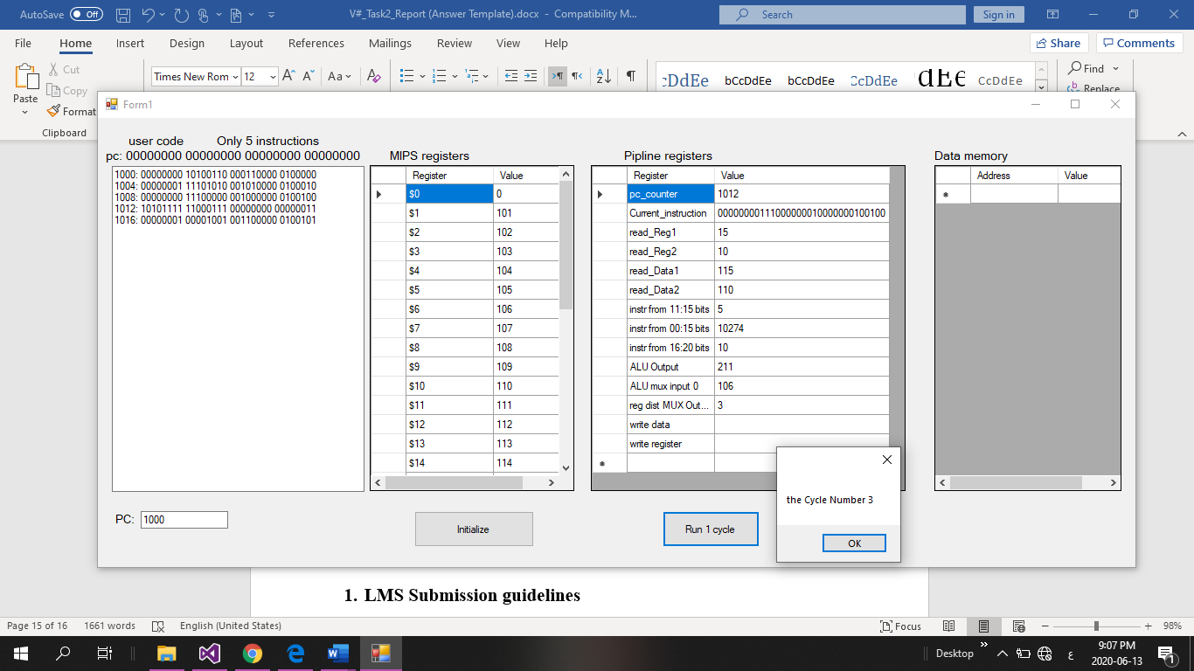

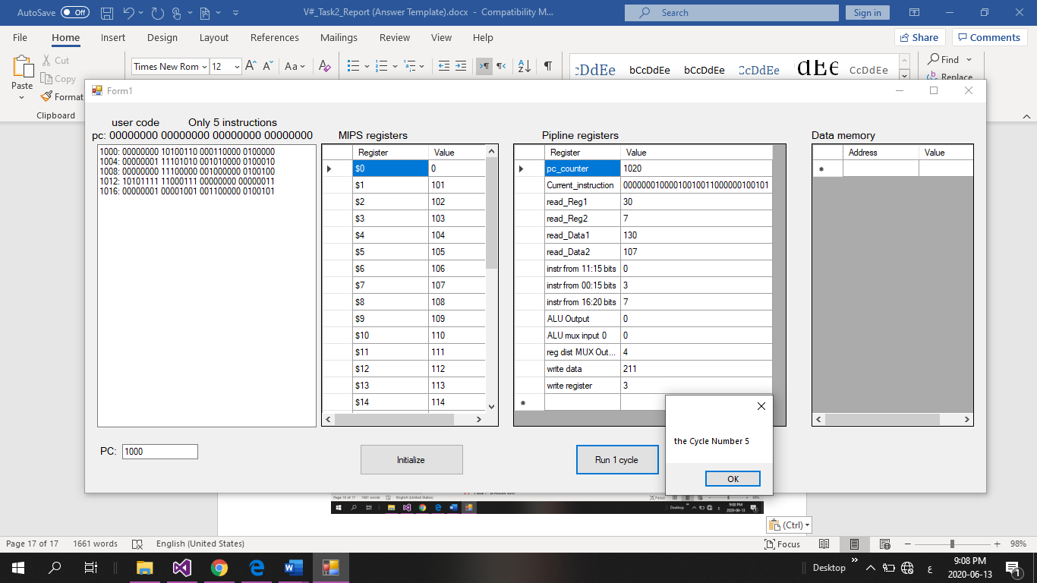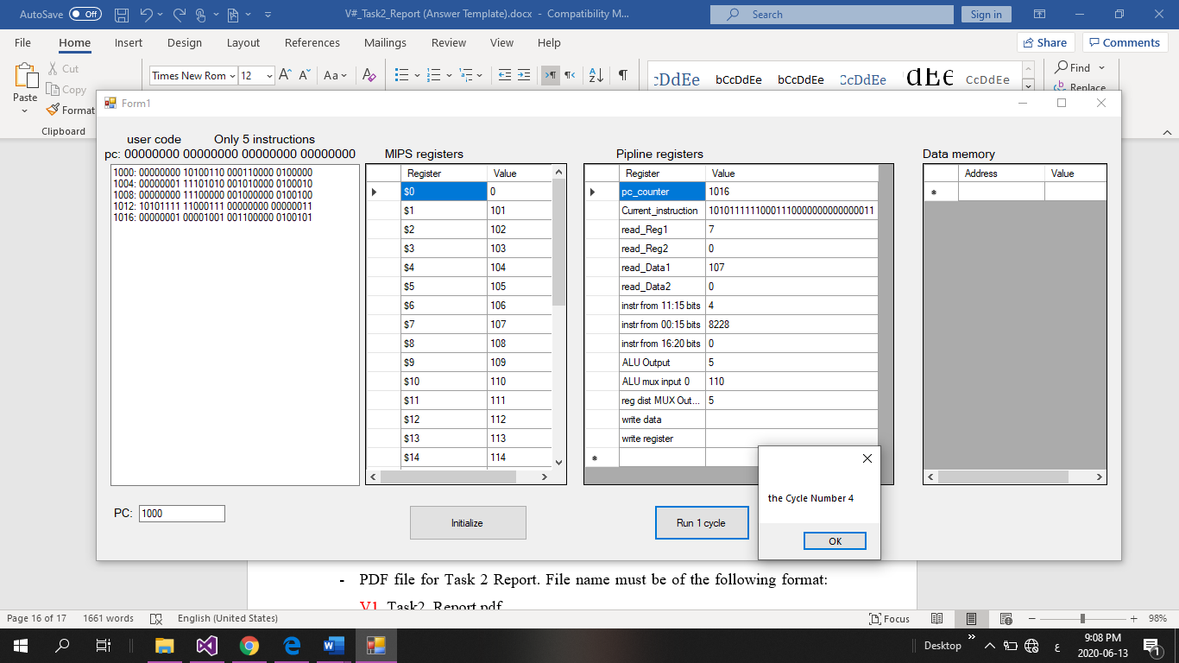

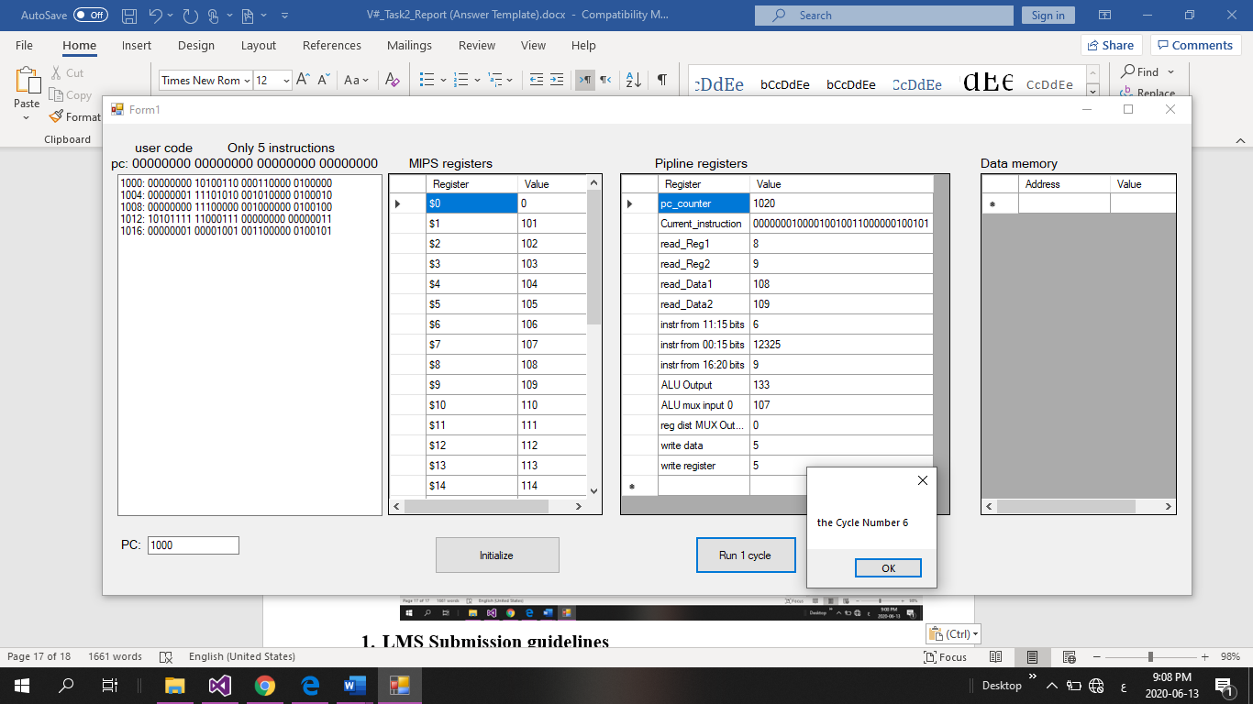

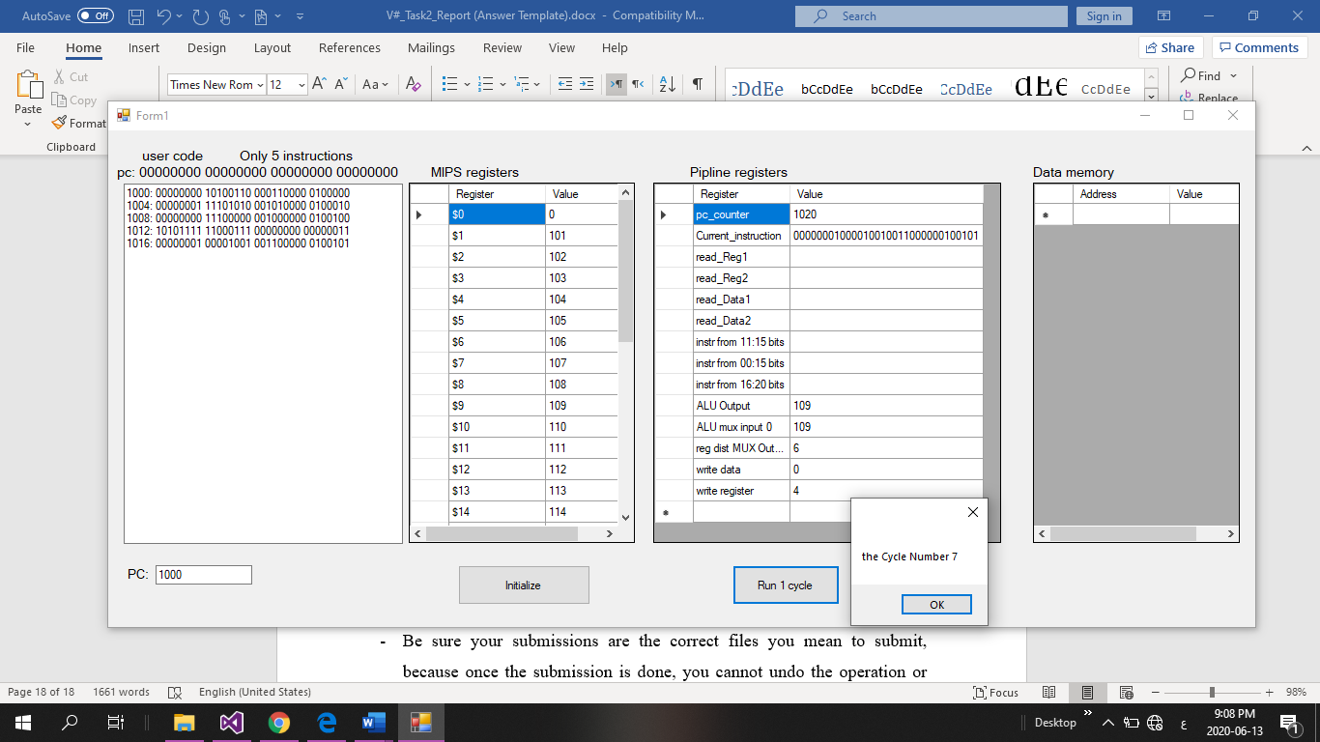

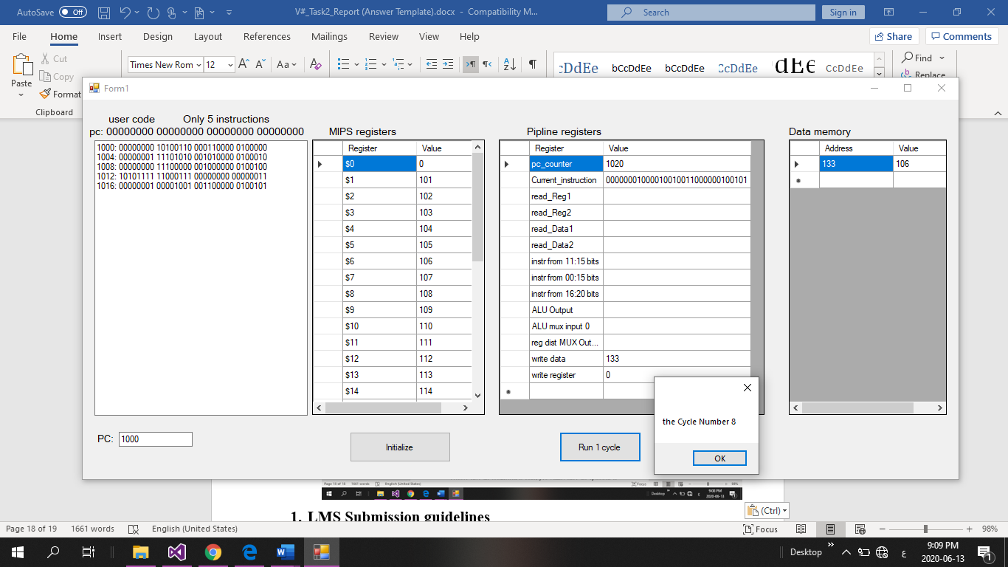

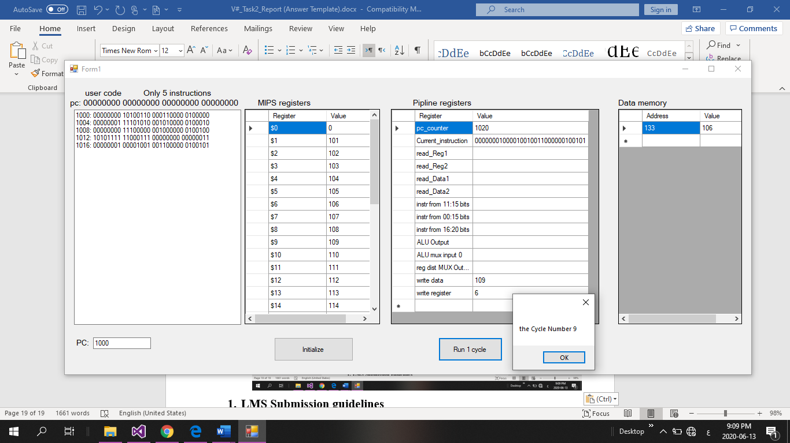

# **LMS Submission guidelines**

* Take care to submit your research not at the last minute, so as to meet the submission successfully without any tension.
* Be sure your submissions are the correct files you mean to submit, because once the submission is done, you cannot undo the operation or resubmit again.
* Do not name your submitted files with your name or ID.
* PDF file for Task 2 Report. File name must be of the following format: V1_Task2_Report.pdf

(V1 is for version1, use your exam version number after the letter V.)