Work Attendance Registration Project

Team GOATs

Second Year

2018/2019

Sections Names

1-عزالدين عبدالرحمن مصطفى حافظ (10)

2-هبه جمال صالح عبدالعال (20)

3-عبدالرحمن سيد عبدالفتاح (10)

4-عبدالرحمن محمد محمد عبدالله (10)

5- مارتينا جرجس عبدالنور (12)

Introduction

There are some basic statistical analyses that we may

need to apply to our data. In out project, we aim to

calculate and show the analyzing raw data numerically

and graphically.

But first we need to know, when to use certain statistics? and what they mean?

The project is about analyzing the raw data, calculating mean, median, mode, variance and standard deviation and analyzing two-dimensional data by performing correlation and regression

We also show in this project analyzing of the data using Histograms, pie charts, box plot and dot plot.

* The Employee should press Register to store its attendance

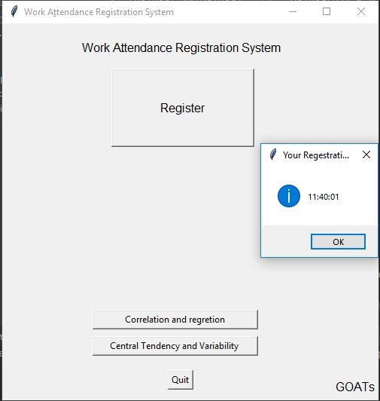

* This System takes the Attendance Registration
* Using the time of device

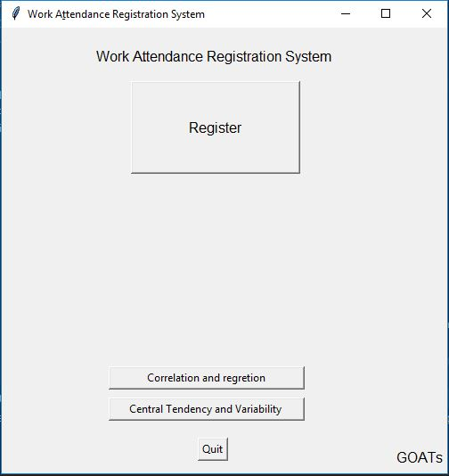

Work Aِttendance Registration System

Time of pc



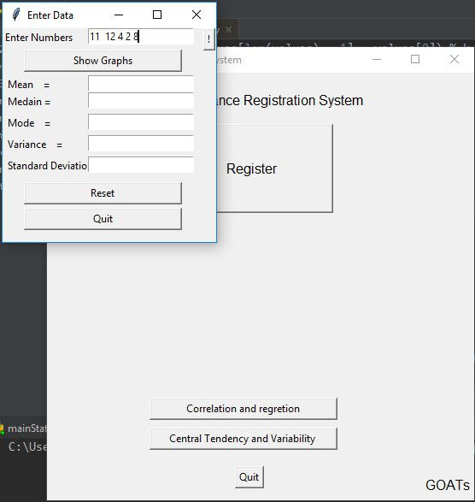

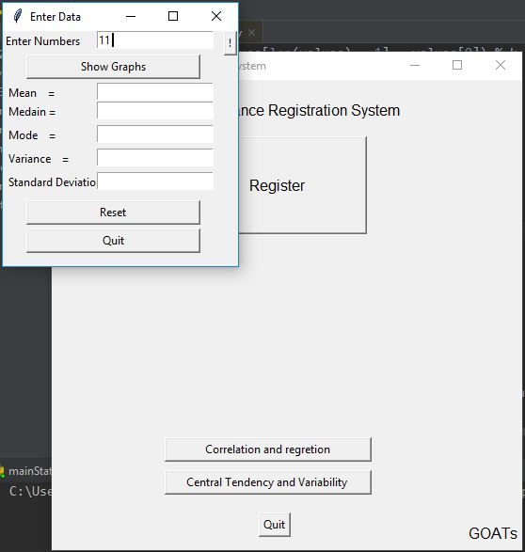

Time Has been enterd

When admin add more time

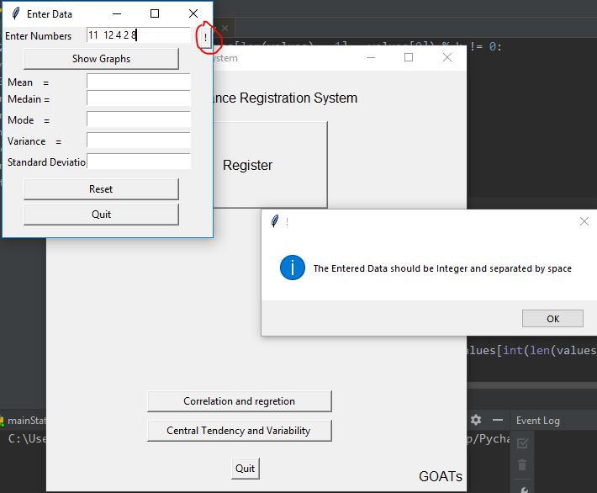

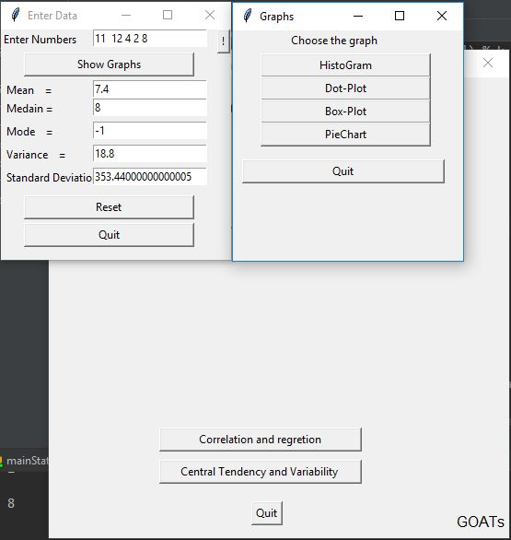

Press show Graphs to calculate the Centeral Tendency and Variability

When need help

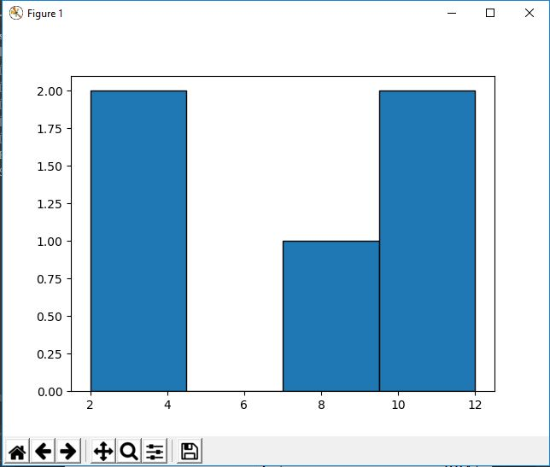

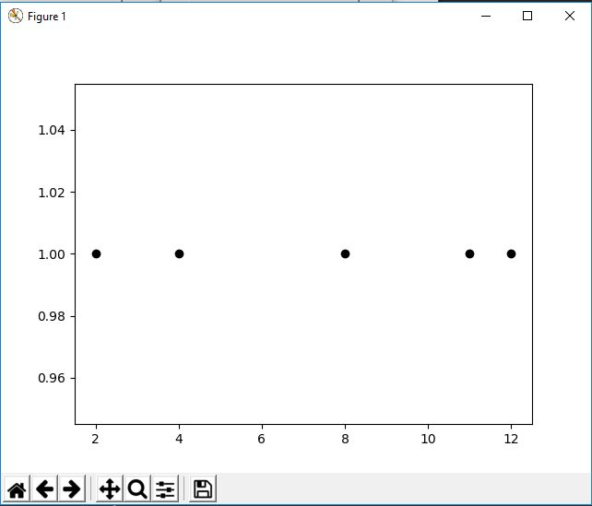

Dot-plot

HestoGram

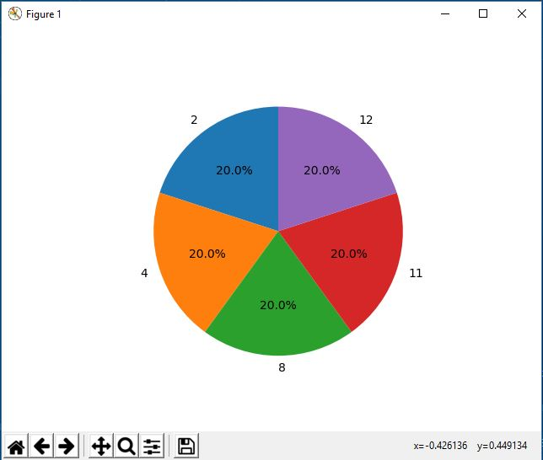

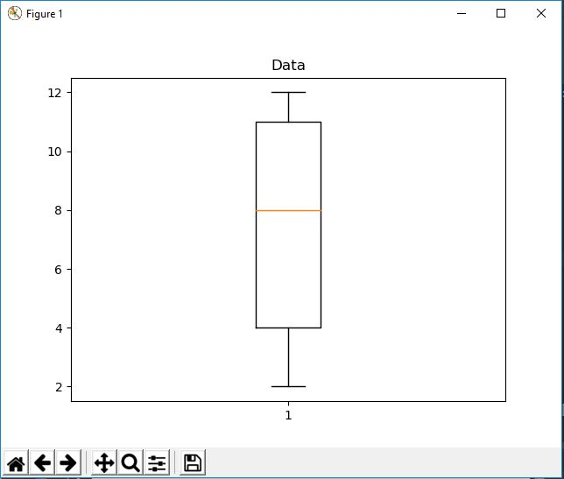

Box-Plot

Pie-Chart

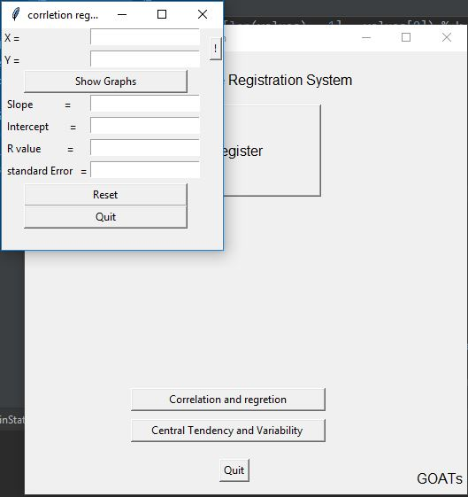

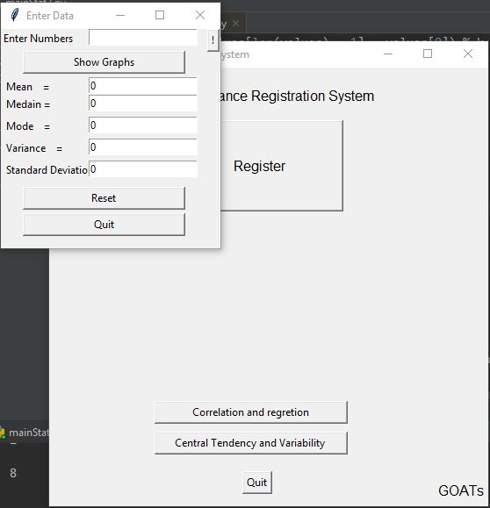

Press Reset to Enter new Data or press quit to close this window

To Correlation and Regretion From Main window press Correlation and Regretion

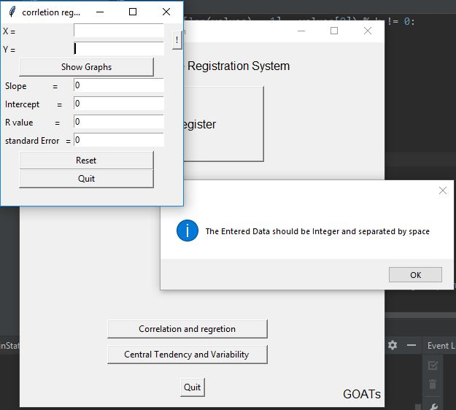

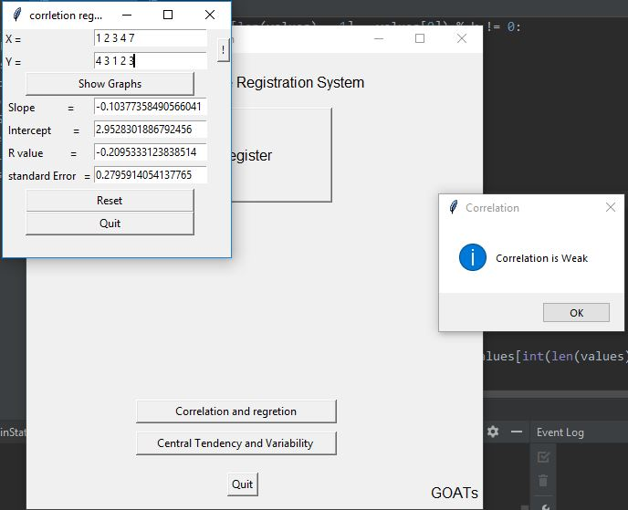

If you want help press”!”

Reset if you want to enter new data

Press show Graph to calculate .To Know the coffiecient of regretion from message Box

thank You