Business Requirements Document
Order Processing Improvement Initiative
MidCart Retail — Fulfillment Operations
Field | Detail
Document Type | Business Requirements Document (BRD)
Project | Order Processing Improvement — West Region (Reno Warehouse)
Prepared By | Business Analyst (Portfolio Case Study)
Prepared For | VP of Operations, MidCart Retail
Status | Draft for Stakeholder Review
Version | 1.0
Date | August 2026

1. Executive Summary
MidCart Retail's order-to-ship process has come under strain as order volume has grown through Q2 2026. Customer complaints about delayed shipping confirmations have increased, support ticket volume tied to “Where is my order” requests has climbed, and warehouse staff report working from pick lists that are frequently out of date.
This document presents the findings of a business analysis engagement into the order processing function, covering current-state process mapping, root-cause analysis, and a data-driven review of order and fulfillment records from May through July 2026. The analysis identifies the Reno (West Region) warehouse as the primary driver of the decline: its on-time shipping rate fell to 38.4%, versus 82-87% across the other three regional warehouses, and it accounts for the largest share of support tickets.
The root cause traces to a manual, twice-daily pick list process built from a spreadsheet, with no warehouse management system (WMS) to prioritize orders or flag at-risk shipments in real time. This document recommends implementing a digital, auto-prioritized pick list with real-time SLA tracking, and proposes the resulting future-state process, requirements, and success metrics.

2. Business Context & Problem Statement

2.1 Background
MidCart Retail operates four regional fulfillment warehouses (North, South, East, West) supporting online, mobile, and phone-in orders across categories including electronics, home goods, apparel, office supplies, and sporting goods. Each warehouse independently manages its own pick-and-pack workflow, with order confirmation and shipping-notification emails handled centrally by the e-commerce platform.

2.2 Problem Statement
Order fulfillment delays originating at the West region warehouse (Reno) are driving customer dissatisfaction and rising support cost. Between May and July 2026, on-time shipping performance in the West region fell to 38.4% against an SLA of shipping within 2 business days, compared to 82-87% in all other regions, while the associated support ticket rate for West-region orders rose to 30.4% of all orders — roughly three times the rate elsewhere.

2.3 Business Impact
- Elevated support-team workload: a disproportionate share of “where is my order” and “order shipped late” tickets originate from West-region orders.
- Risk to customer retention and repeat-purchase rate in the West region if shipping performance does not improve.
- Support cost grows faster than order volume, since delayed orders are far more likely to generate a ticket than on-time orders.
- Brand and reputational risk from delayed-shipping complaints on public channels.

3. Stakeholder Analysis
The table below identifies the stakeholders engaged in this initiative, their interest in the outcome, their level of influence over the solution, and the recommended engagement approach.
Stakeholder | Role / Interest | Influence | Engagement Strategy
VP of Operations | Owns fulfillment KPIs; sponsor for any process/technology change | High | Regular steering updates; final approval on recommendation
Reno Warehouse Manager | Runs day-to-day picking/packing; most affected by process change | High | Involve in process design; validate TO-BE workflow on the floor
Customer Support Lead | Owns ticket volume and customer satisfaction metrics | Medium | Share ticket-reason data; align on expected ticket-volume reduction
IT / Engineering Lead | Owns feasibility and delivery of any WMS or system change | High | Early consultation on technical requirements and constraints
Warehouse Pick/Pack Staff (Reno) | Execute the picking process daily; primary users of any new tool | Medium | Training and feedback sessions during rollout
Finance / Controller | Funds any technology investment; tracks cost-to-serve | Medium | Present cost-benefit case tied to ticket-volume and SLA improvement
Customers | Recipients of the order experience; indirect voice via tickets/NPS | Low (direct) / High (aggregate) | Represented via support-ticket data and satisfaction trends

4. Current State (AS-IS) Process
The diagram below maps the current order-to-ship process for the West region, from order placement through customer support follow-up. Pain points are highlighted in red.
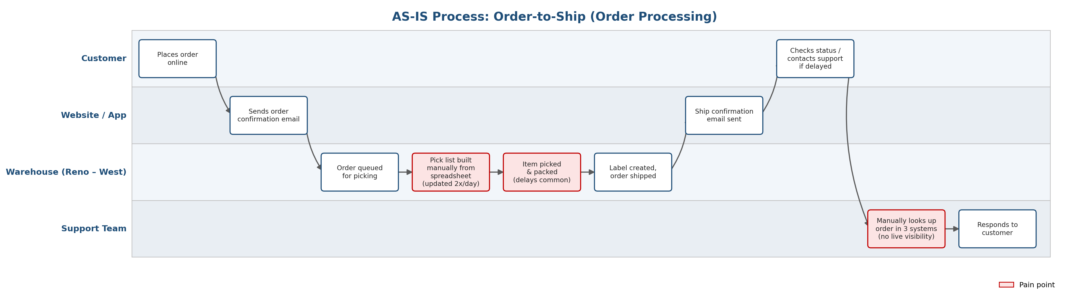
Figure 1. AS-IS swimlane — Order-to-ship process, West region (Reno warehouse).

4.1 Pain-Point Analysis
Pain Point | Process Step | Impact | Supporting Evidence
Pick list built manually from a spreadsheet, refreshed only twice a day | Warehouse — pick list generation | New and re-prioritized orders sit unpicked for hours | West on-time ship rate: 38.4% vs. 82-87% elsewhere
No real-time prioritization of at-risk or delayed orders | Warehouse — pick & pack | Orders already behind SLA are not flagged or expedited | Avg. ship delay in West: 1.3 days vs. 0.3-0.4 days elsewhere
Support has no live visibility into order/warehouse status | Support — status lookup | Agents manually check up to 3 systems per inquiry, slowing response | West ticket rate: 30.4% of orders vs. 9.9-12.2% elsewhere
Delay and ticket rate both trend upward through the quarter | End-to-end | Problem is worsening, not stable | Ticket rate rose from 11.7% (May) to 18.1% (July) company-wide

5. Root Cause Analysis

5.1 Five Whys
Applied to the core symptom: “West-region orders are shipping late.”
Why | Question | Answer
1 | Why are West-region orders shipping late? | Warehouse staff are picking orders later than the SLA allows.
2 | Why are orders picked later than the SLA allows? | The pick list staff work from is not current — it reflects orders as of the last refresh, up to several hours old.
3 | Why is the pick list not current? | It is built manually from a spreadsheet that is only regenerated twice per day.
4 | Why is a manual, twice-daily spreadsheet still the process? | The Reno warehouse never adopted a warehouse management system (WMS); the process was designed for a lower order volume.
5 | Why hasn't a WMS been adopted as volume grew? | No system flags the growing gap in performance, so it has not been prioritized against other initiatives — until now, evidenced by this data.

5.2 Fishbone (Ishikawa) Diagram
The Five Whys points to a single technology gap, but several contributing factors reinforce it across people, process, technology, and data.
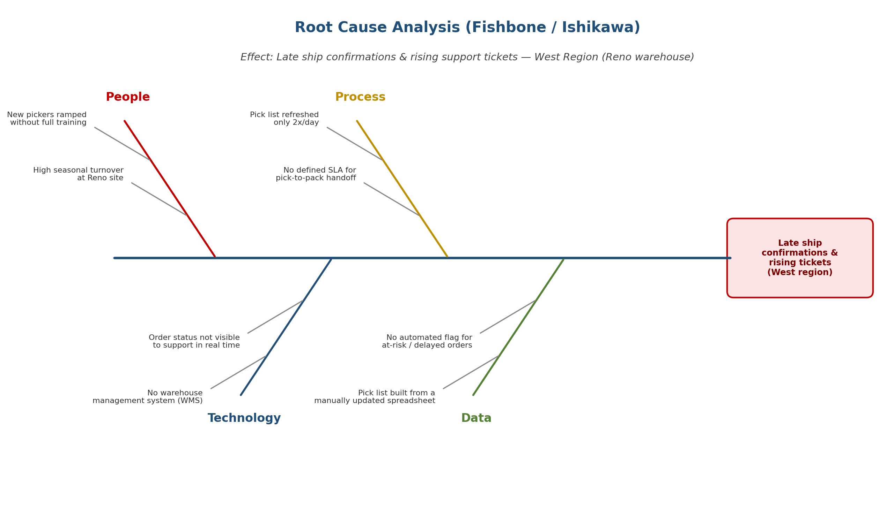
Figure 2. Fishbone diagram — contributing causes of late ship confirmations, West region.

6. Data Analysis & Key Findings
The findings above are grounded in an analysis of 620 orders placed between May and July 2026, covering order dates, promised vs. actual ship dates, delivery dates, and associated support tickets. Full detail, pivot-style breakdowns, and a live KPI dashboard are provided in the companion workbook, MidCart_Order_Analysis.xlsx.

6.1 On-Time Shipping Rate by Region
Region | Total Orders | On-Time Rate | Avg. Ship Delay (days)
North | 164 | 81.7% | 0.4
South | 142 | 85.2% | 0.3
East | 176 | 86.9% | 0.3
West | 138 | 38.4% | 1.3

6.2 Monthly Trend (Company-Wide)
Month | Total Orders | On-Time Rate | Ticket Rate
May 2026 | 77 | 81.8% | 11.7%
June 2026 | 255 | 76.9% | 12.9%
July 2026 | 288 | 70.1% | 18.1%
Both the on-time rate decline and the ticket-rate increase accelerate as order volume grows month over month — consistent with a manual process that does not scale, rather than a one-time disruption.

7. KPI Definitions
The following KPIs are recommended to track order-processing health going forward and to measure the impact of the proposed improvements.
KPI | Definition | Formula | Current (West) | Target
On-Time Ship Rate | % of orders shipped by the promised ship date | On-time orders ÷ Total orders | 38.4% | 95%
Avg. Ship Delay | Average days beyond the promised ship date | AVG(Actual Ship Date − Promised Ship Date) | 1.3 days | ≤ 0.3 days
Support Ticket Rate | % of orders that generate a fulfillment-related support ticket | Orders w/ ticket ÷ Total orders | 30.4% | ≤ 10%
Pick List Freshness | Time between pick list refreshes | Manual measurement / system log | ~12 hours (2x/day) | Real-time
At-Risk Order Detection | % of delayed orders flagged before breaching SLA | Flagged-before-breach ÷ Total delayed orders | 0% (no flagging exists) | ≥ 90%

8. Future State (TO-BE) Process
The proposed future-state process replaces the manual, twice-daily spreadsheet pick list with a digital, auto-prioritized pick list generated in real time, paired with automatic SLA tracking that flags at-risk orders before they breach the shipping SLA. Customers gain self-service order tracking, and the support team is engaged only for system-flagged exceptions rather than manual status lookups.
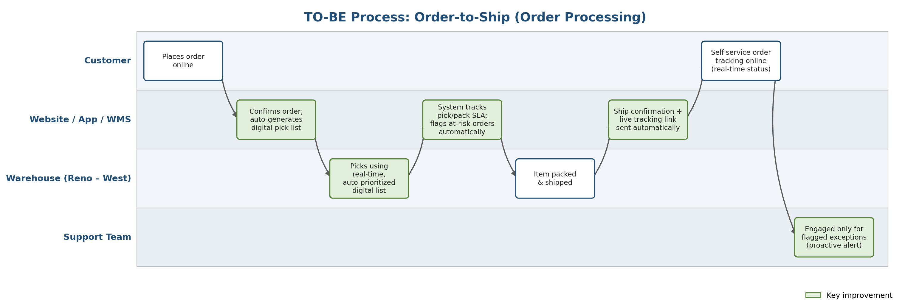
Figure 3. TO-BE swimlane — Order-to-ship process, West region (Reno warehouse).

8.1 Key Differences from AS-IS
- Pick list generation moves from a manual, 2x-daily spreadsheet to a real-time, system-generated, auto-prioritized list.
- Orders at risk of breaching the shipping SLA are flagged automatically, rather than discovered after the fact.
- Customers can self-serve order status, reducing inbound “where is my order” contact volume.
- Support is engaged proactively via system-flagged exceptions, rather than manually looking up status across three systems.

9. Improvement Proposal & Recommendations
The following recommendations are prioritized by expected impact on the on-time ship rate and support ticket volume, weighed against estimated implementation effort.
# | Recommendation | Impact | Effort | Priority
1 | Implement a warehouse management system (WMS) module for real-time, auto-prioritized pick lists at the Reno warehouse | High | Medium-High | P1
2 | Build automated SLA-risk flagging so at-risk orders are surfaced before they breach the ship-by date | High | Medium | P1
3 | Give customers self-service order tracking to reduce inbound status inquiries | Medium | Low-Medium | P2
4 | Integrate order status into a single view for the support team (eliminate the 3-system lookup) | Medium | Medium | P2
5 | Establish a formal pick-to-pack SLA and staffing review for the Reno site, informed by seasonal volume | Medium | Low | P3
Recommendations 1 and 2 directly address the root cause identified in the Five Whys and Fishbone analysis and are expected to have the largest effect on the on-time ship rate. Recommendations 3 and 4 reduce support cost and response time even before the underlying warehouse process is fully modernized, and can be sequenced in parallel.

10. Business Requirements

10.1 Functional Requirements
ID | Requirement | Priority | Related Stakeholder
BR-01 | The system shall generate an updated, prioritized pick list in real time as orders are placed or re-prioritized. | Must Have | Warehouse Manager
BR-02 | The system shall automatically flag any order projected to breach its promised ship date at least 4 hours before the breach. | Must Have | Warehouse Manager, Support Lead
BR-03 | The system shall provide customers a self-service page showing real-time order and shipping status. | Should Have | Customers, Support Lead
BR-04 | The system shall provide the support team a single-screen view of order, warehouse, and shipping status without cross-system lookup. | Must Have | Support Lead
BR-05 | The system shall log pick-to-pack timestamps to support ongoing SLA and staffing analysis. | Should Have | VP of Operations

10.2 Non-Functional Requirements
- Pick list updates must reflect new or changed orders within 5 minutes.
- At-risk order flags must be visible to warehouse and support staff simultaneously (no batch delay).
- Customer-facing tracking page must load within 3 seconds on mobile and desktop.
- Solution must integrate with the existing order-management and shipping-carrier systems without disrupting other regional warehouses.

11. Assumptions, Constraints & Out of Scope

11.1 Assumptions
- Order and fulfillment data for May-July 2026 is representative of ongoing volume trends.
- The Reno warehouse has the physical infrastructure (scanners, network connectivity) to support a digital pick-list system.
- Other regional warehouses are performing within acceptable SLA range and are not in scope for the initial rollout.

11.2 Constraints
- Solution must not require a full replacement of the existing order-management platform.
- Implementation should minimize disruption to in-flight orders during cutover.

11.3 Out of Scope
- Warehouses outside the West region (North, South, East) — may be considered for a future phase if the pilot succeeds.
- Changes to shipping carriers or delivery-transit times.
- Pricing, promotions, or product-catalog related workstreams.

12. Appendix

12.1 Related Deliverables
- MidCart_Order_Analysis.xlsx — raw order data, pivot-style analysis, and live KPI dashboard.
- swimlane_asis.png / swimlane_tobe.png — current- and future-state process diagrams (embedded above).
- fishbone.png — root-cause diagram (embedded above).

12.2 Data Dictionary (Raw Data Tab)
Field | Description
OrderID | Unique order identifier
OrderDate | Date the order was placed
Region / Warehouse | Fulfilling region and warehouse
Channel | Website, Mobile App, or Phone/Call Center
PromisedShipDate | SLA ship-by date (order date + 2 business days)
ActualShipDate | Date the order actually shipped
OnTimeShip | Yes/No — whether ActualShipDate ≤ PromisedShipDate
SupportTicketRaised / TicketReason | Whether a support ticket was raised, and why

