Stevens Institute of Technology
Department of Electrical and Computer Engineering

Summer Semester 2021

CpE 645 Image Processing

Final Exam

Finish in 4 hours

Instruction:

- Provide all necessary intermediate steps in your work. You may get zero credit if you only state the final result without justification or explanation.

- All calculations are to be done by hand, with possible assistance of a calculator. Matlab is not allowed.

Name (print): _____________________________

Problem 1 (20 points) Given an original picture together with three distorted images as shown, for each distorted image
- Describe the nature of the distortion,
- Suggest two image enhancement tools that can be used to improve the appearance of each distorted image, and provide specific parameters (i.e. filter coefficients) for your suggested operators.

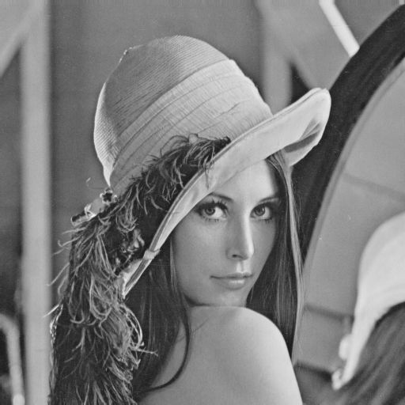  Original Image |   Distorted image 1
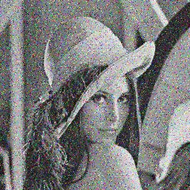  Distorted image 2 |   Distorted image 3

Distorted Image 1

Distorted Image 2

Distorted Image 3

Problem 2: (20 points)
Assume that a bi-level input image x[n₁, n₂] of 512×512 as shown below, where the dark region has amplitude of 50 and the white foreground has amplitude of 100.

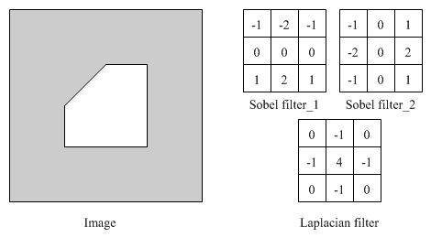
1) Use Sobel edge detector on this image, which will produce two filtered images G₁(x[n₁, n₂]) and G₂(x[n₁, n₂]). Sketch your output images. Note that each actual edge may result in single, double, triple or more lines depending on different edge detectors. You should specify the number of lines for each edge, as well as the amplitude value for each of these lines. (Hint: refer to “edge-detc.pdf”.)
2) Use Laplacian filter on this image and sketch your output image highlighting all pixels with none zero amplitudes.
3) Comment on the difference between these two types of edge detectors.

Problem 3 (20 points)
There are many ways to characterize a segmented object for image analysis. Consider the binary image shown below, where bright pixel represents 1 and dark pixel represents 0.
1) Provide the run length coding representation;
2) Provide the quad-tree coding representation;
3) Provide the Fourier descriptor with the starting point at (1,0); (Note: Just provide the expression as shown in homework 5.1.3 solution, no need to actually calculate the DFT)
4) Following 3), sketch the image corresponding to 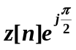.

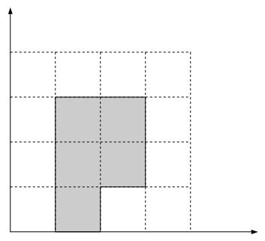

Problem 4: (20 points)
A signal x[n₁,n₂] is distorted by a PSF h[n₁,n₂], and corrupted by additive noise n[n₁,n₂], i.e. x_{d}[n₁,n₂]=x[n₁,n₂]**h[n₁,n₂]+n[n₁,n₂].
1) Assume h[n₁,n₂] = (1/3)*δ[n₁+1,n₂]+ (1/3)*δ[n₁,n₂] + (1/3)*δ[n₁-1,n₂], comment on the type of the distortion or the distortion effect;
2) With the PSF defined in 1) and n[n₁,n₂]=0, derive the frequency response of the Wiener restoration filter;
3) With the PSF defined in 1) and the ratio of power spectra of noise and signal
Γ_{NN}(ω₁, ω₂)/Γ_{xx}(ω₁, ω₂) = 1, derive the frequency response of the Wiener restoration filter. Simplify your expression as much as you can.

Problem 5 (20 points) Based on the motion compensated prediction used in MPEG, generate the prediction frame, the motion vectors, and the difference frame for the current frame as shown. Assume each box represents a pixel, each macro-block is of 2×2 pixels, the white boxes have value of zero (0), and the gray boxes have value of one (1). (Note: motion vectors should point from the location of the best match block in the reference frame to the location of the current macro-block in the current frame.)

