Stevens Institute of Technology
Department of Electrical and Computer Engineering

CpE 645 Image Processing

Homework 4:

4.1 During acquisition, an image undergoes uniform linear motion in the vertical direction for a time T₁. The direction of motion then switches to the horizontal direction for a time interval of T₂. Assuming that the time it takes the image to change direction is negligible, and the shutter only opened during this T₁+T₂ time, give an expression for the blurring function.

4.2 An image x[n₁,n₂] is known to have the power spectrum Γ_{xx}(ω₁, ω₂) in the variable ω₁, as shown below. The image is distorted in the n₁ direction by a causal linear shift-invariant distortion
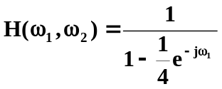.
In addition, the image is corrupted by uncorrelated white noise with a maximum peak power spectral density of Γ_{NN}(ω₁, ω₂)=A/4, leading to the distorted image x_{d}[n₁,n₂].

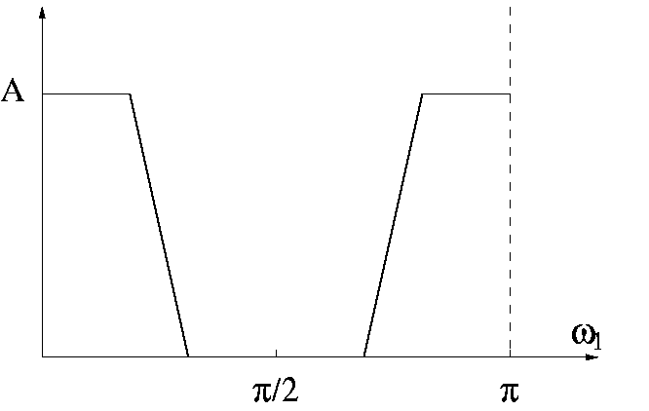

1) Sketch the DTFT magnitude |G(ω₁, ω₂)| of the corresponding Wiener restoration filter, if we assume the additive noise is zero and H(ω₁, ω₂) is as given above. Express your sketch in the variable ω₁.
2) Sketch the corresponding Wiener restoration filter |G(ω₁, ω₂)| in ω₁ if we assume the PSF h[n₁,n₂] = δ[n₁,n₂] (or H(ω₁, ω₂)=1 ) and the noise is as stated above.
3) Sketch the corresponding Wiener restoration filter |G(ω₁, ω₂)| in ω₁ for the distorted image x_{d}[n₁,n₂].

4.3. Consider the edge detection (or segmentation) problem involving the operators:
G1(x[n1, n2]) = x[n1+1, n2+1] - x[n1, n2],
G2(x[n1, n2]) = x[n1, n2+1] - x[n1+1, n2],
i.e. the Roberts' gradient. Assume that a bi-level input image of 512x512 as shown below, where the dark region has amplitude of 50 and the white has an amplitude of 200.

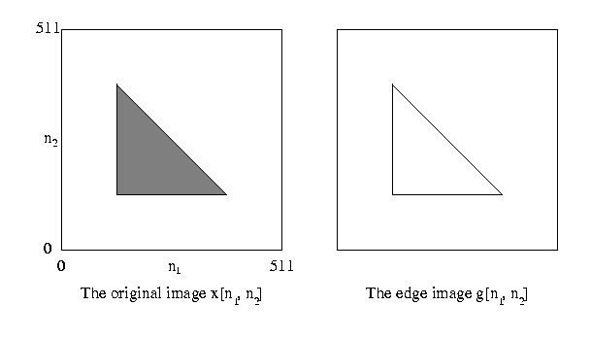
Assume that segmentation is based on the operator
y[n1, n2]=|G1(x[n1, n2])| + |G2(x[n1, n2])|
A threshold T is applied to y[n1, n2] resulting in
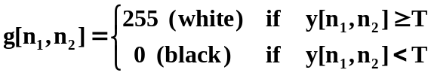

1) Determine the minimum and maximum values of T such that g[n1, n2] will be the edge image as shown.
2) Repeat part one for the case where
