4.1

Because the motion in the x- and y-directions are independent and sequential, i.e. motion is in the vertical y-direction at first, and then switching to motion in the horizontal x-direction, this problem can be solved in two sequential steps, over T₁ + T₂. Assuming the motion velocity is v and similar to the analysis in the lecture notes (CPE645-6), the Fourier transform of the distorted image X’ after the first step vertical motion is
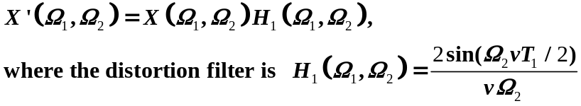

This distorted image is then further distorted when the object is moving horizontally, which yields the final distorted image Y
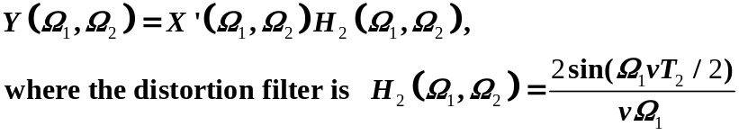

The overall distortion process can be expressed as

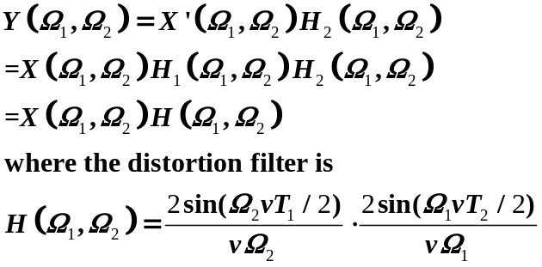

4.2
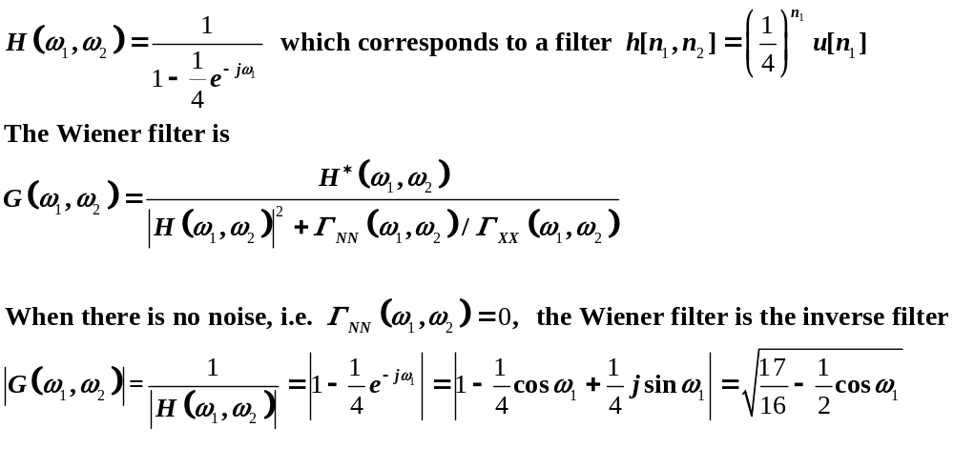

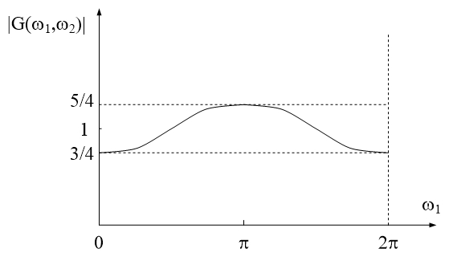

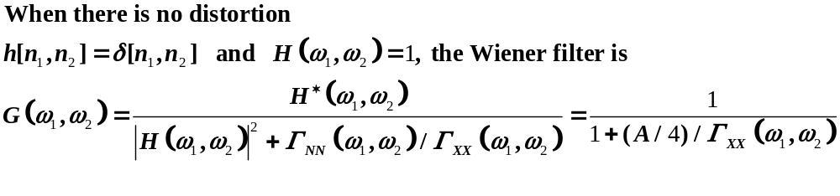

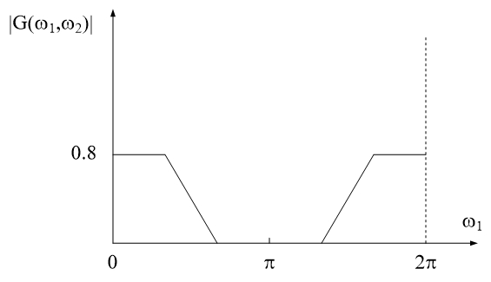

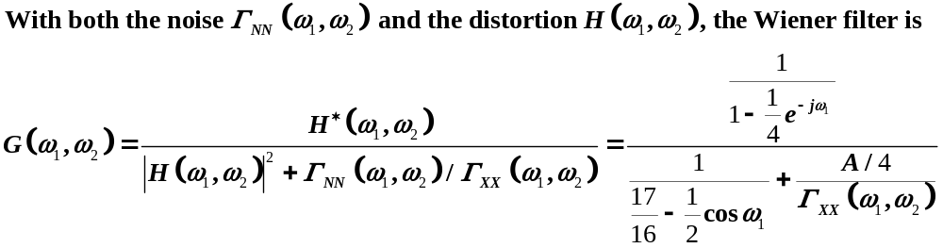

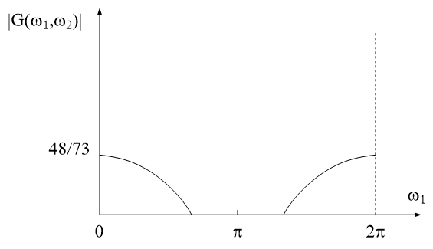

4.3.

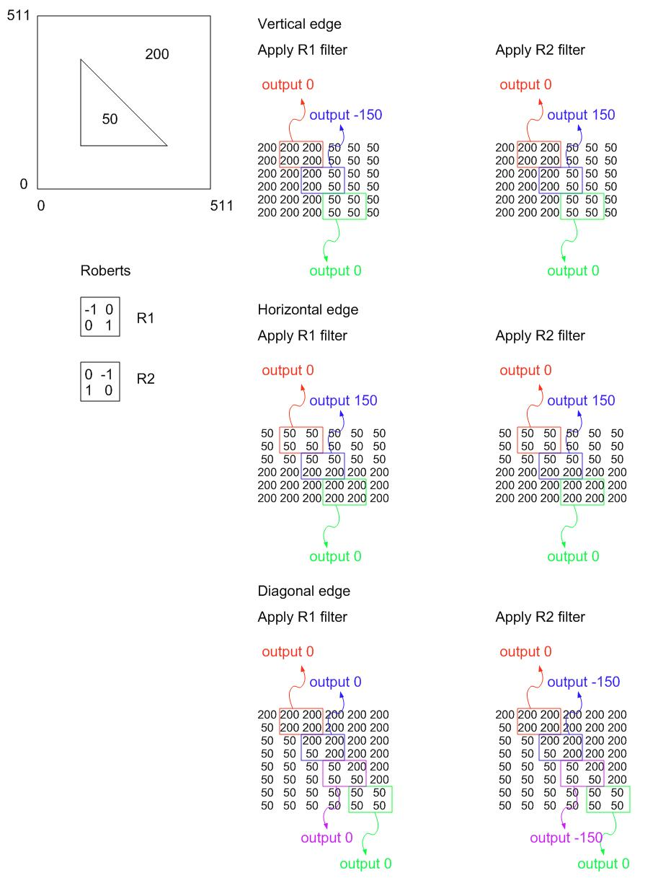

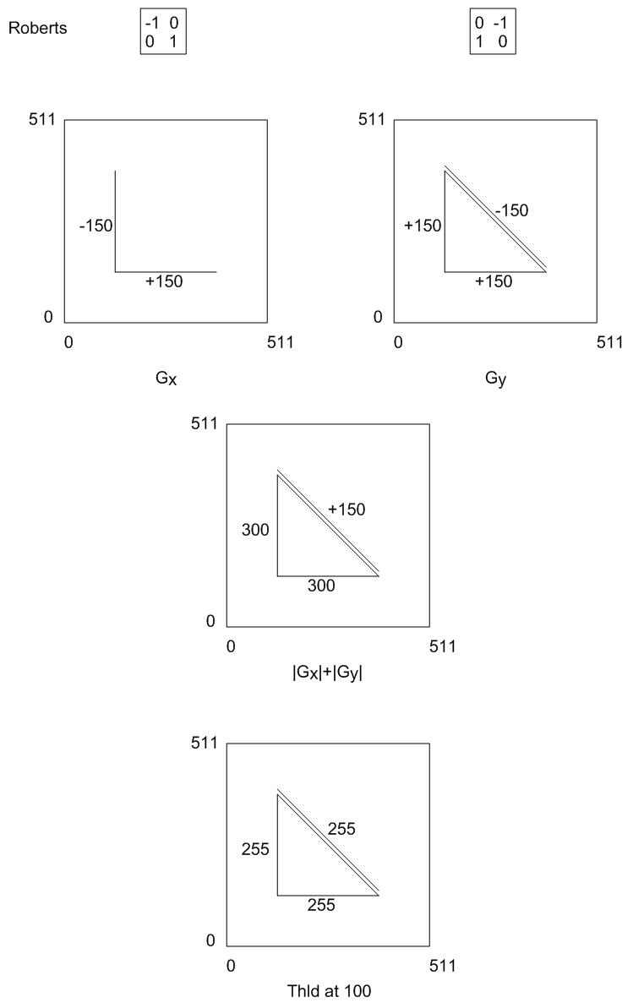

When we combine the two outputs from the two filters together using
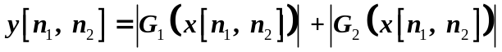

we have the vertical and horizontal lines from both filters, and the combined amplitude will be 150+150=300. The diagonal lines are only from one filter, so the amplitude will be 150. In order to keep all these edge lines, the maximum threshold will be 149, and the minimum threshold will be 1.

When we combine the two outputs from the two filters together using

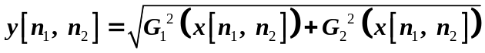

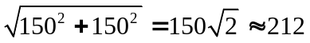we have the vertical and horizontal lines from both filters, and the combined amplitude will be

The diagonal lines are only from one filter, so the amplitude will be 150. In order to keep all these edge lines, the maximum threshold will be 149, and the minimum threshold will be 1.

