Stevens Institute of Technology
Department of Electrical and Computer Engineering

CpE 645 Image Processing

Homework 5:

5.1 Consider an automatic character recognition system in which all characters are represented by 8×8 image arrays. All characters are selected to extend completely from top to bottom and side to side in the array. Assume that the lines used to compose a character always have a width of 2 pixels. Suppose we have the upper case letter T as shown below. Determine its representations through the following methods.

1) Quad-tree coding
2) Run-length coding
3) Fourier descriptors.

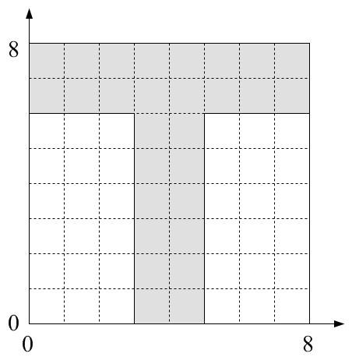

5.2 There are many ways to characterize a segmented object for image analysis. One popular method is to use Fourier descriptors. Let z[n] = x[n] + jy[n] be the sampled x and y components of the object boundary. Let Z[k] be the Fourier descriptor. Assume the object is a triangle as shown below. Let the point (1,2) be the starting point.

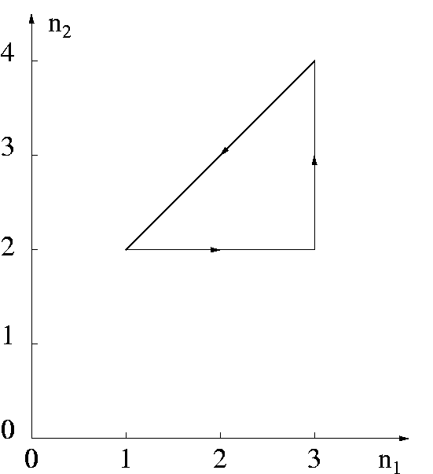

1) Determine z[n] and Z[k].
2) Sketch the object corresponding to z₁[n] = z[n] + (2+j) as a translation of the original object z[n].
3) Determine the Fourier descriptor Z₁[k] of z₁[n].
4) Sketch the object corresponding to z₂[n] = 2 × z[n] as a scaling of the original object z[n].
5) Determine the Fourier descriptor Z₂[k] of z₂[n].
6) Sketch the object corresponding to z₃[n] = z[n] × exp(jπ/2) as a rotation of the original object z[n].
7) Determine the Fourier descriptor Z₃[k] of z₃[n].

5.3 In a JPEG image coder, after the DCT, quantization and zig-zag scanning, all the AC coefficients are coded through a run-length coding. This run-length coding is defined as pairs of (zero-run, amplitude), where the amplitude is a non-zero coefficient and the zero-run is the number of zeros prior to this non-zero coefficient. At a certain point when there is no more non-zero coefficient in the block, a symbol EOB (end-of-block) is coded. For a block of DCT transformed and quantized coefficients as shown, generate the run-length coding pairs for the AC coefficients.
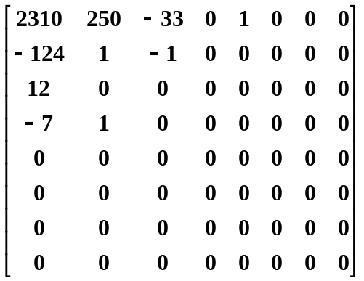

5.4 Based on the motion compensated estimation used in MPEG, calculate the motion vectors, the prediction frame and the difference frame for the current frame as shown. Assume each box represents a pixel, each macro-bolck is of 2x2 pixels, the white boxes have value of zero (0), the gray boxes have value of one (1), and the black boxes have value of two (2).

