5.1

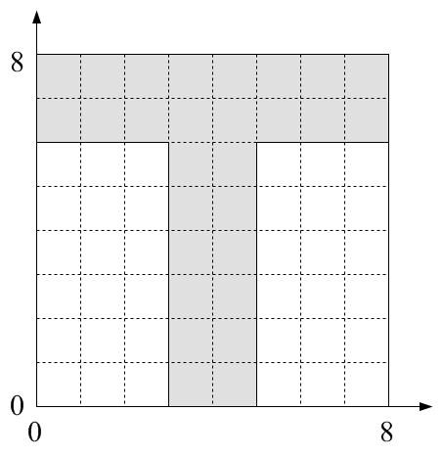

1) Quad-Tree:

first-level G,G,G,G;
second-level: B,B,W,G; B,B,G,W; W,G,W,G; G,W,G,W;
third-level: W,B,W,B; B,W,B,W; W,B,W,B; W,B,W,B; B,W,B,W; B,W,B,W;
Note:
1. following the same scanning order.
2. the next level decompositions following the order of G blacks in the previous level.
3. Quad-Tree is different with other description in the sense that it is dealing with blocks (or areas) while others are dealing with pixels.

2) Run-length:
run on black (0) pixels
n1, n2, run
0 8 8
0 7 8
0 6 8
3 5 2
3 4 2
3 3 2
3 2 2
3 1 2
3 0 2

3) Fourier descriptor

start from (3,0), counter-clockwise.
u[n1,n2]={3, 4, 5, 5+j, 5+2j, 5+3j, 5+4j, 5+5j, 5+6j, 6+6j, 7+6j, 8+6j, 8+7j, 8+8j,
7+8j, 6+8j, 5+8j, 4+8j, 3+8j, 2+8j, 1+8j, 8j, 7j, 6j, 1+6j, 2+6j, 3+6j, 3+5j, 3+4j,
3+3j, 3+2j, 3+1j}.
Fourier Descriptor is the DFT of this complex sequence. You can use Matlab to calculate this 32-point DFT. (But it is not the focus of this exercise.)

5.2
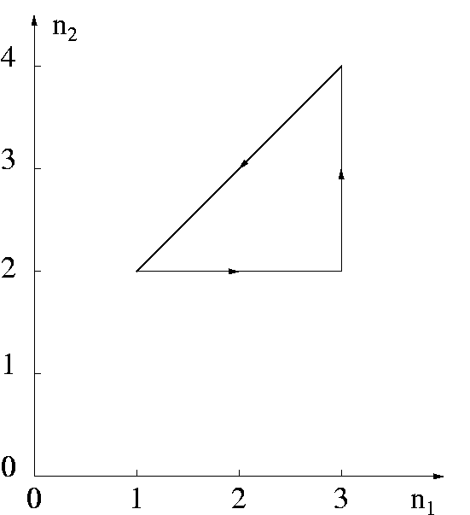

1) z[n]={(1+2j), (2+2j), (3+2j), (3+3j), (3+4j), (2+3j)}

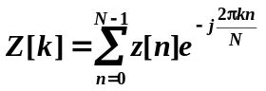 for 0 ≤ n, k ≤ N-1, N=6.

Z[0]= (1+2j) + (2+2j) + (3+2j) + (3+3j) + (3+4j) + (2+3j)
Z[1]= (1+2j) + (2+2j)e^{-j2π/6} + (3+2j)e^{-j4π/6} + (3+3j)e^{-j6π/6} + (3+4j)e^{-j8π/6} + (2+3j)e^{-j10π/6}
Z[2]= (1+2j) + (2+2j)e^{-j4π/6} + (3+2j)e^{-j8π/6} + (3+3j)e^{-j12π/6} + (3+4j)e^{-j16π/6} + (2+3j)e^{-j20π/6}
Z[3]= (1+2j) + (2+2j)e^{-j6π/6} + (3+2j)e^{-j12π/6} + (3+3j)e^{-j18π/6} + (3+4j)e^{-j24π/6} + (2+3j)e^{-j30π/6}
Z[4]= (1+2j) + (2+2j)e^{-j8π/6} + (3+2j)e^{-j16π/6} + (3+3j)e^{-j24π/6} + (3+4j)e^{-j32π/6} + (2+3j)e^{-j40π/6}
Z[5]= (1+2j) + (2+2j)e^{-j10π/6} + (3+2j)e^{-j20π/6} + (3+3j)e^{-j30π/6} + (3+4j)e^{-j40π/6} + (2+3j)e^{-j50π/6}

Again, you can use Matlab to calculate the values.

2) z₁[n]={(1+2j) + (2+j), (2+2j) + (2+j), (3+2j) + (2+j), (3+3j) + (2+j), (3+4j) + (2+j),
(2+3j) + (2+j) }
={(3+3j), (4+3j), (5+3j), (5+4j), (5+5j), (4+4j)}

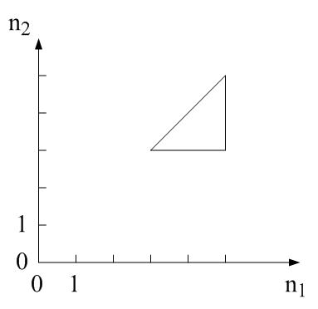

3) Similar to 1)

4) z₂[n]={(1+2j)×2, (2+2j)×2, (3+2j)×2, (3+3j)×2, (3+4j) ×2, (2+3j)×2}
={(2+4j), (4+4j), (6+4j), (6+6j), (6+8j), (4+6j)}

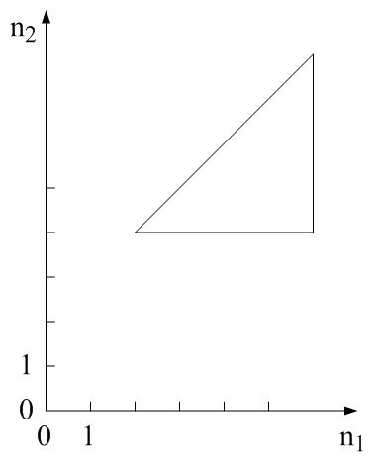
5) Similar to 1)

6) z₂[n]={(1+2j)×e^{-jπ/2}, (2+2j)×e^{-jπ/2}, (3+2j)×e^{-jπ/2}, (3+3j)×e^{-jπ/2}, (3+4j)×e^{-jπ/2}, (2+3j)×e^{-jπ/2}}
={(-2+j), (-2+2j), (-2+3j), (-3+3j), (-4+3j), (-3+2j)}

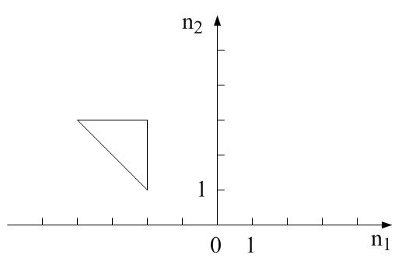

7) Similar to 1)

5.3 For a block of DCT transformed and quantized coefficients as shown, the run-length coding pairs for the AC coefficients
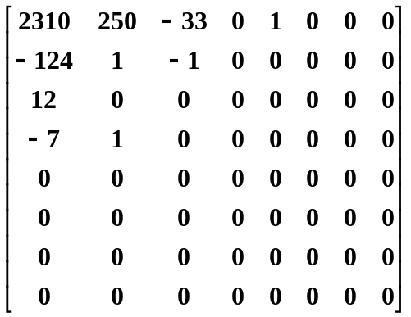

The run-length coding pairs for the AC coefficients are:

(0, 250) (0, -124), (0, 12), (0,1), (0,-33), (1, -1), (1, -7), (1, 1), (2, 1), EOB.

5.4
