Stevens Institute of Technology
Department of Electrical and Computer Engineering

Summer Semester 2021

CpE 645 Image Processing

Midterm Exam

Finish in 4 hours

Instruction:

- Provide all necessary intermediate steps in your work. You may get zero credit if you only state the final result without justification or explanation.

- All calculations are to be done by hand, with possible assistance of a calculator. Matlab is not allowed.

Name (print): _____________________________

Problem 1 (20 points)
- Given x₁[n]=δ[n]-2δ[n-1]+δ[n-2], sketch x₁[n]
- Given x₂[n_{1,} n₂] as shown, express this signal as the sum of weighted deltas.
- Calculate the DTFT of x₁[n] and x₂[n_{1,} n₂]
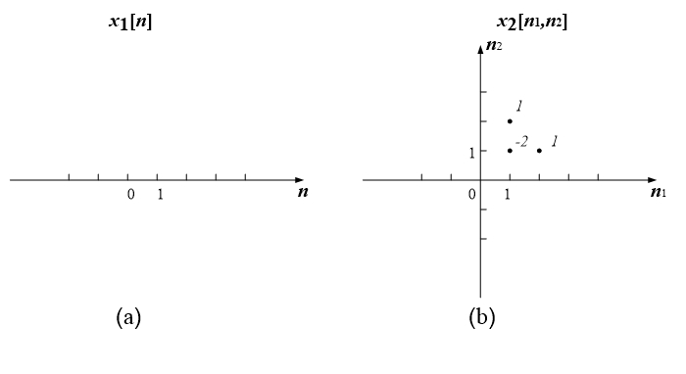

Problem 2. (20 points) Let x[n]=δ[n+1]+2δ[n]-δ[n-2], h[n]=2δ[n]+δ[n-1]-δ[n-2],
- Compute the convolution y[n] = x[n] * h[n].
- Compute X(z), H(z), and Y(z), i.e. z-transform of x[n], h[n] and y[n].
- Show that Y(z) = X(z)H(z),

Problem 3 (20 points): Given a 2-D signal x[n₁, n₂] and a 2-D system h[n₁, n₂] as shown,

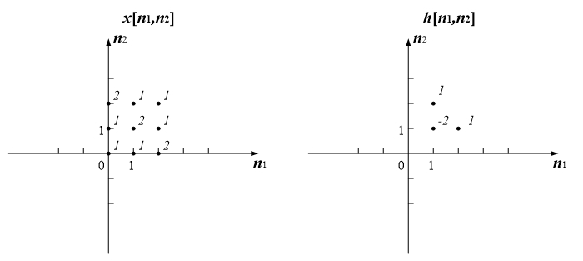
Calculate the 2-D convolution of y[n₁, n₂] = x[n₁, n₂] ** h[n₁, n₂]

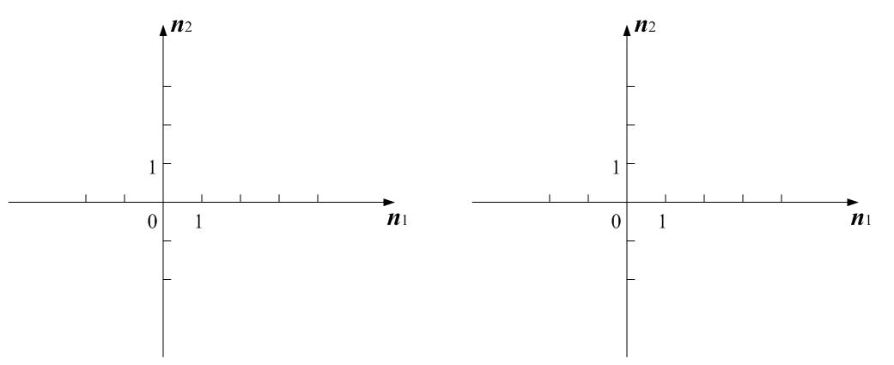

Problem 4. (20 points) 1-D Discrete Sine Transform (DST) is defined as the following.
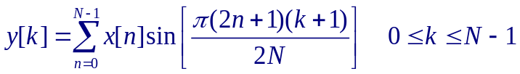

- Generate the transform matrix for 4-point DST
- Identify all basis vectors of 4-point DST
- Calculate 2-D 4-point DST of signal 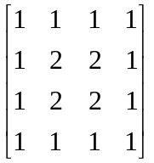

Problem 5. (10 points) A 256-level gray scale image contains a flat background with an amplitude of 200, and a small foreground object with an amplitude of 202.
- Is this object visible to most viewers? Why or why not?
- To enhance the contrast of this image using gamma correction function, suggest a reasonable gamma value, and explain why.

Problem 6 (10 points) The highest frequency in an image is a region with alternating black and white lines. In such case, the period of the waveform is T = 2 pixels. A 65” 4K TV screen has a resolution of 3840 x 2160 pixels and 1439mm x 809mm. Assume a single horizontal frequency test pattern image is displayed on the screen, calculate the viewing distance (Dis) such that the projection of the frequency on retina is 10 cycles/degree, which corresponds to a comfortable and sensitive “viewing distance”.

