Stevens Institute of Technology
Department of Electrical and Computer Engineering

CpE 645 Image Processing

Homework 1
1.1 Calculate the 2-D convolution x[n₁,n₂] ** h[n₁,n₂], provide necessary intermediate steps.

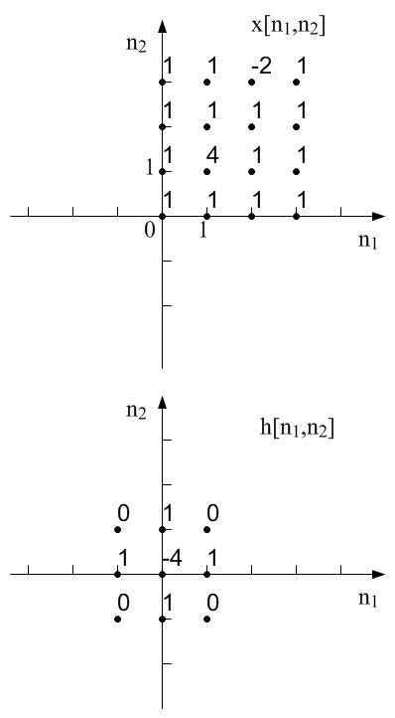

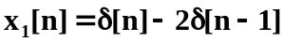1.2 Given:

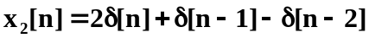

1) Compute the linear convolution y[n] = x₁[n] * x₂[n]

2) Compute 4-point DFT: X₁[k]=DFT{x₁[n]} and X₂[k]=DFT{x₂[n]}.

3) Compute 4-point DFT: Y[k]=DFT{y[n]}

4) Show that Y[k]=X₁[k]X₂[k]

1.3 Find the impulse response for the following 2-D signal representations.

1) H(z₁,z₂) = 1 - a₁ z₁⁻¹ - a₂ z₂⁻¹ - a₃ z₁⁻¹ z₂⁻¹ – a₄ z₁ z₂⁻¹,

2) H(ω₁,ω₂) = 1 - 2cos(ω₁) - 2cos(ω₂).

1.4 Consider the 2-D LSI system with impulse response h[n₁,n₂] and input x[n₁,n₂]. The 2-D DTFTs associated with these signals are H(ω₁,ω₂) and X(ω₁,ω₂) respectively. Let

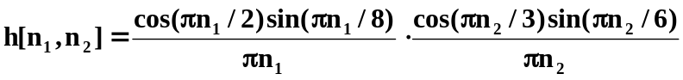

and

x[n₁,n₂] = e^{jπn1/2} e^{j5πn2/12}

1) Sketch X(ω₁,ω₂).

2) Sketch H(ω₁,ω₂)
3) Let y[n₁,n₂] = x[n,n] ** h[n,n], determine y[n₁,n₂].

