Stevens Institute of Technology
Department of Electrical and Computer Engineering

CpE 645 Image Processing

Homework 2:

2.1 Compute the 1D Inverse DFT of the Fourier coefficients for N=4
X[k]={10, -2+2j, -2, -2-2j}.

2.2 Assume an image block
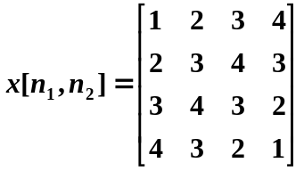
- Generate the transform matrix A for the 1-D 4-point DCT.
- Calculate the forward 2-D 4×4 DCT of the image block using this transform matrix, i.e. Y= AXA^{T}.

2.3 A gray scale image contains a sinusoidal pattern as shown below. The period of the sinusoid is 0.25 mm. Assume that the image is directly in front of the eye and focused on the retina, and that the eye is 20 mm in diameter with a focal point of 3 mm from the lens.

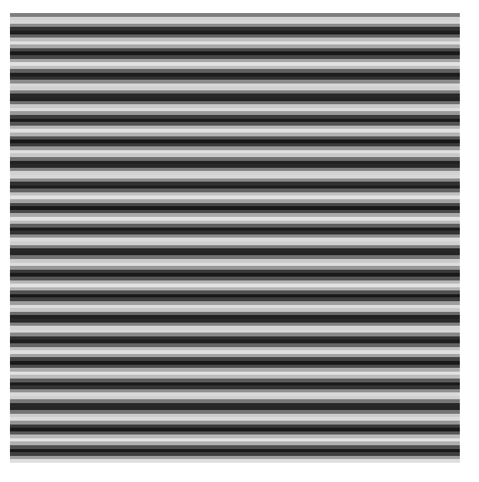

- When the image is viewed at a distance of 25cm away from the eye, what is the vertical spatial frequency of the projection on retina in units of cycles/degree?
- Determine an approximately optimal viewing distance for this image, i.e. the projection of the image has a spatial frequency between 3~10 cycles per degree on retina.

2.4 The chromaticity diagram (pp.33, lecture 3) is useful for color mixing because a straight-line segment joining any two points in the diagram defines all the different color variations that can be obtained by combining these two colors additively. Consider any two valid colors c₁ and c₂ with coordinates (x₁, y₁), and (x₂, y₂) in the chromaticity diagram. Derive the necessary general expression(s) for computing the relative percentages of color c₁ and c₂ composing a given color c that is known to lie on the straight line joining these two colors.

