Stevens Institute of Technology
Department of Electrical and Computer Engineering

CpE 645 Image Processing

Homework 3:

3.1 Let x[n₁,n₂] denote an image of 256x256 pixels. The histogram of x[n₁,n₂] is sketched below.

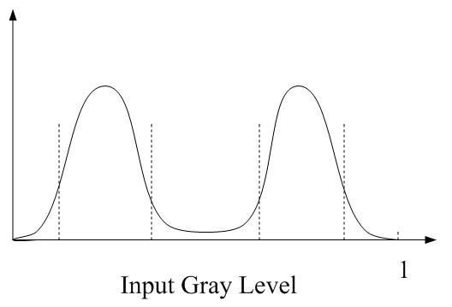

- What can we say about x[n₁,n₂] ?
- Roughly sketch a transformation function which is likely to improve the contrast of the image when it is used to modify the gray scale of the image.

3.2 Suppose that a digital image is subjected to histogram equalization. Show that a second pass of histogram equalization will produce exactly the same result as the first pass.

3.3 Repeated application of a 1-D median filter to a 1-D sequence eventually leads to what is called a root signal, which is invariant under further applications of the 1-D median filter. Consider the 1-D sequence x[n] shown below.

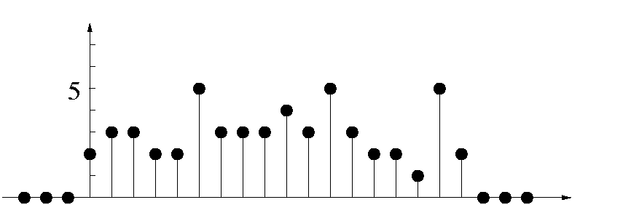

- Determine the root signal of x[n], using a 3-point median filter.
- Is it possible to recover x[n] from the root signal without additional information about x[n] ?
- A median filter without addition specification refers to a non-recursive median filter. It is possible to define a recursive median filter. Let y[n] denote the output of a recursive 3-point median filter. The output y[n] is given by
y[n]= Median(y[n-1],x[n],x[n+1]).

Determine the output y[n] when a recursive 3-point median filter is applied to x[n] above.
- Apply a 1-D recursive median filter to a 1-D sequence x[n] is known to result in the root signal of x[n] without repeated application of the filter. Are your results in 1) and 3) consistent with this?

3.4 Refer to the contraharmonic filter, explain

- why the filter is effective in eliminating pepper noise when Q is positive.
- why the filter is effective in eliminating salt noise when Q is negative.
- Discuss (for positive and negative Qs) the behavior of the filter in areas of constant gray levels.

