Difference Equation Representation
- The “weight and sum” with input samples is just a 2D convolution
- the “weight and sum” with output samples requires that values for all output samples inside the recursive window to be available
  - Recursively computable – recursive windows that satisfy this condition
    - depends on position of current output relating to the recursive window and the scanning order of the recursive window.
- The implementation of an LSI system can be interpreted as two sliding windows
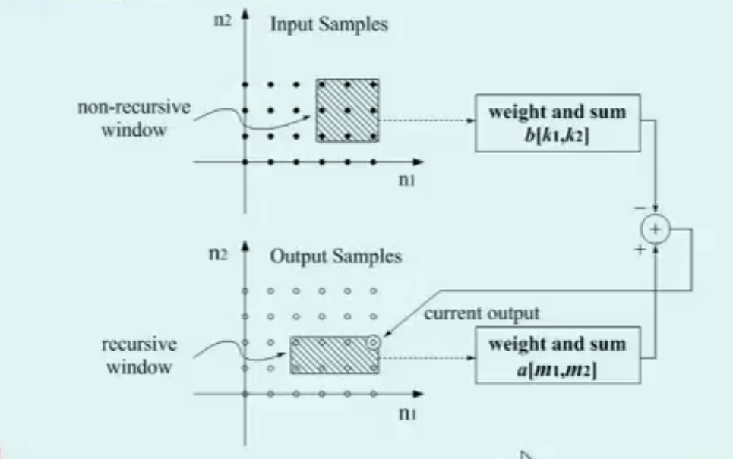

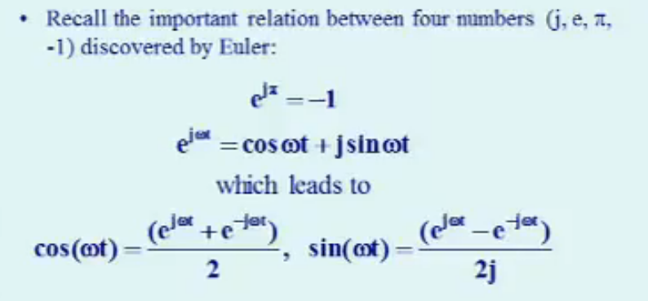
Frequency Response of 2D Systems [6:01]
- How to represent complex sinusoid (right)
  - ω = frequency
  - t = time
  - j = complex index
  - given one, you can easily derive the others

- Using 2D convolution to calculated frequency response
- H(ω1, ω2) is the system frequency response to the complex sinusoid signal, where ω1 is horizontal frequency and q2 is vertical frequency

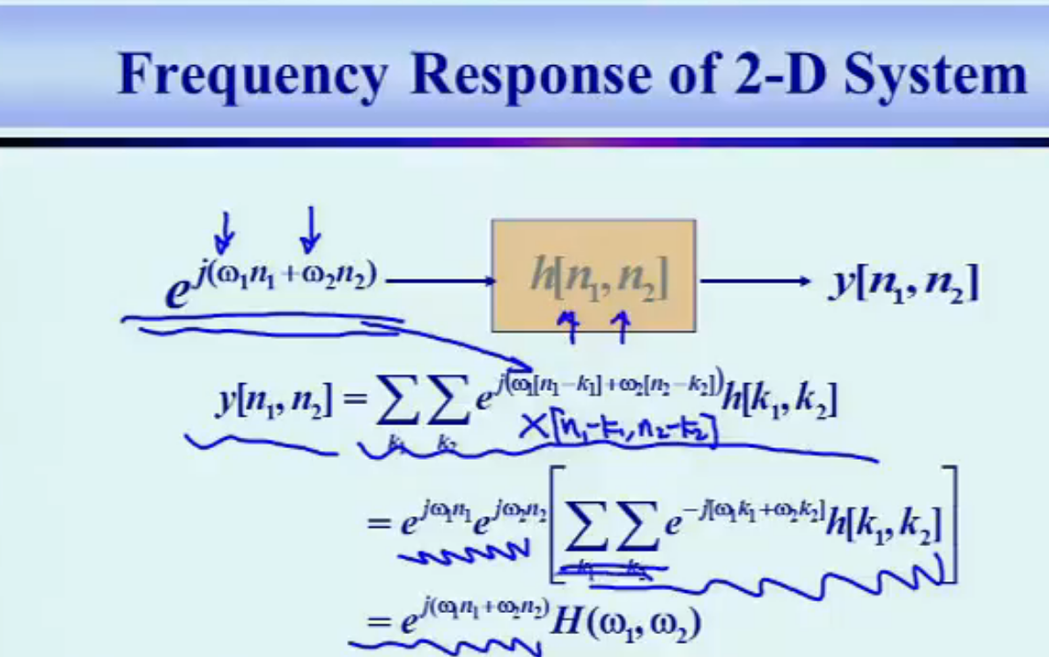

- For an LSI system, the response of a complex sinusoid is another complex sinusoid with the same frequency but modulated amplitude and phase
- an LSI system is able to discriminate among sinusoidal signals on the basis of their frequencies
- if |H(ω1, ω2)| → 1, the frequency component (ω1, ω2) passes.
- If |H(ω1,ω2)| → 0, the frequency component (ω1,ω2) stops.
2D Discrete Time Fourier Transform
- 2D DTFT exists whenever the sequence x[n1,n2] is absolutely summable – the frequency response of an LSI system exists only if the system is stable
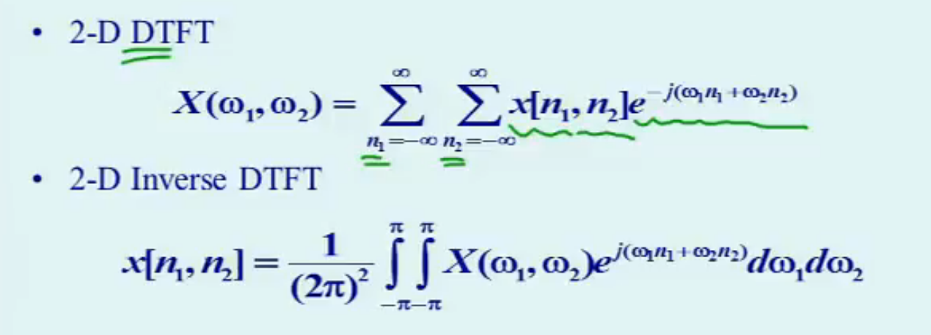

- The inverse is an integral (π) because ω1,ω2 are continuous variables.
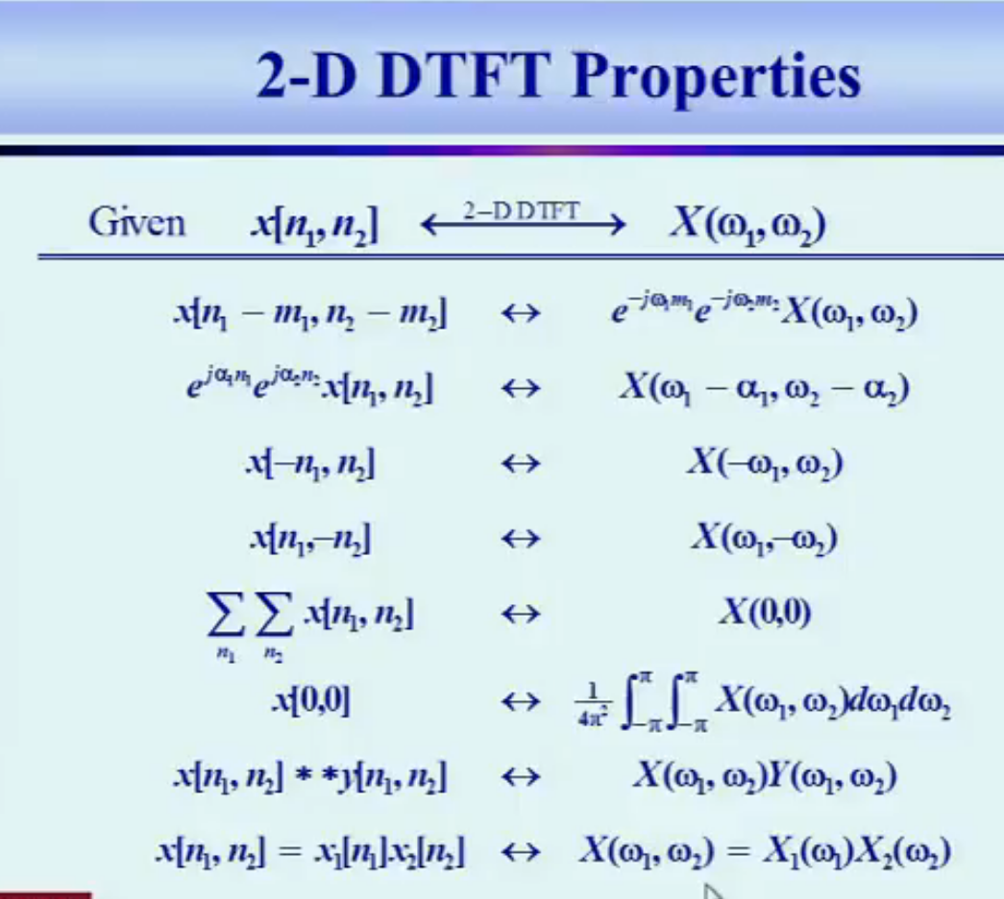

Z-Transform
- z-transform is a generalization of the discrete time Fourier transform in the sense that is used general complex exponential signal z^{-n} instead if complex sinusoid signal e^{jωn} as the basis function (eigenfunction)
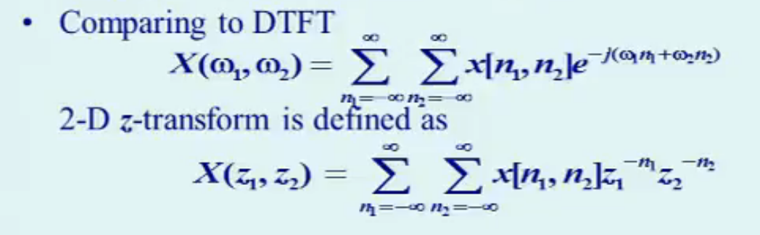
- the z-transform usually provides convenient notation for analytical study of discrete-time systems

- The range of values for which the summation does converge is called the region of convergence (ROC)
- For 2D signals of finite size, the z-transform exists for all z1 and z2 except possibly at (z1,z2)=0 or (z1,z2)→inf
- for 2D signals with quadrant support, if point (Z1,Z2) lies within the ROC, then all points (z1,z2) are in the ROC if |z1| >= |Z1| and |z2| >= |Z2|
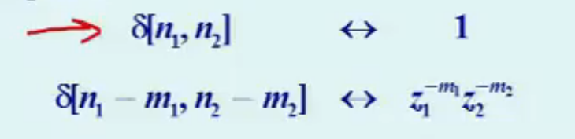

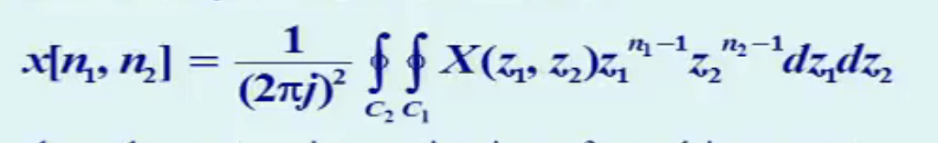
- The inverse z-transform is defined as:

- where the contour integration is performed in a counter-clockwise direction over a closed contour C1,C2 inside the ROC
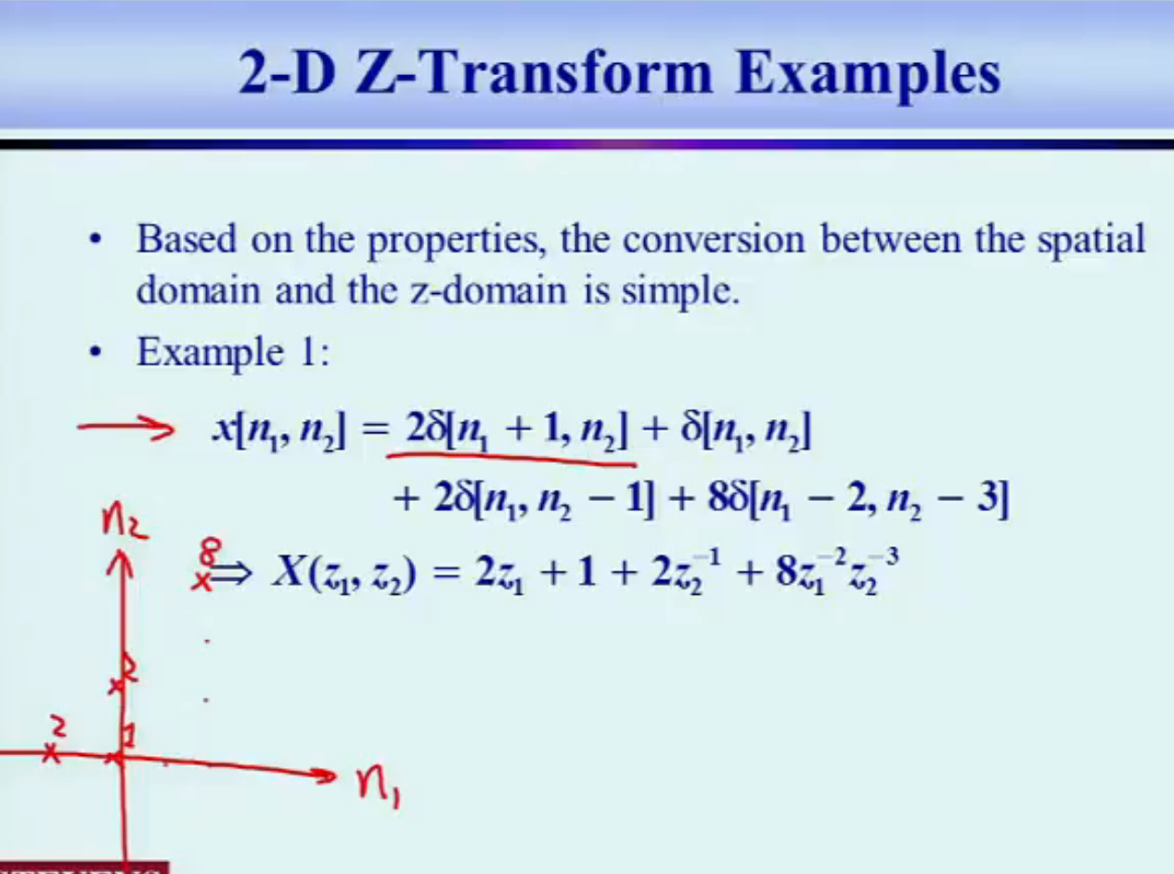
- A more practical approach to compute z-transform is to form a difference equation and use it to evaluate the system response to an impulse
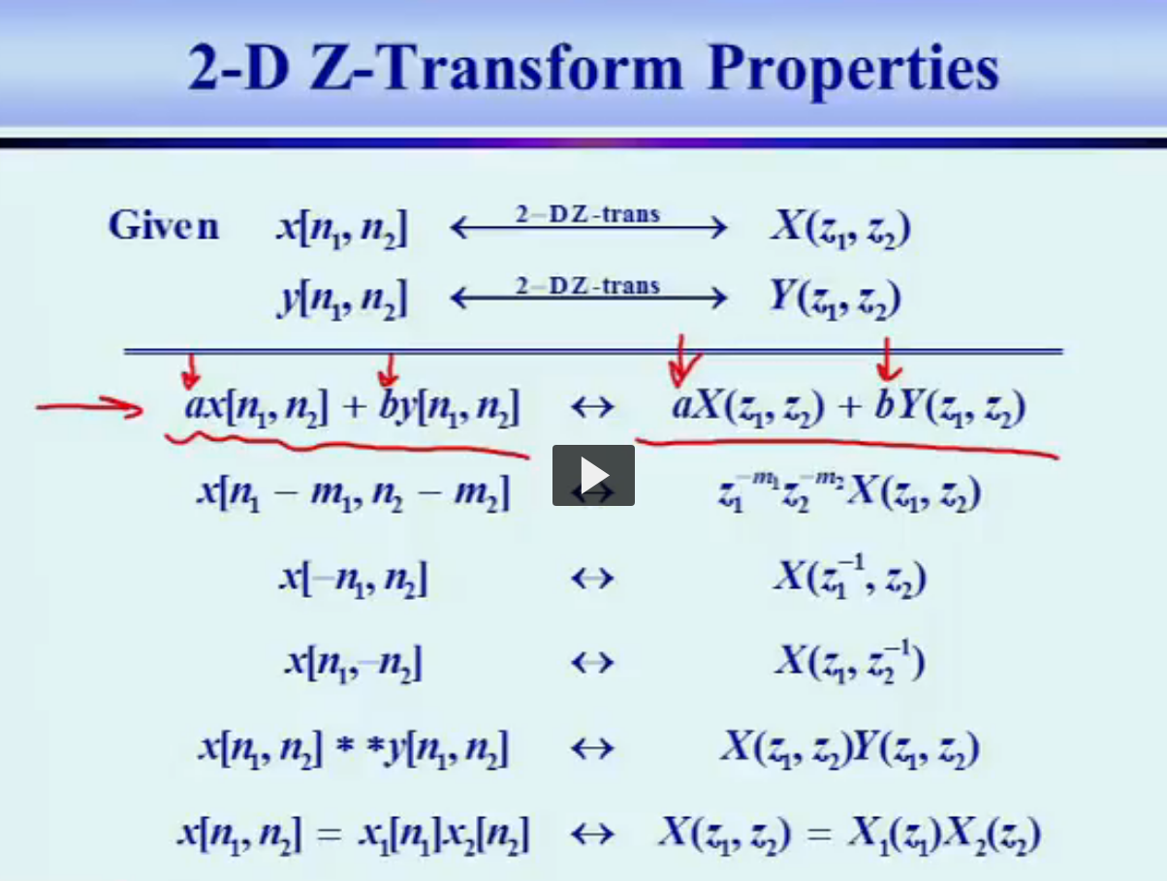

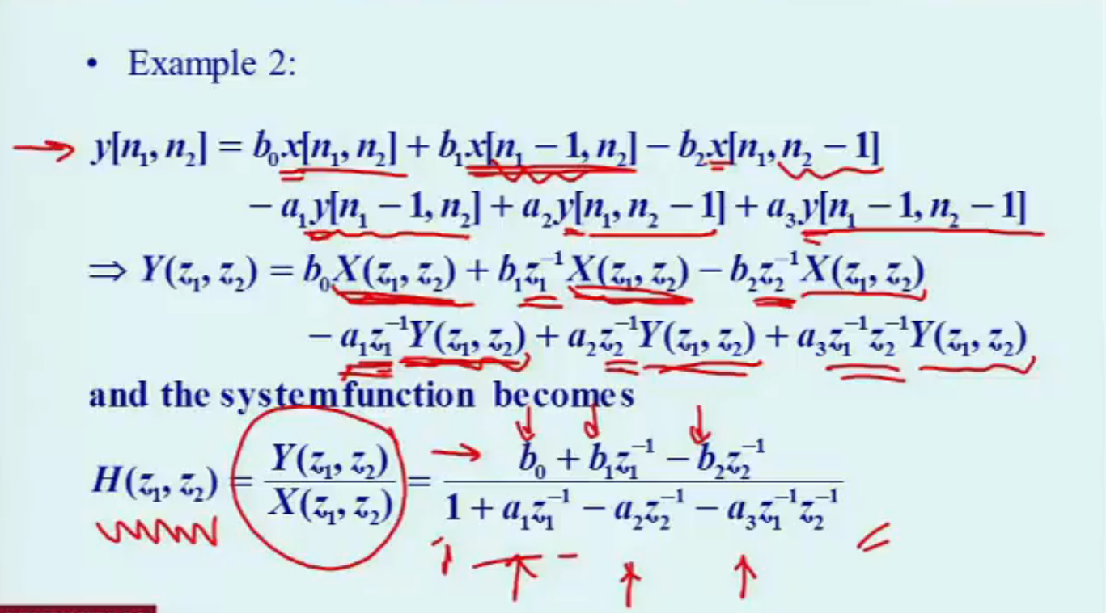

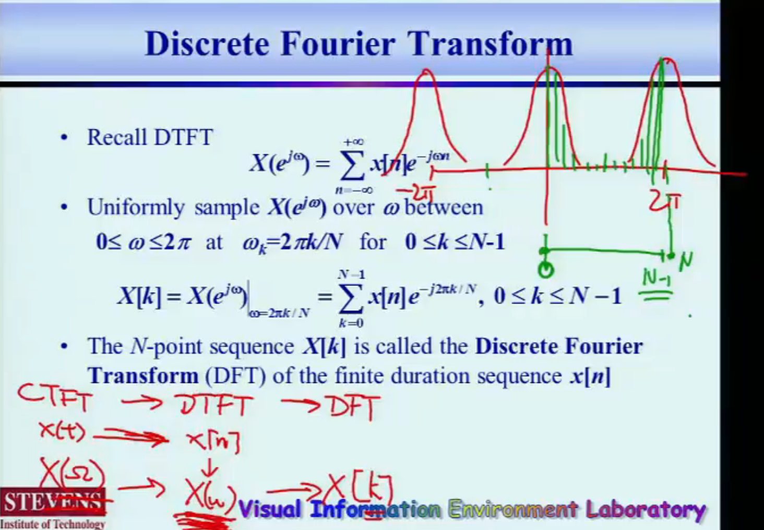
Discrete Fourier Transform

Example
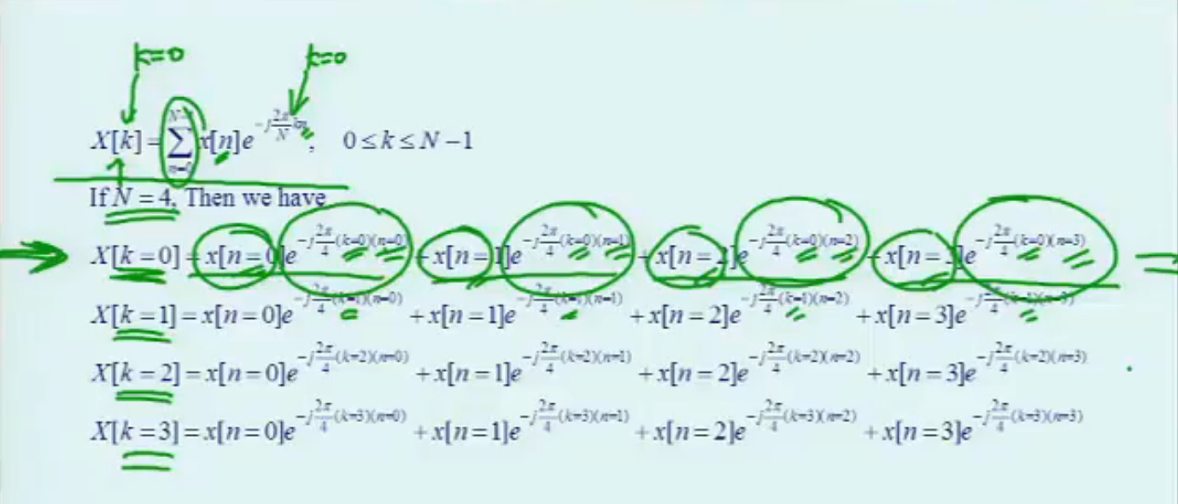

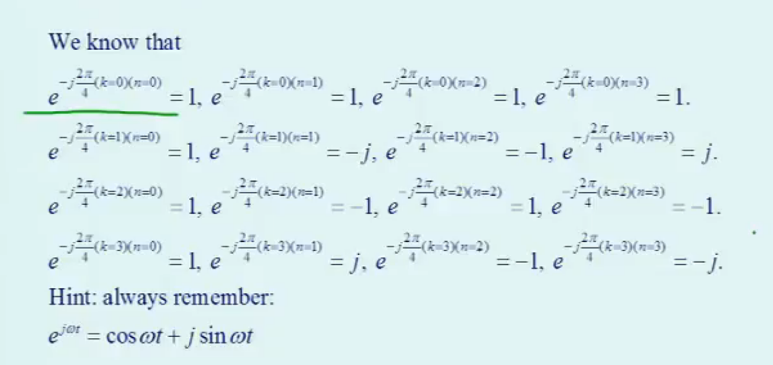

Circular Shift
- In DFT, a N-point sequence x[n] is defined in 0 <= n <=N-1, and all samples outside this range are considered to be zeros
- If x[n] is shifted in time, i.e. x[n]=x[n-n₀], the defined range is no longer 0 <=n<=N-1, and therefore we cannot take direct DFT of x₁[n]
- Circular Shift is defined as a shift which will produce a new sequence that is still the same range 0 <= n <= N-1.
- The traditional shift if called linear shift

