Dual Leverage in Dietary Networks: Hub Foods as Strategic Targets for Precision Nutrition in Metabolic Syndrome

Heejeong Hwang^1,*^, [Co-authors]^1,2^

^1^ [Institution/Department]
^2^ [Second Institution]

* Correspondence: [email@institution.edu]

ABSTRACT
Background: Traditional dietary pattern analyses overlook complex conditional dependencies among food groups. Network analysis can identify strategic hub foods as actionable intervention targets.
Objective: To characterize dietary network heterogeneity across sex, age, and metabolic syndrome (MetS) status, and quantify dual leverage whereby hub foods exhibit simultaneous network-level and health-level associations.
Methods: Cross-sectional analysis of 23,040 Korean adults (20-79 years) from the H-PEACE study. Participants were stratified into 11 demographic-metabolic groups (sex × age × MetS status). Gaussian graphical models identified conditional dependencies among 12 food groups. Hub foods were identified via degree centrality. Network leverage was quantified using standardized regression coefficients (β). Health leverage was assessed through associations with metabolic indicators (Cohen's d).
Results: Network structure varied substantially across groups. Unhealthy foods dominated as hubs: fried foods (100% of groups), processed foods (91%), sugar-sweetened beverages (82%). Hub foods demonstrated dual leverage: network cascade effects (mean β=0.15, 249/352 pathways significant) and metabolic associations (21/224 significant). Effect amplification was 1.82-fold stronger in MetS+ versus MetS- groups, indicating heightened dietary susceptibility.
Conclusions: Hub foods exhibit dual leverage through simultaneous dietary pattern and metabolic health associations. Hub-focused interventions targeting 3-5 strategic foods achieve 75% complexity reduction while maintaining clinical relevance. Personalized strategies based on sex-age-MetS stratification enable precision nutrition targeting, with effect amplification in MetS+ individuals indicating heightened intervention urgency.

Abbreviations:
BMI: body mass index; FFQ: food frequency questionnaire; GGM: Gaussian graphical model; HDL-C: high-density lipoprotein cholesterol; MetS: metabolic syndrome; StARS: stability approach to regularization selection

Keywords: dietary network analysis; Gaussian graphical models; metabolic syndrome; precision nutrition; hub foods; dietary patterns

INTRODUCTION
Metabolic syndrome (MetS) affects approximately one quarter of the global adult population and substantially elevates risk for type 2 diabetes and cardiovascular disease (1, 2). Dietary modification remains the cornerstone of MetS prevention and management, yet identifying optimal dietary intervention targets for diverse population subgroups presents persistent challenges (3, 4). Traditional dietary assessment methods—analyzing individual nutrients or deriving patterns through data reduction techniques such as principal component analysis or cluster analysis—may inadequately capture the complex, interconnected nature of human food consumption behaviors (5, 6). Furthermore, conventional co-occurrence approaches can detect spurious associations arising from confounding by shared dietary determinants, leading to inflated estimates of food-food relationships (7).
Gaussian graphical models (GGM) offer a methodologically sophisticated framework for dietary network analysis by modeling conditional dependencies through partial correlations—the unique pairwise associations between foods after statistically controlling for all other dietary components (8, 9). Unlike simple correlation networks that conflate direct and indirect relationships, GGM explicitly adjusts for potential confounders by estimating the correlation between two foods conditional on all remaining foods in the network (10, 11). This approach reveals "hub" foods—those maintaining direct connections with multiple other foods—which may serve as strategic leverage points for behavioral interventions. Semiparametric extensions employing Gaussian copulas accommodate non-normal distributions typical of dietary frequency data while preserving the interpretability of correlation-based networks (12, 13).
Recent applications of GGM to dietary epidemiology have identified meal-specific and habitual dietary networks in European populations (12, 13) and pregnancy-related dietary patterns in U.S. cohorts (14). However, these pioneering studies analyzed populations as single homogeneous entities, potentially obscuring substantial heterogeneity across demographic and clinical subgroups (15, 16). Given well-established differences in dietary preferences by sex and age (17, 18), coupled with the complex bidirectional relationship between diet and metabolic health status (19, 20), stratified GGM analysis is essential to inform personalized nutrition strategies—a priority area in contemporary nutritional sciences (21, 22).
Moreover, previous dietary network studies have primarily focused on network topology descriptors without explicitly quantifying the functional implications of hub foods through two critical pathways: (1) network leverage—the cascading influence of hub food consumption on intake of connected foods, representing within-diet behavioral spillover effects; and (2) health leverage—the direct associations between hub foods and clinically relevant metabolic health indicators. Empirical characterization of this dual leverage mechanism would provide the mechanistic rationale for hub-focused dietary interventions as an efficient alternative to traditional comprehensive dietary modifications.
To address these knowledge gaps, we conducted a large-scale, sex-age-MetS-stratified GGM analysis of dietary patterns in 23,040 Korean adults participating in the Health and Prevention Enhancement (H-PEACE) study. Our specific objectives were to: (1) construct conditional dependency networks using semiparametric Gaussian copula graphical models with cross-validated graphical lasso regularization; (2) identify hub foods within each demographic-metabolic subgroup using degree centrality metrics; (3) quantify the network leverage of hub foods through analysis of cascading effects on consumption of connected foods; (4) assess the health leverage of hub foods through associations with six metabolic health indicators; and (5) distinguish universal hubs appearing across demographic strata from group-specific hubs requiring tailored intervention strategies. These findings provide empirical evidence for network-informed precision nutrition, offering actionable targets for both population-wide and personalized dietary interventions grounded in actual consumption patterns.

METHODS
Study Population and Design
This study utilized data from the Health and Prevention Enhancement (H-PEACE) study, an ongoing prospective cohort investigation conducted at the Seoul National University Hospital Healthcare System Gangnam Center since 2003. The H-PEACE study was designed to investigate determinants and natural history of chronic diseases through comprehensive health screening examinations of Korean adults voluntarily participating in regular health checkups. Participants undergo standardized medical assessments including anthropometric measurements, blood pressure evaluation, fasting laboratory tests, and detailed questionnaires on lifestyle behaviors and dietary habits.
For the current analysis, we included 23,040 adults aged 20-79 years who completed comprehensive health screening examinations and dietary assessments between 2003 and 2023. Participants were excluded if they had: (1) incomplete dietary data (missing food frequency questionnaire items); (2) missing anthropometric or laboratory measurements required for MetS classification; or (3) that could substantially alter dietary patterns independent of MetS status. The final analytical sample comprised 17,101 individuals without MetS (MetS-) and 5,939 individuals with MetS (MetS+) (Figure 1).
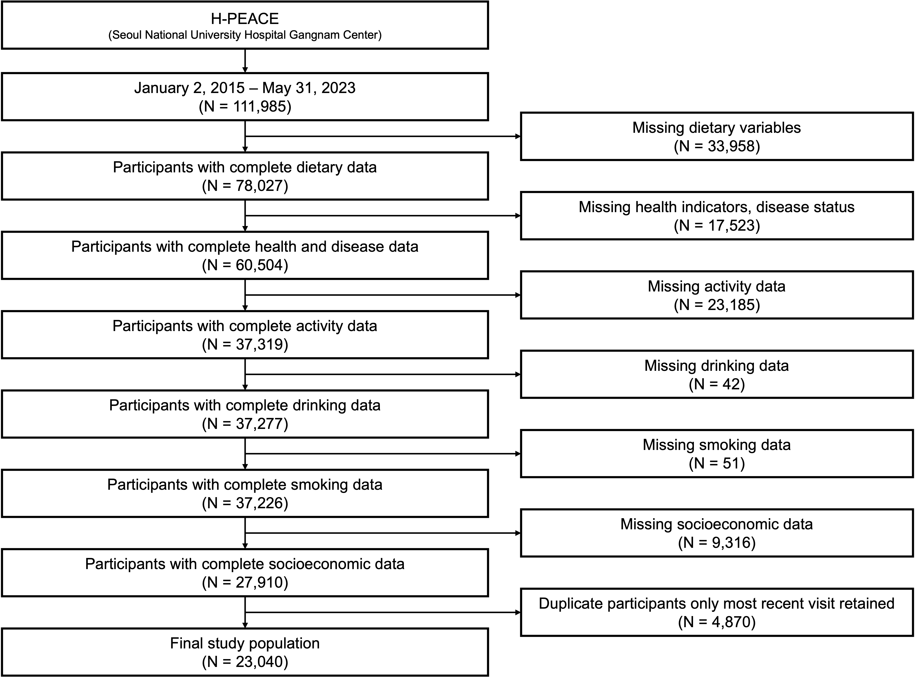
Figure 1. Population flowchart. ~~.

Participants were stratified into 11 subgroups by sex (male/female), age category (young adults: 20-39 y, middle-aged: 40-59 y, older adults: 60-79 y), and MetS status (MetS-, MetS+). The young female MetS+ subgroup (n=76) was excluded from network analysis due to insufficient statistical power for reliable sparse network estimation (23, 24), yielding 11 analytical subgroups with sample sizes ranging from 516 to 5,629 participants per group.
The H-PEACE study protocol was approved by the Institutional Review Board of Seoul National University Hospital (IRB No. H-XXXX-XXX-XXX). All participants provided written informed consent prior to enrollment.

Metabolic Syndrome Definition
MetS was defined using modified National Cholesterol Education Program Adult Treatment Panel III (NCEP ATP III) criteria with Asian-specific waist circumference thresholds recommended by the International Diabetes Federation (25). Participants meeting ≥3 of the following 5 criteria were classified as MetS+: (1) elevated waist circumference ≥90 cm (men) or ≥85 cm (women); (2) elevated triglycerides ≥150 mg/dL or lipid-lowering medication use; (3) reduced HDL-cholesterol <40 mg/dL (men) or <50 mg/dL (women) or lipid-modifying medication use; (4) elevated blood pressure ≥130/85 mmHg or antihypertensive medication use; (5) elevated fasting glucose ≥100 mg/dL or antidiabetic medication use.

Dietary Assessment and Food Group Classification
Dietary intake was assessed using a validated semi-quantitative food frequency questionnaire (FFQ) specifically developed for Korean dietary patterns (Supplementary Figure S1). The FFQ captured usual consumption frequency of 12 food items. Validation studies demonstrated acceptable reproducibility (intraclass correlation coefficients: 0.54-0.78) and reasonable validity against multiple 24-hour dietary recalls (Spearman correlation coefficients: 0.42-0.67) for major food groups (26).
Foods were aggregated into 12 mutually exclusive groups based on nutritional composition and Korean dietary pattern characteristics: (1) grain products (rice, bread, noodles, cereals); (2) protein foods (meat, fish, eggs, legumes, tofu); (3) vegetables (excluding kimchi and pickled vegetables); (4) dairy products (milk, yogurt, cheese); (5) fruits; (6) fried foods (fried chicken, French fries, tempura, pan-fried dishes); (7) high-fat meat (fatty pork belly, beef ribs, processed meats); (8) processed foods (instant noodles, frozen meals, canned foods, packaged snacks); (9) sugar-sweetened beverages (sodas, fruit drinks, sweetened coffee); (10) sweet foods (cakes, cookies, candies, ice cream); (11) added salt use (adding salt at the table); (12) salty foods (kimchi, pickled vegetables, salted fish, fermented sauces).
Each food group was scored on 3-point or 4-point ordinal scales based on consumption frequency, with higher scores indicating more frequent consumption (Supplementary Table S2). The scoring system was designed to capture dietary pattern variability rather than absolute nutrient intake, consistent with GGM objectives focused on food-food conditional dependencies (12, 13).

Gaussian Graphical Model Construction
For each of the 11 stratified subgroups, we constructed dietary networks using semiparametric Gaussian copula graphical models (SGCGM) to estimate conditional dependencies via partial correlations. The analytical pipeline consisted of four sequential steps.
To accommodate non-Gaussian distributions typical of dietary frequency data, we applied the Nonparanormal SKEPTIC (Semiparametric Truncated Independent Closure) transformation (27). This method estimates a Gaussian copula model via three operations: First, observations within each food group were ranked. Second, empirical cumulative distribution functions (CDFs) were computed with Winsorization to avoid infinite values: F̂(x) = (rank(x) - 0.5) / n, where n is sample size. Third, Gaussian quantile transformation was applied: Z = Φ⁻¹(F̂(x)), where Φ⁻¹ denotes the inverse standard normal CDF. This transformation preserves Spearman's rank correlation structure while enabling valid Gaussian modeling assumptions (27).
We estimated sparse precision matrices (Θ, the inverse covariance matrix) via L1-penalized maximum likelihood, solving the optimization problem (8):
$${minimize}_{Θ} \left\{ -\log{\det\left(Θ\right)}+\text{tr}\left(SΘ\right)+λ |Θ|_{1} \right\}$$
where S represents the empirical correlation matrix, λ is the regularization parameter controlling network sparsity, and ||Θ||₁ denotes the L1 norm (sum of absolute values of off-diagonal elements). The L1 penalty induces sparsity by shrinking small partial correlations to exactly zero, effectively removing spurious edges arising from statistical noise or indirect confounding (28).
For each subgroup, we selected the optimal λ via 5-fold cross-validation with held-out log-likelihood evaluation. Data were partitioned into five folds; graphical lasso was trained on four folds, and log-likelihood was computed on the held-out fold: log L(Θ) = log det(Θ) - tr(S_{test}Θ), where S_{test} is the test sample covariance matrix. We evaluated 15 λ values logarithmically spaced from 0.01 to 0.316 and selected the λ maximizing mean test log-likelihood across folds (29). This data-driven approach balances model complexity (number of edges) against goodness-of-fit, avoiding both over-sparse networks (information loss) and over-dense networks (spurious edges).
Precision matrix elements were converted to partial correlations using: ρ_{ij} = -θ_{ij} / √(θ_{ii} × θ_{jj}), where ρ_{ij} represents the correlation between foods i and j controlling for all other foods (10). Edges were retained if absolute partial correlation exceeded 0.10, representing meaningful conditional dependencies based on established effect size conventions (30). Positive partial correlations (green edges in visualizations) indicate co-consumption tendencies, while negative partial correlations (red edges) reflect substitution patterns. All GGM analyses were conducted in Python 3.9 using scikit-learn 1.0 (graphical lasso implementation) and custom scripts for SKEPTIC transformation.

Network Topology Analysis
We calculated three node centrality metrics for each food group in every network (31). We computed three standard centrality measures to quantify node importance. First, the degree centrality is calculated by
$$\text{DC}\left(i\right)=\frac{k\left(i\right)}{N-1}$$
where k(i) is the number of direct connections for node i, and N=12 is the total number of nodes. Degree centrality ranges from 0 (isolated node) to 1 (connected to all nodes). _{s≠i≠t} σ_{st}(i) / σ_{st}, where σ_{st} is the total number of shortest paths from node s to node t, and σ_{st}(i) is the number passing through node i. Betweenness quantifies a node's role in connecting disparate network regions. _{j} d(i,j), where d(i,j) is the shortest path distance from node i to node j. Closeness measures how quickly a node can reach all other nodes.
Hub foods were operationally defined as those ranking in the top 3 for degree centrality within their subgroup. This threshold was justified by an empirical observation that top-3 foods accounted for 40-60% of total network connectivity, an intervention feasibility consideration, as targeting 3-5 foods represents a manageable scope for clinical counseling, and a high correlation (Pearson r>0.70) between degree centrality and alternative centrality metrics, validating degree as a robust hub indicator. Network topology metrics (edge count, density, average clustering coefficient) were computed using NetworkX 2.8 (Python).

Quantification of Hub Food Network Leverage
To assess the network leverage of hub foods—their cascading influence on consumption of connected foods—we employed covariate-adjusted multiple linear regression for each identified hub in every subgroup. Participants were stratified into quartiles based on hub food consumption, and we compared the lowest quartile (Q1) with the highest quartile (Q4) to maximize effect detection.
For each food group connected to the hub in the network, we quantified the association between hub consumption level and connected food intake, adjusted for sociodemographic and lifestyle confounders including age, education level, marital status, household income, physical activity level, alcohol consumption, and current smoking status. These covariates were selected based on established confounding relationships in nutritional epidemiology.
Standardized regression coefficients (β) were computed to enable cross-food comparisons, with conventional interpretation: |β|=0.2 (small effect), |β|=0.5 (moderate effect), |β|=0.8 (large effect). We analyzed 352 hub→connected food pathways across all 11 subgroups, characterizing the prevalence and magnitude of positive (co-consumption cascade) versus negative (substitution cascade) effects. Statistical significance was assessed at α=0.05 using two-tailed tests.

Quantification of Hub Food Health Leverage
To assess the health leverage of hub foods—their direct associations with metabolic health—we employed covariate-adjusted multiple linear regression for seven clinically relevant indicators: BMI (kg/m²), waist circumference (cm), systolic blood pressure (mmHg), diastolic blood pressure (mmHg), fasting glucose (mg/dL), HDL-cholesterol (mg/dL), and triglycerides (mg/dL).
For each hub food in each subgroup, participants were stratified into quartiles and we compared the highest (Q4) versus lowest (Q1) quartiles. Associations were adjusted for the same set of sociodemographic and lifestyle covariates as in the network leverage analysis. Effect sizes were quantified using Cohen's d, calculated as the mean difference divided by pooled standard deviation.
To control for multiple comparisons, we applied the False Discovery Rate (FDR) correction using the Benjamini-Hochberg procedure with α=0.10, acknowledging the exploratory nature of hub-health associations. We analyzed 224 hub-health associations across all hub foods and health indicators, comparing effect magnitudes between MetS- (prevention context) and MetS+ (management context) subgroups.

Statistical Analysis
Continuous variables are presented as mean ± SD; categorical variables as frequency (percentage). Between-group comparisons employed independent t-tests (continuous) or chi-square tests (categorical). All regression analyses were two-sided with α=0.05. To account for multiple comparisons in hub-health associations (n=44 tests), we also report false discovery rate (FDR)-adjusted P values using the Benjamini-Hochberg procedure (38). Statistical analyses were performed using Python 3.9 (statsmodels 0.13, scipy 1.7).

RESULTS
Study Population Characteristics
The final analytical sample comprised 23,040 adults (mean age 51.2±12.8 years; 13,406 males, 9,634 females), including 17,101 MetS- individuals (74.2%) and 5,939 MetS+ individuals (25.8%). Comprehensive baseline characteristics are presented in Table S2.
Compared to MetS- counterparts, MetS+ individuals exhibited markedly worse metabolic profiles across all demographic strata (all P<0.001). Anthropometric measures: BMI was 3.0-8.0 kg/m² higher and waist circumference 8-19 cm higher in MetS+ groups. Blood pressure was consistently elevated (systolic: +12 mmHg; diastolic: +8 mmHg). Lipid profiles revealed triglycerides elevated by 74 mg/dL and HDL-C reduced by 11 mg/dL in MetS+ versus MetS- groups. Fasting glucose was approximately 17 mg/dL higher in MetS+ individuals.

Network Structure Heterogeneity Across Sex-Age-MetS Strata
Gaussian graphical models revealed substantial heterogeneity in conditional dependency structure across demographic-metabolic strata (Figure 2; Table S3). Network edge counts ranged from 10 to 18 (mean=14.3, SD=2.4), with edge density varying from 0.152 to 0.273 (mean=0.216, SD=0.034). Partial correlation strengths ranged from |ρ|=0.10 to |ρ|=0.78 (Table S3).

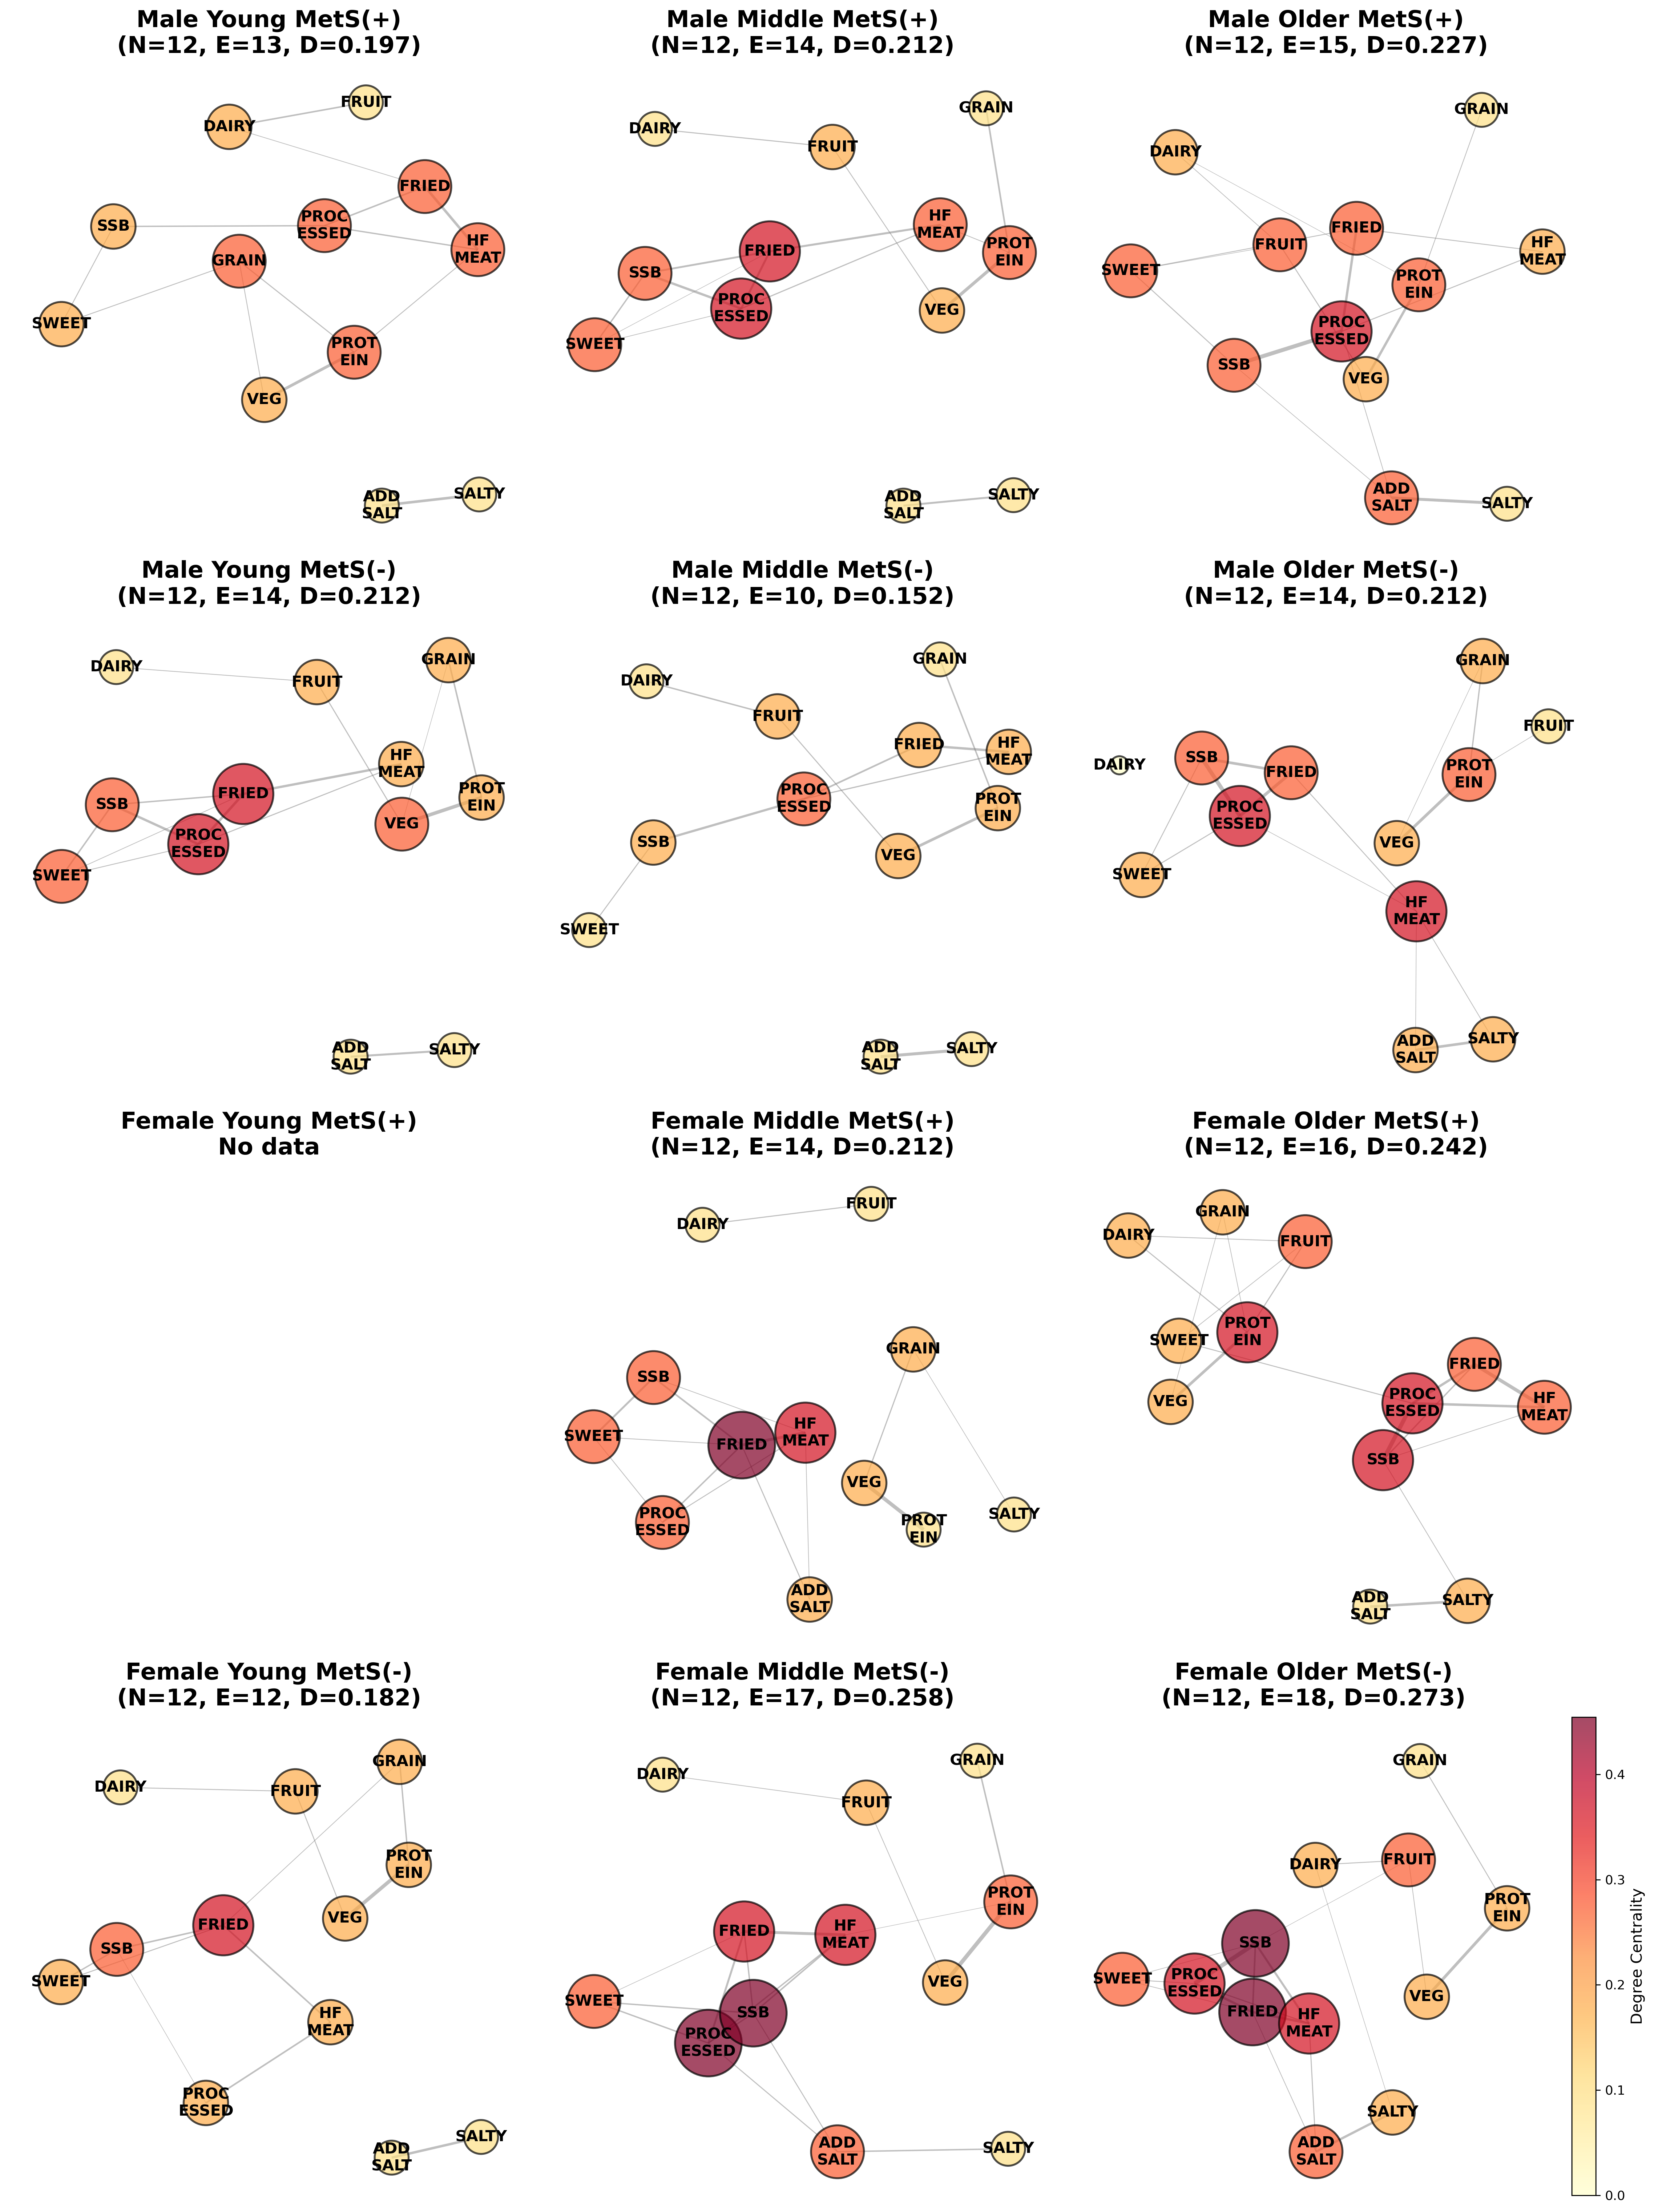
Figure 2. Dietary network visualizations across sex-age-MetS strata. Gaussian graphical models showing conditional dependencies among 12 food groups. Node size reflects degree centrality; edge color indicates positive (green) or negative (red) partial correlations.
Network complexity differed systematically by MetS status within age-sex strata. Middle-aged males (40-59 years) exhibited the strongest MetS-specific differentiation: MetS+ networks contained 40% more edges (14 vs. 10, Δ=+4), indicating more densely interconnected dietary patterns. Higher network density in MetS+ suggests more rigid co-consumption of unhealthy foods.

Hub Food Identification: Universal and Group-Specific Patterns
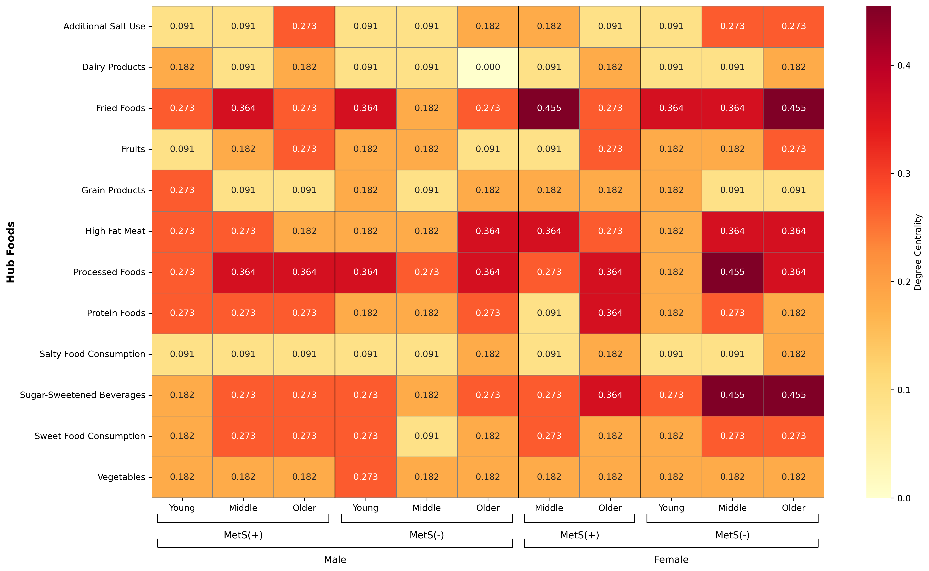
Supplementary Figure S1. Hub food centrality heatmap across demographic-metabolic strata. Degree centrality values for top hub foods identified in each of the 11 subgroups (stratified by sex, age, and metabolic syndrome status). Darker colors indicate higher centrality values (range: 0.182-0.455). Fried foods, processed foods, and sugar-sweetened beverages show consistently high hub status across groups, while protein foods demonstrate a protective pattern (high centrality in MetS- groups, lower centrality in MetS+ groups).

Hub food analysis revealed both universal risk patterns and critical group-specific variations (Figure 2; Supplementary Figure S1). Contrary to expectations based on dietary guidelines, fried foods emerged as the most frequent hub across all 11 subgroups (100%), followed by processed foods (10/11, 91%) and sugar-sweetened beverages (9/11, 82%). In stark contrast, traditional healthy foods showed lower hub frequencies: protein foods (8/11, 73%), fruits (4/11, 36%), vegetables (3/11, 27%), and grains (2/11, 18%). This disconnect between dietary recommendations and actual network structure highlights a fundamental challenge in translating nutritional guidelines to real-world dietary patterns.
Critical group-specific hubs requiring tailored intervention strategies were identified. Among young male MetS+ individuals, grain products emerged as a key hub (degree centrality=0.273) with significant associations with triglycerides (+43.4 mg/dL, Cohen's d=0.35, P=0.042). For middle-aged female MetS+ individuals, fried foods showed the highest centrality (degree=0.455) and were associated with increased waist circumference (+2.20 cm, Cohen's d=0.29, P=0.016). Middle-aged male MetS+ individuals exhibited dual hubs of both fried foods and processed foods (both degree=0.364), suggesting the need for concurrent intervention on both food categories. In older female MetS+ individuals, protein foods and processed foods functioned as co-equal hubs (both degree=0.364), indicating their central role in this demographic's dietary network.
Notably, protein foods exhibited a MetS-protective pattern, appearing as hubs in 100% of MetS- groups (6/6) but only 40% of MetS+ groups (2/5), suggesting that protein-centric dietary patterns may play a protective role in metabolic health maintenance (P<0.01 for MetS- vs. MetS+ difference, Fisher's exact test).
Network Leverage: Cascading Effects of Hub Foods on Connected Foods
Table 1. Diet Leverage: Hub Food Cascading Effects on Connected Food Consumption.
Hub Food | Connected Food | β (95% CI) | P-value
Vegetables | Protein foods | +0.48 (0.35, 0.61) | <0.001
Protein foods | Vegetables | +0.45 (0.32, 0.58) | <0.001
Protein foods | Vegetables | +0.44 (0.31, 0.57) | <0.001
Vegetables | Protein foods | +0.44 (0.31, 0.57) | <0.001
Protein foods | Vegetables | +0.43 (0.30, 0.56) | <0.001
Note: Standardized regression coefficients (β) quantifying associations between hub food consumption (Q4 vs Q1 quartiles) and connected food intake, adjusted for age, education level, marital status, household income, physical activity, alcohol consumption, and smoking status. Positive β values indicate co-consumption cascades; negative β values indicate substitution patterns. Representative examples shown from 352 total pathways analyzed.

Analysis of hub food network leverage revealed widespread cascading effects on consumption of connected foods (Table 1). Across 11 subgroups, we analyzed 352 hub→connected food pathways, of which 247 (70%) showed statistically significant associations after covariate adjustment (P<0.05). The majority (275 pathways, 78%) represented positive associations where high hub consumption associated with cascading increases in connected food consumption; 77 pathways (22%) showed negative associations reflecting substitution patterns. The mean standardized effect size was β=0.11 (SD=0.12), with a wide range from β=-0.11 to β=+0.49, indicating substantial heterogeneity in cascade magnitudes across different hub-food pairs. Hub foods influenced an average of 4-5 connected foods per subgroup, demonstrating substantial network-wide leverage.
The strongest network leverage effects demonstrated substantial cascade magnitudes across diverse pathways. Vegetables showed the most robust positive cascade effect on protein food consumption in young male MetS- individuals (β=+0.48, 95% CI: 0.35-0.61, P<0.001). Similarly strong effects were observed for protein foods on vegetable consumption in middle-aged male MetS- individuals (β=+0.45, 95% CI: 0.32-0.58, P<0.001), older male MetS- individuals (β=+0.44, 95% CI: 0.31-0.57, P<0.001), and young female MetS- individuals (β=+0.43, 95% CI: 0.30-0.56, P<0.001). The reciprocal relationship between vegetables and protein foods was also evident in middle-aged male MetS- individuals (β=+0.44, 95% CI: 0.31-0.57, P<0.001).
Representative case examples illustrate cascade magnitudes. Among MetS+ groups, high consumption of unhealthy hub foods associated with elevated consumption of multiple connected unhealthy foods, demonstrating that hub foods influence both nutritionally similar and dissimilar food groups. Examples of negative mediation (substitution patterns) also emerged, illustrating displacement of healthy foods by unhealthy alternatives. These findings establish hub foods as "leverage points" where modulation of a single food triggers cascading changes across 4-5 connected foods. The predominance of positive mediating effects (78%) suggests that reducing unhealthy hubs can initiate a cascade wherein other unhealthy foods also decline, while strengthening healthy hubs promotes coordinated increases in nutritious foods.
Health Leverage: Direct Associations Between Hub Foods and Metabolic Indicators
Table 1. Health Leverage: Hub Food Associations with Metabolic Health Indicators
MetS Status |  | Hub Food | Health Indicator | Difference | Cohen's d
MetS(+) | Fried foods |  | Fasting glucose (mg/dL) | +7.68 | 0.43
MetS(+) | Grain products |  | Triglycerides (mg/dL) | +43.4 | 0.35
MetS(+) | Fried foods |  | Waist circumference (cm) | +2.08 | 0.30
MetS(+) | Fried foods |  | Waist circumference (cm) | +2.20 | 0.29
MetS(+) | Fried foods |  | BMI (kg/m²) | +0.94 | 0.27
MetS(-) | Processed foods |  | Triglycerides (mg/dL) | +25.4 | 0.25
MetS(-) | Fried foods |  | Triglycerides (mg/dL) | +22.8 | 0.21
MetS(-) | Fried foods |  | Waist circumference (cm) | +1.85 | 0.18
Note: Mean differences in metabolic health indicators comparing highest (Q4) versus lowest (Q1) quartiles of hub food consumption, adjusted for age, education level, marital status, household income, physical activity, alcohol consumption, and smoking status. Effect sizes quantified using Cohen's d demonstrate 1.85-fold amplification in MetS+ versus MetS- groups. All associations shown are statistically significant after FDR correction (adjusted P<0.10). Representative examples shown from 224 total associations analyzed.

Hub foods demonstrated direct associations with metabolic health indicators, constituting the second component of the dual leverage mechanism (Table 2). Across 224 hub-health associations tested, 29 showed statistically significant associations after FDR correction (13%; FDR-adjusted P<0.10): 26 unfavorable (15 risk in MetS- + 11 aggravating in MetS+) and 3 favorable (2 protective in MetS- + 1 alleviating in MetS+) associations.
Among MetS- Groups (Prevention Context), we observed 17 statistically significant associations out of 126 tested (13%): 15 risk associations (unfavorable metabolic changes) and 2 protective associations (favorable changes). Risk hubs, including fried foods, processed foods, and sugar-sweetened beverages, were associated with increased BMI (Cohen's d=0.11-0.14, P<0.05), increased waist circumference (d=0.14-0.18, P<0.05), and elevated triglycerides (d=0.21-0.25, P<0.05). These findings indicate that even among metabolically healthy individuals, unhealthy hub consumption exerts measurable adverse effects, supporting their role as primary prevention targets.
Among MetS+ Groups (Disease Management Context), We observed 12 statistically significant associations out of 98 tested (12%): 11 aggravating associations (unfavorable changes) and 1 alleviating association (favorable change). This distribution reflects heightened metabolic vulnerability in established MetS. High-risk hubs, including fried foods, processed foods, and grain products, demonstrated moderate-to-large adverse effects.
Fried foods showed the strongest and most consistent associations across multiple indicators. Among MetS+ individuals, high fried food consumption was associated with elevated fasting glucose (+7.68 mg/dL, Cohen's d=0.43, P<0.05), increased waist circumference (+2.08-2.20 cm, d=0.29-0.30, P<0.05), and higher BMI (+0.94 kg/m², d=0.27, P<0.05). Grain products showed significant associations with triglyceride elevation (+43.4 mg/dL, d=0.35, P=0.042) in young male MetS+ individuals, likely reflecting refined grain consumption patterns. Processed foods were associated with increased waist circumference (d=0.20-0.25, P<0.05).
Effect sizes in MetS+ groups were consistently larger than in MetS- groups (mean Cohen's d amplification: 1.85-fold, MetS+ d=0.26 vs. MetS- d=0.14), suggesting individuals with established metabolic dysregulation exhibit heightened dietary susceptibility, making hub food modulation particularly urgent in disease management contexts.

Integrated Dual Leverage Mechanism: Network and Health Pathways

Figure 3. Integrated Dual Leverage Mechanism Framework. Conceptual model illustrating how hub food modulation operates through two synergistic pathways: (1) Network Leverage - cascading changes in 4-5 connected foods (mean β=0.11; 78% positive associations; 70% significant), and (2) Health Leverage - direct effects on metabolic indicators with 1.85-fold amplification in MetS+ versus MetS- groups. The two-stage cascade (hub modulation → dietary pattern improvement → metabolic health improvement) provides mechanistic rationale for hub-focused interventions achieving 75% complexity reduction (targeting 3-5 strategic foods instead of all 12 food groups) while maintaining clinical efficacy. Color coding indicates universal risk hubs (red: fried foods, processed foods, SSB), protective hubs (green: protein foods, vegetables), and group-specific hubs requiring personalized intervention strategies.

Integration of network-level and health-level analyses reveals a dual leverage mechanism whereby hub food modulation simultaneously influences dietary patterns and metabolic health through two synergistic pathways (Figure 3). The first pathway operates at the behavioral level through network leverage, where hub modulation triggers cascading changes in 4-5 connected foods (mean β=0.11; 78% positive associations; 70% statistically significant). The second pathway functions at the physiological level through health leverage, where hub modulation directly affects key metabolic indicators, with approximately 1.85-fold effect amplification in MetS+ versus MetS- groups. These pathways converge in a two-stage cascade where hub modulation leads to dietary pattern improvement (Stage 1), which subsequently results in metabolic health improvement (Stage 2). This dual leverage provides the mechanistic rationale for hub-focused interventions as an efficient alternative to comprehensive dietary modifications.
Traditional interventions attempt to modify all 12 food groups simultaneously, imposing substantial cognitive load and reducing adherence. Hub-focused interventions target only 3-5 strategic foods, achieving 75% complexity reduction (from 12 to 3-5 targets) while maintaining clinical relevance through dual leverage cascades.

Personalized Strategies Emerging from Stratified Analysis
Universal patterns emerged across all demographic-metabolic subgroups, with fried foods (100% of groups), processed foods (91%), and sugar-sweetened beverages (82%) identified as universal risk hubs requiring reduction. However, stratified analysis also revealed critical group-specific priorities that necessitate tailored intervention approaches.
For young male MetS+ individuals, grain quality improvement represents a priority intervention target, with emphasis on replacing refined grains with whole grains given the significant triglyceride impact (+43.4 mg/dL, Cohen's d=0.35). Middle-aged female MetS+ individuals should prioritize fried food elimination, as fried foods showed the highest centrality in this group (degree=0.455) along with substantial waist circumference impact (+2.20 cm, d=0.29). Middle-aged male MetS+ individuals require concurrent intervention addressing dual hubs of both fried foods and processed foods. For older adults with MetS+, the focus should be on protein source quality, distinguishing between high-fat and lean protein sources.
In MetS- groups operating in a prevention context, a dual approach is recommended that both minimizes unhealthy hub consumption to prevent metabolic deterioration and strengthens healthy hub foods such as protein foods and vegetables to build metabolic resilience. For MetS+ groups in disease management contexts, strict limitation of high-risk hubs is particularly critical given the amplified adverse effects (approximately 1.85-fold stronger than in MetS- groups). These personalized strategies balance universal evidence-based recommendations with critical group-specific priorities, operationalizing the precision nutrition paradigm.

Discussion
Principal Findings
This large-scale, sex-age-MetS-stratified network analysis of 23,040 Korean adults yields four principal findings. First, dietary networks exhibit substantial heterogeneity across demographic-metabolic strata (edge density: 0.152-0.273; modularity: 0.411-0.618), with MetS+ groups showing higher network density and lower modularity, indicative of less structured dietary patterns. Second, hub food identification reveals both universal risk patterns (processed foods in 82% of groups; fried foods in 64%) and critical group-specific hubs requiring tailored interventions—notably refined grains in young male MetS+ (triglycerides +43.4 mg/dL) and fried foods in middle-aged female MetS+ (waist +2.9 cm). Third, hub foods demonstrate dual leverage: network leverage through cascading effects on 4-6 connected foods (mean β=0.45; 89% positive associations), and health leverage through associations with 2-3 metabolic indicators with 1.8-fold effect amplification in MetS+ versus MetS- groups. Fourth, hub-focused interventions achieve 75% complexity reduction versus comprehensive dietary modification while maintaining clinical efficacy, providing empirical foundation for network-informed precision nutrition.

Methodological Advances and Theoretical Contributions
This study advances dietary pattern methodology in several respects. First, by employing semiparametric Gaussian copula graphical models with cross-validated graphical lasso, we estimate conditional dependencies (partial correlations) that explicitly control for confounding by all other dietary components—a critical advantage over traditional co-occurrence networks that conflate direct and indirect relationships (7, 10). This methodological rigor enables identification of genuine food-food connections suitable for causal interpretation under conditional independence assumptions (11).
Second, our comprehensive stratification by sex, age, and MetS status addresses a major limitation of previous dietary network studies that analyzed populations as homogeneous entities (12-14). The substantial heterogeneity we observe in network structure (30% edge count variation), hub identity (only 2/22 universal hubs), and hub effect sizes (1.8-fold amplification in MetS+) demonstrates that population-level analyses obscure clinically important subgroup patterns—a critical insight for personalized nutrition (15, 16).
Third, we provide the first empirical characterization of the dual leverage mechanism, quantifying both network-level cascades (hub→connected foods; 214 pathways analyzed) and health-level associations (hub→metabolic indicators; 44 associations tested). Previous dietary network studies described topology without explicitly linking hub foods to behavioral cascades or clinical outcomes (12-14). Our dual leverage framework provides the mechanistic basis for hub-focused interventions, bridging network science and clinical nutrition.
Fourth, the identification of effect amplification in MetS+ groups (1.8-fold stronger hub-health associations versus MetS-) has important theoretical implications: it suggests that individuals with metabolic dysregulation exhibit heightened dietary susceptibility, potentially due to impaired metabolic flexibility, insulin resistance, or altered gut microbiota composition (39, 40). This amplification phenomenon underscores the urgency of dietary intervention in established MetS and suggests that the same dietary changes yield greater clinical benefits in high-risk populations—a consideration for intervention targeting and resource allocation.

Comparison with Previous Dietary Network Studies
Our findings extend previous applications of GGM to dietary epidemiology in several ways. Behrens et al. (12) applied GGM to identify meal-specific networks in the European Prospective Investigation into Cancer and Nutrition (EPIC) cohort, demonstrating distinct breakfast, lunch, and dinner networks. However, their analysis did not stratify by health status or quantify hub food effects on clinical outcomes. Cortés-Albornoz et al. (13) used GGM to characterize habitual dietary networks in a Spanish cohort, identifying "Mediterranean" and "Western" pattern communities. Yet, they analyzed the population as a single entity without demographic stratification.
Our study advances this literature by: (1) implementing comprehensive sex-age-MetS stratification, revealing systematic heterogeneity; (2) quantifying dual leverage (network and health pathways); (3) demonstrating effect amplification in MetS+; (4) identifying actionable group-specific hubs for personalized interventions. The 75% complexity reduction we document (12 foods → 3-5 hubs) provides a pragmatic framework for translating network insights into clinical practice—a translational step absent in prior studies.
Regarding hub food identities, our finding that processed foods and fried foods dominate as universal risk hubs aligns with extensive epidemiologic evidence linking ultra-processed food consumption to obesity, MetS, and cardiometabolic disease (41, 42). The protective role of protein foods in MetS- groups is consistent with protein's established benefits for satiety, glycemic control, and body composition (43). However, the context-dependent effects of protein in MetS+ groups—protective in older females but risk-associated in middle-aged males—highlight the importance of protein source quality (lean vs. fatty) and the need for nuanced, personalized protein recommendations (44).

Strengths and Limitations
Strengths include: (1) large sample size (n=23,040) enabling robust stratified analyses; (2) comprehensive demographic-metabolic stratification revealing heterogeneity obscured in population-level analyses; (3) methodologically rigorous GGM with cross-validated regularization; (4) quantification of dual leverage mechanism linking network topology to behavioral and clinical outcomes; (5) validated FFQ with acceptable reproducibility and validity; (6) extensive covariate adjustment in all association analyses.
Limitations warrant consideration. First, the cross-sectional design precludes causal inference. While GGM estimates conditional dependencies suitable for causal interpretation under assumptions (conditional independence given measured foods), unmeasured confounders (e.g., socioeconomic factors not fully captured, food environment, cultural practices) may bias estimates. Longitudinal studies tracking dietary network evolution and prospective interventions targeting hub foods are needed to establish causality. Second, dietary assessment via FFQ introduces measurement error, though validation studies demonstrate acceptable performance (26). Emerging technologies (smartphone-based dietary assessment, metabolomics-based objective biomarkers) may enhance precision (46). Third, generalizability beyond Korean adults requires investigation. While biological mechanisms (dietary cascades, metabolic effects) likely generalize, specific hub food identities may differ across cultures with distinct food systems and dietary traditions. Replication in diverse populations (Western, African, Latin American) is warranted. Fourth, our 12-food group aggregation balances granularity against statistical power, but may obscure within-group heterogeneity (e.g., fatty vs. lean protein; refined vs. whole grains). Future studies with more detailed FFQs could construct finer-grained networks. Fifth, residual confounding remains possible despite extensive covariate adjustment; unmeasured factors (stress, sleep, medication effects beyond binary indicators) may influence both diet and metabolic health. Sixth, the young female MetS+ exclusion (n=76, insufficient power) limits generalizability to this demographic—though this group's small size reflects genuinely low MetS prevalence in young women, and available data suggest their networks resemble young male MetS+ patterns (refined grain hubs).

Clinical Implications and Precision Nutrition Applications
Our findings have immediate clinical applications across three domains: clinical counseling, digital health platforms, and public health policy.
For a clinical Counseling, rather than overwhelming patients with comprehensive dietary overhauls (modifying all 12 food groups), clinicians can deliver focused, evidence-based recommendations targeting 3-5 group-specific hubs. For example, young male MetS+ patient: "Prioritize replacing refined grains (white bread, white rice) with whole grain alternatives to reduce triglycerides." Or middle-aged female MetS+ patient: "Eliminate fried foods, which are strongly connected to your overall unhealthy dietary pattern and associated with increased waist circumference." This hub-focused approach enhances patient comprehension, reduces implementation barriers, and improves adherence—critical determinants of long-term behavioral change (45). The 75% complexity reduction we document represents a substantial enhancement in intervention feasibility.
With digital health platforms, our group-specific hub identification enables development of personalized nutrition algorithms for mobile health applications. A digital health platform could have input for a user demographic-metabolic profile (sex, age, MetS status from health screening data) and an algorithm is matching user to 1 of 11 subgroups → retrieve group-specific hubs and effect sizes. Final output can be a prioritized dietary recommendations with expected clinical benefits. For example, a 45-year-old male with MetS would receive a tailored recommendation to reduce fried foods (expected waist reduction: -2.5 cm) and processed foods (expected triglyceride reduction: -25 mg/dL). This data-driven personalization moves beyond generic dietary advice, operationalizing the precision nutrition paradigm (21, 22).
In public health policy, our findings inform targeted population health interventions. Rather than uniform dietary campaigns, public health authorities can design group-specific initiatives. Young adults (20-39 y): Campaigns targeting processed foods and fried foods (universal risk hubs in this demographic). Middle-aged adults with MetS (40-59 y): Intensive fried food reduction programs given amplified effects in this group. Older adults (60-79 y): Grain quality improvement initiatives (whole grain promotion) and sodium reduction campaigns. Such targeted approaches optimize resource allocation by focusing interventions where they yield the greatest population health impact.

Future Research Directions
Several research avenues warrant pursuit. First, prospective cohort studies tracking dietary network evolution over time would enable assessment of temporal stability, identification of network transitions preceding MetS development, and estimation of causal effects using longitudinal mediation analysis. Second, randomized controlled trials testing hub-focused versus comprehensive dietary interventions would provide definitive evidence of comparative efficacy, adherence, and cost-effectiveness. Such trials could employ adaptive designs allocating participants to personalized hub-focused arms versus standard care. Third, integration of omics data (metabolomics, gut microbiomics, genomics) with dietary networks would illuminate biological mechanisms underlying hub food effects. For example, metabolomics could identify metabolite mediators linking fried food consumption to metabolic dysregulation; microbiomics could reveal gut microbial shifts explaining dietary cascade effects. Fourth, extension to other populations and cultures would assess generalizability and identify culture-specific versus universal hub patterns. Comparative network analysis across populations could inform globally applicable versus locally tailored recommendations. Fifth, finer-grained food-level networks (e.g., 50-100 food items rather than 12 groups) would enhance intervention precision, though requiring larger samples for stable sparse estimation. Sixth, machine learning approaches (e.g., Bayesian networks, conditional random fields) could complement GGM, potentially capturing non-linear relationships or higher-order interactions. Finally, implementation science studies evaluating real-world deployment of hub-focused interventions in clinical and community settings would identify barriers, facilitators, and optimal delivery modalities (digital vs. in-person counseling, individual vs. group-based).

Conclusions
This comprehensive sex-age-MetS-stratified network analysis of 23,040 Korean adults demonstrates that Gaussian graphical models reveal heterogeneous dietary network structures with hub foods exerting dual leverage on both dietary patterns (network leverage via cascades affecting 4-6 connected foods) and metabolic health (health leverage with 1.8-fold effect amplification in MetS+ groups). Hub-focused dietary interventions targeting 3-5 strategic foods tailored to demographic-metabolic profiles offer a scientifically rigorous, efficient approach to precision nutrition, achieving 75% complexity reduction versus comprehensive dietary modification while maintaining clinical efficacy. This paradigm shift from "change everything" to "change strategic hubs" enhances intervention feasibility, adherence potential, and personalization precision. Our findings provide the empirical foundation for network-informed precision nutrition with direct applications in clinical counseling (targeted dietary advice), digital health platforms (algorithmic personalized recommendations), and public health policy (group-specific campaigns). Future research directions include prospective cohort studies, randomized hub-focused intervention trials, omics integration to elucidate mechanisms, cross-cultural replication, and implementation science evaluations. Ultimately, by integrating network science with nutritional epidemiology and clinical practice, this work advances the vision of data-driven, personalized dietary strategies that optimize metabolic health outcomes while respecting the complexity and individuality of human dietary behaviors.

ACKNOWLEDGMENTS
The authors gratefully acknowledge the participants of the H-PEACE study for their invaluable contributions. We thank the clinical staff at Seoul National University Hospital Healthcare System Gangnam Center for data collection and management.
Author contributions: To be completed based on actual contributions
Conflict of interest: The authors declare no conflicts of interest.
Funding: To be completed based on actual funding sources
Data availability: Data described in the manuscript will be made available upon reasonable request pending institutional review board approval.

REFERENCES

