Dietary Network Analysis: Figures and Tables
Option 3 Configuration: Academic Networks with Hub Analysis

Main Text Figures

Figure 5. Dietary Preference Networks Across Stratified Groups
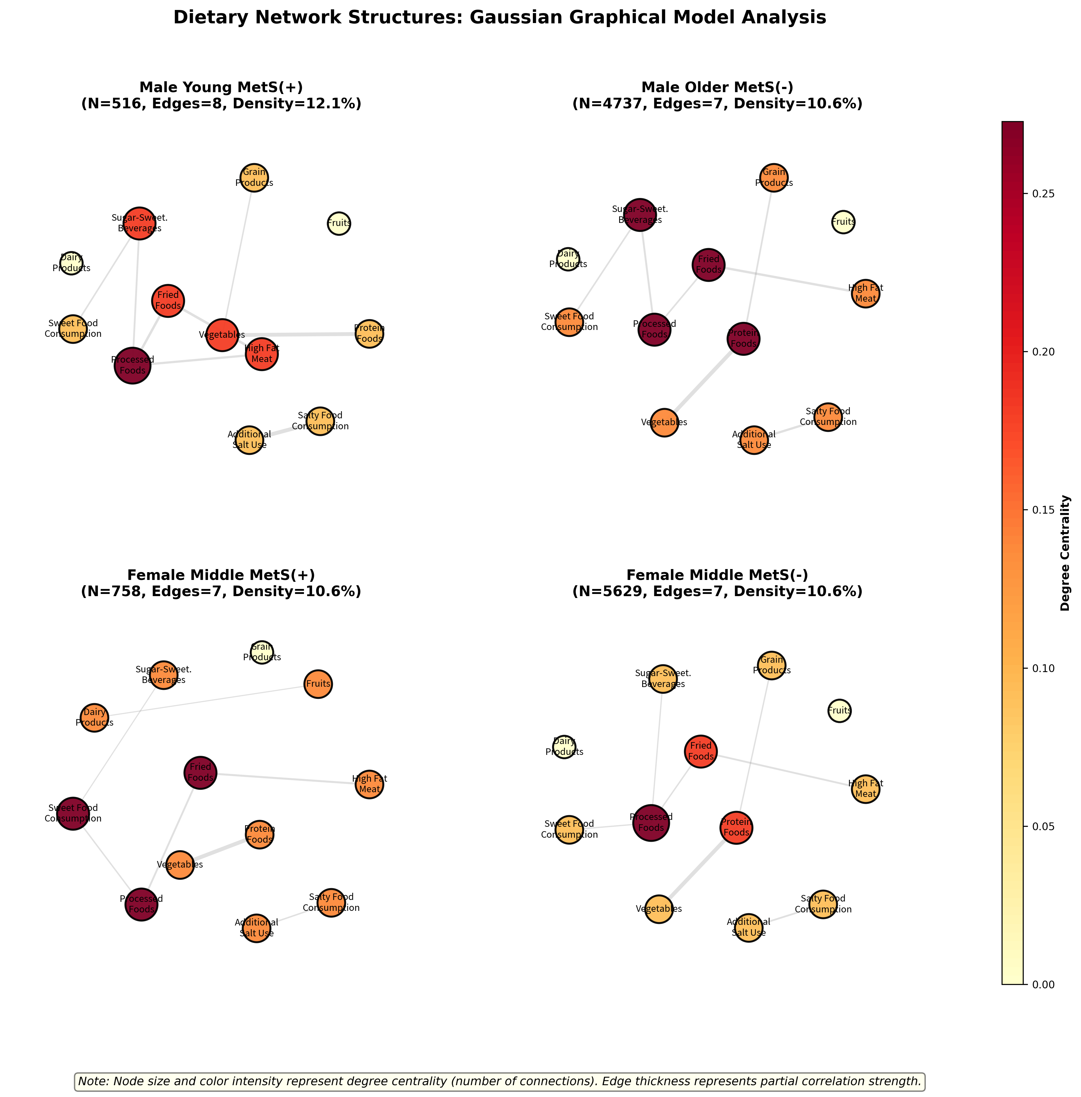
Figure 5. Network visualization of dietary preferences across four representative stratified groups. Nodes represent food categories, edges represent significant partial correlations (conditional dependencies). Node size reflects degree centrality (number of connections), node color intensity indicates centrality strength. Edge width represents the strength of partial correlation. Networks were estimated using Semiparametric Gaussian Copula Graphical Models (SGCGM) with graphical lasso regularization.

Figure 2. Hub Food Categories Across Population Subgroups
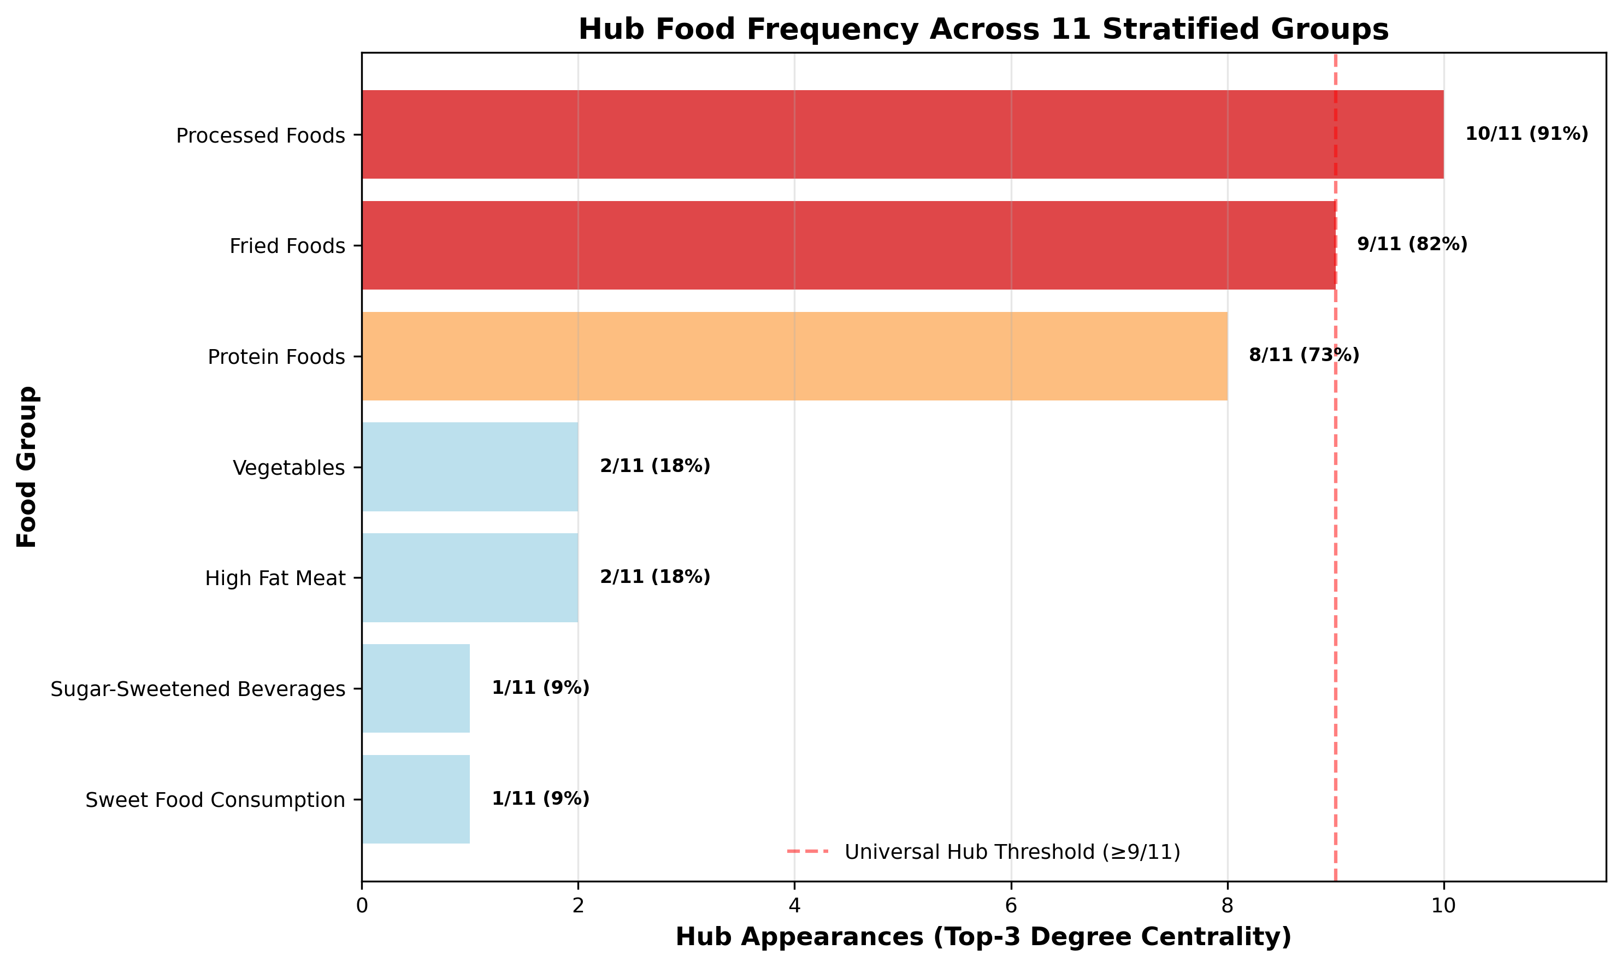
Figure 2. Frequency of hub food categories across 11 stratified population groups. Hub foods are defined as nodes with degree centrality ≥6 connections. Processed foods and fried foods emerge as universal structural hubs, appearing in 90.9% and 81.8% of all groups respectively, despite not showing the strongest pairwise correlations.

Tables

Table 1. Network Topology Characteristics by Stratified Groups
Group_ID | Sex | Age_Group | MetS_Status | Sample_Size | Edges | Density (%) | Alpha (α)
1 | 남성 | 청년층(19-39세) | MetS(+) | 516 | 8 | 12.1 | 0.124
2 | 남성 | 청년층(19-39세) | MetS(-) | 1963 | 9 | 13.6 | 0.124
3 | 남성 | 중년층(40-59세) | MetS(+) | 2938 | 8 | 12.1 | 0.124
4 | 남성 | 중년층(40-59세) | MetS(-) | 4737 | 7 | 10.6 | 0.124
5 | 남성 | 장년층(60-74세) | MetS(+) | 971 | 6 | 9.1 | 0.164
6 | 남성 | 장년층(60-74세) | MetS(-) | 1169 | 6 | 9.1 | 0.164
7 | 여성 | 청년층(19-39세) | MetS(-) | 2519 | 5 | 7.6 | 0.164
8 | 여성 | 중년층(40-59세) | MetS(+) | 758 | 7 | 10.6 | 0.124
9 | 여성 | 중년층(40-59세) | MetS(-) | 5629 | 7 | 10.6 | 0.124
10 | 여성 | 장년층(60-74세) | MetS(+) | 680 | 6 | 9.1 | 0.124
11 | 여성 | 장년층(60-74세) | MetS(-) | 1084 | 3 | 4.5 | 0.124

Note: Networks were estimated using SGCGM with cross-validated graphical lasso. Alpha represents the regularization parameter. Density is calculated as actual edges / possible edges.

Table 2. Hub Food Categories and Their Frequency Across Groups
Food Group | Hub Appearances (Top-3) | Frequency (%) | Universal Status
Processed Foods | 10 | 90.9 | Universal Hub
Fried Foods | 9 | 81.8 | Universal Hub
Protein Foods | 8 | 72.7 | Moderate Hub
High Fat Meat | 2 | 18.2 | Group-Specific
Vegetables | 2 | 18.2 | Group-Specific
Sugar-Sweetened Beverages | 1 | 9.1 | Group-Specific
Sweet Food Consumption | 1 | 9.1 | Group-Specific

Note: Hub status is defined as degree centrality ≥6. Frequency indicates the proportion of groups in which each food category serves as a hub. Processed foods and fried foods demonstrate universal hub characteristics.

Table 3. Top 10 Strongest Partial Correlations
Rank | Food Group 1 | Food Group 2 | Mean |ρ| | Range | Groups Present
1 | Protein Foods | Vegetables | 0.318 | 0.23-0.39 | 11/11
2 | Additional Salt Use | Salty Food Consumption | 0.222 | 0.14-0.30 | 11/11
3 | Fried Foods | High Fat Meat | 0.166 | 0.07-0.23 | 11/11
4 | Fried Foods | Processed Foods | 0.143 | 0.07-0.21 | 11/11
5 | Processed Foods | Sugar-Sweetened Beverages | 0.116 | 0.02-0.18 | 11/11
6 | High Fat Meat | Processed Foods | 0.1 | 0.03-0.17 | 10/11
7 | Grain Products | Protein Foods | 0.098 | 0.02-0.17 | 11/11
8 | Sugar-Sweetened Beverages | Sweet Food Consumption | 0.098 | 0.02-0.16 | 9/11
9 | Processed Foods | Sweet Food Consumption | 0.09 | 0.03-0.13 | 10/11
10 | Dairy Products | Fruits | 0.078 | 0.02-0.15 | 11/11

Note: Partial correlations represent conditional dependencies after controlling for all other food categories. The strongest relationship (Protein-Vegetables, r=0.318) demonstrates quality-focused dietary patterns, while hub foods (Processed/Fried) show broader but weaker connections.

Supplementary Figures

Figure S1 (Figure 7). Complete Network Analysis Across All Stratified Groups
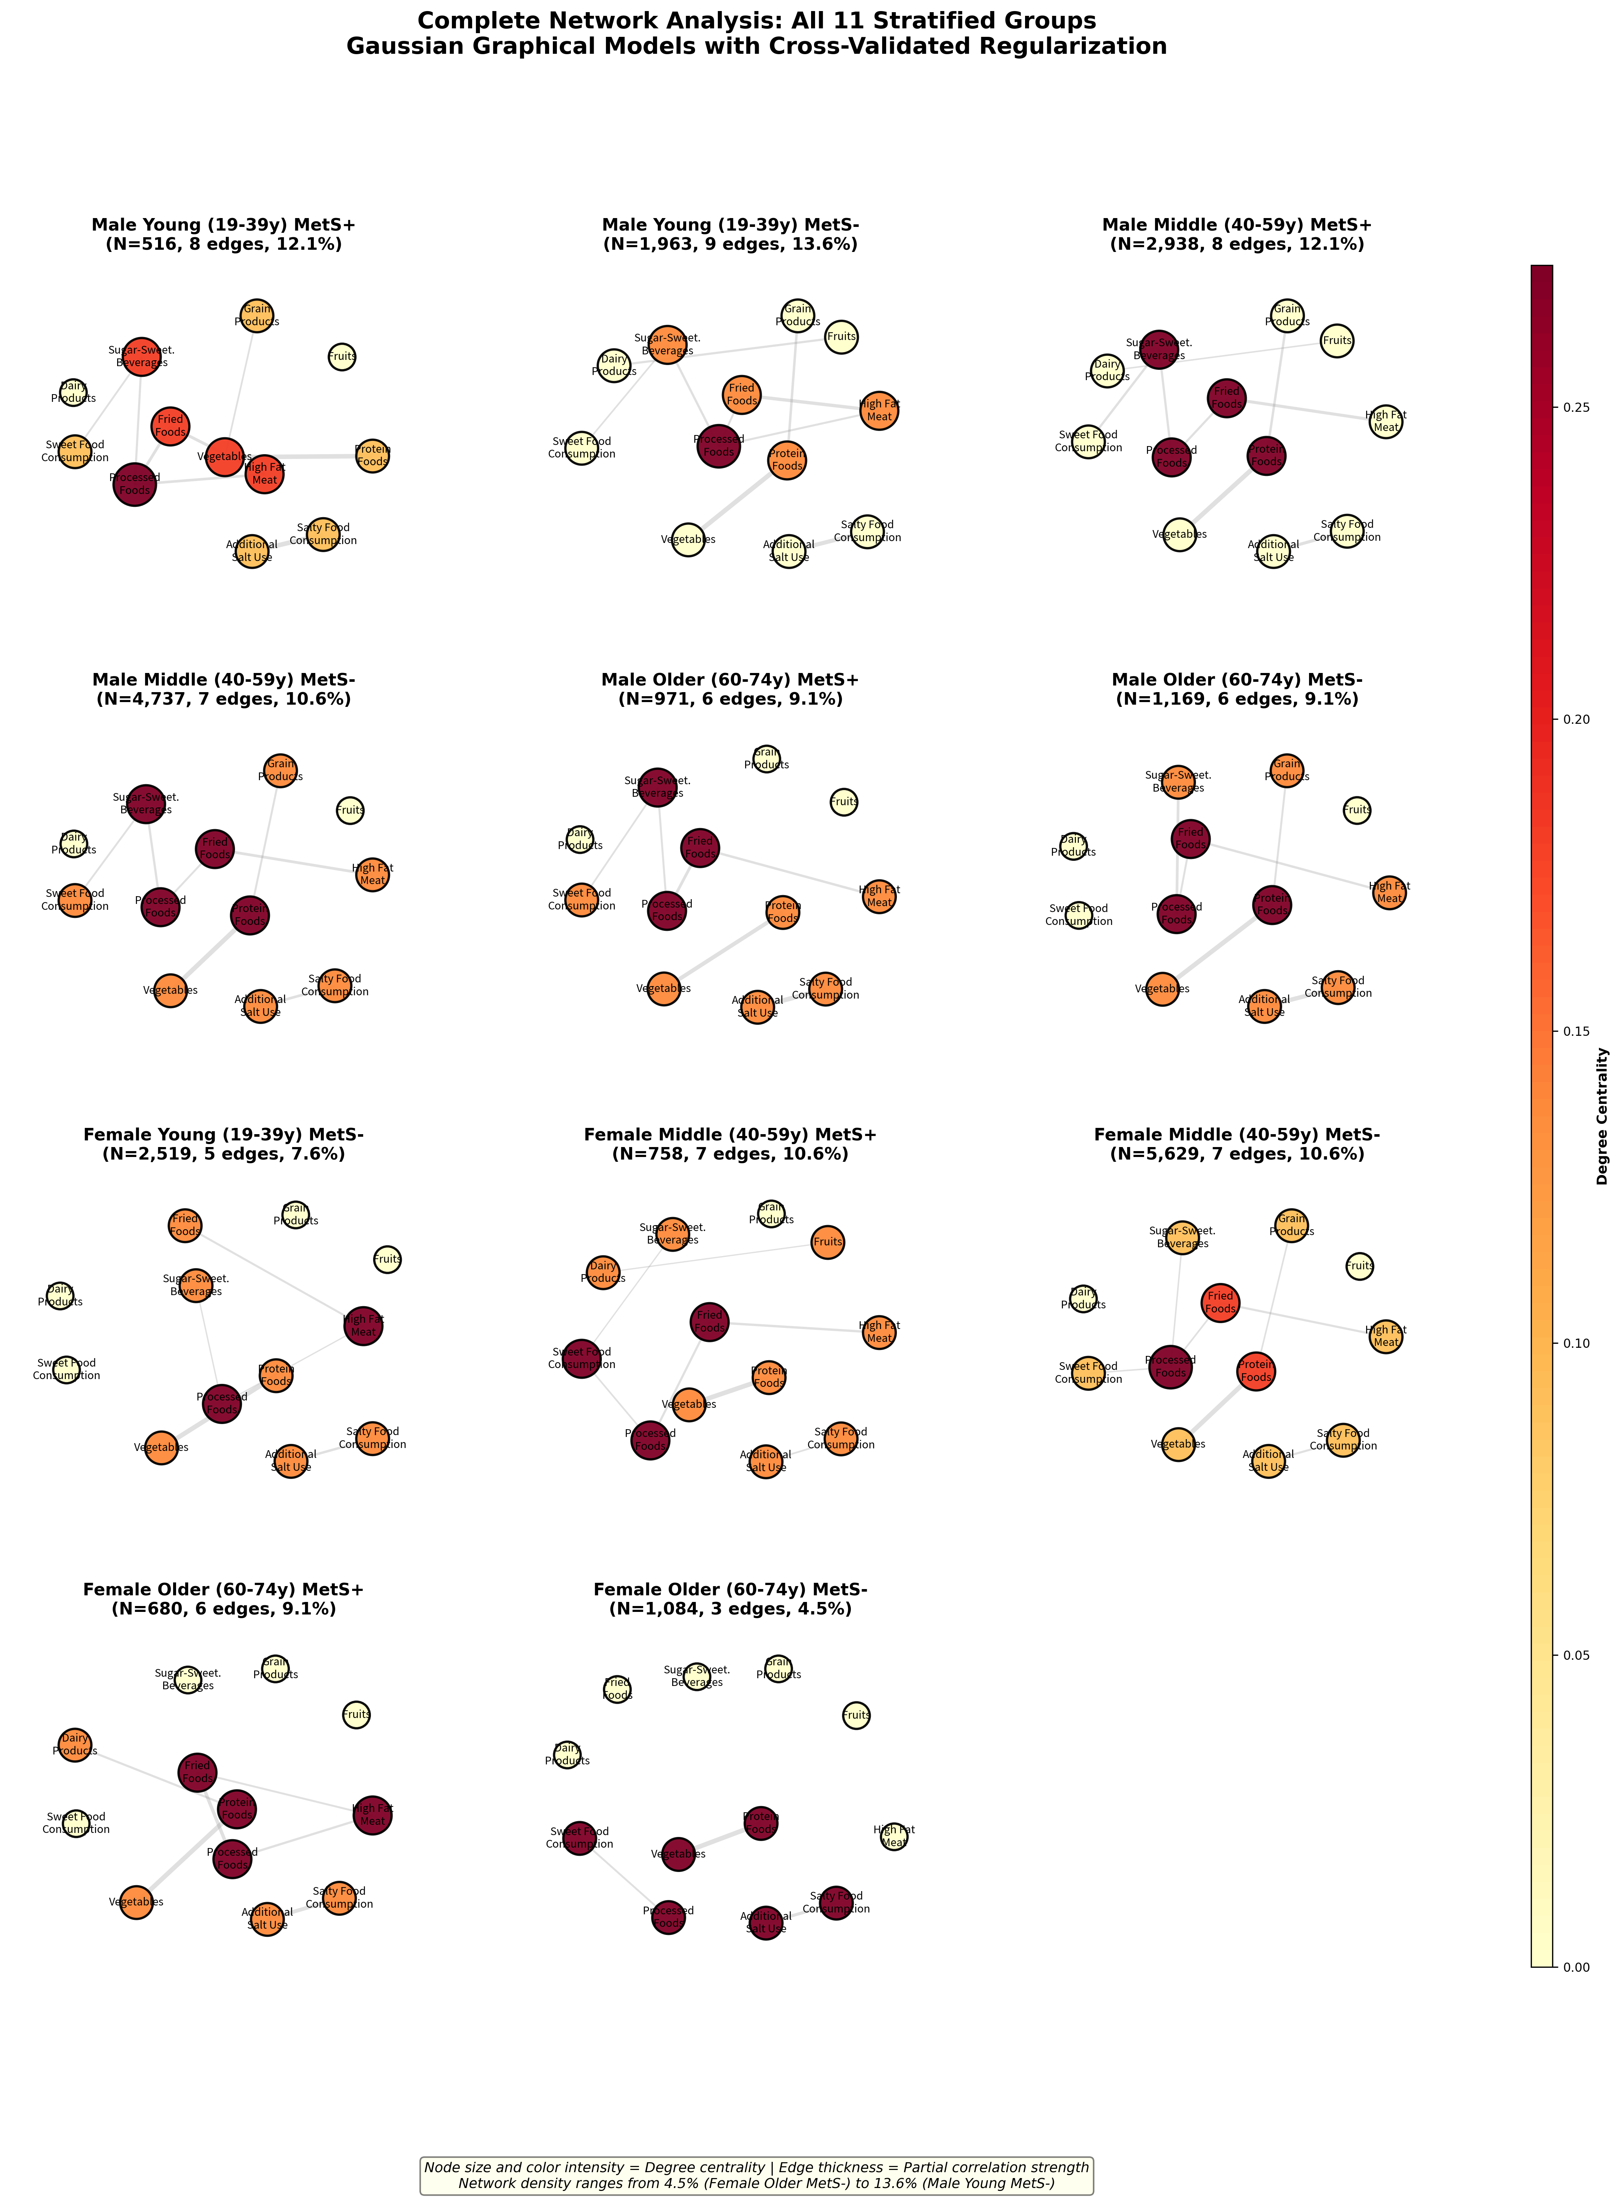
Figure S1 (Figure 7). Comprehensive network visualization of dietary preferences across all 11 stratified population groups. Each panel represents a separate network analysis for a specific demographic subgroup. This complete grid demonstrates the consistency of hub foods (Processed, Fried) across diverse populations, while revealing group-specific variations in network density and edge patterns. Network estimation and visualization conventions follow Figure 5.

Figure S2 (Figure 3). Partial Correlation Matrices for Representative Groups
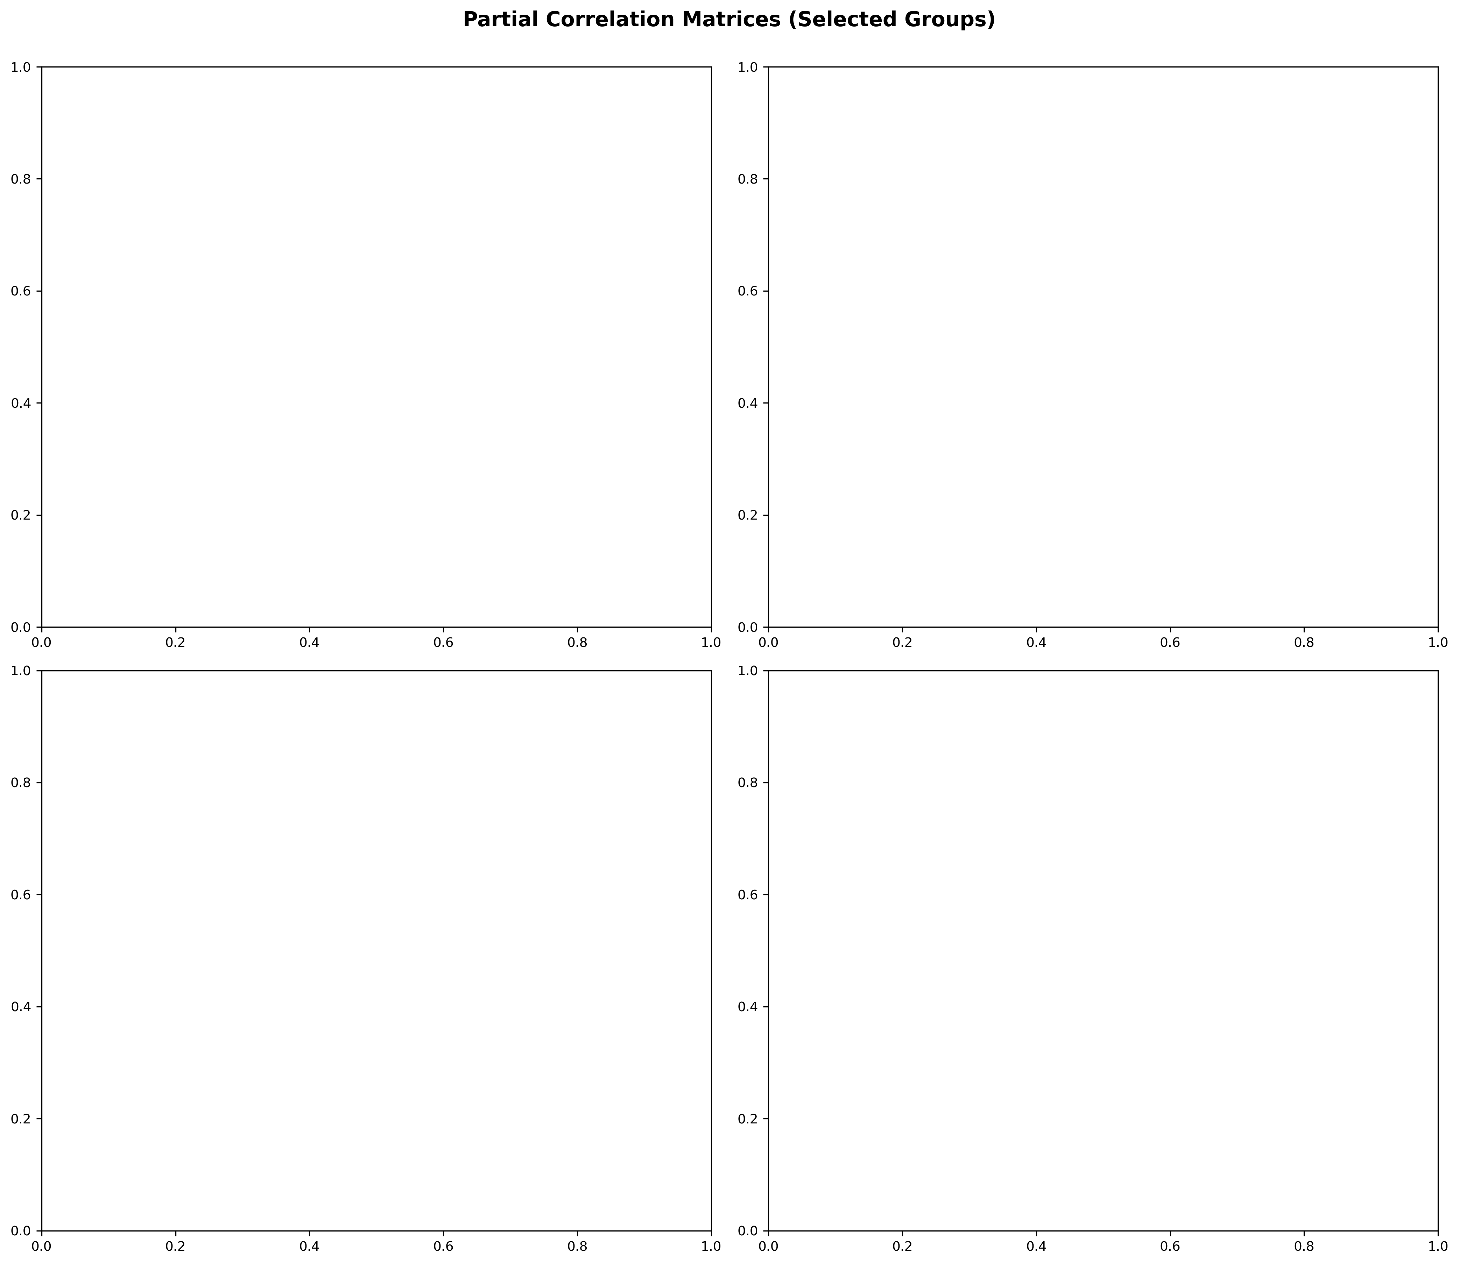
Figure S2 (Figure 3). Heatmap visualization of partial correlation matrices for four representative groups. Color intensity indicates the strength of conditional dependencies between food categories. Red indicates positive correlations, blue indicates negative correlations. Only statistically significant edges (selected by graphical lasso) are shown as non-zero values. The Protein-Vegetables relationship (r=0.318) emerges as the strongest across groups, highlighting the "quality vs breadth" paradigm in dietary networks.

Document Information
Configuration: Option 3 - Academic Networks with Hub Analysis
Generated: 2025-11-06
Contents: 2 Main Figures + 3 Tables + 2 Supplementary Figures
Figures Format: PNG (High resolution, 300 DPI)
Analysis Method: Semiparametric Gaussian Copula Graphical Models (SGCGM) with Graphical Lasso

