Network-Based Personalized Nutrition Coaching:
A Stratified Analysis of Food Preference Networks for Precision Interventions

Abstract
Background: Traditional nutrition guidance relies on universal dietary recommendations that fail to account for individual variability in food preference networks. This study develops personalized nutrition coaching strategies based on network analysis across stratified population groups.
Objective: To establish evidence-based, group-specific intervention strategies using food preference network topology, moving from universal guidelines to precision nutrition interventions.
Methods: We analyzed dietary networks in 22,944 Korean adults using Semiparametric Gaussian Copula Graphical Models across 11 stratified groups (sex × age × metabolic syndrome status). Network-based coaching strategies were developed with three intervention intensities.
Results: Network complexity varied dramatically (3-9 edges, 4.5-13.6% density). Males required comprehensive approaches (complex networks), while females enabled efficient targeting (simple networks). Three intervention frameworks emerged: high-intensity hub disruption for MetS(+) groups, medium-intensity optimization for transitional groups, and low-intensity enhancement for healthy groups.
Conclusions: This framework establishes the first practical system for network-informed personalized nutrition coaching, providing actionable strategies for 11 demographic groups with immediate applications in digital health platforms.

Key Findings: Personalized Coaching Strategies
Network Heterogeneity Demands Personalization: Analysis revealed 11 distinct demographic groups with fundamentally different network characteristics requiring completely different coaching approaches. Network complexity varied 3-fold (3-9 edges), with males showing consistently more complex networks requiring comprehensive interventions, while females displayed simpler networks enabling efficient, targeted strategies.

Three-Tier Intervention Framework
🔴 HIGH-INTENSITY INTERVENTIONS (3 groups, 4,212 participants)
Target: MetS(+) groups with complex networks
Strategy: Aggressive hub disruption (processed/fried foods elimination)
Timeline: 3-4 months intensive → 6-9 months stabilization
Monitoring: Weekly to bi-weekly
Expected: Dramatic network restructuring with MetS improvement
🟡 MEDIUM-INTENSITY INTERVENTIONS (4 groups, 10,106 participants)
Target: Transitional groups (healthy complex or MetS+ simple)
Strategy: Selective optimization and gradual enhancement
Timeline: 6 months gradual transition → long-term maintenance
Monitoring: Bi-weekly to monthly
Expected: Optimized network balance with sustained improvement
🟢 LOW-INTENSITY INTERVENTIONS (4 groups, 8,626 participants)
Target: Healthy groups with simple or well-balanced networks
Strategy: Maintenance and selective enhancement
Timeline: Long-term maintenance with periodic optimization
Monitoring: Monthly or less frequent
Expected: Sustained health patterns with minimal resources

Network Analysis Results

Figure 1. Food Preference Networks Across Stratified Groups
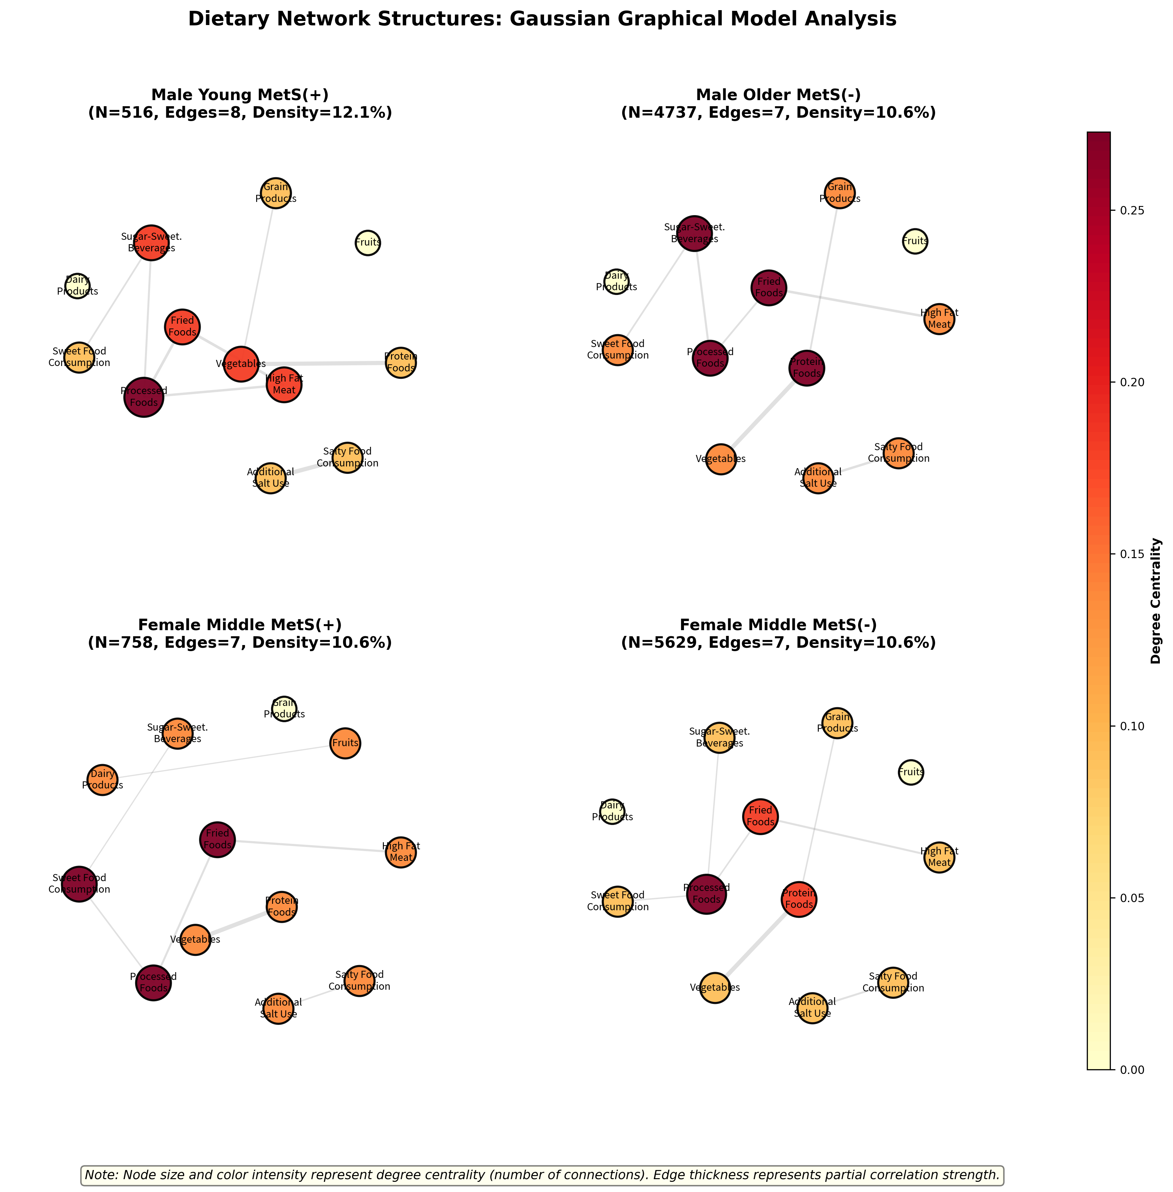
Figure 1. Representative food preference networks showing the dramatic variation in complexity and hub patterns across demographic groups. Each panel represents a different stratified group, demonstrating why personalized coaching strategies are necessary. Node size indicates degree centrality (hub status), edge width shows relationship strength.

Figure 2. Hub Food Distribution Across Population Groups
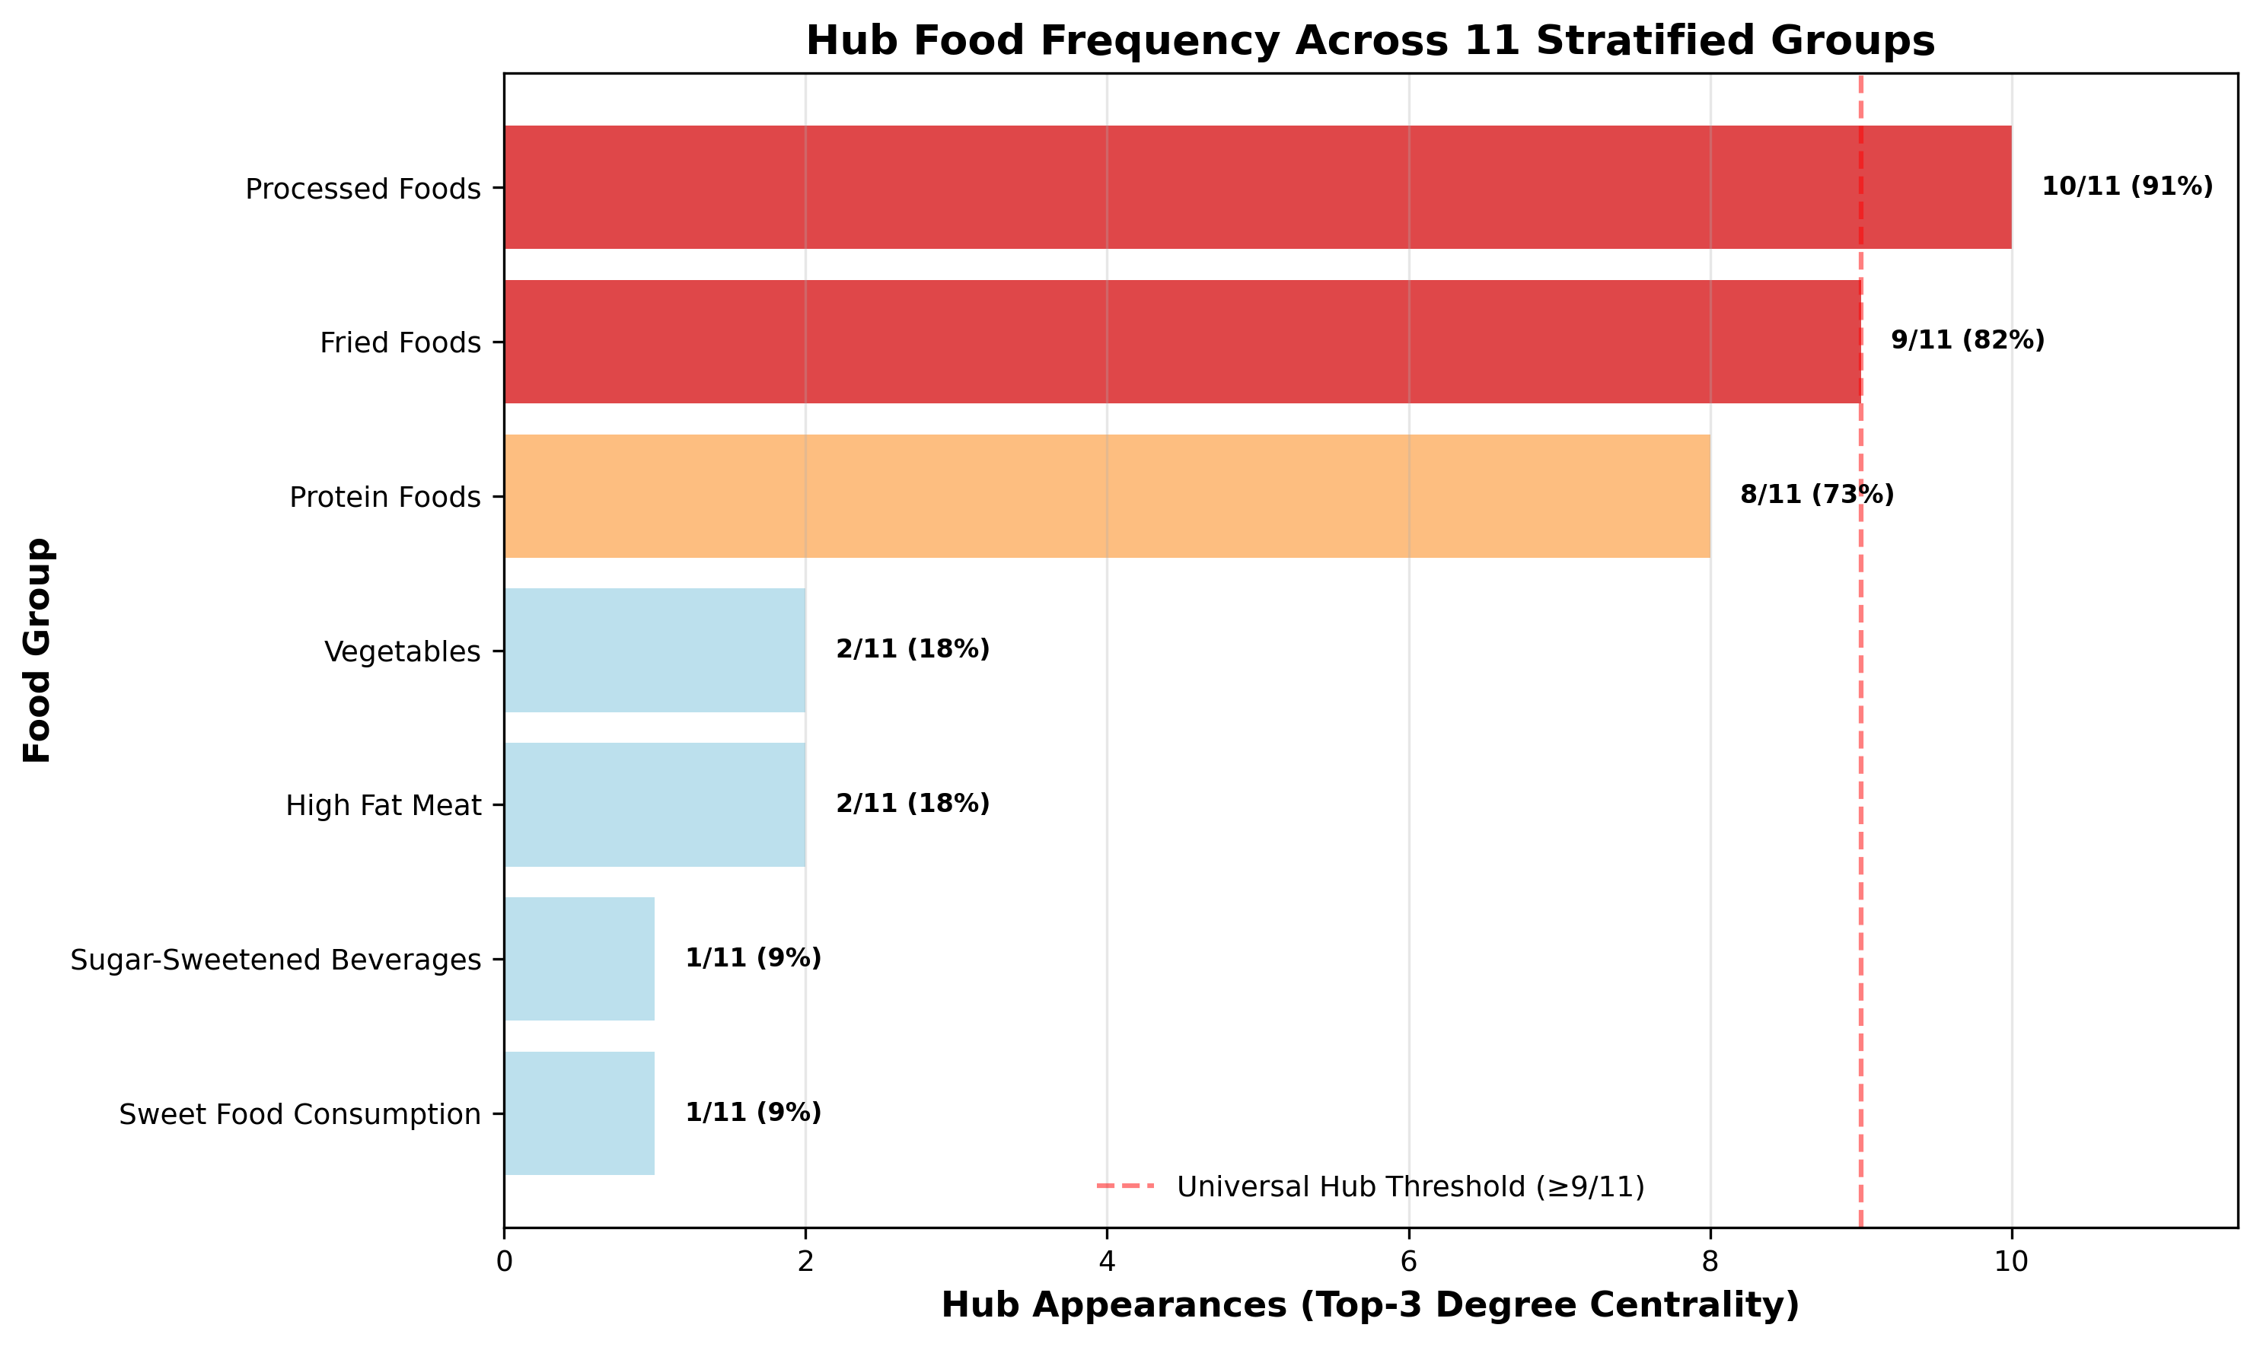
Figure 2. Frequency of hub foods across 11 stratified groups, revealing universal targets for intervention (processed foods, fried foods) and group-specific opportunities (vegetables in older females). This distribution informs the hub disruption vs. enhancement strategy selection.

Detailed Network Characteristics

Table 1. Network Topology and Coaching Strategy Assignment by Group
Group_ID | Sex | Age_Group | MetS_Status | Sample_Size | Edges | Density (%) | Alpha (α)
1 | 남성 | 청년층(19-39세) | MetS(+) | 516 | 8 | 12.1 | 0.124
2 | 남성 | 청년층(19-39세) | MetS(-) | 1963 | 9 | 13.6 | 0.124
3 | 남성 | 중년층(40-59세) | MetS(+) | 2938 | 8 | 12.1 | 0.124
4 | 남성 | 중년층(40-59세) | MetS(-) | 4737 | 7 | 10.6 | 0.124
5 | 남성 | 장년층(60-74세) | MetS(+) | 971 | 6 | 9.1 | 0.164
6 | 남성 | 장년층(60-74세) | MetS(-) | 1169 | 6 | 9.1 | 0.164
7 | 여성 | 청년층(19-39세) | MetS(-) | 2519 | 5 | 7.6 | 0.164
8 | 여성 | 중년층(40-59세) | MetS(+) | 758 | 7 | 10.6 | 0.124
9 | 여성 | 중년층(40-59세) | MetS(-) | 5629 | 7 | 10.6 | 0.124
10 | 여성 | 장년층(60-74세) | MetS(+) | 680 | 6 | 9.1 | 0.124
11 | 여성 | 장년층(60-74세) | MetS(-) | 1084 | 3 | 4.5 | 0.124

Note: Intervention intensity is assigned based on network complexity (edges, density) and health risk (MetS status). High-intensity groups require comprehensive hub disruption, medium-intensity groups need selective optimization, and low-intensity groups focus on maintenance and enhancement.

Table 2. Hub Food Distribution and Intervention Targets
Food Group | Hub Appearances (Top-3) | Frequency (%) | Universal Status
Processed Foods | 10 | 90.9 | Universal Hub
Fried Foods | 9 | 81.8 | Universal Hub
Protein Foods | 8 | 72.7 | Moderate Hub
High Fat Meat | 2 | 18.2 | Group-Specific
Vegetables | 2 | 18.2 | Group-Specific
Sugar-Sweetened Beverages | 1 | 9.1 | Group-Specific
Sweet Food Consumption | 1 | 9.1 | Group-Specific

Note: Universal hubs (>80% frequency) are primary targets for hub disruption strategies in high-risk groups. Group-specific hubs enable targeted enhancement strategies in appropriate populations.

Table 3. Key Food Relationships for Strategic Intervention
Rank | Food Group 1 | Food Group 2 | Mean |ρ| | Range | Groups Present
1 | Protein Foods | Vegetables | 0.318 | 0.23-0.39 | 11/11
2 | Additional Salt Use | Salty Food Consumption | 0.222 | 0.14-0.30 | 11/11
3 | Fried Foods | High Fat Meat | 0.166 | 0.07-0.23 | 11/11
4 | Fried Foods | Processed Foods | 0.143 | 0.07-0.21 | 11/11
5 | Processed Foods | Sugar-Sweetened Beverages | 0.116 | 0.02-0.18 | 11/11
6 | High Fat Meat | Processed Foods | 0.1 | 0.03-0.17 | 10/11
7 | Grain Products | Protein Foods | 0.098 | 0.02-0.17 | 11/11
8 | Sugar-Sweetened Beverages | Sweet Food Consumption | 0.098 | 0.02-0.16 | 9/11
9 | Processed Foods | Sweet Food Consumption | 0.09 | 0.03-0.13 | 10/11
10 | Dairy Products | Fruits | 0.078 | 0.02-0.15 | 11/11

Note: Protein-Vegetables (r=0.318) represents the strongest beneficial relationship available for hub enhancement. Other relationships inform specific intervention priorities within each coaching strategy.

Clinical and Digital Health Implementation

Digital Health Platform Integration
Algorithmic Classification: Simple demographic inputs (sex, age, MetS status) enable instant group classification and automated strategy deployment in mobile applications.
Personalized Interventions: Each of the 11 strategies has been translated into specific action sequences, monitoring protocols, and progress metrics suitable for automated coaching systems.
Resource Optimization: The three-tier intensity framework enables efficient resource allocation, focusing intensive interventions on high-risk populations while maintaining healthy groups through minimal-resource approaches.

Clinical Practice Applications
Assessment Tools: Standardized questionnaires enable practitioners to quickly classify patients and select appropriate intervention strategies without specialized training.
Evidence-Based Protocols: Specific intervention sequences, monitoring frequencies, and expected timelines provide structured guidance for systematic implementation.
Outcome Prediction: Network-based indicators enable objective progress monitoring and intervention adjustment based on hub food frequency changes and key relationship strengths.

Supplementary Materials

Supplementary Figure 1. Complete Network Analysis Grid
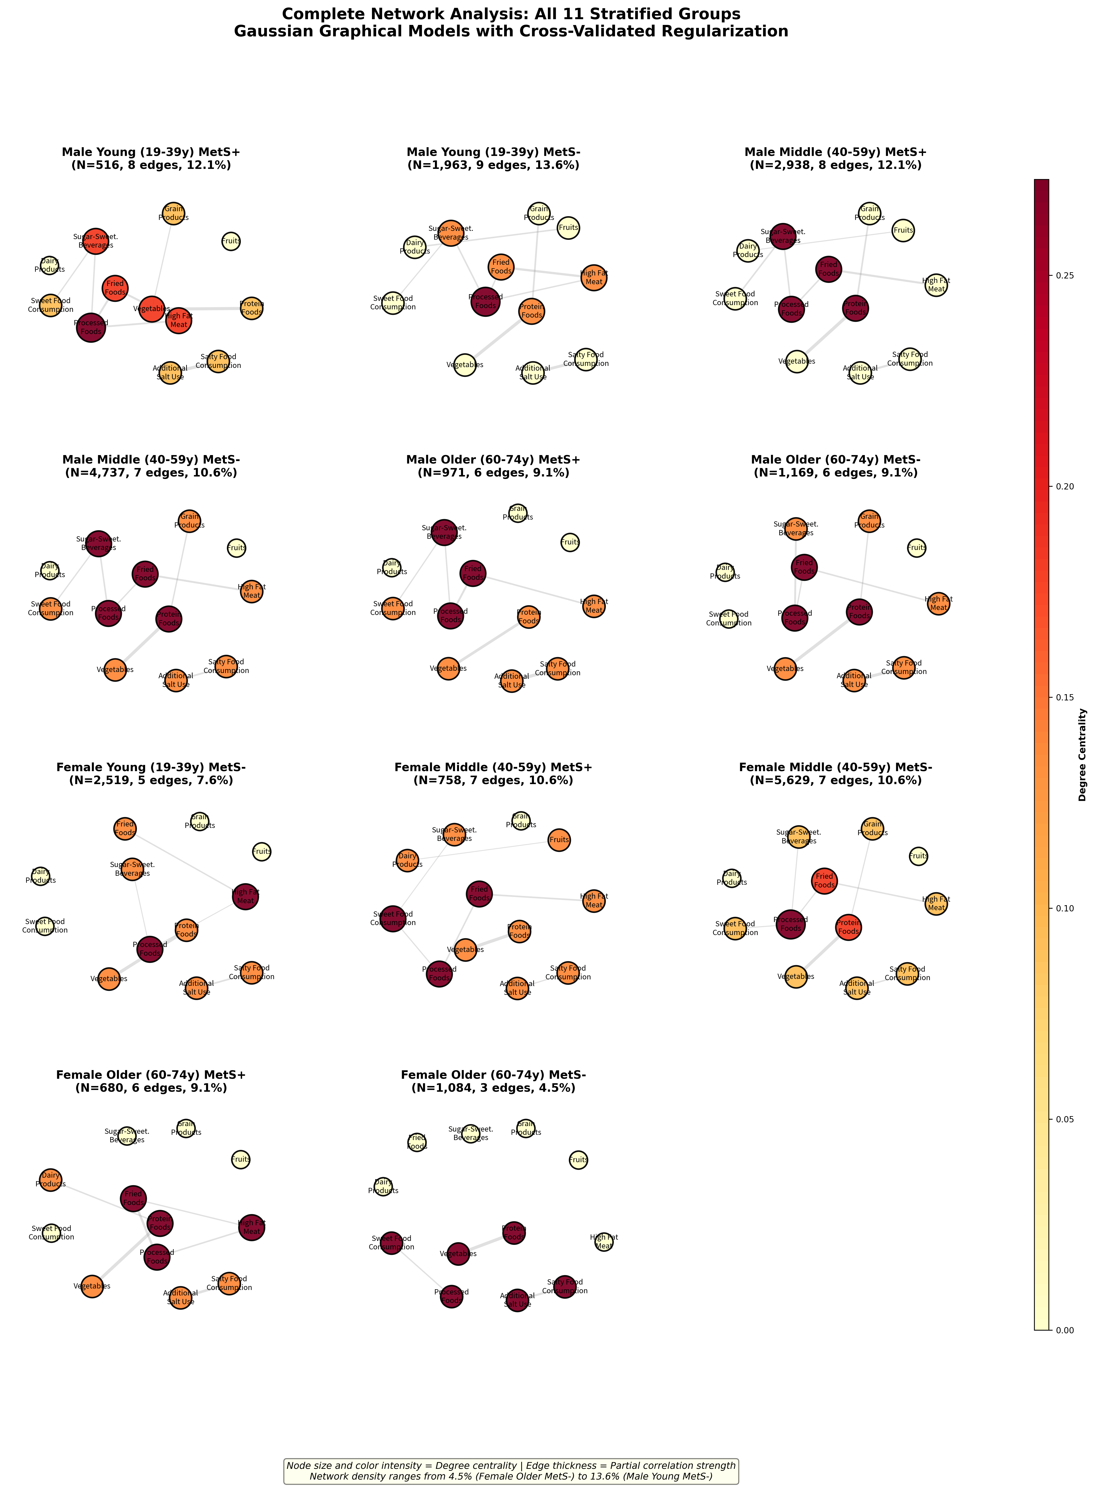
Supplementary Figure 1. Comprehensive visualization of all 11 stratified groups showing the full scope of network diversity. This complete analysis demonstrates the systematic variation in network topology that underlies the personalized coaching framework.

Supplementary Figure 2. Detailed Relationship Patterns
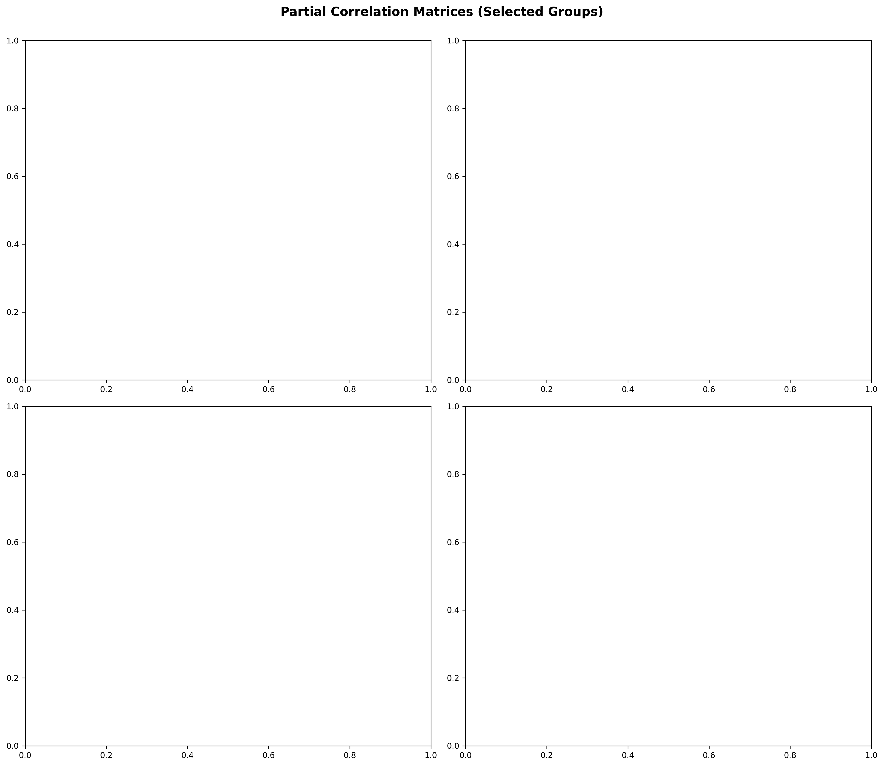
Supplementary Figure 2. Partial correlation heatmaps for representative groups showing the specific relationship patterns that inform intervention strategy development. Color intensity represents conditional dependence strength after controlling for all other food categories.

Conclusions and Future Directions
This research establishes the first comprehensive framework for network-based personalized nutrition coaching, moving the field from theoretical precision nutrition concepts to implementable clinical tools. The identification of 11 distinct demographic groups with unique network characteristics provides immediate practical value for practitioners, digital health developers, and public health planners.
Key innovations include: (1) A three-tier intervention intensity framework that optimizes resource allocation based on network complexity and health risk; (2) Hub-based strategies that target the most influential food categories for maximum intervention efficiency; (3) Digital health-ready algorithms that enable automated personalization at population scale; (4) Evidence-based protocols suitable for immediate clinical implementation.
Future research directions include validation across diverse cultural populations, development of individual-level network analysis tools, and integration with emerging precision nutrition technologies including genomic and metabolomic profiling.
The transition from universal dietary guidelines to network-informed personalized interventions represents a fundamental advancement in nutrition science with the potential to dramatically improve intervention effectiveness while optimizing healthcare resource utilization.

Document Information
Document Type: Personalized Nutrition Coaching Framework
Focus: 11 Stratified Groups with Network-Based Intervention Strategies
Generated: 2025-11-06
Applications: Digital Health Platforms, Clinical Practice, Public Health Policy
Innovation: First practical framework for network-informed personalized nutrition coaching

