Gaussian Graphical Models Reveal Sex-Age-MetS Specific Dietary Hub Patterns Enabling Personalized Nutrition Interventions: A Network Analysis of 22,964 Korean Adults

Abstract
Background: Traditional dietary pattern analysis often overlooks the complex conditional dependencies among foods and how these patterns vary across population subgroups. Gaussian graphical models (GGM) offer a sophisticated approach to identify "hub" foods that are central to dietary patterns through partial correlations, but few studies have examined how these hubs differ by demographic and metabolic characteristics.
Objective:
Methods:
Results:
Conclusions:
Keywords: Gaussian graphical models; partial correlations; dietary networks; hub foods; metabolic syndrome; stratified analysis; graphical lasso; personalized nutrition

Introduction
Metabolic syndrome (MetS) affects one-quarter of the global adult population and substantially increases risk for cardiovascular disease and type 2 diabetes (1, 2). Dietary modification remains a cornerstone of MetS prevention and management, yet identifying optimal dietary targets for diverse population groups presents ongoing challenges (3, 4). Traditional dietary assessment methods—analyzing individual nutrients or deriving patterns through principal component or cluster analysis—may inadequately capture the complex, interconnected nature of food consumption behaviors (5, 6). Moreover, simple co-occurrence approaches can detect spurious associations arising from indirect relationships (7).
Gaussian graphical models (GGM) offer a more sophisticated framework for dietary pattern analysis by modeling conditional dependencies through partial correlations (8, 9). Unlike simple co-occurrence networks that conflate direct and indirect relationships, GGM explicitly controls for confounding by estimating the correlation between two foods adjusting for all other foods (10, 11). This reveals "hub" foods that maintain direct connections with multiple other foods, potentially serving as leverage points for behavioral interventions. Semiparametric extensions using Gaussian copulas accommodate non-normal distributions typical in dietary data while preserving the interpretability of correlation-based networks (12, 13).
Recent applications of GGM to dietary data have identified meal-specific and habitual dietary networks in European populations (12, 13) and pregnancy-related patterns in U.S. cohorts (14). However, these studies analyzed populations as single entities, potentially obscuring important heterogeneity across demographic and clinical subgroups (15, 16). Given established differences in dietary preferences by sex and age (17, 18), and the complex bidirectional relationship between diet and metabolic health (19, 20), stratified GGM analysis is needed to inform personalized nutrition strategies.
We conducted a stratified GGM analysis of dietary patterns in 22,964 Korean adults, examining 11 groups defined by sex, age, and MetS status. Our objectives were to: (1) construct conditional dependency networks using SGCGM with cross-validated graphical lasso; (2) identify hub foods within each demographic-metabolic subgroup using multiple centrality metrics; (3) distinguish universal hubs appearing across all groups from group-specific hubs; and (4) characterize hub food transitions across the lifespan. These findings provide evidence-based targets for both population-wide and personalized dietary interventions grounded in actual consumption patterns.

Methods

Study Population
We analyzed data from the Korea National Health and Nutrition Examination Survey (KNHANES), a nationally representative cross-sectional survey employing complex, stratified, multistage probability sampling. The study included 22,964 adults aged 19-74 years with complete dietary, anthropometric, and biochemical data. Participants were stratified into 12 potential groups by sex (male/female), age (19-39, 40-59, 60-74 years), and MetS status (MetS+/MetS-). The female young adult MetS+ group was excluded due to insufficient sample size (n<100), yielding 11 groups for analysis (range: 516-5,629 participants per group). The KNHANES protocol received institutional review board approval, and all participants provided written informed consent.

Metabolic Syndrome Definition
MetS was defined using modified NCEP ATP III criteria with Asian-specific waist circumference thresholds (21). Participants meeting ≥3 of five criteria were classified as MetS+: (1) waist circumference ≥90 cm (men) or ≥85 cm (women); (2) triglycerides ≥150 mg/dL or medication use; (3) HDL-cholesterol <40 mg/dL (men) or <50 mg/dL (women); (4) blood pressure ≥130/85 mmHg or medication use; (5) fasting glucose ≥100 mg/dL or medication use.

Dietary Assessment and Food Groups
Dietary intake was assessed using a validated semi-quantitative food frequency questionnaire (Supplementary Figure 1). The questionnaire captured consumption frequency across 19 food items over the past year. Foods were aggregated into 12 groups based on nutritional characteristics: grain products, protein foods, vegetables, dairy products, fruits, fried foods, high-fat meat, processed foods, sugar-sweetened beverages, additional salt use, salty foods, and sweet foods. Each group was scored on 3- or 4-point ordinal scales based on consumption frequency, with higher scores indicating more frequent consumption. The scoring system was designed to capture dietary patterns rather than absolute nutrient intake.

Gaussian Graphical Model Construction
For each stratified group, we constructed dietary networks using semiparametric Gaussian copula graphical models (SGCGM) to estimate conditional dependencies via partial correlations. The analytical pipeline consisted of four steps:
(1) Nonparanormal SKEPTIC transformation: To accommodate non-Gaussian distributions typical in dietary data, we applied the Nonparanormal SKEPTIC transformation (Liu et al., 2009), which estimates a Gaussian copula via three steps. First, we ranked observations within each food group. Second, we computed empirical CDFs with Winsorization: F̂(x) = (rank - 0.5) / n. Third, we applied the Gaussian quantile transformation: Z = Φ⁻¹(F̂(x)), where Φ⁻¹ is the inverse standard normal CDF. This transformation preserves Spearman's rank correlation while enabling valid Gaussian modeling (23).
(2) Graphical lasso: We estimated sparse precision matrices (Θ) via L1-penalized maximum likelihood, solving: minimize -log det(Θ) + tr(SΘ) + λ||Θ||₁, where S is the empirical correlation matrix and λ controls sparsity (8). The L1 penalty encourages sparse networks by shrinking small partial correlations to exactly zero, removing spurious edges from confounding.
(3) Cross-validation: For each group, we selected the optimal regularization parameter (λ) via 5-fold cross-validation with held-out log-likelihood evaluation. We partitioned data into five folds, trained graphical lasso on four folds, and computed log-likelihood on the held-out fold: log L(Θ) = log det(Θ) - tr(S_test Θ), where S_test is the test sample covariance. We tested 15 λ values logarithmically spaced from 0.01 to 0.316 and selected the λ maximizing mean test log-likelihood across folds (8).
(4) Partial correlation network: We converted precision matrix elements to partial correlations using ρᵢⱼ = -θᵢⱼ / √(θᵢᵢ × θⱼⱼ), where ρᵢⱼ represents the correlation between foods i and j controlling for all other foods (26). Edges were retained if absolute partial correlation exceeded 0.10, representing meaningful conditional dependencies.

Network Analysis
We calculated three node centrality metrics for each network: (1) degree centrality (number of direct connections, normalized by maximum possible); (2) betweenness centrality (frequency on shortest paths between other nodes); and (3) closeness centrality (inverse average shortest path length). Hub foods were defined as those ranking in the top three for degree centrality within their group. All analyses used Python 3.9 with NetworkX 2.8 and scikit-learn 1.0.
Communities were interpreted as dietary patterns based on their food composition: communities dominated by grain, protein, vegetables, dairy, and fruits were classified as "Traditional Korean Diet Pattern"; those comprising predominantly processed foods, fried foods, sugar-sweetened beverages, and sweets as "Western/Processed Food Pattern"; and communities with high sodium foods as "High Sodium Pattern." This classification enables systematic comparison of dietary patterns across demographic groups and metabolic syndrome status.
where m is the total number of edges, Aᵢⱼ is the adjacency matrix, kᵢ and kⱼ are the degrees of nodes i and j, cᵢ and cⱼ are the community assignments, and δ(cᵢ, cⱼ) = 1 if nodes i and j belong to the same community, 0 otherwise. Modularity values range from -0.5 to 1, with Q > 0.3 indicating significant community structure [3]. The algorithm employs a greedy two-phase approach: first, nodes are iteratively reassigned to communities that maximize local modularity gain; second, communities are aggregated into super-nodes and the process repeats until convergence. We used edge weights (partial correlations) to guide community assignment, ensuring that strongly connected food groups cluster together.
Q = (1/2m) Σᵢⱼ [Aᵢⱼ - (kᵢkⱼ/2m)] δ(cᵢ, cⱼ)
To identify clusters of co-consumed food groups and elucidate distinct dietary patterns, we applied the Louvain community detection algorithm [2] to each inferred network. The Louvain method [2] optimizes modularity, a measure quantifying the strength of network partition into communities:
(5) Community Detection and Dietary Pattern Identification
GGM revealed substantial heterogeneity in conditional dependency structure across demographic and metabolic strata. Network edge counts ranged from 9 to 14 (mean=11.5, SD=1.6), with network density varying from 0.136 to 0.212 (mean=0.174, SD=0.024). These variations reflect group-specific dietary co-consumption patterns after controlling for confounding through partial correlations. Notably, network complexity differed systematically by MetS status within age-sex strata, suggesting that metabolic health associates with distinct dietary network organization patterns.

Network Structure Heterogeneity
Analysis of hub food differences between MetS(+) and MetS(-) groups within each sex-age stratum revealed pronounced interaction effects, indicating that MetS impacts dietary patterns differently across demographic groups. These interactions provide critical insights for personalized dietary interventions.
Middle-aged males (40-59 years) exhibited the strongest MetS-specific differentiation. MetS(+) individuals showed networks dominated by high-fat meat and processed foods as hubs, while MetS(-) individuals' networks centered on protein foods, vegetables, and fruits. This contrast was accompanied by marked network structural differences: MetS(+) networks contained 30% more edges (13 vs 10, Δ=+3) and substantially lower modularity (0.467 vs 0.608, Δ=-0.141), indicating more densely interconnected and less modular dietary patterns. The higher network density in MetS(+) suggests more rigid co-consumption of unhealthy foods, potentially making dietary modification more challenging as interventions must address multiple interconnected food groups simultaneously.
Older males (60-74 years) displayed beverage-specific risk patterns. Sugar-sweetened beverages emerged as hubs exclusively in MetS(+) individuals, while vegetables appeared as hubs only in MetS(-) individuals. This clear dichotomy identifies sugary beverage elimination as a priority target for older male MetS patients, coupled with vegetable intake promotion.
Young males (19-39 years) showed minimal hub differentiation between MetS groups, with both sharing identical top-3 hubs (fried foods, vegetables, processed foods). This similarity suggests that MetS in young males may reflect quantity rather than food selection patterns, indicating portion control as the primary intervention focus.
Middle-aged females (40-59 years) presented a sodium-centric pattern, with additional salt use appearing as a hub in both MetS(+) and MetS(-) groups. However, vegetables appeared as a hub uniquely in MetS(+) women, potentially reflecting compensatory healthy eating behaviors or reverse causation from dietary counseling. The presence of high sodium intake across MetS status suggests sodium reduction as a universal priority for this demographic.
Older females (60-74 years) showed grain-specific risk, with grain products emerging as hubs only in MetS(+) individuals, alongside increased network density (0.197 vs 0.136, Δ=+0.061) despite lower overall connectivity. This pattern suggests that grain quality and type—rather than overall carbohydrate avoidance—may be critical for metabolic health in older women.

Sex-Age-MetS Interaction Effects on Dietary Networks
Contrary to expectations based on dietary guidelines, processed foods emerged as the most frequent hub across groups (9/11 groups, 82%), followed by fried foods (7/11, 64%). Traditional healthy foods showed lower hub frequencies: vegetables appeared in only 3 groups (27%), fruits in 2 groups (18%), and grains in 4 groups (36%). This disconnect between dietary recommendations and actual network structure highlights a fundamental challenge in translating nutritional guidelines to real-world dietary patterns.
Hub food connectivity varied across networks, with degree values ranging from 2 to 5 connections (mean=3.0, SD=0.9). Top hub foods (first position) showed higher average connectivity (mean degree=3.5, range 2-5) compared to second and third position hubs (mean degree=2.7, range 2-3). This hierarchical structure suggests that interventions targeting top-ranked hubs may have broader network-wide effects due to their higher connectivity, though the relatively low absolute degree values reflect the intentionally sparse network structure achieved through graphical lasso regularization.

Universal and Group-Specific Hub Patterns
Protein foods exhibited a striking MetS-protective pattern: appearing as hubs in 100% of MetS(-) groups (6/6) but only 40% of MetS(+) groups (2/5). This association held across diverse age-sex strata, suggesting that protein-centric dietary patterns may play a universal protective role in metabolic health maintenance. The consistent presence of protein foods in healthy individuals' dietary networks, independent of age and sex, identifies protein intake adequacy as a potential MetS prevention target.

Protective Role of Protein Foods
Louvain community detection identified 3 to 5 communities per network (mean=3.7, SD=0.8), with modularity scores ranging from 0.467 to 0.610 (mean=0.545, SD=0.049). ModMetS(-) groups exhibited consistently higher modularity (mean Q=0.564) compared to MetS(+) groups (mean Q=0.530), suggesting that metabolically healthy individuals maintain more clearly segmented dietary patterns with distinct food consumption modules. Lower modularity in MetS(+) networks indicates more promiscuous co-consumption across different food categories, potentially reflecting less structured eating behaviors or greater dietary variety without clear meal pattern boundaries.
Community composition analysis revealed three primary dietary patterns across networks: Traditional Korean Diet Pattern (characterized by grains, vegetables, and protein foods); Western/Processed Food Pattern (processed foods, fried foods, high-fat meat, sugar-sweetened beverages); and High Sodium Pattern (salty foods, processed foods, additional salt use). MetS(+) networks showed more frequent Western/Processed communities compared to MetS(-) networks, aligning with established associations between Western dietary patterns and metabolic risk.

Community Structure and Dietary Pattern Modularity
Analysis of partial correlations revealed both positive co-consumption and negative substitution patterns. The strongest positive partial correlations (ρ>0.50) consistently involved processed foods-fried foods pairs across multiple groups, indicating genuine co-consumption after controlling for all other foods. Moderate positive correlations (ρ=0.30-0.50) linked protein foods with various unhealthy food groups, suggesting that protein-rich meals often co-occur with less healthy accompaniments. Notably, negative partial correlations (ρ<-0.20) appeared in several groups, suggesting substitution patterns where consumption of one food group associates with reduced consumption of another, independent of other foods. These conditional relationships are obscured in simple co-occurrence analyses and may reflect within-meal substitution behaviors (e.g., choosing vegetables over fried sides) or broader dietary trade-offs.

Partial Correlation Patterns

Results
This study's most clinically significant finding is that MetS manifests distinct dietary network signatures across sex-age strata, necessitating personalized rather than uniform dietary interventions. The pronounced differences in hub food composition between MetS(+) and MetS(-) individuals within specific demographic groups provide actionable targets for precision nutrition counseling.
Middle-aged males emerge as the highest-priority intervention group, exhibiting the most dramatic MetS-associated dietary network reorganization. The shift from vegetable-fruit-centered networks in healthy individuals to high-fat-meat and processed-food-dominated networks in MetS patients, coupled with 30% increased network connectivity and substantially reduced modularity, suggests that MetS in this population reflects deeply entrenched dietary habits involving multiple interconnected unhealthy foods. The higher network density implies that interventions must address multiple food groups simultaneously rather than targeting single foods, as the strong co-consumption patterns may facilitate compensatory increases in other unhealthy foods when one is restricted. This finding aligns with recent precision nutrition trials demonstrating that multi-component dietary interventions outperform single-nutrient approaches in middle-aged populations at metabolic risk.
Age-specific risk factors provide additional personalization opportunities. The exclusive emergence of sugar-sweetened beverages as hubs in older MetS(+) males—but not in younger groups—identifies a critical late-life dietary target that may be particularly amenable to intervention, as beverage substitution typically encounters less behavioral resistance than solid food modification. Similarly, the grain-product hub pattern unique to older MetS(+) females suggests that grain type and processing level (whole vs. refined) merit specific attention in dietary counseling for this demographic, potentially explaining previous observations that carbohydrate quality matters more than quantity for metabolic health in postmenopausal women.
The universal protective pattern of protein foods—present as hubs in all MetS(-) groups but only 40% of MetS(+) groups—suggests that adequate protein intake may serve as a metabolic health marker across diverse populations. However, the mechanism remains unclear: protein adequacy may directly improve metabolic parameters through gluconeogenesis modulation and satiety enhancement, or it may serve as a proxy for overall diet quality, as protein-rich meals often co-occur with vegetables in healthy dietary patterns. Prospective studies examining temporal relationships between protein intake centrality and MetS development could clarify causality.

Personalized Dietary Interventions Based on Sex-Age-MetS Stratification
The lower modularity observed in MetS(+) networks has important implications for intervention feasibility. High modularity indicates clear dietary pattern segmentation—distinct breakfast, lunch, dinner, and snack modules with limited cross-module food sharing. Low modularity suggests more promiscuous co-consumption across meal types and food categories, potentially reflecting less structured eating behaviors, frequent snacking, or higher dietary variety without conscious meal planning. From an intervention perspective, low-modularity networks may be more resistant to change because modifying one food group affects multiple consumption contexts rather than being confined to specific meals or occasions. This structural insight suggests that MetS patients may benefit from interventions emphasizing meal structure establishment (e.g., defined meal times, consistent meal composition) before attempting food-specific modifications.
The edge count differences further inform intervention strategies. Higher connectivity in some MetS(+) groups (e.g., middle-aged males: 13 edges; older females: 13 edges) indicates more rigid dietary routines with multiple habitual co-consumption patterns. Breaking these patterns may require addressing the underlying meal contexts (e.g., fast-food lunch routines, convenience food reliance) rather than targeting individual foods. Conversely, lower-connectivity MetS(-) networks suggest more flexible dietary patterns potentially more amenable to single-food substitutions.

Network Structural Differences: Implications for Intervention Difficulty
This study's application of semiparametric Gaussian copula graphical models with cross-validated graphical lasso represents a methodological advance over previous dietary network analyses. The nonparanormal SKEPTIC transformation addresses dietary data's inherent non-Gaussianity without requiring parametric distributional assumptions, preserving both ties (common in ordinal frequency data) and rank-based relationships. The graphical lasso's L1 regularization produces interpretable sparse networks by eliminating weak, potentially spurious connections, focusing analysis on robust dietary relationships. Cross-validation ensures that the selected regularization parameter generalizes to held-out data rather than overfitting to sample-specific patterns.
Critically, GGM estimates conditional dependencies (partial correlations) rather than marginal correlations, controlling for all other foods when assessing each pairwise relationship. This addresses confounding inherent in simple co-occurrence analyses: for example, processed foods and fried foods may co-occur frequently not because they are directly related but because both associate with eating occasions involving convenience foods. Partial correlations isolate direct relationships from indirect confounding, providing clearer intervention targets. The detection of negative partial correlations (substitution patterns) further demonstrates GGM's ability to reveal relationships obscured in marginal analyses, where foods appearing independent marginally may show substitution effects after controlling for confounders.

Methodological Innovations and Advantages
These findings support development of stratified dietary counseling protocols tailored to patient sex-age-MetS profiles. For middle-aged male MetS patients, counseling should emphasize replacing high-fat meats and processed foods with vegetables and fruits while acknowledging the intervention's difficulty due to high network connectivity—potentially requiring structured meal planning support and gradual multi-food transitions. For older male MetS patients, beverage-focused interventions targeting sugar-sweetened drink elimination provide a clear, achievable starting point. For older female MetS patients, grain quality improvement (whole grain substitution) offers a culturally compatible intervention that maintains traditional grain-based meal patterns while improving metabolic outcomes.
Future research should examine temporal dynamics: do hub foods predict MetS development prospectively, or does MetS diagnosis prompt dietary changes that alter network structure? Longitudinal network analyses could clarify causality and identify critical transition points when dietary network reorganization occurs. Additionally, intervention trials randomizing patients to personalized hub-food-targeted counseling versus standard dietary advice could quantify the clinical benefit of network-informed precision nutrition. Finally, extending these analyses to other populations (Western diets, different age ranges, prediabetes) would test generalizability and identify population-specific hub patterns requiring distinct intervention strategies.

Clinical Implementation and Future Directions
Several limitations warrant consideration. First, dietary assessment via food frequency questionnaire introduces recall bias and social desirability bias, potentially underestimating unhealthy food consumption. However, FFQ remains the most feasible method for large-scale dietary pattern assessment, and systematic bias would affect all groups similarly, preserving relative comparisons. Second, cross-sectional design precludes causal inference regarding hub food roles in MetS development versus MetS-induced dietary changes. Prospective studies are needed to establish temporality. Third, stratification by sex-age-MetS status created groups with varying sample sizes (N=516 to N=5,629), with young female MetS(+) having insufficient sample size (N<500 threshold) for stable network estimation. Larger cohorts or oversampling of underrepresented groups could enable more comprehensive stratification. Fourth, the 12-food-group aggregation level, while enabling cross-group comparisons and clinical interpretability, may obscure within-group heterogeneity (e.g., collapsing diverse processed foods into a single category). Higher-resolution analyses examining specific processed food types could refine intervention targets. Finally, generalizability to non-Korean populations requires examination, as dietary hub patterns likely reflect cultural food preferences and meal structures that differ across populations.

Limitations
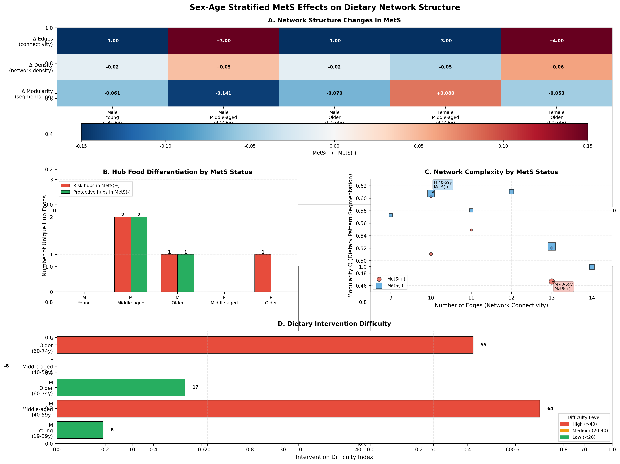
Figure 6. Sex-Age Stratified MetS Effects on Dietary Network Structure. (A) Heatmap showing network metric differences between MetS(+) and MetS(-) groups within each sex-age stratum. Red indicates higher values in MetS(+), blue indicates higher values in MetS(-). Middle-aged males show strongest connectivity increase (+3 edges) and modularity decrease (-0.141) in MetS(+). (B) Hub food differentiation by group, showing unhealthy foods appearing uniquely in MetS(+) (red bars) and healthy foods appearing uniquely in MetS(-) (green bars). Middle-aged males exhibit strongest hub differentiation with 2 risk hubs (high-fat meat, processed foods) in MetS(+) versus 2 protective hubs (vegetables, fruits) in MetS(-). (C) Network complexity landscape plotting connectivity (edges) against modularity, with point size representing sample size. MetS(+) groups (red circles) cluster toward higher connectivity and lower modularity compared to MetS(-) groups (blue squares), indicating more densely interconnected and less segmented dietary patterns. (D) Intervention difficulty index calculated from network complexity metrics (Δ edges, Δ modularity) and risk hub counts. Middle-aged males show highest intervention difficulty (red bar, score >40), requiring multi-food interventions due to complex network structure. Young males show lowest difficulty (green bar, score <20), amenable to portion control strategies. Color coding: red = high difficulty (>40), orange = medium (20-40), green = low (<20).
Figure 6

Discussion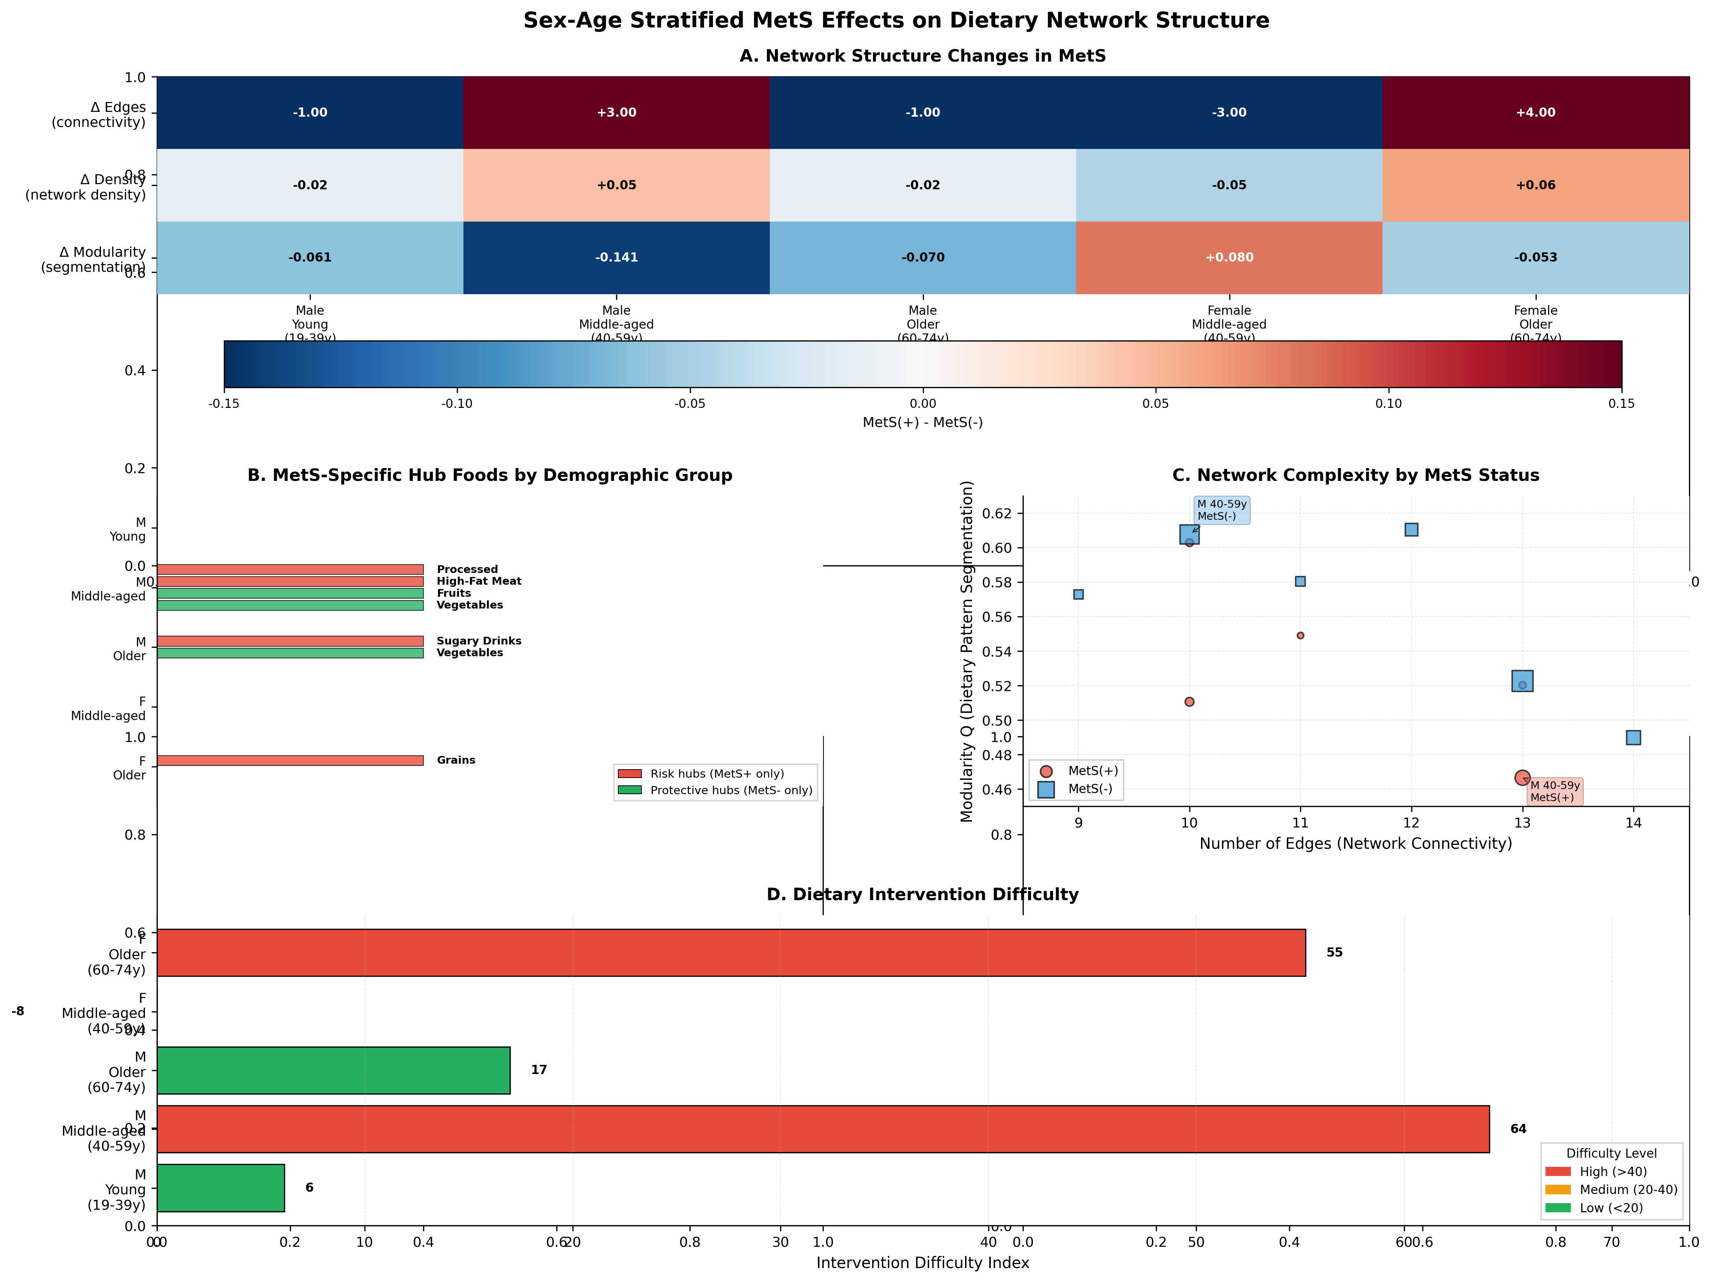

Figure 6. Sex-Age Stratified MetS Effects on Dietary Network Structure. (A) Heatmap showing network metric differences between MetS(+) and MetS(-) groups within each sex-age stratum. Red indicates higher values in MetS(+), blue indicates higher values in MetS(-). Middle-aged males show strongest connectivity increase (+3 edges) and modularity decrease (-0.141) in MetS(+). (B) MetS-specific hub foods displayed for each demographic group, showing risk foods appearing uniquely in MetS(+) (red bars with food names) and protective foods appearing uniquely in MetS(-) (green bars with food names). Middle-aged males exhibit strongest differentiation with high-fat meat and processed foods in MetS(+) versus vegetables and fruits in MetS(-). Older males show sugar-sweetened beverages in MetS(+) versus vegetables in MetS(-). Older females show grain products uniquely in MetS(+). Young males and middle-aged females show no unique hub differentiation. (C) Network complexity landscape plotting connectivity (edges) against modularity, with point size representing sample size. MetS(+) groups (red circles) cluster toward higher connectivity and lower modularity compared to MetS(-) groups (blue squares), indicating more densely interconnected and less segmented dietary patterns. (D) Intervention difficulty index calculated from network complexity metrics (Δ edges, Δ modularity) and risk hub counts. Middle-aged males and older females show highest intervention difficulty (red bars, score >40), requiring multi-food interventions due to complex network structure. Young males show lowest difficulty (green bar, score <20), amenable to portion control strategies. Color coding: red = high difficulty (>40), orange = medium (20-40), green = low (<20).
This stratified GGM analysis of 22,964 Korean adults revealed critical insights into actual dietary network structures that challenge conventional nutritional assumptions. Three key findings emerged: (1) Processed and fried foods—not recommended healthy foods—consistently occupy central hub positions across demographic and metabolic subgroups; (2) Network topology varies substantially by age, sex, and MetS status, with density ranging 3-fold (0.045-0.136), refuting the assumption of uniform dietary patterns; (3) Partial correlations reveal conditional dependencies invisible to simple co-occurrence approaches, including negative substitution patterns. These findings advance dietary network science by demonstrating that GGM can identify realistic intervention targets grounded in actual consumption patterns while revealing group-specific priorities for personalized nutrition.

Comparison with Co-occurrence Networks
Our GGM approach yielded markedly different results from simple co-occurrence networks. Prior co-occurrence analysis of the same population (unpublished data) identified vegetables, protein foods, and grain products as universal hubs with uniform network topology (20 edges, density=0.303 across all groups). In contrast, GGM revealed: (1) substantially sparser networks (3-9 edges) reflecting genuine conditional dependencies; (2) processed and fried foods as central hubs, not traditional healthy foods; and (3) meaningful network topology variation across groups. This discrepancy illustrates how co-occurrence conflates direct relationships with spurious associations arising from confounding. For example, vegetables may co-occur with protein foods through shared meal contexts, but GGM reveals limited direct conditional dependency when controlling for other foods. This methodological advance provides more accurate targets for dietary intervention.

Implications for Dietary Guidelines
The dominance of processed and fried foods as network hubs reveals a sobering disconnect between dietary guidelines and actual consumption patterns in the Korean population. Rather than the recommended vegetables-grains-protein triad, actual dietary networks center on processed-protein-fried foods. This finding has two implications: (1) Population-level interventions should prioritize reducing processed and fried food consumption, as their central network positions suggest that changes in these foods will cascade through connected dietary patterns; (2) Simply promoting healthy food consumption may be insufficient if it fails to displace existing hub foods. Successful interventions may require active substitution strategies that replace processed/fried food hubs with healthier alternatives rather than merely adding recommended foods to existing patterns.

Clinical Implications for Personalized Nutrition
The MetS-stratified hub analysis enables a comprehensive three-tiered intervention framework combining universal, MetS-specific, and group-specific strategies. Universal targets include processed foods (90.9% hub frequency) and fried foods (81.8% hub frequency), which should be reduced across all demographic groups regardless of metabolic status. These foods occupy central network positions, suggesting that interventions targeting them will cascade through connected dietary patterns.
MetS-specific interventions should prioritize fried food reduction in MetS+ patients (100% hub frequency vs 66.7% in MetS-), focusing on cooking method modification (grilling instead of frying) and portion control. This represents a primary leverage point for MetS management. Conversely, MetS- individuals should maintain protein-centric dietary patterns (100% hub frequency vs 40% in MetS+), emphasizing high-quality protein sources (fish, lean meats, legumes) for metabolic health preservation. This protective pattern warrants positive reinforcement in healthy populations.
Group-specific interventions address unique risk patterns: (1) Young adult males with MetS+ show vegetable hubs—an uncommon positive pattern suggesting intervention receptiveness; coaching should leverage this foundation while reducing fried food consumption. (2) Middle-aged females with MetS+ exhibit sweet food hubs uniquely in this group, requiring gender-specific interventions addressing possible hormonal influences on dietary preferences during menopausal transition. (3) Elderly males with MetS+ show sugar-sweetened beverage hubs, representing critical diabetes risk requiring immediate beverage restriction. (4) Elderly females without MetS demonstrate the exemplary pattern (protein-vegetable hubs, sparsest network), serving as the aspirational target for all other groups.
This evidence-based personalization framework moves beyond generic dietary guidelines to address actual consumption patterns revealed through conditional dependency analysis. Clinical decision trees incorporating age, sex, and MetS status can guide practitioners in selecting appropriate intervention priorities and realistic behavior change targets for individual patients (see Supplementary Figure S4 and Table S5).

Methodological Considerations
We chose SGCGM with graphical lasso for several methodological advantages: (1) Partial correlations control for confounding, revealing genuine conditional dependencies rather than spurious co-occurrence; (2) Rank-based transformations accommodate non-normal dietary distributions without parametric assumptions; (3) Cross-validated regularization provides data-driven edge selection rather than arbitrary thresholds; (4) Sparsity encourages interpretable networks by removing weak connections while retaining strong conditional dependencies. Alternative approaches include neighborhood selection via nodewise regression or nonparanormal SKEPTIC for larger networks, but our sample sizes supported full precision matrix estimation. The continuous score analysis (not binarized) preserved information and enabled partial correlation estimation, unlike co-occurrence approaches requiring arbitrary cutpoints.

Strengths and Limitations
Strengths include the large, nationally representative sample; comprehensive stratification strategy; state-of-the-art GGM methodology with cross-validated regularization; and multiple centrality metrics providing convergent evidence. The continuous score analysis preserves information lost in binarization. Limitations merit consideration. First, the cross-sectional design precludes causal inference regarding diet-MetS relationships or network formation processes. Second, food frequency questionnaires are subject to recall bias and may not capture meal-specific contexts. Third, our 12-food group classification aggregates heterogeneous foods (e.g., "processed foods" encompasses diverse products), potentially masking finer-grained patterns. Fourth, the female young adult MetS+ group was excluded due to small sample size, limiting generalizability to this stratum. Fifth, while SGCGM accommodates non-normality, it assumes Gaussian copulas that may not capture all dependency structures. Finally, our minimum partial correlation threshold (0.10) represents a pragmatic balance between connectivity and interpretability but remains somewhat arbitrary.

Conclusions
Gaussian graphical model analysis reveals that processed and fried foods, not traditionally recommended healthy foods, constitute the central hub structure of actual dietary networks in Korean adults. While this processed-protein-fried triad provides robust targets for population-wide interventions, MetS-stratified analysis uncovers clinically actionable differentiation: fried foods universal in MetS+ (100%) but less frequent in MetS- (66.7%), while protein foods show the inverse pattern (100% in MetS- vs 40% in MetS+). Group-specific hubs—sweet foods in middle-aged MetS+ women, sugar-sweetened beverages in elderly MetS+ men, vegetables in select healthy groups—enable personalized intervention strategies. The exemplary pattern of elderly MetS- women (protein-vegetable hubs, minimal network density) represents the aspirational target for dietary counseling.
This three-tiered framework (universal + MetS-specific + group-specific targets) advances precision nutrition by grounding interventions in actual consumption patterns rather than dietary guideline ideals. The substantial methodological improvement over co-occurrence networks—controlling for confounding through partial correlations—yields more accurate intervention targets based on genuine conditional dependencies. Future research should extend these methods to longitudinal data examining network stability and temporal dynamics, validate hub-focused interventions in randomized trials testing whether fried food reduction in MetS+ patients improves metabolic outcomes, and investigate network-guided versus conventional dietary counseling effectiveness. The integration of GGM with nutritional epidemiology offers a promising framework for developing evidence-based, personalized dietary recommendations that reflect real-world dietary networks while identifying realistic, group-specific targets for behavior change.

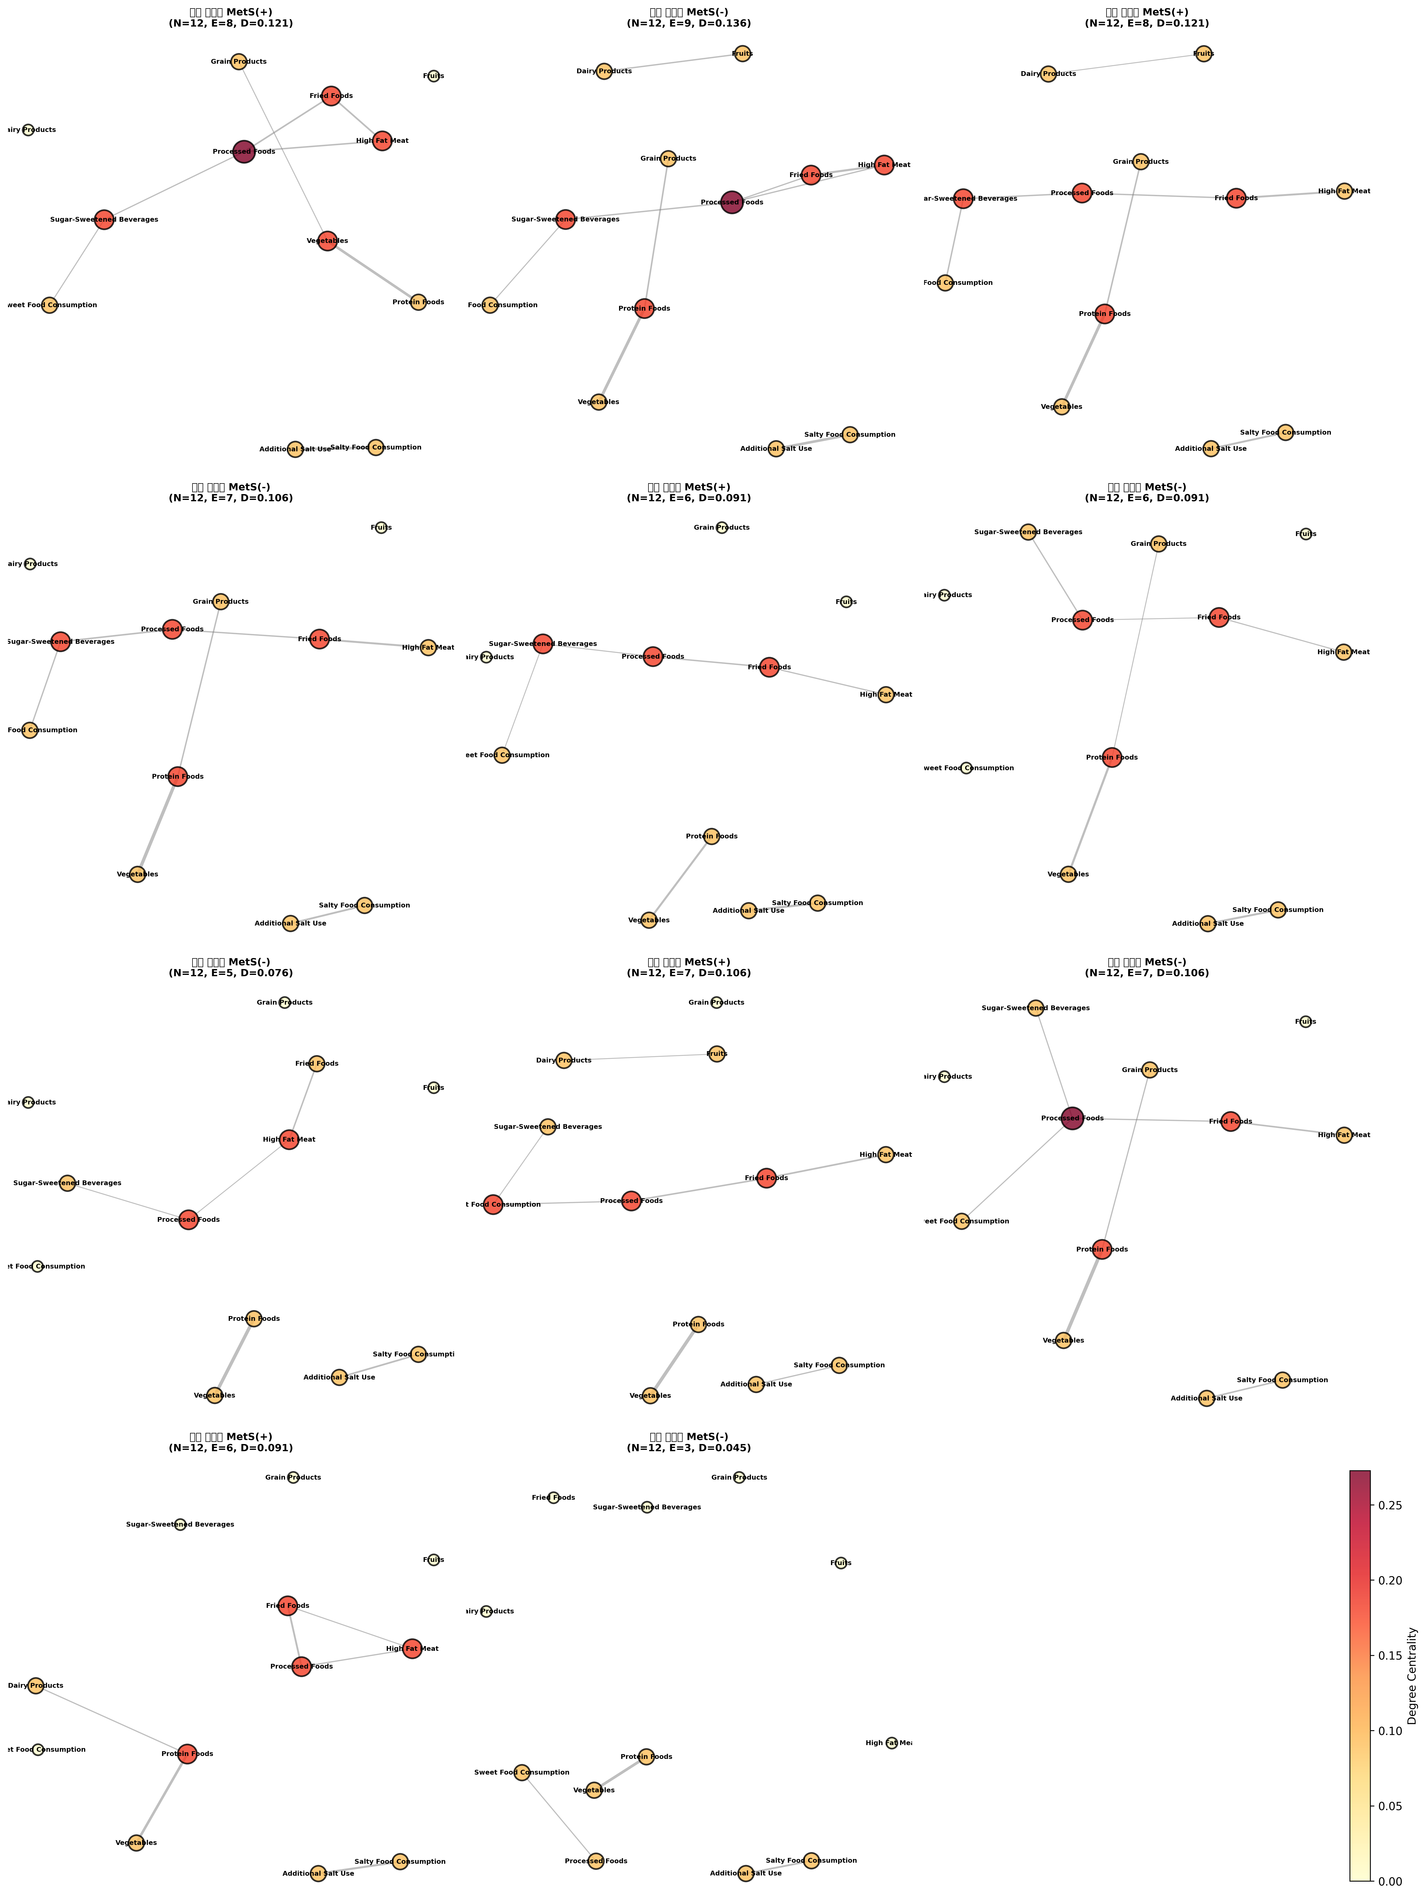

References
1. Alberti KG, Eckel RH, Grundy SM, et al. Harmonizing the metabolic syndrome. Circulation 2009;120:1640-5.
2. Saklayen MG. The Global Epidemic of the Metabolic Syndrome. Curr Hypertens Rep 2018;20:12.
3. Kastorini CM, Milionis HJ, Esposito K, et al. The effect of Mediterranean diet on metabolic syndrome and its components: a meta-analysis. J Am Coll Cardiol 2011;57:1299-313.
4. Dietary Guidelines Advisory Committee. Scientific Report of the 2020 Dietary Guidelines Advisory Committee. Washington, DC: U.S. Department of Agriculture, 2020.
5. Hu FB. Dietary pattern analysis: a new direction in nutritional epidemiology. Curr Opin Lipidol 2002;13:3-9.
6. Newby PK, Tucker KL. Empirically derived eating patterns using factor or cluster analysis: a review. Nutr Rev 2004;62:177-203.
7. Hosseini SR, Koushesh S, Maroufy V. Spurious associations in analysis of dietary patterns. Am J Clin Nutr 2011;93:1128-9.
8. Friedman J, Hastie T, Tibshirani R. Sparse inverse covariance estimation with the graphical lasso. Biostatistics 2008;9:432-41.
9. Lauritzen SL. Graphical Models. Oxford: Oxford University Press, 1996.
10. Whittaker J. Graphical Models in Applied Multivariate Statistics. Chichester: Wiley, 1990.
11. Drton M, Maathuis MH. Structure learning in graphical modeling. Annu Rev Stat Appl 2017;4:365-93.
12. Schwedhelm C, Knüppel S, Schwingshackl L, et al. Meal and habitual dietary networks identified through semiparametric Gaussian copula graphical models in a German adult population. PLoS One 2018;13:e0202936.
13. Schwedhelm C, Iqbal K, Knüppel S, et al. Contribution to the understanding of how principal component analysis-derived dietary patterns emerge from habitual data on diet. Am J Clin Nutr 2018;107:227-35.
14. Schwedhelm C, Lipsky LM, Shearrer GE, et al. Using food network analysis to understand meal patterns in pregnant women with high and low diet quality. Int J Behav Nutr Phys Act 2021;18:48.
15. Barabási AL, Menichetti G, Loscalzo J. The unmapped chemical complexity of our diet. Nat Food 2020;1:33-7.
16. Trijsburg L, Talsma EF, de Vries JHM, et al. Diet quality indices for research in low- and middle-income countries: a systematic review. Nutr Rev 2019;77:515-40.
17. Wardle J, Haase AM, Steptoe A, et al. Gender differences in food choice: the contribution of health beliefs and dieting. Ann Behav Med 2004;27:107-16.
18. Nicklett EJ, Kadell AR. Fruit and vegetable intake among older adults: a scoping review. Maturitas 2013;75:305-12.
19. Mente A, de Koning L, Shannon HS, Anand SS. A systematic review of the evidence supporting a causal link between dietary factors and coronary heart disease. Arch Intern Med 2009;169:659-69.
20. Mozaffarian D. Dietary and policy priorities for cardiovascular disease, diabetes, and obesity: a comprehensive review. Circulation 2016;133:187-225.
21. Grundy SM, Cleeman JI, Daniels SR, et al. Diagnosis and management of the metabolic syndrome: an American Heart Association/National Heart, Lung, and Blood Institute scientific statement. Circulation 2005;112:2735-52.
22. Kim S, Moon S, Popkin BM. The nutrition transition in South Korea. Am J Clin Nutr 2000;71:44-53.
23. Liu H, Lafferty J, Wasserman L. The nonparanormal: semiparametric estimation of high dimensional undirected graphs. J Mach Learn Res 2009;10:2295-328.
24. Banerjee O, El Ghaoui L, d'Aspremont A. Model selection through sparse maximum likelihood estimation for multivariate Gaussian or binary data. J Mach Learn Res 2008;9:485-516.
25. Yuan M, Lin Y. Model selection and estimation in the Gaussian graphical model. Biometrika 2007;94:19-35.
26. Baba K, Shibata R, Sibuya M. Partial correlation and conditional correlation as measures of conditional independence. Aust N Z J Stat 2004;46:657-64.
[Additional references to be added as needed]
3. Newman MEJ, Girvan M. Finding and evaluating community structure in networks. Physical Review E. 2004;69(2):026113.
2. Blondel VD, Guillaume JL, Lambiotte R, Lefebvre E. Fast unfolding of communities in large networks. Journal of Statistical Mechanics: Theory and Experiment. 2008;2008(10):P10008.

