Time-Division Measurement and Embedded-AI Signal Decoupling for a Soft Single-Electrode Multimodal Sensor: Simultaneous Estimation of Strain, Proximity, and Contact Force
Heejun Moon
BioRobotics and Control Laboratory (BiRC), Department of Mechanical Engineering, Korea University, Seoul, Republic of Korea
Abstract
Flexible multimodal sensors suffer from signal coupling: several physical stimuli are superimposed on the same electrical readout, which makes independent measurement of each stimulus difficult. This work proposes a measurement architecture in which a single planar spiral coil, printed from eutectic gallium-indium (EGaIn) liquid metal by direct ink writing (DIW) and connected through only two wires, is used simultaneously as three signal sources: inductance L, DC resistance R, and triboelectric (TENG) voltage V. A 1 ms time-division measurement (TDM) schedule, driven by a TIM7 interrupt on an STM32G473CBT6 microcontroller, sequentially connects the same coil to the three measurement paths through an analog multiplexer while running I²C DMA and ADC DMA in parallel, sustaining a 1 kHz acquisition rate. Gridded measurements over a two-dimensional parameter space of 0–30 % strain and 0–52 mm proximity, for both a conductive (metal) and a dielectric (hand) target, quantitatively confirm an asymmetry: ΔR/R₀ depends monotonically on strain alone and is essentially independent of proximity, whereas ΔL/L₀ depends on both. This asymmetry is the physical basis for decoupling. Extending the modality set to contact introduced viscoelastic hysteresis and creep together with a strain-force cross-sensitivity; a standard linear solid (SLS) model was fitted to the measured dwell relaxation, giving a time constant of τ = 1.0 s that was encoded into the model as a causal exponential-moving-average (EMA) history feature. The final decoupler is a mixture-of-experts (MoE) network consisting of a contact-detection gate and two mode-specific experts, totalling only 1,413 parameters, and was embedded on the MCU through X-CUBE-AI. Inference runs on the board itself once per TDM cycle with a measured median latency of 260 µs (95th percentile 263 µs), completing well inside the 1 ms period. In segments where the proximity axis was actually moving, on-hardware accuracy reached R² = 0.981 (RMSE 1.37 %p) for strain, R² = 0.940 (RMSE 2.11 mm) for distance and 1.80 N RMSE for contact force, with gate accuracy of 98–99 %. In quasi-static proximity segments, by contrast, the signal-to-noise ratio of the distance estimate collapsed and R² became negative; this is a hardware-specific limitation invisible to offline held-out evaluation and is reported here as measured. The study presents the complete pipeline — design, fabrication, data acquisition, modelling and embedded deployment — of a single-electrode multimodal sensing system that operates without a host PC.
Index Terms - Soft sensor, liquid metal (EGaIn), single electrode, multimodal sensing, signal decoupling, time-division measurement, mixture of experts, physics-informed neural network, edge AI, STM32
1. Introduction
As robots increasingly share workspaces with people, sensors are required that can detect an approaching object before contact occurs, measure the contact force once contact is established, and at the same time perceive their own deformation. Implementing all three with rigid sensors requires separate proximity, tactile and strain devices, and such assemblies are difficult to apply to curved or highly deformable surfaces. Flexible sensors remove this constraint, but reading several physical quantities from a single compliant element inevitably introduces signal coupling.
Existing decoupling strategies fall into three groups. (i) Material-level designs engineer composites so that responses to different stimuli separate, but the processes are complex and poorly generalizable. (ii) Structural designs separate layers or multiply electrodes, at the cost of additional wiring and reduced compliance and reliability. (iii) Data-driven approaches learn the inverse mapping, but inference is usually performed on a host PC, where a 20–40 ms USB round trip precludes real-time feedback control. Moreover, most inductive flexible sensor studies rely on benchtop instruments such as LCR meters and are therefore unsuitable for mobile applications.
The present work belongs to the third group but differs in three respects. First, the physical asymmetry is verified by measurement and encoded directly into the model architecture. Second, inference is executed inside the MCU, eliminating the host PC entirely. Third, offline held-out performance and on-hardware performance are reported separately, and the segments where the two diverge — together with the cause — are stated explicitly. The contributions are as follows.
- A TDM measurement architecture that acquires L, R and V_TENG every 1 ms from a two-wire single-electrode EGaIn spiral coil, together with a dedicated six-layer PCB and ISR-driven non-blocking firmware.
- An automated acquisition platform combining a five-axis stepper stage and a six-axis force/torque sensor with PC-MCU time synchronization and steady-state tagging, yielding synchronized multi-stimulus datasets of more than 300,000 rows.
- Gridded (strain, distance) response surfaces for conductive and dielectric targets, quantitatively establishing the strain-only dependence of R and the joint dependence of L.
- Identification of the viscoelastic relaxation observed in the contact regime with a standard linear solid model, and conversion of its time constant into a causal EMA feature that halved the force prediction error.
- Embedding of a 1,413-parameter MoE decoupler on the STM32 with a measured 260 µs inference time, and a report of the failure mode revealed only on hardware (a self-reinforcing EMA loop) together with its correction.
2. Sensor Design and Physical Principles
2.1 Single-Electrode EGaIn Spiral Coil
The sensing electrode is a planar rectangular spiral coil printed from EGaIn liquid metal onto an elastomer substrate by direct ink writing (DIW). The liquid metal maintains a continuous conductive path under large deformation, permitting repeated use up to 30 % strain, and the coil geometry lets a single conductive trace act simultaneously as a resistive element and as an inductor. The initial effective length of the sensor is 120 mm, and tensile tests were performed over 0–36 mm of elongation (0–30 % strain). The coil connects to the readout circuit through two wires only; it is single-electrode in the sense that no separate ground or counter electrode is required.
2.2 Generation Mechanisms of the Three Signals
Three signals are generated from the same coil through distinct physical mechanisms.
- DC resistance R - stretching increases the conductor length and reduces its cross-section, raising the resistance. A nearby object does not alter the conductive path, so R is in principle independent of proximity.
- Inductance L - the self-inductance of the coil depends on its geometry (turn area and perimeter) and therefore responds to strain. At the same time, an approaching conductor lowers the effective inductance through eddy-current reflected impedance, while an approaching dielectric shifts the resonant frequency through a change in parasitic capacitance. L therefore depends on both strain and proximity.
- TENG voltage V - a self-generated voltage produced by the triboelectric effect during surface contact and separation, marking the instant at which a contact event occurs. It was not used as a decoupler input in this work (Section 3.1) and was retained only as an acquisition channel.
The inductance is derived from the resonant frequency f of the LC tank measured by the LDC1614. Since f is proportional to 1/√L, the relative change with respect to a reference state is computed as
ΔL/L₀ = (f₀ / f)² − 1, ΔR/R₀ = (r − r₀) / r₀
Here f₀ and r₀ are session-wise median baselines taken in the undeformed, maximum-separation condition. Baselines are re-estimated for every session because the initial resistance of a liquid-metal sensor varies by a few percent with remounting and temperature.
2.3 Coupling Structure and the Decoupling Premise
The following reflected-impedance formulation is commonly used as a theoretical model.
L(ε, d) = L_self(ε) − ω²M(ε,d)²·L_t / (R_t² + ω²L_t²)
R_s(ε, d) = R_DC(ε) + ω²M(ε,d)²·R_t / (R_t² + ω²L_t²)
Inverting these expressions directly, however, requires an analytical form for the mutual inductance M(strain, d), and the Jacobian becomes singular in the extreme regime of short distance and large deformation, producing numerical divergence. This work instead adopts the empirical fitting model
ΔR/R₀ = α₁ε + α₂ε², ΔL/L₀ = β₁ε + β₂/(d+d₀)^k + β₃·ε/(d+d₀)
and uses it only as a constraint term in the training loss rather than for analytical inversion (Section 6.1). The premise for decoupling is the structural asymmetry of these two expressions - R is a function of strain alone while L is a function of both strain and distance — and Section 5 verifies by measurement whether that premise actually holds.
3. Measurement System
3.1 Time-Division Measurement Firmware
Reading a single coil in three different ways requires the measurement paths to be separated in time. Figure 1 shows the signal path together with the 1 ms TDM schedule. When TIM7 fires every 1 ms, two paths start concurrently. The I²C path reads the 28-bit resonant-frequency registers of the LDC1614 through chained DMA transfers, completing in about 200 µs, while the ADC path switches the ADG734 multiplexer to TENG mode and starts TIM6. When TIM6 expires after 150 µs the TENG value is latched and the multiplexer is switched to resistance mode (switching time 29 ns); after a further 150 µs the resistance value is latched. Whichever path finishes last sets the update flag and returns the state machine to IDLE. Because all transfers use DMA there is no blocking wait, and the CPU idle fraction was 93.9 % before inference was added.
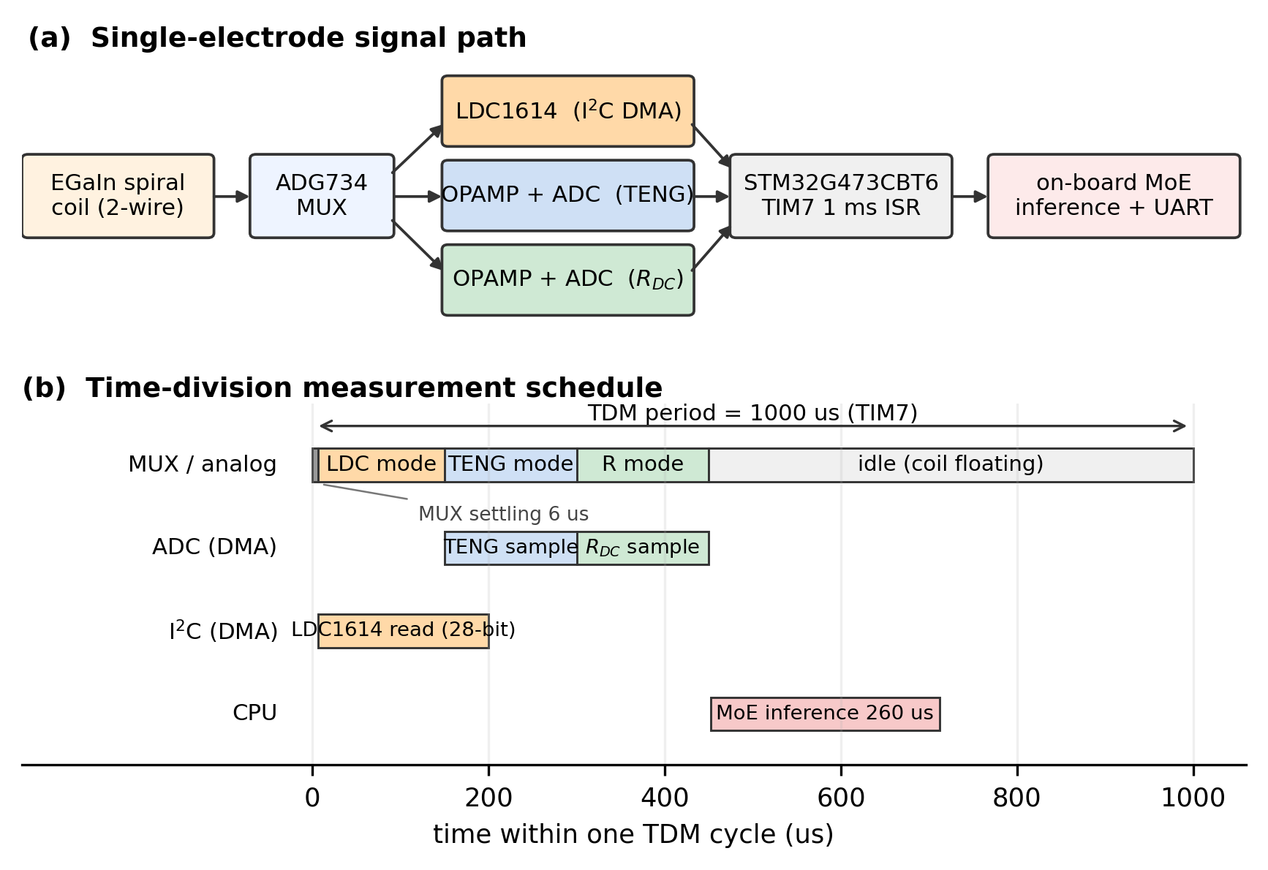
Fig. 1. (a) Single-electrode signal path. The same EGaIn coil is connected in turn to the LDC1614, the TENG ADC and the resistance ADC through an ADG734 analog multiplexer. (b) The 1 ms TDM schedule. I²C DMA and ADC DMA proceed in parallel, and MoE inference (measured at 260 µs) runs in the remaining time.
3.2 Multisignal Switching PCB
The dedicated board is a 65 × 52 mm six-layer design produced in EasyEDA Pro. The main MCU is an STM32G473CBT6 (Cortex-M4F, 170 MHz, 128 KB flash, 32 KB SRAM); inductance is measured by an LDC1614 (I2C2, address 0x2A, 28-bit output) and the signal path is switched by ADG734 four-channel analog switches. Each channel's ADC input is buffered by an operational amplifier, and the board supports up to four simultaneous channels (all experiments in this work used one). Three multiplexer states are defined: with SW1/SW2 high the coil is connected to the LDC resonant circuit; with all switches low the coil floats so that the TENG voltage can be read; with SW3/SW4 high a voltage divider is engaged for DC resistance. The USB-UART interface is used for data streaming and is not required for system operation.
3.3 Five-Axis Test Platform and Synchronized Acquisition
A five-axis stepper positioning stage was built in-house so that strain and proximity/contact could be controlled independently. Four axes (XA/XB/YA/YB) stretch the sensor symmetrically while the Z axis moves the target perpendicular to the sensor surface. Arduino firmware based on AccelStepper handles absolute and relative moves, homing and limit-switch alarms, and a PyQt5 GUI drives the sequence from a script. The default conversion is 200 steps/rev × 8 microsteps / 5 mm pitch = 320 steps/mm.
Early experiments logged the PC and the MCU asynchronously and interpolated between extracted peaks, which misaligned position labels and sensor signals during stepper acceleration and deceleration. A synchronized acquisition system was therefore built in which the PC aligns motor-command timestamps and the MCU stream on a common time base and automatically tags acceleration transients as is_steady = 0. Ground-truth contact force was recorded simultaneously with a six-axis force/torque sensor. Because the F/T zero drifted by a few hundred millinewtons between sessions, the mean of the non-contact region (z >= 0) was removed as a session-wise offset before the force was used as a label.
4. Datasets
Five datasets were acquired in sequence as the study progressed; their purposes and sizes are summarized in Table 1. The only quantities available to the model as inputs are always (ΔL/L₀, ΔR/R₀) and values computable causally from them; stage positions and F/T forces were used solely as ground-truth labels.
Table 1. Summary of the datasets.
Dataset | Protocol | Size | Purpose
D1 (0332) | 37 strain levels (1 mm steps), continuous 50->0 mm proximity, asynchronous | approx. 78,000 rows | initial two-stage PINN training
D2 (P1/P2) | P1: 19 strain levels × continuous proximity sweep; P2: 13 proximity levels x strain sweep (2 reps) | metal 45,633 rows / hand 37,116 rows | characterization of the (strain, d) response surface
D3 (0519) | two continuous simultaneous sweeps (ramp / oscillate), PC-MCU synchronized | 188,232 rows -> 33,450 after preprocessing | training of the proximity + strain decoupler
D4 (0806) | 19 strain levels × proximity-to-contact sweep with simultaneous F/T recording, up to 10.1 N | 51,858 rows / 569 s | contact physics analysis and MoE training
D5 (0819) | three on-hardware validation sessions: Part 1 proximity sweeps, Part 2 strain sweeps, Part 3 simultaneous | 26,673 / 34,016 / 32,556 rows | embedded real-time validation

Preprocessing of D3 proceeded as follows. (1) Baselines L₀ and R₀ were re-extracted as medians over the region with strain < 0.5 % and distance > 35 mm, and ΔL and ΔR were recomputed. (2) LDC1614 register saturation (0x0FFFFFFF) and physically impossible ranges (|ΔL| > 30 %, ΔR outside (-5, 30) %) were removed. (3) The (strain, d) plane was divided into a 24 × 24 grid and capped at 30 samples per cell to correct over-representation. (4) The two sessions were merged, shuffled and split 70/15/15. Training on raw signals rather than IIR-filtered ones was a deliberate choice: an IIR filter with α = 0.02 has a time constant of about 500 ms, which at a traverse speed of 10 mm/s corresponds to a 5 mm phase lag, so that delayed inputs would be mapped onto present-time labels and dynamic-segment error would grow.
5. Signal Characterization
5.1 (Strain, Distance) Response Surfaces
Figure 2 shows the response surfaces obtained by grid-averaging D2. For the metal target the contours of ΔR (Fig. 2b) are essentially parallel to the distance axis, confirming by measurement the premise of Section 2.3 that resistance depends on strain alone. The contours of ΔL (Fig. 2a), by contrast, bend sharply for d < 10 mm and, at a fixed strain, vary from -15.7 % to +14.5 % - changing sign — as the distance changes. This strong curvature is the component that encodes proximity information in the inductance.
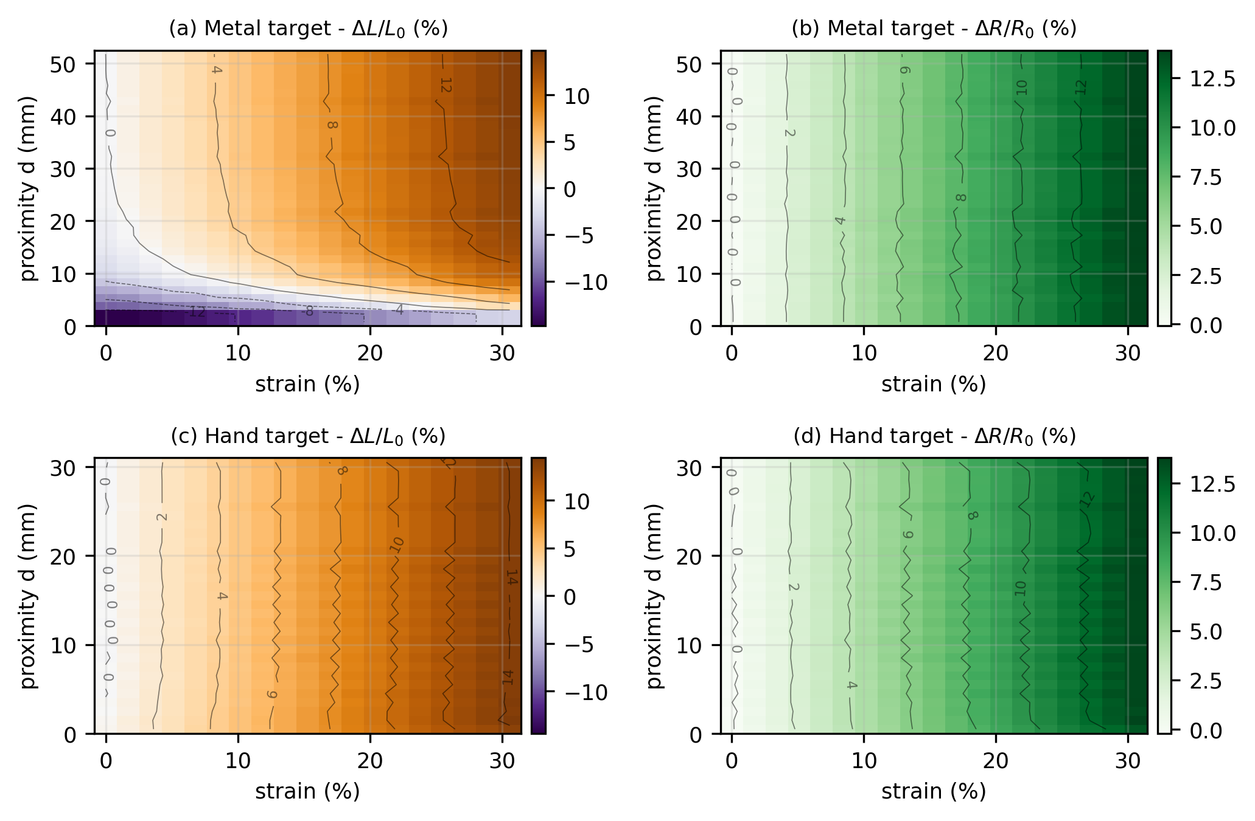
Fig. 2. Signal response surfaces over strain and proximity (D2, grid-averaged). (a),(b) Metal target: ΔL depends strongly on distance whereas the contours of ΔR are vertical (strain only). (c),(d) Hand target: contours of both signals are nearly vertical, indicating that for a dielectric target the proximity information carried by the inductance is weak over this distance range.
The difference between targets follows from the underlying mechanism. For metal, eddy-current loss dominates and the effective inductance drops substantially on approach; for a hand (a dielectric), only the parasitic capacitance changes, so ΔL remains positive and small. The nearly vertical ΔL contours for the hand target in Fig. 2c mean that, under these conditions, the inductance behaves essentially as a strain sensor alone, and proximity decoupling for dielectric targets is therefore fundamentally harder than for conductive ones. All subsequent modelling targets the conductive case.
5.2 Viscoelasticity in the Contact Regime
Adding the contact modality produced three phenomena absent from the non-contact experiments. First, within the same cycle and at the same depth, the sample-to-sample standard deviation of the inductance grew about fivefold, from 0.09 %p to 0.52 %p, as compression deepened. Since the resistance measurement is a simple voltage division independent of resonance quality while only the inductance measurement depends on the resonant frequency, this asymmetry is interpreted as a reduction of the coil Q factor caused by the local cross-section reduction under compression.
Second, hysteresis was observed between the loading and unloading paths (Figs. 3a, 3b). While the depth was held constant (dwell), ΔL drifted by a further 2.33 %p and ΔR by 5.73 %p, whereas the residuals after full unloading were only 0.57 %p and 0.08 %p respectively. Most of the change is therefore a reversible time-lag component rather than permanent damage. This behaviour matches a standard linear solid (SLS) model in which an instantaneous elastic component and a time-relaxing viscous component act in parallel. During a constant-depth dwell the solution of the governing equation τ·dσ/dt + σ = E·ε is an exponential relaxation; a least-squares fit to the measured dwell curve gave τ = 0.93 s (Fig. 3c). Channel-wise fits over the whole dataset gave τ_L = 1.33 s, τ_R = 0.59 s and a combined τ = 1.01 s.
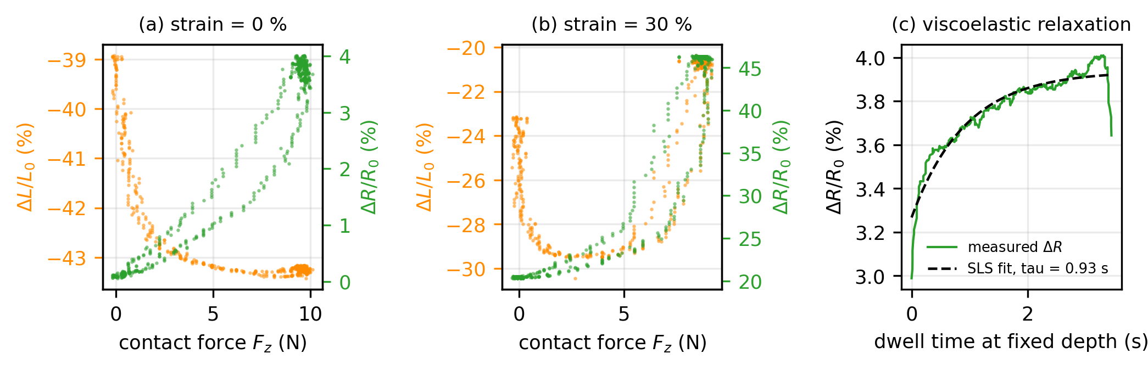
Fig. 3. Signal behaviour in the contact regime (D4). (a) Loading to 10.1 N at zero strain: the ΔR span is only 3.95 %p. (b) Loading to 9.2 N at 30 % strain: the ΔR span grows 6.6-fold to 26.14 %p, and ΔL falls to -30.4 % before reversing to -20.7 % near peak force. The separation of the loading and unloading paths is the hysteresis. (c) Relaxation of ΔR during a constant-depth dwell with an SLS exponential fit (τ = 0.93 s).
5.3 Strain-Force Cross-Sensitivity
The third finding, which most strongly shaped the model design, is that the strain state changes the pressure sensitivity itself. As Fig. 3 shows, applying 10 N at zero strain moves ΔR by only 3.95 %p, whereas at 30 % strain a comparable force moves it by 26.14 %p, a factor of about 6.6. The assumption R_theory(ε) = α₁ε + α₂ε² of Section 2.3 therefore fails when pressure is applied simultaneously, and a strain-force cross term is required. A linear approximation of the two sensitivity directions gives (ΔL, ΔR) = (+0.635, +0.664) per %p of strain and (+2.070, +11.575) per newton of contact force; the angle between the vectors is 33.6 degrees and the condition number is about 23. The two stimuli are therefore not perfectly degenerate, but the problem is poorly conditioned for linear inversion. Indeed, physics-only inversion achieved a coefficient of determination of just 0.26 (Appendix S3).
6. Decoupling Models
6.1 Two-Stage Physics-Informed Decoupler
Transferring the asymmetry established in Section 5.1 directly into the architecture yields a two-stage estimator: stage 1 estimates strain from ΔR alone, and stage 2 receives both ΔL and the estimated strain to predict distance. The structure imposes the physical fact that resistance is a function of strain only as an inductive bias, and is therefore advantageous over a single end-to-end model at equal parameter budget. In a fair comparison at approximately 50 K parameters the two-stage model achieved a proximity MAE of 1.783 mm against 1.827 mm for the end-to-end model.
When trained as a physics-informed neural network (PINN), a physics residual is added to the data loss.
L_total = L_data + λ · L_phys
L_phys = MSE(R_theory(ε̂), ΔR) + MSE(L_theory(ε̂, d̂), ΔL)
The weight λ was held at zero for the first 50 epochs and then increased linearly to 0.10, so that the initial convergence direction is set by the data loss alone before the physics constraint is applied progressively. To avoid a singularity, d₀ and k were constrained positive through a softplus. Training with 818 network parameters and 7 physical parameters gave test MAEs of 0.356 % for strain and 1.797 mm for distance, improving to 0.337 mm for d <= 15 mm and 0.200 mm for d <= 10 mm within the useful proximity range. With ample data, however, the isolated contribution of the physics loss was small (0.01 mm improvement in proximity MAE); its practical value appears to lie less in accuracy than in suppressing divergence in extrapolation regions.
6.2 Architecture Search and Quantization
To minimize embedding cost, thirteen network sizes were trained with the same two-stage structure to map the trade-off between parameter count and accuracy (Fig. 4). Even the smallest 46-parameter model reached a proximity MAE of 2.115 mm, and a 978-parameter medium-deep configuration sat at the Pareto knee with 1.765 mm. Increasing the parameter count to 10,946 gave no improvement (1.773 mm), confirming that the intrinsic difficulty of the problem is set by the data and the physics rather than by model capacity. Relative to the 50,306-parameter scikit-learn model used for the first deployment, medium-deep reduces parameters by 47x, weight ROM by 29x and activation SRAM by 53x for a proximity MAE penalty of only 0.09 mm. Post-training INT8 quantization error was 0.020 % in strain and 0.032 mm in distance, below the sensor noise floor.
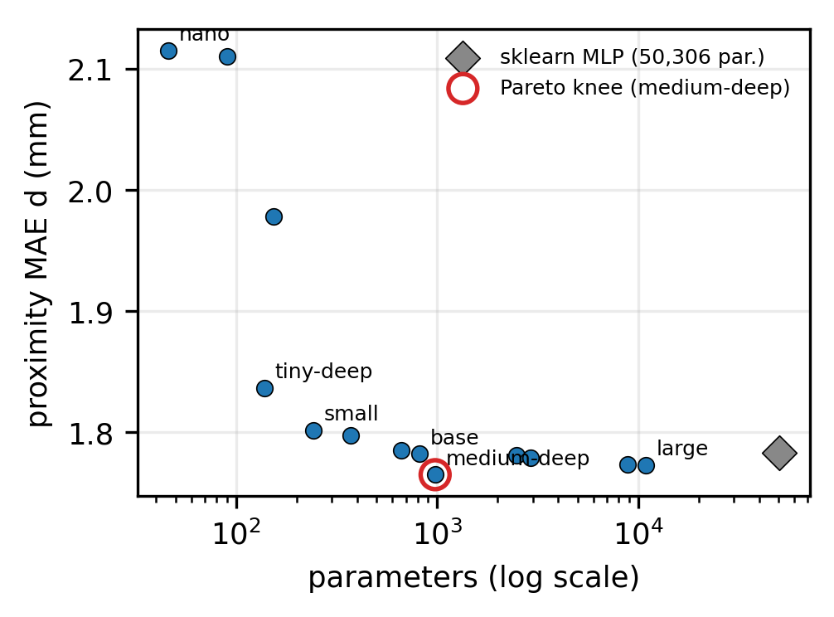
Fig. 4. Architecture search for the two-stage decoupler. The horizontal axis is the parameter count (log scale) and the vertical axis the proximity MAE. The 978-parameter medium-deep configuration lies at the Pareto knee, within 0.09 mm of the 50,306-parameter model.
6.3 History Features Derived from Viscoelasticity
As established in Section 5.2, the signal in the contact regime is not determined by the instantaneous depth alone but also by how long the sensor has been compressed. A model that receives only instantaneous values therefore cannot in principle recover this information. Starting from the exponential relaxation solution of the SLS model, a weighted average in which the contribution of past samples decays as exp(−Δt/τ) — that is, a causal exponential moving average — follows naturally. In a real-time implementation it is computed by the recursion yₙ = yₙ₋₁ + α(xₙ − yₙ₋₁), requiring one multiplication and one state variable, so its cost on the MCU is effectively zero. The half-life corresponding to τ = 1.01 s is 0.702 s.
Adding this single feature reduced the RMSE of the contact-force prediction from 0.521 N to 0.240 N, less than half. For reference, the F/T sensor used as ground truth itself fluctuates by ±0.19 N under the same conditions, so this error is close to the measurement limit of the label.
6.4 Gate-Expert (MoE) Architecture
The non-contact and contact regimes differ in the very quantities to be produced: the former requires (strain, distance) and the latter (strain, force), and the input-output relations also differ in form. Forcing a single regressor to cover both degrades accuracy in each, so a mixture-of-experts architecture was adopted in which contact is classified first and the regression is then delegated to a regime-specific expert (Fig. 5). Six candidate structures compared under the same cycle-wise held-out split are summarized in Table 2.
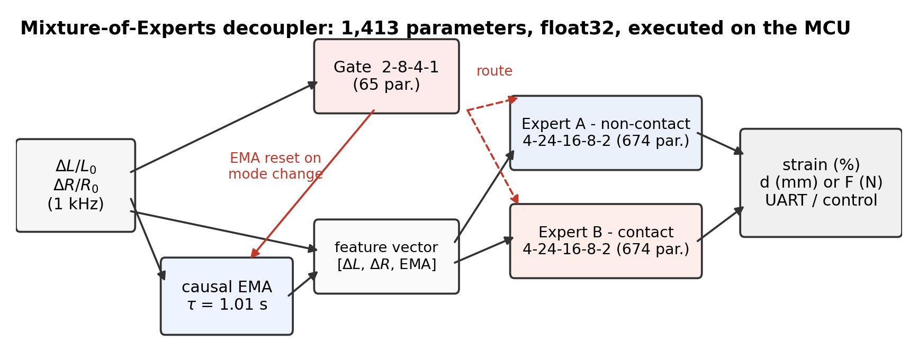
Fig. 5. Structure of the MoE decoupler. The gate observes only the raw (ΔL, ΔR) pair to decide contact, and its decision immediately resets the EMA within the same cycle before the corresponding expert is executed. Total: 1,413 parameters.
Table 2. Comparison of MoE candidates (D4, cycle-wise held-out).
Candidate | Gate acc. | Distance RMSE | Force RMSE | Overall strain RMSE | Param.
C1 baseline (no history) | 0.982 | 0.410 mm | 0.521 N | 0.194 %p | 1,317
C2 gate + EMA | 1.000 | 0.318 mm | 0.253 N | 0.108 %p | 1,429
C3 unified MLP | — | 0.322 mm | — | 0.288 %p | 1,506
C4 physics + residual | — | — | 0.314 N | — | 704
C5 multi-τ | 0.999 | 0.259 mm | 0.240 N | 0.215 %p | 1,765
C5b GRU (pressure expert) | — | — | 0.263 N | — | 306
C6 hybrid | 1.000 | 0.318 mm | 0.263 N | 0.123 %p | 1,061

Four observations follow. First, contact detection is not the hard part: even without history features accuracy reaches 98.2 %, because ΔL and ΔR bend sharply at the instant of contact. Second, the benefit of history features is concentrated in force rather than strain prediction. Third, purely physics-based inversion (C4) fell far short of the learned models even on high-quality data. Fourth, the GRU (C5b) was essentially tied with the EMA-based models in accuracy while using only 306 parameters — the recurrent network compressed, into a smaller representation, the same information supplied manually through a hand-chosen τ. Nevertheless C2 was selected for deployment because dense layers are the most mature path in X-CUBE-AI and require no hidden state to be carried between calls, eliminating the risk of error accumulation under quantization.
7. Embedded Implementation
7.1 Deployment Pipeline
The trained scikit-learn models were converted to ONNX with skl2onnx and then generated as STM32 C code with ST's stedgeai tool. Numerical verification between scikit-learn and ONNX agreed to better than 1e-6 for the gate and 1e-5 for the experts. The StandardScaler was not embedded in the ONNX graph; instead the mean and scale constants were exported as a C header and the normalization is performed directly in firmware. Because the gate and the two experts use independently fitted scalers, three constant sets appear in the header. In firmware, moe_inference_run(ΔL, ΔR) is called once per TDM cycle and executes gate -> EMA update -> expert in that order, after which the result is streamed over UART. Inference time is measured directly with the DWT cycle counter.
7.2 Resource Usage and Latency
Table 3 summarizes the resource usage of the embedded implementation. The 50 K parameter INT8 model deployed initially had 52 KB of weights that did not fit in the instruction cache, incurring flash wait states and a measured inference time of 1,068 µs — exceeding the TDM period — at 3.56 cycles per MAC. The MoE model, by contrast, has only 5.7 KB of weights that stay resident in cache, and its measured latency is 260.4 µs median with a 95th percentile of 262.5 µs, completing comfortably within the 1 ms period. That the spread is only about 2 µs means the architecture is usable in a deterministic control loop. By comparison, performing the same inference on a host PC incurs 20–40 ms of USB round-trip delay with ±5–15 ms of jitter.
Table 3. Embedded resource comparison on the STM32G473CBT6 (170 MHz, 128 KB flash, 32 KB SRAM).
Item | sklearn two-stage INT8 (first deployment) | MoE float32 (final)
Parameters | 50,306 | 1,413
MACs per inference | 50,306 | 2,510 (gate 202 + experts 1,154 × 2)
Weight ROM | ~52 KB | 5.66 KB (272 B + 2,696 B × 2)
Activation SRAM | 15.3 KB | 368 B
Total flash (with firmware) | 112.5 KB (85.8 %) | 83.5 KB (65.2 %)
Inference latency (DWT) | 1,068 µs | 260 µs median, 263 µs p95
Completes within TDM period | no | yes

7.3 A Failure Mode Visible Only on Hardware
The gate deployed first had four inputs including the EMA features and achieved 100.0 % held-out accuracy offline. When the board was physically pressed and released, however, the gate kept reporting contact for some time after release. The cause was a mismatch between the training and deployment conditions. During training the EMA was reset at the exact instant the true contact label (from z_mm) changed, but the deployed board has no such ground truth and had to approximate it by resetting whenever the gate's own decision changed. This produced a self-reinforcing loop: on release the raw ΔL and ΔR change immediately while the EMA remains at the pressed value for about τ = 1 s; the gate, observing that stale EMA, continues to report contact; and because its decision does not change, the reset condition is never triggered.
The remedy was to revert the gate to a two-input form without EMA features. Contact is an inherently instantaneous physical transition with no reason to be smoothed, and with this change the loop cannot form. The firmware execution order was also changed to gate first, then an immediate same-cycle decision on whether to reset the EMA, then the expert, removing the previous one-cycle delay. Experts A and B, where history genuinely helps regression, retained their four inputs. The substitution lowered offline gate accuracy from 100.0 % to 98.2 % but restored correct behaviour on hardware. Because the offline metric relied on an assumption that cannot be reproduced at deployment, this case shows that embedded validation cannot be replaced by offline evaluation.
8. Real-Time Validation
8.1 Validation Protocol
Validation was performed on three continuous sessions (D5) acquired separately from those used for training. Each session has three parts. In Part 1 (0–398 s) the strain is held at stepped values while the Z axis repeatedly travels between 25 mm and contact; in Part 2 (400–730 s) the distance is held fixed while the strain is swept repeatedly over 0–30 %; and in Part 3 (from 738 s) both axes move together. This structure isolates the performance when each axis varies alone from that when both vary. All reported figures compare the board's own estimates, streamed over UART, against stage and F/T ground truth; no post-hoc inference was performed on the PC.
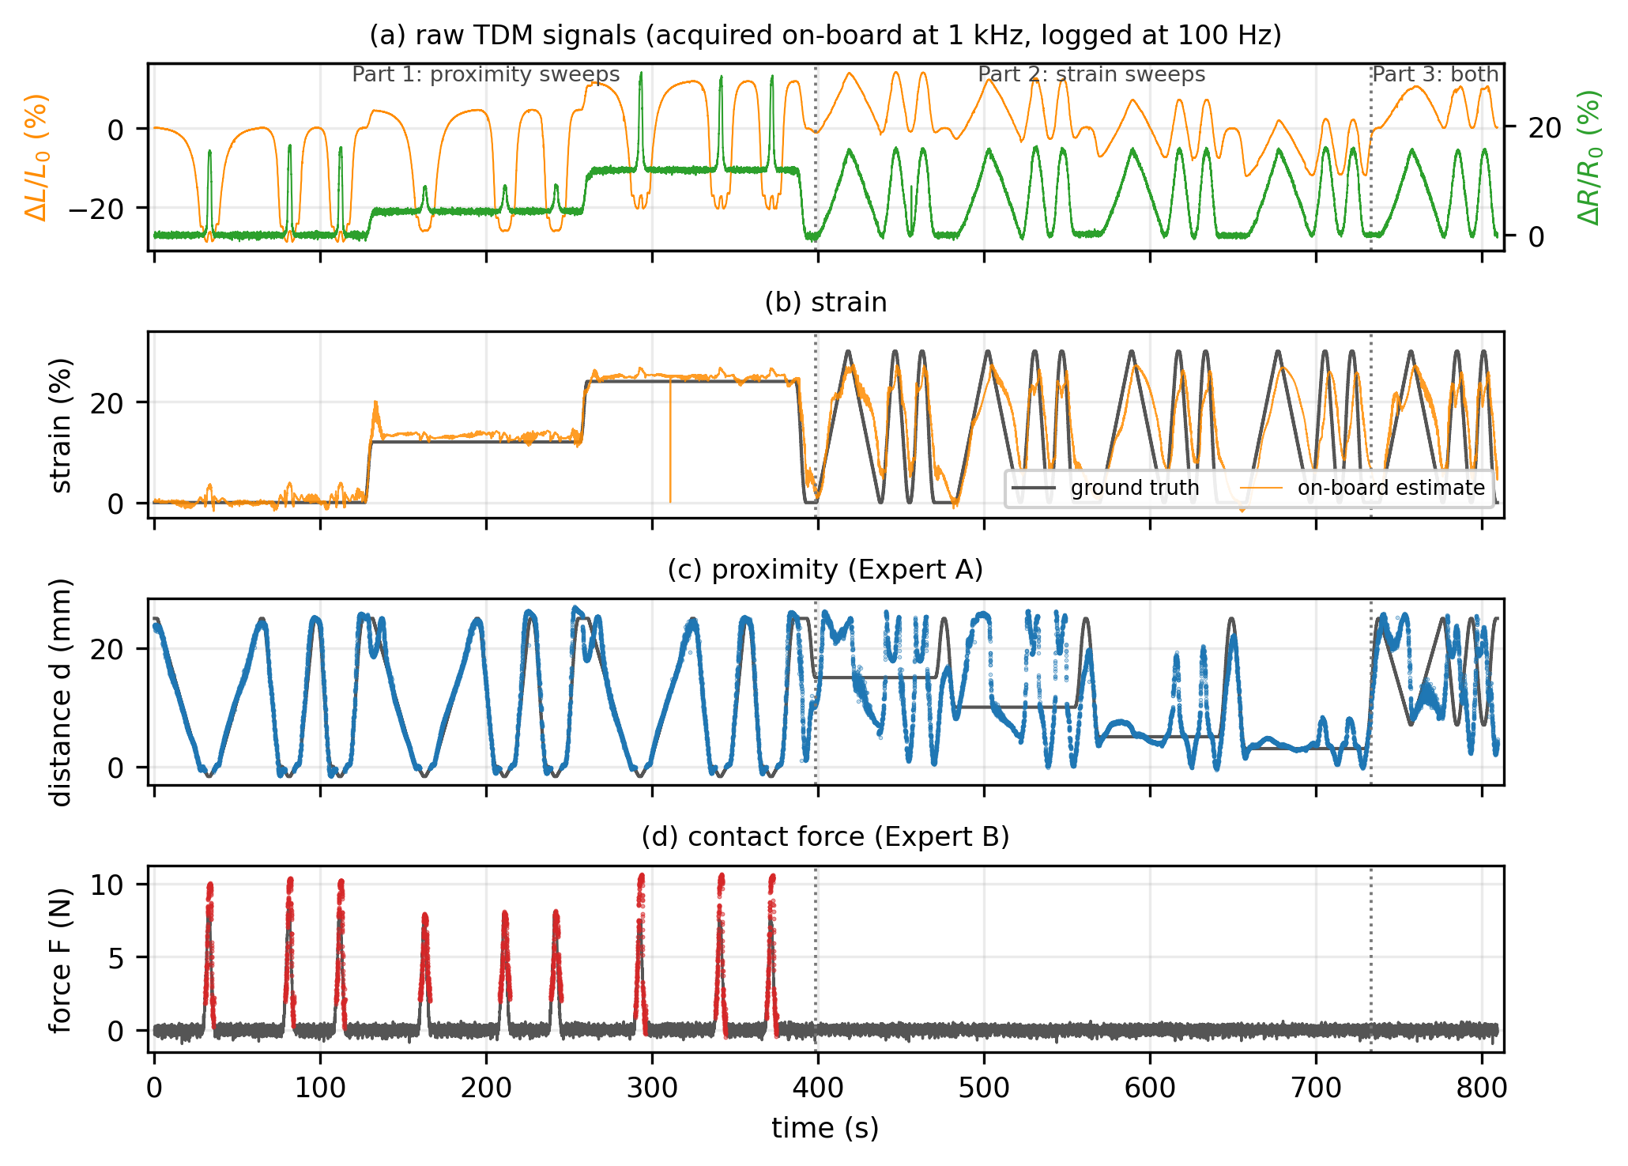
Fig. 6. On-hardware real-time decoupling (session 0819-153948, 809 s). (a) Raw TDM signals acquired on the board at 1 kHz and logged at 100 Hz. (b) Strain: grey is ground truth, orange the on-board estimate. (c) Distance, shown only where the gate reports non-contact. (d) Contact force, shown only where the gate reports contact. Dotted lines mark the Part boundaries.
8.2 Part-Wise Results
Figure 6 and Table 4 summarize the results. In Part 1 all three quantities are recovered well: in the second session, strain reached R² = 0.981 (RMSE 1.37 %p) and distance R² = 0.940 (RMSE 2.11 mm), with 98.3 % gate accuracy. The parity plots of Fig. 7 show the estimates distributed along the diagonal. Contact force varied more between sessions (R² = 0.430–0.777), largely because the second session contained only 2,185 contact samples with a maximum force of 7.8 N and therefore lower variance.
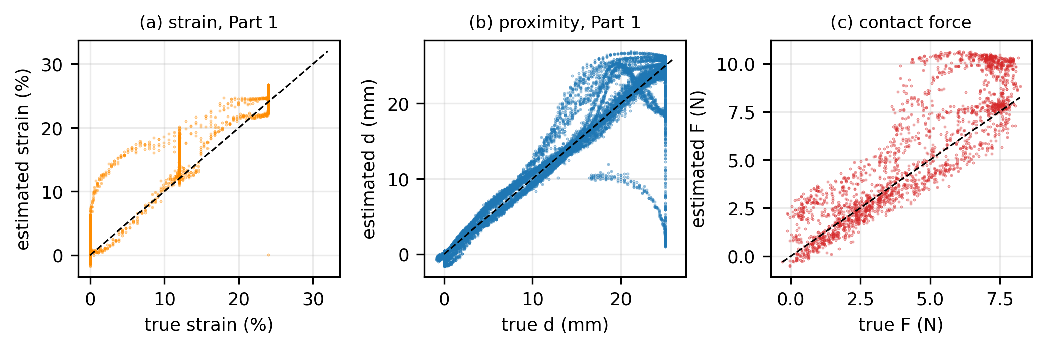
Fig. 7. Parity plots for Part 1 (session 0819-153948): (a) strain, (b) distance, (c) contact force. Dashed lines show the ideal diagonal.
Table 4. On-hardware real-time performance (session 0819-153948). Each Part excludes, with a ±1 s guard band, the instants at which the other axis was actually moving. Gate accuracy 98.3 %.
Segment | Strain R² / RMSE | Distance R² / RMSE | Force R² / RMSE
Part 1 - proximity only | 0.981 / 1.37 %p | 0.940 / 2.11 mm | 0.430 / 1.86 N
Part 2 - strain only | 0.492 / 6.97 %p | −0.797 / 6.19 mm | —
Part 3 - simultaneous | 0.602 / 6.27 %p | −2.051 / 10.40 mm | —
Whole session (reference) | 0.780 / 4.78 %p | 0.488 / 5.59 mm | 0.430 / 1.86 N

8.3 Degradation in Quasi-Static Segments and Its Cause
In Parts 2 and 3 the R² of the distance estimate became negative. A negative R² means the prediction is worse than the mean and must be reported as such. In these segments, however, the distance is essentially fixed, so the variance of the ground truth is very small. Since R² = 1 − RMSE²/Var(y), a small denominator degrades R² sharply even when the absolute error is modest: the distance RMSE in Part 2 was 6.19 mm, only about three times the 2.11 mm of Part 1. The degradation is nonetheless real and shows that, when the proximity signal is quasi-static, the information remaining in the inductance falls to the noise level.
To narrow the cause, the same raw ΔL and ΔR were replayed on a PC in float64 with identical gate, EMA and routing logic. Gate decisions matched the embedded ones 100 %, so the classification stage is not responsible. In the regression stage, however, the PC replay improved the Part 2 distance R² from −0.797 to 0.225 and Part 3 from −2.051 to −0.230. Since scikit-learn and ONNX agree to about 1e-5, floating-point precision alone cannot explain the gap. The most plausible cause is a difference in how the EMA is reconstructed: the board updates the EMA from every raw sample arriving each millisecond and therefore absorbs all the noise in between, whereas the PC replay sees only values decimated by a factor of five during logging and interpolates smoothly across the gaps with a continuous-time approximation. Where the true signal greatly exceeds the noise (Part 1) the difference is masked; where there is almost no signal (Parts 2 and 3) the PC appears artificially more stable. This does not mean the PC is physically more accurate — it means that, in noise-dominated segments, the degree of smoothing propagates directly into the metric.
9. Discussion
The results delineate fairly clearly what is already achievable in single-electrode multimodal sensing and what remains limited. On the achievable side: first, acquiring three signals at 1 kHz through only two wires is entirely feasible with commercial components on a six-layer board, and a DMA-based ISR design keeps the CPU load below 6 %. Second, for conductive targets the physical asymmetry of strain-only dependence in R genuinely holds, and encoding it in the architecture outperforms an end-to-end model at equal parameter budget. Third, a model of only 1,413 parameters suffices to estimate three quantities simultaneously, and at that size the weights stay resident in cache, yielding a deterministic 260 µs latency. Because this removes the 20–40 ms round trip and ±5–15 ms jitter of a PC-based arrangement, edge inference is a requirement rather than an option for this system.
The limitations are equally clear. First, proximity estimation is practical only for conductive targets; as Fig. 2c shows, a dielectric target imprints little proximity information on the inductance. Second, performance degrades substantially where the distance is quasi-static (Section 8.3) — less a defect of the model than a limit on the information carried by a single channel. Third, the accuracy of the force estimate approaches the ±0.19 N noise of the F/T sensor used as ground truth, so claiming lower error would require more precise reference instrumentation first. Fourth, the TENG channel was acquired but not used as a decoupler input: since the gate already detects contact events with over 98 % accuracy from ΔL and ΔR alone, no additional value from TENG has yet been demonstrated, although it may prove useful for light touch or dynamic texture recognition.
Three directions follow. (i) Multi-frequency impedance measurement. Only the single resonant frequency of the LDC1614 is used at present; obtaining the real and imaginary parts of the impedance at several frequencies could improve material discrimination and proximity estimation together, and the extra channels may also mitigate the quasi-static problem of Section 8.3. (ii) Two-dimensional strain decomposition. A rectangular spiral has asymmetric sensitivity along its x and y axes, so the fact that L and R possess different effective eigen-directions should permit biaxial strain to be separated from a single electrode; this requires the test platform to be modified for independent x/y actuation. (iii) Migration to a recurrent structure. In Table 2 the GRU matched the EMA-based models with 306 parameters; verifying X-CUBE-AI's recurrent-layer support, hidden-state reset logic and quantization stability on this board is the next task.
10. Conclusion
A multimodal sensing system was designed, built and validated in which inductance, resistance and triboelectric voltage are acquired every millisecond by time-division measurement from a two-wire single-electrode EGaIn spiral coil and decoupled in real time by embedded AI. Gridded measurements against a conductive target quantitatively confirmed the physical asymmetry whereby resistance depends on strain alone while inductance depends on both strain and distance; in the contact regime, a standard linear solid model identified a viscoelastic relaxation (τ = 1.0 s) that was encoded as a causal EMA history feature. The final decoupler is a 1,413-parameter mixture-of-experts network that completes inference on the STM32G473 in a median of 260 µs once per TDM cycle. Where the proximity axis actually moved, on-hardware accuracy reached R² = 0.981 for strain and R² = 0.940 for distance with 98 % gate accuracy; degradation in quasi-static proximity segments, caused by the signal-to-noise limit, is reported alongside. The work demonstrates on real hardware that a single-electrode multimodal sensor can operate autonomously without a host PC, and shows through a concrete failure case that offline metrics alone cannot guarantee embedded performance.
References
Note: the following list records the sources actually consulted during this work; volume, issue and page details must be verified against the originals before submission.
[1] M. Raissi, P. Perdikaris, and G. E. Karniadakis, “Physics-informed neural networks: A deep learning framework for solving forward and inverse problems involving nonlinear partial differential equations,” Journal of Computational Physics, vol. 378, pp. 686–707, 2019.
[2] Wang et al., “Programming stretchable planar coils,” Materials Today Physics, 2025.
[3] Li et al., “Fingertip-inspired spatially anisotropic inductive liquid metal sensors,” Advanced Materials, 2025.
[4] “Recent progress on flexible multimodal sensors: decoupling strategies,” Advanced Materials, 2026.
[5] Texas Instruments, LDC1612/LDC1614 Multi-Channel 28-Bit Inductance-to-Digital Converter, datasheet.
[6] Analog Devices, ADG733/ADG734 CMOS Low Voltage Triple/Quad SPDT Switches, datasheet.
[7] STMicroelectronics, STM32G473xB/xC/xE Datasheet and RM0440 Reference Manual.
[8] STMicroelectronics, X-CUBE-AI: Artificial Intelligence Expansion Package for STM32Cube, User Manual UM2526.
[9] F. Pedregosa et al., “Scikit-learn: Machine learning in Python,” Journal of Machine Learning Research, vol. 12, pp. 2825–2830, 2011.
[10] R. A. Jacobs, M. I. Jordan, S. J. Nowlan, and G. E. Hinton, “Adaptive mixtures of local experts,” Neural Computation, vol. 3, no. 1, pp. 79–87, 1991.
[11] R. M. Christensen, Theory of Viscoelasticity: An Introduction, 2nd ed. Academic Press, 1982.

Supplementary Information
Details omitted from the main text as not directly required for the conclusions, but needed for reproduction and follow-up work.
S1. Detailed Hardware Specifications
Item | Specification
Sensing electrode | EGaIn liquid metal, DIW-printed planar rectangular spiral coil, two-wire single electrode
Initial sensor length | 120 mm
Strain range | 0–36 mm (0–30 %)
Proximity range | 0–52 mm (metal) / 0–30 mm (hand)
Contact-force range | 0–10.1 N
MCU | STM32G473CBT6, Cortex-M4F @ 170 MHz, 128 KB flash, 32 KB SRAM
Inductance IC | LDC1614, I2C2, address 0x2A, 28-bit, SD pin PA10, INT pin PA11
Analog MUX | ADG734 ×4, control GPIO PB2/PB10/PB11/PB15, 29 ns switching
PCB | 65 × 52 mm, six layers, EasyEDA Pro v2.2.47.7
UART | USART2 at 115,200 baud (PA2/PA3)
TDM parameters | period 1000 µs (TIM7), TENG 150 µs, R 150 µs, LDC I²C ~200 µs, settling 6 µs
Test stage | five-axis stepper (XA/XB/YA/YB/Z), Arduino + AccelStepper, 320 steps/mm, 115,200 baud
Force reference | six-axis F/T sensor, zeroed session-wise on the non-contact mean, noise ±0.19 N

S2. Complete Architecture Search Results
All candidates use the same two-stage structure (stage 1: ΔR → strain; stage 2: [ΔL, strain] → d) with tanh activations; INT8 flash requirement is estimated at one byte per parameter.
Name | Stage 1 | Stage 2 | Param. | MACs | MAE strain (%) | MAE d (mm) | MAE d≤15 (mm)
nano | 1-4-1 | 2-8-1 | 46 | 32 | 0.381 | 2.115 | 0.806
tiny | 1-8-1 | 2-16-1 | 90 | 64 | 0.363 | 2.110 | 0.781
tiny-asym | 1-8-1 | 2-32-1 | 154 | 112 | 0.368 | 1.978 | 0.561
tiny-deep | 1-4-4-1 | 2-8-8-1 | 138 | 112 | 0.352 | 1.837 | 0.394
small | 1-16-1 | 2-16-8-1 | 242 | 200 | 0.351 | 1.802 | 0.348
small-sym | 1-16-8-1 | 2-16-8-1 | 370 | 320 | 0.349 | 1.798 | 0.346
base | 1-16-8-1 | 2-32-16-1 | 818 | 744 | 0.349 | 1.782 | 0.322
base-asym | 1-8-1 | 2-32-16-1 | 666 | 608 | 0.350 | 1.785 | 0.326
medium-deep | 1-16-8-4-1 | 2-32-16-8-1 | 978 | 892 | 0.352 | 1.765 | 0.322
base-s2+ | 1-16-8-1 | 2-64-32-1 | 2,482 | 2,360 | 0.349 | 1.781 | 0.317
medium | 1-32-16-1 | 2-64-32-1 | 2,914 | 2,768 | 0.352 | 1.779 | 0.312
medium-asym | 1-16-8-1 | 2-128-64-1 | 8,882 | 8,664 | 0.350 | 1.774 | 0.318
large | 1-64-32-1 | 2-128-64-1 | 10,946 | 10,656 | 0.349 | 1.773 | 0.313
sklearn (first deployment) | 1-128-128-64-1 | 2-128-128-64-1 | 50,306 | 49,664 | 0.344 | 1.783 | 0.301

S3. Learned Physical Parameters and Limits of Physics-Only Inversion
The empirical coefficients obtained by PINN training (on D3) are: α₁ = 55.535, α₂ = 26.676, β₁ = 15.434, β₂ = 4.255, β₃ = −2.367, d₀ = 7.547 mm, k = 0.0027. The parameters d₀ and k are constrained positive through a softplus to avoid the singularity as d approaches zero.
In an experiment that inverted the physics expression including the strain-force cross term directly (candidate C4), the forward fit itself was good (R² = 0.955), but inversion gave R² = 0.714 even when the true strain was supplied and only R² = 0.263 under realistic conditions using the estimated strain. When lower-quality data were included, the inversion diverged to R² = −75 near zero strain. This is consistent with the condition number of 23 found in Section 5.3 and shows that the physics expression is useful as a training constraint but not as a stable inversion tool by itself.
S4. Toolchain Issues Encountered During Embedded Conversion
Issue | Cause | Resolution
stedgeai path error | paths longer than 40 characters | copied to a short path C:\ai\xe\
cp949 encoding error | Korean Windows locale | used a pre-quantized ONNX file
MatMulInteger unsupported | use of quantize_dynamic | switched to quantize_static with QDQ format
flash overflow | -O0 compilation with 52 KB of weights | changed the .cproject optimization option to -Og
PyTorch DLL load failure | the Windows 260-character path limit | rebuilt the virtual environment at the short path C:\ml_env

S5. Detailed Acquisition Protocols
- P1 (discrete strain, continuous proximity sweep): 19 strain levels (0, 2, ..., 36 mm); sweep at 5 mm/s approaching and 10 mm/s returning; one repetition per level; 19 CSV files for metal (27,123 rows) and 19 for hand (18,611 rows).
- P2 (discrete proximity, continuous strain sweep): 13 proximity levels; strain sweep at 2 mm/s stretching and 10 mm/s returning; two repetitions per level; 26 CSV files for metal (18,510 rows) and 26 for hand (18,505 rows).
- D4 (contact protocol): one cycle is a single Z traverse of 25 mm -> 0 mm -> -1.2 mm -> 0 mm -> 25 mm; the strain is advanced one step per cycle for 19 cycles in total, with contact force recorded simultaneously by the F/T sensor.
- Splitting rule: to prevent leakage between temporally adjacent samples, held-out sets were formed cycle-wise rather than sample-wise (one cycle in five). For D3, 2-D grid-uniform sampling followed by a random split was used instead.
- Caveat: in an early analysis, homing motions and strain-transition ramps were grouped inside a single cycle and the performance was underestimated. Redefining cycles by changes in strain and requiring a minimum length of 500 rows corrected the proximity R² from 0.982 to 0.9989.
S6. Glossary
Term | Definition
TDM | Time-division measurement: sequentially measuring several quantities from one sensor within short time slots.
EMA | Exponential moving average: causal smoothing that weights recent samples more heavily, implemented as a single recursion.
MoE | Mixture of experts: a gate classifies the situation and regime-specific expert models perform the regression.
SLS | Standard linear solid: a viscoelastic model combining an instantaneous elastic component with a time-delayed viscous component.
PINN | Physics-informed neural network: a method that adds the residual of a physical equation to the training loss as a constraint.
Q-factor | Quality factor: a measure of resonance sharpness; a low value increases the noise in reading the resonant frequency.
Condition number | A measure of how sensitive an inversion is to input noise; values near one are stable.
INT8 PTQ | Post-training 8-bit integer quantization: reduces weight size fourfold and enables integer-arithmetic acceleration.

S7. Code and Data Locations
- Firmware: TDMFirmware/ (TDM.c, LDC1614.c, moe_inference.c, nn_inference.c)
- Test platform: 26.03.10_Tensile_Tester/ (Python GUI and Arduino firmware)
- Datasets: nn_decoupling/data/, nn_decoupling/data_acquisition/, nn_decoupling/pressure_0805test/test0805_dataset/, nn_decoupling/test0816_RealtimeDecoupling/
- Model training: nn_decoupling/train_pinn_csv.py, arch_search.py, test0807_MoEDecoupling/candidate*.py, test0816_RealtimeDecoupling/retrain_moe_v3.py
- Embedded conversion: nn_decoupling/export_moe_onnx.py, test0816_RealtimeDecoupling/stm32_deploy_moe_v3/
- Figure generation for this paper: Paper/make_figures.py

