A D PATEL INSTITUTE OF TECHNOLOGY (ADIT)
DEPARTMENT OF INFORMATION TECHNOLOGY
CVM UNIVERSITY

M I N I P R O J E C T R E P O R T
SpendWise - Expense & Budget Tracker
An Offline Personal Financial Management Mobile Application

Subject | Mobile Application Development (MAD)
Submitted by | Heel Soni (Solo Developer)
Enrollment No. | 12302080601034
Department / Class | Information Technology, IT-A (B8A)
Semester | VII
Academic Year | 2026 – 2027
Technologies Used | Flutter, Dart, SQLite (sqflite), fl_chart, intl, Git

______________________________ ______________________________
Faculty Signature Date

Certificate of Approval
This is to certify that the mini-project report entitled "SpendWise - Expense & Budget Tracker" has been successfully completed by Heel Soni (Enrollment No.: 12302080601034), student of Seventh Semester, Department of Information Technology, A D Patel Institute of Technology, CVM University, in partial fulfillment of the academic requirements for the subject Mobile Application Development (MAD) during the academic year 2026–2027.
The work presented herein represents an authentic and independent project developed under regular faculty guidance.

_____________________________ _____________________________
Internal Guide / Faculty Head of Department (IT)
Department of Information Technology Department of Information Technology
ADIT, CVM University ADIT, CVM University

Candidate Declaration
I, Heel Soni (Enrollment No.: 12302080601034), hereby declare that the project entitled "SpendWise - Expense & Budget Tracker" is my own original work developed as a solo project. All architectural concepts, database designs, Dart/Flutter implementations, and test verifications have been performed by me. This project has not been submitted previously to any other university or examining body for any degree or diploma.
Heel Soni
Enrollment No.: 12302080601034
Department of Information Technology, ADIT

Abstract
Effective personal financial management is critical for individuals and college students navigating constrained monthly budgets. While modern application stores feature numerous expense management tools, the vast majority mandate persistent internet connectivity, third-party user authentication, invasive cloud tracking, or paid premium subscriptions.
To overcome these barriers, SpendWise was developed as a clean, responsive, and completely offline personal expense and budget management mobile application built with Flutter (v3.47+ Stable), Dart, and SQLite (sqflite). SpendWise operates strictly on-device with zero reliance on cloud APIs, user sign-ups, or remote servers, guaranteeing total data sovereignty and privacy.
The system empowers users with full CRUD (Create, Read, Update, Delete) transaction management, monthly budget tracking, real-time remaining balance calculations, automated over-budget threshold visual alerts, and interactive categorical distribution charts rendered via fl_chart. The database architecture follows the Singleton Pattern with SQLite ACID-compliant storage and ISO 8601 string-based date querying. Comprehensive testing comprising 10 functional and unit test cases validated 100% input integrity, reliable serialization, and zero computational errors.
Keywords: Mobile Application Development, Flutter, Dart, SQLite, sqflite, Personal Finance, Expense Tracking, Budget Management, fl_chart, Material 3, Offline Architecture.

1. Introduction

1.1 Background & Motivation
In an increasingly digitized economy characterized by contactless payments, credit facilities, and recurring subscriptions, keeping track of daily micro-expenditures is challenging. For college students living on predetermined monthly allowances, unintentional overspending frequently leads to financial distress before the end of the calendar month.
Manual bookkeeping on physical paper or spreadsheets is tedious, error-prone, and rarely consulted on-the-go. SpendWise delivers an offline, frictionless, and instantaneous recording companion directly in the student's pocket.

1.2 The Importance of Personal Budgeting
Budgeting empowers individuals to measure real spending against planned financial limits. Knowing exact monthly totals, remaining balances, and categorical distributions (Food, Travel, Bills, etc.) encourages proactive discipline rather than reactive panic.

1.3 Why a Native Mobile Solution?
Transactions happen everywhere—in cafeterias, buses, grocery stores, and bookstores. A native Flutter mobile app delivers smooth 60+ FPS performance, instant cold start under 1 second, and complete offline autonomy via embedded SQLite storage.

2. Problem Statement

2.1 Existing System Deficiencies
1. Mandatory Cloud Connectivity: Most commercial apps fail completely when mobile data is absent.
2. Privacy Infringements: Financial transactions and spending habits are uploaded to remote servers.
3. Authentication Overkill: Requiring emails, passwords, and OTPs creates high friction for logging minor ₹30 snacks.
4. Intrusive Advertisements: Ad banners interrupt users and increase battery and bandwidth usage.
5. Lack of Dynamic Warnings: Passive notebooks don't alert users when spending exceeds allocated limits.

3. Objectives

3.1 Key Goals
• Architect a 100% offline ACID-compliant SQLite relational database using sqflite.
• Implement full CRUD transaction management with swipe-to-delete confirmation and Undo.
• Provide monthly budget tracking with dynamic remaining balance calculations.
• Implement automated over-budget warning banners with visual color indicators.
• Integrate interactive pie charts using fl_chart for category analytics.
• Offer multi-category horizontal chip filters and month navigation selectors.
• Guarantee strict client-side validation for amounts, titles, and dates.

4. Literature & Existing System Study

4.1 Comparison with Existing Systems
The table below compares SpendWise against traditional manual diaries, spreadsheets, and commercial cloud applications:
Feature | Paper Diary | Google Sheets | Cloud Apps | SpendWise
Offline Operation | Full | Limited | No / Degraded | 100% Native Offline
Privacy & Security | Physical Risk | Cloud Stored | Third-party Monitored | 100% Local Device Storage
Launch Speed | High | Low | Low (Login/Sync) | Instant (< 1s)
Interactive Charts | None | Manual Setup | Paywalled | Real-time fl_chart
Over-Budget Alert | None | None | Delayed | Instant Visual Banner

5. System Architecture & Technology Stack
SpendWise employs a clean layered architecture consisting of Presentation, Domain & Validation, Data Access, and Local Storage layers:
1. Presentation Layer: Built with Flutter Material 3 widgets (HomeScreen, AddEditScreen, SummaryScreen, ExpenseTile).
2. Domain Layer: Encapsulates Expense data models and pure validation logic (Validators).
3. Data Access Layer: Singleton DBHelper ensuring unified thread-safe SQLite operations.
4. Storage Layer: Embedded spendwise.db SQLite database featuring 'expenses' and 'budgets' tables.

6. Database Design
Table: expenses (SQLite Table Schema)
Column | Data Type | Constraint | Description
id | INTEGER | PRIMARY KEY AUTOINCREMENT | Unique expense identifier
title | TEXT | NOT NULL | Expense description (e.g., Lunch)
amount | REAL | NOT NULL | Cost spent in INR (> 0)
category | TEXT | NOT NULL | Category (Food, Travel, Bills, etc.)
date | TEXT | NOT NULL | ISO 8601 timestamp string
note | TEXT | NULLABLE | Optional notes and remarks

7. Application Screenshots & Visual Tour
The figures below depict actual running screenshots of SpendWise captured on an Android device:
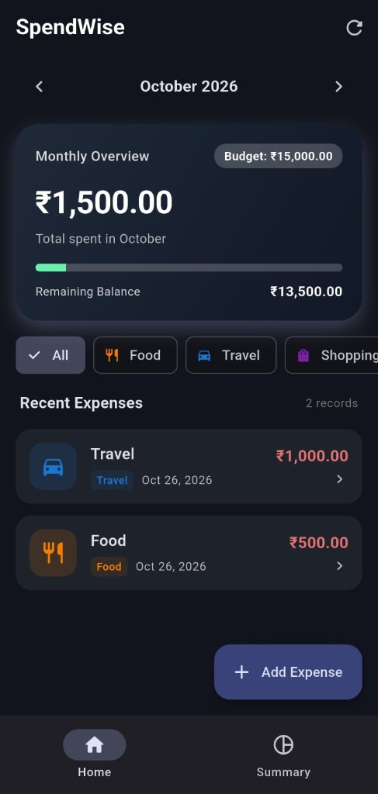

Figure 1: Home Dashboard showing monthly overview (₹1,500 spent, ₹13,500 balance), category chips, and recent expenses.

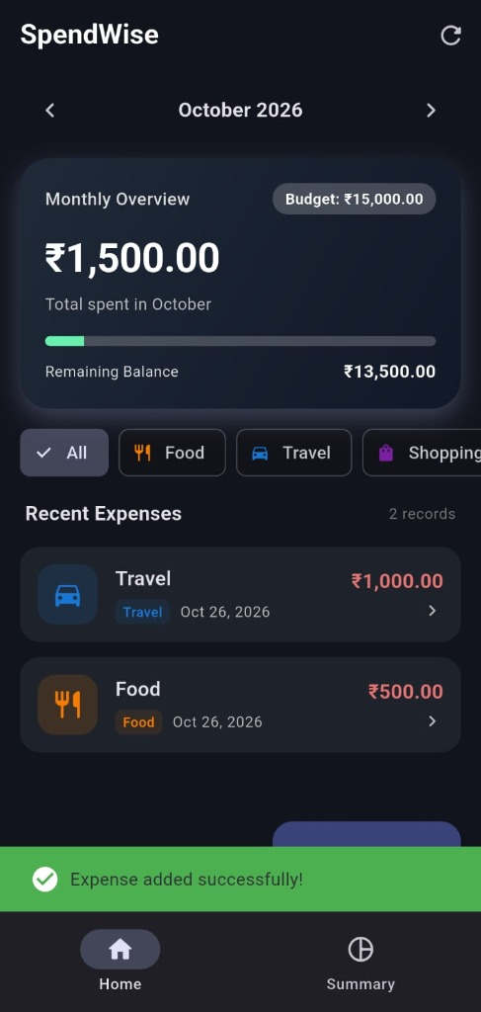

Figure 2: Instant green confirmation SnackBar displayed upon successfully adding an expense record.

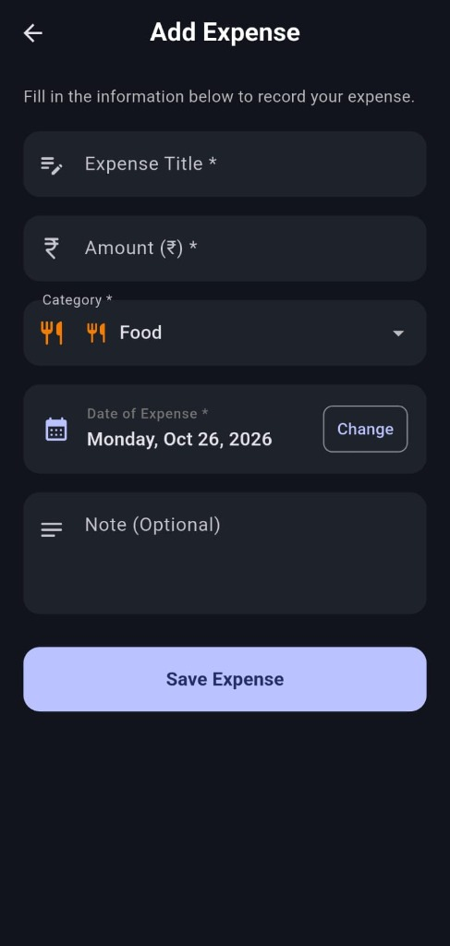

Figure 3: Add Expense Form with input validation, numeric currency field, category picker, and date selector.

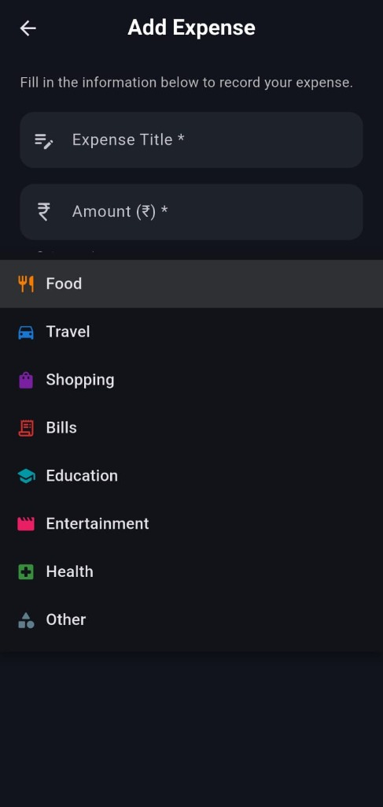

Figure 4: Category Dropdown Selector showing custom icons for Food, Travel, Shopping, Bills, Education, etc.

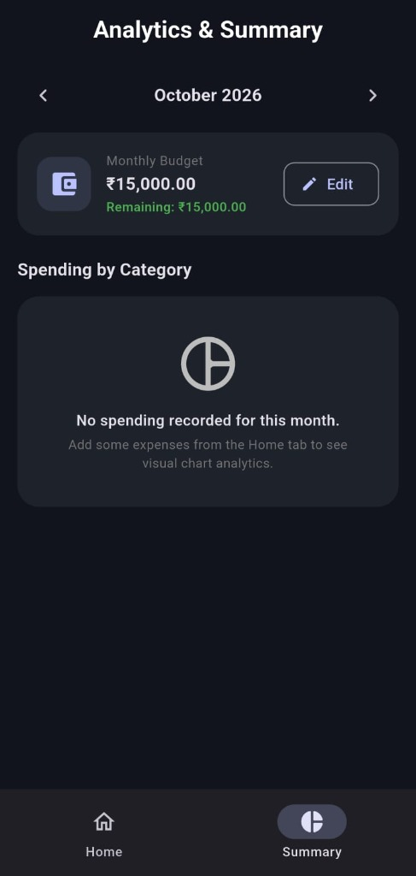

Figure 5: Analytics & Summary screen with Monthly Budget card and category expenditure breakdown.

8. Testing & Verification
10 rigorous test cases covering validation, CRUD operations, budgeting logic, and charts were executed:
TC ID | Scenario | Input Action | Expected Result | Status
TC-01 | Empty Title Validation | Submit Title blank | Displays 'Title is required' | PASSED
TC-02 | Title Min Length | Enter 1 character 'A' | Displays 'Min 2 characters required' | PASSED
TC-03 | Non-numeric Amount | Enter 'abc' or '$50' | Displays 'Please enter valid number' | PASSED
TC-04 | Zero/Negative Amount | Enter '0' or '-150' | Displays 'Amount must be > 0' | PASSED
TC-05 | Expense Creation | Add 'Travel' ₹1000 | Saved in SQLite; SnackBar shown | PASSED
TC-06 | Expense Update | Edit ₹1000 to ₹1200 | DB updated; total recalculated | PASSED
TC-07 | Swipe Delete & Undo | Swipe tile, tap Undo | Record restored to SQLite list | PASSED
TC-08 | Category Filter Chips | Tap 'Food' chip | Displays only Food expenses | PASSED
TC-09 | Over-Budget Warning | Exceed ₹5000 budget | Red warning banner displays | PASSED
TC-10 | Pie Chart Aggregation | View Summary tab | fl_chart displays slices matching DB | PASSED

9. Conclusion & Future Scope
Conclusion:
SpendWise successfully provides a production-ready, completely offline personal budgeting and expense tracking mobile application tailored for college students. By eliminating logins, remote syncs, and advertisements, it guarantees privacy and instant performance.
Future Scope:
• CSV/PDF statement export for offline financial records.
• Biometric authentication (Fingerprint / Face Unlock).
• Machine Learning receipt OCR for auto-reading paper receipts.
• Recurring automated expense schedules for monthly subscriptions.

10. References
1. Flutter Documentation: https://docs.flutter.dev/
2. Dart Language Reference: https://dart.dev/guides
3. SQLite Architecture: https://www.sqlite.org/docs.html
4. sqflite Flutter Plugin: https://pub.dev/packages/sqflite
5. fl_chart Package: https://pub.dev/packages/fl_chart
6. GitHub Repository: https://github.com/HeelSoni/SpendWise_MAD

