Sequence of the pages in the Home Page:

- Hero section
- Trusted partners
- Workflow
- Testimonials
- CTA
Footer - Maps under contact us (PHONE NUMBER, EMAIL), Address also required
CHANGE TWITTER LOGO
Maps will be mentioned in contact us page
Social media links
…………………………………………………………….

Display Mode: Add dark and white modes (not yet done - there are issues)

At the header, while we are selecting home/about/services, we need to know which page we are on. So represent with the colour/highlight it in some other way

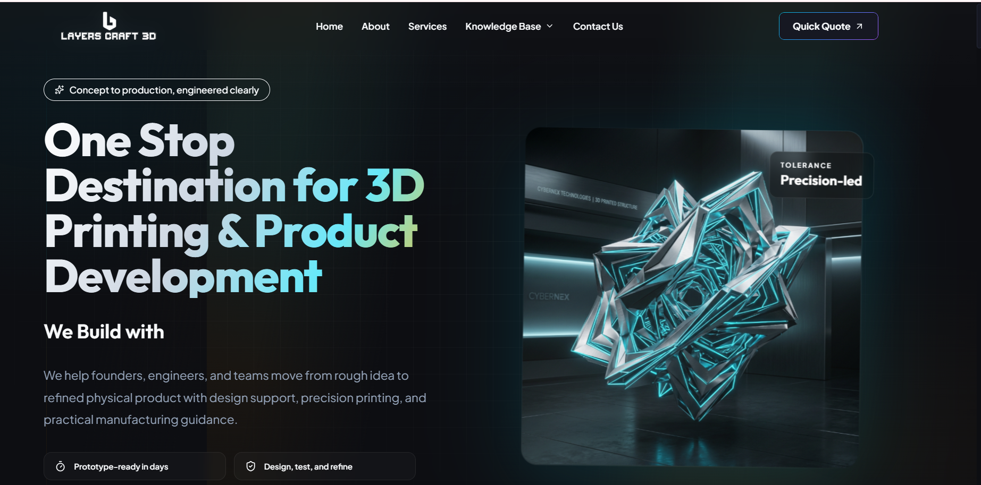

Left side: place the images in the sliding format (ex, carousel)

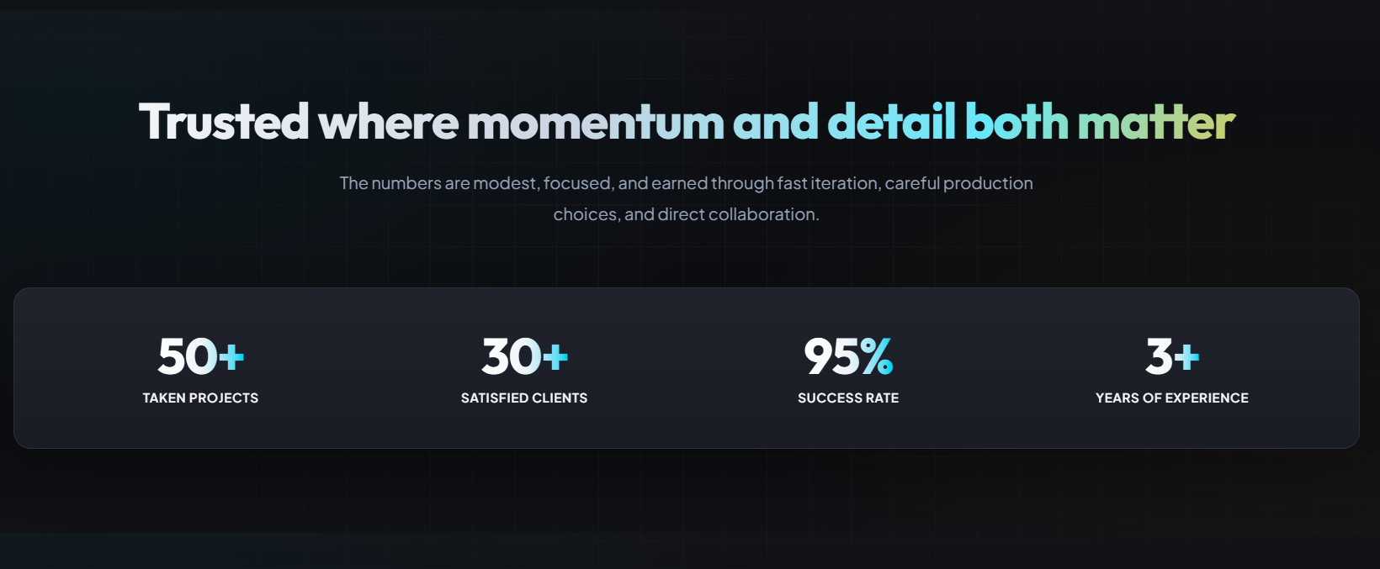
Place this as the 2nd section in the home page.

Remove the numberings, in place of that we need to display “Client Logo’s” in the scrolling format. (need to ask Surya)

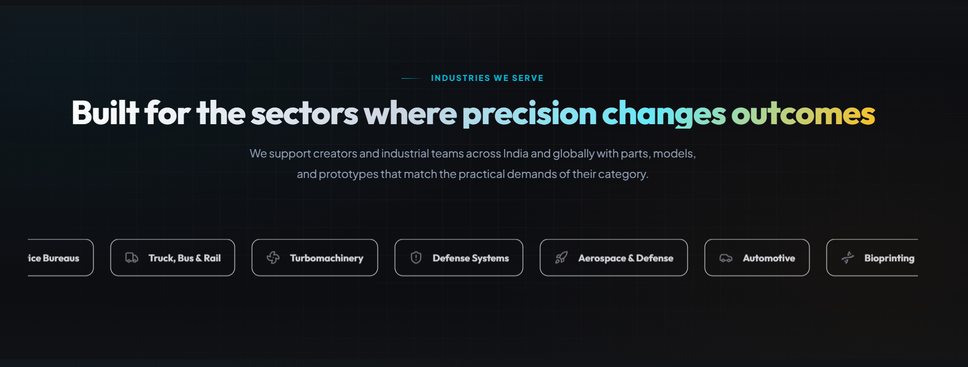

Remove carbon capture and consumer technology from the list.

Don’t scroll them - display in the cards format

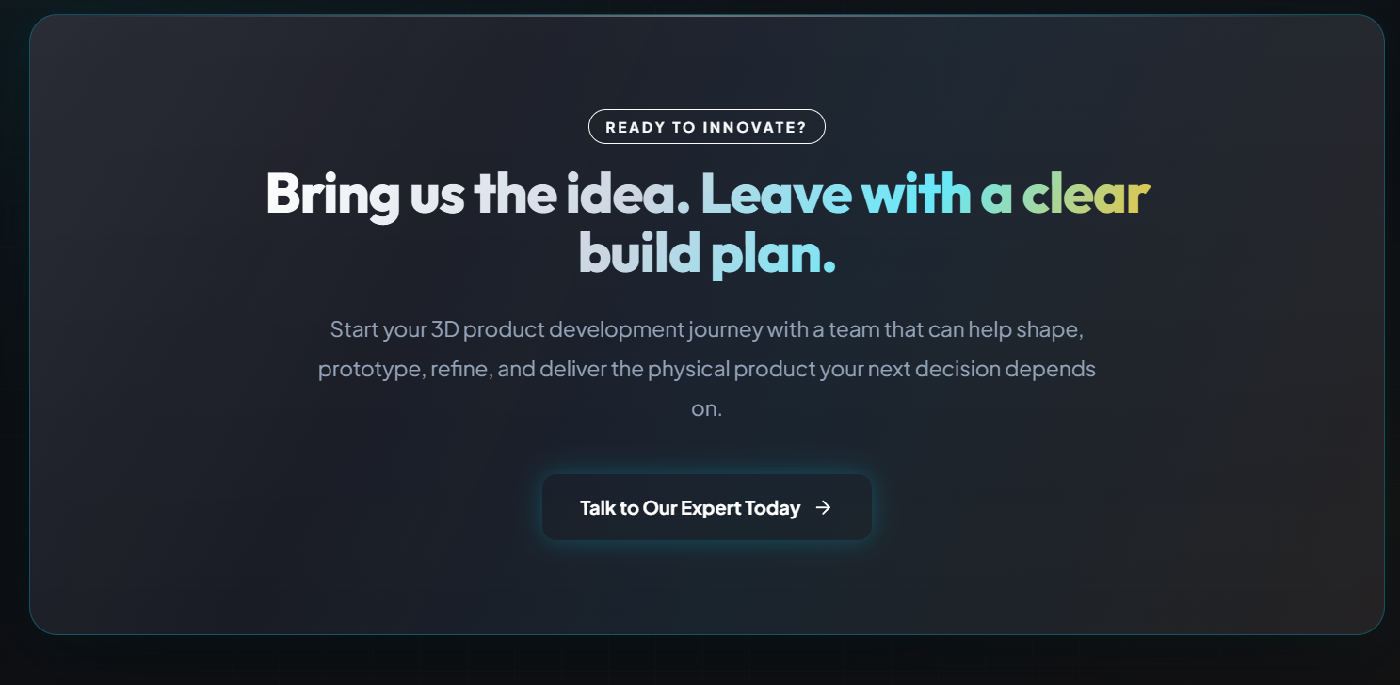

Display the “CTA section” at the end of every section page

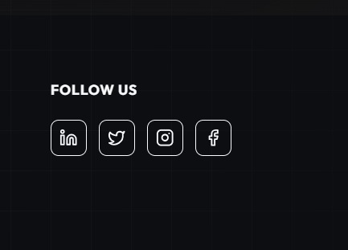

For SM logos, use their respective colours
……………..

- Remove the " About Us " section from the home page

- About us / contact us- add FAQ’

…………………………………………………………….
About us page:
About us
Our story’
Our mission
USP
Trust we earned (remove this section)
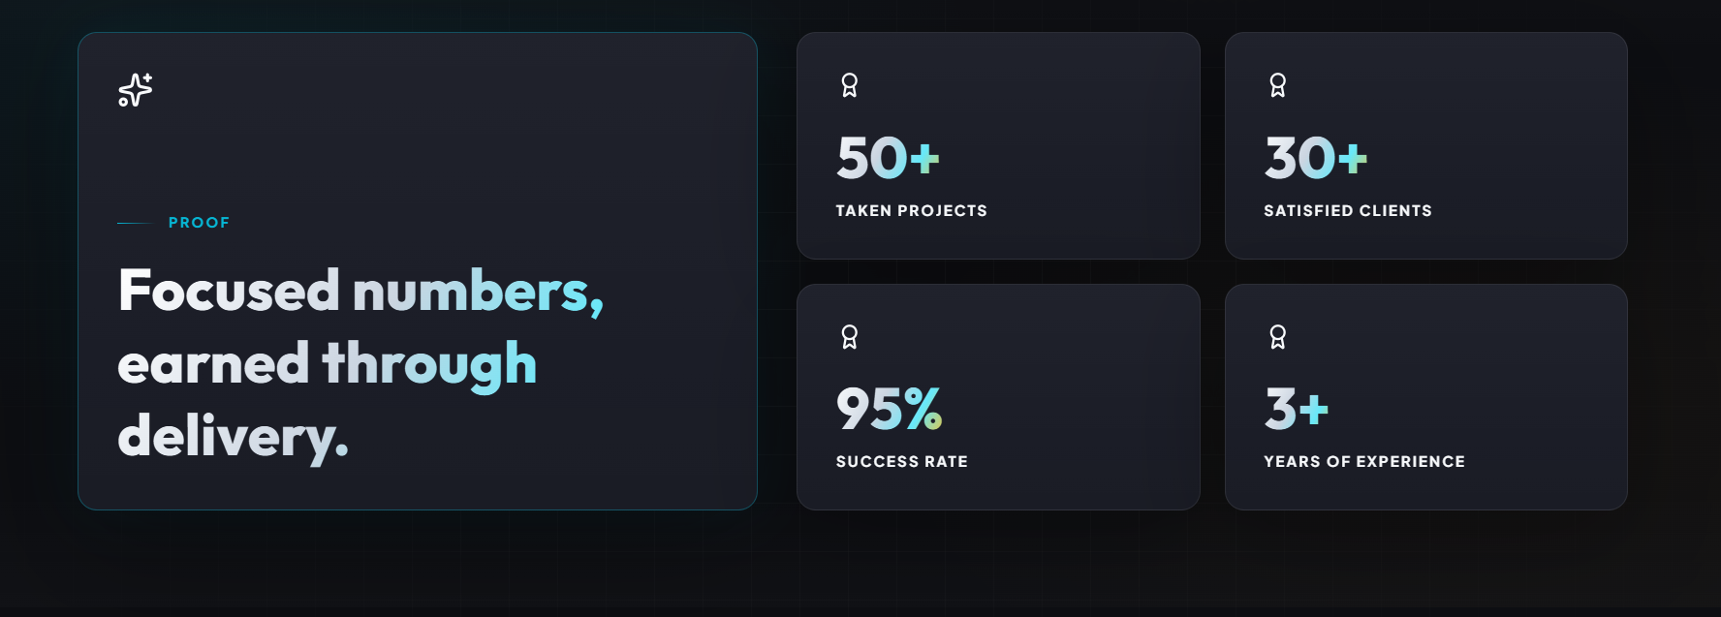
CTA (use at every page)
Services Page:
One more service is added
List should be mentioned while arrow is placed on the services header
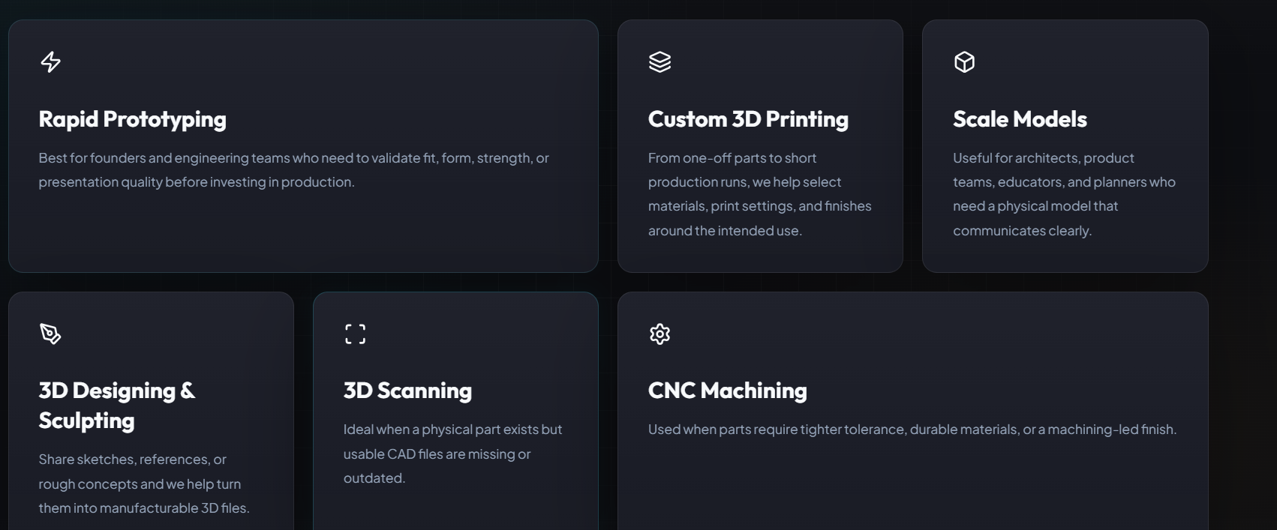
Remove this

…………………………………………………………….
Blogs Page:

Reference Image:
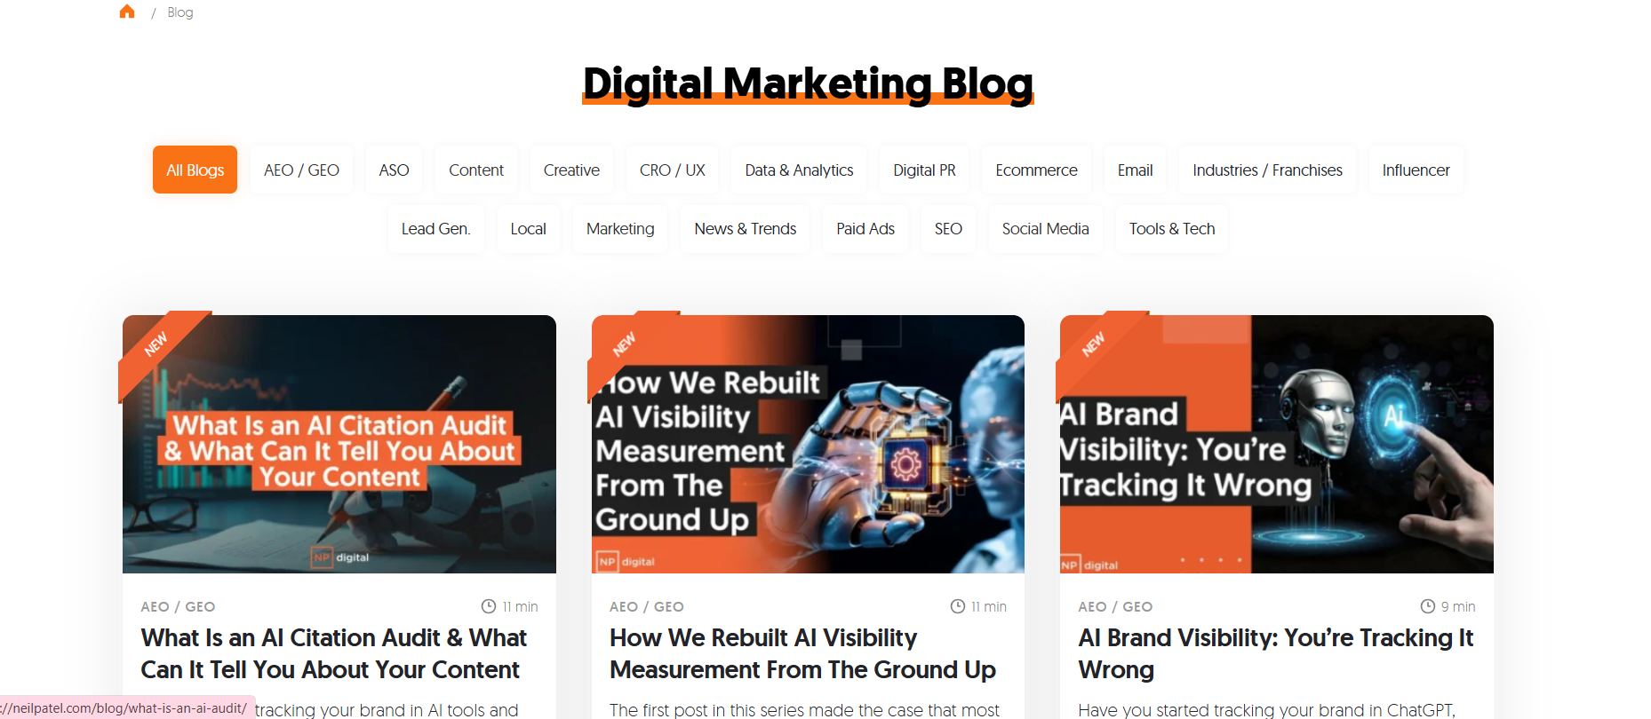

Headline - Stay Updated with Blogs
Place the services names in the boxes
Blogs representation should be as above or else if you have anyother interesting format you can use.
…………………………………………………………….

Changes in the Home Page Content
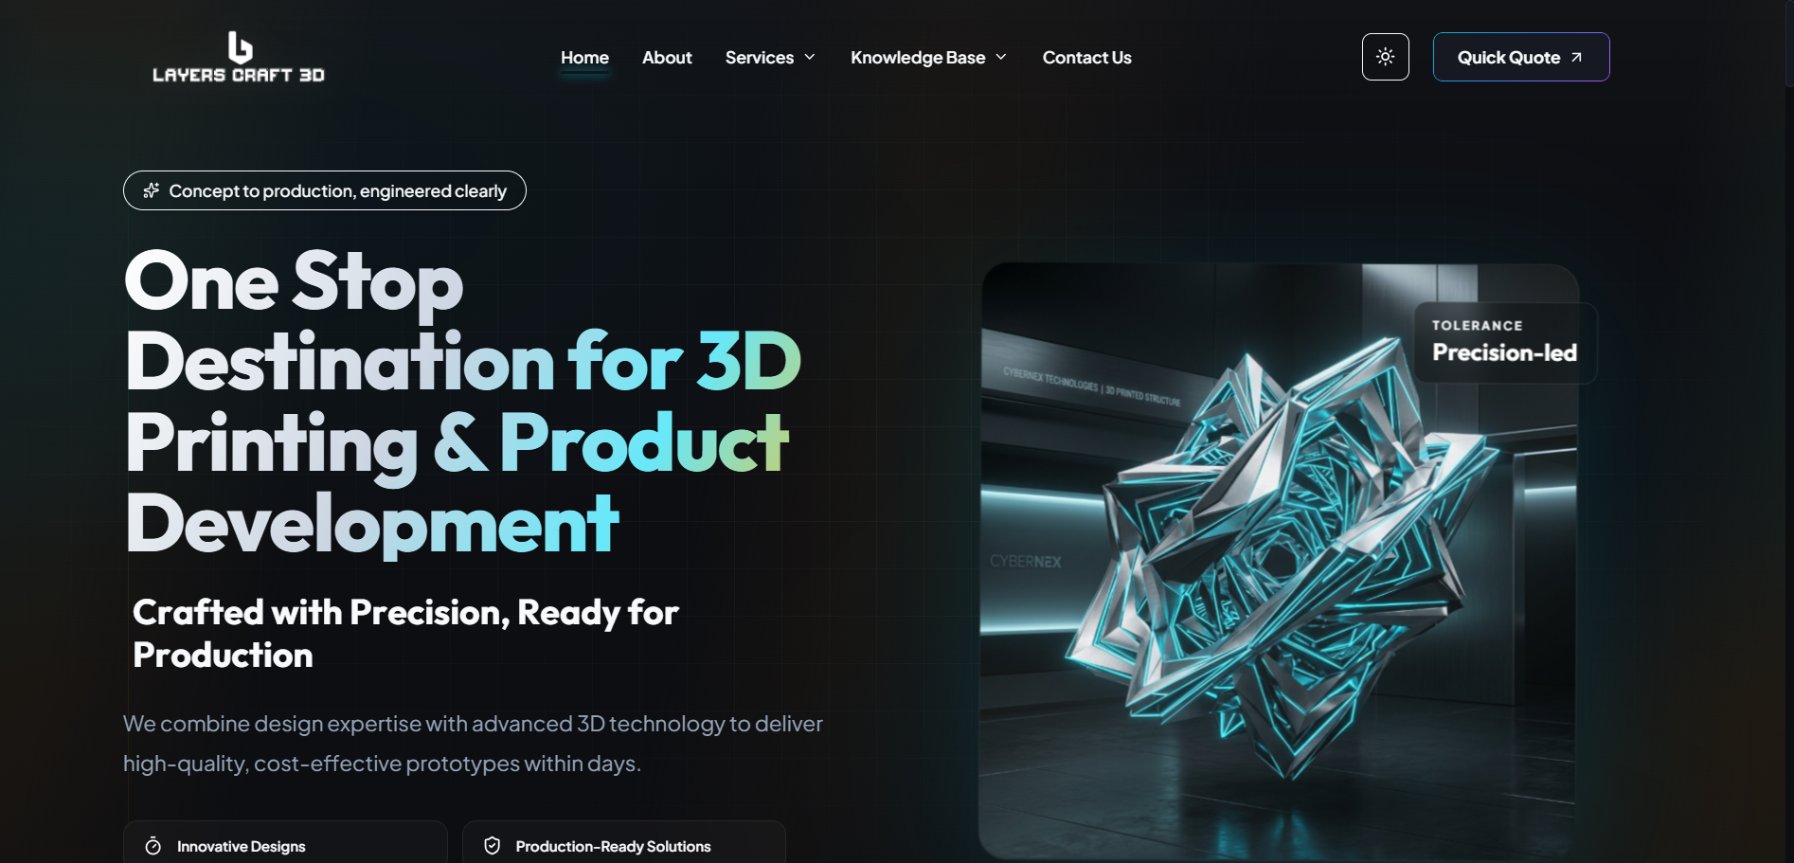

- At the header, while we are selecting home/about/services, we need to know which page we are on. So represent it with the colour/highlight it in some other way.

- Sequence of Header section “Home - Services - Knowledge Hub - About - Contact Us”

- Replace “Concept to production, engineered clearly” line with “Crafted with Precision, Ready for Production". If the character limit is more then you can use this line “Precision Engineered in Every Layer”
(As for every tagline you have used “Blue Colour,” here also you use the same colour)

- Let the H1 be the same, i.e., “One-Stop Destination for 3D Printing & Product Development”

- Completely remove the short heading line, i.e., “Crafted with Precision, Ready for Production”

- Let the short para be the same, i.e., “We combine design expertise with advanced 3D technology to deliver high-quality, cost-effective prototypes within days.”

- Place the images in the sliding format (ex, carousel)

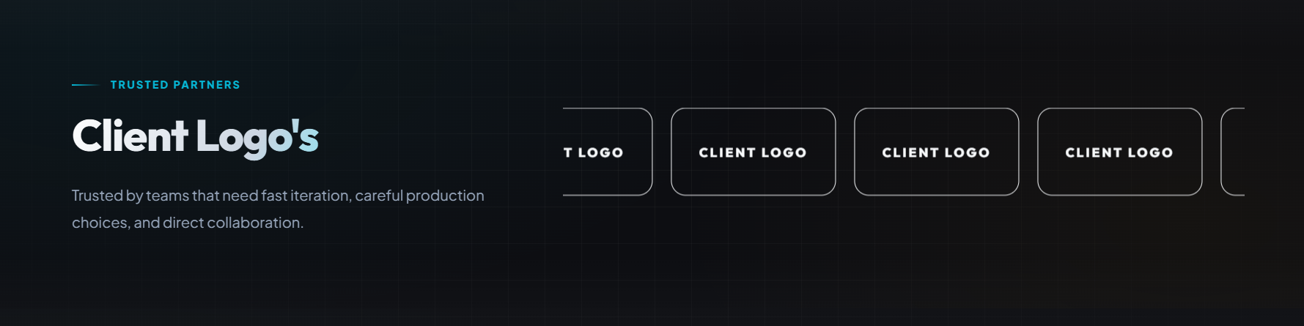

- Let the “Trusted Partners” be the same.

- Replace “Client Logo’s” with the line “Brands We Serve”

- Remove the short paragraph



- Let the “Explore Our Services” be the same.
- Replace “Choose the Best Solutions for your Business” line with “The Best 3D Solutions for your Business".

- Let the short para be the same, i.e., “Select the right service to transform your ideas into refined designs and functional products.”

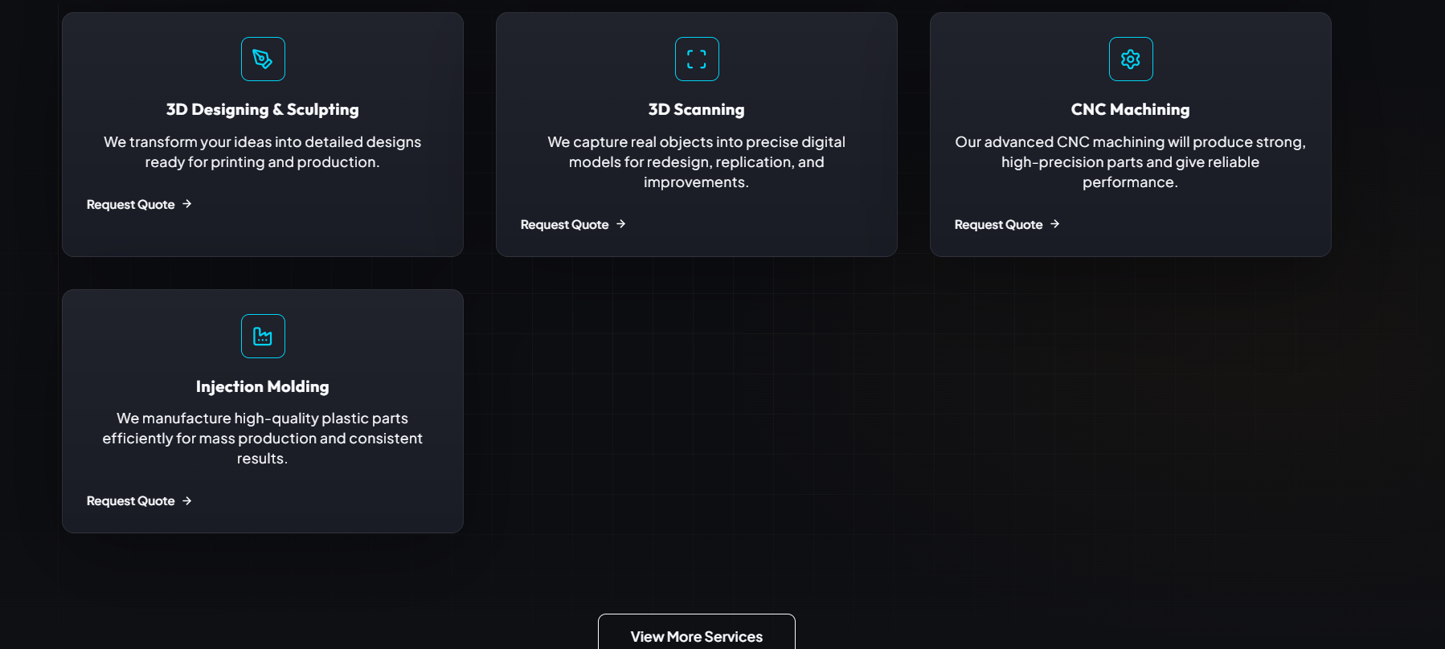

Here we need to add one more service:
- Laser Cutting & Engraving
We give you the product with precise cutting and detailed engraving for custom designs and high-quality finishes.

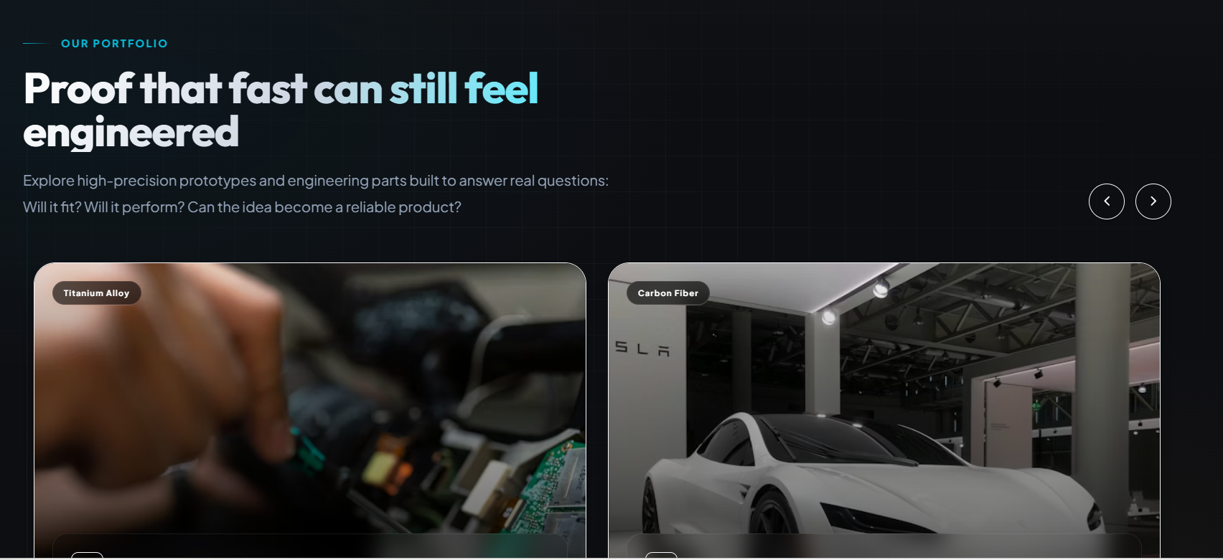

- As the format of placing the content is at center, place this content as the respective format.

- Replace “Proof that fast can still feel engineered ” line with “Every Project Reflects Our Excellence".

- Remove the short paragraph

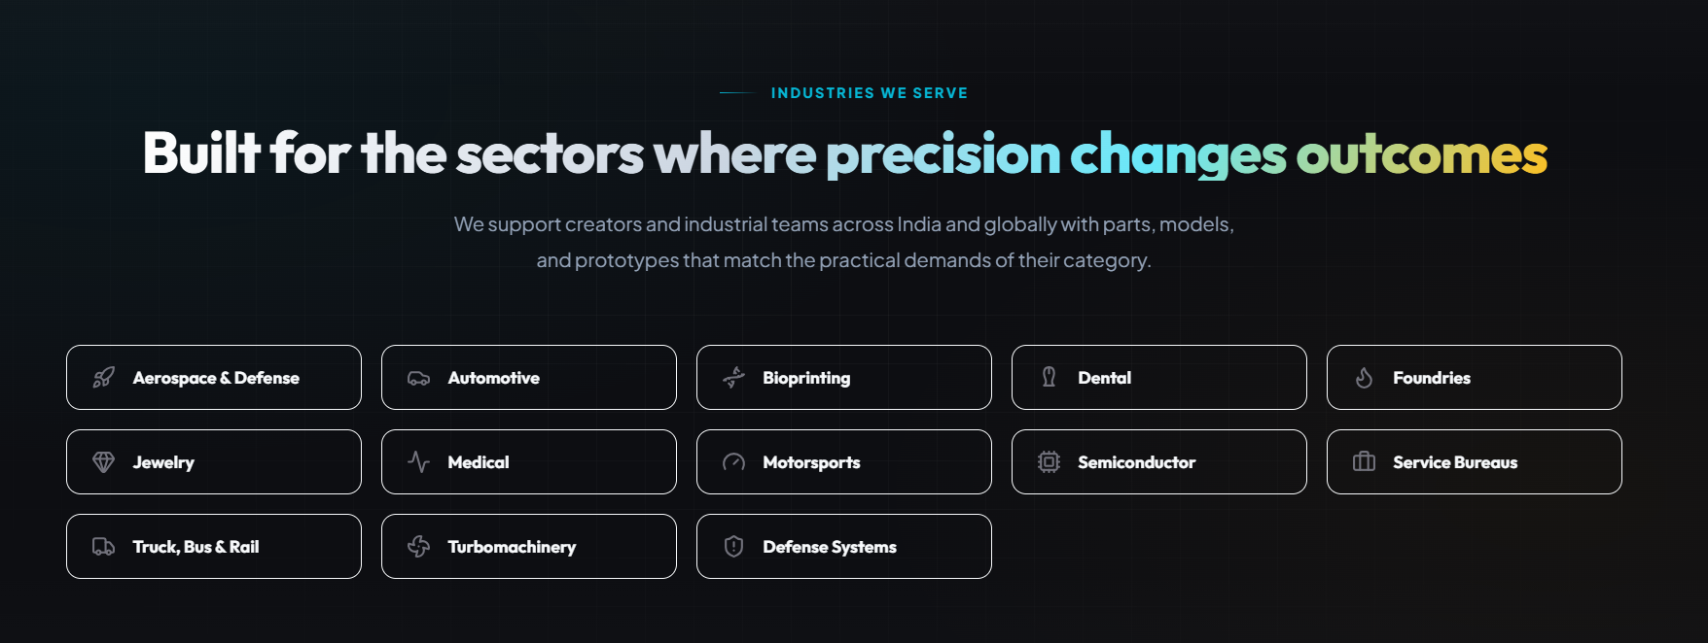

- Let the “Industries We Serve” be the same.

- Replace “Built for the sectors where precision changes outcomes” line with “Building Beyond Expectations Across Multiple Sectors".

- Replace the short para as “No matter the sector, we deliver reliable 3D solutions customized to its unique requirements.”
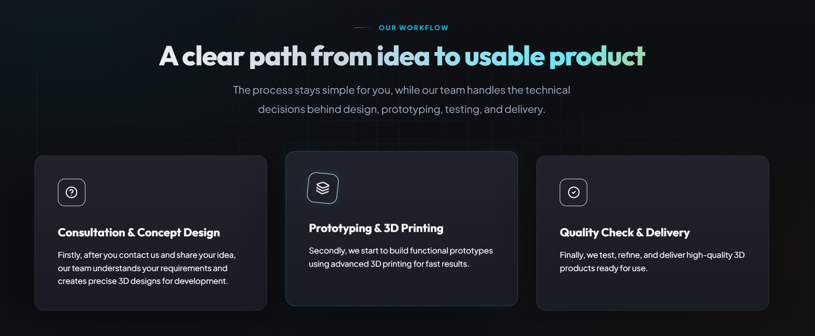

- Let the “Our Workflow” be the same.

- Replace “A Clear Path from idea to usable product” line with “Layers Craft 3D Makes Your Product Development Simple & Fast”

- Remove the short paragraph

- Let the cards content be the same

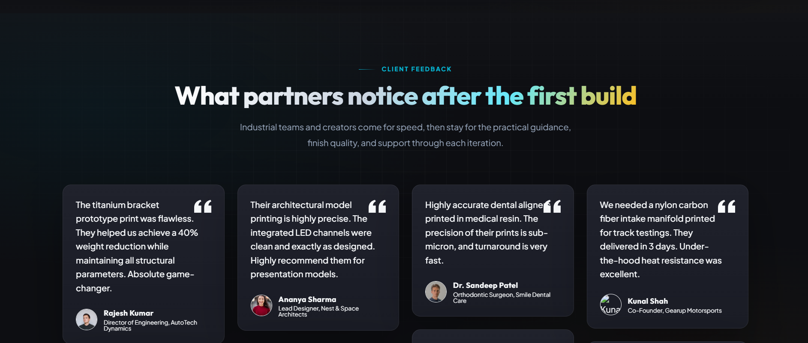
- Replace the Tagline “Client Feedback” with “Happy Client Stories”

- Replace “What Partners notice after the first build” line with “Voices of Trust, Quality & Precision”

- Replace the short para as “Hear directly from businesses that experienced our reliable service and outstanding results with every project.”
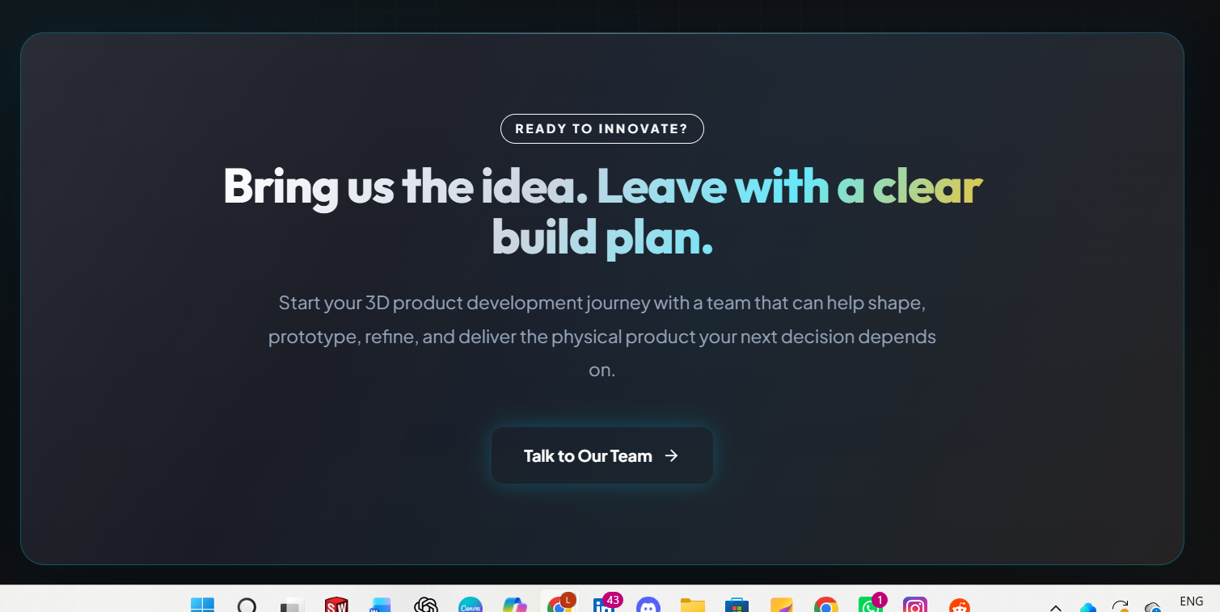

- Replace the Tagline “Ready to innovate?” with “Have an Idea?”

- Replace “Bring us the idea.Leave with a clear build plan” line with “Let's Create Something Exceptional Together”

- Remove the short paragraph.

- Replace CTC Button content “Talk to our team” with “Let's Connect Today”
…………………………………………………………….

