Sequence of the pages in the Home Page:

- Hero section
- Trusted partners
- Services
- Portfolio
- Industries we serve
- Workflow
- Testimonials
- CTA

…………………………………………………………….

Display Mode: Add dark and white modes

At the header, while we are selecting home/about/services, we need to know which page we are on. So represent with the colour/highlight it in some other way

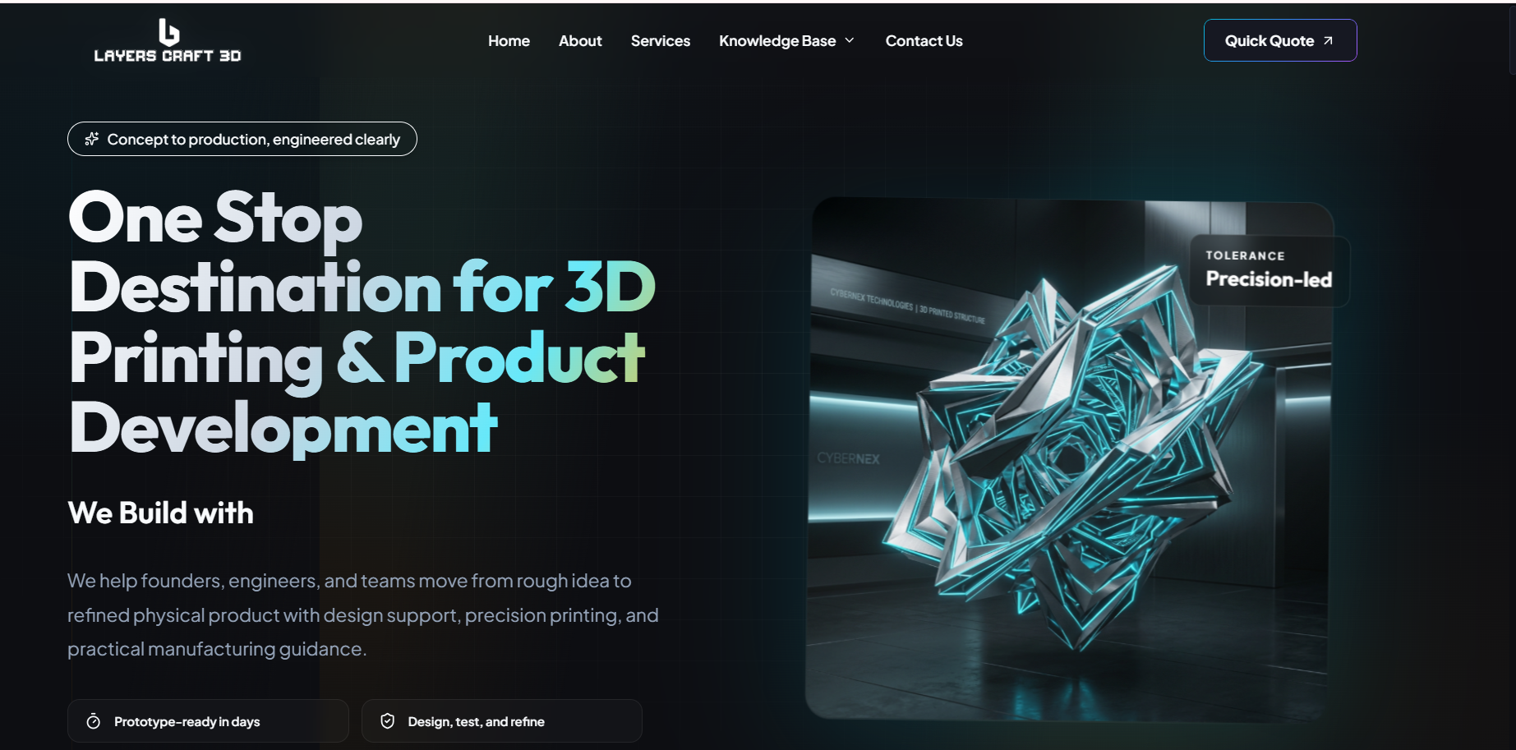

Left side: place the images in the sliding format (ex, carousel)

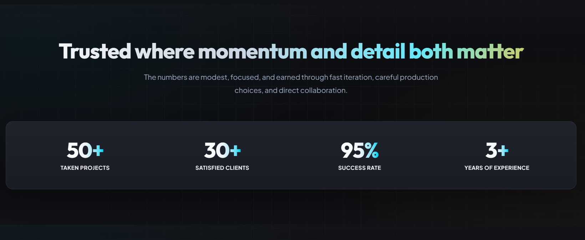
Place this as the 2nd section in the home page.

Remove the numberings, in place of that we need to display “Client Logo’s” in the scrolling format. (need to ask Surya)

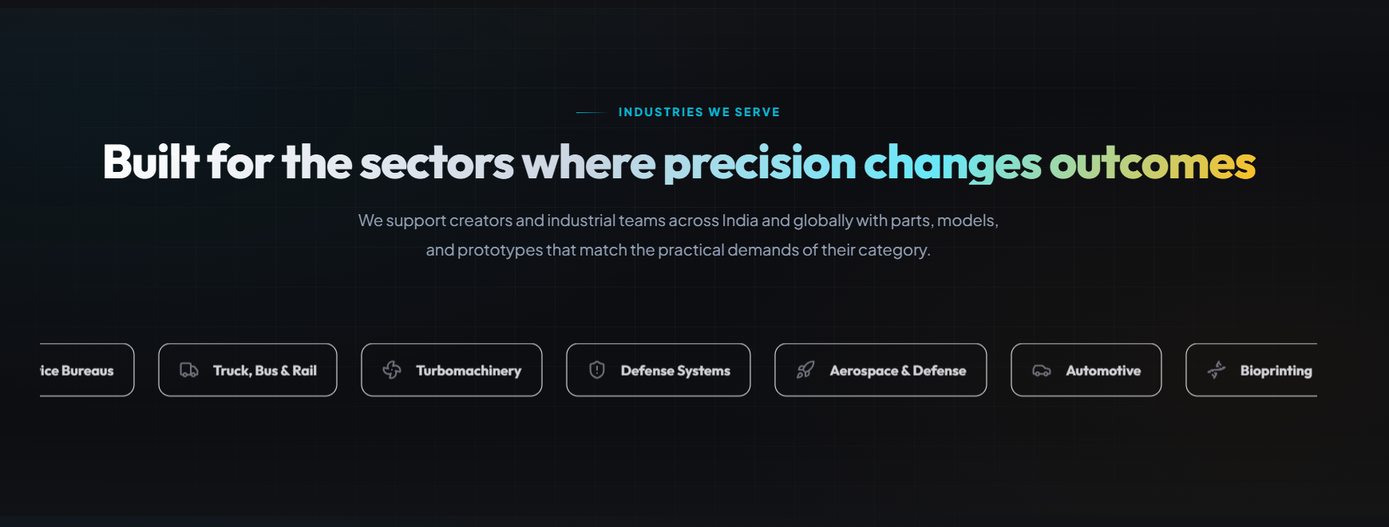

Remove carbon capture and consumer technology from the list.

Don’t scroll them - display in the cards format

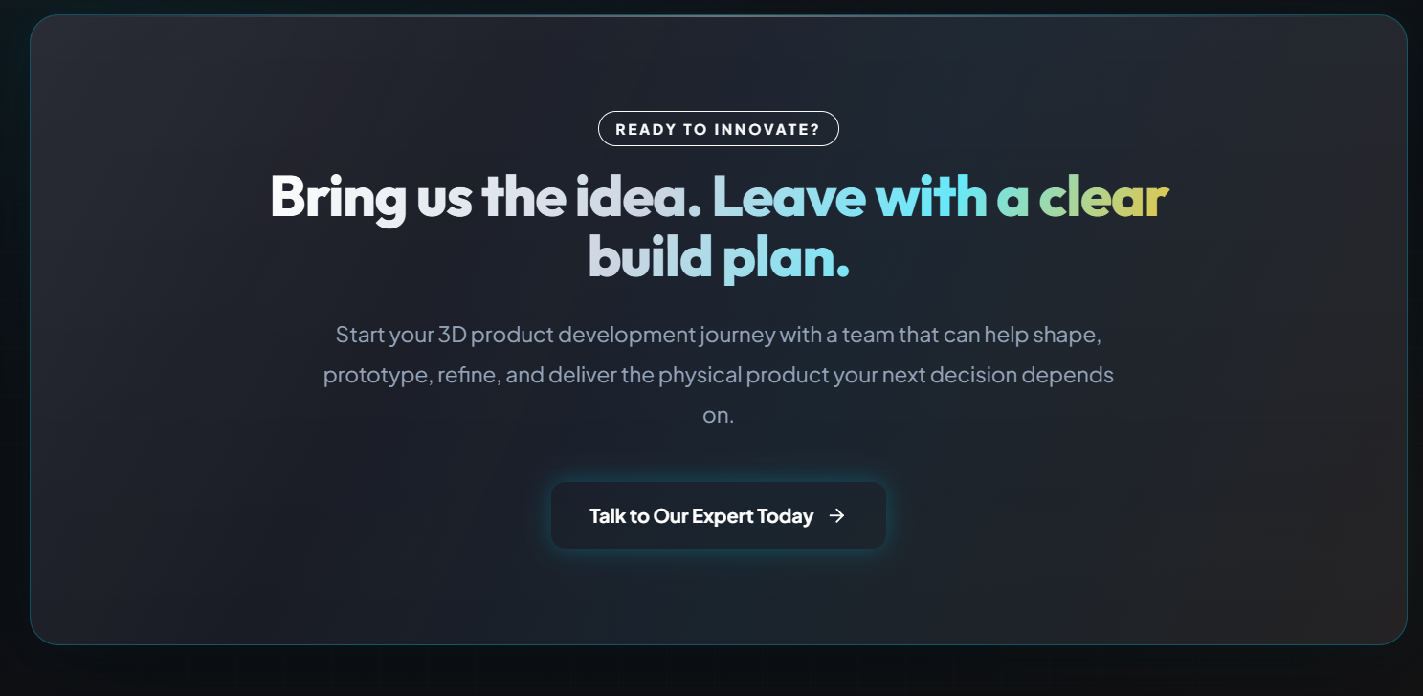

Display the “CTA section” at the end of every section page

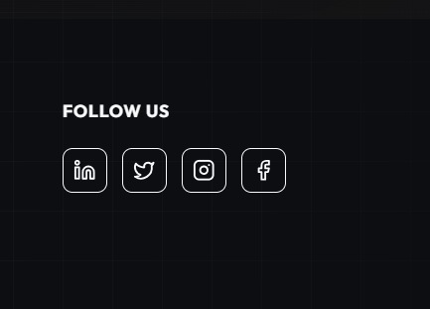

For SM logos, use their respective colours
……………..

- Remove the " About Us " section from the home page

- About us / contact us- add FAQ’

…………………………………………………………….
About us page:
About us
Our story’
Our mission
USP
Trust we earned (remove this section)
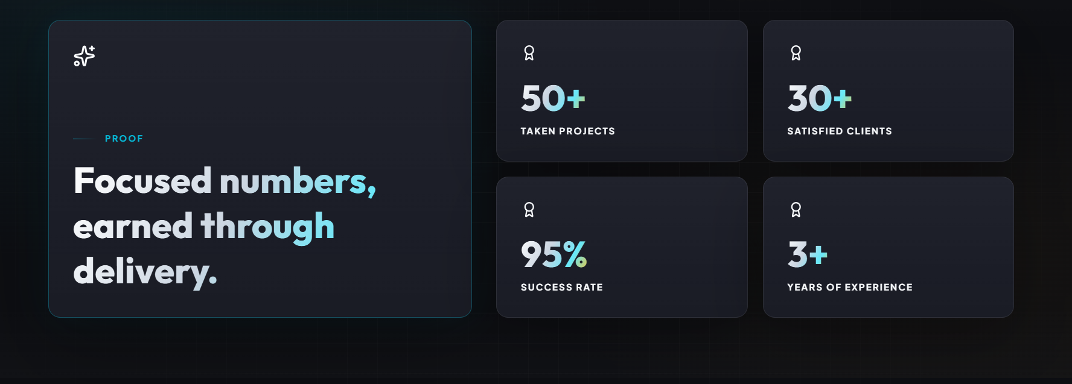
CTA (use at every page)
Services Page:
One more service is added
List should be mentioned while arrow is placed on the services header
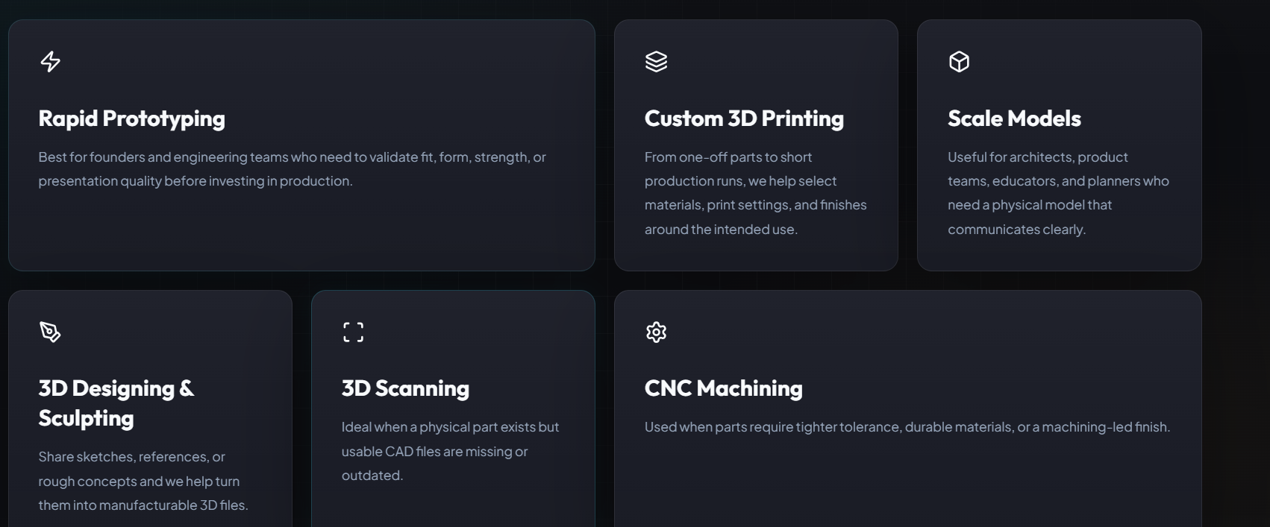
Remove this

…………………………………………………………….
Blogs Page:

Reference Image:
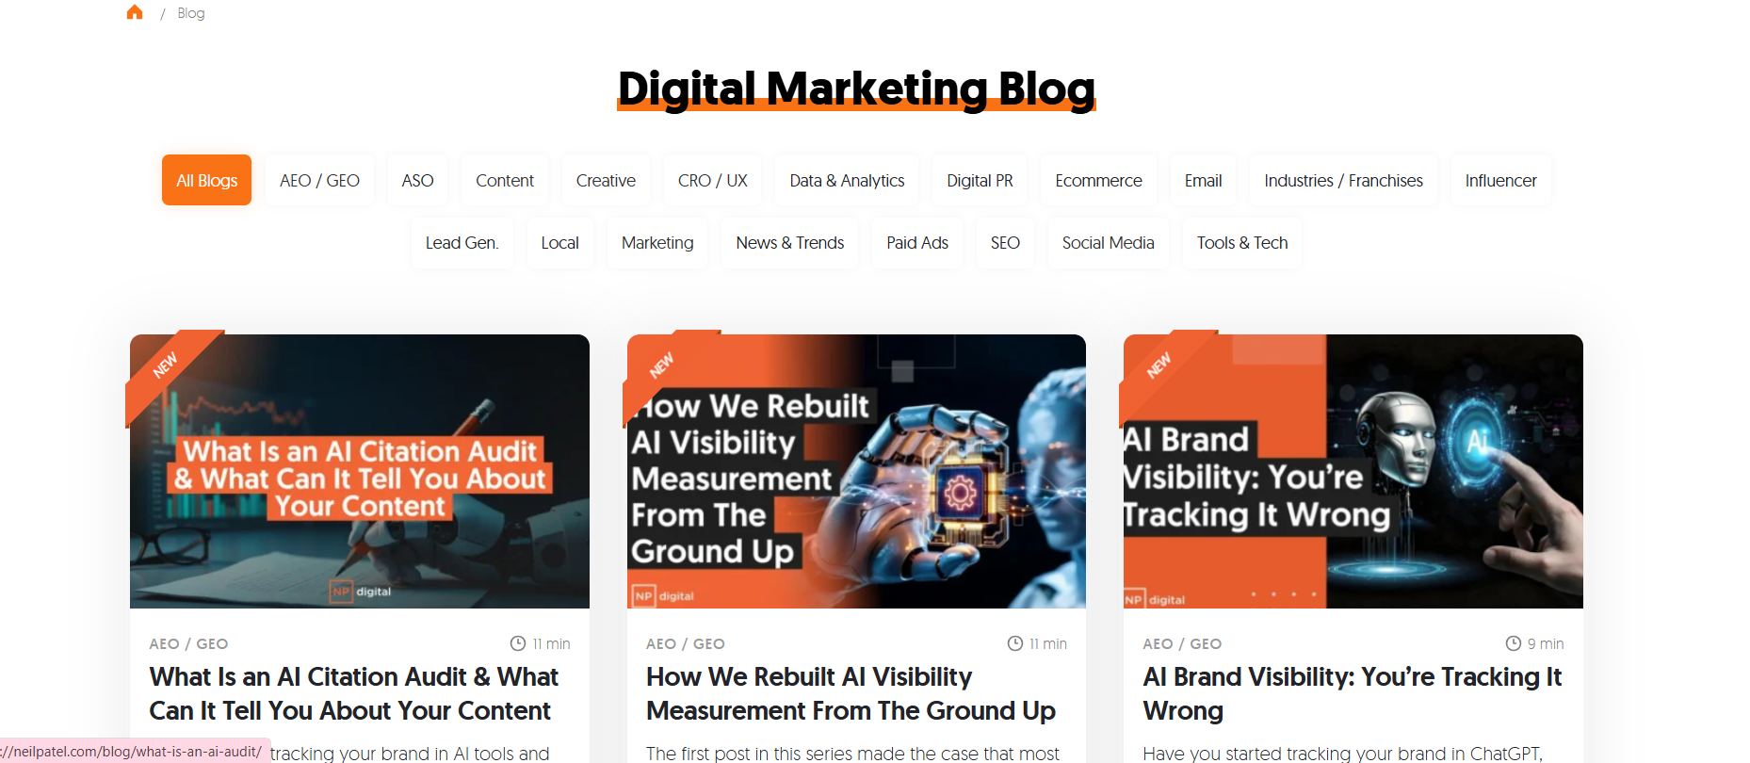

Headline - Stay Updated with Blogs
Place the services names in the boxes
Blogs representation should be as above or else if you have anyother interesting format you can use.
…………………………………………………………….

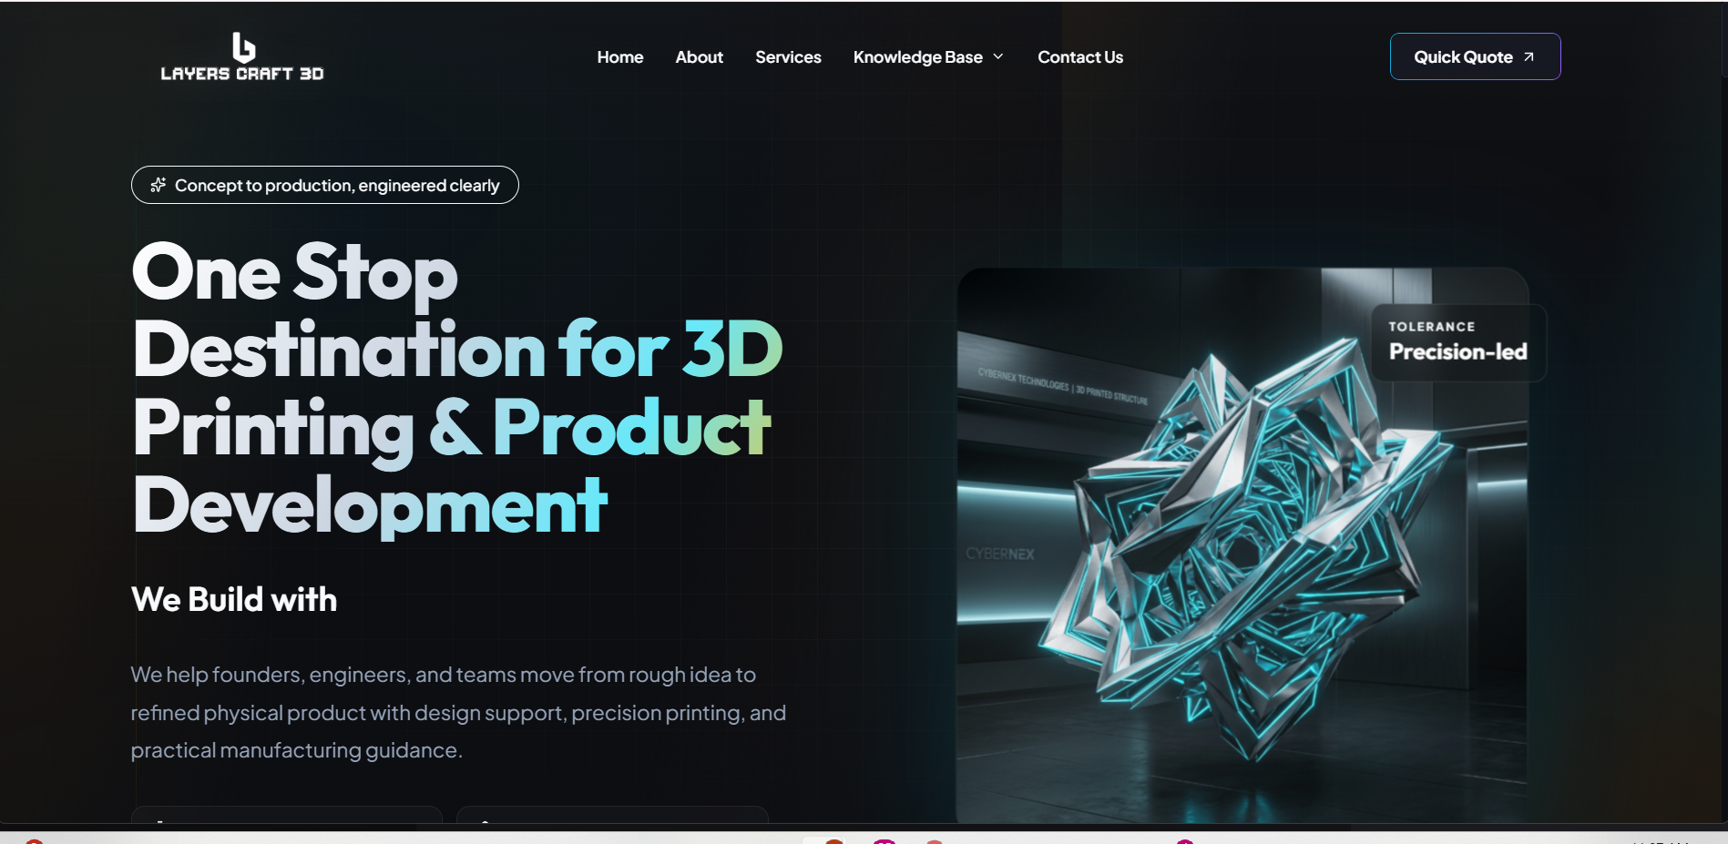
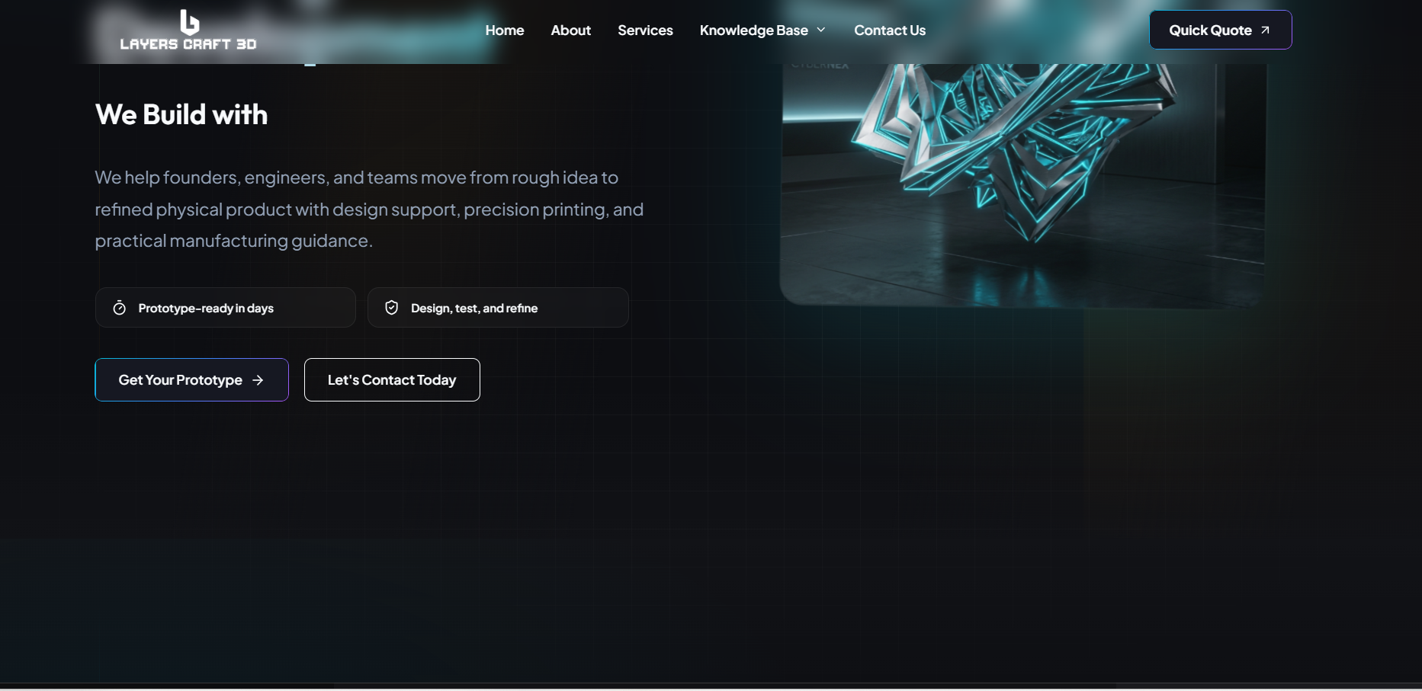
Tagline --- replace with ---- "Crafted with Precision, Ready for Production"

We Build with ---- Remove it

Short Para ---- replace with ---- "We combine design expertise with advanced 3D technology to deliver high-quality, cost-effective prototypes within days."

Short benefit tags ---- replace with ------ Tag1 "Innovative Designs" Tag2 "Production-Ready Solutions"

Let's Connect Today ---- replace with ------ "Talk to Our Team"

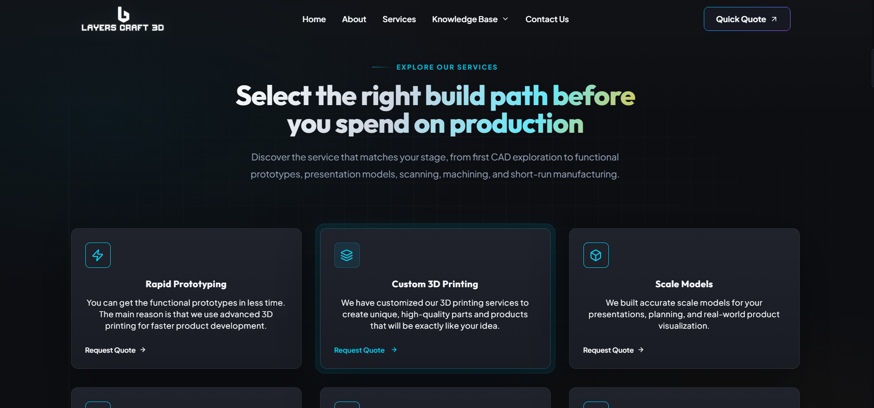
Heading: Choose the Best Solutions for Your Business

Short Para: Select the right service to transform your ideas into refined designs and functional products.
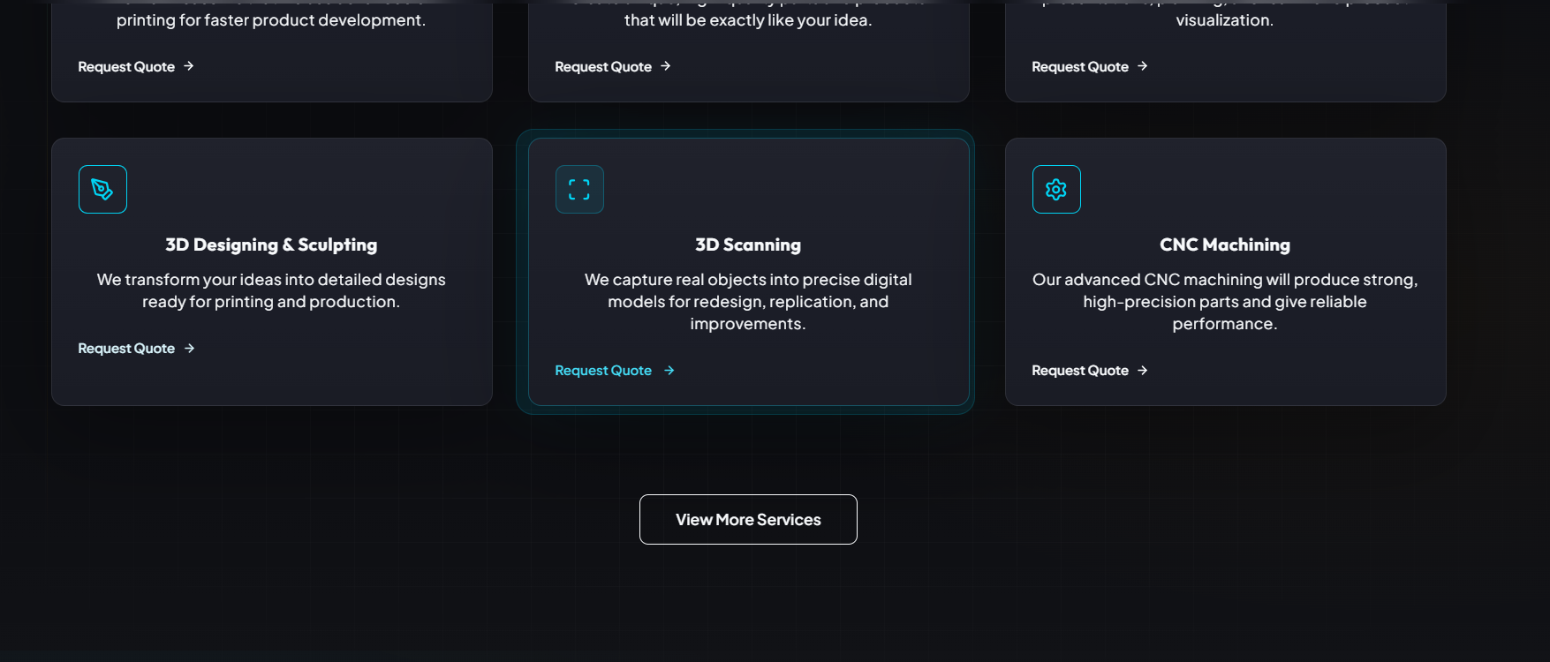
View More Services Button should navigate to “Services Page”. But it is navigating to request a quote form.

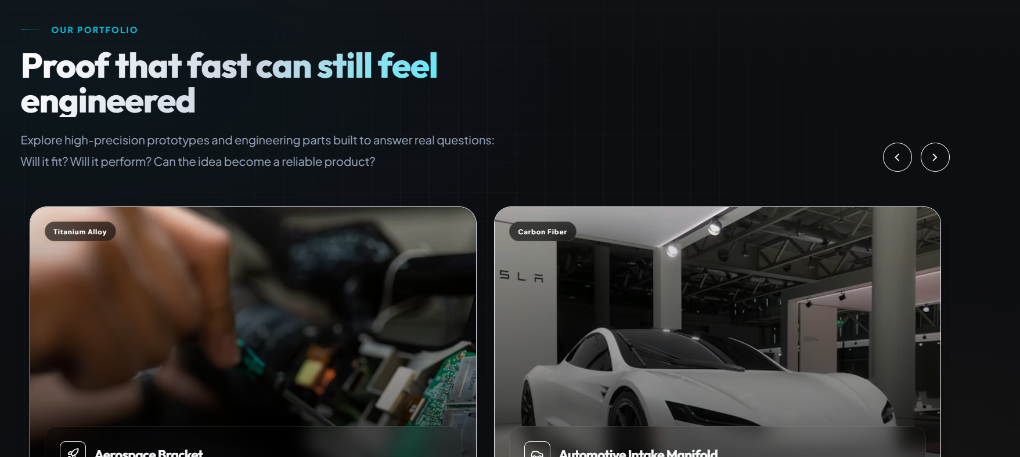

Technologies we use in 3D printing:
1.FDM
2.SLA
3.SLS
4.Metal 3D printing

