Calendar常用方法

**一、成员方法**

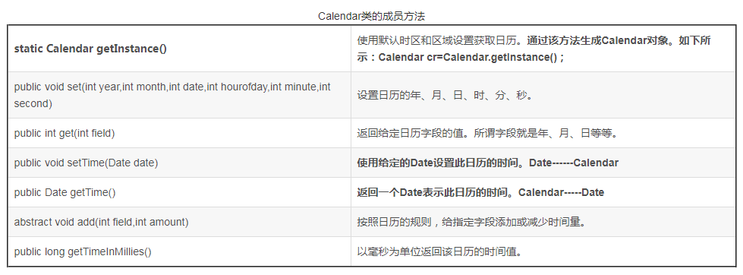

### 二、日历字段

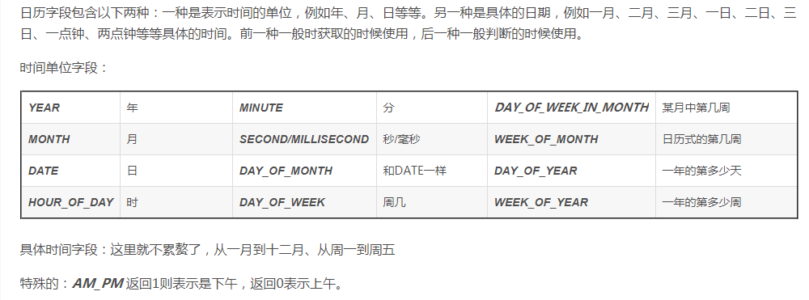

**package** com.sino.time;

**import** java.util.Calendar;

**import** java.util.Date;

/**

* 特殊的：AM_PM 返回1则表示是下午，返回0表示上午

* 月份是从0-11

*

* calendar

* set()

* setTime(Date date)

* Date getTime()

* long getTimeInMillies()

* **@author** lihe

*

*/

**public** **class** TestCalendar {

**public** **static** **void** main(String[] args) {

Calendar cal = Calendar.*getInstance*();

//获取字段

**int** year = cal.get(Calendar.***YEAR***); //2020

**int** month = cal.get(Calendar.***MONTH***);//2

**int** date = cal.get(Calendar.***DATE***);//2

**int** hour = cal.get(Calendar.***HOUR***);//12小时制 1

**int** hour1 = cal.get(Calendar.***HOUR_OF_DAY***);//24小时制 13

**int** minute = cal.get(Calendar.***MINUTE***); //54

**int** second = cal.get(Calendar.***SECOND***); //28

**int** millsecond = cal.get(Calendar.***MILLISECOND***); //289

**int** day_of_month = cal.get(Calendar.***DAY_OF_MONTH***); //2

**int** day_of_week = cal.get(Calendar.***DAY_OF_WEEK***); //2

**int** day_of_week_in_month = cal.get(Calendar.***DAY_OF_WEEK_IN_MONTH***);//1

**int** week_of_month = cal.get(Calendar.***DAY_OF_WEEK***); //2

**int** day_of_year = cal.get(Calendar.***DAY_OF_YEAR***); // 62

**int** week_of_year = cal.get(Calendar.***WEEK_OF_YEAR***);//10

//获取上午下午 0

**int** moa = cal.get(Calendar.***AM_PM***);

System.***out***.println(hour);

System.***out***.println(hour1);

System.***out***.println(moa);

**if**(moa == 1){

System.***out***.println("下午");

}**else**{

System.***out***.println("上午");

}

System.***out***.println(year + "年" + (month + 1) + "月" + date + "日" + hour + "时");

//设置日期

cal.set(2021, 3, 4);//设置指定日期

cal.setTime(**new** Date()); //设置实时日期

System.***out***.println("-----" +cal.get(Calendar.***YEAR***));

Date date1 = cal.getTime();

System.***out***.println(date1);

cal.add(Calendar.***YEAR***, 5);

cal.add(Calendar.***DATE***, -1);

System.***out***.println(cal.get(Calendar.***YEAR***) + "年" + (month + 1) + "月" + date1 + "日" + hour + "时");

System.***out***.println(cal.getTimeInMillis());

}

}