Shell Script Code:

1> #!bin/sh

netstat -ano

Save the file and execute :#bash ShellSample.sh

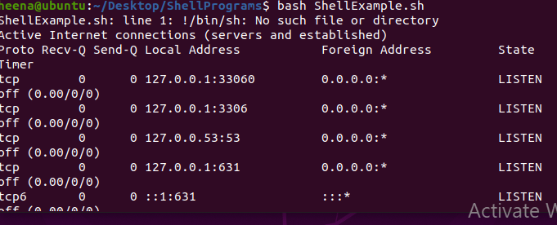

**Kernel Program**

**1>C Program With Kernel Header**

#include <linux/module.h>

#include <linux/kernel.h>

#include <linux/init.h>

MODULE_LICENSE("GPL/GNU");

MODULE_AUTHOR("Hena Firdaus, Linux Sexurity");

MODULE_DESCRIPTION("Kernel Testing Sample ");

MODULE_VERSION("1.01");

static int __init hello_start(void)

{

printk(KERN_INFO "Loading X module...\n");

printk(KERN_INFO "Hello world\n");

return 0;

}

static void __exit hello_end(void)

{

printk(KERN_INFO "Welcome.... Ms.\n");

}

2> Make Make File

obj-m = hello.o

all:

make -C /lib/modules/$(shell uname -r)/build/ M=$(shell pwd) modules

clean:

make -C /lib/modules/$(shell uname -r)/build M=$(shell pwd) clean