Project: Multi-Region Disaster Recovery
Ensuring High Availability and Business Continuity with Cloud Automation.
Submitted By – Heena

1. Introduction
1.1. Problem Statement
In today’s digital world, downtime can result in significant business losses and damage to reputation. Many organizations struggle to ensure their applications remain available and data is protected in the event of regional outages or disasters. Traditional disaster recovery solutions are often complex, expensive, and slow to recover.
1.2. Scope
This project implements a multi-region disaster recovery (DR) solution on AWS. It uses Infrastructure as Code (Terraform) and DevOps automation (Jenkins) to deploy, monitor, and validate a resilient cloud environment that can withstand regional failures and ensure minimal downtime.
1.3. Objectives
- Deploy infrastructure across two AWS regions for redundancy.
- Automate provisioning using Terraform and Jenkins.
- Set up cross-region data replication for S3 and RDS.
- Implement failover using Route 53.
- Monitor all components and set up automated alerts.
- Validate the DR setup with comprehensive testing.

2. AWS Services Utilized: A Comprehensive Overview
The following AWS services were instrumental in building and deploying Door-O-Help:
2.1. Networking Services
- VPC (Virtual Private Cloud): Isolated network environments in both regions.
- Subnets: Public and private subnets for resource segregation.
- Internet Gateway & NAT Gateway: Enable secure internet access.
- Route Tables: Control traffic flow.
- VPC Peering: (Optional) For secure cross-region communication.
2.2. Compute Services
- EC2: Runs the application servers and Jenkins automation server.
- Application Load Balancer (ALB): Distributes traffic and supports health checks.
2.3. Storage & Database Services
- S3: Stores files with cross-region replication for durability.
- RDS (MySQL): Managed database with cross-region read replica for DR.
2.4. DNS & Failover Services
- Route 53: Manages DNS and health checks for automated failover.
2.5. Security and Identity Services
- IAM: Manages user and service permissions.
- Security Groups: Firewall rules for EC2, RDS, and ALB
2.6. Monitoring and Alert Services
- CloudWatch: Collects logs and metrics, triggers alarms.
- SNS: Sends notifications for alarms and failures.

3. DevOps Approach
3.1. Infrastructure as Code
- All AWS resources are defined in Terraform scripts for repeatable, auditable deployments.
3.2. Continuous Integration & Delivery
- Jenkins pipeline automates:
  - Pulling code from GitHub.
  - Running Terraform to deploy/update infrastructure.
  - Notifying the team on success/failure.

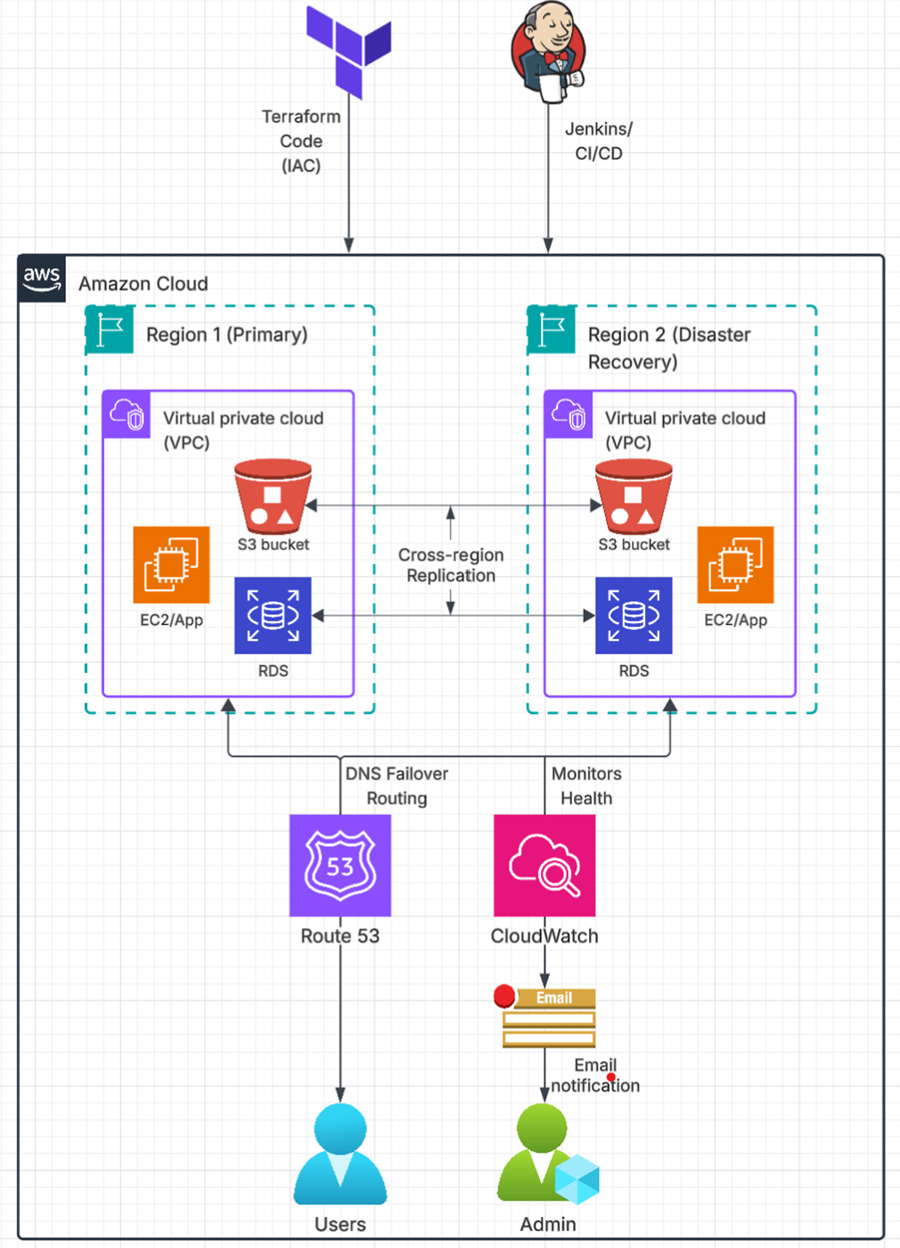
    - Architectural Diagram of Multi-Region Disaster Recovery Setup.

4. Detailed Service Implementation
4.1. Networking with VPC
- Created VPCs in both of us-east-1 (primary) and us-west-2 (secondary) regions.
- Set up public and private subnets, internet gateways, NAT gateways, and route tables.
- Configured VPC peering for secure cross-region communication.
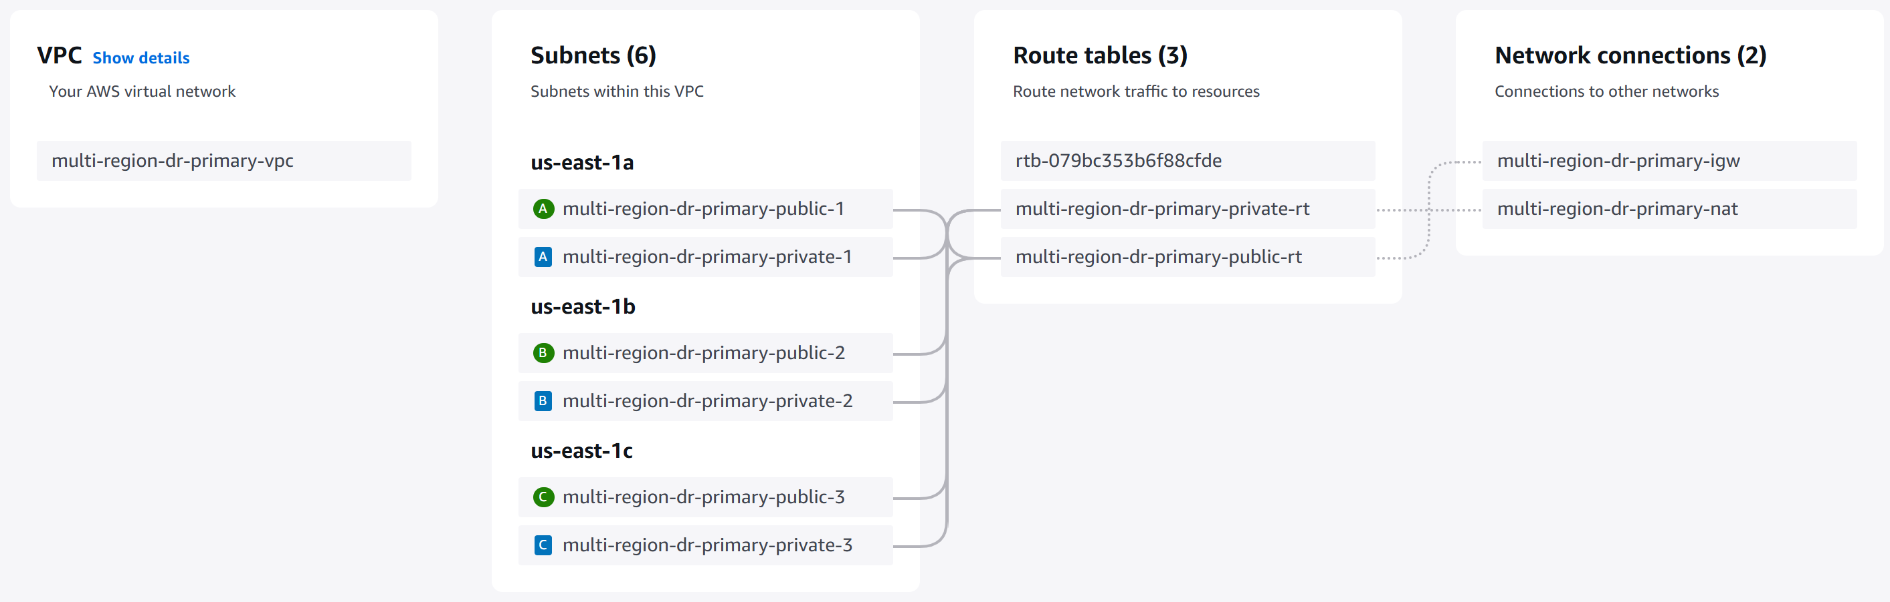
    - VPC, Subnets in different zones, Route tables and Internet & Network Gateway in us-east-1 region.

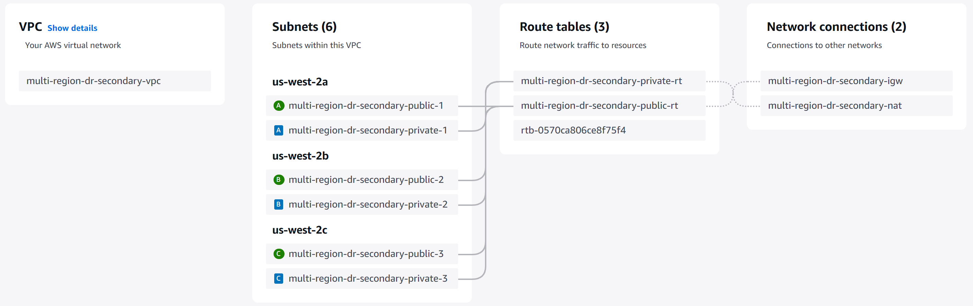
    - VPC, Subnets in different zones, Route tables and Internet & Network Gateway in us-west-2 region.

4.2. Compute and Load Balancing
- Deployed EC2 instances in both regions for application servers.
- Set up Application Load Balancers (ALB) in both regions to distribute traffic and perform health checks.
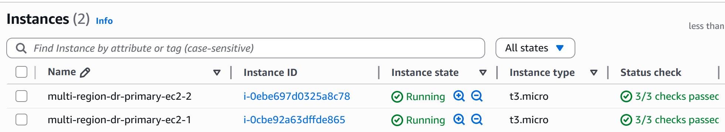
    - Two EC2 instances running in us-east-1 (primary) region.

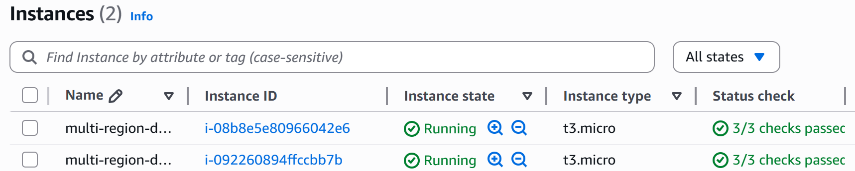
    - Similarly, two EC2 instances running in us-west-2 (disaster-recovery/secondary) region.

4.3. Storage and Database Replication
- Created S3 buckets in both regions with cross-region replication enabled.
- Deployed RDS MySQL in the primary region and configured a cross-region read replica.

    - S3 buckets in both regions with cross-region replication enabled.

    - MySQL RDS instance in primary region with its read-replica in secondary region.

4.4. DNS and Failover
- Configured Route 53 with health checks and failover routing.
- If the primary region fails, traffic is automatically routed to the secondary region.
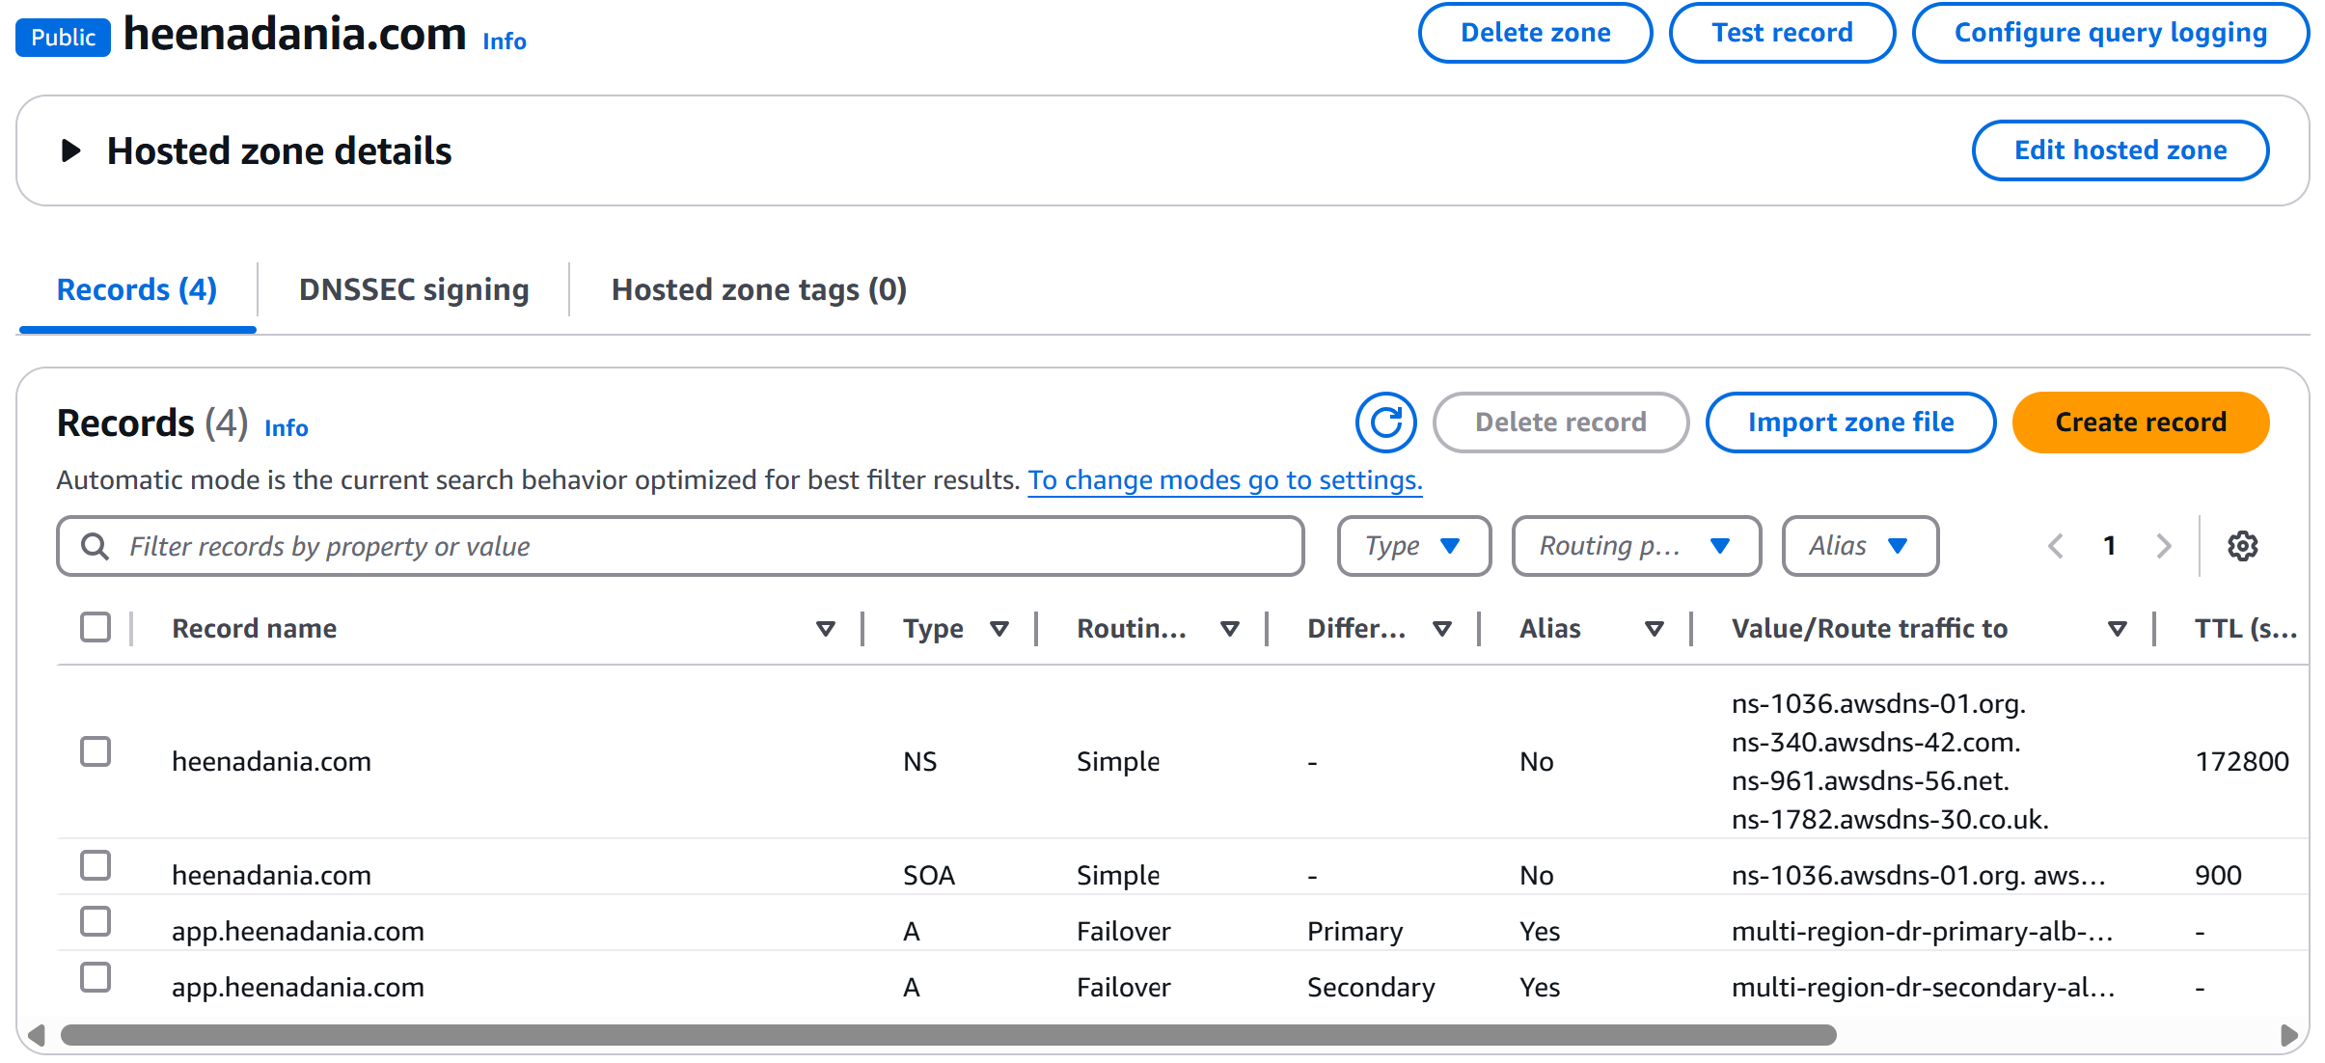
    - Route 53 records for hosted zone.

4.5. Monitoring and Alerts
- Enabled CloudWatch logging for EC2, VPC, S3, and RDS.
- Set up CloudWatch alarms for:
  - S3 replication failures
  - RDS replica lag
  - Route 53 health check failures
- Configured SNS topics to send email notifications for each alarm.
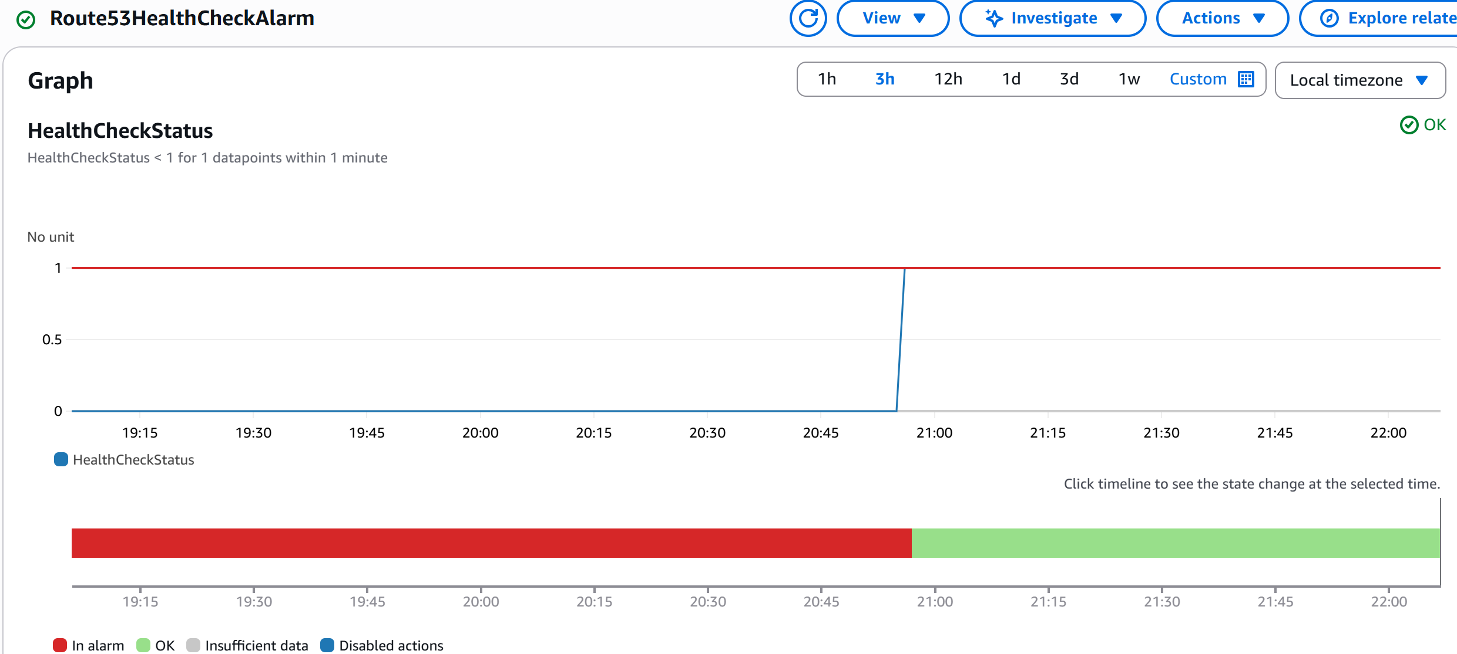
    - CloudWatch Alarm for Route 53 health.
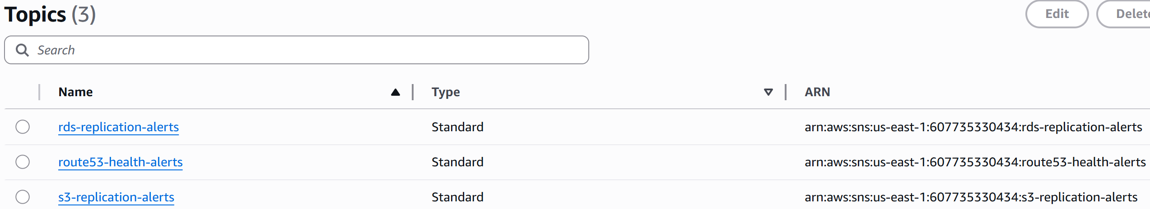
    - SNS Topics configured to send email notifications whenever health-checks fail.

4.6. CI/CD with Jenkins
- Launched a Jenkins at localhost:8080/.
- Installed Jenkins, required plugins (Git, Pipeline), and configured credentials for Git & AWS.
- Created a Jenkins pipeline to:
  - Pull Terraform code from GitHub.
  - Run terraform init, plan, and apply automatically.
  - Require manual approval before production changes.
- Set up GitHub webhooks for automatic pipeline triggers.

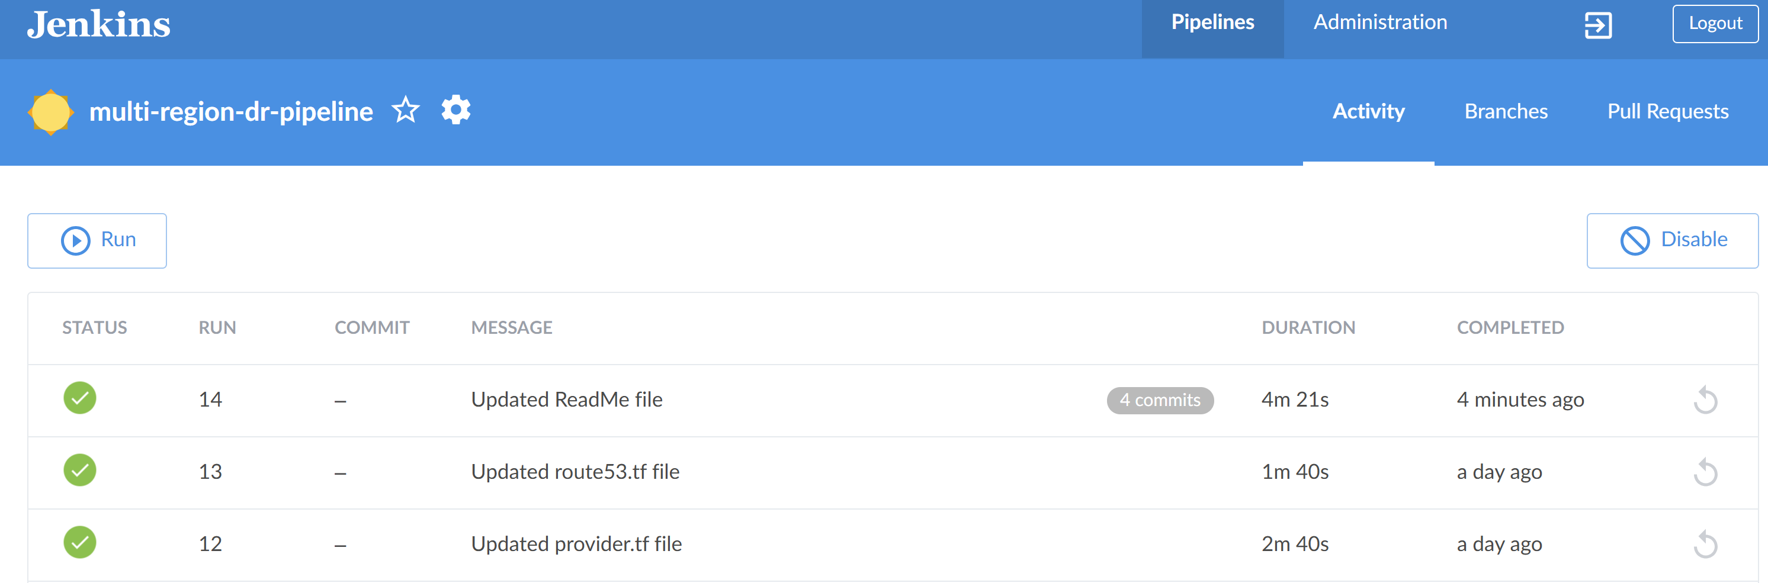
    - Jenkins pipeline running successful builds for each changes in GitHub repository.

5. Testing and Validation
5.1. Infrastructure Validation
- Verified all AWS resources were created via the AWS Console and Terraform outputs.
5.2. S3 Replication Test
- Uploaded a file to the primary S3 bucket.
- Confirmed it appeared in the secondary bucket after replication delay.
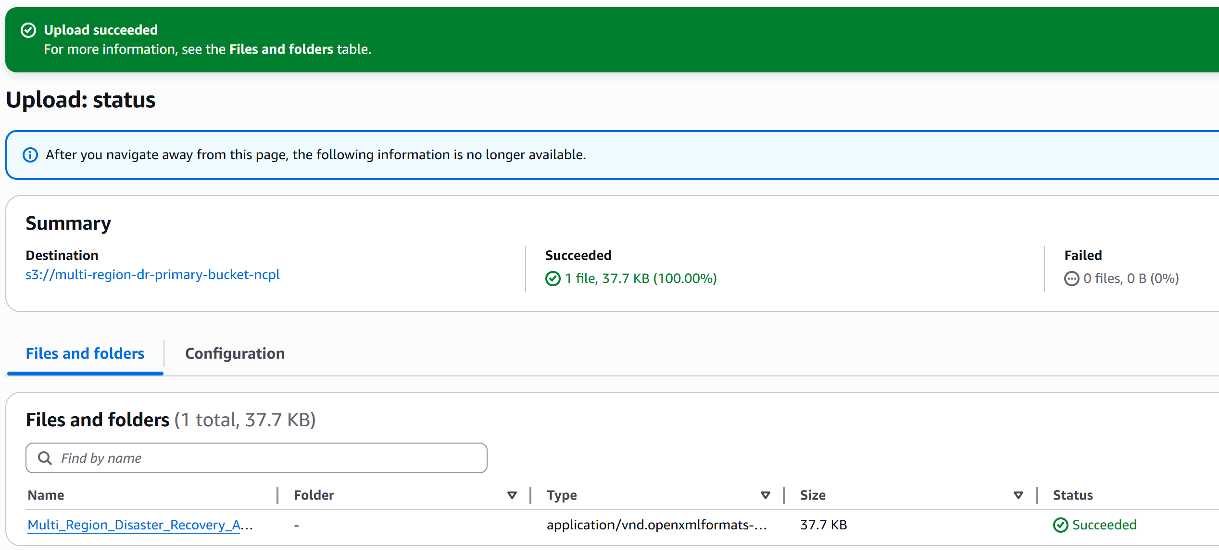
    - Uploading file in primary S3 bucket.

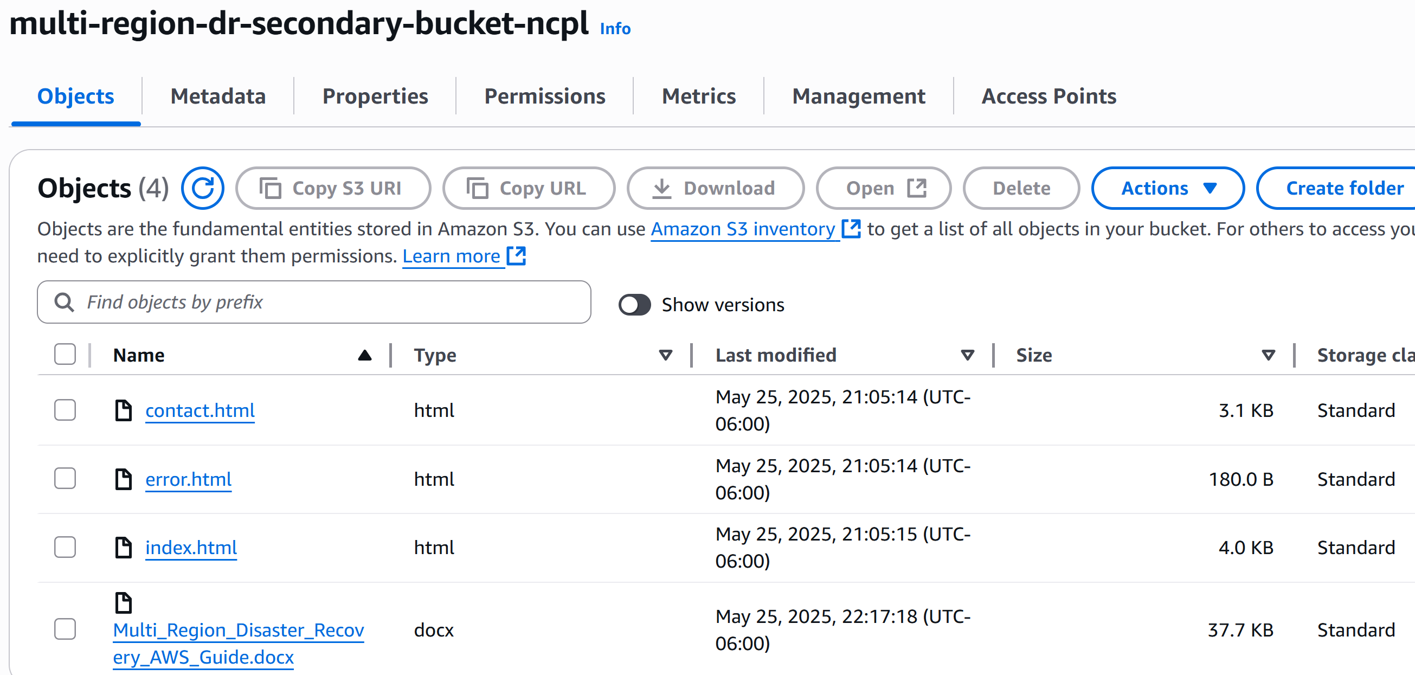
    - Same file got replicated in secondary S3 bucket automatically.

5.3. RDS Replication Test
- Inserted and updated a row in the primary RDS database.
- Verified the row appeared in the read replica.
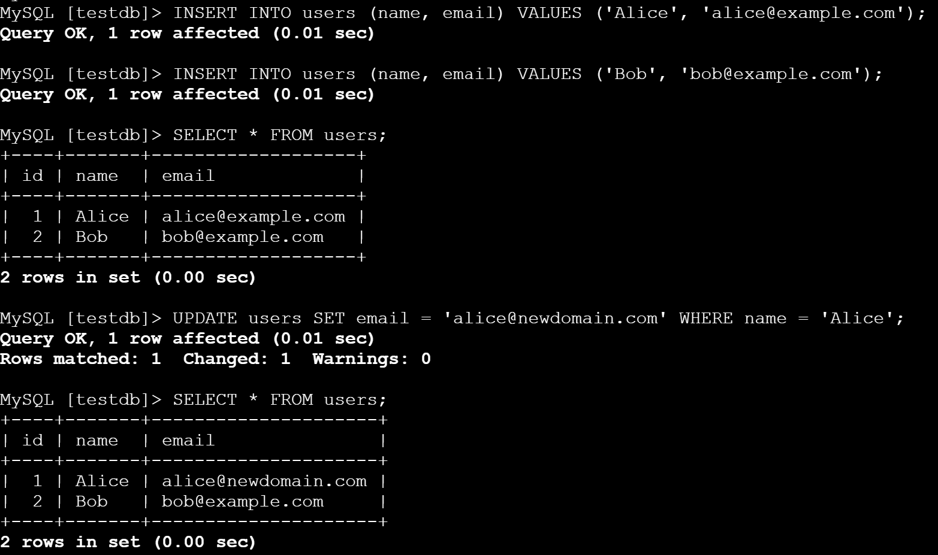
    - Inserted and updated data in primary region RDS instance.

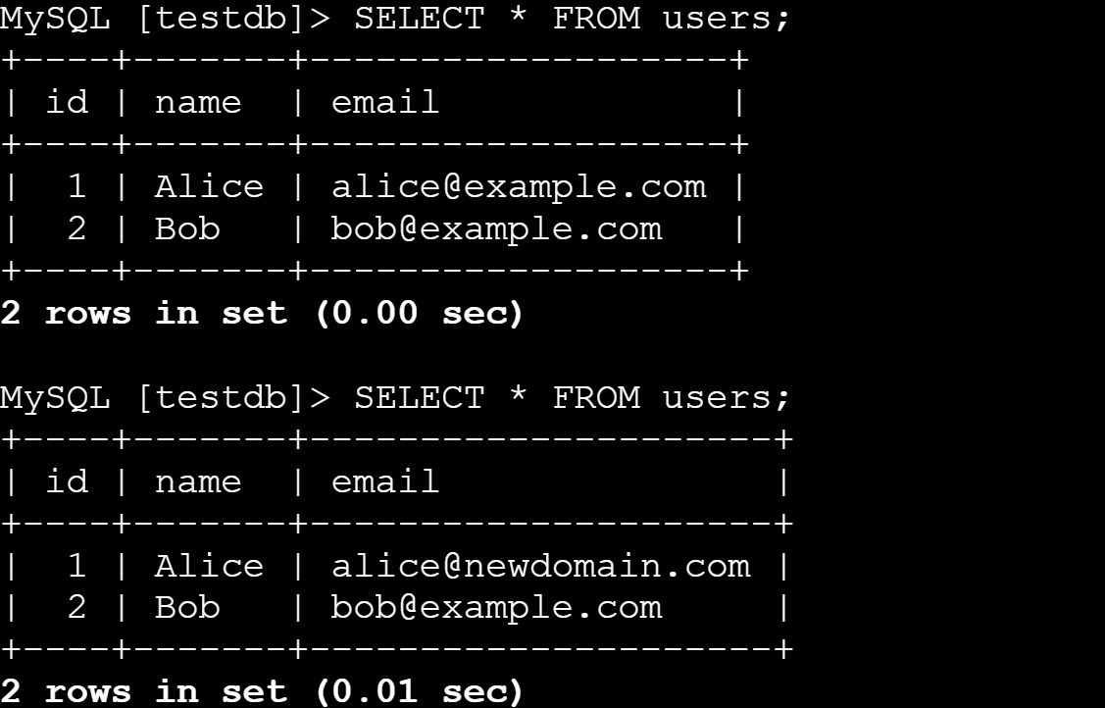
    - Same changes got reflected into read replica located in secondary region.

5.4. Route 53 Failover Test
- Stopped EC2 instances in the primary region.
- Waited for Route 53 health check to fail.
- Confirmed traffic was routed to the secondary region.
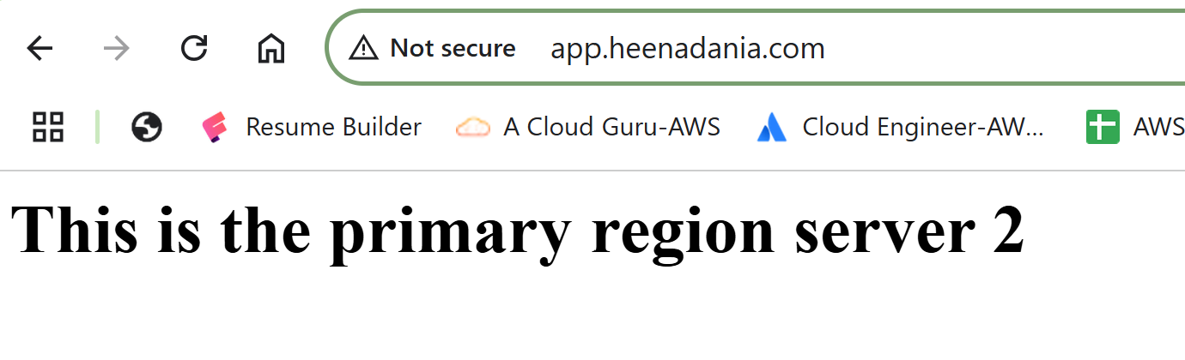
    - Initially Route 53 was hosting on primary region servers.

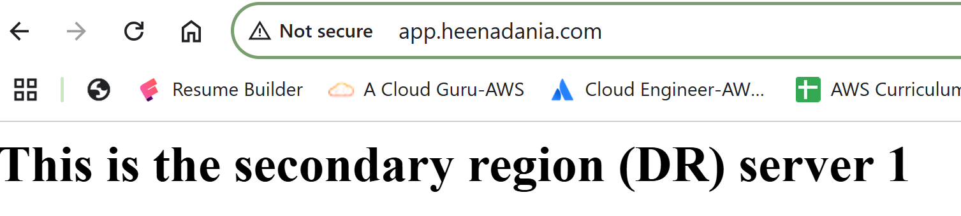
    - Route 53 switched hosting to secondary region within seconds, when simulated a failure.

5.5. Monitoring and Alerts Test
- Simulated S3 and RDS failures to trigger CloudWatch alarms.
- Received SNS email notifications for each alarm.

5.6. Clean-Up
- Ran terraform destroy to remove all resources and avoid unwanted AWS charges.

6. Challenges and Solutions
- IAM Permissions: Faced issues with cross-region replication due to missing IAM roles. Fixed by updating policies.
- Terraform State Management: Learned the importance of remote state in S3 and DynamoDB for team collaboration.
- Testing Failover: Route 53 failover delay required patience and careful monitoring.

7. Lessons Learned
- Gained hands-on experience with AWS multi-region architecture and Disaster Recovery best practices.
- Learned how to automate infrastructure with Terraform and Jenkins.
- Understood the importance of monitoring and alerting for real-world reliability.
- Improved troubleshooting skills by resolving real AWS errors.

8. Future Scope
- Use private subnets and bastion hosts for enhanced security.
- Integrate more advanced monitoring (e.g., AWS X-Ray, CloudTrail).
- Add auto-remediation scripts for faster recovery.
- Explore cost optimization with spot instances and reserved RDS.

9. Conclusion
This project demonstrates how to build a robust, automated, and highly available cloud infrastructure using AWS, Terraform, and Jenkins. The multi-region DR setup ensures business continuity and minimal downtime, while automation and monitoring provide confidence in ongoing operations. This approach is applicable to any organization seeking to improve resilience and reliability in the cloud.

10. Demo
Application URL: http://app.heenadania.com/

Appendix
- Terraform Scripts:
https://github.com/HeenaDania/multi-region-dr-aws/tree/main/terraform
- Jenkinsfile:
https://github.com/HeenaDania/multi-region-dr-aws/blob/main/cicd/Jenkinsfile

