Dataset: Digital Habits & Smartphone Addiction DatasetLinks to an external site. (KAGGLE LINK)
Dataset Download Here: Smartphone_Usage_And_Addiction_Analysis_7500_Rows-2.csvDownload Smartphone_Usage_And_Addiction_Analysis_7500_Rows-2.csv
GITHUB LINK(FOR CODES): https://github.com/Heer972005/DVD
About Dataset
The dataset contains 7,500 records representing individuals with different smartphone usage behaviors. Each record includes demographic information and smartphone interaction metrics that help measure digital activity and addiction tendencies.
Key information included in the dataset:
- Demographics: Age and Gender
- Usage Behavior: Daily screen time, social media usage hours, gaming hours, and work/study usage
- Device Interaction: Number of notifications received and app opens per day
- Lifestyle Factors: Sleep duration and stress level
- Impact Indicators: Academic/work performance impact due to smartphone use
- Addiction Metrics: Smartphone addiction level and addiction classification
These variables allow researchers and analysts to explore relationships between digital habits, lifestyle factors, and smartphone addiction tendencies.
Context
Smartphones have become an essential part of daily life, influencing communication, productivity, entertainment, and social interaction. However, excessive smartphone usage may lead to behavioral addiction and negative impacts on mental health, sleep patterns, and academic or work performance.
This dataset was created to analyze smartphone usage patterns and identify potential indicators of smartphone addiction. It captures various behavioral metrics such as screen time, app usage frequency, notifications received, sleep duration, and perceived stress levels. By examining these factors, researchers and data analysts can better understand how smartphone habits relate to digital dependency.

Question 1 – Average Smartphone Usage by Age Group (Bar Plot)
Using the dataset, first create a new variable called Age Group by dividing the Age column into four categories: Youth (15–25), Young Adults (26–35), Adults (36–50), and Senior Citizens (50+). After grouping the data, calculate the average smartphone usage for each age group and represent it using a bar plot.
While constructing the visualization, experiment with parameters such as bar color or palette, bar width, edge color, and transparency. Rotate the x-axis labels for better readability and include a suitable title along with clearly labeled axes. Grid lines may be added to enhance clarity.
After generating the plot, interpret which age group shows the highest usage and comment on whether the variation across age groups is significant.
Bloom’s Level: Applying, Analyzing
Code:
import pandas as pd
import matplotlib.pyplot as plt
import seaborn as sns

df = pd.read_csv("Smartphone_Usage_And_Addiction_Analysis_7500_Rows-2.csv")

bins = [15, 26, 36, 51, 100]
labels = ["Youth", "Young Adults", "Adults", "Senior Citizens"]

df["Age Group"] = pd.cut(df["age"], bins=bins, labels=labels)

avg_usage = df.groupby("Age Group")["daily_screen_time_hours"].mean()

plt.bar(avg_usage.index,
avg_usage.values,
color="skyblue",
edgecolor="black",
alpha=0.7,
width=0.6)

plt.xticks(rotation=30)
plt.title("Average Smartphone Usage by Age Group")
plt.xlabel("Age Group")
plt.ylabel("Avg Screen Time")

plt.show()

sns.barplot(x="Age Group",
y="daily_screen_time_hours",
data=df,
palette="viridis",
edgecolor="black")

plt.title("Average Smartphone Usage by Age Group")
plt.xlabel("Age Group", fontsize=12)
plt.ylabel("Avg Screen Time (hours)", fontsize=12)

plt.xticks(rotation=30)
plt.show()

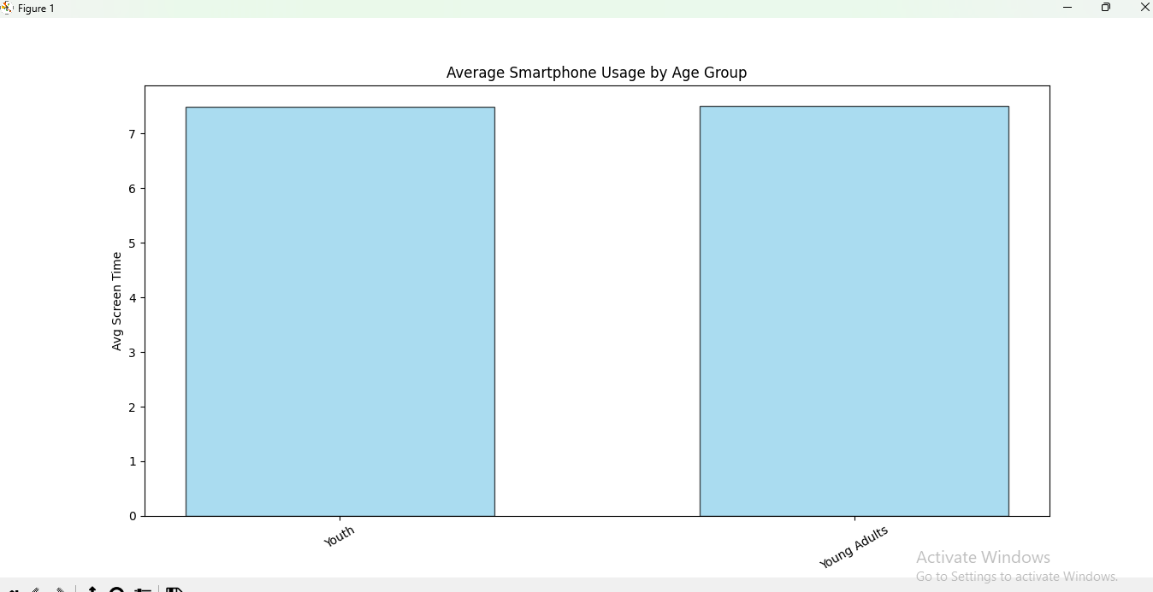
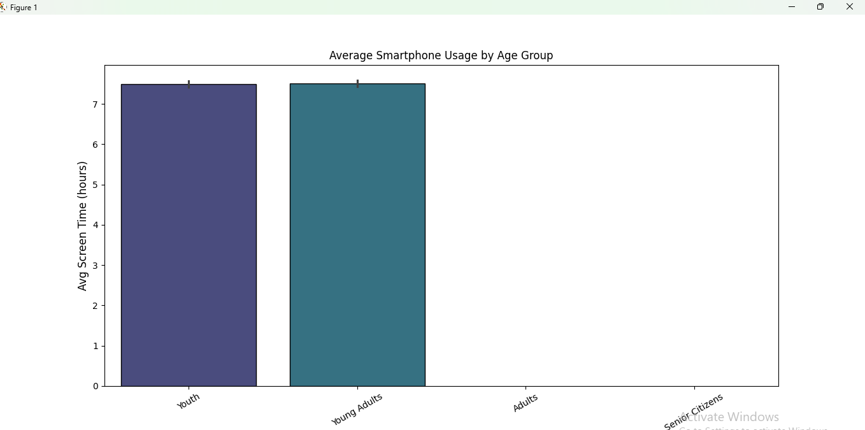The bar plot shows that both Youth and Young Adults have nearly equal and high average smartphone usage, indicating that individuals aged 15–35 are the most active smartphone users. However, the absence of other age groups suggests negligible use of smartphones

Question 2 – Addiction Level Comparison (Horizontal Bar Chart)
Create a horizontal bar chart to display the distribution or average values of addiction levels across categories. Before plotting, arrange the data in a sorted order to ensure clear ranking.
While designing the chart, adjust parameters such as bar height, color gradients, and edge colors. Ensure that axis labels and titles are properly added and that the orientation improves readability compared to a standard vertical bar chart.
After visualization, identify which category stands out the most in terms of addiction level and comment on whether the ranking is clearly distinguishable.
Bloom’s Level: Applying, Understanding
Code:
import pandas as pd
import matplotlib.pyplot as plt
import seaborn as sns

df = pd.read_csv("Smartphone_Usage_And_Addiction_Analysis_7500_Rows-2.csv")

addiction = df["addiction_level"].value_counts().sort_values()

plt.barh(addiction.index,
addiction.values,
color="orange",
edgecolor="black",
height=0.6)
plt.title("Addiction Level Distribution")
plt.xlabel("Count")
plt.ylabel("Addiction Level")

plt.show()

sns.countplot(y="addiction_level",
data=df,
order=df["addiction_level"].index,
palette="coolwarm",
edgecolor="black"
)

plt.title("Addiction Levels")
plt.xlabel("Count")
plt.ylabel("Addiction Level")
plt.show()

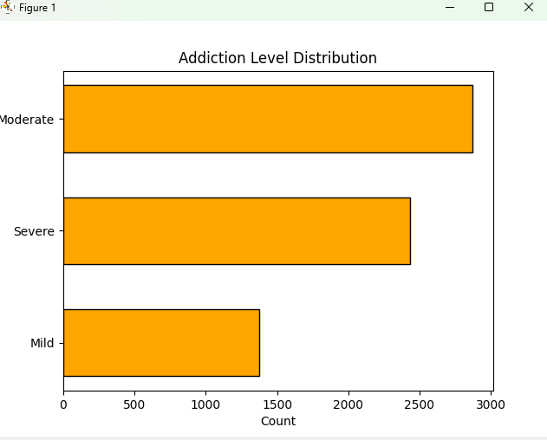
The horizontal bar chart shows that moderate addiction is the most common category, followed by severe addiction, while mild addiction has the lowest count. This indicates that majority of individuals exhibit moderate to high levels of smartphone addiction highlighting the growing concern of excessive smartphone usage.

Question 3 – Trend of Smartphone Usage (Line Plot)
Construct a line plot to analyze the trend between age (or grouped age categories) and smartphone usage. The goal is to observe how usage changes across different age values.
While creating the plot, experiment with marker styles, line styles, and line width. If applicable, include multiple lines using grouping (hue) to compare different categories within the same graph. Add appropriate labels, title, and legend for clarity.
After plotting, analyze whether there is an increasing or decreasing trend and identify any sudden changes or irregular patterns in usage.
Bloom’s Level: Analyzing
Code:
import pandas as pd
import matplotlib.pyplot as plt
import seaborn as sns

df = pd.read_csv("Smartphone_Usage_And_Addiction_Analysis_7500_Rows-2.csv")

age_usage = df.groupby("age")["daily_screen_time_hours"].mean()

plt.plot(age_usage.index,
age_usage.values,
marker='o',
linestyle='--',
linewidth=2,
color="blue"
)
plt.title("Usage Trend by Age")
plt.xlabel("Age")
plt.ylabel("Average Screen Time (hours)")
plt.grid(alpha=0.5)
plt.show()

sns.lineplot(x=age_usage.index,
y=age_usage.values,
marker='o',
linewidth=2)

plt.title("Usage Trend")
plt.xlabel("Age")
plt.ylabel("Average Screen Time (hours)")
plt.show()

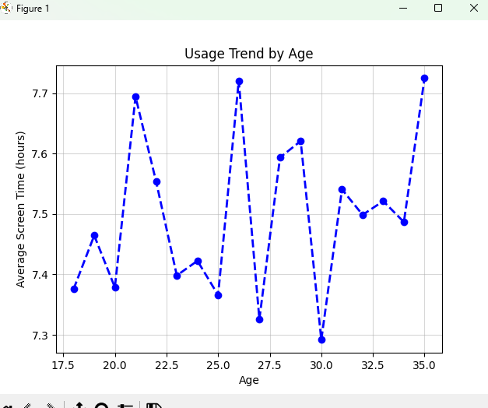
The graph shows consistent screen time across ages, meaning people in almost all age range use smartphones almost equally.
There are slight peaks (around ages 21, 26, 35) indicate higher engagement at certain ages, possibly due to lifestyle (college, work pressure, social media).
Drops (around 30) may reflect busy schedules or reduced leisure time.
Question 4 – Relationship Between Usage and Addiction (Scatter Plot)
Develop a scatter plot to explore the relationship between smartphone usage and addiction score. This visualization should help identify patterns, clusters, or correlations between the two variables.
While constructing the scatter plot, vary marker size, apply color mapping, and adjust transparency to improve readability. If using Seaborn, include a categorical distinction using hue. Ensure proper axis labels and title are included.
After generating the plot, interpret whether a correlation exists and describe any visible clusters or unusual patterns.
Bloom’s Level: Analyzing
Code:
import pandas as pd
import seaborn as sns
import matplotlib.pyplot as plt
df = pd.read_csv("Smartphone_Usage_And_Addiction_Analysis_7500_Rows-2.csv")

plt.scatter(
df["daily_screen_time_hours"],
df["addicted_label"],
alpha=0.5,
color="blue")

plt.title("Usage vs Addiction")
plt.xlabel("Daily Screen Time")
plt.ylabel("Weekend Screen Time")
plt.grid(alpha=0.4)
plt.show()

sns.scatterplot(x="daily_screen_time_hours",
y="addicted_label",
hue="addiction_level",
data=df,
alpha=0.6)
plt.title("Usage vs Addiction Level")
plt.xlabel("Daily Screen Time")
plt.ylabel("Addicted Label")
plt.show()

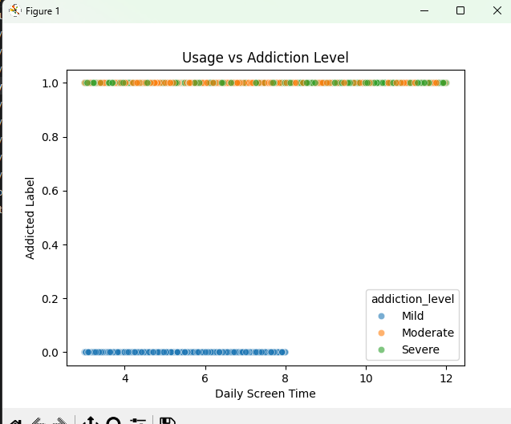
The scatter plot indicates a positive relationship between daily screen time and smartphone addiction. The graph shows that people who have lower screen times are mostly non-addicted(0), and people who have higher screen times are mostly addicted(1). The data points are clustered together, indicating a threshold beyond which increased screen times result in increased levels of addiction.

Question 5 – Distribution of Usage Across Categories (Box Plot)
Create a box plot to visualize the distribution of smartphone usage across different categories such as age group or gender. This plot should highlight median values, spread, and outliers.
While designing the plot, experiment with different color palettes and choose whether to display or hide outliers. Compare multiple categories within the same visualization. Ensure the plot includes appropriate labels and title.
After plotting, identify which category has the highest variability and comment on the presence of outliers.
Bloom’s Level: Analyzing
Code:
import pandas as pd
import matplotlib.pyplot as plt
import seaborn as sns

df = pd.read_csv("Smartphone_Usage_And_Addiction_Analysis_7500_Rows-2.csv")

bins = [15, 25, 35, 50, 100]
labels = ["Youth", "Young Adults", "Adults", "Senior Citizens"]

df["Age Group"] = pd.cut(df["age"], bins=bins, labels=labels)

grouped = df.groupby("Age Group", observed=True)

groups = []
labels = []

for name, group in grouped:
groups.append(group["daily_screen_time_hours"].values)
labels.append(name)

plt.boxplot(groups,
tick_labels=labels,
patch_artist=True, # enables color
showfliers=True)

plt.title("Box Plot of Usage by Age Group")
plt.xlabel("Age Group")
plt.ylabel("Screen Time")
plt.grid(axis='y', alpha=0.5)
plt.show()

sns.boxplot(x="Age Group",
y="daily_screen_time_hours",
data=df,
palette="Set2",
showfliers=True)
plt.title("Distribution of Smartphone Usage by Age Group", fontsize=14)
plt.xlabel("Age Group")
plt.ylabel("Screen Time (hours)")

plt.xticks(rotation=20)
plt.show()

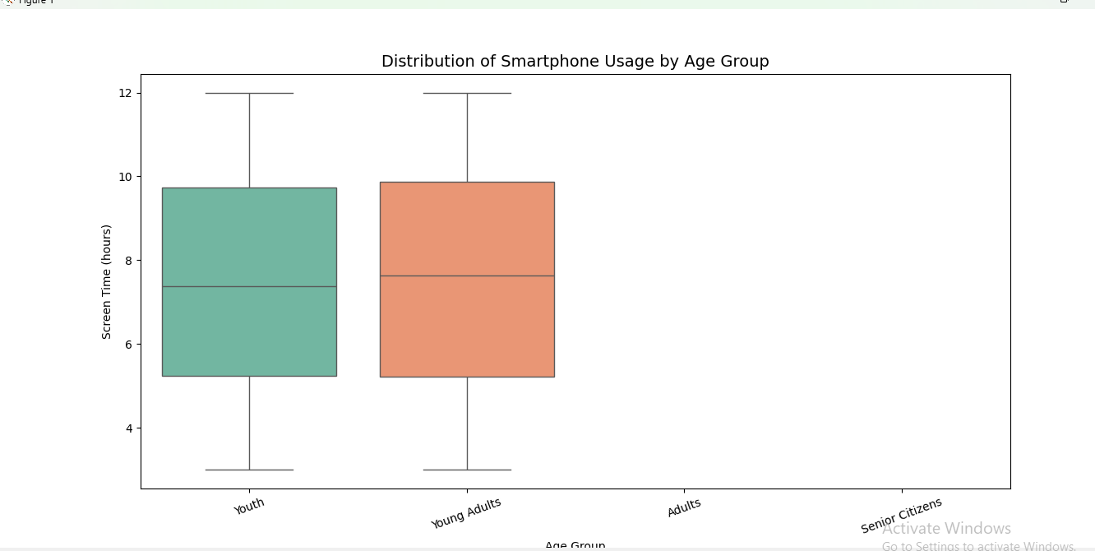
From the plot one can infer that he interquartile range (IQR) is wide for both groups which indicates high variability in usage. Some individuals use phones very little (~3 hrs)while others use extremely high (~12 hrs). Also, there is a higher median for Young Adults which might suggest the usage phone more.
Question 6 – Density Analysis Using Violin Plot
Construct a violin plot using the same variables as the box plot to gain deeper insight into the data distribution. This visualization should reveal the density and shape of the data.
While creating the plot, modify parameters such as color palette and internal representation (quartiles). Ensure the plot is well-labeled and visually clear.
After generating the visualization, compare it with the box plot and explain what additional insights the violin plot provides.
Bloom’s Level: Evaluating
Code:
import pandas as pd
import matplotlib.pyplot as plt
import seaborn as sns

df = pd.read_csv("Smartphone_Usage_And_Addiction_Analysis_7500_Rows-2.csv")
bins = [15, 26, 36, 51, 100]
labels = ["Youth", "Young Adults", "Adults", "Senior Citizens"]

df["Age Group"] = pd.cut(df["age"], bins=bins, labels=labels)

sns.violinplot(x="Age Group",
y="daily_screen_time_hours",
data=df,
palette="Pastel1",
inner="quartile" )
plt.title("Density Distribution of Smartphone Usage by Age Group")
plt.xlabel("Age Group")
plt.ylabel("Screen Time (hours)")

plt.xticks(rotation=20)
plt.show()

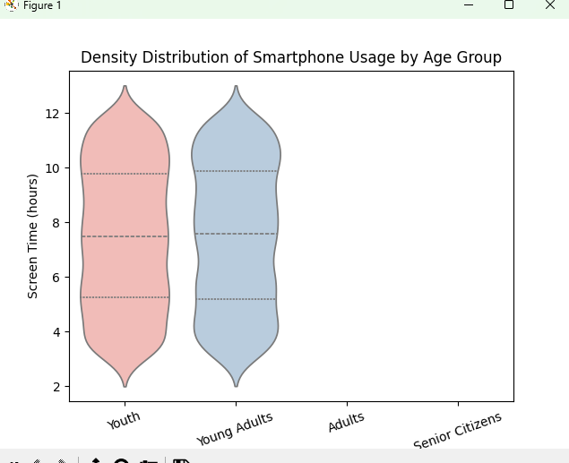
Here the violin plot showed the density distribution of screen time for Youth Young and Adults which both have wide and similar distributions (~3 to 12 hours).
One can observe that the shape is broader in middle and upper ranges(7-11hrs), indicating more data concentration there which infers that users spend high screen time leading to addiction.
Also, compared to the box plot:
Violin plot revealed the density (where data is concentrated), not just spread.

Question 7 – Multivariate Relationship Analysis (Pair Plot)
Create a pair plot using Seaborn to visualize relationships between multiple numerical variables in the dataset. This plot should help you understand how variables interact with each other through scatter plots and how their distributions appear along the diagonal.
While constructing the pair plot, experiment with parameters such as different color palettes and the use of a categorical variable as a hue to distinguish groups (for example, addiction level or gender). Ensure that the plot is clearly readable and appropriately scaled.
After generating the visualization, analyze the relationships between variables and identify any strong patterns or trends. Comment on whether any variables appear positively or negatively related and highlight any clusters or group separations visible in the plot.
Code:
import pandas as pd
import matplotlib.pyplot as plt
import seaborn as sns
df=pd.read_csv("Smartphone_Usage_And_Addiction_Analysis_7500_Rows-2.csv")
plt.figure(figsize=(7,4))
sns.pairplot(df, hue="addiction_level",diag_kind="kde",palette="Set2",corner=True )
plt.show()
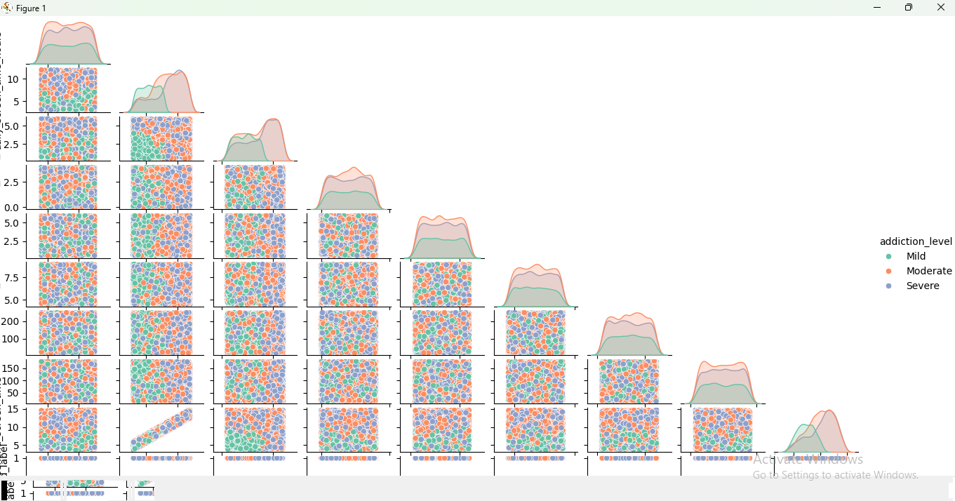
The pair plot shows relationships between multiple numerical variables. Diagonal plots show distribution (density) of each variable. Off-diagonal plots show scatter relationships between variables. Data points are colored by addiction level (Mild, Moderate, Severe).
One can infer that most scatter plots look randomly distributed leading no strong linear relationships between many variables.
But, screen time vs addiction-related variables shows slight clustering. Higher values tend to have more Moderate and Severe (orange & blue) points. Therefore, there is no single strong predictor, but a combined effect of multiple factors.

Question 8 – Category Contribution Analysis (Stack Plot)
Develop a stack plot to represent how different categories contribute to overall smartphone usage or another relevant metric. This visualization should show cumulative contribution across categories.
While creating the plot, experiment with different colors, adjust transparency, and include a legend for clarity. Ensure proper labeling of axes and title.
After plotting, interpret which category contributes the most overall and whether this dominance remains consistent across the dataset.
Bloom’s Level: Applying, Analyzing
Code:
import matplotlib.pyplot as plt
import pandas as pd

df=pd.read_csv("Smartphone_Usage_And_Addiction_Analysis_7500_Rows-2.csv")
bins=[15, 26, 36, 51, 100]
labels = ["Youth", "Young Adults", "Adults", "Senior Citizens"]
df["Age Group"]=pd.cut(df["age"],bins=bins,labels=labels)
group = df.groupby("Age Group")[[
"social_media_hours",
"gaming_hours"
]].sum()

plt.stackplot(group.index,
group["social_media_hours"],
group["gaming_hours"],
labels=["Social Media", "Gaming"],
alpha=0.8)

plt.title("Contribution by Age Group")
plt.xlabel("Age Group")
plt.ylabel("Total Hours")
plt.show()
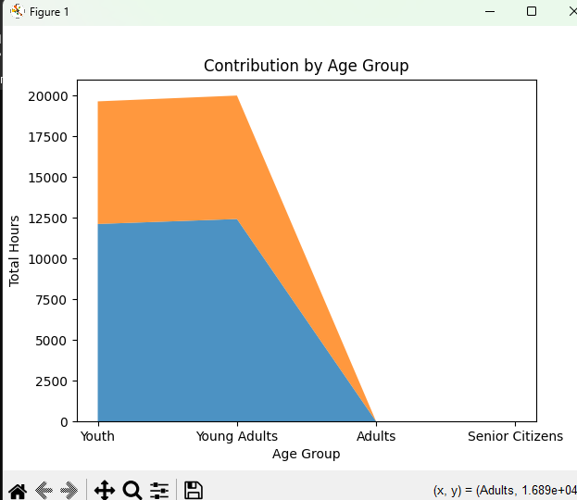
The plot shows total smartphone usage contribution by age group. Youth and Young Adults contribute the most (very high total hours) which indicates younger people are more inclined towards the screen. Adults and Senior Citizens show almost zero contribution in the graph. Youth contribution is slightly lower than Young Adults but both are dominant. Therefore the contribution is not evenly distributed and is highly skewed toward younger populations.

Question 9 – Distribution of Addiction Levels (Pie Chart)
Create a pie chart to represent the proportion of different addiction levels in the dataset. This visualization should clearly show the relative contribution of each category.
While constructing the chart, experiment with slice explosion, color combinations, percentage labels, and starting angle. Ensure the chart is visually balanced and labeled appropriately.
After generating the chart, identify which segment dominates and evaluate whether the pie chart effectively communicates the information.
Bloom’s Level: Understanding, Evaluating
Code:
import matplotlib.pyplot as plt
import pandas as pd

df = pd.read_csv("Smartphone_Usage_And_Addiction_Analysis_7500_Rows-2.csv")
counts=df["addiction_level"].value_counts()

explode = [0.05] * len(counts) # slight explosion

colors = ["#ff9999", "#66b3ff", "#99ff99"]

plt.pie(
counts,
labels=counts.index,
autopct="%1.1f%%",
startangle=90,
explode=explode,
colors=colors
)

plt.title("Addiction Distribution")
plt.show()
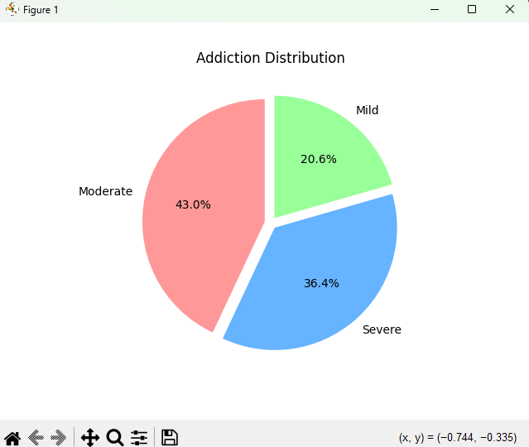
The pie chart shows proportion of addiction levels: Moderate → 43.0% (largest), Severe → 36.4% and Mild → 20.6% (smallest). Also, we can infer that the majority of users fall under Moderate addiction, meaning most people use smartphones heavily but not extremely though a large portion is severely addicted, which is a serious concern (Nearly 80% (Moderate + Severe) users show significant addiction). Only a small percentage mild usage, indicating fewer people maintain controlled usage habits. Therefore, the distribution clearly shows a shift toward higher addiction levels.

Question 10 – Multi-Visualization Dashboard (Subplots)
Create a dashboard using Matplotlib subplots that combines multiple visualizations into a single figure. The dashboard should include at least six different plots such as a bar plot, line plot, scatter plot, box plot, violin plot, and pie chart.
Arrange the plots using a structured layout (such as 2×3, 2×4, or 4×2) and ensure proper spacing using layout adjustments. Maintain a consistent color theme across all visualizations and include clear titles for each subplot.
Below the dashboard, write a brief summary highlighting key insights, major patterns, and one important conclusion derived from the visualizations.
Bloom’s Level: Creating
Code:
import pandas as pd
import matplotlib.pyplot as plt
import seaborn as sns

df=pd.read_csv("Smartphone_Usage_And_Addiction_Analysis_7500_Rows-2.csv")

bins = [15, 26, 36, 51, 100]
labels = ["Youth", "Yo ung Adults", "Adults", "Senior Citizens"]

df["Age Group"] = pd.cut(df["age"], bins=bins, labels=labels)

fig, axs = plt.subplots(2, 3, figsize=(15,7))
# Bar
sns.barplot(x="Age Group", y="daily_screen_time_hours", data=df, ax=axs[0,0], palette="viridis")
axs[0,0].set_title("Avg Usage by Age Group")
axs[0,0].tick_params(axis='x', rotation=20)

# Line
sns.lineplot(x="age", y="daily_screen_time_hours", data=df, ax=axs[0,1])
axs[0,1].set_title("Usage Trend by Age")

# Scatter
sns.scatterplot(x="daily_screen_time_hours", y="addicted_label",hue="addiction_level",data=df,ax=axs[0,2])
axs[0,2].set_title("Usage vs Addiction")

# Box
sns.boxplot(x="Age Group", y="daily_screen_time_hours", data=df, ax=axs[1,0],palette="Pastel1")
axs[1,0].set_title("Distribution (Box Plot)")
axs[1,0].tick_params(axis='x', rotation=20)

# Violin
sns.violinplot(x="Age Group", y="daily_screen_time_hours", data=df, ax=axs[1,1],palette="coolwarm")
axs[1,1].set_title("Density (Violin Plot)")
axs[1,1].tick_params(axis='x', rotation=20)
# Pie
counts = df["addiction_level"].value_counts()
axs[1,2].pie(counts, labels=counts.index, autopct="%1.1f%%", startangle=90)
axs[1,2].set_title("Addiction Distribution")

plt.tight_layout(rect=[0, 0, 1, 0.96])
plt.show()
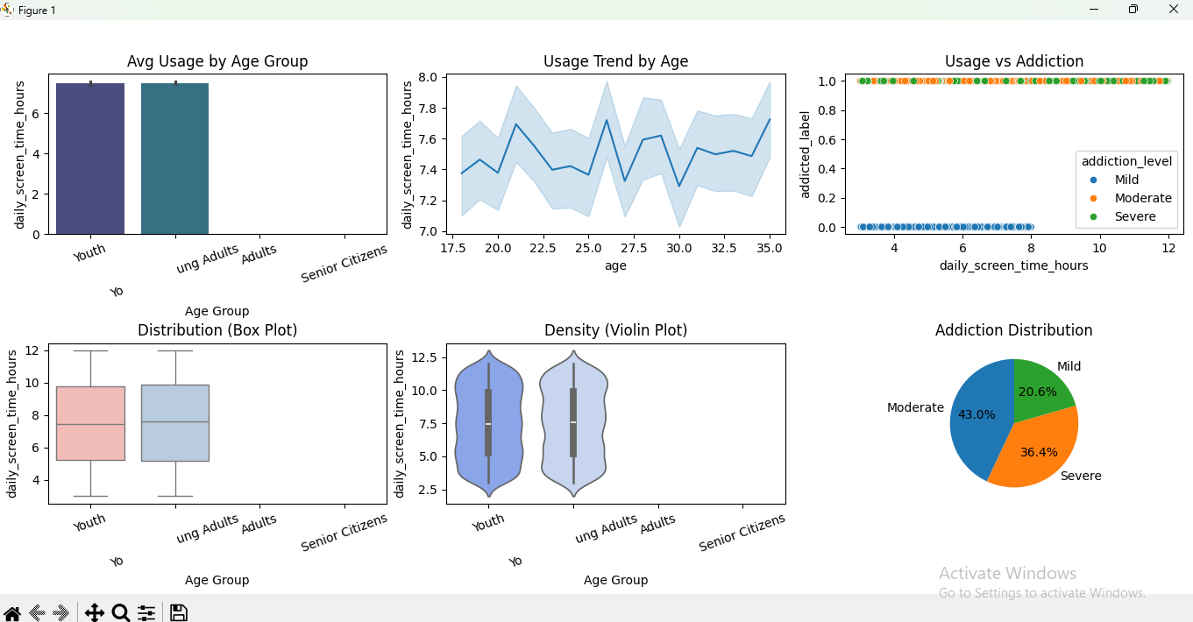
Overall Summary (Dashboard Insights)
- Phone usage among Youth and Young Adults is consistently high at around 7-8 hours of usage on a daily basis.
- The trend of using smartphones is consistent among all ages ranging from 18 to 35 years, with minor fluctuations.
- There is a positive correlation between screen time and addiction, and the more users use their smartphones, the higher the addiction level.
- The distribution plots (box & violin) show:
  - Wide variability in usage
  - Majority of users clustered in higher screen time ranges
- The addiction distribution reveals:
  - Moderate (43%) and Severe (36.4%) dominate
  - Very few users fall under Mild category
- Addiction is strongly linked to screen time, not just age.
The dashboard provides a comprehensive understanding of the data using various visualizations. Excessive usage of smartphones is a widely observed behaviour among users, and it may have some impacts on their lifestyle and well-being.

