Chapter 1 – Abstract
FraudNet is an AI-powered fraud detection system designed to help merchants detect coordinated fraud rings before financial losses occur.
Unlike traditional fraud detection systems that evaluate transactions individually, FraudNet combines Graph Analytics with Machine Learning.
The project generates a realistic synthetic payment ecosystem, discovers suspicious customer communities, predicts fraud probability using XGBoost, explains every prediction through SHAP, and presents results inside an interactive Streamlit dashboard.
The dashboard provides:
- Real-time payment monitoring
- Community investigation
- Fraud relationship visualization
- Business insights
- AI-powered recommendations
- PDF investigation reports

Chapter 2 – Introduction
Online merchants process thousands of transactions every day.
Most fraud detection systems ask one question:
"Is this transaction suspicious?"
FraudNet asks a different question:
"Is this customer secretly working with other accounts?"
This difference is important because organized fraud usually happens through groups of connected accounts, not isolated transactions.
Instead of analyzing transactions one by one, FraudNet studies relationships between customers.

Chapter 3 – Problem Statement
Merchants face several challenges:
- Refund abuse
- Shared device fraud
- Multiple fake accounts
- Coordinated payment fraud
- False positives
Traditional rule-based systems struggle to identify these hidden relationships.
The project solves this by combining:
- Graph Analytics
- Feature Engineering
- XGBoost
- Explainable AI

Chapter 4 – Objectives
The project aims to:
- Detect coordinated fraud rings.
- Build a customer relationship graph.
- Generate realistic payment data.
- Predict fraud probability using XGBoost.
- Explain predictions using SHAP.
- Help merchants make understandable decisions.
- Visualize suspicious communities.

Chapter 5 – Existing System
Current fraud systems usually rely on:
- Transaction amount
- Location mismatch
- Velocity rules
Limitations
Existing System | FraudNet
Checks one transaction | Checks entire communities
Rule-based | AI-based
Limited explanations | SHAP explanations
No relationship analysis | Graph Analytics
Static monitoring | Live dashboard

Chapter 6 – Proposed System
FraudNet follows a complete AI pipeline.
Complete System Flow
Configuration
↓
Synthetic Dataset Generation
↓
Relationship Graph
↓
Community Detection
↓
Feature Engineering
↓
XGBoost Prediction
↓
SHAP Explainability
↓
Merchant Dashboard

Chapter 7 – Technology Stack
Component | Technology
Language | Python
Dashboard | Streamlit
Machine Learning | XGBoost
Graph Analytics | NetworkX
Explainability | SHAP
Visualization | Plotly
Data Processing | Pandas
Numerical Computing | NumPy
Reports | ReportLab
Chapter 8 – System Architecture
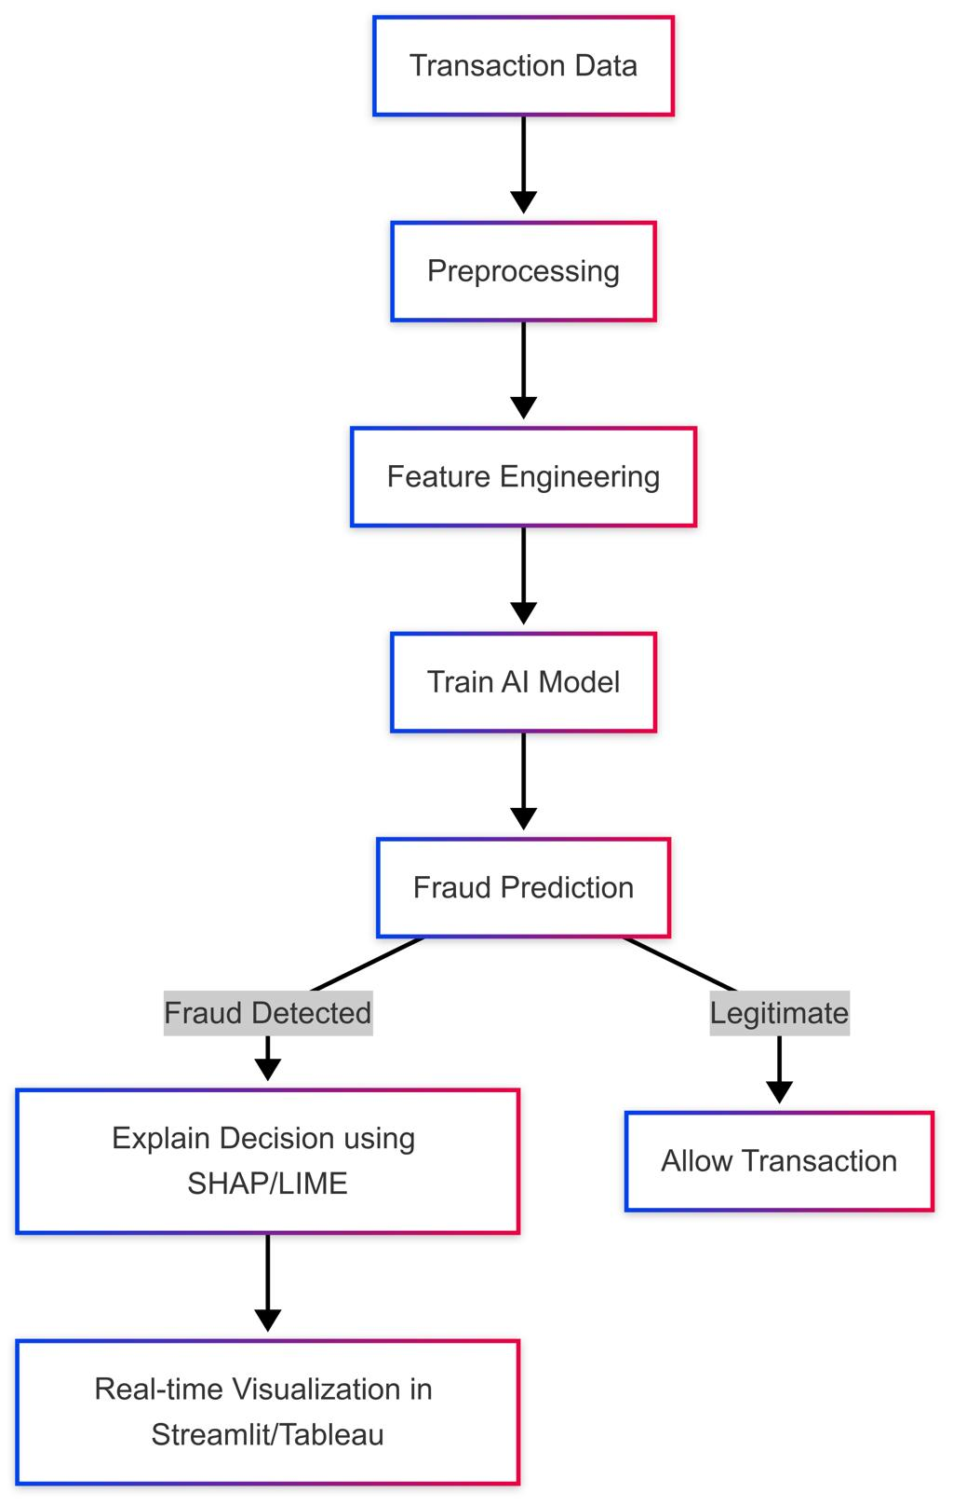
The system consists of six connected modules.
- Config
- Data Generator
- Graph Detector
- Train Model
- Live Simulator
- Streamlit Dashboard
Each module has one responsibility, making the project easier to maintain.

Chapter 9 – Configuration Module (config.py)
The first file controls the entire project.
Instead of changing numbers across multiple files, every module reads values from one central location. This makes config.py the single source of truth.
FraudNet_Config_Explanation.pdf
Important Parameters
Parameter | Purpose
NUM_ACCOUNTS | 1000 customers
NUM_TRANSACTIONS | 5000 transactions
NUM_FRAUD_RINGS | 8 fraud rings
MIN_RING_SIZE | 4 accounts
MAX_RING_SIZE | 8 accounts
NORMAL_REFUND_RANGE | 2–8% refunds
FRAUD_REFUND_RANGE | 15–35% refunds
These values create a realistic payment ecosystem.

Chapter 10 – Data Generation (data_generator.py)
What problem does this file solve?
Real payment data cannot be used because it contains sensitive customer information.
This file creates a realistic synthetic payment ecosystem that includes:
- customer accounts
- transactions
- refunds
The generated data becomes the foundation for the rest of the pipeline.
Generated Files
File | Purpose
accounts.csv | Customer information
transactions.csv | Purchases
refunds.csv | Refund requests

Merchant Database
Five merchants make transactions look realistic:
- TechKart
- StyleHub
- FreshMart
- HomeNest
- FitFuel

Customer Types
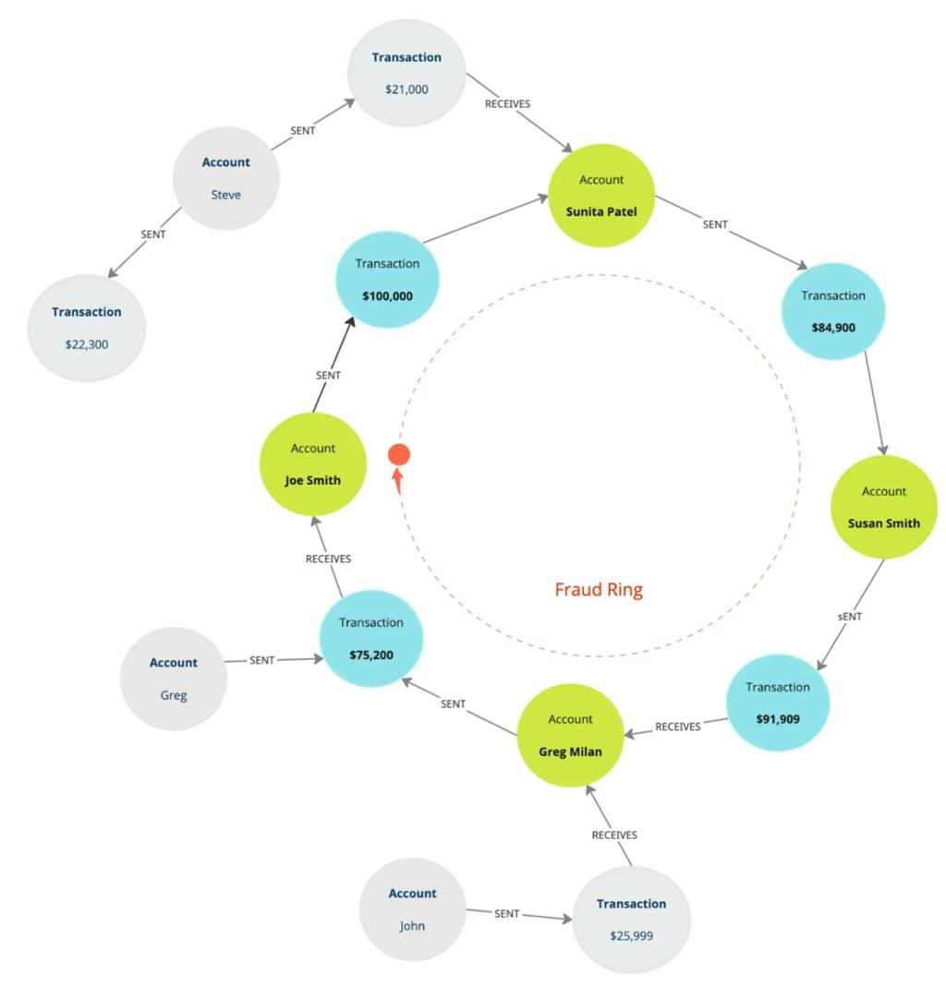
The generator creates:
- Normal users
- Households
- Obvious fraud rings
- Moderate fraud rings
- Sneaky fraud rings
- Expert fraud rings
Each behaves differently to mimic real-world behavior.

Meaning of Important Fields
Field | Meaning
account_id | Customer ID
device_id | Customer device
payment_method_fingerprint | Anonymous payment identifier
refund_probability | Likelihood of refund
account_type | Customer category
is_fraud_ring | Ground-truth fraud label

Data Flow
config.py
↓
Generate Accounts
↓
Generate Transactions
↓
Generate Refunds
↓
Save CSV Files
↓
Graph Detector

Chapter 11 – Graph Analytics (graph_detector.py)
What problem does this file solve?
Instead of checking every account independently, FraudNet asks:
"Who is this account connected to?"
Shared devices, payment fingerprints, refund timing, and merchant behavior reveal coordinated fraud rings that row-by-row machine learning can miss.
FraudNet_Graph_Detector_Developer_Guide.pdf
What is a Graph?
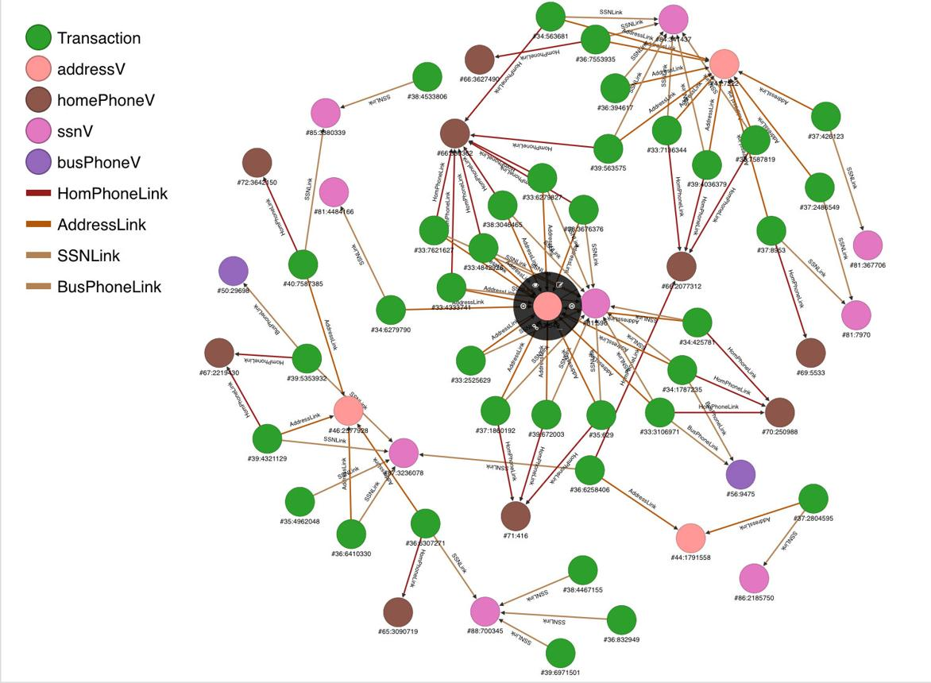
- Nodes represent customer accounts.
- Edges represent suspicious relationships.
Relationship Signals
The graph connects customers through:
- Shared devices
- Shared IP addresses
- Payment fingerprints
- Merchant campaigns
- Refund timing
Edge Weights
Signal | Weight
Device | +3
Payment | +3
Refund Timing | +3
IP | +2
Merchant Campaign | +2
Multiple signals strengthen existing relationships.

Community Detection
FraudNet uses the Louvain Algorithm.
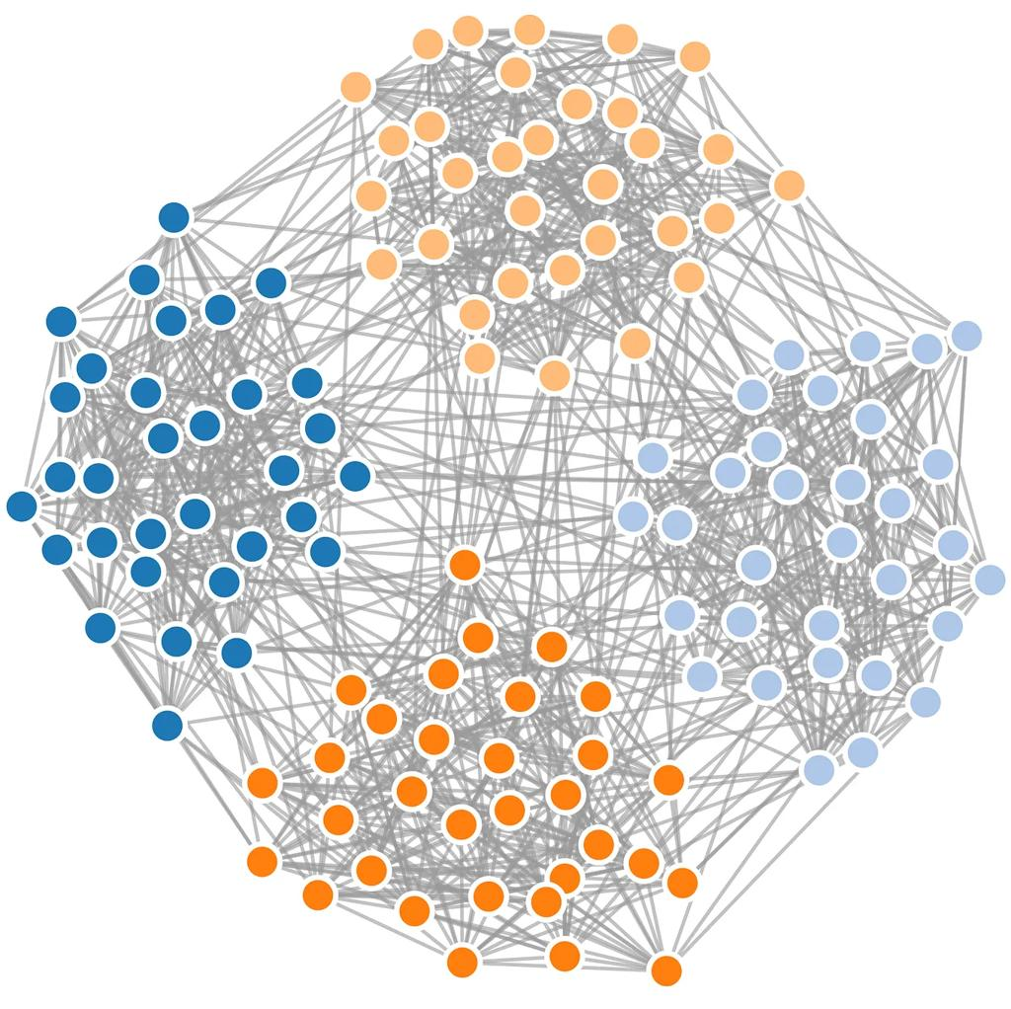
Instead of manually searching thousands of customers, the algorithm automatically discovers tightly connected communities.

Community Statistics
For every community the system calculates:
- Size
- Density
- Average account age
- Shared devices
- Shared payment methods

Risk Score Logic
Condition | Points
Community Size ≥6 | +20
Heavy Device Reuse | +25
Shared Payment Fingerprints | +25
Account Age 0.6 | +20
Maximum possible risk becomes 100.

Chapter 12 – Machine Learning (train_model.py)
What problem does this file solve?
The graph detector finds suspicious communities.
However, merchants approve or reject individual accounts, not entire groups.
This file converts graph intelligence into numerical features, trains an XGBoost model, explains predictions using SHAP, and estimates business savings.
ML Pipeline
The complete pipeline is:
CSV Files
↓
Graph Detection
↓
Feature Engineering
↓
Train/Test Split
↓
XGBoost
↓
SHAP
↓
Merchant Cost Simulation
FraudNet_train_model_Complete_Developer_Guide.pdf
Feature Engineering
Machine learning understands numbers, so each account becomes numerical features.

Feature | Why it Matters
Account Age | New accounts may be fraudulent
Community Risk | Brings graph intelligence into ML
Graph Degree | More connections may indicate coordination
Weighted Degree | Stronger suspicious evidence
Refund Rate | Normalizes refund behavior

Train-Test Split
The dataset is divided into:
- 80% Training
- 20% Testing
stratify keeps fraud percentages balanced.

Why XGBoost?
XGBoost builds hundreds of decision trees.
Every new tree learns from previous mistakes, making the model much stronger than a single decision tree.

Important parameters:
Parameter | Value
Trees | 200
Max Depth | 5
Learning Rate | 0.05

Chapter 13 – Explainable AI (SHAP)
Merchants need to know why an account was flagged.
SHAP explains:
- which feature increased fraud probability
- which feature reduced risk
This turns the AI into an explainable system rather than a black box.

Chapter 14 – Model Evaluation
The model is evaluated using:
- Precision
- Recall
- F1 Score
- ROC-AUC

Metric Meaning
Metric | Purpose
Precision | Correct fraud alerts
Recall | Fraud caught
F1 | Balance
ROC-AUC | Overall ranking ability

Chapter 15 – Business Threshold Optimization
Instead of maximizing only accuracy, FraudNet estimates business value.
Assumptions:
- Prevented fraud saves ₹5000
- Manual review costs ₹500
Different thresholds are tested to maximize net savings.

Chapter 16 – Live Transaction Simulator
What problem does this file solve?
Historical data makes dashboards look static.
The simulator creates live payment events so merchants can watch:
- Approvals
- Reviews
- Fraud Alerts
appear in real time.

How It Works
- Select a random account.
- Choose a random merchant.
- Generate an amount.
- Check community risk.
- Predict fraud.
- Return a transaction dictionary.

Transaction Fields
Field | Meaning
Time | Current transaction
Merchant | Receiving store
Amount | Payment value
Status | Approved/Review/Fraud
Reason | Human explanation

Chapter 17 – Streamlit Dashboard
The dashboard transforms technical AI outputs into merchant-friendly decisions.
Major sections include:
- Home Dashboard
- Merchant Action Center
- Live AI Payment Monitor
- Business Insights
- Community Deep Dive
- Fraud Relationship Network
- AI Copilot
- PDF Report Export
The merchant sees explanations rather than raw ML numbers.

Chapter 18 – Dashboard Visualizations
The dashboard displays multiple business insights.
Available Charts
Chart | Purpose
Account Distribution | Customer types
Refund Behavior | Refund patterns
Fraud Probability Distribution | ML predictions
Highest-Risk Communities | Community ranking
The training pipeline also generates ROC, Precision-Recall, Feature Importance, Threshold Savings, and SHAP Summary charts for evaluation.

Chapter 19 – Fraud Relationship Network
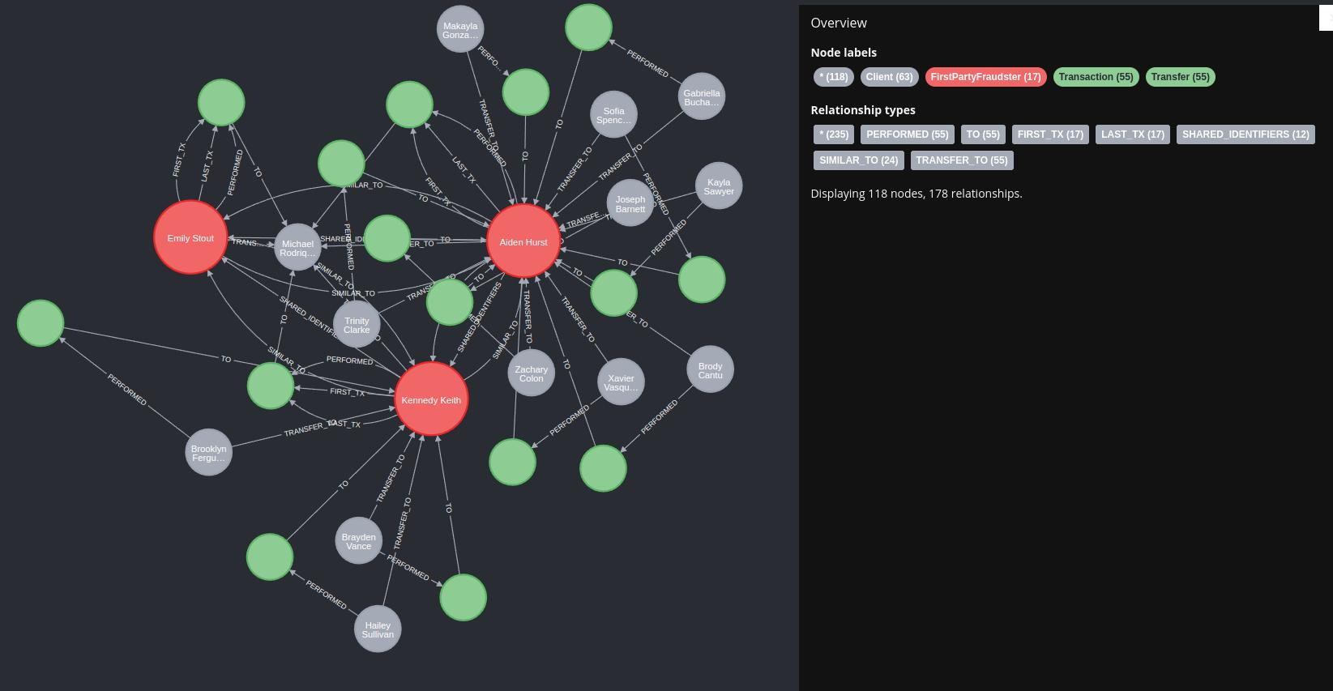
The network graph helps merchants understand why accounts were grouped together.
Colors indicate different account types.
Hovering over nodes reveals fraud probability and account information.

Chapter 20 – Business Impact
FraudNet helps merchants by:
- detecting fraud rings earlier
- reducing refund abuse
- prioritizing investigations
- explaining AI decisions
- maximizing business savings
Instead of simply predicting fraud, the system supports real business decision-making through graph intelligence, explainability, and threshold optimization.

Chapter 21 – Future Scope
Future improvements include:
- Real payment gateway integration
- Kafka streaming pipeline
- Graph Neural Networks
- Multi-merchant fraud intelligence
- Mobile merchant dashboard

Chapter 22 – Conclusion
FraudNet demonstrates that fraud detection becomes significantly more effective when Machine Learning and Graph Analytics work together.
The project begins by generating a realistic payment ecosystem, discovers hidden customer communities using weighted relationship graphs, converts graph intelligence into numerical features, predicts fraud using XGBoost, explains every prediction through SHAP, and presents merchant-friendly decisions inside a real-time dashboard.
The combination of synthetic data generation, explainable AI, graph-based community detection, and business-oriented threshold optimization makes FraudNet closer to a practical payment risk engine than a basic fraud classifier

