AIM:
Five different degraded images are provided in the Module Section.
Use suitable gray-level transformation techniques to enhance each image.
After processing, describe your observations in detail for every enhancement step, explaining how the chosen operations improved the visual quality.
Finally, write a clear conclusion summarizing the effectiveness and limitations of the applied graylevel techniques.

CO3, CO4
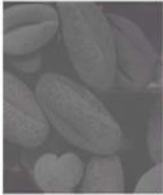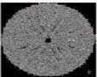

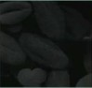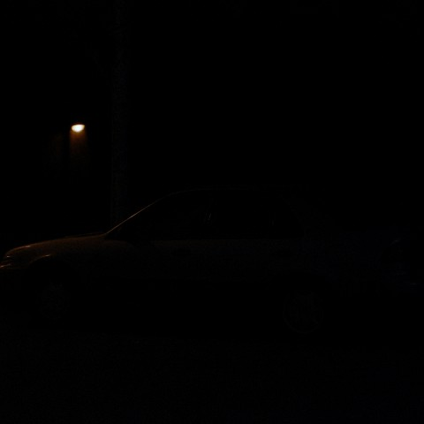

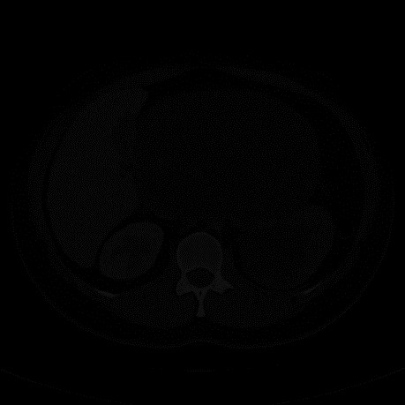
Gray-level transformation
A gray-level transformation converts an input pixel intensity into an output intensity :
s=T(r)
where:
- r = original pixel intensity
- s = enhanced pixel intensity
- L= number of gray levels, normally 256

Image 1 — Contrast Stretching
Contrast stretching expands a narrow range of intensities into a wider range.
A simple transformation is:
$$s = ((r - r_{min}​)/(r_{max} - r_{min}​)​)​×255$$
If the original image has most pixels concentrated around a small gray-level range, contrast stretching makes dark pixels darker and bright pixels brighter.

Original
The original image has a relatively narrow range of grey levels. The objects are visible, but the difference between the objects and their background is not very strong.
Enhanced
After percentile-based contrast stretching:
- dark background regions become darker,
- object regions become more distinguishable,
- object boundaries are clearer,
- texture within the objects is easier to observe.
Contrast stretching was applied to expand the original intensity range to the available 0–255 gray-level range. After processing, dark regions became darker and bright regions became brighter. As a result, the boundaries of the objects became more distinct and their internal texture became easier to observe.
Percentile-based contrast stretching was used instead of conventional min-max stretching because min-max stretching can be strongly affected by extreme pixel values or outliers. By selecting the 2nd and 98th percentiles as the lower and upper limits, extreme intensity values are excluded and the main range of image information is expanded more effectively.
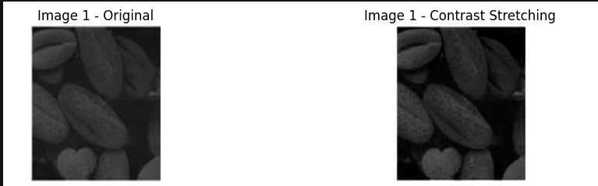

Image 2
Histogram equalization redistributes the gray-level values across a wider intensity range. The intention was to make the different structures in the CT image more distinguishable.
However, after applying it, we observed that the existing noise in the image was also strongly amplified. Instead of producing a naturally enhanced CT image, the output became very grainy, with excessive bright and dark variations.
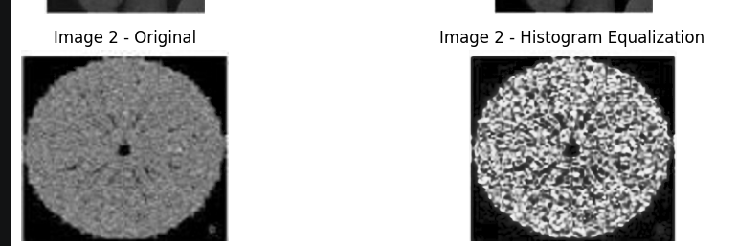
To overcome this problem, we used Contrast Limited Adaptive Histogram Equalization (CLAHE).
Unlike ordinary histogram equalization, which considers the entire image at once, CLAHE divides the image into smaller local regions and performs contrast enhancement within those regions.
The clipLimit=3.0 restricts excessive contrast amplification, while the tileGridSize=(8,8) divides the image into smaller regions for local enhancement.
After applying CLAHE, the local contrast of the CT image was improved and the anatomical structures became more distinguishable. The result was more controlled than the standard histogram-equalized image. Some noise is still visible because the original image contains noise, but it is not amplified as aggressively as with ordinary histogram equalization.
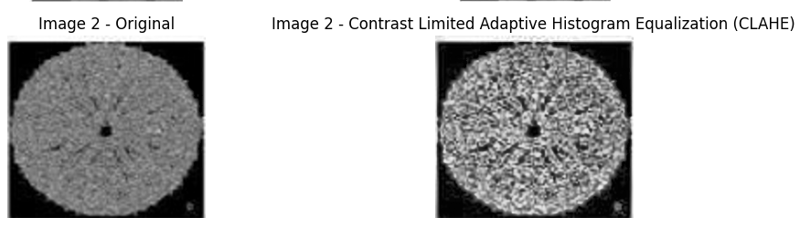

Image 3
The original image was relatively dark, and several details were difficult to distinguish clearly.
Gamma transformation is:
s = cr^{γ}
For a dark image:
0<γ<1
This increases the intensity of darker pixels.
For example:
gamma = 0.4
is useful for strongly dark images.
When we used γ = 0.9 the transformation was very mild because 0.9 is close to 1. The enhanced image looked quite similar to the original image, and the darker details were still not sufficiently visible.
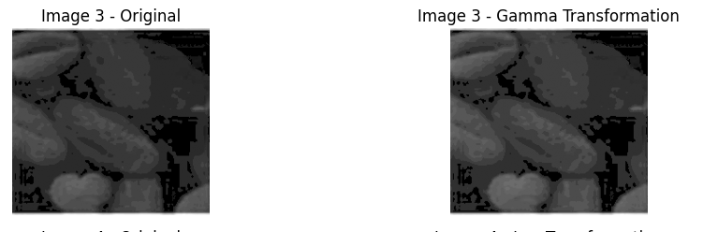

When I kept γ = 0.2 it got worst as even the lighter pixels got more lighter. 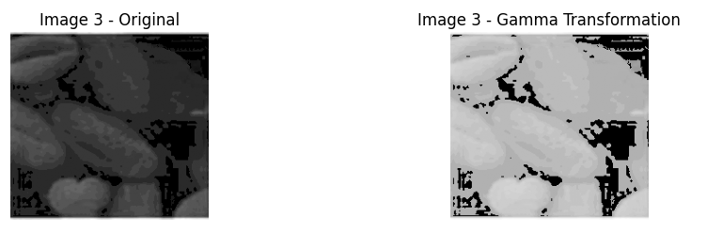

Finally I used γ = 0.6
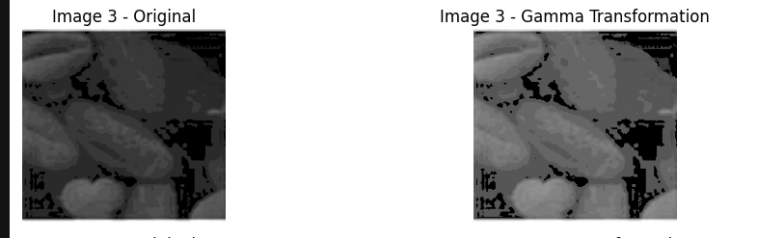
The final image showed improved visibility of the objects and their internal details while maintaining the overall structure of the image. A very low gamma value was avoided because excessive gamma correction could result in over-brightening and loss of subtle intensity information. Hence, γ = 0.6 was selected as the final value because it provided a suitable balance between enhancement and preservation of image details.

Image 4
The original image is extremely dark. Most of the pixels are concentrated near the black/low-intensity region, making the car and surrounding details almost invisible. Therefore, the main problem is not simply low contrast; important information is concentrated in the lower gray-level range.
For this image, I selected a logarithmic transformation because it is particularly useful for expanding low-intensity values.
The transformation is:
s=c*log(1+r)
where:
- r = input gray level
- s = output gray level
- c = scaling constant
The logarithmic function expands the lower intensity values more strongly than the higher intensity values.
After applying the transformation, there is a significant improvement:
- The car becomes clearly visible.
- The road/ground region becomes more distinguishable.
- Some surrounding structures become visible.
- The light source remains visible.
- Details that were almost completely hidden in the original image can now be observed.
However, it may compress bright intensity values and can also reveal some noise present in the original image. Overall, the log transformation provided a significant improvement in the visual quality of this severely dark image.
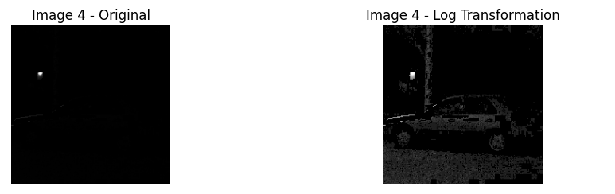

After using log, I used contrast stretching to see if the image quality contrast could be improved, but it just further degraded the image quality.

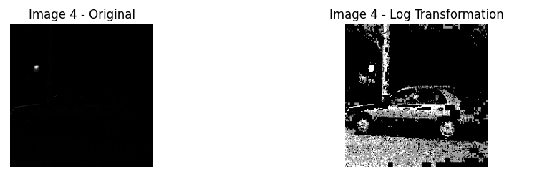

Image 5
The original image is a CT/medical image. The anatomical structures are visible to some extent, but the image contains a large amount of dark-region information and has limited contrast between different structures.

The original CT image contained visible anatomical structures but had limited contrast, particularly in darker regions. Gamma transformation was initially applied with γ = 0.4 to enhance the dark intensity levels. Although this revealed additional information, the enhancement was relatively strong and caused some regions to become excessively bright. Therefore, the gamma value was increased to 0.6 to obtain a more controlled enhancement. After gamma correction, percentile-based contrast stretching using the 2nd and 98th percentiles was applied to expand the useful gray-level range while reducing the influence of extreme pixel values. The combined transformation improved the visibility of anatomical structures and increased the distinction between different regions of the CT image. Some fine-grained noise was also enhanced, which represents a limitation of the technique. Overall, the combination of gamma transformation with γ = 0.6 and contrast stretching provided a better balance between brightness enhancement and contrast improvement.
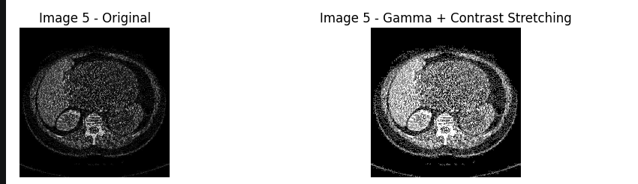

Code
import cv2
import numpy as np
import matplotlib.pyplot as plt

#contrast stretching
# def contrast_stretching(img):
# r_min = np.min(img)
# r_max = np.max(img)

# stretched = ((img - r_min) / (r_max - r_min)) * 255

# return np.uint8(stretched)
def contrast_stretching(img):
low = np.percentile(img, 2)
high = np.percentile(img, 98)

stretched = (img - low) / (high - low) * 255
stretched = np.clip(stretched, 0, 255)

return np.uint8(stretched)

#gamma
def gamma_transform(img, gamma):
# Normalize image to 0-1
normalized = img / 255.0

# Gamma transformation
corrected = np.power(normalized, gamma)

# Convert back to 0-255
corrected = corrected * 255

return np.uint8(corrected)

#Log Transformation
def log_transform(img):
# Convert to float
img_float = img.astype(np.float32)

# c is selected so that output lies in 0-255
c = 255 / np.log(1 + np.max(img_float))

log_img = c * np.log(1 + img_float)

return np.uint8(log_img)

# Histogram Equalization
def histogram_equalization(img):
return cv2.equalizeHist(img)
# clahe = cv2.createCLAHE(
# clipLimit=2.0,
# tileGridSize=(8, 8)
# )

# enhanced2 = clahe.apply(img2)

img1 = cv2.imread("pic1.png", cv2.IMREAD_GRAYSCALE)
img2 = cv2.imread("pic2.png", cv2.IMREAD_GRAYSCALE)
img3 = cv2.imread("pic3.png", cv2.IMREAD_GRAYSCALE)
img4 = cv2.imread("pic4.png", cv2.IMREAD_GRAYSCALE)
img5 = cv2.imread("pic5.png", cv2.IMREAD_GRAYSCALE)

# Image 1 - Contrast Stretching
enhanced1 = contrast_stretching(img1)

clahe = cv2.createCLAHE(
clipLimit=3.0,
tileGridSize=(8, 8)
)

enhanced2 = clahe.apply(img2)
# Image 2 - Histogram Equalization
#enhanced2 = histogram_equalization(img2)

# Image 3 - Gamma Transformation
enhanced3 = gamma_transform(img3, 0.6)

# Image 4 - Log Transformation
# enhanced4 = log_transform(img4)
log4 = log_transform(img4)
enhanced4 = contrast_stretching(log4)

# Image 5 - Gamma + Contrast Stretching
gamma5 = gamma_transform(img5, 0.6)
enhanced5 = contrast_stretching(gamma5)

images = [
img1, enhanced1,
img2, enhanced2,
img3, enhanced3,
img4, enhanced4,
img5, enhanced5
]

titles = [
"Image 1 - Original",
"Image 1 - Contrast Stretching",

"Image 2 - Original",
"Image 2 - Contrast Limited Adaptive Histogram Equalization (CLAHE)",

"Image 3 - Original",
"Image 3 - Gamma Transformation",

"Image 4 - Original",
"Image 4 - Log Transformation",

"Image 5 - Original",
"Image 5 - Gamma + Contrast Stretching"
]

plt.figure(figsize=(12, 12))

for i in range(10):
plt.subplot(5, 2, i + 1)
plt.imshow(images[i], cmap="gray")
plt.title(titles[i])
plt.axis("off")

plt.tight_layout()
plt.show()
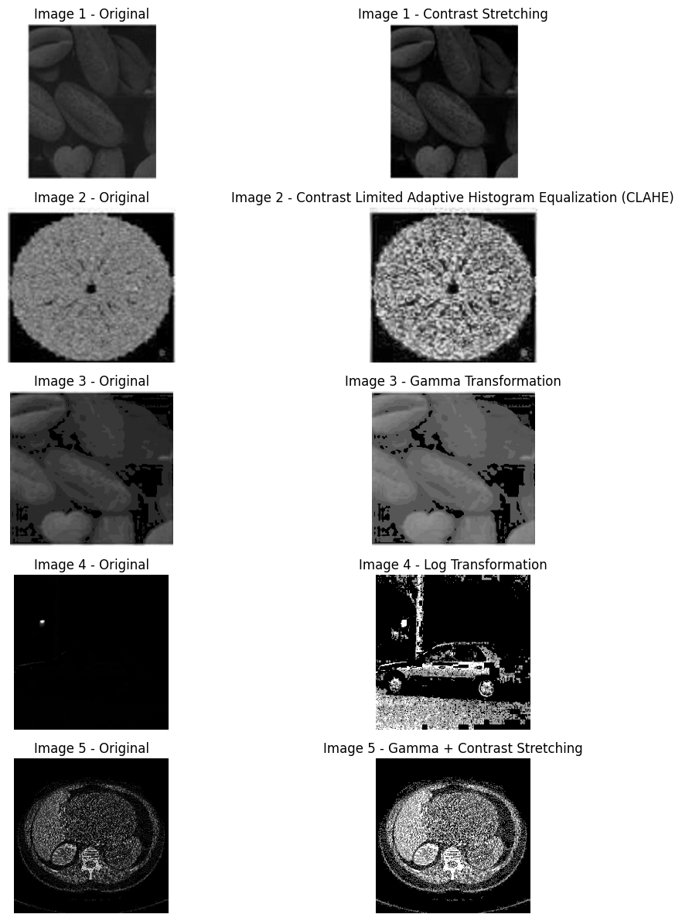
Technique | Main purpose | Suitable image
Contrast Stretching | Expand compressed intensity range | Image 1
Histogram Equalization | Redistribute gray levels | Image 2
Gamma (γ<1) | Brighten dark regions | Image 3
Log Transformation | Reveal low-intensity details | Image 4
Gamma + Contrast Stretching | Brighten and improve contrast | Image 5

