Use appropriate smoothing and sharpening techniques to enhance the clarity of the images. CO3, CO4

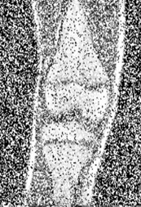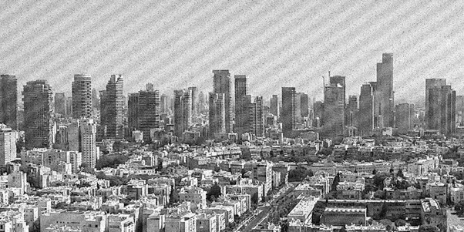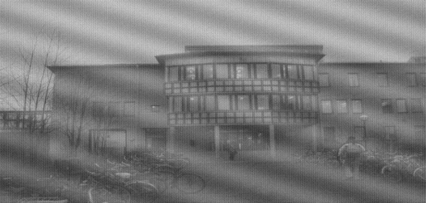

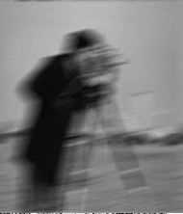
Apply multiple filters, observe the changes produced by each method, and document your observations in detail.
Discuss how smoothing and sharpening individually affect image quality, and summarize your conclusions based on the results.

