Introduction
Low-contrast or poorly illuminated images often hide important visual details, making them difficult to interpret. Histogram-based enhancement techniques improve image visibility by modifying the distribution of pixel intensities.
In this experiment, two enhancement methods were applied to the same set of five degraded images:
- Histogram Equalization (HE): Histogram Equalization (HE) is an automatic contrast enhancement technique that redistributes the pixel intensity values of an image across the entire grayscale range (0–255). It calculates the cumulative distribution function (CDF) of the image histogram and remaps each pixel to a new intensity value based on this distribution. As a result, the contrast is increased, and details that were previously hidden in dark or bright regions become more visible.
First, the probability of occurrence of each intensity level is calculated as:
$$p\left(r_{k}\right)=\frac{n_{k}}{N}$$
where:
- $n_{k}$= number of pixels with intensity $r_{k}$
- $N$= total number of pixels
The cumulative distribution function (CDF) is:
$$CDF\left(r_{k}\right)=\sum_{j=0}^{k}{p}\left(r_{j}\right)$$
The new pixel intensity is obtained using:
$$s_{k}=\left(L-1\right)×CDF\left(r_{k}\right)$$
where:
- $L$= total number of gray levels (256 for an 8-bit image)
- $s_{k}$= transformed intensity value

- Histogram Matching (HM): also known as histogram specification, is a technique that modifies the histogram of an input image so that it resembles the histogram of a chosen reference image. Instead of simply spreading pixel values uniformly, it uses the cumulative distribution functions of both the input and reference images to map pixel intensities accordingly. This produces a more controlled enhancement while preserving a natural appearance.
Methodology
The following steps were followed for each image:
- Read the degraded image.
- Convert it to grayscale.
- Apply Histogram Equalization
- Apply Histogram Matching using the first image as the reference.
- Generate histograms for the original and processed images.
- Compare the visual appearance and histogram distributions.
Code and Results
import cv2
import numpy as np
import matplotlib.pyplot as plt
image_paths = [
"pic1.png",
"pic2.png",
"pic3.png",
"pic4.png",
"pic5.png"
]

def generate_histogram(image):
histogram=cv2.calcHist(
[image],
[0],#for grey scale no plane,no rgb
None,#for mask whole image will be considered as 1 mask s we are ot divinding the image to get parts to do local operations
[256], #no of bins,no. of levels aas 8 bit imaage
[0,256]#[0,256)
)
return histogram

for input_path in image_paths:
input_image=cv2.imread(input_path)
gray_image=cv2.cvtColor(input_image,cv2.COLOR_BGR2GRAY)
input_hist=generate_histogram(gray_image)
intensity=np.arange(256)
plt.figure(figsize=(12,6))
plt.subplot(1,2,1)
plt.imshow(gray_image,cmap="gray")
plt.title("Input Image")
plt.axis("off")

plt.subplot(1, 2, 2)
plt.bar(intensity, input_hist)
plt.title("Input Image Histogram")
plt.xlabel("Intensity")
plt.ylabel("Frequency / number of pixels")
plt.xlim([0, 255])
plt.grid(alpha=0.25)
plt.show()

Histogram Normalisation
for input_paths in image_paths:
#input_image=cv2.imread(input_path)
#gray_image=cv2.cvtColor(input_image,cv2.COLOR_BGR2GRAY)
#input_hist=generate_histogram(gray_image)
ttl_pi=gray_image.size
normalized_hist=input_hist/ttl_pi
plt.figure(figsize=(12,5))
plt.subplot(1,2,1)
plt.bar(intensity,input_hist,width=1)
plt.title("Original Histogram")
plt.xlabel("Intensity")
plt.ylabel("Frequency / Number of Pixels")
plt.xlim([0, 255])
plt.grid(alpha=0.25)
# Normalized histogram
plt.subplot(1, 2, 2)
plt.bar(intensity, normalized_hist)
plt.title("Normalized Histogram")
plt.xlabel("Intensity")
plt.ylabel("Probability")
plt.xlim([0, 255])
plt.ylim([0, 1])
plt.grid(alpha=0.25)
plt.show()

Histogram Equalisation
def hist_equalisation(image):
# gray_image=cv2.cvtColor(image,cv2.COLOR_BGR2GRAY)
equalised_image=cv2.equalizeHist(gray_image)
return equalised_image
for input_path in image_paths:
input_image=cv2.imread(input_path)
gray_image=cv2.cvtColor(input_image,cv2.COLOR_BGR2GRAY)
equalized_image = hist_equalisation(input_image)
original_hist=generate_histogram(gray_image)
equalized_hist=generate_histogram(equalized_image)
intensity=np.arange(256)
plt.figure(figsize=(12,8))
plt.subplot(2, 2, 1)
plt.imshow(gray_image, cmap="gray")
plt.title("Original Image")
plt.axis("off")
plt.subplot(2,2,2)
plt.bar(intensity, original_hist)
plt.title("Original Image Histogram")
plt.xlabel("Intensity")
plt.ylabel("Frequency")
plt.xlim([0, 255])
plt.grid(alpha=0.25)
# 3. Equalized Image
plt.subplot(2, 2, 3)
plt.imshow(equalized_image, cmap="gray")
plt.title("Equalized Image")
plt.axis("off")
# 4. Equalized Histogram
plt.subplot(2, 2, 4)
plt.bar(intensity, equalized_hist)
plt.title("Equalized Image Histogram")
plt.xlabel("Intensity")
plt.ylabel("Frequency")
plt.xlim([0, 255])
plt.grid(alpha=0.25)
plt.tight_layout()
plt.show()

Histogram matching
from skimage.exposure import match_histograms
for input_pth in image_paths:
input_image = cv2.imread(input_pth)

# Convert the image to grayscale
gray_image = cv2.cvtColor(input_image, cv2.COLOR_BGR2GRAY)

# Load the reference image
reference_path = "image.png"
reference_image = cv2.imread(reference_path)

# Convert the reference image to grayscale
gray_reference = cv2.cvtColor(reference_image, cv2.COLOR_BGR2GRAY)
matched_image = match_histograms(gray_image,gray_reference)
matched_image.dtype
# Convert the matched image to 8-bit format
matched_image = np.uint8(matched_image)
# Generate the histogram of the original image
original_hist = generate_histogram(gray_image)
# Generate the histogram of the reference image
reference_hist = generate_histogram(gray_reference)

# Generate the histogram of the matched image
matched_hist = generate_histogram(matched_image)
# Create intensity values from 0 to 255
intensity = np.arange(256)

# Display images and histograms
plt.figure(figsize=(15, 9))

# Display the original image
plt.subplot(2, 3, 1)
plt.imshow(gray_image, cmap="gray")
plt.title("Original Image")
plt.axis("off")

# Display the reference image
plt.subplot(2, 3, 2)
plt.imshow(gray_reference, cmap="gray")
plt.title("Reference Image")
plt.axis("off")

# Display the matched image
plt.subplot(2, 3, 3)
plt.imshow(matched_image, cmap="gray")
plt.title("Histogram Matched Image")
plt.axis("off")

# Display the original histogram
plt.subplot(2, 3, 4)
plt.bar(intensity, original_hist, width=1)
plt.title("Original Image Histogram")
plt.xlabel("Intensity")
plt.ylabel("Frequency / number of pixels")
plt.xlim([0, 255])
plt.grid(alpha=0.25)

# Display the reference histogram
plt.subplot(2, 3, 5)
plt.bar(intensity, reference_hist, width=1)
plt.title("Reference Image Histogram")
plt.xlabel("Intensity")
plt.ylabel("Frequency / number of pixels")
plt.xlim([0, 255])
plt.grid(alpha=0.25)

# Display the matched histogram
plt.subplot(2, 3, 6)
plt.bar(intensity, matched_hist, width=1)
plt.title("Matched Image Histogram")
plt.xlabel("Intensity")
plt.ylabel("Frequency / number of pixels")
plt.xlim([0, 255])
plt.grid(alpha=0.25)

# Adjust spacing
plt.tight_layout()

# Display the results
plt.show()

Results and Observations
Image 1
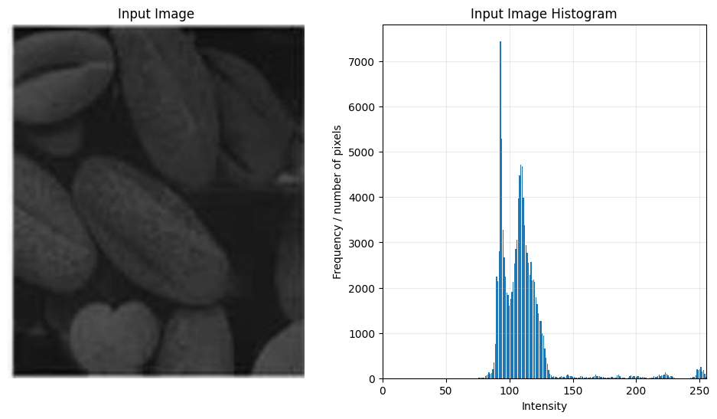
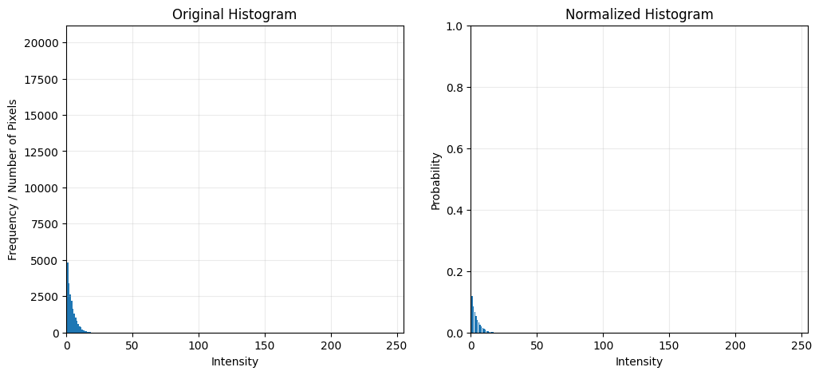
Histogram Equalization
- Increased the overall brightness and contrast.
- The texture on individual seeds became more visible.
- The histogram spread across a wider intensity range.
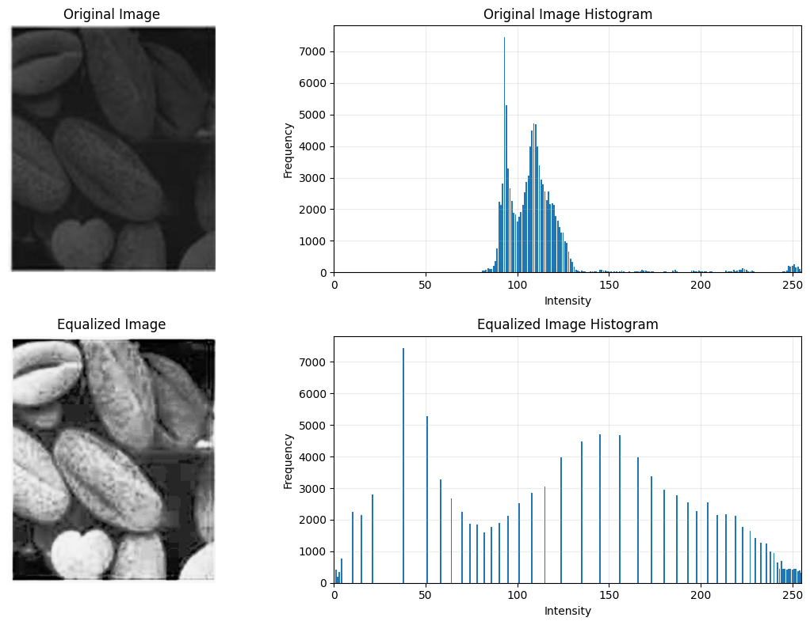
Histogram Matching
- Produced a smoother enhancement.
- Avoided excessive brightness.
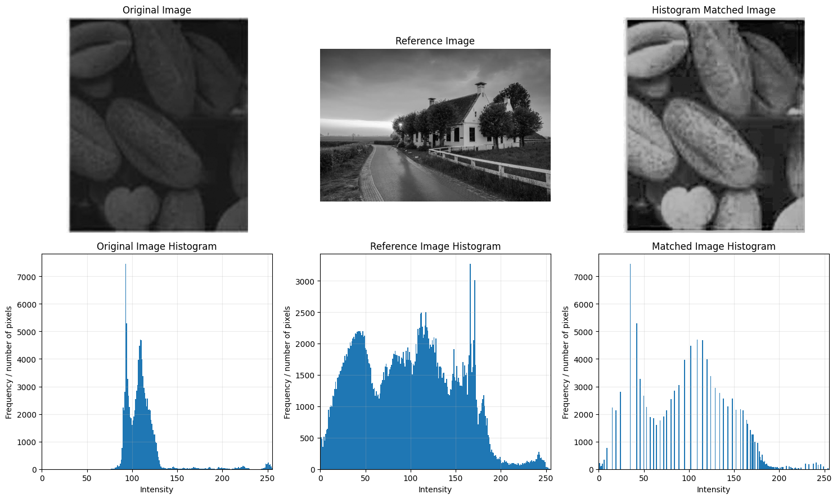
Better Method: Histogram Equalization
Reason: The seed textures became sharper and more distinguishable.

Image 2
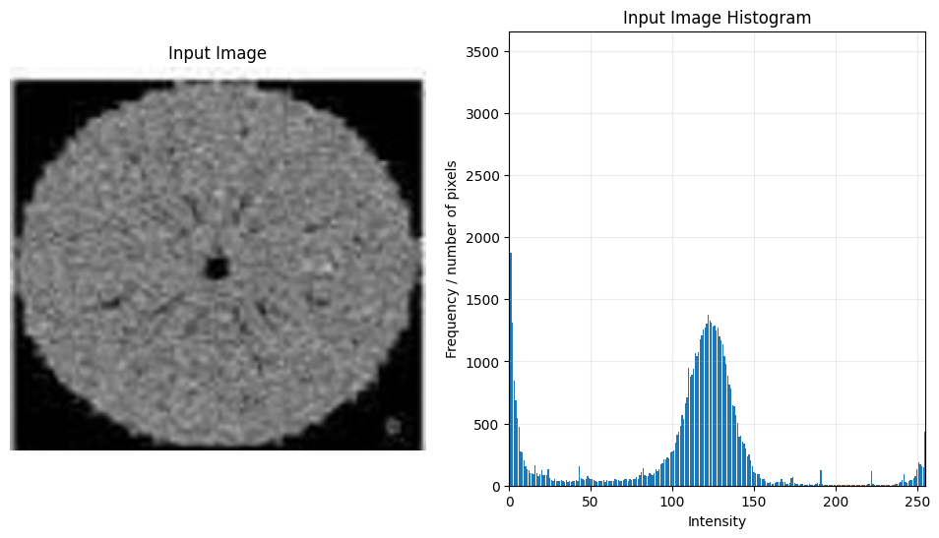

Histogram Equalization
- Enhanced internal structures significantly.
- Made edges and fine patterns easier to observe.
- Increased global contrast.
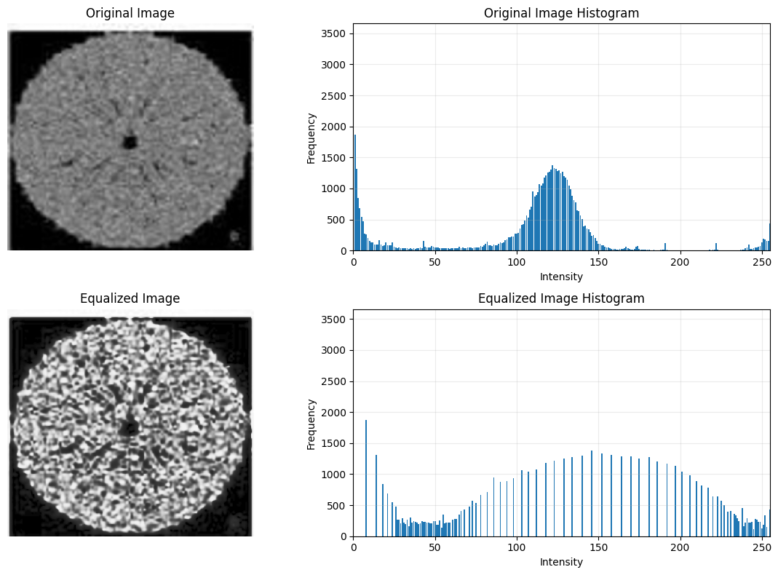
Histogram Matching
- Improved clarity without making the image overly bright.
- Produced a softer appearance.
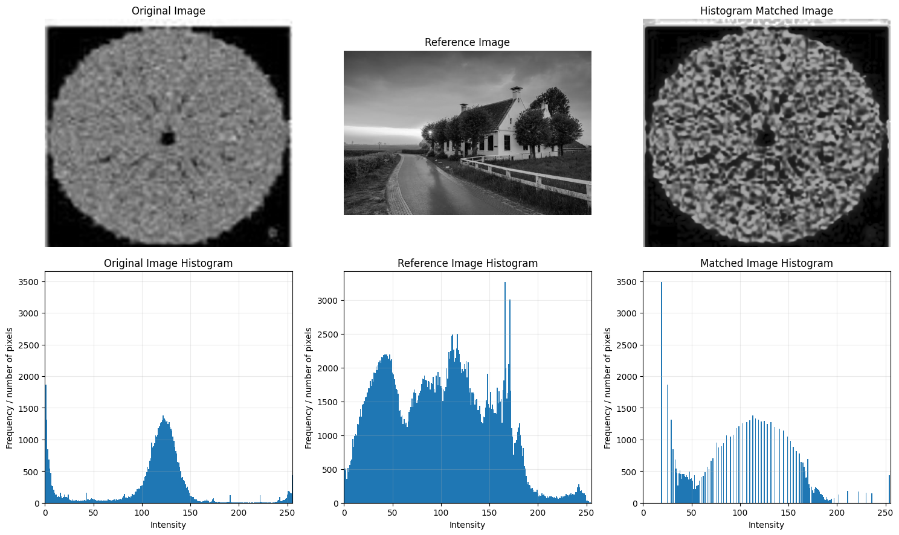
Better Method: Histogram Equalization
Reason: More internal details became visible.

Image 3
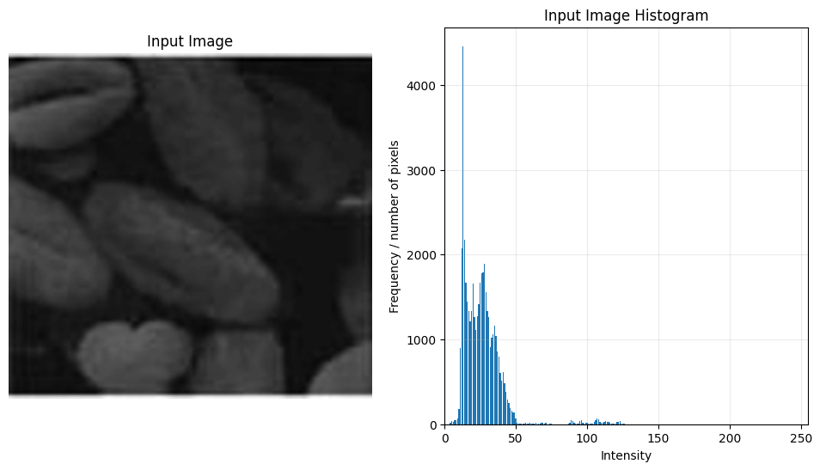

Histogram Equalization
- Brightened the image considerably.
- Revealed previously hidden seed outlines.
- Slightly increased noise.
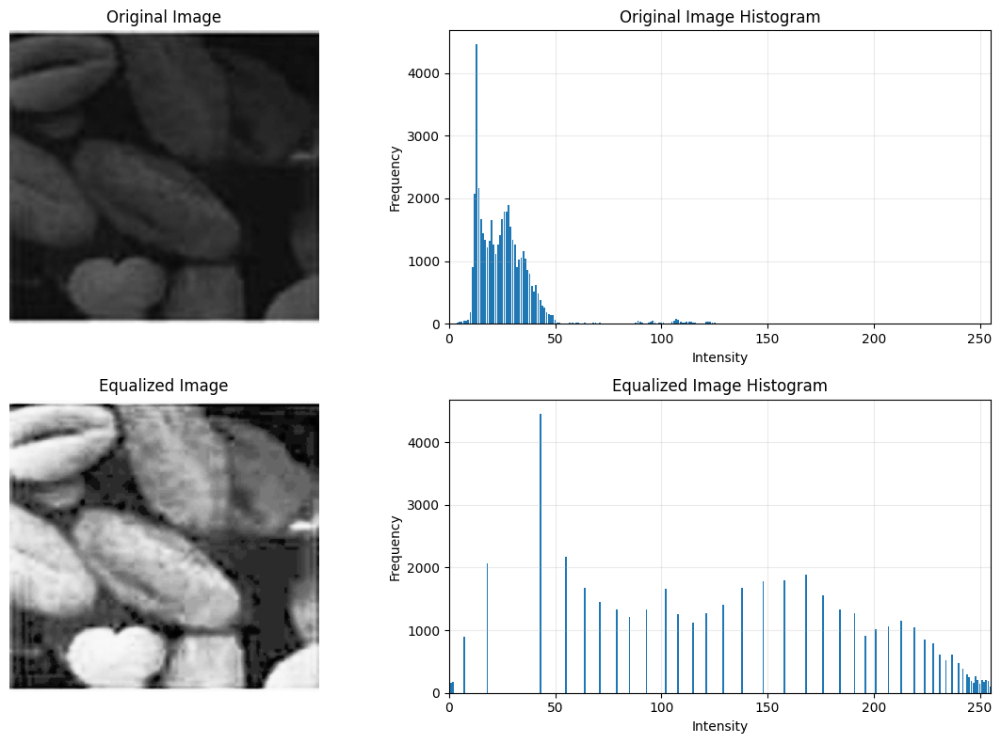
Histogram Matching
- Improved visibility while keeping brightness balanced.
- Preserved smoother intensity transitions.
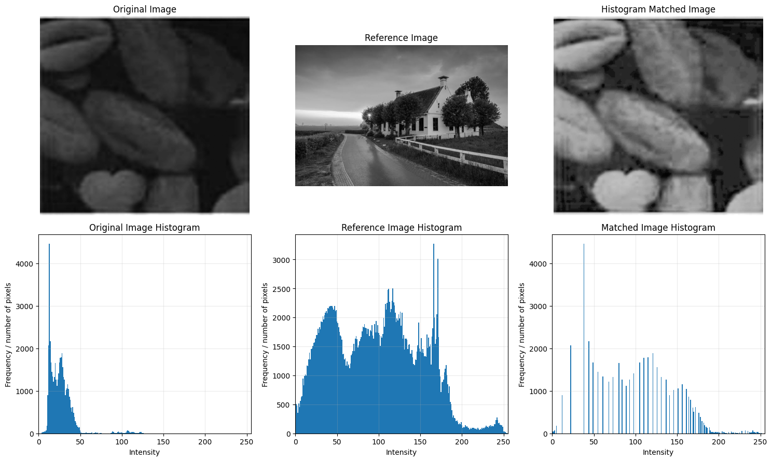
Better Method: Histogram Matching
Reason: It provided better visibility without over-enhancing the image.

Image 4
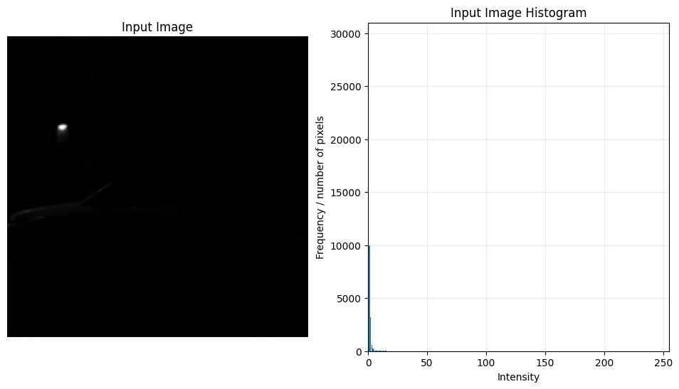

Histogram Equalization
- Revealed the car and road details.
- Increased noise in the dark regions.
- Produced a harsher appearance.
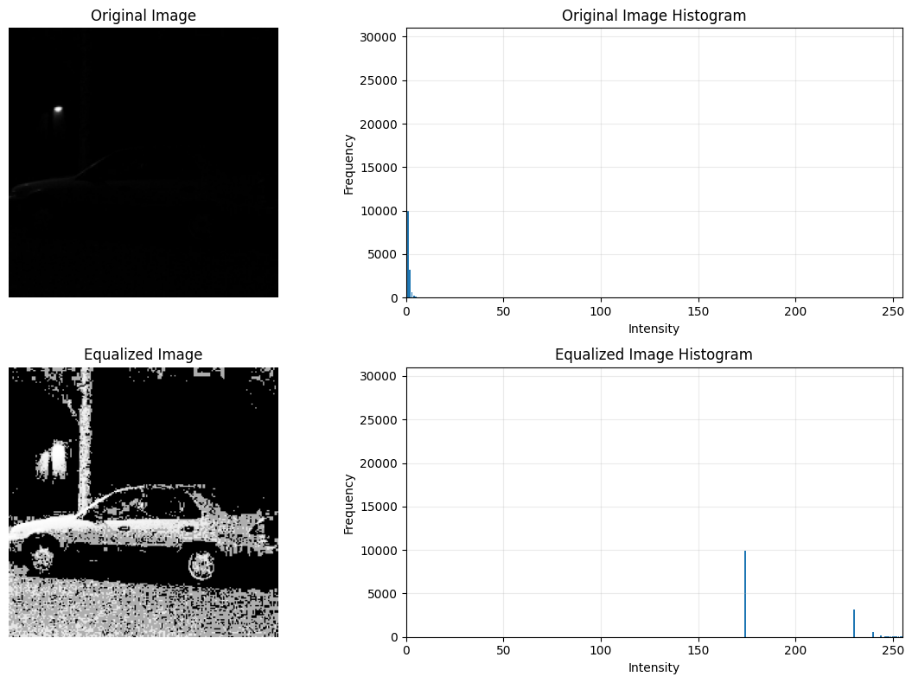
Histogram Matching
- Preserved the nighttime atmosphere.
- Improved visibility with less noise amplification.
- Produced a more balanced result.
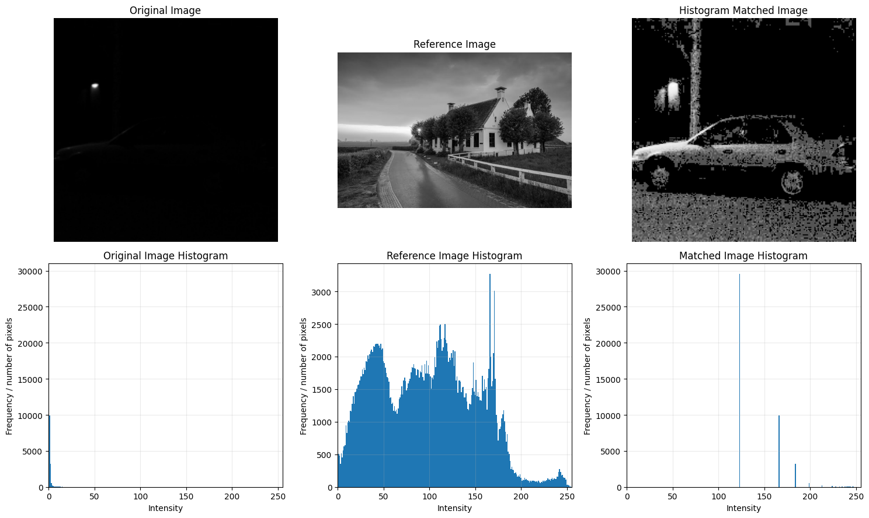
Better Method: Histogram Matching
Reason: The enhancement looked more natural.

Image 5
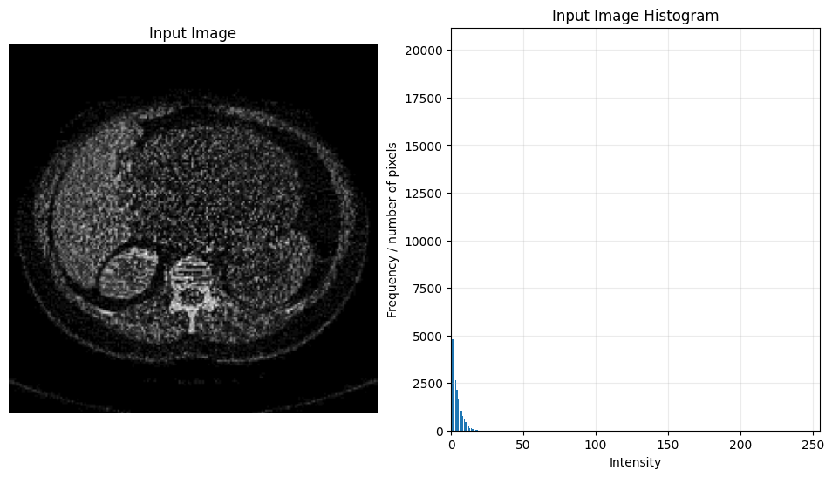

Histogram Equalization
- Increased the visibility of anatomical boundaries.
- Introduced noticeable graininess.
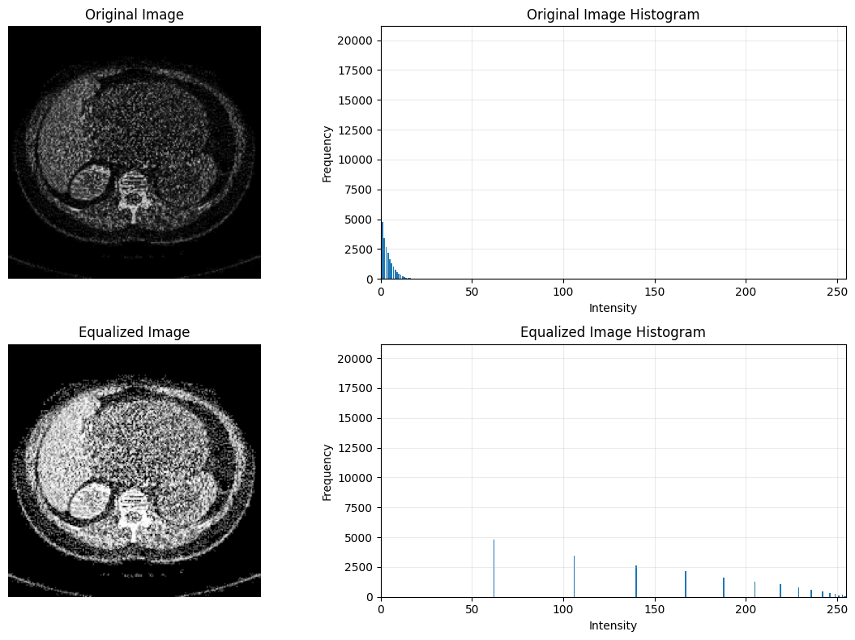
Histogram Matching
- Preserved realistic grayscale intensities.
- Enhanced important structures while reducing harshness.
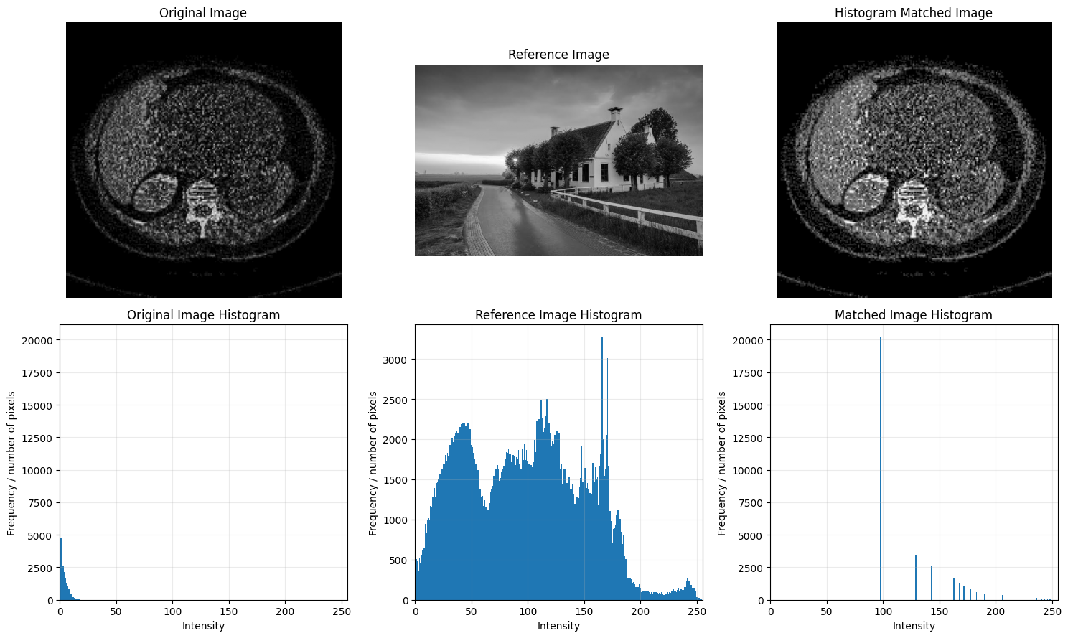
Better Method: Histogram Matching
Reason: Medical images benefit from preserving natural intensity relationships.

How Each Technique Changes Contrast and Clarity
Histogram Equalization
- Redistributes pixel values across the full intensity range.
- Increases global contrast.
- Makes hidden details more visible.
- Can also amplify noise in dark regions.
- Works best for images with uniformly low contrast.
Histogram Matching
- Adjusts the histogram to resemble a reference image.
- Produces controlled and natural-looking enhancement.
- Preserves brightness relationships better.
- Avoids excessive contrast enhancement.
- Depends on selecting a suitable reference image.
Histogram Behaviour
The histogram changes clearly illustrate how both methods operate.
- Original images: Pixel intensities were concentrated within a narrow range, indicating low contrast.
- Histogram Equalization: The histograms became more evenly distributed across the grayscale range, increasing overall contrast.
- Histogram Matching: The histograms shifted toward the reference distribution, producing smoother intensity transitions while preserving a more natural appearance.

Conclusion
In this experiment, both Histogram Equalization and Histogram Matching successfully improved the visual quality of degraded images, but they performed differently depending on the image characteristics.

