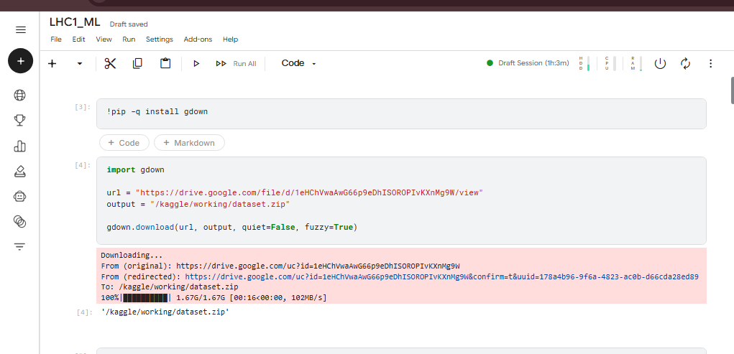
Q1. Number of tags per question
Tags were extracted from each question's tags field and counted. The distribution showed that questions commonly contain two or three tags.
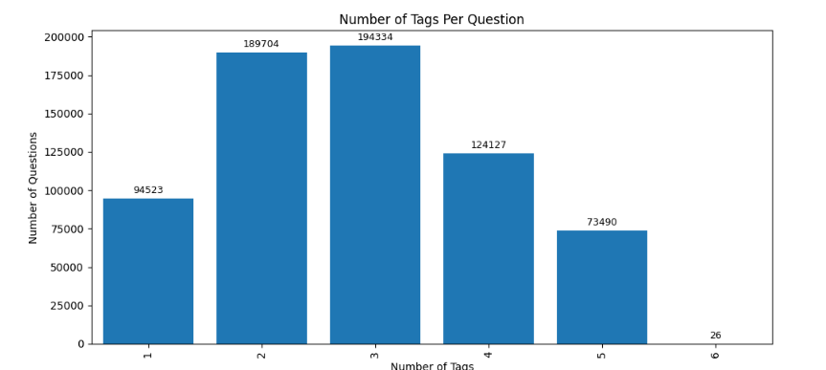

Q2. Total number of unique tags
The dataset contains 25,310 unique tags.
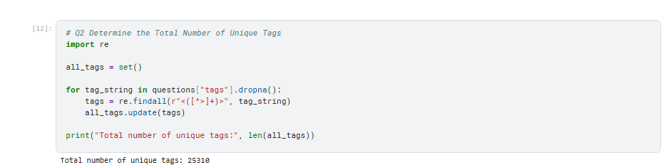
Q3. Top 25 most frequent tags
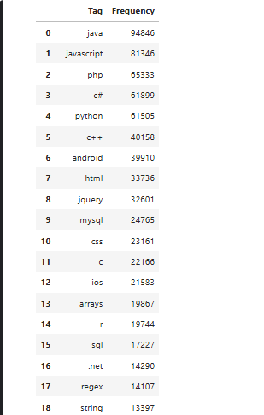

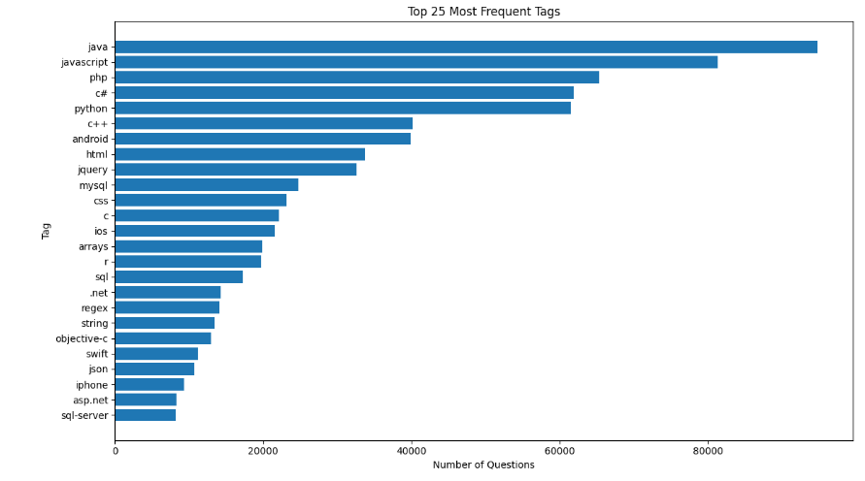

Q4. Distribution of the top 500 tags
The frequency plot for the top 500 tags showed a steep decline from the most frequent tags to lower-ranked tags. This indicates an uneven, long-tailed distribution: a relatively small number of tags occur very frequently, while many other tags appear less often.
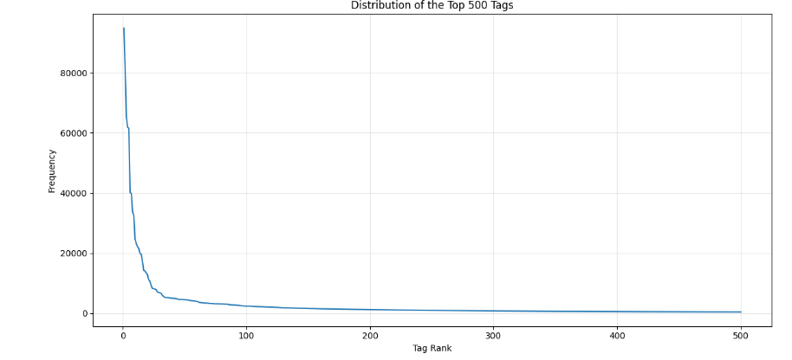

Q5. Monthly ratio of duplicate questions (2008–2018)
The monthly percentage was calculated as the number of questions whose IDs appeared as duplicate post IDs divided by the total number of questions in that month, multiplied by 100. The observed yearly percentages rose from 5.98% in 2008 to 92.87% in 2018. The monthly line chart also showed a strong upward trend.
$$\text{Duplicate percentage}=\frac{\text{Duplicate questions in a month}}{\text{Total questions in that month}}×100$$
I used
File | Columns used | Purpose
posts_short.csv | id, post_type_id, creation_date | Identifies questions and tells us when each question was created
postLinks.csv | post_id, related_post_id, link_type_id | Identifies links between posts and helps us find duplicate questions
- id: The unique ID of a question in posts_short.csv.
- post_type_id: Identifies the type of post. In our dataset, 1 represents a question.
- creation_date: The date and time when the question was created.
- post_id: The post being linked in postLinks.csv.
- related_post_id: The other post to which it is linked.
- link_type_id: Identifies the type of link. The dataset used 3 for duplicate links.
The dataset contained 682,329 duplicate-link records.However, these are link records, not necessarily 682,329 different questions. One question may have multiple duplicate-link records.
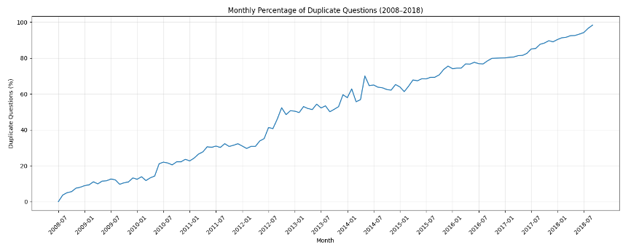
The calculated duplicate percentage showed a general upward trend, increasing from approximately 5.98% in 2008 to 92.87% in 2018. However, further investigation revealed that 231,253 unique IDs marked as duplicates in the duplicate-link dataset were not found in the question dataset, indicating incomplete or mismatched data coverage. Additionally, the percentage reached 98.32% in September 2018, when only 179 questions were recorded. Therefore, these results should not be interpreted as the actual duplicate-question rate on Stack Overflow. The investigation highlights the importance of validating dataset completeness, matching records consistently, and accounting for partial months before drawing conclusions from time-series analysis.
Since a large number of duplicate-question IDs were missing from the question dataset, we should contact the dataset owner to clarify the cause of these missing records and verify the dataset's completeness.

Q6. Duplicate-question percentage by tag
For each tag, the duplicate percentage was calculated as duplicate questions containing that tag divided by all questions containing that tag, multiplied by 100. The top 20 chart was restricted to tags occurring in at least 100 questions to reduce the influence of rare tags. The highest-ranking tags in the chart included nullreferenceexception, nullptrexception, python-3.6, jsf-2.2, and contact. These are associations in the supplied dataset and do not imply that a tag causes duplication.
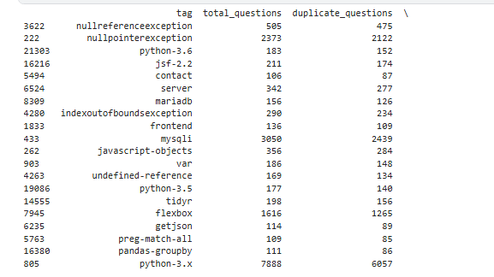
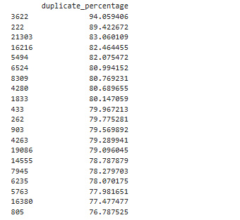
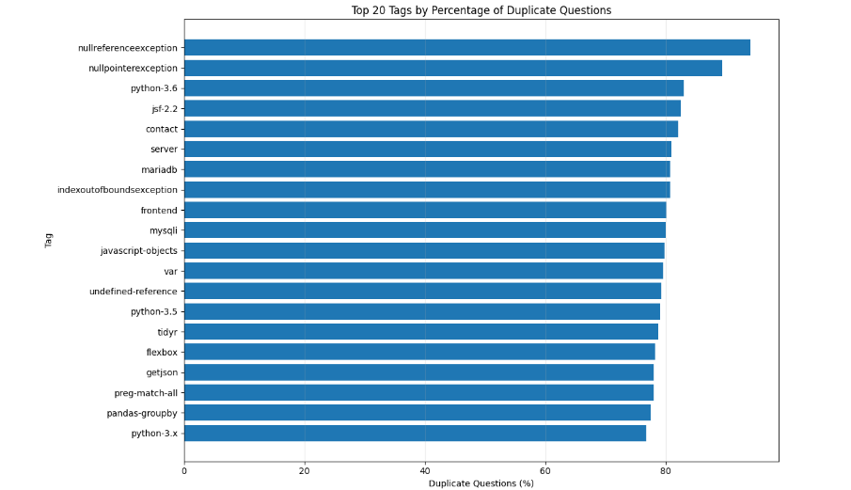
Q7. Time required to close duplicate questions
The chart showed that the largest category was under one hour. The mean was much larger than the median, indicating a right-skewed distribution with some very long intervals. The over-seven-days category covers a broad range of times.
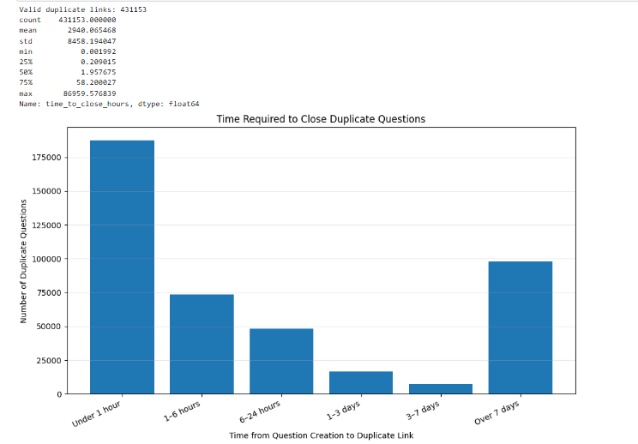
Q8. Reputation distribution of duplicate-question owners
The analysis examined the reputation distribution of users who asked questions marked as duplicates on Stack Overflow. A total of 393,539 duplicate-question records were matched to user reputation data, representing 284,611 unique users. The 1–100 reputation category contained the largest number of question records.
These findings suggest that, in our dataset, duplicate questions were more frequently associated with lower-reputation users. However, the analysis counted question records rather than unique users, so users who asked multiple duplicate questions could be counted more than once.
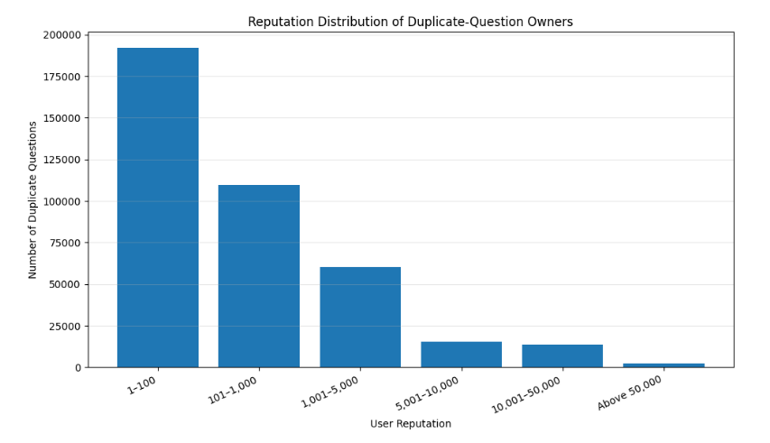
Q9. Question coverage by the top 500 tags
A question was counted as covered if it contained at least one of the 500 most frequent tags. The top 500 tags covered 97.98% of the questions.
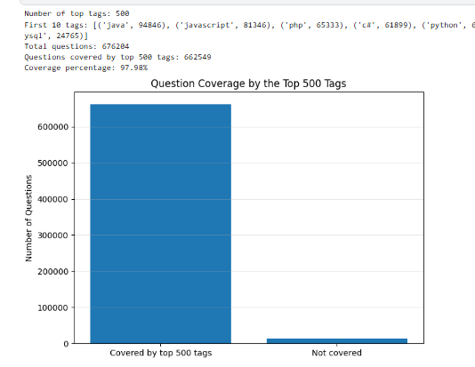
Q10. Question coverage by the top 5,000 tags
The top 5,000 tags covered 99.84% of questions. Compared with the top 500 tags, coverage increased by 1.86 percentage points and an additional 12,596 questions were covered.
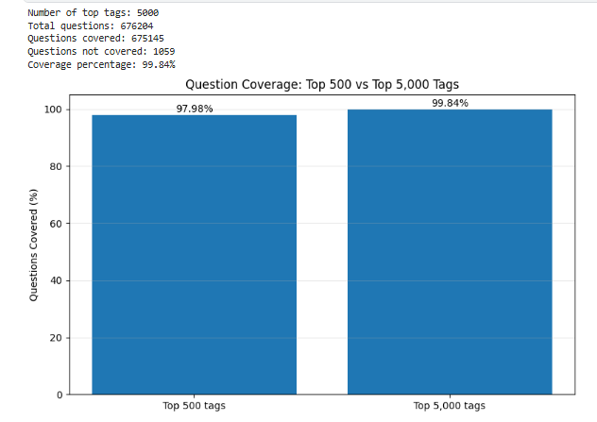
Question 11: Top 10 Tags with the Highest Number of Duplicate Questions.
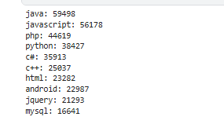
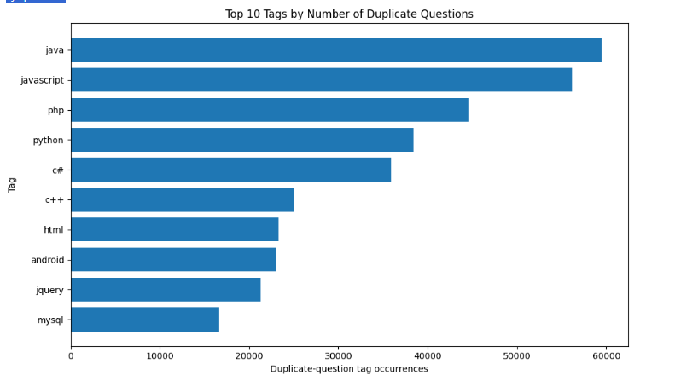
This question to identifies which programming languages, technologies, and topics are most frequently associated with duplicate questions on Stack Overflow. This analysis helps to understand where duplicate-question activity is concentrated and which tags contribute the greatest number of duplicate-question records.The analysis revealed that java had the highest number of duplicate-question tag occurrences, with 59,498, followed by javascript with 56,178 and php with 44,619. However, these counts do not necessarily mean that these topics have the highest proportion of duplicate questions, because they may also have more questions overall.
Question 12: Yearly Distribution of Duplicate Questions
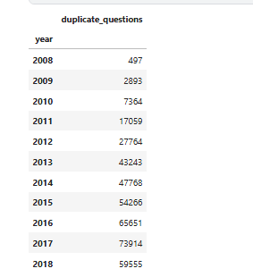

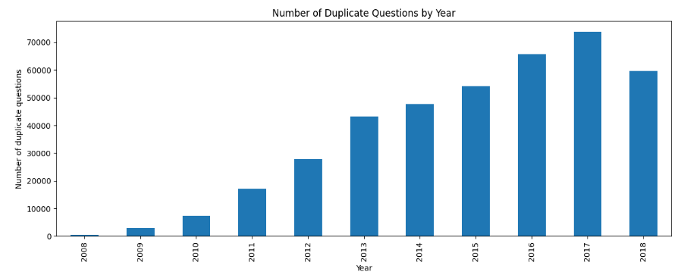
This question investigate how the number of questions marked as duplicates changed over time. A yearly analysis makes it easier to identify long-term trends and understand whether the number of duplicate-question records increased or decreased between 2008 and 2018. The analysis showed a substantial increase in the number of duplicate questions over the study period. The count rose from 497 in 2008 to 2,893 in 2009 and continued increasing, reaching 43,243 in 2013, 65,651 in 2016, and a peak of 73,914 in 2017. In 2018, the count decreased to 59,555. This decline may partly reflect the fact that the dataset ends on September 2, 2018, meaning that the year is incomplete. Overall, the results show an upward trend in the number of recorded duplicate questions. However, as identified in Question 5, incomplete or mismatched dataset coverage means that these counts should not automatically be interpreted as the actual yearly duplicate-question rate across all of Stack Overflow.
Question 13: Distribution of Questions by Number of Tags
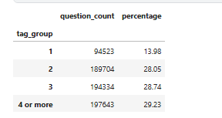
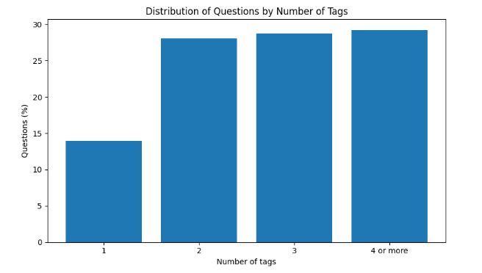
This question analyses how many tags are typically assigned to a question and how questions are distributed across different tag counts. Although Question 1 calculated the number of tags for individual questions, this question summarises those results into groups and expresses them as percentages, making the overall distribution easier to interpret. The results showed that 94,523 questions (13.98%) had one tag, 189,704 questions (28.05%) had two tags, and 194,334 questions (28.74%) had three tags. A further 197,643 questions (29.23%) had four or more tags. The largest category was therefore questions with four or more tags, closely followed by questions with three tags. These findings indicate that most questions in the dataset contain multiple tags, which can help categorise questions under different topics and make them easier to discover. This analysis complements Question 1 by presenting the tag counts as an overall distribution rather than focusing only on the number of tags attached to each individual question.
Question 14: Question Score by Duplicate Status
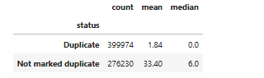
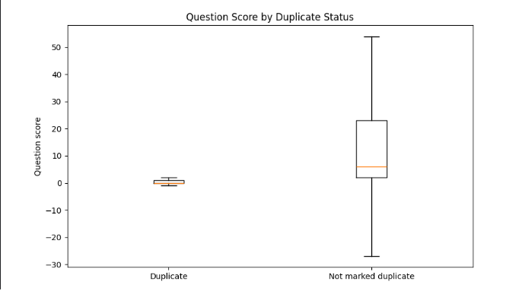
This question investigates whether questions marked as duplicates receive different community voting scores from questions not marked as duplicates. Comparing their scores helps us explore whether duplicate status is associated with differences in community feedback. The analysis compared 399,974 questions marked as duplicates with 276,230 questions not marked as duplicates. The duplicate-question group had a mean score of 1.84 and a median score of 0, whereas the non-duplicate group had a mean score of 33.40 and a median score of 6. The box plot also showed a much wider score distribution for questions not marked as duplicates. These findings indicate that duplicate questions generally had lower scores in the available dataset than questions not marked as duplicates. One possible explanation is that duplicate questions may provide less new information when similar questions already exist. Furthermore, the difference should be interpreted cautiously because the dataset may contain incomplete duplicate-link records.
Question 15: Top 10 Users by Number of Duplicate Questions
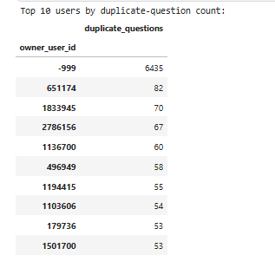
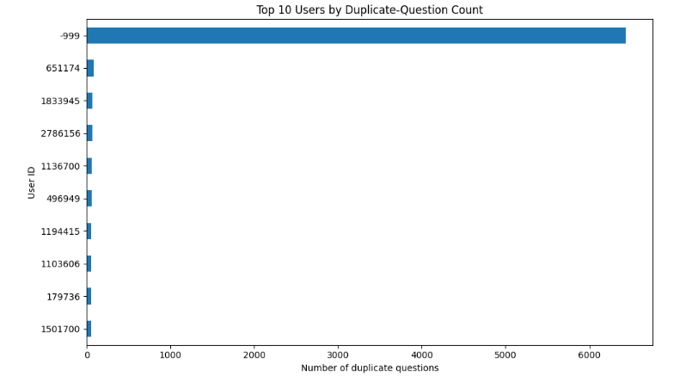
This question identifies the users associated with the greatest number of questions marked as duplicates. This analysis helps explore whether duplicate-question records are distributed evenly among users or concentrated among a smaller number of question authors. The results showed that user ID -999 was associated with 6,435 duplicate-question records, substantially more than any other entry. The next highest counts belonged to user IDs 651174 (82), 1833945 (70), 2786156 (67), and 1136700 (60). The remaining users in the top 10 had between 53 and 58 duplicate-question records. The unusually high count for user ID -999 requires special attention because it may represent an unknown, missing, or placeholder user ID rather than a single identifiable user. Therefore, it should not be interpreted as evidence that one actual user asked 6,435 duplicate questions without further validation. Excluding or separately analysing placeholder IDs would provide a more meaningful understanding of duplicate-question activity among identifiable users. Therefore, we should contact the dataset owner to confirm whether it represents a missing or unknown user ID or a valid user identifier. we should contact the dataset owner to confirm whether it represents a missing or unknown user ID or a valid user identifier.

