Description
'''
This dataset contains 55,000 synthetic customer transactions generated using Python's Faker library.
It simulates real-world retail transactions and can be used for data preprocessing, statistical analysis,
and visualization.

Shape of Dataset
Rows: 55,000
Columns: 13
'''
Column | Description
CID | Unique Customer ID
TID | Unique Transaction ID
Gender | Gender of the customer (Male, Female, Other)
Age Group | Age category of the customer
Purchase Date | Date and time when the transaction took place
Product Category | Category of the purchased product
Discount Availed | Indicates whether a discount was availed (Yes/No)
Discount Name | Name of the discount applied
Discount Amount (INR) | Amount of discount received in Indian Rupees
Gross Amount | Total amount before applying the discount
Net Amount | Final amount after applying the discount
Purchase Method | Payment method used (Credit Card, Debit Card, UPI, etc.)
Location | City where the purchase occurred

Code:
import pandas as pd

df = pd.read_csv("project1_df.csv")

print(df.shape)
print(df.columns)
print(df.dtypes)
print(df.info())
print(df.head())

df["Purchase Date"] = pd.to_datetime(
df["Purchase Date"],
format="%d/%m/%Y %H:%M:%S"
)
df["Year"] = df["Purchase Date"].dt.year
df["Month"] = df["Purchase Date"].dt.month
df["Day"] = df["Purchase Date"].dt.day
print(df["Purchase Date"].dtypes)

print(df.isnull().sum())
print((df.isnull().sum()/len(df))*100)
df["Discount Name"] = df["Discount Name"].fillna("No Discount")
print(df.duplicated().sum())

#statistics
print(df.describe())
print("Mean Gross Amount =", df["Gross Amount"].mean())
print("Mean Net Amount =", df["Net Amount"].mean())
print("Mean Discount Amount =", df["Discount Amount (INR)"].mean())
print("Median of Gross Amount",df["Gross Amount"].median())
print("Median of Net Amount",df["Net Amount"].median())
print("Std of Gross Amount",df["Gross Amount"].std())
print("Std of Net Amount",df["Net Amount"].std())
print("Minimum of Gross Amount",df["Gross Amount"].min())
print("Maximum of Gross amount",df["Gross Amount"].max())
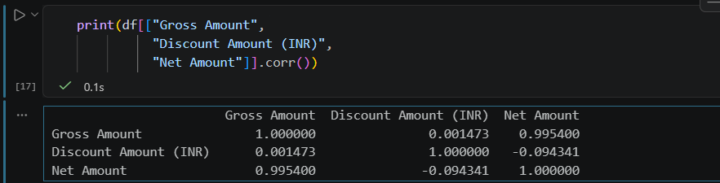

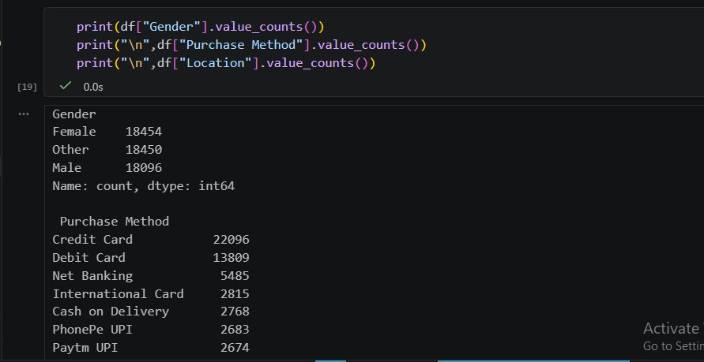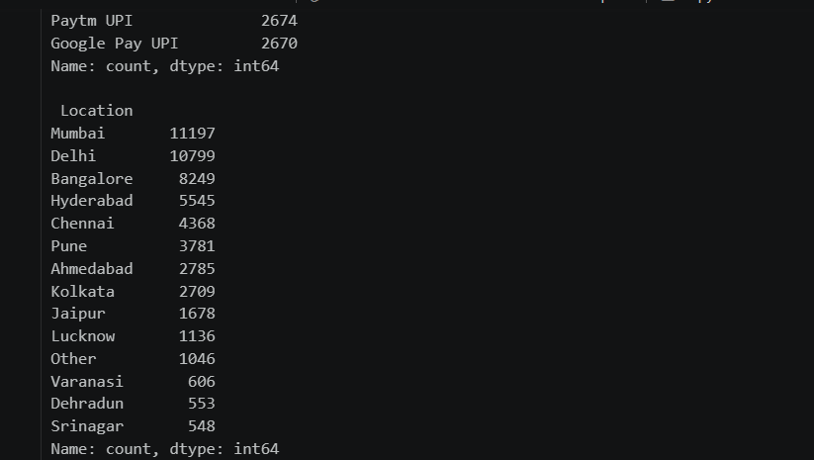

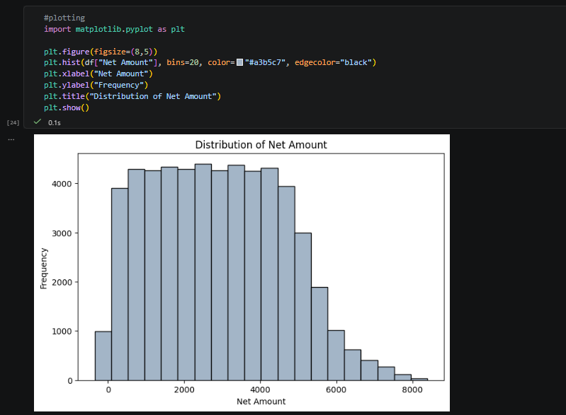
df.loc[0, "Gross Amount"] = 10000
plt.figure(figsize=(8,5))
plt.boxplot(df["Gross Amount"],
patch_artist=True,
boxprops=dict(facecolor='skyblue', color='black'),
medianprops=dict(color='red', linewidth=2),
whiskerprops=dict(color='black'),
capprops=dict(color='purple'),
flierprops=dict(marker='*',
markerfacecolor='orange',
markersize=8,
markeredgecolor='red'))
plt.title("Boxplot of Gross Amount")
plt.show()
Q1 = df["Gross Amount"].quantile(0.25)
Q2 = df["Gross Amount"].quantile(0.50)
Q3 = df["Gross Amount"].quantile(0.75)
IQR = Q3 - Q1

print("Lower limit =", Q1 - 1.5*IQR)
print("Upper limit =", Q3 + 1.5*IQR)
print("Q1 =", Q1)
print("Median =", Q2)
print("Q3 =", Q3)
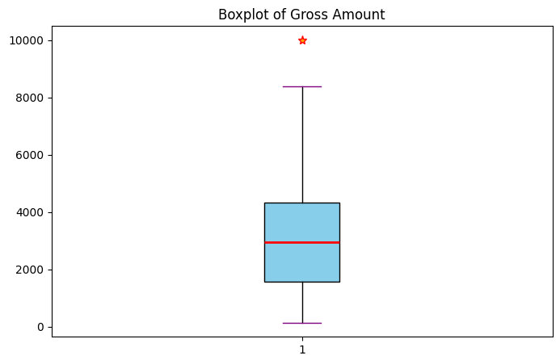
Lower limit = -2607.981562499999
Upper limit = 8512.5991375
Q1 = 1562.2362
Median = 2954.4383500000004
Q3 = 4342.381375

