PRACTICAL - 3

Aim:
Design, spin up, and evaluate two parallel data ingestion pipelines: a periodic timetriggered block batch pipeline and a continuous low-latency real-time event streaming processor.Students must capture telemetry statistics and benchmark performance parameters
across both options, measuring data delivery latency, processing throughput spikes, and fault tolerance during simulated infrastructure drops.

Code Screenshot: 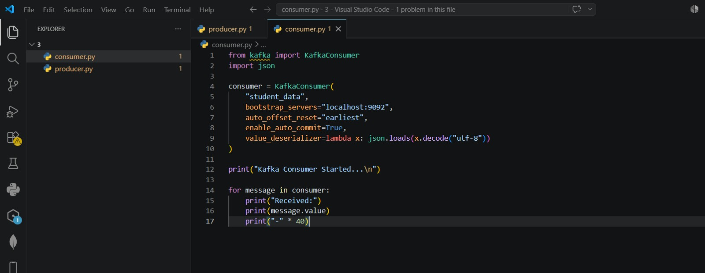

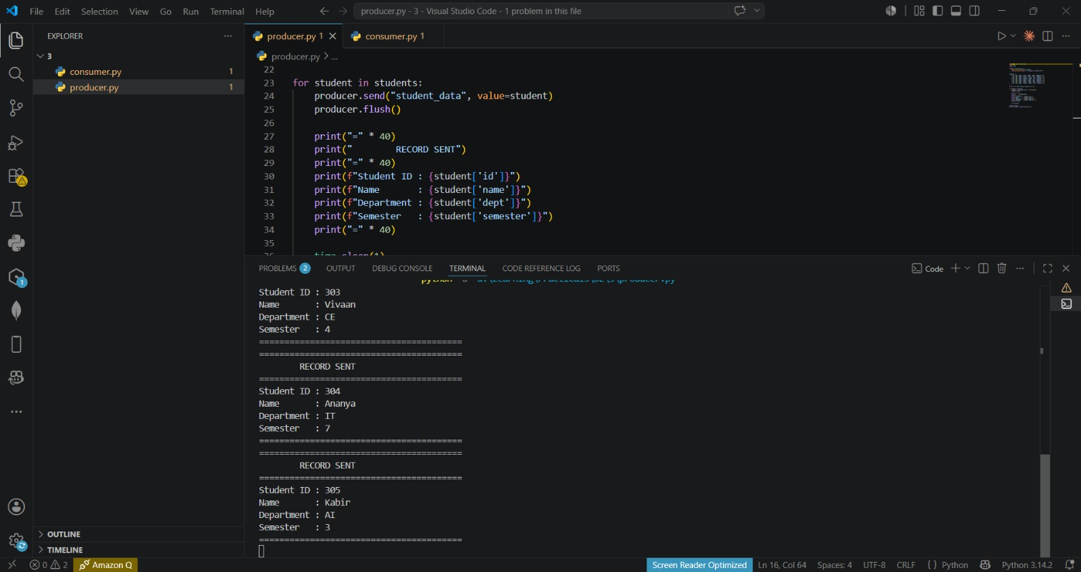

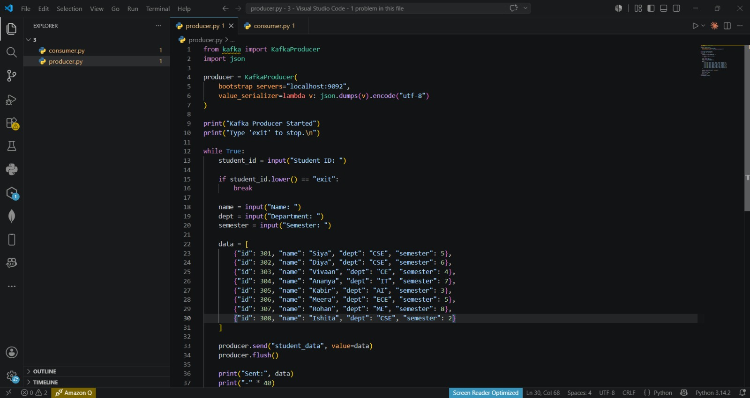
Output Screenshot: 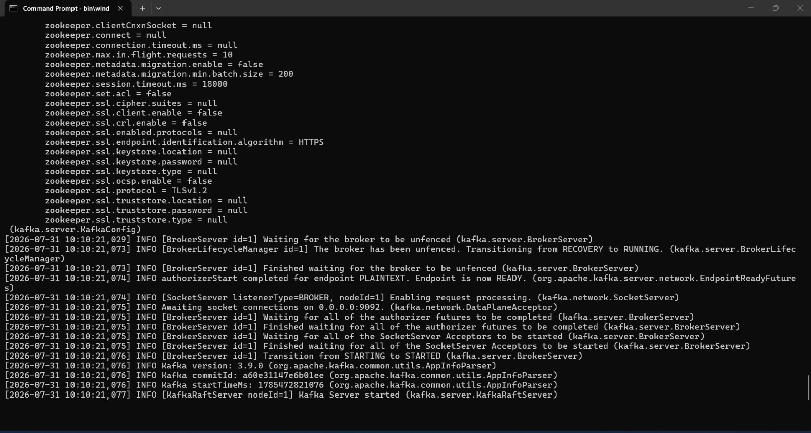
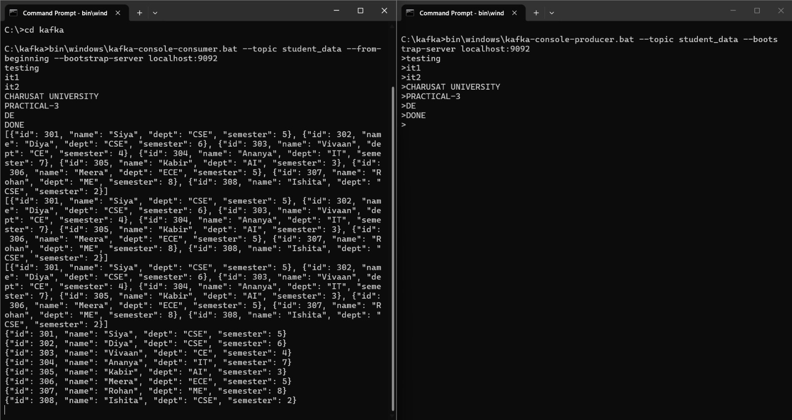

Learning Outcome:
Through this practical, I gained hands-on experience in designing and evaluating both batch and real-time data ingestion pipelines using Kafka/Redpanda, Docker, Python, and Pandas. I learned how to compare latency, throughput, scalability, and fault tolerance between micro-batch and streaming architectures under different workloads and failure scenarios. The implementation enhanced my understanding of message broker operations, consumer group scaling, performance benchmarking, and the factors influencing the selection of batch or streaming solutions for real-world data processing applications.

