PRACTICAL -5

Aim:
To implement data storage structures using distributed storage paradigms by partitioning a large analytical dataset using Hive-style partitioning based on year and region, storing the partitioned data in MinIO object storage using Python and Boto3, querying specific partitions, and comparing the performance with a full-table scan.

Code Screenshot:
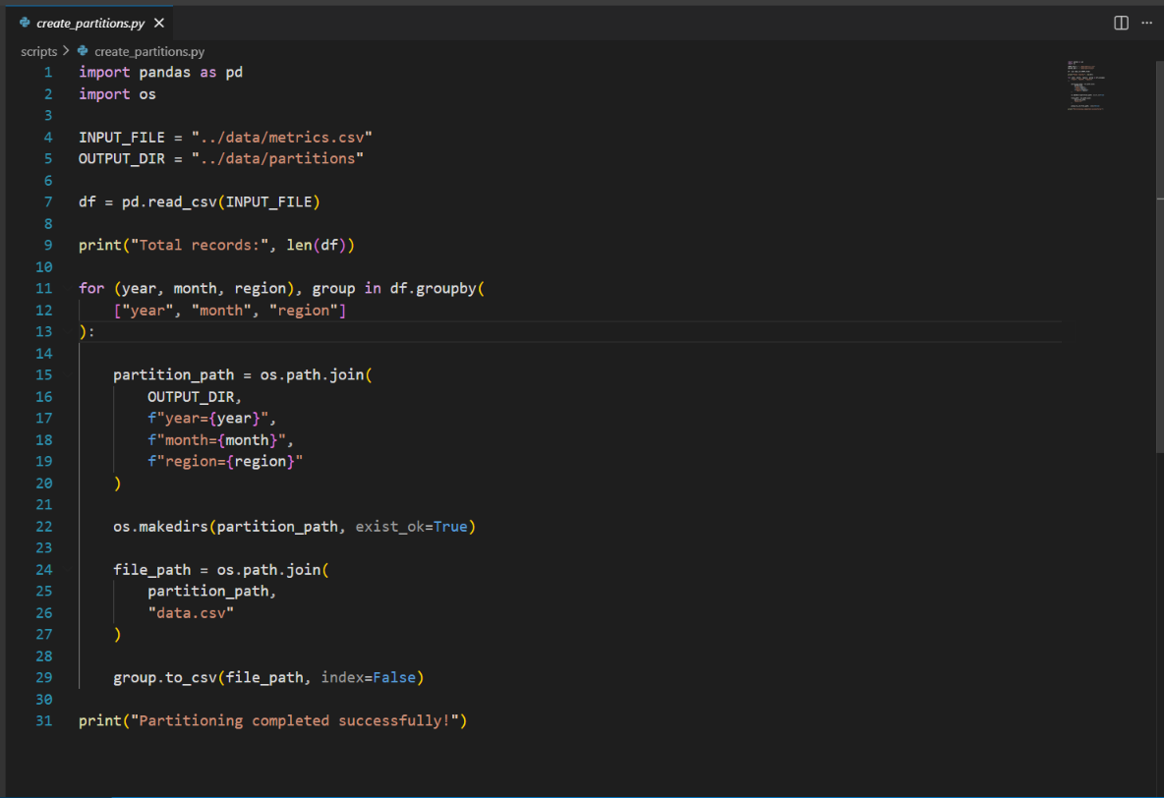
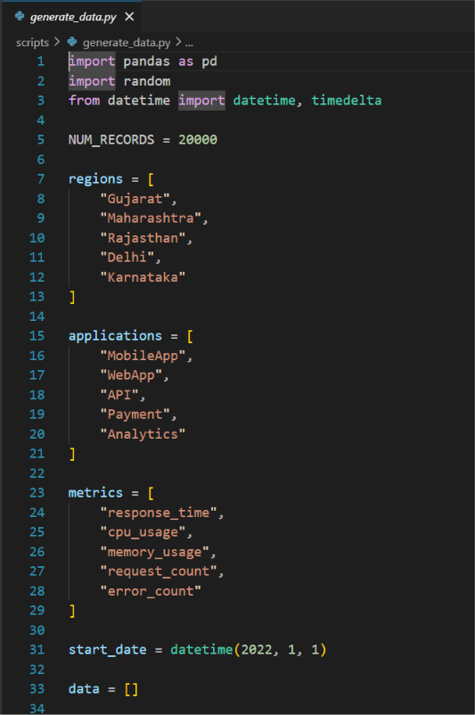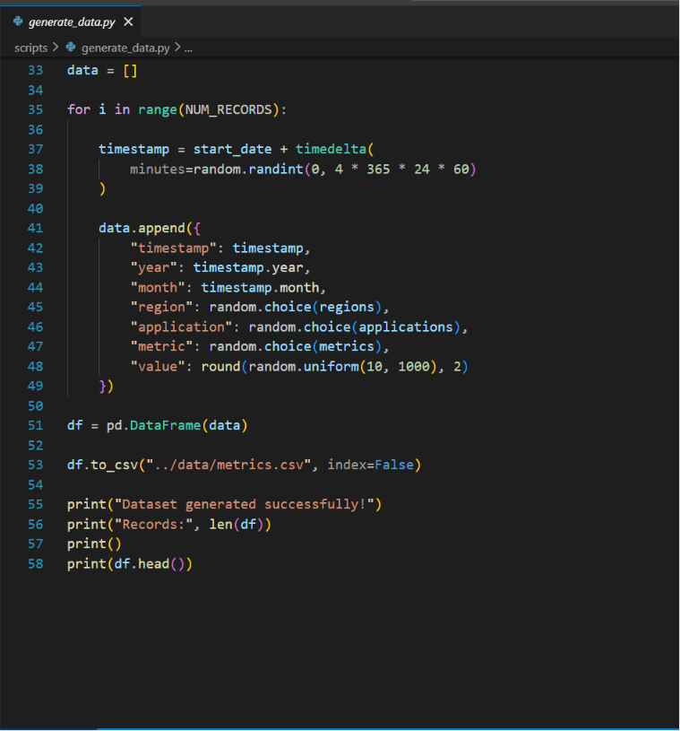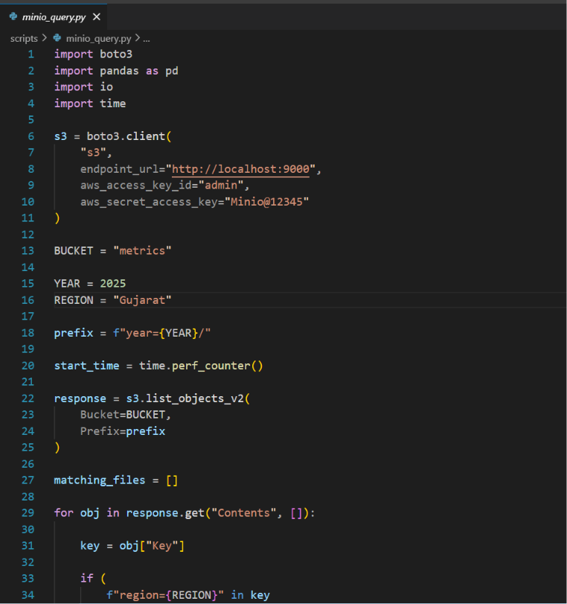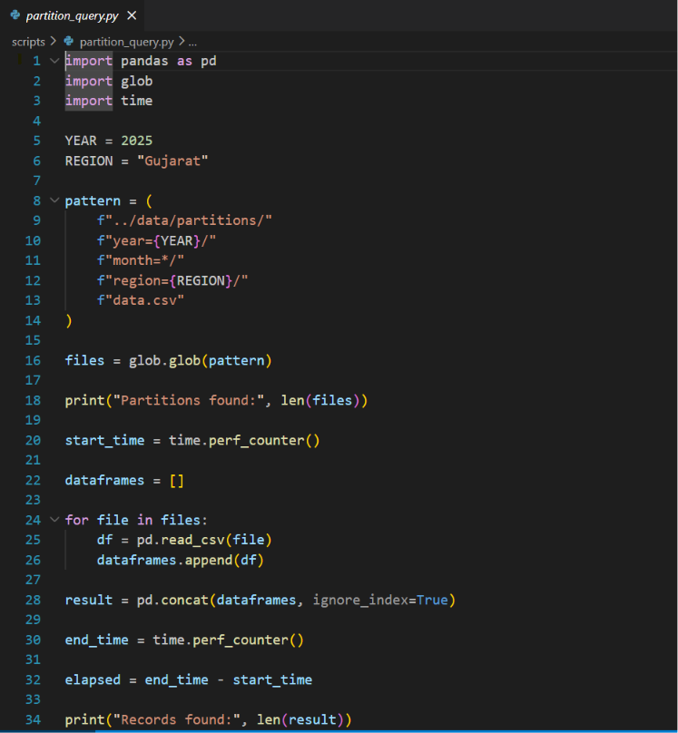

Output Screenshot:
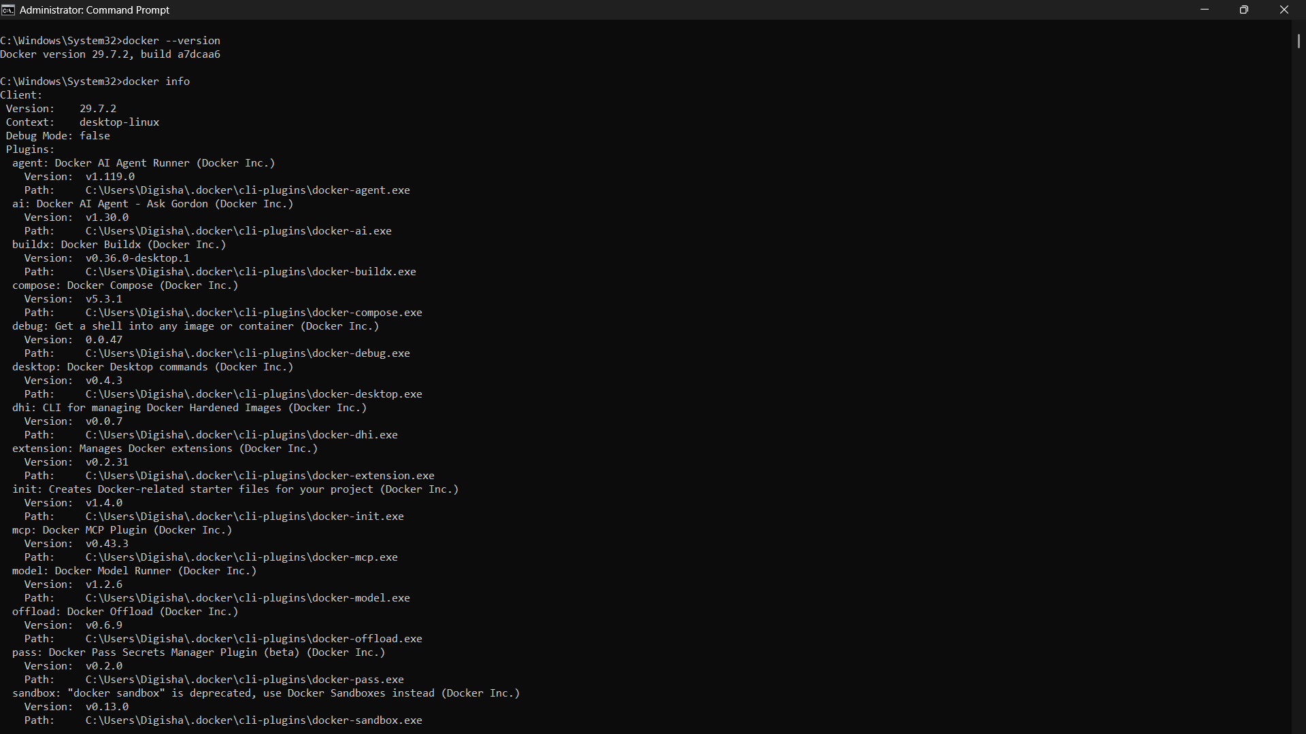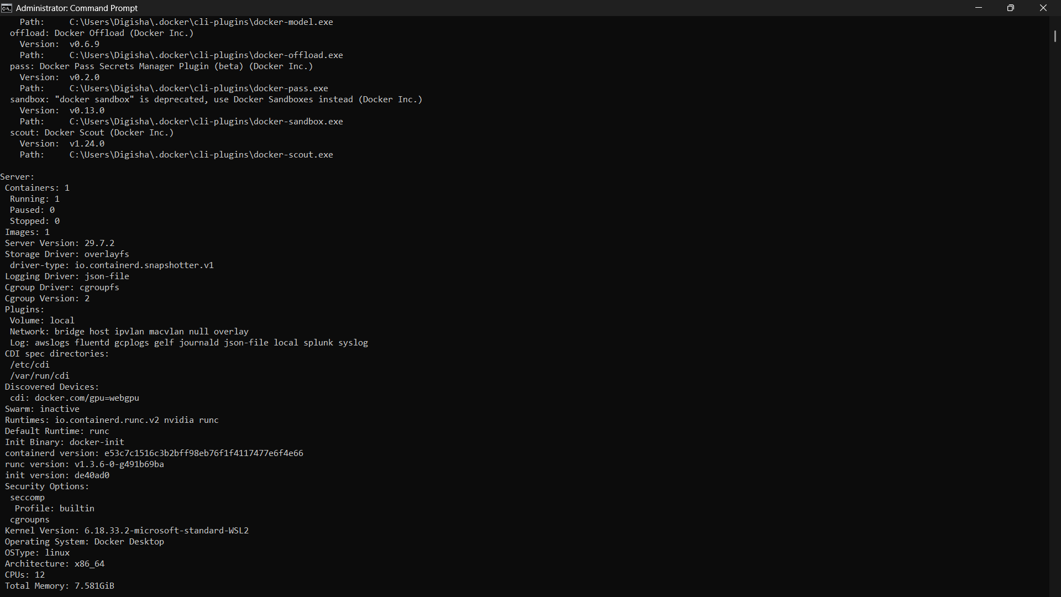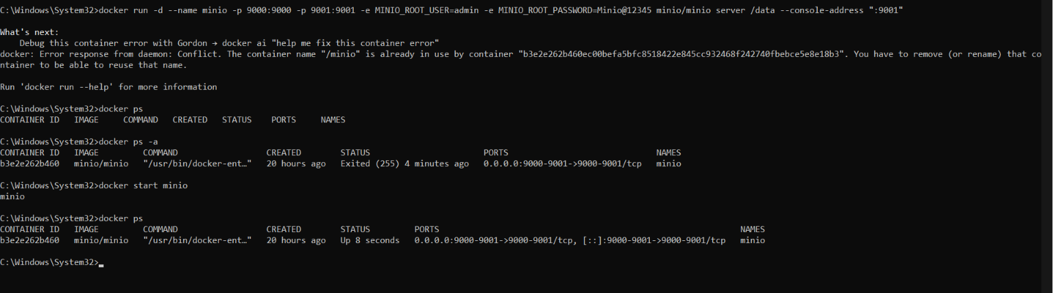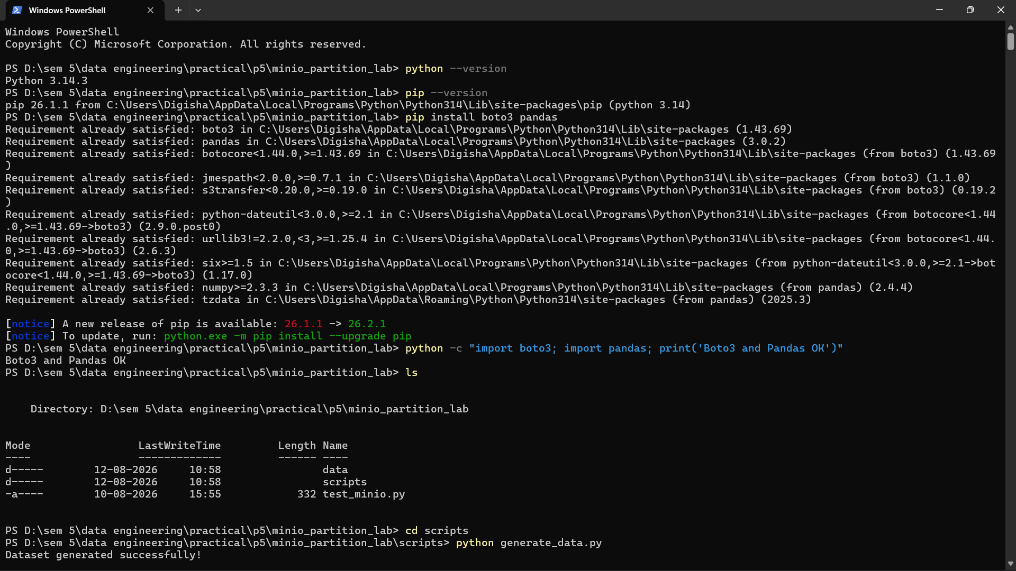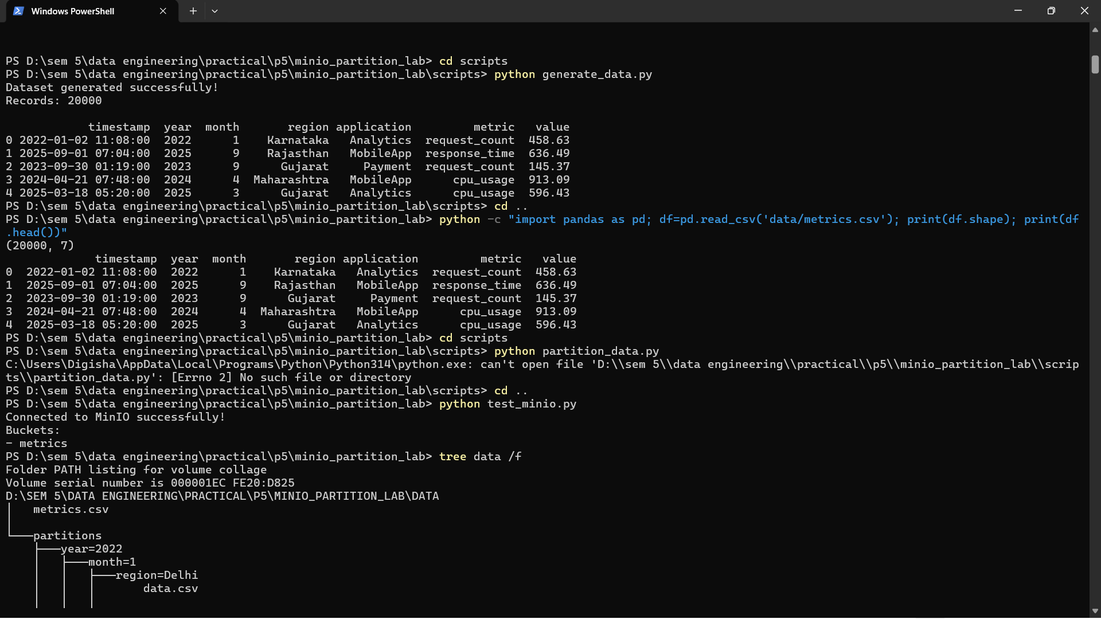
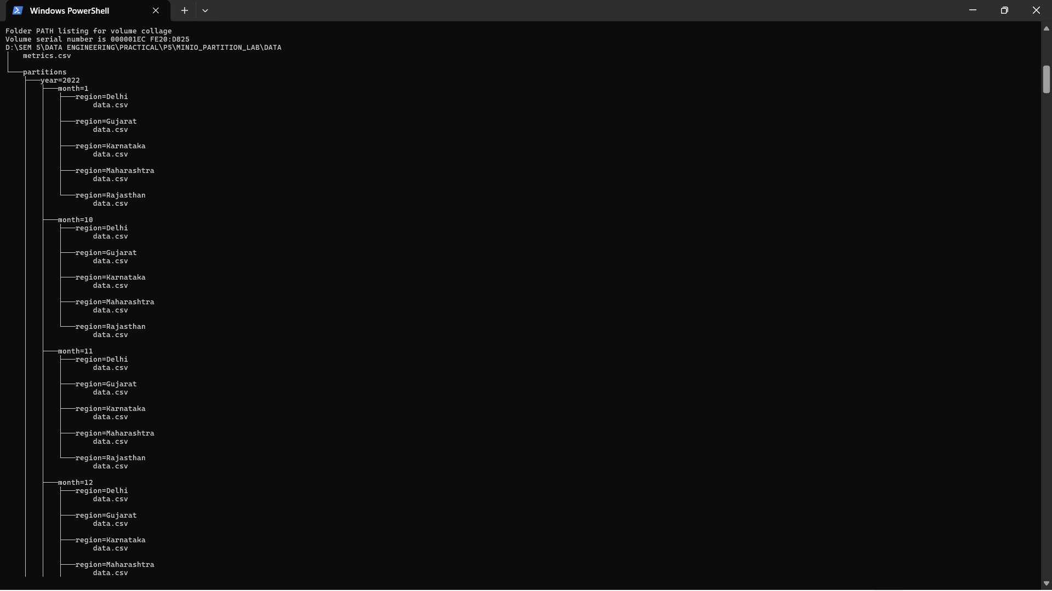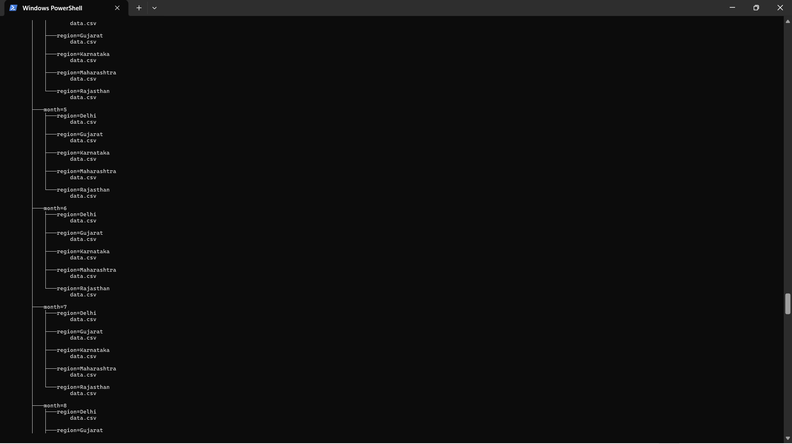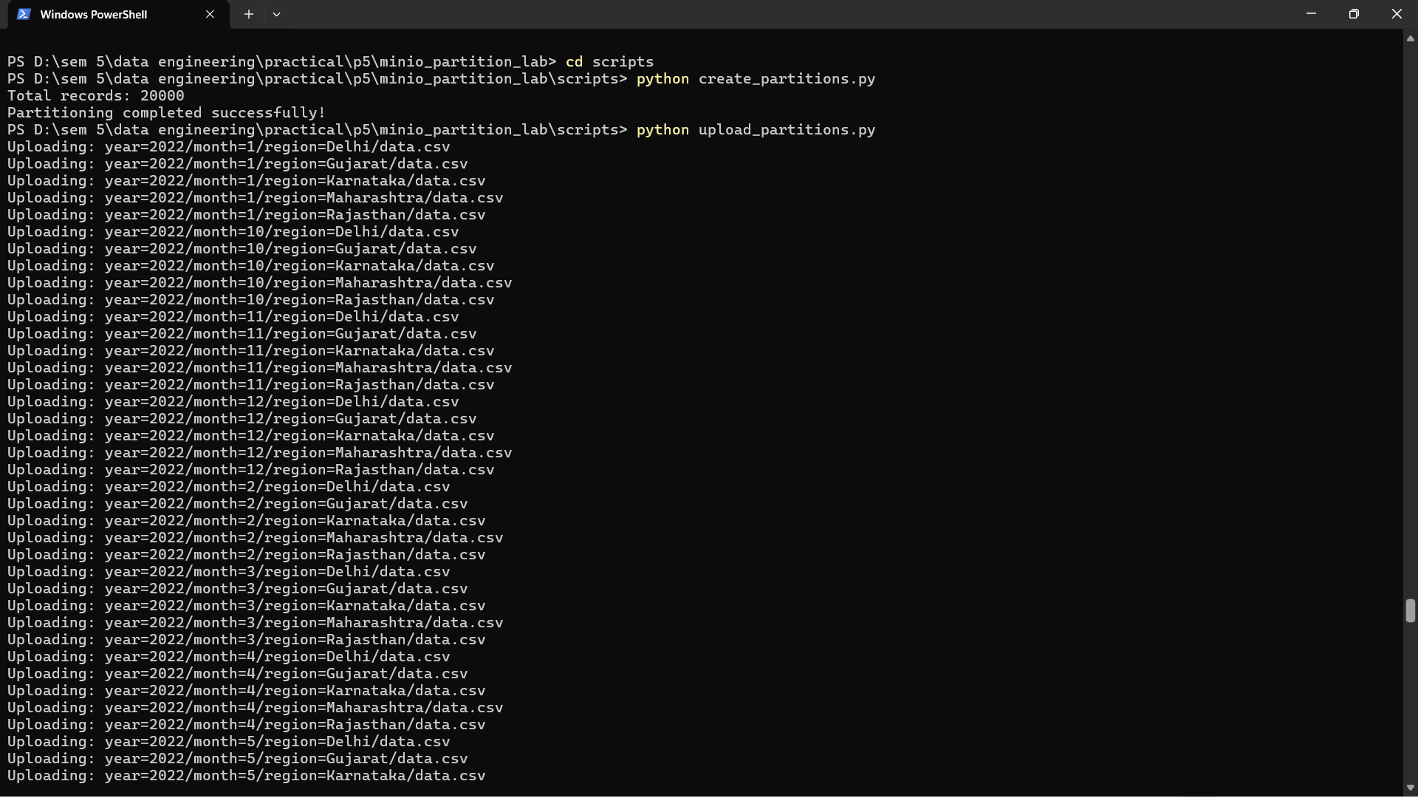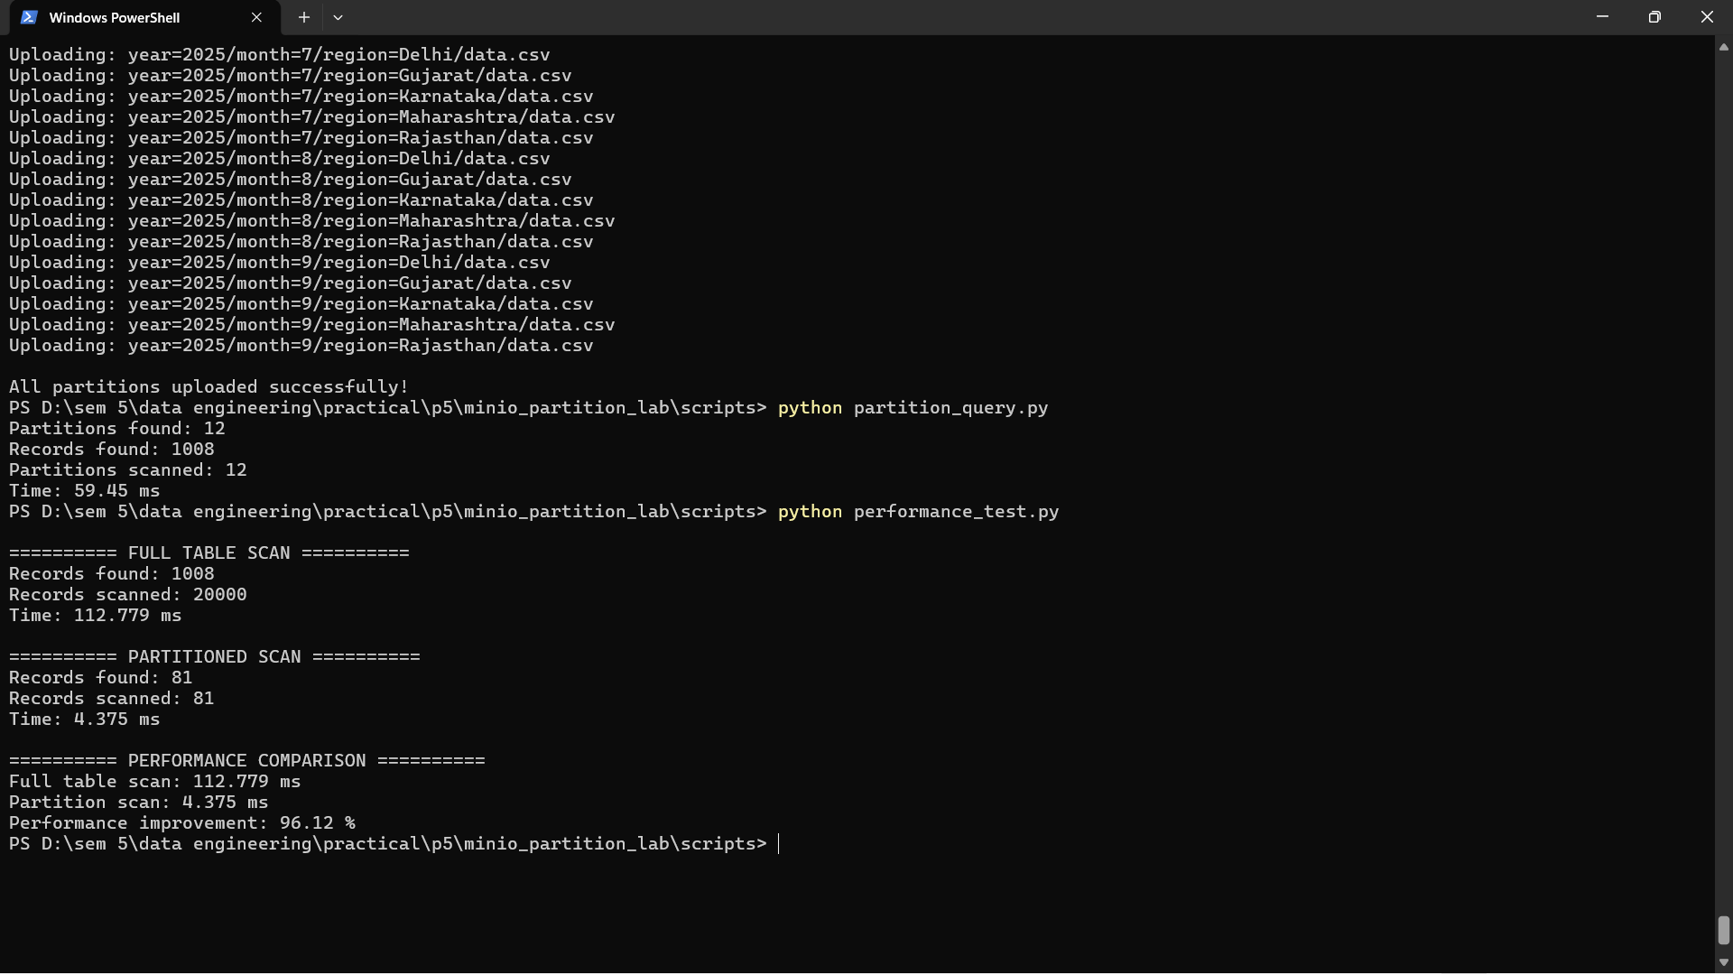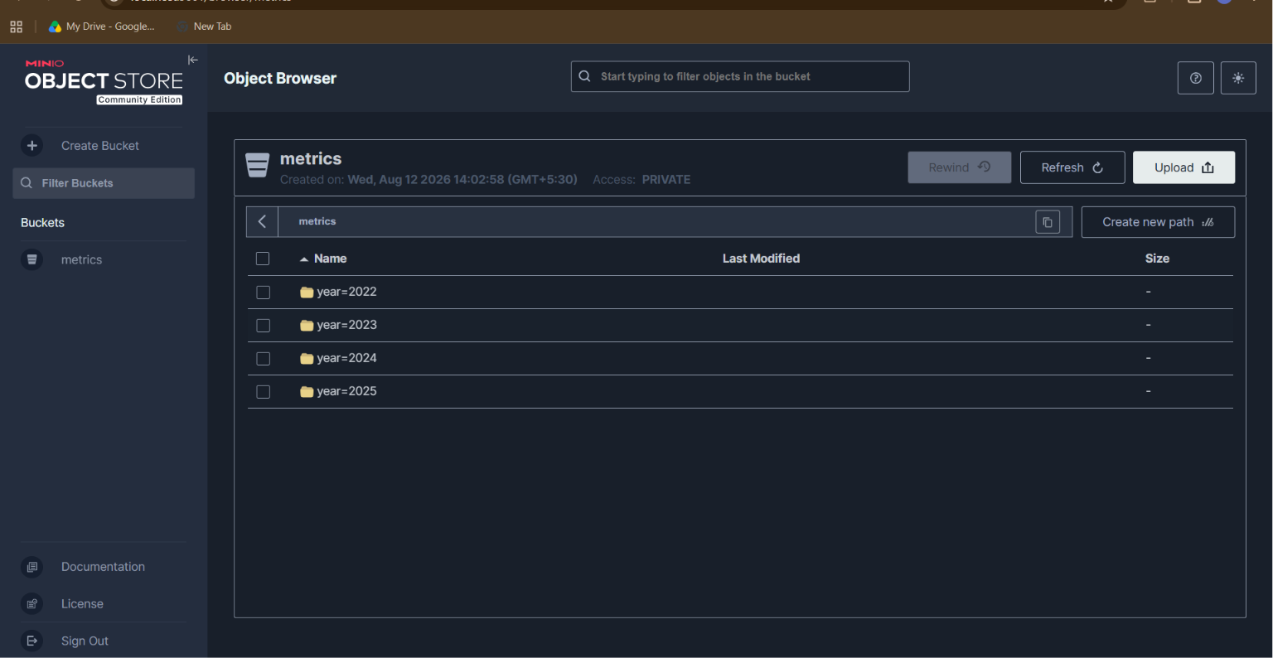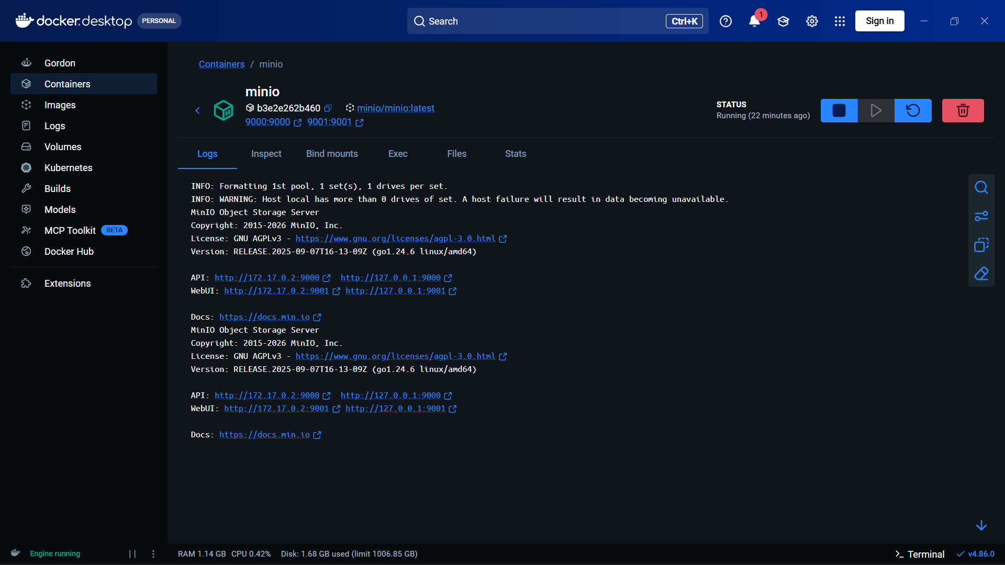

Learning Outcome:
After completing this practical, I learned how to organize analytical data using Hive-style partitioning and store it in an S3-compatible MinIO object storage system. I learned to use Python and Boto3 to upload and retrieve partitioned data, query only the required partitions, and compare partition-based access with full-table scanning. I also understood how partitioning can reduce unnecessary data access and improve the efficiency of analytical queries.

