STEP1:
Download jenkins.war:
Go to the location of the jenkins.war
and the following command

C:\Users\bandaru\Downloads>java -jar jenkins.war
Running from: C:\Users\bandaru\Downloads\jenkins.war
webroot: $user.home/.jenkins
Nov 30, 2015 3:38:30 PM winstone.Logger logInternal
INFO: Beginning extraction from war file
Nov 30, 2015 3:38:30 PM org.eclipse.jetty.util.log.JavaUtilLog info
INFO: jetty-winstone-2.9
Nov 30, 2015 3:38:38 PM org.eclipse.jetty.util.log.JavaUtilLog info
INFO: NO JSP Support for , did not find org.apache.jasper.servlet.JspServlet
Jenkins home directory: C:\Users\bandaru\.jenkins found at: $user.home/.jenkins
Nov 30, 2015 3:38:40 PM org.eclipse.jetty.util.log.JavaUtilLog info
INFO: Started SelectChannelConnector@0.0.0.0:8080
Nov 30, 2015 3:38:40 PM winstone.Logger logInternal
INFO: Winstone Servlet Engine v2.0 running: controlPort=disabled
Nov 30, 2015 3:38:40 PM jenkins.InitReactorRunner$1 onAttained
INFO: Started initialization
Nov 30, 2015 3:38:50 PM jenkins.InitReactorRunner$1 onAttained
INFO: Listed all plugins
Nov 30, 2015 3:38:50 PM jenkins.InitReactorRunner$1 onAttained
INFO: Prepared all plugins
Nov 30, 2015 3:38:50 PM jenkins.InitReactorRunner$1 onAttained
INFO: Started all plugins
Nov 30, 2015 3:39:01 PM jenkins.InitReactorRunner$1 onAttained
INFO: Augmented all extensions
Nov 30, 2015 3:39:02 PM jenkins.InitReactorRunner$1 onAttained
INFO: Loaded all jobs
Nov 30, 2015 3:39:06 PM hudson.model.AsyncPeriodicWork$1 run
INFO: Started Download metadata
Nov 30, 2015 3:39:06 PM hudson.model.AsyncPeriodicWork$1 run
INFO: Finished Download metadata. 182 ms
Nov 30, 2015 3:39:07 PM org.jenkinsci.main.modules.sshd.SSHD start
INFO: Started SSHD at port 49388
Nov 30, 2015 3:39:07 PM jenkins.InitReactorRunner$1 onAttained
INFO: Completed initialization
Nov 30, 2015 3:39:07 PM jenkins.InitReactorRunner$1 onAttained
INFO: Started initialization
Nov 30, 2015 3:39:07 PM jenkins.InitReactorRunner$1 onAttained
INFO: Listed all plugins
Nov 30, 2015 3:39:07 PM jenkins.InitReactorRunner$1 onAttained
INFO: Prepared all plugins
Nov 30, 2015 3:39:07 PM jenkins.InitReactorRunner$1 onAttained
INFO: Started all plugins
Nov 30, 2015 3:39:07 PM jenkins.InitReactorRunner$1 onAttained
INFO: Augmented all extensions
Nov 30, 2015 3:39:07 PM jenkins.InitReactorRunner$1 onAttained
INFO: Loaded all jobs
Nov 30, 2015 3:39:07 PM jenkins.InitReactorRunner$1 onAttained
INFO: Completed initialization
Nov 30, 2015 3:39:07 PM hudson.WebAppMain$3 run
INFO: Jenkins is fully up and running

STEP2:
open the browser and hit the url:as
http://localhost:8080

then u will see the Jenkins console
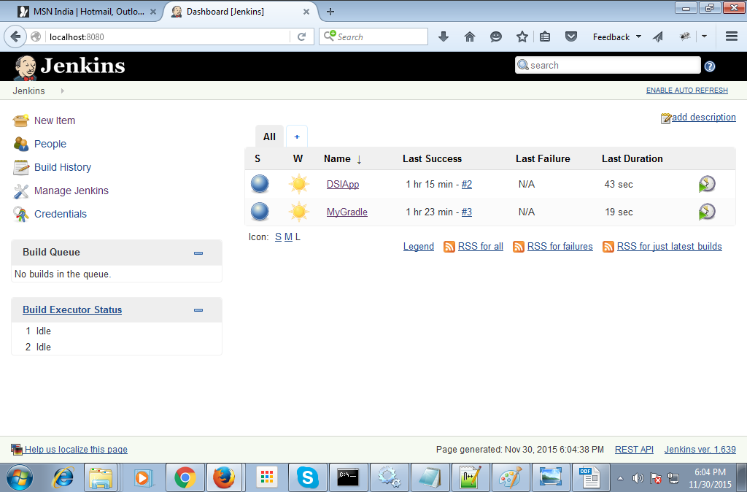
STEP3:
click on the Manage Jenkins->Install as windows Service
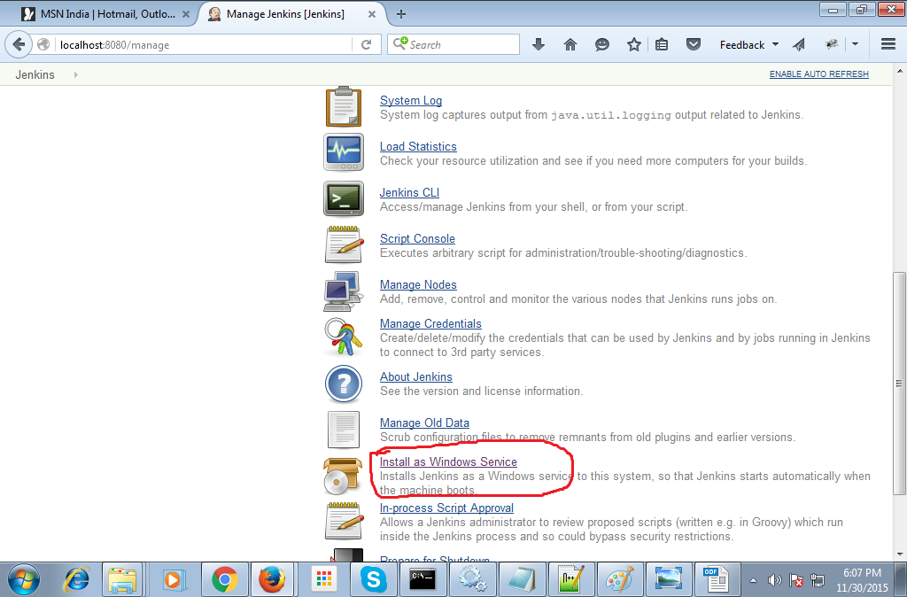
Then :
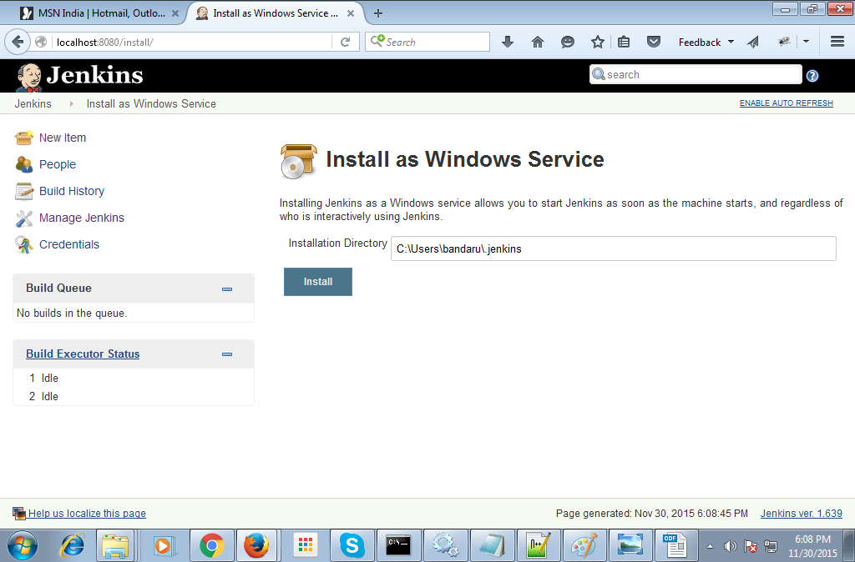
Then click in install and restart the Jenkins by running the above command java -jar jenkins.war

STEP4:
Then create a new Job by click on new Item:

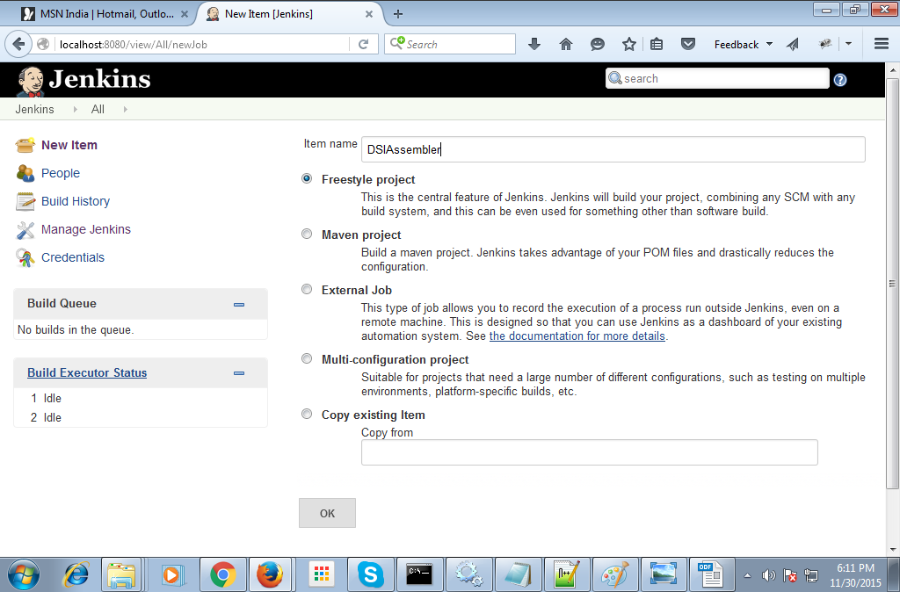
then click ok.
Then next step is in part by part
