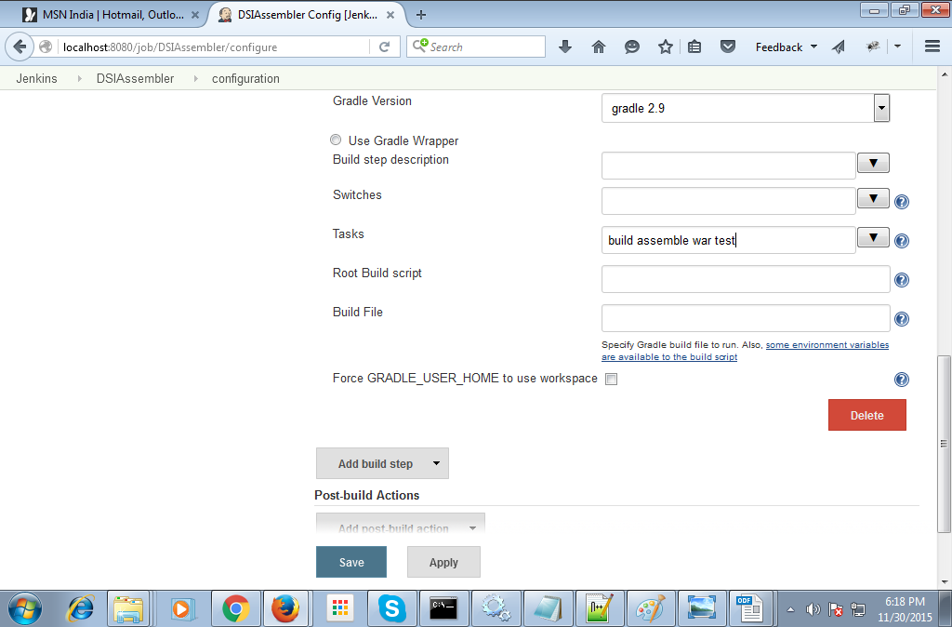
Click apply and save:

STEP5:
Extract u r DSIAssembler.zip and u will get DSIAssembler App
Then Open DSIAssembler and copy all the File
paste inside the
C:\Users\bandaru\.jenkins\jobs\DSIApp(DSIApp is the job name, while I create by click on new item)
then come to the Jenkins: http://localhost:8080/job/ DSIApp
and click on Build Now.
You will see build failed.
Then u again open DSIAssembler and copy all the files and paste inside the
C:\Users\bandaru\.jenkins\workspace\DSIApp
then go to jenkins: http://localhost:8080/job/DSIApp
and then click on Build Now u see Build success and it create u r war file.

