import pandas as pd  
import seaborn as sns  
import matplotlib.pyplot as plt  
import numpy as np  
sns.set_style('darkgrid')  
sns.set(font_scale=1.3)

df=pd.read_csv("/content/drive/MyDrive/IBM/Assignment - 2 /Churn_Modelling.csv")

df.head()

RowNumber CustomerId Surname CreditScore Geography Gender Age \  
0 1 15634602 Hargrave 619 France Female 42   
1 2 15647311 Hill 608 Spain Female 41   
2 3 15619304 Onio 502 France Female 42   
3 4 15701354 Boni 699 France Female 39   
4 5 15737888 Mitchell 850 Spain Female 43   
  
 Tenure Balance NumOfProducts HasCrCard IsActiveMember \  
0 2 0.00 1 1 1   
1 1 83807.86 1 0 1   
2 8 159660.80 3 1 0   
3 1 0.00 2 0 0   
4 2 125510.82 1 1 1   
  
 EstimatedSalary Exited   
0 101348.88 1   
1 112542.58 0   
2 113931.57 1   
3 93826.63 0   
4 79084.10 0

df.drop(["RowNumber","CustomerId","Surname"],axis=1,inplace=True)

df.info()

<class 'pandas.core.frame.DataFrame'>  
RangeIndex: 10000 entries, 0 to 9999  
Data columns (total 11 columns):  
 # Column Non-Null Count Dtype   
--- ------ -------------- -----   
 0 CreditScore 10000 non-null int64   
 1 Geography 10000 non-null object   
 2 Gender 10000 non-null object   
 3 Age 10000 non-null int64   
 4 Tenure 10000 non-null int64   
 5 Balance 10000 non-null float64  
 6 NumOfProducts 10000 non-null int64   
 7 HasCrCard 10000 non-null int64   
 8 IsActiveMember 10000 non-null int64   
 9 EstimatedSalary 10000 non-null float64  
 10 Exited 10000 non-null int64   
dtypes: float64(2), int64(7), object(2)  
memory usage: 859.5+ KB

#Perform Univariate Analysis  
plt.figure(figsize=(8,8))  
sns.countplot(x='Tenure',data=df)  
plt.xlabel('0:Customers with Bank, 1: exited from bank')  
plt.ylabel('No.of.Customers')  
plt.title("Bank Customers viz")  
plt.show()

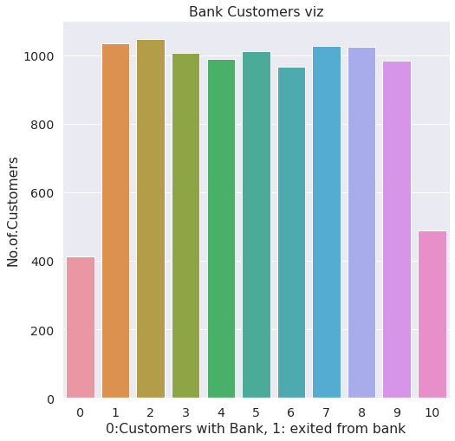

#Perform Univariate Analysis  
plt.figure(figsize=(8,8))  
sns.kdeplot(x=df['Balance'])

<matplotlib.axes._subplots.AxesSubplot at 0x7fa0c03906d0>

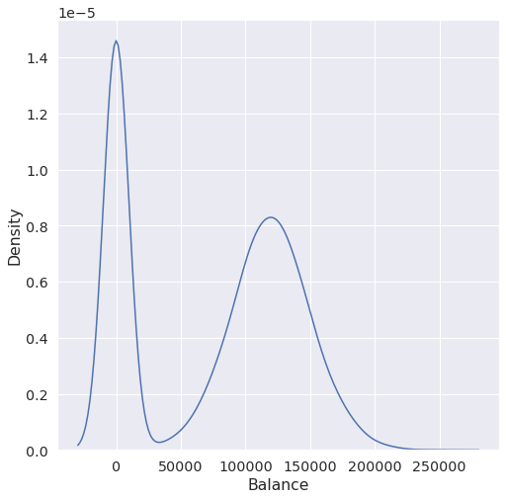

#Perform Bivariate Analysis   
plt.scatter(df.Age,df.Balance)

<matplotlib.collections.PathCollection at 0x7fa0d35a7dd0>

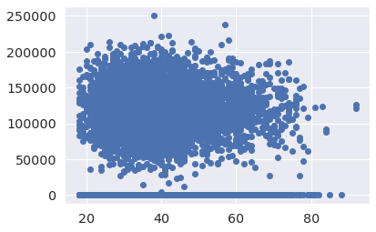

#Perform Bivariate Analysis  
df.corr()

CreditScore Gender Age Tenure Balance \  
CreditScore 1.000000 0.007888 -0.003965 0.000842 0.006268   
Gender 0.007888 1.000000 0.022812 0.003739 0.069408   
Age -0.003965 0.022812 1.000000 -0.009997 0.028308   
Tenure 0.000842 0.003739 -0.009997 1.000000 -0.012254   
Balance 0.006268 0.069408 0.028308 -0.012254 1.000000   
NumOfProducts 0.012238 0.003972 -0.030680 0.013444 -0.304180   
HasCrCard -0.005458 -0.008523 -0.011721 0.022583 -0.014858   
IsActiveMember 0.025651 0.006724 0.085472 -0.028362 -0.010084   
EstimatedSalary -0.001384 -0.001369 -0.007201 0.007784 0.012797   
Exited -0.027094 0.035943 0.285323 -0.014001 0.118533   
  
 NumOfProducts HasCrCard IsActiveMember EstimatedSalary \  
CreditScore 0.012238 -0.005458 0.025651 -0.001384   
Gender 0.003972 -0.008523 0.006724 -0.001369   
Age -0.030680 -0.011721 0.085472 -0.007201   
Tenure 0.013444 0.022583 -0.028362 0.007784   
Balance -0.304180 -0.014858 -0.010084 0.012797   
NumOfProducts 1.000000 0.003183 0.009612 0.014204   
HasCrCard 0.003183 1.000000 -0.011866 -0.009933   
IsActiveMember 0.009612 -0.011866 1.000000 -0.011421   
EstimatedSalary 0.014204 -0.009933 -0.011421 1.000000   
Exited -0.047820 -0.007138 -0.156128 0.012097   
  
 Exited   
CreditScore -0.027094   
Gender 0.035943   
Age 0.285323   
Tenure -0.014001   
Balance 0.118533   
NumOfProducts -0.047820   
HasCrCard -0.007138   
IsActiveMember -0.156128   
EstimatedSalary 0.012097   
Exited 1.000000

#Perform Bivariate Analysis  
import statsmodels.api as sm  
  
#define response variable  
y = df['CreditScore']  
  
#define explanatory variable  
x = df[['EstimatedSalary']]  
  
#add constant to predictor variables  
x = sm.add_constant(x)  
  
#fit linear regression model  
model = sm.OLS(y, x).fit()  
  
#view model summary  
print(model.summary())

OLS Regression Results   
==============================================================================  
Dep. Variable: CreditScore R-squared: 0.000  
Model: OLS Adj. R-squared: -0.000  
Method: Least Squares F-statistic: 0.01916  
Date: Sat, 24 Sep 2022 Prob (F-statistic): 0.890  
Time: 05:06:19 Log-Likelihood: -59900.  
No. Observations: 10000 AIC: 1.198e+05  
Df Residuals: 9998 BIC: 1.198e+05  
Df Model: 1   
Covariance Type: nonrobust   
===================================================================================  
 coef std err t P>|t| [0.025 0.975]  
-----------------------------------------------------------------------------------  
const 650.7617 1.940 335.407 0.000 646.958 654.565  
EstimatedSalary -2.326e-06 1.68e-05 -0.138 0.890 -3.53e-05 3.06e-05  
==============================================================================  
Omnibus: 132.939 Durbin-Watson: 2.014  
Prob(Omnibus): 0.000 Jarque-Bera (JB): 84.242  
Skew: -0.072 Prob(JB): 5.10e-19  
Kurtosis: 2.574 Cond. No. 2.32e+05  
==============================================================================  
  
Notes:  
[1] Standard Errors assume that the covariance matrix of the errors is correctly specified.  
[2] The condition number is large, 2.32e+05. This might indicate that there are  
strong multicollinearity or other numerical problems.

/usr/local/lib/python3.7/dist-packages/statsmodels/tsa/tsatools.py:142: FutureWarning: In a future version of pandas all arguments of concat except for the argument 'objs' will be keyword-only  
 x = pd.concat(x[::order], 1)

#Perform Multivariate Analysis  
plt.figure(figsize=(4,4))  
sns.pairplot(data=df[["Balance","CreditScore","EstimatedSalary","NumOfProducts","Tenure","Exited"]],hue="Exited")

<seaborn.axisgrid.PairGrid at 0x7fa0b00a1b10>

<Figure size 288x288 with 0 Axes>

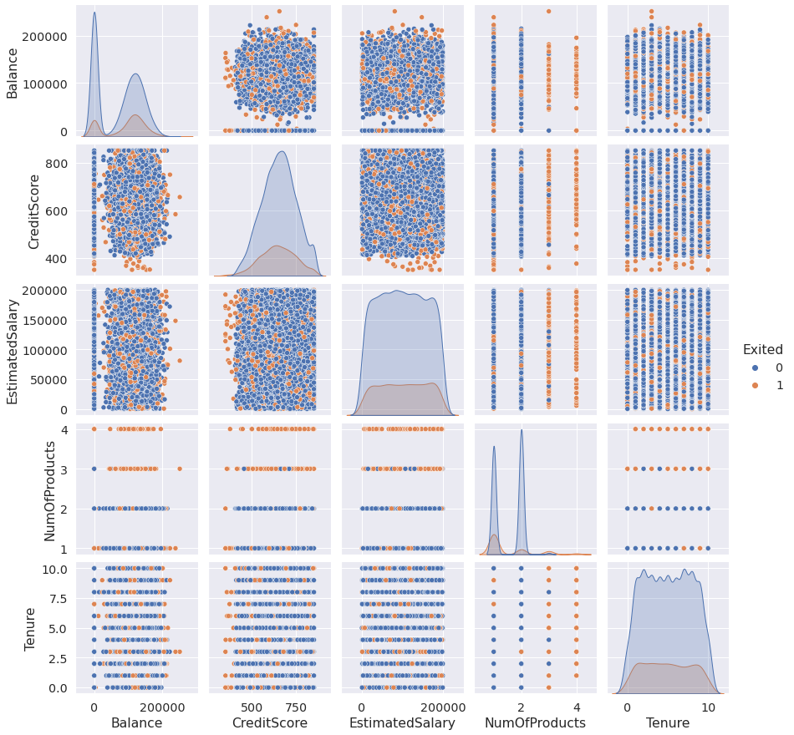

#Perform Descriptive Statistics  
df=pd.DataFrame(df)  
print(df.sum())

CreditScore 6505288  
Geography FranceSpainFranceFranceSpainSpainFranceGermany...  
Gender FemaleFemaleFemaleFemaleFemaleMaleMaleFemaleMa...  
Age 389218  
Tenure 50128  
Balance 764858892.88  
NumOfProducts 15302  
HasCrCard 7055  
IsActiveMember 5151  
EstimatedSalary 1000902398.81  
Exited 2037  
dtype: object

#Perform Descriptive Statistics  
print("----Sum Value-----")  
print(df.sum(1))  
print("----------------------------------")  
print("-----Product Value-----")  
print(df.prod())  
print("----------------------------------")

----Sum Value-----  
0 102015.88  
1 197002.44  
2 274149.37  
3 94567.63  
4 205492.92  
 ...   
9995 97088.64  
9996 159633.38  
9997 42840.58  
9998 168784.83  
9999 169159.57  
Length: 10000, dtype: float64  
----------------------------------  
-----Product Value-----  
CreditScore 0.0  
Age 0.0  
Tenure 0.0  
Balance 0.0  
NumOfProducts 0.0  
HasCrCard 0.0  
IsActiveMember 0.0  
EstimatedSalary inf  
Exited 0.0  
dtype: float64  
----------------------------------

/usr/local/lib/python3.7/dist-packages/ipykernel_launcher.py:3: FutureWarning: Dropping of nuisance columns in DataFrame reductions (with 'numeric_only=None') is deprecated; in a future version this will raise TypeError. Select only valid columns before calling the reduction.  
 This is separate from the ipykernel package so we can avoid doing imports until  
/usr/local/lib/python3.7/dist-packages/numpy/core/_methods.py:52: RuntimeWarning: overflow encountered in reduce  
 return umr_prod(a, axis, dtype, out, keepdims, initial, where)  
/usr/local/lib/python3.7/dist-packages/ipykernel_launcher.py:6: FutureWarning: Dropping of nuisance columns in DataFrame reductions (with 'numeric_only=None') is deprecated; in a future version this will raise TypeError. Select only valid columns before calling the reduction.

#Perform Descriptive Statistics  
print("----------Mean Value-----------")  
print(df.mean())  
print("-------------------------------")  
print("----------Median Value---------")  
print(df.median())  
print("-------------------------------")  
print("----------Mode Value------------")  
print(df.mode())  
print("-------------------------------")

----------Mean Value-----------  
CreditScore 650.528800  
Age 38.921800  
Tenure 5.012800  
Balance 76485.889288  
NumOfProducts 1.530200  
HasCrCard 0.705500  
IsActiveMember 0.515100  
EstimatedSalary 100090.239881  
Exited 0.203700  
dtype: float64  
-------------------------------  
----------Median Value---------  
CreditScore 652.000  
Age 37.000  
Tenure 5.000  
Balance 97198.540  
NumOfProducts 1.000  
HasCrCard 1.000  
IsActiveMember 1.000  
EstimatedSalary 100193.915  
Exited 0.000  
dtype: float64  
-------------------------------  
----------Mode Value------------  
 CreditScore Geography Gender Age Tenure Balance NumOfProducts \  
0 850 France Male 37 2 0.0 1   
  
 HasCrCard IsActiveMember EstimatedSalary Exited   
0 1 1 24924.92 0   
-------------------------------

/usr/local/lib/python3.7/dist-packages/ipykernel_launcher.py:3: FutureWarning: Dropping of nuisance columns in DataFrame reductions (with 'numeric_only=None') is deprecated; in a future version this will raise TypeError. Select only valid columns before calling the reduction.  
 This is separate from the ipykernel package so we can avoid doing imports until  
/usr/local/lib/python3.7/dist-packages/ipykernel_launcher.py:6: FutureWarning: Dropping of nuisance columns in DataFrame reductions (with 'numeric_only=None') is deprecated; in a future version this will raise TypeError. Select only valid columns before calling the reduction.

#Handling with missing Values  
df.isnull()#Checking values are null

CreditScore Geography Gender Age Tenure Balance NumOfProducts \  
0 False False False False False False False   
1 False False False False False False False   
2 False False False False False False False   
3 False False False False False False False   
4 False False False False False False False   
... ... ... ... ... ... ... ...   
9995 False False False False False False False   
9996 False False False False False False False   
9997 False False False False False False False   
9998 False False False False False False False   
9999 False False False False False False False   
  
 HasCrCard IsActiveMember EstimatedSalary Exited   
0 False False False False   
1 False False False False   
2 False False False False   
3 False False False False   
4 False False False False   
... ... ... ... ...   
9995 False False False False   
9996 False False False False   
9997 False False False False   
9998 False False False False   
9999 False False False False   
  
[10000 rows x 11 columns]

#Handling with missing Values  
df.notnull()#Checking values are not null

CreditScore Geography Gender Age Tenure Balance NumOfProducts \  
0 True True True True True True True   
1 True True True True True True True   
2 True True True True True True True   
3 True True True True True True True   
4 True True True True True True True   
... ... ... ... ... ... ... ...   
9995 True True True True True True True   
9996 True True True True True True True   
9997 True True True True True True True   
9998 True True True True True True True   
9999 True True True True True True True   
  
 HasCrCard IsActiveMember EstimatedSalary Exited   
0 True True True True   
1 True True True True   
2 True True True True   
3 True True True True   
4 True True True True   
... ... ... ... ...   
9995 True True True True   
9996 True True True True   
9997 True True True True   
9998 True True True True   
9999 True True True True   
  
[10000 rows x 11 columns]

#Find outliers & replace the outliers  
sns.boxplot(df['Balance'])

/usr/local/lib/python3.7/dist-packages/seaborn/_decorators.py:43: FutureWarning: Pass the following variable as a keyword arg: x. From version 0.12, the only valid positional argument will be `data`, and passing other arguments without an explicit keyword will result in an error or misinterpretation.  
 FutureWarning

<matplotlib.axes._subplots.AxesSubplot at 0x7fa0af6dcf90>

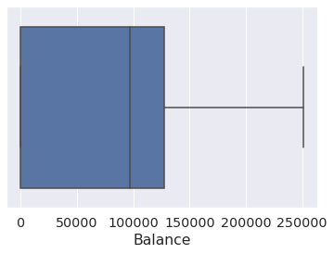

#Find outliers & replace the outliers  
print(np.where(df['Balance']>100000))

(array([ 2, 4, 5, ..., 9987, 9993, 9999]),)

#Find outliers & replace the outliers  
from scipy import stats  
import numpy as np  
   
z = np.abs(stats.zscore(df["EstimatedSalary"]))  
print(z)

0 0.021886  
1 0.216534  
2 0.240687  
3 0.108918  
4 0.365276  
 ...   
9995 0.066419  
9996 0.027988  
9997 1.008643  
9998 0.125231  
9999 1.076370  
Name: EstimatedSalary, Length: 10000, dtype: float64

#Check for categorical columns & performs encoding  
from sklearn.preprocessing import LabelEncoder  
df['Gender'].unique()

array(['Female', 'Male'], dtype=object)

#Check for categorical columns & performs encoding  
df['Gender'].value_counts()

Male 5457  
Female 4543  
Name: Gender, dtype: int64

#Check for categorical columns & performs encoding  
encoding=LabelEncoder()  
df["Gender"]=encoding.fit_transform(df.iloc[:,1].values)  
df

CreditScore Geography Gender Age Tenure Balance NumOfProducts \  
0 619 France 0 42 2 0.00 1   
1 608 Spain 2 41 1 83807.86 1   
2 502 France 0 42 8 159660.80 3   
3 699 France 0 39 1 0.00 2   
4 850 Spain 2 43 2 125510.82 1   
... ... ... ... ... ... ... ...   
9995 771 France 0 39 5 0.00 2   
9996 516 France 0 35 10 57369.61 1   
9997 709 France 0 36 7 0.00 1   
9998 772 Germany 1 42 3 75075.31 2   
9999 792 France 0 28 4 130142.79 1   
  
 HasCrCard IsActiveMember EstimatedSalary Exited   
0 1 1 101348.88 1   
1 0 1 112542.58 0   
2 1 0 113931.57 1   
3 0 0 93826.63 0   
4 1 1 79084.10 0   
... ... ... ... ...   
9995 1 0 96270.64 0   
9996 1 1 101699.77 0   
9997 0 1 42085.58 1   
9998 1 0 92888.52 1   
9999 1 0 38190.78 0   
  
[10000 rows x 11 columns]

#Check for categorical columns & performs encoding

#Split the data into Dependent & Independent Variables  
print("----------Dependent Variables----------")  
X=df.iloc[:,1:4]  
print(X)  
print("---------------------------------------")  
print("---------Independent Variables---------")  
Y=df.iloc[:,4]  
print(Y)  
print("---------------------------------------")

----------Dependent Variables-----------  
 Age Tenure Balance  
0 42 2 0.00  
1 41 1 83807.86  
2 42 8 159660.80  
3 39 1 0.00  
4 43 2 125510.82  
... ... ... ...  
9995 39 5 0.00  
9996 35 10 57369.61  
9997 36 7 0.00  
9998 42 3 75075.31  
9999 28 4 130142.79  
  
[10000 rows x 3 columns]  
---------------------------------------  
---------Independent Variables---------  
0 1  
1 1  
2 3  
3 2  
4 1  
 ..  
9995 2  
9996 1  
9997 1  
9998 2  
9999 1  
Name: NumOfProducts, Length: 10000, dtype: int64  
---------------------------------------

#Scale the independent Variables  
from sklearn.preprocessing import StandardScaler  
object= StandardScaler()  
# standardization   
scale = object.fit_transform(df)   
print(scale)

[[-0.32622142 0.29351742 -1.04175968 ... 0.97024255 0.02188649  
 1.97716468]  
 [-0.44003595 0.19816383 -1.38753759 ... 0.97024255 0.21653375  
 -0.50577476]  
 [-1.53679418 0.29351742 1.03290776 ... -1.03067011 0.2406869  
 1.97716468]  
 ...  
 [ 0.60498839 -0.27860412 0.68712986 ... 0.97024255 -1.00864308  
 1.97716468]  
 [ 1.25683526 0.29351742 -0.69598177 ... -1.03067011 -0.12523071  
 1.97716468]  
 [ 1.46377078 -1.04143285 -0.35020386 ... -1.03067011 -1.07636976  
 -0.50577476]]

#Split the data into training & testing  
from sklearn.model_selection import train_test_split

#Split the data into training & testing  
x_train, x_test, y_train, y_test = train_test_split(x, y, test_size=4,random_state=4)  
x_train

const EstimatedSalary  
2558 1.0 137903.54  
7642 1.0 121765.00  
8912 1.0 109470.34  
3319 1.0 2923.61  
6852 1.0 7312.25  
... ... ...  
456 1.0 7666.73  
6017 1.0 9085.00  
709 1.0 147794.63  
8366 1.0 102515.42  
1146 1.0 54776.64  
  
[9996 rows x 2 columns]

#Split the data into training & testing  
x_test

const EstimatedSalary  
1603 1.0 23305.85  
8713 1.0 41248.80  
4561 1.0 143317.42  
6600 1.0 174123.16

#Split the data into training & testing  
y_train

2558 727  
7642 811  
8912 623  
3319 430  
6852 600  
 ...   
456 733  
6017 487  
709 686  
8366 637  
1146 614  
Name: CreditScore, Length: 9996, dtype: int64

#Split the data into training & testing  
y_test

1603 576  
8713 786  
4561 562  
6600 505  
Name: CreditScore, dtype: int64