**CASE STUDY BOOK APPLICATION**

Project Title: BetterReads Book Application

Software Requirements:

Software required to make working of this application is,

* Java(JDK11)
* Database: MongoDB
* IDE: Spring Tool Suite4
* Testing tools: JUnit5 & Mockito Framework
* Web Server: Eureka Server and Discovery Client
* Spring Boot, Spring REST & Spring Security

Hardware Requirements:

* Processor- Core i3, Core i5
* Higher RAM-8 GB
* Hard Disk-1 TB

Synopsis:

The primary objective behind this case study is to build the microservices in Spring Boot. Developing the individual services and integrate them to form a single application is part of this case study. “Better Reads Book Application” involves a kind of management system for storing book records, fetching those and getting the desired outcome. Likewise, User Registration, adding user records and fetching all records or single record by a particular Id.

Application features:

1. Registration and Login facilities for Users.
2. Manages the users information.
3. Manages the books information.
4. Perform CRUD Operations on Book Details.
5. Perform CRUD Operations on User Details.
6. Login and Registration Validations.

User Stories:

Admin

* Login
* Add New Books
* View Books Available
* Remove Books
* View All Users or Single User by ID

Users

* Register
* Login
* View Available Books
* Add Favorite Books
* Display Books by ID

Services included in application:

* Eureka Service
* API Gateway Service
* Books Service
* Users Service

Use Case Diagram:

A visual representation of Book Application have two main use cases- Admin & User. The diagram shows the working of application in simplified form.

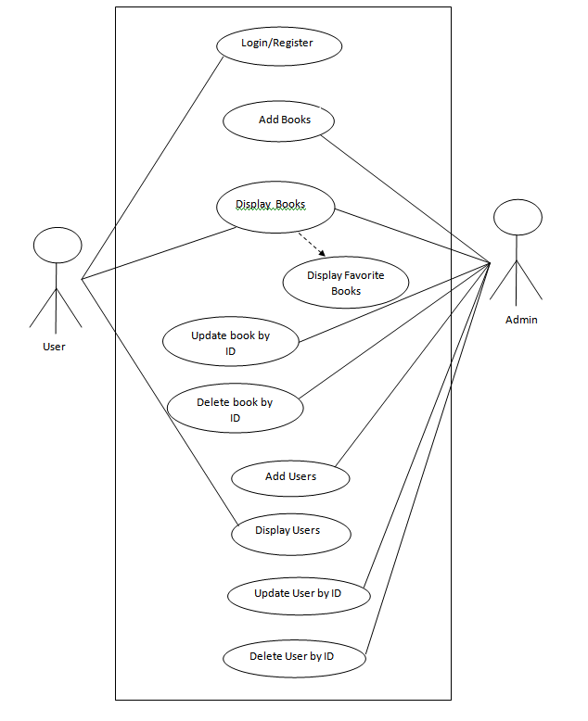Fig 1: Use Case Diagram

Project Enhancements:

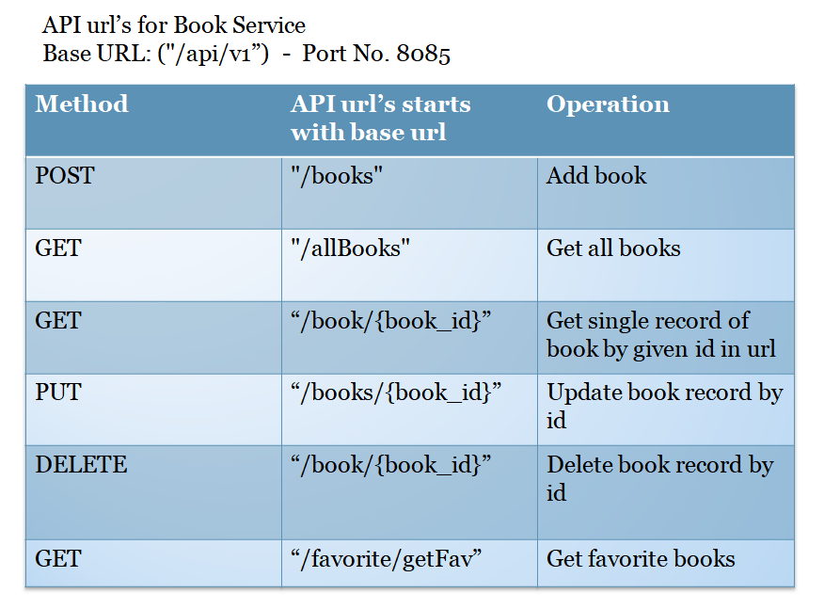

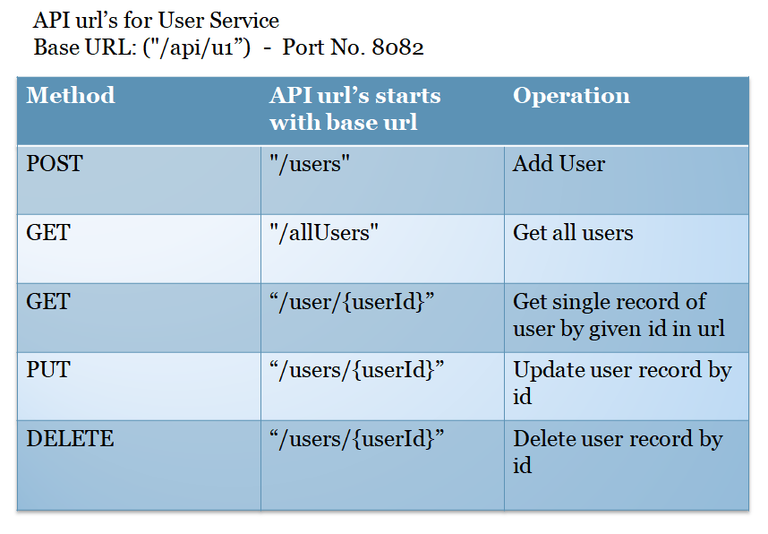

Conclusion:

Endpoints created like UserService, BookService,Eureka Service, API Gateway. Spring boot REST API is used to fetch data from these endpoints and to integrate these microservices and make communication between them , Rest Template is used.