Sentiment Analysis
IMDB Movie Reviews — NLP Text Classification
Best model: TF-IDF + Logistic Regression · 90.9% accuracy · F1 0.910
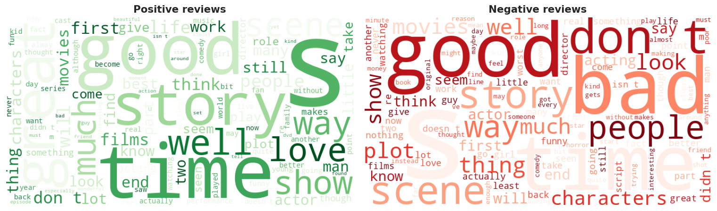
Ankit Saxena
Portfolio Project · NLP / Text Classification
Dataset: 50,000 IMDB reviews (balanced)

Table of Contents
Executive Summary 3
1. Problem Statement & Objectives 4
2. Dataset Overview 5
3. Text Cleaning 6
4. Exploratory Data Analysis 7
5. Modelling Approach 8
6. Model Comparison & Results 9
7. Error Analysis 10
8. Interactive Demo 11
9. Conclusions 12

Executive Summary
This project classifies the sentiment of movie reviews as positive or negative — a benchmark natural-language-processing task. It uses the canonical IMDB Large Movie Review dataset: 50,000 reviews, perfectly balanced between the two classes.
Headline result: after light text cleaning and a TF-IDF representation (unigrams + bigrams), a Logistic Regression classifier reaches 90.9% accuracy (F1 = 0.910, ROC-AUC = 0.970) — beating Naive Bayes, Linear SVM and an embedding neural network. This is the classic finding that a well-tuned linear model is very hard to beat on IMDB with bag-of-words features.

Key numbers
Metric | Value
Reviews (after de-dup) | 49582
Class balance | 25,000 / 25,000
Best model | TF-IDF + Logistic Regression
Accuracy | 90.9%
F1 score | 0.910
ROC-AUC | 0.970

1. Problem Statement & Objectives
Automated sentiment classification underpins review aggregation, brand monitoring, customer-feedback triage and recommendation systems. The objective is to predict, from the raw text of a review, whether the writer's sentiment is positive or negative — and to do so accurately and interpretably.
- Predictive: classify review sentiment as accurately as possible.
- Comparative: benchmark classical TF-IDF models against a deep-learning model, and understand the trade-offs.

2. Dataset Overview
The IMDB Large Movie Review dataset contains 50,000 reviews labelled positive or negative, split evenly (25,000 each). Reviews are free-form English text of widely varying length (a median of roughly 175 words), and many contain leftover HTML such as <br> line-break tags from the original web scrape.
Because the classes are perfectly balanced, plain accuracy is a meaningful headline metric, complemented here by precision, recall, F1 and ROC-AUC.

3. Text Cleaning
Reviews are normalised with a light, robust pipeline — heavy preprocessing is unnecessary because TF-IDF and the embedding layer are themselves robust:
- Strip HTML and <br> tags; lowercase the text.
- Remove non-letter characters and collapse repeated whitespace.
- Drop duplicate reviews (about 418), and map the label to 1 = positive, 0 = negative.

4. Exploratory Data Analysis
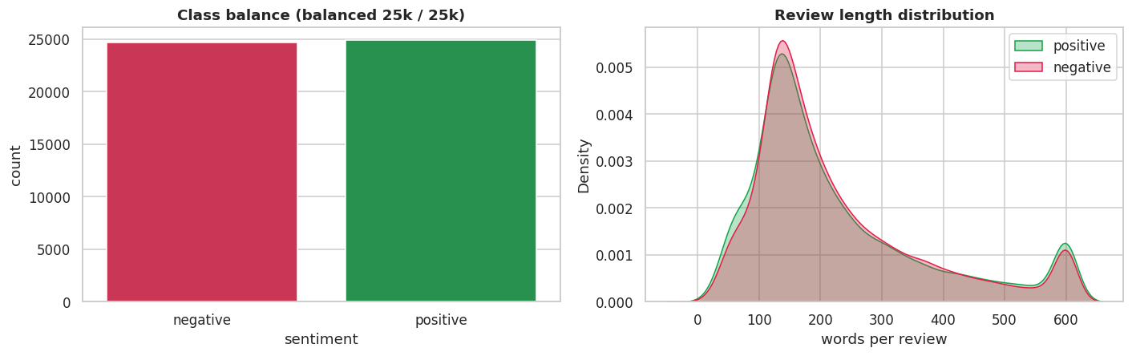
Figure 1 — The classes are perfectly balanced (left); review-length distributions barely differ by sentiment (right).
Figure 2 — Word clouds: the vocabulary that dominates positive (left) vs negative (right) reviews.
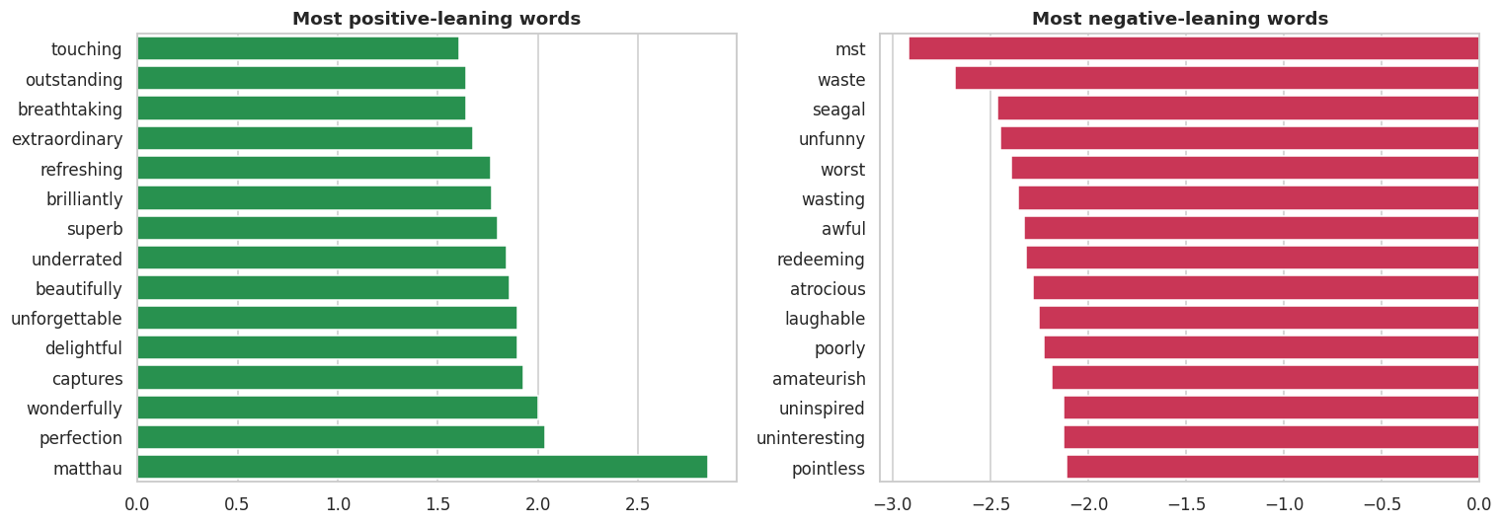
Figure 3 — Most distinctive words by sentiment (log count-ratio).
Takeaways: the data is balanced (so accuracy is informative); review length is not a useful sentiment signal; and the distinctive terms are intuitive — great, excellent, wonderful and perfect mark positive reviews, while worst, waste, awful, boring and terrible mark negative ones.

5. Modelling Approach
Every model is trained and judged on one shared, stratified 80/20 split. Two families are compared:
- Classical (TF-IDF): a TF-IDF representation with unigrams and bigrams (30,000 features) feeds Logistic Regression, a Linear SVM and Multinomial Naive Bayes.
- Deep learning: a Keras neural network with a learned word-embedding layer, global average pooling and a dense head, trained on tokenised, padded sequences.
Vectorisers are fit on the training split only (no leakage). Performance is reported as accuracy, precision, recall, F1 and ROC-AUC.

6. Model Comparison & Results
Model | Accuracy | Precision | Recall | F1 | ROC-AUC
Logistic Regression | 0.909 | 0.901 | 0.919 | 0.910 | 0.970
Linear SVM | 0.907 | 0.900 | 0.917 | 0.908 | 0.970
Neural Net (embeddings) | 0.896 | 0.894 | 0.900 | 0.897 | 0.959
Multinomial NB | 0.879 | 0.873 | 0.890 | 0.881 | 0.950
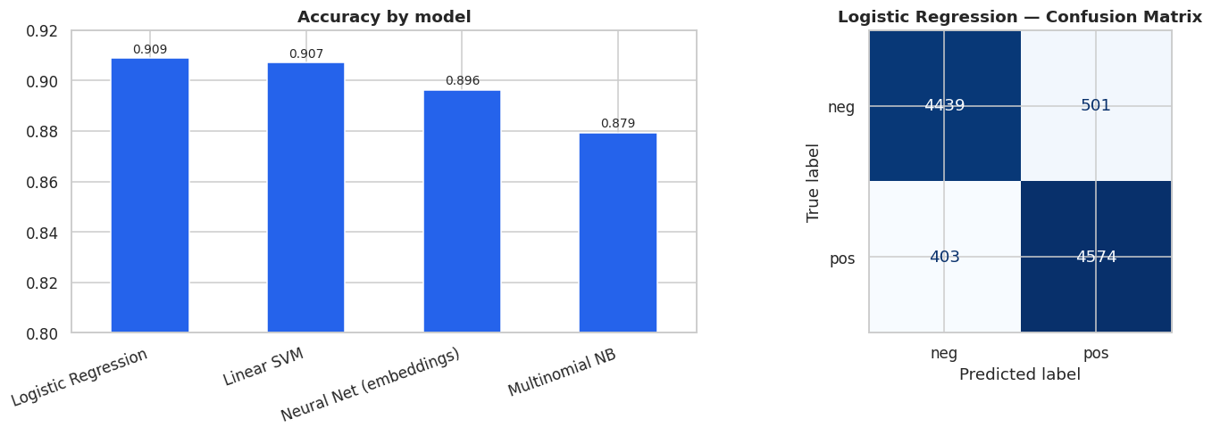
Figure 4 — Accuracy by model (left); Logistic Regression confusion matrix (right).
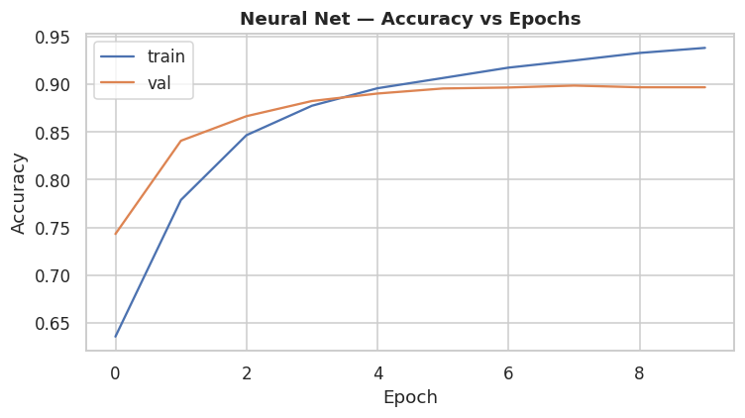
Figure 5 — Neural-network training/validation accuracy across epochs.
Logistic Regression wins. TF-IDF with a linear classifier reaches 90.9% accuracy, narrowly ahead of the Linear SVM and clearly ahead of the embedding network (89.6%) and Naive Bayes (87.9%). On IMDB, bag-of-words bigrams already capture most of the signal, and strong linear models are the standard tough baseline that deep models struggle to beat at this scale and training budget.

7. Error Analysis
Inspecting the best model's most confident mistakes is more instructive than the aggregate score. These are the reviews where the model was sure but wrong:
Mistake 1 — predicted p(positive) = 0.99, actually negative:
“when i finally had the opportunity to watch zombie zombie flesheaters in europe on an import region japanese dvd i was blown away by just how entertai…”
Mistake 2 — predicted p(positive) = 0.01, actually positive:
“comanche moon had everything going for it for starters simon wincer s back a man who s name is synonymous with high quality tv westerns unfortunately …”
Mistake 3 — predicted p(positive) = 0.01, actually positive:
“yes this a b grade horror but at least the producers directors and cast does not pretend this flick is manna from heaven the plot is corny a psychotic…”
The pattern is clear: confident errors are dominated by sarcasm, irony and mixed-sentiment reviews, where surface word counts mislead a bag-of-words model. This is the known blind spot of TF-IDF approaches and the motivation for sequence models and pretrained transformers.

8. Interactive Demo
The TF-IDF + Logistic Regression model is small, fast and well-calibrated, so it is ideal to deploy. It is serialised with joblib and served through an interactive Streamlit app: a user types or pastes a review and instantly sees a positive/negative prediction with a confidence score and a few built-in examples.
Spot checks behave exactly as expected — a glowing review scores ~0.99 positive, a scathing one ~0.00, and a genuinely mixed review lands near the decision boundary. The app runs locally with one command and deploys free on Streamlit Community Cloud (see the project's STEPS guide).

9. Conclusions
A disciplined NLP pipeline — careful cleaning, leakage-safe TF-IDF, and a fair four-model benchmark — yields a strong, interpretable sentiment classifier. Logistic Regression is the clear winner at 90.9% accuracy, and the residual errors are concentrated in sarcasm and mixed sentiment. The model is packaged behind a live demo that classifies any review on demand.
Next steps: fine-tune a pretrained transformer (e.g. DistilBERT) to push past ~92% and better handle negation and sarcasm, and add aspect-level sentiment (acting, plot, visuals) for richer feedback.

