**Heet Dobariya**  
20 Silver Street  
Chicago, 10001  
heet@email.com  
(123) 456-7890  
AutoSwift Solutions  
Founder & CEO  
March 17, 2025

**To,**  
Richard Watson  
AutoMotive LLC  
231 Mobility Park  
Los Angeles, CA 90032

**Subject:** Submission of Business Proposal for AutoSwift – Smart Vehicle Solutions

Dear Ms. Williams,

I am pleased to submit my business proposal titled **"AutoSwift: Smart Vehicle Solutions"** as part of my assignment. This proposal presents an innovative approach to revolutionizing vehicle management through smart diagnostics, AI-driven maintenance, and EV charging infrastructure. Our goal is to enhance vehicle performance, reduce environmental impact, and provide cost-effective solutions for individual owners and fleet operators.

The proposal includes a comprehensive overview of AutoSwift’s mission, product offerings, market analysis, financial projections, and implementation strategies. Additionally, I have attached all necessary appendices and financial statements to provide a complete understanding of the business model. The document adheres to the specified guidelines, with each section structured for clarity and ease of review.

I appreciate your time in reviewing this proposal and look forward to your valuable feedback. Please feel free to reach out if you require any further details or clarifications.

**Thank you for your time and consideration.**

**Sincerely,**  
Heet Dobariya  
Founder & CEO  
AutoSwift Solutions  
(123) 456-7890  
heet@email.com

Title page in pdf

**Table of Contents**

Executive Summary 2

Background and History 4

Description of Products 4

Market Description 4

Competition 5

Marketing Strategies 5

Manufacturing Plans 6

Financial Projections 6

Income Statement 7

Cash Flow Analysis 11

Balance Sheet 12

Financial Ratios 13

Contingency Plans 14

Appendices 15

# Executive Summary

AutoSwift Solutions is an innovative automotive technology company dedicated to enhancing vehicle efficiency, sustainability, and safety. In response to the growing demand for smart and eco-friendly mobility solutions, AutoSwift offers AI-powered diagnostics, predictive maintenance, and intelligent fleet management systems. By integrating advanced telematics and machine learning, the company provides real-time insights that optimize vehicle performance, reduce fuel consumption, and minimize carbon emissions. AutoSwift’s mission is to revolutionize the automotive industry by making smart vehicle management accessible, cost-effective, and environmentally responsible.

The initial product lineup includes an AI-driven vehicle health monitoring system, an automated predictive maintenance tool, and an EV charging network optimization platform. The vehicle health monitoring system continuously analyzes engine performance, tire pressure, and battery health, alerting users to potential issues before they become costly repairs. The predictive maintenance tool leverages machine learning to anticipate component failures, extending the lifespan of vehicles and improving overall reliability. Meanwhile, the EV charging optimization platform streamlines charging station accessibility and energy distribution, ensuring seamless electric vehicle operations.

Targeting individual car owners, fleet operators, and ride-sharing companies, AutoSwift addresses the increasing need for efficient and sustainable mobility solutions. With the rise of connected vehicles and the push for greener transportation, the company is positioned for rapid growth. Through strategic partnerships with automakers, service providers, and sustainability advocates, AutoSwift aims to lead the transition toward smarter, cleaner, and more efficient vehicle management, driving innovation while reducing environmental impact.

## Background and History

AutoSwift was founded by a team of automotive and technology experts with extensive experience in vehicle engineering, telematics, and AI-driven solutions. Having witnessed the inefficiencies and environmental challenges in the automotive industry, they set out to develop smarter, more sustainable mobility solutions without compromising performance or reliability. Their passion led them to innovate in predictive maintenance, intelligent fleet management, and eco-friendly vehicle optimization, gaining recognition for advancing smart transportation technologies. As the demand for connected and sustainable mobility grew, they launched AutoSwift to revolutionize vehicle management, making transportation safer, more efficient, and environmentally responsible.

## Product Offerings

AutoSwift offers a range of cutting-edge automotive solutions designed to enhance efficiency, safety, and sustainability. The product lineup includes AI-powered vehicle diagnostics, which provide real-time insights into engine health and predictive maintenance, reducing breakdowns and repair costs. The company also offers fleet management systems that optimize fuel consumption, track vehicle performance, and enhance route planning for maximum efficiency.

For eco-conscious drivers, AutoSwift introduces smart electric vehicle (EV) integration solutions, ensuring seamless charging, energy optimization, and enhanced battery life. Additionally, the company provides advanced telematics devices that offer real-time tracking, driver behaviour analysis, and accident prevention alerts. Every product is designed with innovation, reliability, and sustainability in mind, making AutoSwift a leader in intelligent automotive technology.

## Market Description

The sustainable fashion industry is rapidly expanding, projected to reach **$10 billion by 2026**, with a **9.1% CAGR** driven by increasing consumer demand and government regulations. Studies show that **80% of Gen Z consumers** prefer brands that prioritize sustainability, pushing companies to adopt eco-friendly materials and ethical production methods. Governments worldwide are enforcing stricter sustainability policies, while innovations in **recycled fabrics, vegan leather, and biodegradable textiles** are making sustainable fashion more accessible and appealing to mainstream markets.**Target Audience:**

* Young professionals who value ethical shopping.
* Fashion-conscious individuals seeking eco-friendly options.
* Environmentally aware consumers reducing their carbon footprint.

## Competition

The smart automotive industry is dominated by established brands that focus on vehicle diagnostics, fleet management, and electric vehicle integration. While these companies have built strong reputations for innovation, their premium pricing and complex solutions often make them less accessible to everyday consumers and small fleet operators. **AutoSwift** differentiates itself by offering **affordable, AI-driven vehicle solutions**, bridging the gap between high-end automotive technology and practical, cost-effective mobility solutions for individuals and businesses. Unlike competitors that primarily focus on traditional telematics, AutoSwift integrates **advanced predictive maintenance, real-time diagnostics, and AI-powered fleet optimization** to enhance vehicle efficiency and reduce operational costs. Additionally, AutoSwift ensures **full transparency in data security and system integration**, using blockchain technology to safeguard vehicle diagnostics while maintaining compliance with industry regulations. While major players dominate the market with enterprise-level solutions, their focus on large-scale operations leaves a gap for **affordable, intelligent, and user-friendly vehicle management solutions**—one that **AutoSwift aims to fill**.

## Marketing Strategies

AutoSwift’s distribution strategy will focus on a **strong digital presence**, ensuring customers can easily access its AI-driven vehicle solutions. The company’s platform will feature **real-time diagnostics and predictive maintenance tools**, helping users monitor vehicle performance seamlessly. Additionally, AutoSwift will offer **subscription-based services** for fleet operators and individual car owners, ensuring affordability and accessibility.

Beyond its digital-first approach, AutoSwift plans to **partner with auto service centers, dealerships, and EV charging networks** to expand its reach. These collaborations will allow customers to integrate AutoSwift’s smart vehicle solutions with routine maintenance and charging services, enhancing convenience and efficiency.

Marketing efforts will emphasize **influencer partnerships, digital campaigns, and industry collaborations** to build credibility and brand awareness. AutoSwift will work with **automotive experts, fleet operators, and sustainability advocates** to showcase its innovative vehicle management solutions. By prioritizing smart technology, accessibility, and sustainability, AutoSwift aims to redefine modern vehicle management.

## Manufacturing Plans

AutoSwift operates through a **tech-driven and sustainable automotive solutions framework**, ensuring efficiency, environmental responsibility, and ethical practices at every stage. The company collaborates with **trusted automotive suppliers and manufacturers** to integrate **AI-powered diagnostics, predictive maintenance, and fleet optimization technologies** that enhance vehicle performance while reducing carbon emissions. AutoSwift’s solutions prioritize **fuel efficiency, reduced downtime, and lower maintenance costs**, helping businesses and individual car owners extend vehicle lifespan sustainably. The company leverages **renewable energy sources** in its EV charging integration, promotes **low-emission transportation**, and ensures **secure, transparent data management** through blockchain technology. Beyond innovation, AutoSwift is committed to **ethical business practices**, partnering with manufacturers who uphold **global labor standards** and promote **safe working conditions**. By combining **smart vehicle technology with sustainability**, AutoSwift sets a new benchmark for the future of eco-friendly and intelligent mobility solutions.

## Financial Projections

The following pages present **financial projections**, including **income statements, cash flow analysis, balance sheets, and key financial ratios**. These projections focus on **AutoSwift's smart vehicle solutions division**, detailing expected **revenue growth, operating expenses, and overall profitability trends**. Additional financial data on **AutoSwift’s initial investment and operational costs** is available upon request.

# AutoSwift LLC

## Pro Forma Income Statement January 2025 - December 2025

|  |  |  |  |
| --- | --- | --- | --- |
| Net Sales | $320,000.00 |  |  |
| Less: Cost of Goods Sold Gross Income | $182,000.00 | $58,450.00 |
| Operating Expenses Labor | $12,000.00 |  |
| Utilities | $3,000.00 |  |
| Insurance | $2,400.00 |  |
| Sales Promotion | $12,000.00 |  |
| Delivery and Transportation | $6,000.00 |  |
| W3Miscellaneous Total Expenses | $1,500.00 | $36,900.00 |
| Net Income Before Taxes |  | $21,550.00 |
| Less: Income Taxes |  | $6,465.00 |
| Net Income After Taxes |  |  | $15,085.00 |
| Assumptions: |  |  |  |

1. Net sales based on price of $2.29 per unit,

24,000 units sold in Antlers 2,000 units per month 36,000 units sold in Hugo 3,000 units per month 45,000 units sold in Oklahoma City 9,000 units per month for 5

months

Sales estimates based on 5% market share for prepared whipped topping in each market.

1. Cost of goods sold includes ingredients, packaging materials, labels, and co- packing expenses for canned product.
2. No salary will be drawn by the owners/managers in the first year. All profits will be re-invested for new market entry and increased production.

AutoSwift LLC

Pro Forma Cash Flow Statement January 2025 - December 2025

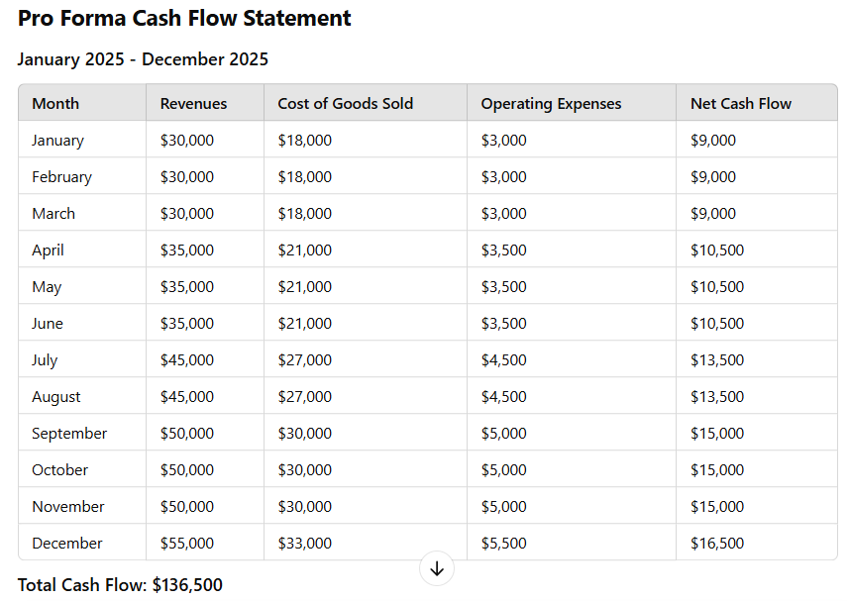

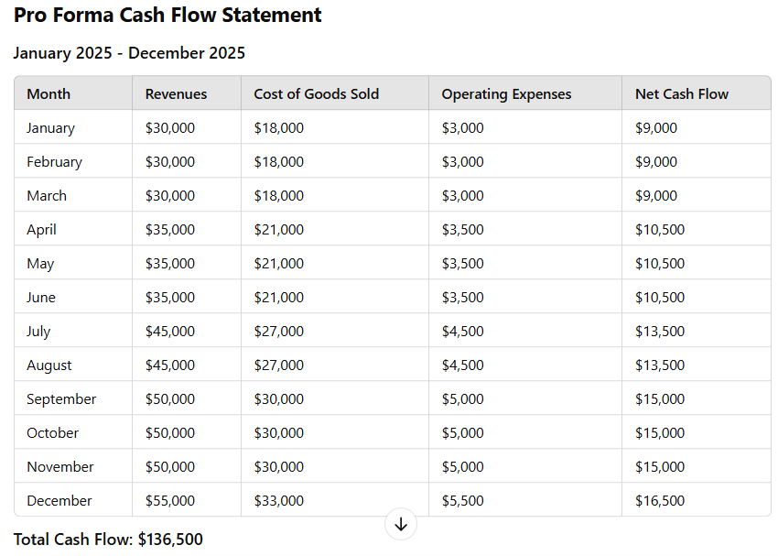

# AutoSwift LLC

# Pro Forma Balance Sheet

December 31, 2024

|  |  |  |  |
| --- | --- | --- | --- |
| Current Assets |  | | |
|  |  | | |
| Cash | $7,054.00 | |  |
| Accounts Receivable | $60,484.00 | |  |
| Inventory | $80,042.00 | |  |
| Pre-Paid Expenses | $1,046.00 | |  |
| Total Current Assets |  | | $148,626.00 |
| Fixed Assets |  | |  |
| Building | $100,500.00 |  |  |
| Equipment | $40,950.00 |  |  |
| Gross Fixed Assets |  | $141,450.00 |  |
| Less Accumulated Depreciation |  | $16,900.00 |  |
| Net Fixed Assets |  |  | $124,550.00 |
| **Total Assets** |  |  | **$273,176.00** |
| LIABILITIES AND OWNERS EQUITY |  |  |  |
| Liabilities |  |  |  |
| Current Liabiliities |  |  |  |
| Accounts Payable | $51,343.00 |  |  |
| Accrued Payables | $3,060.00 |  |  |
| Total Current Liabilities |  | $54,408.00 |  |
| Long Term Liabilities |  |  |  |
| Mortgage Payable | $20,708.00 | |  |
| **Total Liabilities** |  | | **$75,116.00** |
| **Owner's Equity** |  | | **$198,060.00** |
| **Total Liabilities and Owner's Equity** |  | | **$273,176.00** |

# AutoSwift LLC

## Financial Ratios December 31, 2024

|  |  |  |  |  |  |  |
| --- | --- | --- | --- | --- | --- | --- |
| Return on Equity | **=** | Net Profit before Taxes | **=** | $21,550.00 | **=** | 10.88% |
|  |  | Net Equity |  | $198,060.00 |  |  |
| Current Ratio | **=** | Current Assets | **=** | $148,626.00 | **=** | 2.73 |
|  |  | Current Liabilities |  | $54,408.00 |  |  |
| Quick Ratio | **=** | Curr. Assets - Inventory | **=** | $68,584.00 | **=** | 1.26 |
|  |  | Current Liabilities |  | $54,408.00 |  |  |
| Debt to Equity | **=** | Total Liabilities | **=** | $75,116.00 | **=** | 0.38 |
|  |  | Net Equity |  | $198,060.00 |  |  |

## 

## Contingency Plans

While AutoSwift has a strong strategic foundation, potential risks could impact its growth. To address these challenges, the company has developed a proactive response plan:

1. **Supply Chain Disruptions:** AutoSwift will diversify suppliers and establish local alternatives to maintain stability. If disruptions persist, nearshore manufacturing will be explored.
2. **Market Competition:** To stand out, AutoSwift will focus on exclusive product features and data-driven marketing. If differentiation efforts fall short, partnerships with industry influencers and expansion of unique offerings will be prioritized.
3. **Regulatory Challenges:** Compliance with automotive and sustainability regulations is a priority. Regular audits and third-party certifications will ensure adherence. In case of compliance issues, legal experts will help adjust policies and operations.
4. **Sales Performance:** If sales underperform, AutoSwift will refine marketing strategies, enhance product lines, and explore new sales channels, including dealership partnerships and direct-to-consumer initiatives, to boost growth.

**APPENDIX**

**Supporting Documents**

1. **Management Hierarchy** – AutoSwift’s leadership, engineering, production, sales, and support team structure.
2. **Processing Flowchart** – Overview of manufacturing and distribution from raw materials to delivery.
3. **Letters of Intent** – Dealership and fleet management interest in AutoSwift vehicles.
4. **Marketing Materials** – Samples of digital campaigns, partnerships, and brand promotions.
5. **Certifications** – ISO 9001, ISO 14001, DOT, EU safety, and emissions compliance.
6. **Training Records** – Employee and supplier training on sustainability and safety.

These documents reinforce AutoSwift’s commitment to innovation, quality, and sustainability.