**EXPERIMENT-7,8**

**TITLE:** Nested sql queries or Subquries

**Objective:** To understand the use **SQL Subquery**

**1.Create the following two tables (EMP and DEPT)**

**EMP TABLE**

EMPNO ENAME JOB MGR HIREDATE SAL COMM DEPTNO

---------- ---------- --------- ---------- --------- ---------- ---------- ----------

7369 SMITH CLERK 7902 17-DEC-80 500 800 20

7499 ALLEN SALESMAN 7698 20-FEB-81 1600 300 30

7521 WARD SALESMAN 7698 22-FEB-81 1250 500 30

7566 JONES MANAGER 7839 02-APR-81 2975 20

7654 MARTIN SALESMAN 7698 28-SEP-81 1250 1400 30

7698 BLAKE MANAGER 7839 01-MAY-81 2850 30

7782 CLARK MANAGER 7839 09-JUN-81 2450 10

7788 SCOTT ANALYST 7566 09-DEC-82 3000 20

7839 KING PRESIDENT 17-NOV-81 5000 10

7844 TURNER SALESMAN 7698 08-SEP-81 1500 0 30

7876 ADAMS CLERK 7788 12-JAN-83 1100 20

7900 JAMES CLERK 7698 03-DEC-81 950 30

7902 FORD ANALYST 7566 03-DEC-81 3000 20

7934 MILLER CLERK 7782 23-JAN-82 1300 10

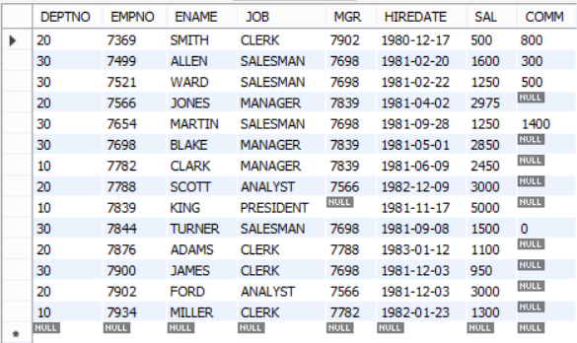

**DEPT TABLE**

DEPTNO DNAME LOC

---------- -------------- -------------

10 ACCOUNTING NEW YORK

20 RESEARCH DALLAS

30 SALES CHICAGO

40 OPERATIONS BOSTON

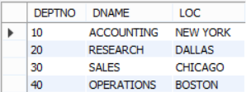

Write the Nested Queries for the following queries.

1. List the details of the emps whose Salaries more than the employee BLAKE.

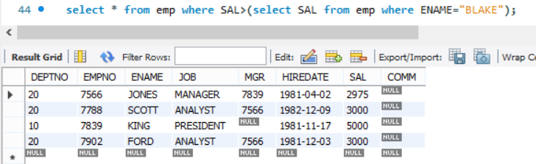

1. List the emps whose Jobs are same as ALLEN.

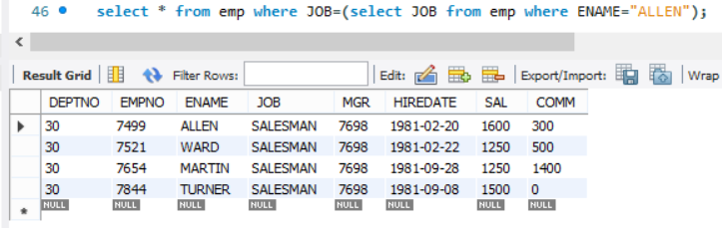

1. List the Emps whose Sal is same as FORD or SMITH in desc order of Names.

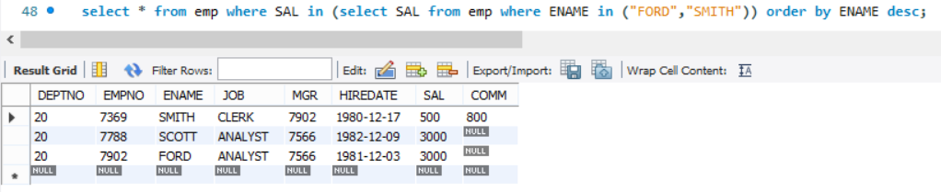

1. List the emps Whose Jobs are same as MILLER or Sal is more than ALLEN.

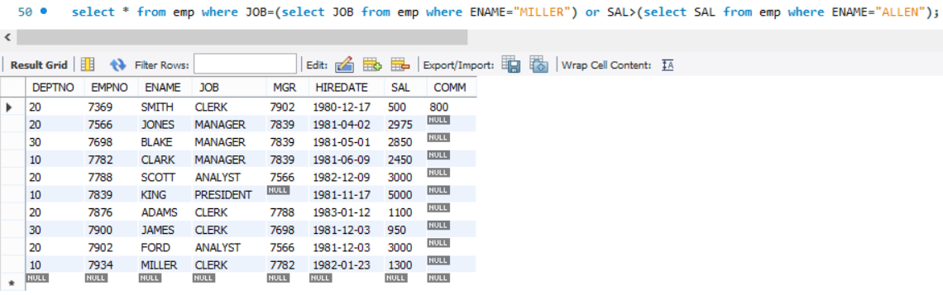

1. Find the highest paid employee of sales department.

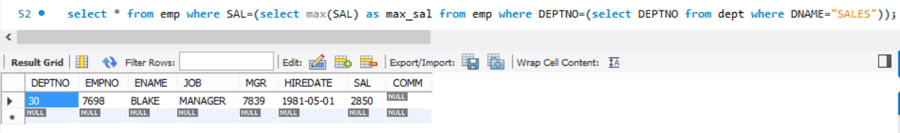

1. List the employees who are senior to most recently hired employee working under king.

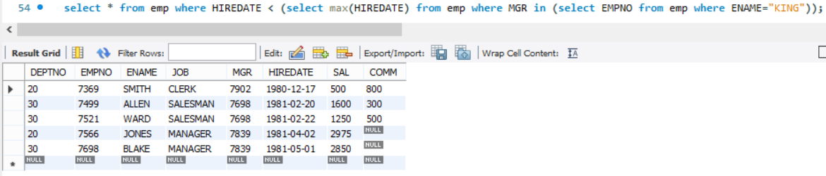

1. List the names of the emps who are getting the highest sal dept wise.

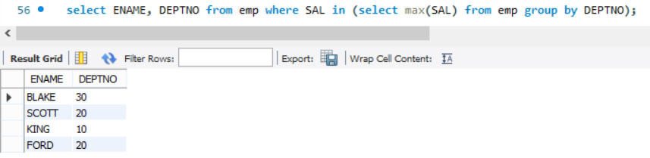

1. List the emps whose sal is equal to the average of max and minimum

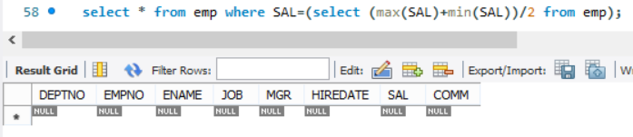

1. List the emps who joined in the company on the same date.

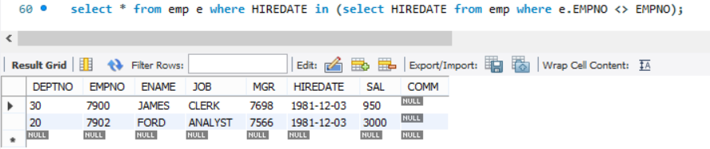

1. Find out the emps who joined in the company before their Managers.

