GENESIS
Emergent social organisation in survival-only learning agents
Problem Definition Report
What we study, why it matters, and how success is judged

Course | Design Experience I (Semester IV), VIP vertical
Institute | MPSTME, NMIMS (Vertically Integrated Projects vertical)
Domain | Artificial Intelligence & Data Systems
Team | Heet Ranpura (Sem V), Advik Divekar (Sem V)
Faculty mentor | [to fill]
Repository | github.com/HeetRanpura/Genesis
Version / date | 1.0, 27 October 2026

1. Summary
Problem in one paragraph
When many AI agents share a world, do they develop social organisation (grouping, sharing, signalling, division of labour) on their own, or only when their designers reward it? Most multi-agent reinforcement-learning studies put a social term into the reward, so the answer is built in. GENESIS removes every social term: each agent is rewarded only for keeping its own body near a healthy set-point. We build the world, the learners and the measurement tools needed to see what social structure, if any, appears, and in what order.
This report fixes the problem statement, research questions, scope, constraints and success criteria for the VIP project. The project sits in the VIP domain Artificial Intelligence & Data Systems.

2. Background and motivation

2.1 Cooperation is usually specified, not discovered
Influential multi-agent RL work studies cooperation by changing the reward: shared team rewards, inequity-averse utilities [Hughes2018], rewards for influencing others [Jaques2019], or communication objectives [Foerster2016; Lazaridou2017]. These designs are useful for engineering cooperative systems, but they cannot tell us whether cooperation would emerge without being asked for. Sequential social dilemmas [Leibo2017; Perolat2017] come closest to selfish rewards, but their environments are built around a specific dilemma.

2.2 Why the question matters beyond the lab
- Multi-agent AI deployments. Autonomous agents (trading systems, fleets of robots, LLM-based assistants acting on the web) increasingly share environments. Knowing which collective behaviours appear without being designed in is a safety question: emergent coordination can be beneficial or harmful.
- Computational social science. Agent-based models such as Sugarscape [Epstein1996] show that simple rules can produce social patterns. Learning agents let us ask the same question without hand-writing the rules.
- Origins of human social organisation. Human prehistory shows a broad order of social innovations. A testbed where social structure must emerge from survival pressure allows careful structural analogies (never claims of equivalence) with that record.
- Methodology. Deep RL results are fragile across seeds and reporting choices [Henderson2018; Agarwal2021]. A testbed with preregistration [Nosek2018], held-out worlds and baselines in every comparison is itself a contribution.
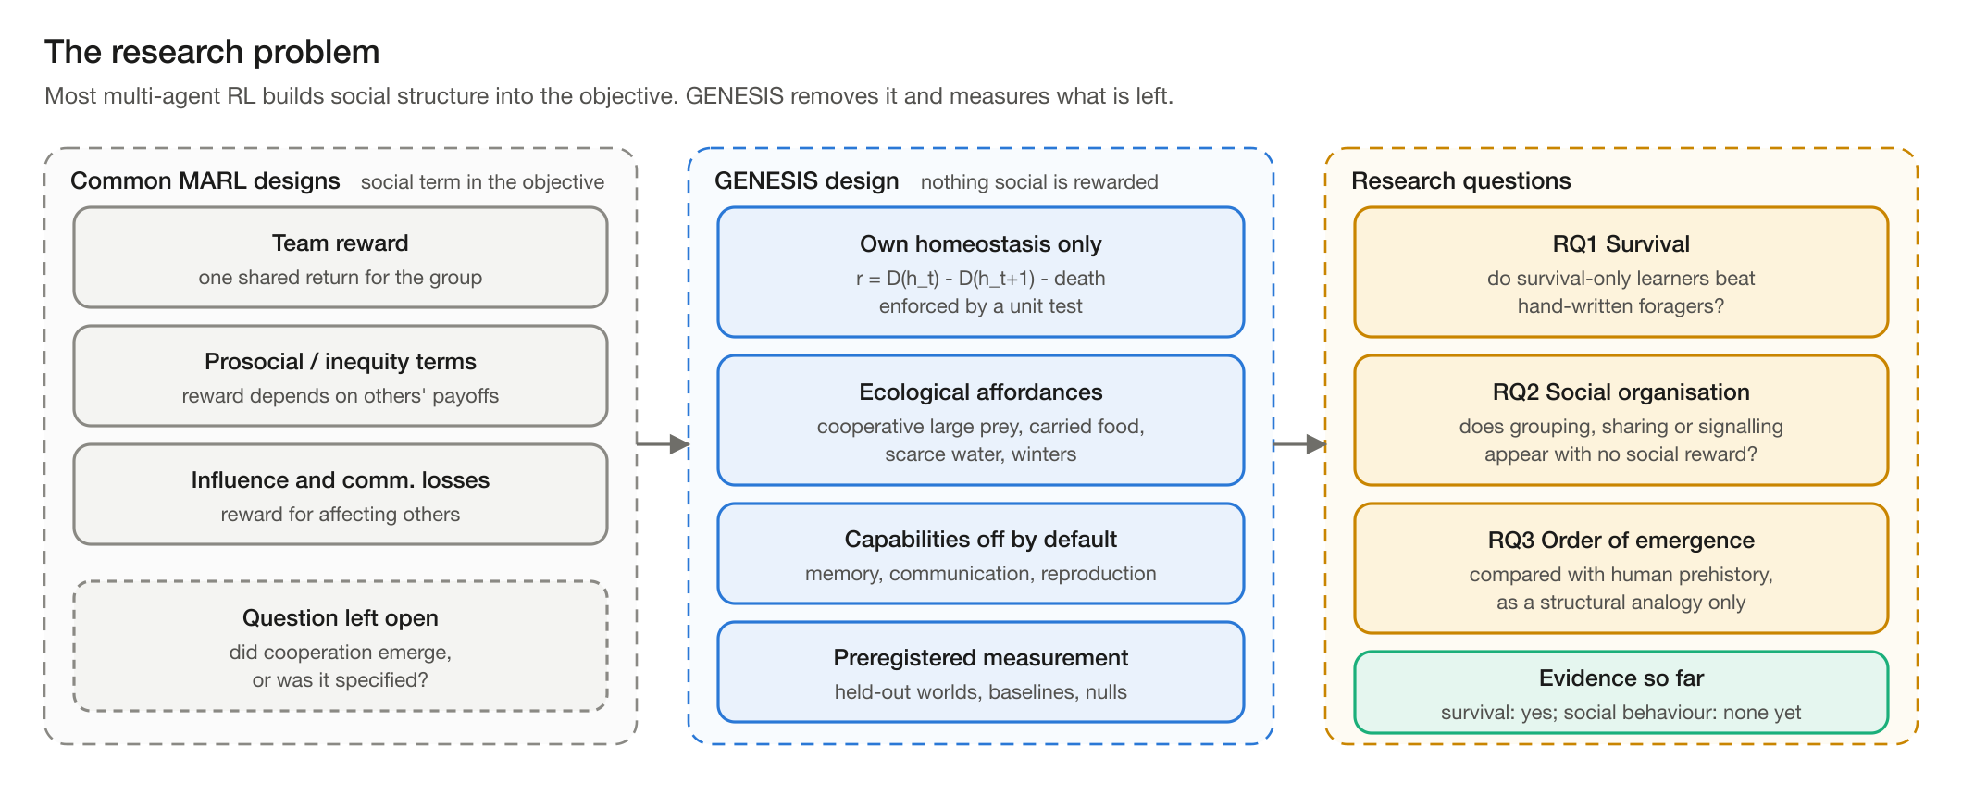
Figure 1. The research problem: common designs specify social structure in the objective; GENESIS removes it and measures what remains.

3. Problem statement
Design, build and validate a reproducible artificial-life testbed in which a population of learning agents, rewarded only for their own homeostasis, lives in a seeded, seasonal foraging ecology; and use it to measure, against baselines and null models, whether and how social organisation emerges.

4. Research questions and hypotheses
ID | Question | How it is answered
RQ1 | Do survival-only learners outlive hand-written foragers? | Deaths per agent-year on held-out worlds 0-4 vs random, greedy and heuristic baselines (H1, H2).
RQ2 | Does memory change behaviour where resources leave view? | GRU vs memoryless ablation: thirst deaths and all-cause mortality (H3).
RQ3 | Does any social organisation appear without social reward? | Group hunts, food transfer, aggregation against habitat and place-preference nulls, social-blinding ablation (H4, H7).
RQ4 | If structure appears, in what order, and under which capabilities? | Capability switches (communication, reproduction, social learning) and a cited human timeline used as structural analogy (Stages 3-4, Semester VI).
Hypotheses are preregistered in docs/PREREGISTRATION.md with dated entries, written before the runs that test them; corrections are appended, never edited in place.

5. Objectives
Semester | Objective | Measure of done
IV | Define the problem, survey literature and tools, fix the concept and team roles | This report; literature survey; concept report; team charter; concept presentation
V | Build the engine, learners, recorder and viewer; test and validate them | >= 100k env steps/min with observations at 1,000 agents; bit-identical seeded runs; held-out evaluation; CI
V | Answer RQ1-RQ2 with replication | Preregistered 3-seed experiment (H2/H3) with decision rules applied
VI | Measure social structure (RQ3-RQ4), integrate, publish | Stage 3 metrics with synthetic-data tests; arXiv preprint; final demonstration

6. Scope and constraints

6.1 In scope
- A procedurally generated 256 x 256 island with terrain, rivers, lakes, vegetation, three animal species, weather, seasons, fire and floods.
- Agents with egocentric, occluded vision and a four-variable body (energy, hydration, health, warmth).
- Parameter-shared PPO learners with and without memory; three non-learning baselines.
- Flight recording of every agent at every tick, exact replay, statistical analysis, a live 3-D viewer.

6.2 Out of scope
- Any reward term that depends on other agents (forbidden by design, enforced by a unit test).
- Scripted agent behaviour (animals are scripted because they are the environment; agents never are).
- Claims that agents have feelings or human-like minds; human comparisons are structural analogies only.
- Large-cluster training: everything must run on student laptops.

6.3 Hard rules (non-negotiable)
- Reward = own homeostasis only, plus a death penalty.
- Every capability (memory, communication, reproduction, social learning, ...) is a configuration switch, off by default.
- Every run is seeded and reproducible; randomness inside the engine comes only from a counter-based hash RNG.
- No scripted agent behaviour.
- Baselines appear in every comparison; negative results are logged, never dropped.

6.4 Resource constraints
Resource | Constraint | Consequence for the design
Compute | Two laptops: MacBook Air M4 (fanless, 16 GB) and MacBook Pro M3 Pro (18 GB); no CUDA GPU | Numba-compiled CPU engine; PyTorch on Apple-silicon GPU (MPS); one shared network for all agents
Heat | The Air throttles 15-30% under sustained load | Long runs on the M3 Pro; benchmarks compared only as interleaved A/B runs
Disk | ~10-15 GB free on the Air | Recording can be thinned (1 rollout in k) and stops automatically below a free-space threshold
Time | Course semesters; two members | Staged plan with acceptance criteria per stage; handoff documents between sessions

7. Stakeholders
Stakeholder | Interest
Faculty mentor / VIP evaluators | Technical depth, rigour, documentation, teamwork
MARL and artificial-life researchers | A testbed where social behaviour is measured, not specified; reusable engine and protocol
AI-safety community | Evidence on which collective behaviours appear without being designed in
Future VIP members (Sem IV juniors) | A documented codebase, study guide (TEACHER.md) and onboarding path

8. Success criteria
- Engineering: >= 100k environment steps per minute including observations at 1,000 agents on a laptop; bit-identical results for the same seed; every world rule unit-tested.
- Science: every claim made on held-out worlds against all three baselines, with bootstrap confidence intervals and effect sizes, under preregistered decision rules.
- Honesty: emergence is never claimed without measurement against a null model; negative results are reported.
- Team: documented handoffs, reviewed pull requests, a test suite that runs on every change.

9. Ethical considerations
- No human participants or personal data are involved.
- Comparisons with human prehistory are framed as structural analogies and cite their sources.
- Language about agents avoids anthropomorphism: value estimates and probe results are functional correlates, never feelings.
- Compute is kept small (laptops); experiment scale is stated next to every claim.

References
[Agarwal2021] R. Agarwal, M. Schwarzer, P. S. Castro, A. Courville, M. G. Bellemare. Deep reinforcement learning at the edge of the statistical precipice. NeurIPS 2021 (outstanding paper). arXiv:2108.13264.
[Epstein1996] J. M. Epstein, R. Axtell. Growing Artificial Societies: Social Science from the Bottom Up. MIT Press, 1996.
[Foerster2016] J. N. Foerster, Y. M. Assael, N. de Freitas, S. Whiteson. Learning to communicate with deep multi-agent reinforcement learning. NeurIPS 2016.
[Henderson2018] P. Henderson, R. Islam, P. Bachman, J. Pineau, D. Precup, D. Meger. Deep reinforcement learning that matters. AAAI 2018, 32(1):3207-3214.
[Hughes2018] E. Hughes, J. Z. Leibo, et al. Inequity aversion improves cooperation in intertemporal social dilemmas. NeurIPS 2018 (NeurIPS 31), 3326-3336.
[Jaques2019] N. Jaques, A. Lazaridou, E. Hughes, C. Gulcehre, P. Ortega, D. Strouse, J. Z. Leibo, N. de Freitas. Social influence as intrinsic motivation for multi-agent deep reinforcement learning. ICML 2019, PMLR 97:3040-3049.
[Lazaridou2017] A. Lazaridou, A. Peysakhovich, M. Baroni. Multi-agent cooperation and the emergence of (natural) language. ICLR 2017.
[Leibo2017] J. Z. Leibo, V. Zambaldi, M. Lanctot, J. Marecki, T. Graepel. Multi-agent reinforcement learning in sequential social dilemmas. AAMAS 2017, 464-473. arXiv:1702.03037.
[Nosek2018] B. A. Nosek, C. R. Ebersole, A. C. DeHaven, D. T. Mellor. The preregistration revolution. PNAS 115(11):2600-2606, 2018. doi:10.1073/pnas.1708274114.
[Perolat2017] J. Pérolat, J. Z. Leibo, V. Zambaldi, C. Beattie, K. Tuyls, T. Graepel. A multi-agent reinforcement learning model of common-pool resource appropriation. NeurIPS 2017 (NIPS 30), 3644-3653.

