GENESIS
Emergent social organisation in survival-only learning agents
Literature Review & Technology Survey
Prior work, the gap GENESIS fills, and the tools chosen

Course | Design Experience I (Semester IV), VIP vertical
Institute | MPSTME, NMIMS (Vertically Integrated Projects vertical)
Domain | Artificial Intelligence & Data Systems
Team | Heet Ranpura (Sem V), Advik Divekar (Sem V)
Faculty mentor | [to fill]
Repository | github.com/HeetRanpura/Genesis
Version / date | 1.0, 27 October 2026

1. Method
We surveyed work on (a) artificial life and agent-based societies, (b) social dilemmas and cooperation in multi-agent RL, (c) emergent communication, (d) open-ended multi-agent environments, (e) social and cultural learning, (f) homeostatic reward, and (g) methodology for RL experiments. Sources were found through NeurIPS, ICML, ICLR, AAMAS, eLife and Nature-family journals, arXiv, and the reference lists of key papers.
Verification policy
Every reference below was checked online on 27 October 2026 against the publisher, proceedings or arXiv record (authors, title, venue, year, and volume/pages where listed). Details that could not be confirmed were removed rather than guessed; the reference table marks each entry's status. An earlier draft of the project paper had 24 references written from memory; this list supersedes it.

2. Themes in the literature

2.1 Artificial life and agent-based societies
PolyWorld [Yaeger1994] combined genetics, metabolism, Hebbian neural networks and vision in one artificial ecology and reported emergent "species" with distinct survival strategies, including flocking and foraging. Sugarscape [Epstein1996] showed that hand-written agent rules on a resource landscape produce trade, migration and inequality. Both establish the value of growing societies from the bottom up; neither uses modern deep RL, and Sugarscape's behaviour is written by the modeller.

2.2 Social dilemmas in multi-agent RL
Leibo et al. [Leibo2017] introduced sequential social dilemmas (Gathering, Wolfpack), in which independent deep Q-learners with selfish rewards show cooperation or conflict depending on resource scarcity. Pérolat et al. [Perolat2017] used the same approach to model common-pool resource appropriation, linking exclusion, sustainability and inequality. Later work added social terms to the reward to increase cooperation: inequity aversion [Hughes2018] and causal social influence [Jaques2019]. Melting Pot [Leibo2021] turned many such scenarios into an evaluation suite focused on generalisation to new co-players.

2.3 Emergent communication
Foerster et al. [Foerster2016] and Lazaridou et al. [Lazaridou2017] showed agents can learn communication protocols when a shared objective rewards successful coordination. Lowe et al. [Lowe2019] warned that common metrics can report "communication" where messages have no effect on behaviour, which motivates GENESIS's insistence on causal and null-model checks before any claim.

2.4 Open-ended multi-agent environments
Hide-and-seek [Baker2020] produced tool use through an autocurriculum, under team rewards. Neural MMO [Suarez2019] provides a persistent world with many agents competing for resources; it found that larger populations push agents to fill different niches. Crafter [Hafner2022] benchmarks a spectrum of survival skills for a single agent. Johanson et al. [Johanson2022] observed emergent bartering in a market-like environment.

2.5 Social and cultural learning
Ndousse et al. [Ndousse2021] found that independent RL agents usually fail to learn from experts unless the environment and an auxiliary loss support it. Bhoopchand et al. [Bhoopchand2023] demonstrated few-shot imitation as cultural transmission in 3-D worlds. Duéñez-Guzmán et al. [Duenez2023] argue that a social path is needed for human-like AI. These works show what social learning can look like and what support it needs, which GENESIS will test as switchable capabilities.

2.6 Homeostatic reward
Keramati and Gutkin [Keramati2014] define reward as the reduction of deviation from a physiological set-point and prove that maximising it is equivalent to maintaining homeostasis. GENESIS adopts this definition directly: r_t = D(h_t) - D(h_{t+1}) minus a death penalty, with D the distance below the set-point. Silver et al. [Silver2021] argue that reward maximisation may suffice for intelligence in general; GENESIS tests a narrow, measurable version of that claim for social behaviour.

2.7 LLM-based social simulation
Generative agents [Park2023] simulate believable social life with large language models. Their social behaviour comes from language models trained on human text and from prompts, so it is supplied rather than learned from survival pressure; GENESIS is the opposite end of this spectrum.

2.8 Methodology for RL experiments
Henderson et al. [Henderson2018] showed that seeds, implementations and reporting choices can change deep RL conclusions. Agarwal et al. [Agarwal2021] showed point estimates over few runs mislead, and recommend interval estimates. Nosek et al. [Nosek2018] argue for preregistration to separate confirmatory tests from exploration. GENESIS applies all three: multiple training seeds as the unit of replication, bootstrap intervals and effect sizes, and dated preregistration.

2.9 Algorithms used
Learners use proximal policy optimisation [Schulman2017] with generalised advantage estimation [Schulman2016] and a GRU recurrent core [Cho2014]. Survival is analysed with Kaplan-Meier estimates [Kaplan1958], bootstrap intervals [Efron1993] and Hedges' g [Hedges1981].

3. Comparison and gap
Work | Reward / objective | Environment | What GENESIS takes / changes
PolyWorld (1994), Sugarscape (1996) | Evolution / hand-written rules | Rich ecology | Takes the ecological richness; replaces scripted rules with RL
Sequential social dilemmas (2017) | Selfish | Small dilemma games | Takes selfish reward; removes the built-in dilemma framing
Inequity aversion (2018), social influence (2019) | Social term added | Dilemma games | Forbids social terms by rule and test
Emergent communication (2016-2017) | Shared objective | Referential games | Communication only as a switch; causal + null checks
Hide-and-seek (2020) | Team reward | Physics sandbox | No teams; individual survival only
Neural MMO (2019) | Survival-like | Persistent MMO world | Adds seasons, physiology, cooperative prey; preregistered tests
Crafter (2022) | Achievements | Survival, single agent | Many agents; social measurement
Generative agents (2023) | LLM prompts | Sims-like town | No language prior; behaviour must be learned
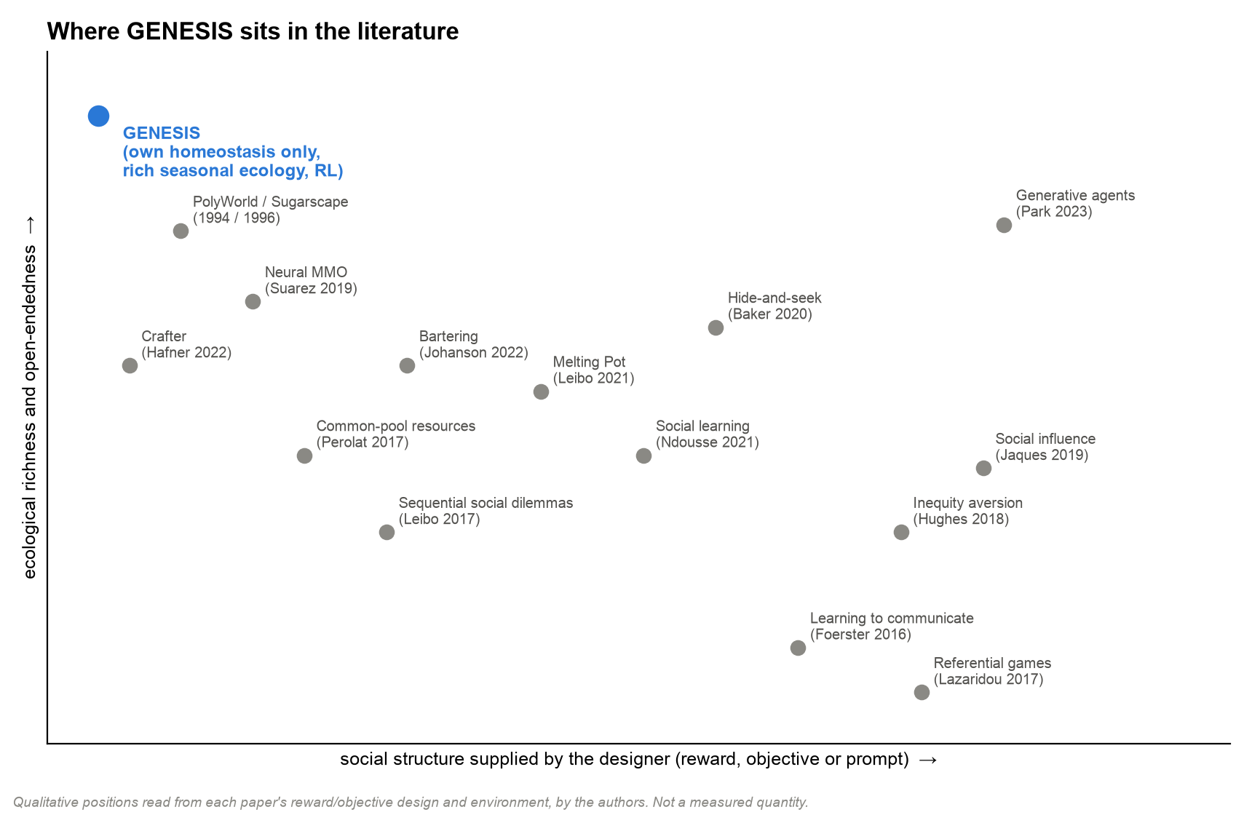
Figure 1. Qualitative positioning of prior work by how much social structure the designer supplies and how rich the ecology is (the authors' reading, not a measurement).
Gap
No surveyed system combines (1) learning agents whose reward is strictly their own physiology, (2) an ecology rich enough that cooperation, sharing and grouping could pay (large prey needing two hunters, carried food, scarce water, winters), (3) capabilities that can be switched on one at a time, and (4) a preregistered measurement protocol with baselines and null models. GENESIS is designed to fill that gap.

4. Technology survey
Each decision below was scored by the team on the criteria that mattered for this project (scores 1-5, weights in brackets). Scores are team judgements recorded at decision time; the measured outcome is noted where one exists.

4.1 Simulation engine
Option | Laptop speed, no CUDA (0.35) | Determinism control (0.25) | Dev speed (0.2) | Ecosystem (0.2) | Weighted
Numba (chosen) | 5 | 5 | 4 | 4 | 4.6
JAX | 3 (no CUDA here) | 4 | 3 | 4 | 3.5
Pure NumPy | 2 | 5 | 5 | 4 | 3.8
Unity ML-Agents [Juliani2018] | 3 | 2 | 3 | 5 | 3.2
C++ engine + bindings | 5 | 5 | 1 | 2 | 3.7
Outcome: the fused Numba tick reaches about 112,000 environment steps per minute with observations at 1,000 agents on the MacBook Air M4 (Stage 1.1 benchmark), above the 100k target. Numba [Lam2015] compiles Python functions to machine code and supports multi-core loops.

4.2 Learning framework
Option | Apple GPU (0.35) | Recurrent PPO support (0.25) | Team familiarity (0.2) | Debuggability (0.2) | Weighted
PyTorch on MPS (chosen) [Paszke2019] | 4 | 5 | 5 | 5 | 4.65
JAX / Flax | 2 | 4 | 2 | 3 | 2.75
TensorFlow | 3 | 3 | 2 | 3 | 2.8
Outcome: CPU inference was measured about 13x slower than MPS for the shared network, so training uses MPS while sampling stays on a seeded CPU generator for reproducibility.

4.3 Environment API
The batched slot-based API serves the learner; a PettingZoo ParallelEnv wrapper [Terry2021] makes the world usable by standard multi-agent libraries and is checked by PettingZoo's API test. Gymnasium [Towers2024] conventions are followed for observation and action spaces.

4.4 Live viewer
Option | 3-D diorama look (0.3) | No build step (0.25) | Frame rate at 1,000 agents (0.25) | Effort (0.2) | Weighted
three.js (chosen) | 5 | 5 | 4 | 4 | 4.55
PixiJS (original plan, 2-D) | 2 | 4 | 5 | 4 | 3.65
Unity WebGL | 5 | 1 | 4 | 2 | 3.15
Outcome: the three.js viewer was measured at 85-115 fps with 256 agents and 75-90 fps with 1,000 agents at 1600x900 (M3 Pro, headless Chromium). The original plan named PixiJS; the change to three.js was a recorded decision on 26 October 2026.

4.5 Supporting tools
Need | Tool | Why
Environment management | uv + Python 3.11 venv | Fast, reproducible installs (make setup)
Testing | pytest, pytest-cov, GitHub Actions | 59 tests on every change; coverage report
Statistics | NumPy/SciPy: bootstrap, Kaplan-Meier, Hedges' g | Matches the preregistered protocol
Paper | LaTeX via Tectonic | Single-binary build of the preprint
Diagrams | Hand-built SVG (checked label fit), Graphviz, matplotlib | Reproducible figures from code

5. References
Key | Reference | Check
Agarwal2021 | R. Agarwal, M. Schwarzer, P. S. Castro, A. Courville, M. G. Bellemare. Deep reinforcement learning at the edge of the statistical precipice. NeurIPS 2021 (outstanding paper). arXiv:2108.13264. | verified
Baker2020 | B. Baker, I. Kanitscheider, T. Markov, Y. Wu, G. Powell, B. McGrew, I. Mordatch. Emergent tool use from multi-agent autocurricula. ICLR 2020. | classic
Barnes2014 | R. Barnes, C. Lehman, D. Mulla. Priority-Flood: an optimal depression-filling and watershed-labeling algorithm for digital elevation models. Computers & Geosciences, 2014. arXiv:1511.04463. | verified (pages not confirmed)
Bhoopchand2023 | A. Bhoopchand et al. Learning few-shot imitation as cultural transmission. Nature Communications 14, 7536 (2023). doi:10.1038/s41467-023-42875-2. | verified
Cho2014 | K. Cho, B. van Merriënboer, C. Gulcehre, D. Bahdanau, F. Bougares, H. Schwenk, Y. Bengio. Learning phrase representations using RNN encoder-decoder for statistical machine translation. EMNLP 2014. | classic
Duenez2023 | E. A. Duéñez-Guzmán, S. Sadedin, J. X. Wang, K. R. McKee, J. Z. Leibo. A social path to human-like artificial intelligence. Nature Machine Intelligence, 2023. doi:10.1038/s42256-023-00754-x. | verified (volume/pages not confirmed)
Efron1993 | B. Efron, R. J. Tibshirani. An Introduction to the Bootstrap. Chapman & Hall, 1993. | classic
Epstein1996 | J. M. Epstein, R. Axtell. Growing Artificial Societies: Social Science from the Bottom Up. MIT Press, 1996. | classic
Foerster2016 | J. N. Foerster, Y. M. Assael, N. de Freitas, S. Whiteson. Learning to communicate with deep multi-agent reinforcement learning. NeurIPS 2016. | classic
Hafner2022 | D. Hafner. Benchmarking the spectrum of agent capabilities (Crafter). ICLR 2022. arXiv:2109.06780. | verified
Hedges1981 | L. V. Hedges. Distribution theory for Glass's estimator of effect size and related estimators. Journal of Educational Statistics 6(2):107-128, 1981. | classic
Henderson2018 | P. Henderson, R. Islam, P. Bachman, J. Pineau, D. Precup, D. Meger. Deep reinforcement learning that matters. AAAI 2018, 32(1):3207-3214. | verified
Hughes2018 | E. Hughes, J. Z. Leibo, et al. Inequity aversion improves cooperation in intertemporal social dilemmas. NeurIPS 2018 (NeurIPS 31), 3326-3336. | verified
Jaques2019 | N. Jaques, A. Lazaridou, E. Hughes, C. Gulcehre, P. Ortega, D. Strouse, J. Z. Leibo, N. de Freitas. Social influence as intrinsic motivation for multi-agent deep reinforcement learning. ICML 2019, PMLR 97:3040-3049. | verified
Johanson2022 | M. B. Johanson, E. Hughes, F. Timbers, J. Z. Leibo. Emergent bartering behaviour in multi-agent reinforcement learning. arXiv:2205.06760, 2022. | classic
Juliani2018 | A. Juliani et al. Unity: a general platform for intelligent agents. arXiv:1809.02627, 2018. | verified
Kaplan1958 | E. L. Kaplan, P. Meier. Nonparametric estimation from incomplete observations. Journal of the American Statistical Association 53(282):457-481, 1958. | classic
Keramati2014 | M. Keramati, B. Gutkin. Homeostatic reinforcement learning for integrating reward collection and physiological stability. eLife 3:e04811, 2014. doi:10.7554/eLife.04811. | verified
Lam2015 | S. K. Lam, A. Pitrou, S. Seibert. Numba: a LLVM-based Python JIT compiler. Workshop at SC15, 2015. | verified (workshop name not confirmed)
Lazaridou2017 | A. Lazaridou, A. Peysakhovich, M. Baroni. Multi-agent cooperation and the emergence of (natural) language. ICLR 2017. | classic
Leibo2017 | J. Z. Leibo, V. Zambaldi, M. Lanctot, J. Marecki, T. Graepel. Multi-agent reinforcement learning in sequential social dilemmas. AAMAS 2017, 464-473. arXiv:1702.03037. | verified
Leibo2021 | J. Z. Leibo, E. Duéñez-Guzmán, A. S. Vezhnevets, et al. Scalable evaluation of multi-agent reinforcement learning with Melting Pot. ICML 2021, PMLR 139:6187-6199. | verified
Lowe2019 | R. Lowe, J. Foerster, Y.-L. Boureau, J. Pineau, Y. Dauphin. On the pitfalls of measuring emergent communication. AAMAS 2019, 693-701. arXiv:1903.05168. | verified
Ndousse2021 | K. Ndousse, D. Eck, S. Levine, N. Jaques. Emergent social learning via multi-agent reinforcement learning. ICML 2021, PMLR 139:7991-8004. | verified
Nosek2018 | B. A. Nosek, C. R. Ebersole, A. C. DeHaven, D. T. Mellor. The preregistration revolution. PNAS 115(11):2600-2606, 2018. doi:10.1073/pnas.1708274114. | verified
Park2023 | J. S. Park, J. C. O'Brien, C. J. Cai, M. R. Morris, P. Liang, M. S. Bernstein. Generative agents: interactive simulacra of human behavior. UIST 2023. doi:10.1145/3586183.3606763. | verified
Paszke2019 | A. Paszke et al. PyTorch: an imperative style, high-performance deep learning library. NeurIPS 2019. arXiv:1912.01703. | verified
Perolat2017 | J. Pérolat, J. Z. Leibo, V. Zambaldi, C. Beattie, K. Tuyls, T. Graepel. A multi-agent reinforcement learning model of common-pool resource appropriation. NeurIPS 2017 (NIPS 30), 3644-3653. | verified
Schulman2016 | J. Schulman, P. Moritz, S. Levine, M. Jordan, P. Abbeel. High-dimensional continuous control using generalized advantage estimation. ICLR 2016. | classic
Schulman2017 | J. Schulman, F. Wolski, P. Dhariwal, A. Radford, O. Klimov. Proximal policy optimization algorithms. arXiv:1707.06347, 2017. | classic
Silver2021 | D. Silver, S. Singh, D. Precup, R. S. Sutton. Reward is enough. Artificial Intelligence, 2021. | verified (volume not confirmed)
Suarez2019 | J. Suarez, Y. Du, P. Isola, I. Mordatch. Neural MMO: a massively multiagent game environment for training and evaluating intelligent agents. arXiv:1903.00784, 2019. | verified
Terry2021 | J. K. Terry et al. PettingZoo: Gym for multi-agent reinforcement learning. NeurIPS 2021 (NeurIPS 34), 15032-15043. | verified
Towers2024 | M. Towers et al. Gymnasium: a standard interface for reinforcement learning environments. arXiv:2407.17032 (NeurIPS 2025 Datasets and Benchmarks). | verified
Yaeger1994 | L. Yaeger. Computational genetics, physiology, metabolism, neural systems, learning, vision, and behavior or PolyWorld: life in a new context. In C. Langton (ed.), Artificial Life III, SFI Studies in the Sciences of Complexity XVII, Addison-Wesley, 263-298, 1994. | verified
"verified": confirmed online on 27 October 2026. "classic": widely cited work whose details the team is confident of; re-check page numbers before any submission.

