GENESIS
Emergent social organisation in survival-only learning agents
Initial System Concept & Feasibility
Subsystems, interfaces, key decisions and whether it fits on two laptops

Course | Design Experience I (Semester IV), VIP vertical
Institute | MPSTME, NMIMS (Vertically Integrated Projects vertical)
Domain | Artificial Intelligence & Data Systems
Team | Heet Ranpura (Sem V), Advik Divekar (Sem V)
Faculty mentor | [to fill]
Repository | github.com/HeetRanpura/Genesis
Version / date | 1.0, 27 October 2026

1. Concept overview
GENESIS is one seeded simulator, a set of interchangeable policies (baselines or learners), and a recorder that captures every agent at every tick. Analysis reads the recordings; it never feeds back into reward. A live viewer shows any run in 3-D.
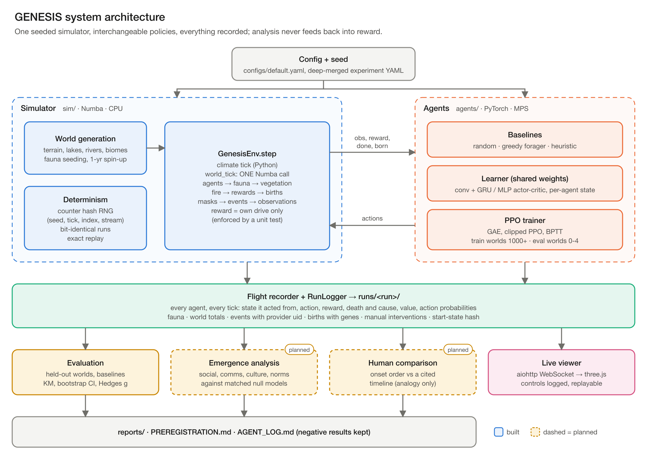
Figure 1. System architecture (diagram by Advik Divekar, from the project's preprint).

2. Subsystems and interfaces
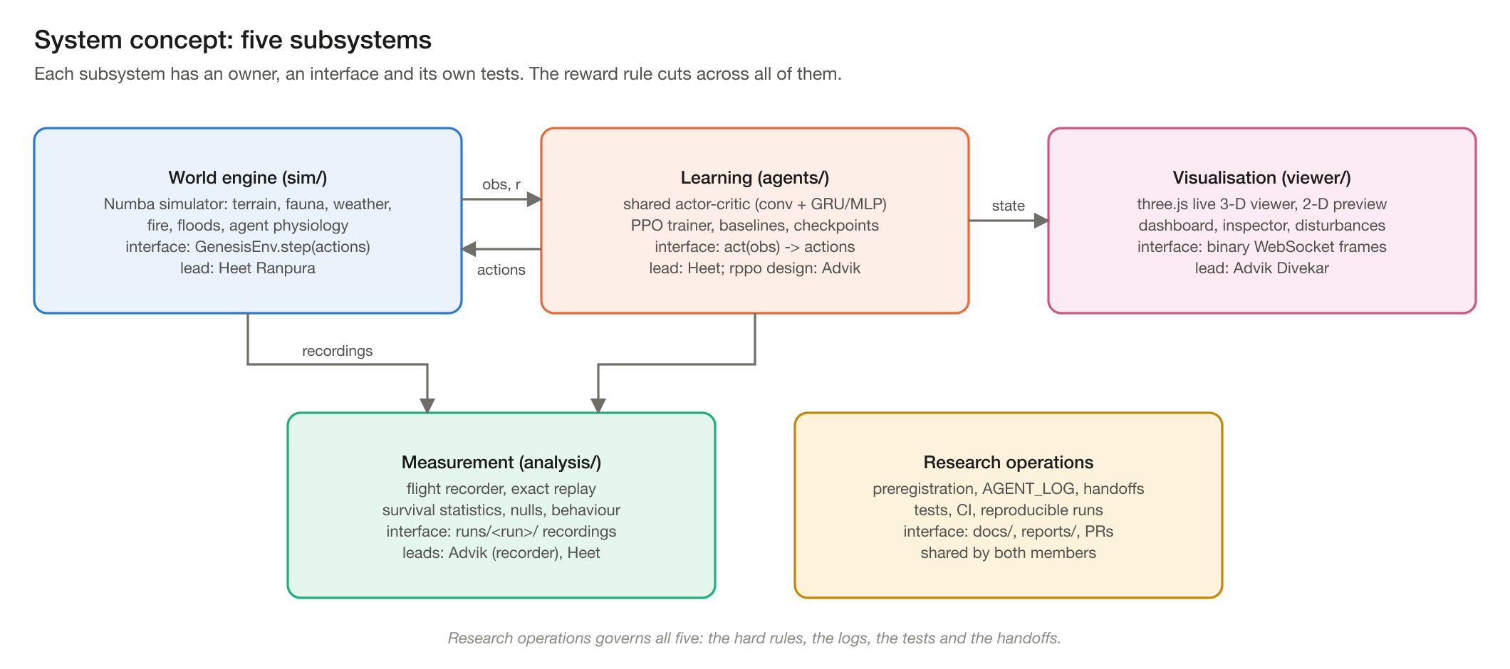
Figure 2. Five subsystems with owners and interfaces.
Subsystem | Responsibility | Interface | Verified by
World engine (sim/) | World generation, ecology, physiology, observations | GenesisEnv.step(actions) -> obs, reward, died, info | World-rule unit tests, determinism tests, benchmark
Learning (agents/) | Shared actor-critic, PPO trainer, baselines | PolicyAgent.act(obs, alive), checkpoint format 2 | Learner tests: determinism, unroll = stepwise, round-trip
Measurement (analysis/, experiments/) | Recording, replay, survival statistics, behaviour | runs/<run>/ (manifest, metrics, events, trajectory) | Replay is bit-exact; preregistered protocol
Visualisation (viewer/) | Live 3-D view, dashboard, disturbance tools | Binary WebSocket frames; logged controls | Server smoke test; measured frame rate
Research operations | Rules, preregistration, logs, handoffs, CI | docs/, logs/, HANDOFF*.md, pull requests | Review checklist; CI

3. The world and the agent
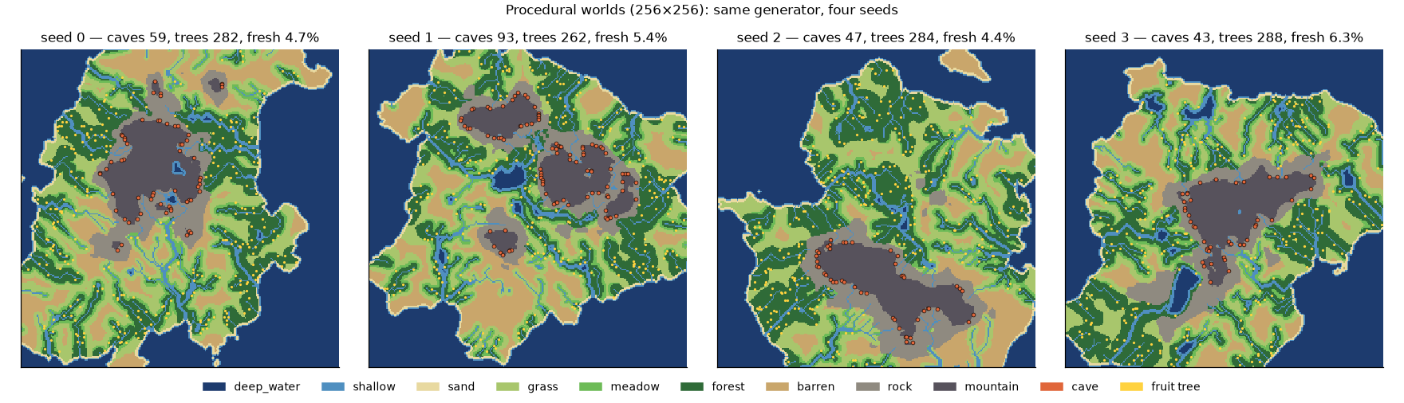
Figure 3. Procedurally generated islands for several seeds (Stage 1 evidence).
- World: 256 x 256 cells; elevation from fractal noise; lakes by priority-flood [Barnes2014]; rivers by flow accumulation; ten terrain classes. The ocean is salt water, so fresh water is spatially scarce.
- Ecology: plants with seasonal regrowth, fruiting trees, small prey, large prey that need two or more simultaneous attackers, and predators. Fauna are limited by food, not by caps.
- Climate: day/night, four seasons, a weather Markov chain (rain, fog), droughts, cold snaps, famines, wildfires and floods.
- Agent body: energy, hydration, health and warmth. Eleven actions: wait, move (4), rest, eat, drink, hunt, pick up, drop.
- Perception: an 11 x 11 egocentric, occluded view with 16 channels, plus 13 body signals and nearby-agent features.
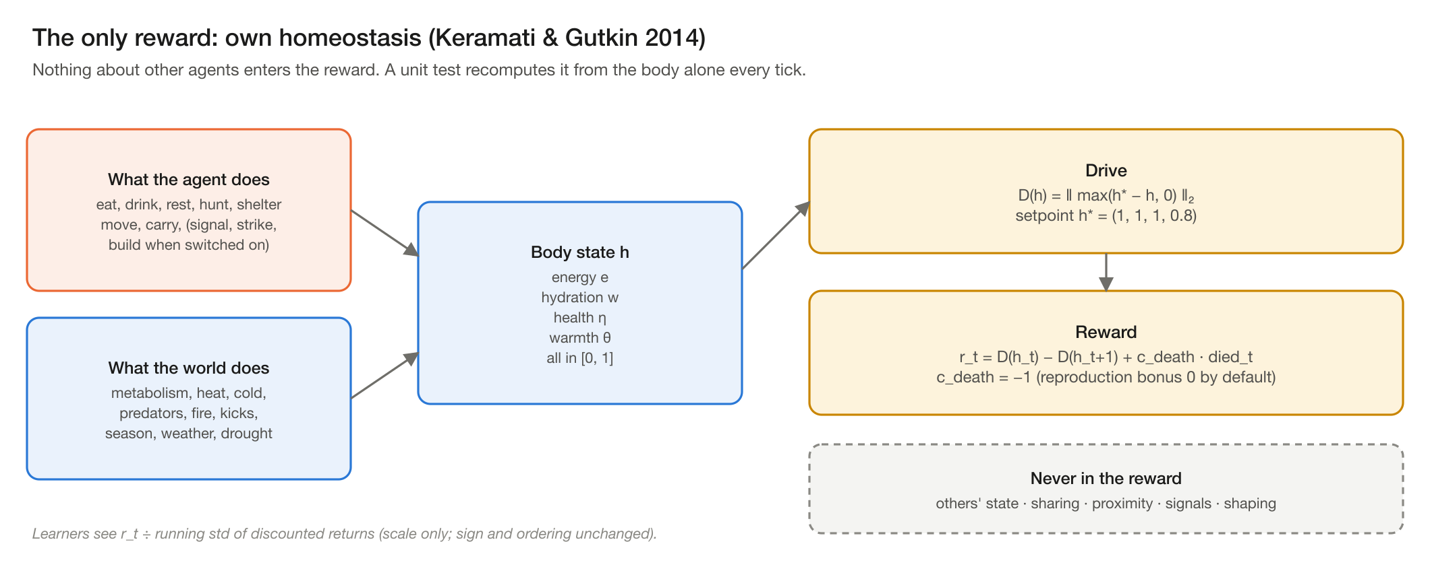
Figure 4. Homeostatic reward: the agent is paid for reducing its own distance below the set-point (diagram by Advik Divekar).

4. Key design decisions
Decision | Alternatives considered | Reason
Shared network for all agents, per-agent memory | Independent networks per agent | 1,000 independent networks do not fit in 16-18 GB; sharing is standard and keeps learning stable. Independent learners remain an ablation.
Counter-based hash RNG (seed, tick, index, stream) | Global NumPy RNG | Results identical regardless of thread count and order of evaluation
One fused Numba call per tick | Separate kernels called from Python | Each extra Python-side dispatch costs ~5-10 us; fusing reached the throughput target
Large prey need >= 2 attackers | Single-agent hunting only | Creates a stag-hunt affordance: cooperation can pay, but is never rewarded directly
Held-out test worlds 0-4; training worlds 1000+ | Evaluate on training worlds | Separates learning from memorising a map

5. Feasibility
Question | Estimate or measurement | Verdict
Can the world run fast enough? | Measured 112k env steps/min with observations at 1,000 agents (MacBook Air M4) | Feasible
Can agents learn on a laptop? | 20M agent-steps of PPO in 1.0-1.7 h on the Air with two runs sharing it; about 50 min on the M3 Pro | Feasible for 20-100M steps
Can we keep all the data? | Full recording costs ~63 MB per simulated year at 256 agents; thinning to 1 rollout in 20 keeps a 100M-step run near 0.5 GB | Feasible with thinning
Can we show it live? | 75-90 fps at 1,000 agents in the browser (M3 Pro) | Feasible
Can results be trusted? | Seeded, bit-identical runs; baselines reproduce bit-for-bit across both machines | Feasible
Main risks at concept stage
Learners might never discover cooperative strategies such as group hunting (the most likely negative result). The testbed is still valuable if it measures that absence rigorously, so the plan treats it as a reportable outcome, not a failure.
Compute and heat on fanless laptops; mitigated by moving long runs to the M3 Pro and thinning recordings.

6. From concept to plan
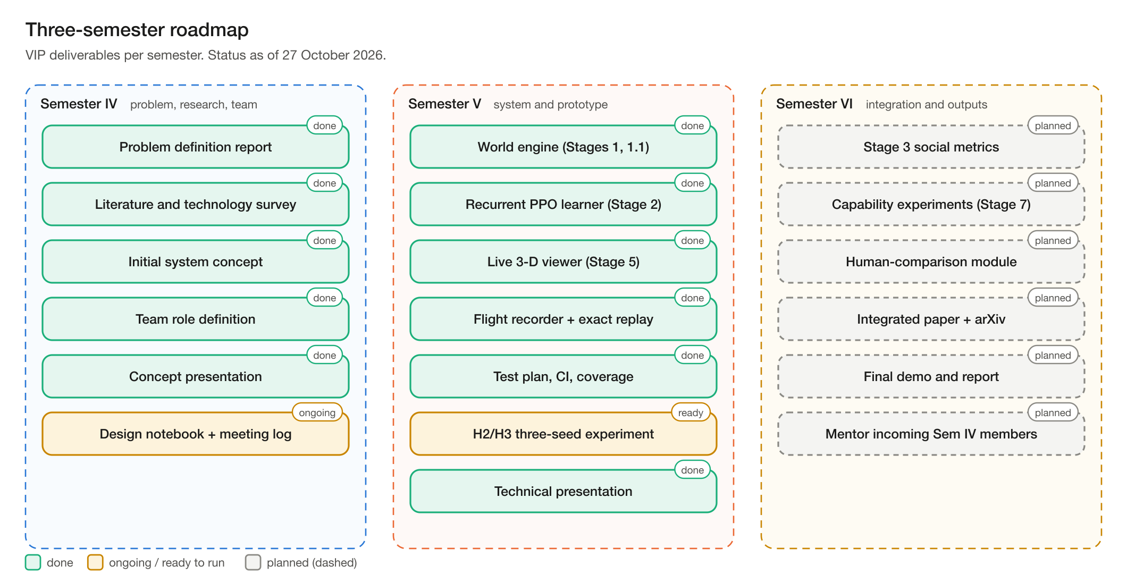
Figure 5. Three-semester roadmap with current status.

References
[Barnes2014] R. Barnes, C. Lehman, D. Mulla. Priority-Flood: an optimal depression-filling and watershed-labeling algorithm for digital elevation models. Computers & Geosciences, 2014. arXiv:1511.04463.

