GENESIS
Emergent social organisation in survival-only learning agents
Team Role Definition & Working Agreement
Who does what, how we collaborate, and how the team grows vertically

Course | Design Experience I (Semester IV), VIP vertical
Institute | MPSTME, NMIMS (Vertically Integrated Projects vertical)
Domain | Artificial Intelligence & Data Systems
Team | Heet Ranpura (Sem V), Advik Divekar (Sem V)
Faculty mentor | [to fill]
Repository | github.com/HeetRanpura/Genesis
Version / date | 1.0, 27 October 2026

1. Team
Fill before submission
Faculty mentor, any Semester VI or Semester IV members, and meeting dates are not recorded in the repository. They are marked [to fill]. Do not invent them: add only real names and real meetings.
Member | Semester / level | Role | Primary responsibilities
[Faculty mentor, to fill] | Faculty | Mentor | Research guidance, milestone reviews, connections to labs and venues
Heet Ranpura | Sem V (mid-level) | Engine & learning lead; integrator | World engine, PPO learner, experiments, statistics, paper; reviews and merges PRs; repository owner
Advik Divekar | Sem V (mid-level) | Visualisation & measurement lead | 3-D viewer, flight recorder and replay, evaluation tooling, preregistration, pilot preprint and diagrams; long training runs on the M3 Pro
[Sem VI senior, open role] | Sem VI | System integration lead | Integration and mentoring (VIP model); filled by the current Sem V members next semester if no senior joins
[Sem IV juniors, to onboard] | Sem IV | Research assistants | Literature, documentation, tests, small analyses under guidance
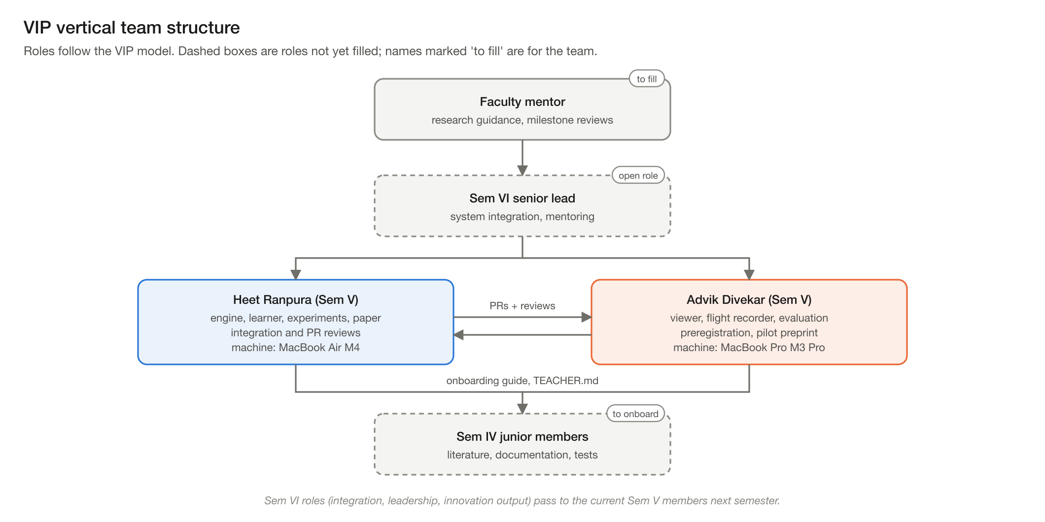
Figure 1. The team in the VIP vertical structure.

2. Sub-teams
Sub-team | Scope | Lead | Support
Engine & ecology | sim/: world generation, kernels, fauna, climate, performance | Heet | Advik (survival-analysis fix, recorder hooks)
Learning | agents/: network, PPO trainer, baselines, checkpoints | Heet | Advik (original rppo design, now the trainer defaults)
Visualisation | viewer/: three.js client, server, dashboard | Advik | Heet (preview server, learner integration)
Measurement & analysis | analysis/, experiments/: recorder, evaluation, statistics, behaviour | Advik (recorder), Heet (analysis) | Both
Research operations | Preregistration, logs, handoffs, CI, papers | Shared | Both

3. Responsibility matrix (RACI)
R = responsible (does the work), A = accountable (signs off), C = consulted, I = informed.
Activity | Heet | Advik | Mentor
World engine changes | R/A | C | I
Learner and training runs | R/A | R (long runs) | I
Viewer | C | R/A | I
Flight recorder, evaluation tooling | C | R/A | I
Preregistration entries | R | R | C
Pull-request review and merge | R/A | C | I
Papers and reports | R | R | A
Milestone reviews | R | R | A

4. Working agreement
- Code flow: Heet commits to HeetRanpura/Genesis main; Advik works on the fork advikdivekar/Genesis and opens pull requests. make test must pass before a PR; CI runs on every push and PR.
- Reviews check: tests, append-only edits to shared logs, data provenance (which run produced which number), and the hard rules.
- Handoffs: whoever stops work updates HANDOFF.md (and a personal handoff such as HANDOFF_ADVIK.md) with state, results, next tasks and exact commands.
- Records: logs/SESSION_LOG.md (engineering sessions), logs/AGENT_LOG.md (how agents are doing, negative results kept), docs/PREREGISTRATION.md (hypotheses before results).
- Compute: long training on the M3 Pro; analysis and writing on the Air; one heavy job at a time on the fanless Air.
- Meetings (proposed cadence): a weekly sync with minutes in the meeting template, and a fortnightly mentor review. Record only meetings that actually happen.

5. Contribution evidence (from the repository)
Evidence | Heet Ranpura | Advik Divekar
Commits on main (27 Oct 2026) | 16 | 8
Pull requests | reviewer / merger of #1-#4 | author of #1-#4 (#1 re-applied by cherry-pick, #2-#4 merged)
Main areas (files touched) | reports, experiments, paper, sim, tests, agents | reports, viewer, experiments, tests, docs

6. Growing the team vertically
- TEACHER.md is the RL study guide and FAQ for new members.
- Suggested first tasks for Sem IV juniors: verify a reference, add a world-rule test, reproduce a baseline number with make baselines, write up one figure.
- In Semester VI the current members take the senior role: integration, mentoring and the innovation output.

