GENESIS
Emergent social organisation in survival-only learning agents
System Design Document
Architecture, components, interfaces, data and performance of GENESIS

Course | Design Experience II (Semester V), VIP vertical
Institute | MPSTME, NMIMS (Vertically Integrated Projects vertical)
Domain | Artificial Intelligence & Data Systems
Team | Heet Ranpura (Sem V), Advik Divekar (Sem V)
Faculty mentor | [to fill]
Repository | github.com/HeetRanpura/Genesis
Version / date | 1.0, 27 October 2026

1. Purpose and scope
This document describes the design of GENESIS as built in Semester V: the world engine, the learners, the measurement pipeline and the live viewer. It records requirements, the architecture and the reasons behind key decisions, and links each requirement to the test or evidence that verifies it.

2. Requirements
ID | Requirement | Verified by | Status
FR1 | Seeded procedural world (terrain, water, biomes) | test_world_rules, test_engine (same seed = same world) | Met
FR2 | Ecology: vegetation, fruit, 3 fauna species, weather, seasons, fire, flood, famine | test_world_rules; fauna diagnostics report | Met
FR3 | Agent physiology and egocentric occluded perception | test_world_rules (occlusion, eating, drinking) | Met
FR4 | Reward = own homeostasis + death penalty only | test_engine::test_reward_is_own_homeostatic_drive_only | Met
FR5 | Capabilities are switches, off by default | configs/default.yaml; config loader rejects unknown keys | Met
FR6 | Three baselines in every comparison | test_baselines; reports/stage1/baselines.json | Met
FR7 | Learner with memory ablation (GRU vs MLP) | test_ppo (11 tests) | Met
FR8 | Held-out evaluation protocol | eval_policy.py; preregistration | Met
FR9 | Flight recorder with exact replay | test_recorder (bit-exact replay) | Met
FR10 | Live viewer with logged controls | test_viewer (boot, stream, log) | Met
FR11 | PettingZoo ParallelEnv API | pettingzoo parallel_api_test in test_engine | Met
FR12 | Social-behaviour metrics (Stage 3) | planned: unit tests on synthetic data | Planned (Sem VI)
NFR1 | >= 100k env steps/min with observations, 1,000 agents | make bench: 111,992 steps/min (M4 Air) | Met
NFR2 | Bit-identical results for the same seed | test_engine determinism; sequential = parallel twins | Met
NFR3 | Every run reproducible from its folder | manifest (git commit, versions, world hash) + config per run | Met
NFR4 | Runs on laptops without CUDA | Numba CPU + PyTorch MPS; all results produced on two laptops | Met
NFR5 | Viewer >= 60 fps | 75-90 fps at 1,000 agents, 1600x900 (M3 Pro); 1440p unmeasured | Partly met
NFR6 | Long runs resumable | run_h2h3.py: Ctrl-C and crash tests (toy scale) | Met

3. Architecture
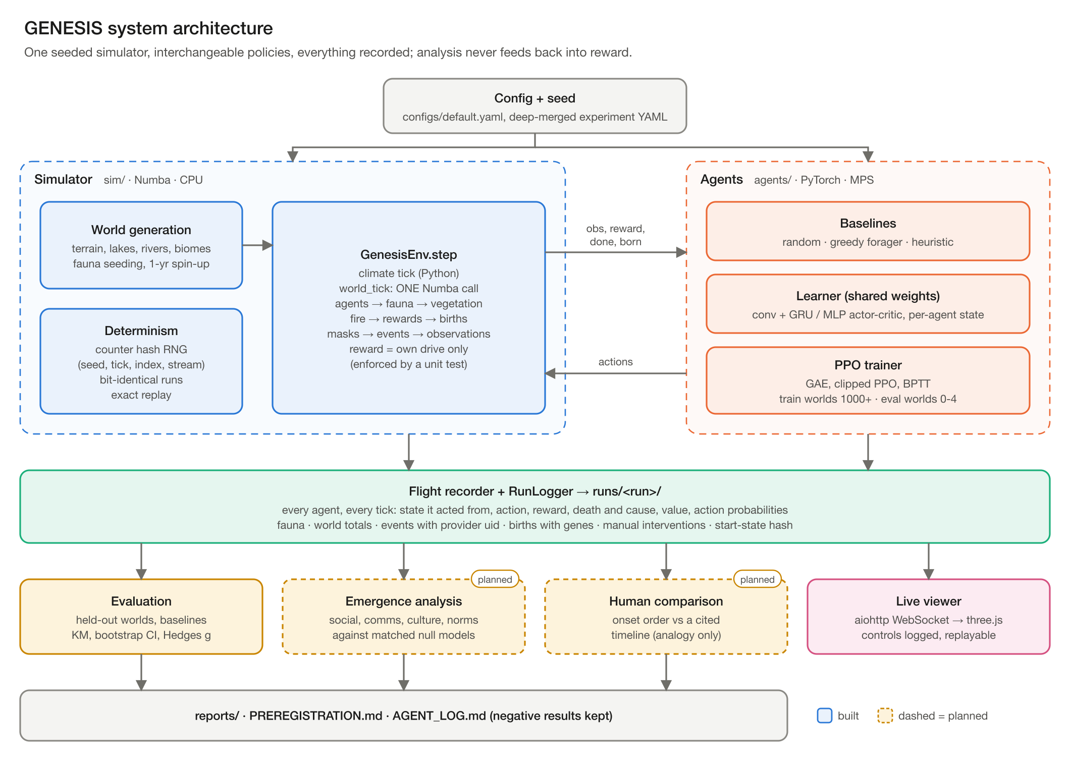
Figure 1. System architecture (Advik Divekar).
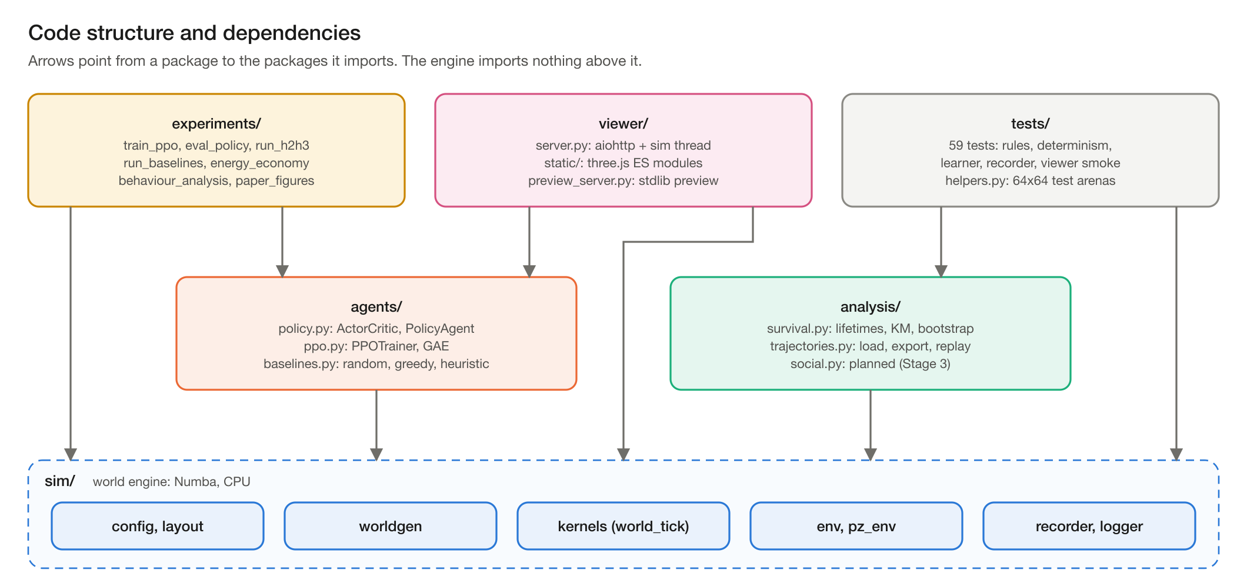
Figure 2. Packages and their dependencies. The engine imports nothing above it, so it can be tested in isolation.
Package | Python lines | Contents
sim/ | 3,059 | config, layout, worldgen, kernels (Numba), env, pz_env, recorder, logger, rng
agents/ | 720 | policy (ActorCritic, PolicyAgent), ppo (PPOTrainer), baselines
analysis/ | 246 | survival statistics, trajectory loading and replay
experiments/ | 2,105 | training, evaluation, baselines, benchmarks, energy economy, behaviour, figures, H2/H3 driver
viewer/ | 955 (+2,586 JS) | aiohttp server, three.js client, stdlib preview
tests/ | 909 | 59 tests

4. World engine design

4.1 World generation
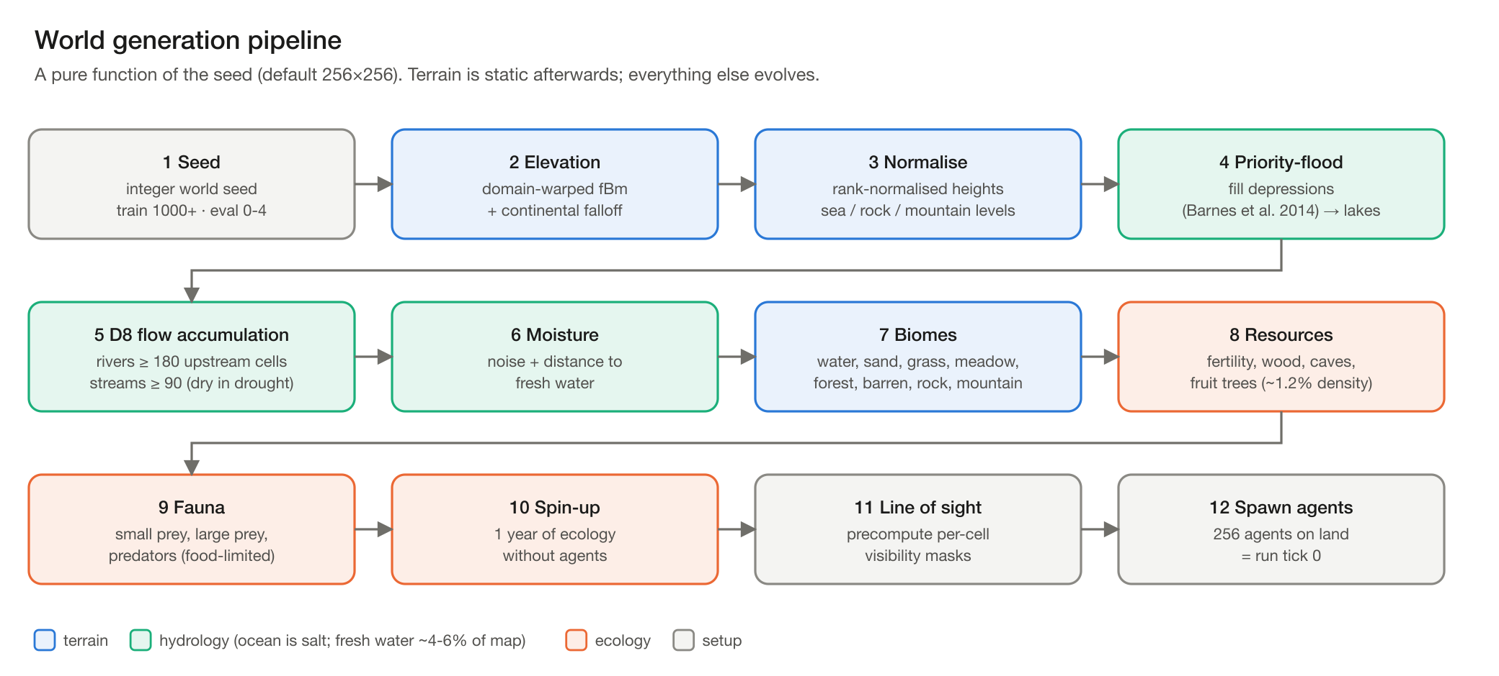
Figure 3. World generation pipeline (Advik Divekar).

4.2 One simulation tick
A tick is one Python climate step plus one Numba call, kernels.world_tick, which runs agents, fauna, vegetation, fire, rewards, deaths and births, masks, the event tally and observations in sequence. Keeping all per-tick work inside one compiled call avoids ~5-10 us of Python dispatch overhead per extra kernel.
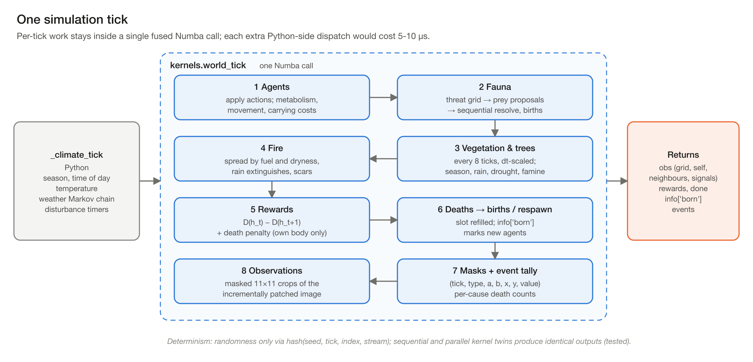
Figure 4. Stages of world_tick (Advik Divekar).

4.3 State layout
Array | Type and shape | Holds
A | float32 [N, 6] | energy, hydration, health, warmth, carried amount, felt temperature
I | int64 [N, 19] | alive, x, y, age, lifespan, uid, parent, generation, carry type, last action, signal, cause of death, flags
S | float64 [N, 12] | lifetime statistics: energy eaten, water drunk, distance, kills, food dropped/received, strikes, ...
FF / FI | float32 [M, 2] / int64 [M, 14] | fauna energy, health; alive, position, species, age, flee timer, up to 4 attacker uids and ticks
P / FP | float64 [60] / [3, 12] | packed scalar parameters per tick; per-species fauna parameters
EV | rows of 7 | events: (tick, type, a_uid, b_uid, x, y, value)
img | float32 [H, W, 16] | observer-independent observation image, patched in place at every world mutation

4.4 Determinism
- All randomness inside kernels comes from a counter-based hash uniform(seed, tick, index, stream); no shared generator is drawn inside parallel loops.
- Small workloads run sequential twins of parallel kernels (a parallel launch costs ~60 us on macOS); a test checks that both give identical outputs.
- Each run writes a manifest with the git commit, library versions, threading layer and a world hash; replay checks the start-state hash.

4.5 Observations
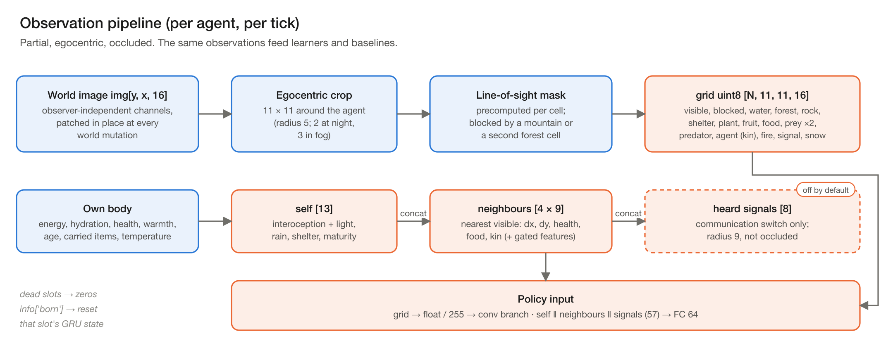
Figure 5. Observation pipeline: masked 11 x 11 crops of an incrementally patched image with precomputed line-of-sight masks (Advik Divekar).
Rebuilding the observation image every tick was the throughput bottleneck. The image is now patched at every mutation site, and line-of-sight masks are precomputed once because terrain is static. A test compares the patched image with a full rebuild to catch drift.

5. Agent and learning design
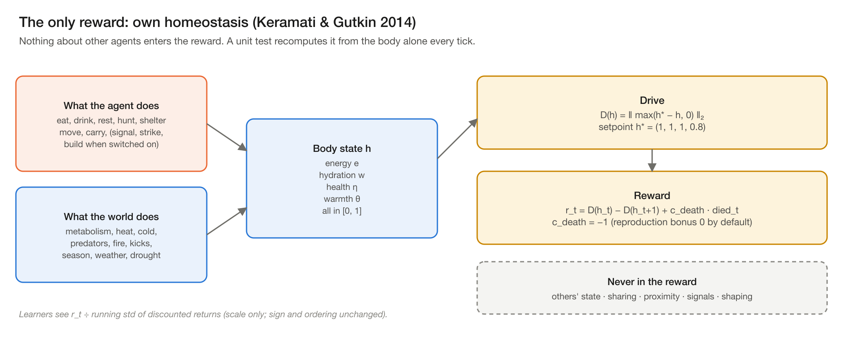
Figure 6. Homeostatic reward (Advik Divekar).
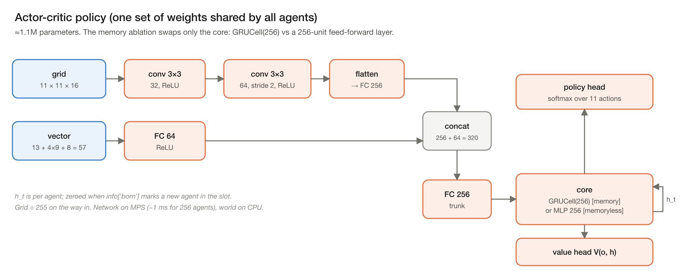
Figure 7. Shared policy network (Advik Divekar).
Hyper-parameter | Value | Hyper-parameter | Value
Rollout length | 128 ticks | Discount gamma | 0.995
BPTT | full 128-tick sequences | GAE lambda | 0.95
Epochs x minibatches | 4 x 4 (split by agent) | Clip | 0.2
Learning rate | 3e-4 | Entropy / value coef. | 0.01 / 0.5
Agents (shared weights) | 256 | Gradient clip | 0.5
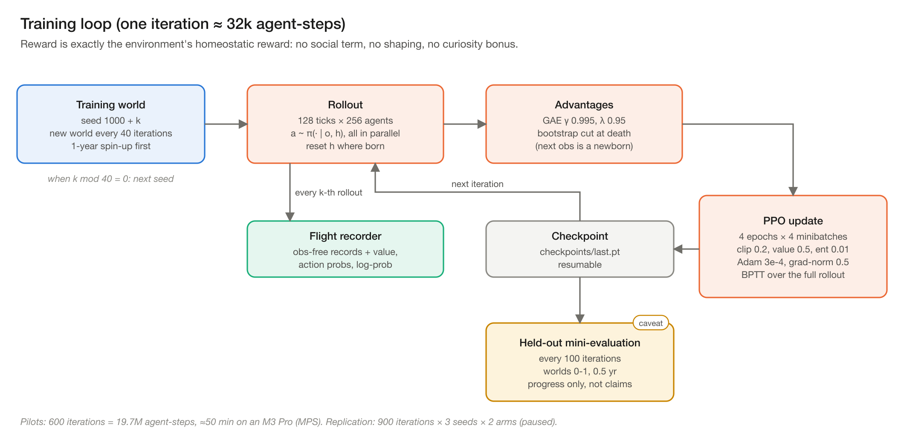
Figure 8. Training loop (Advik Divekar).
- Checkpoints: format 2 (self-describing: network config, trainer state, RNG states); older formats are refused with a clear error.
- Training worlds 1000 + 100 x seed + w (a new world every 40 iterations); validation worlds 500-502; test worlds 0-4, never trained on.
- Long runs: make h2h3 trains six preregistered runs with progress bars, keeps checkpoints every 200 iterations and at 900, resumes after interruption and applies the preregistered decision rules.

6. Measurement design
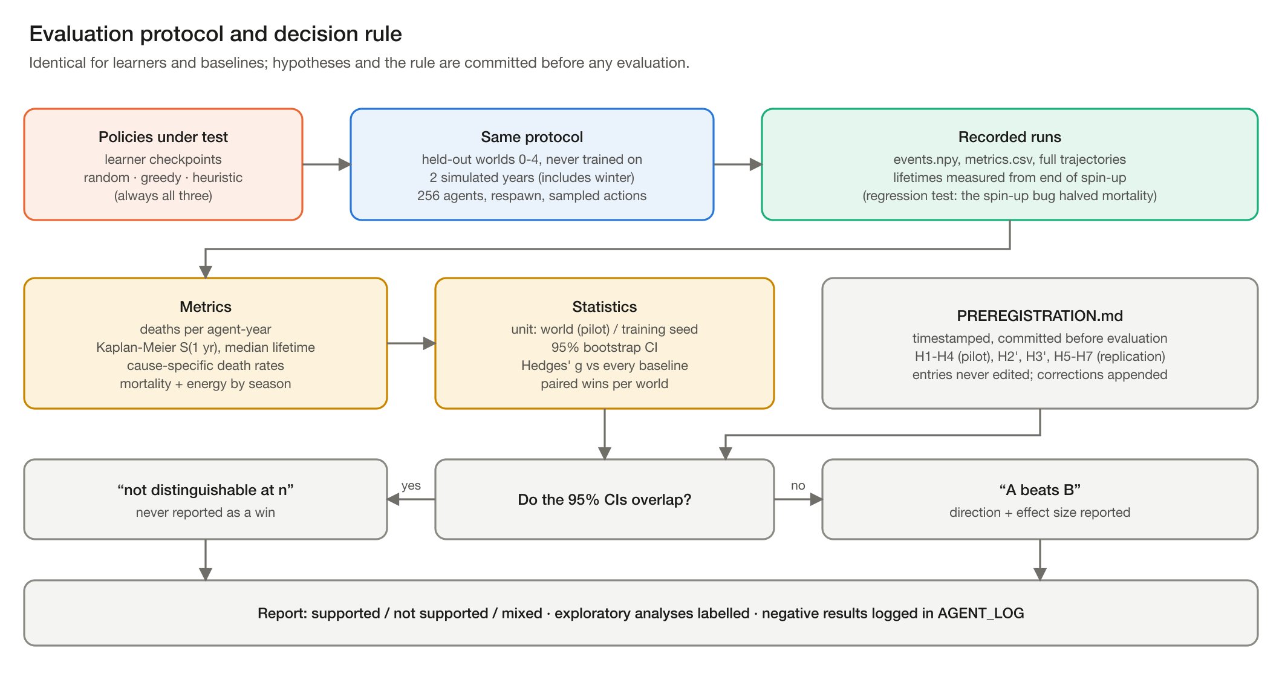
Figure 9. Evaluation protocol (Advik Divekar).
- Flight recorder: every agent, every tick: the state it acted from, action, reward, death and cause, value estimate and action probabilities; plus fauna, world totals, events, births with genes and manual interventions. About 63 MB per simulated year at 256 agents; recording runs at about 70% of full speed.
- Replay: analysis/trajectories.replay() re-simulates a recording bit-exactly, including manual disturbances.
- Statistics: deaths per agent-year with exposure from lifetimes (spin-up excluded), Kaplan-Meier survival, bootstrap 95% CIs, Hedges' g. The unit of replication is the world (single-run tests) or the training seed (H2/H3).
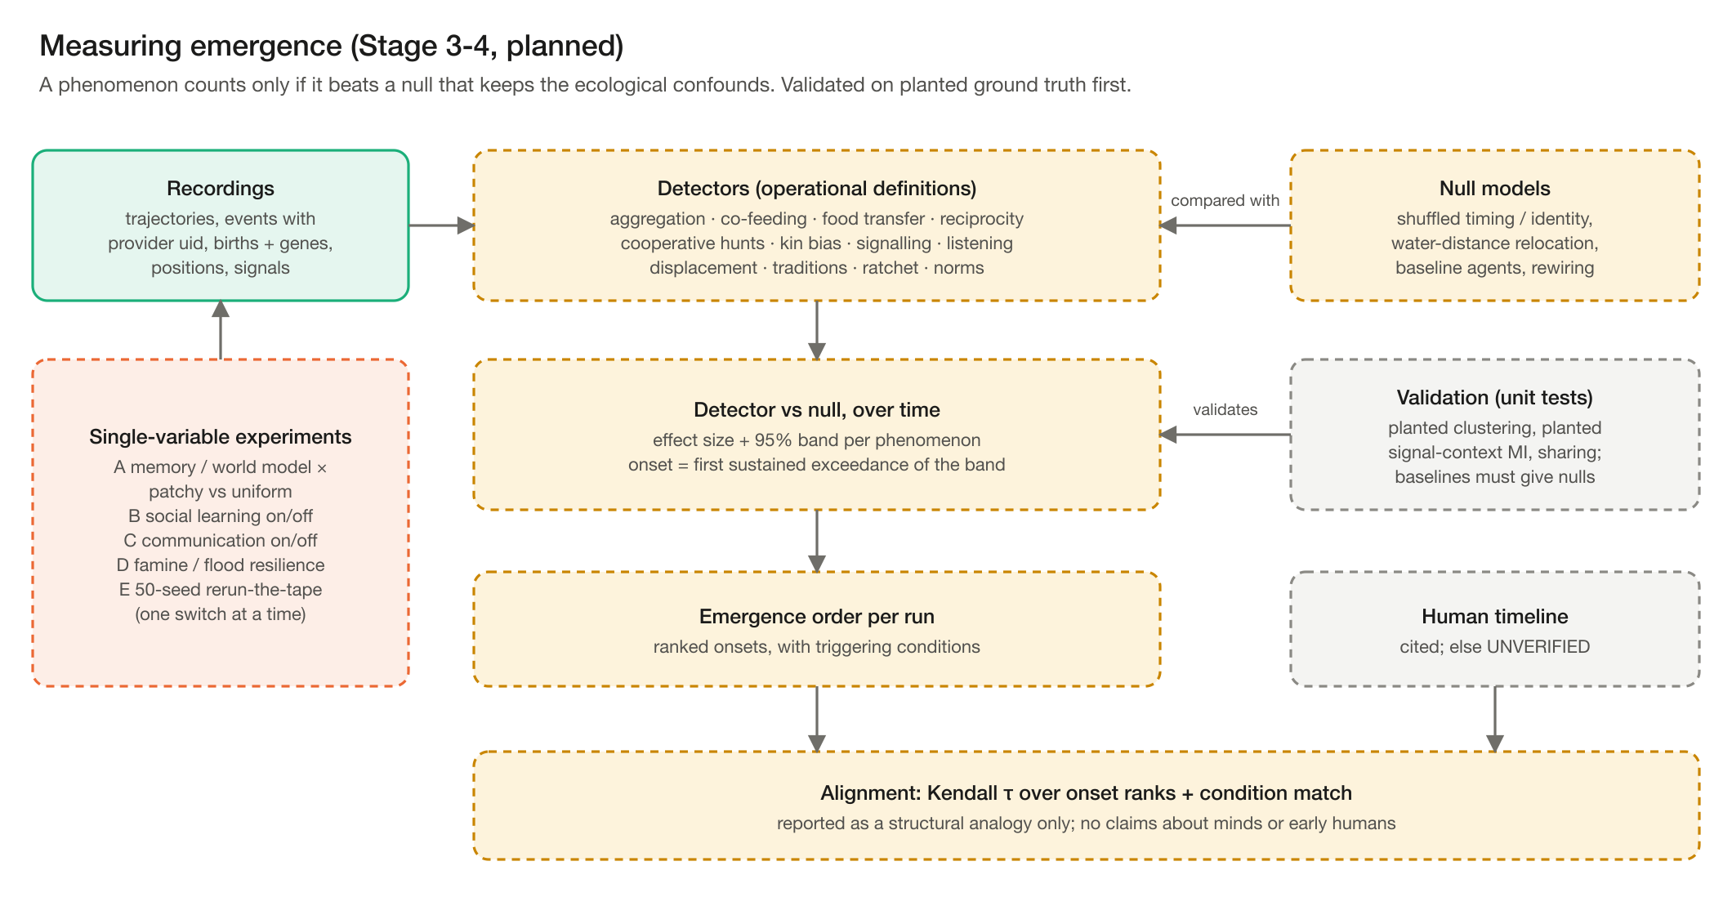
Figure 10. Planned emergence measurement (Advik Divekar).

7. Viewer design
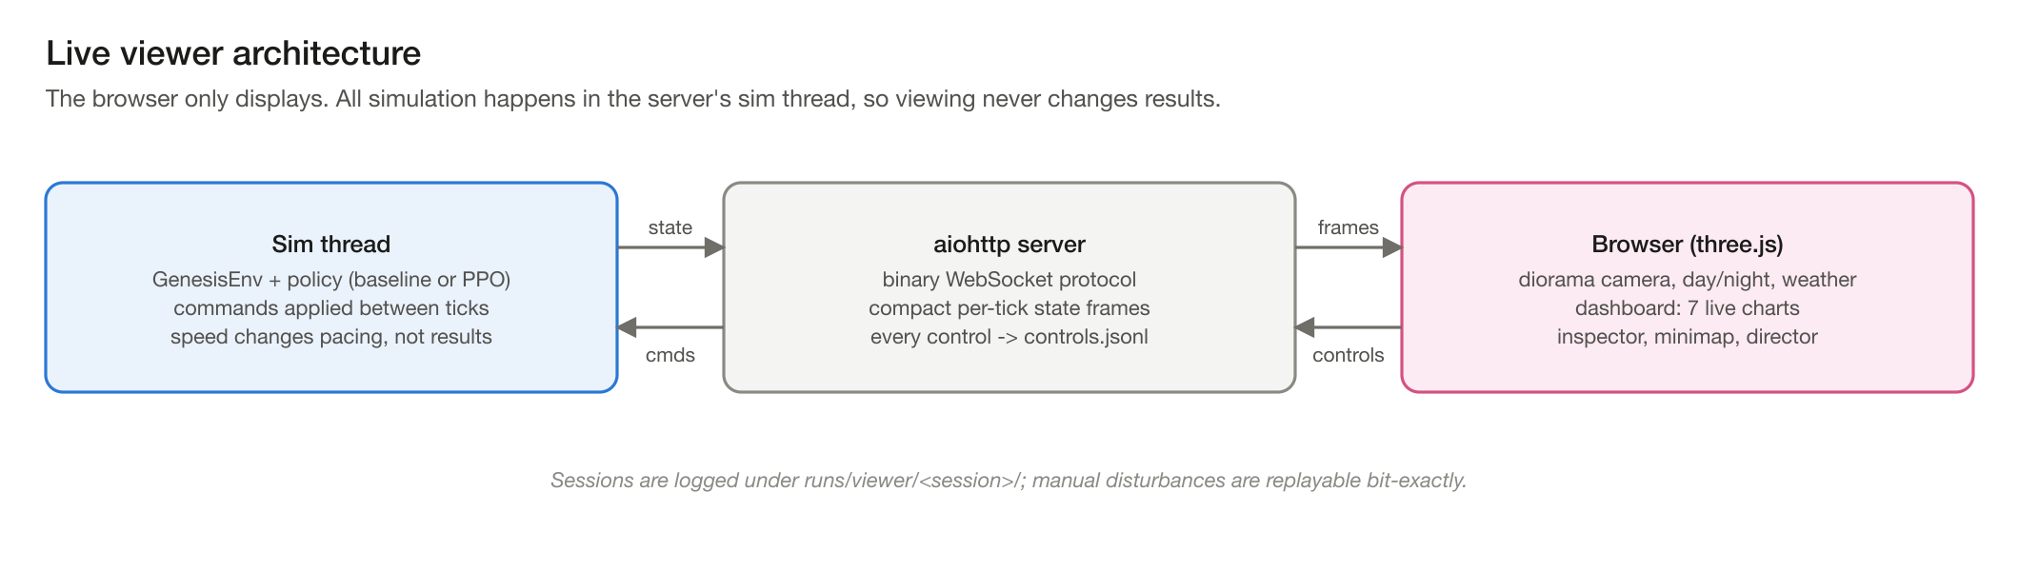
Figure 11. Viewer architecture.
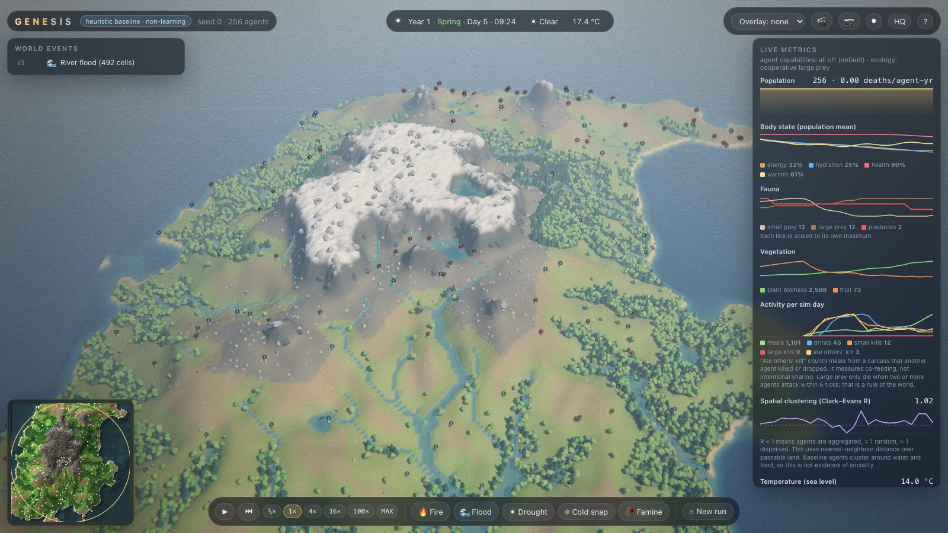
Figure 12. The live viewer: overview of a running world.

8. Interfaces
Interface | Signature / format | Used by
Environment step | GenesisEnv.step(actions[N]) -> obs, reward[N], died[N], info; info['born'] marks refilled slots | learners, baselines, viewer, experiments
Observation | dict: grid [N, 11, 11, 16], self [N, 13], neighbors, heard | policies
Policy | act(obs, alive) -> actions; reset(mask) for new agents | experiments, viewer
Recorder | rec.pre(obs); rec.post(actions, rewards, info, extras); rec.close() | experiments, viewer
PettingZoo | ParallelEnv, agents named agent_<uid> | external MARL libraries
Viewer | binary WebSocket state frames; JSON commands, logged to controls.jsonl | browser client

9. Data and storage
Path | Contents
runs/<experiment>/<run>/ | config.yaml, manifest.json, metrics.csv, events.npy, summary.json, trajectory/ (git-ignored)
runs/stage2/<run>/ | config.json, train.jsonl, val.jsonl, checkpoints/ (last.pt, iter_XXXXX.pt), world_*/ recordings
reports/ | committed results (JSON), figures, stage reports
docs/PREREGISTRATION.md | dated hypotheses, appended only
logs/ | AGENT_LOG.md (results incl. negative), SESSION_LOG.md (engineering)

10. Performance
World | Agents | Observations | Env steps / min (median) | Agent-steps / s
256 x 256 | 256 | no | 211,287 | 0.90 M
256 x 256 | 256 | yes | 146,188 | 0.62 M
256 x 256 | 1,000 | no | 171,568 | 2.86 M
256 x 256 | 1,000 | yes | 111,992 | 1.87 M
256 x 256 | 2,000 | yes | 89,041 | 2.97 M
512 x 512 | 1,000 | yes | 59,499 | 0.99 M
Measured with make bench on the MacBook Air M4 (fanless; medians of repeated runs). Known regression: 512 x 512 is slower than expected because the daily refresh rebuilds the whole image when only the water channel changes.

11. Risks and mitigations
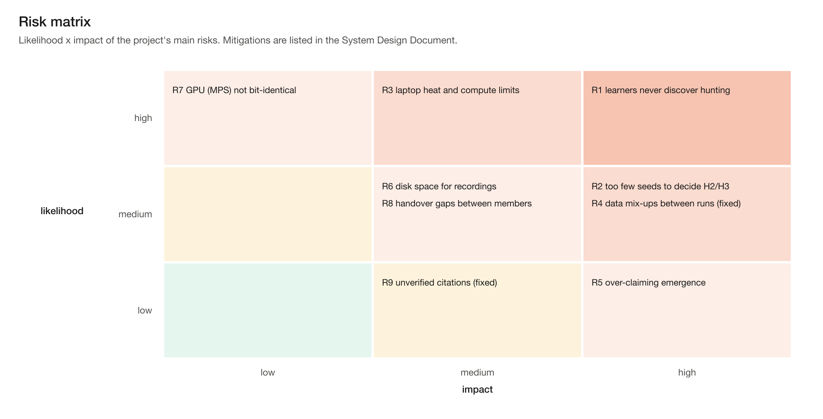
Figure 13. Risk matrix.
Risk | Mitigation | Status
R1 Learners never discover hunting (winter starvation) | Energy-economy probe shows the world pays for hunting; exploration probes planned (curriculum, denser prey as a separate config) | Open
R2 Too few seeds to decide H2/H3 | Preregistered 3-seed experiment, unit of replication = training seed | In progress
R3 Laptop heat and compute | Long runs on the M3 Pro; thinned recording; one job at a time on the Air | Mitigated
R4 Data mix-ups between runs | Run-name prefixes; pilot scripts check checkpoint format and recording fingerprints | Fixed (b248efd)
R5 Over-claiming emergence | Preregistration, null models, social-blinding ablation, negative results logged | Mitigated
R6 Disk space | Disk guard stops recording below a threshold; 1-in-k recording | Mitigated
R7 GPU arithmetic not bit-identical | Replication framed as replication; CPU path deterministic and tested | Accepted
R8 Handover gaps | HANDOFF documents with exact commands; CLAUDE.md engine facts | Mitigated
R9 Unverified citations | All references checked online (27 Oct 2026) | Fixed

12. Open design issues
- Stage 3 social metrics (analysis/social.py) with synthetic-data unit tests.
- World-model and continual-learning capabilities (Stage 2 plan).
- 512 x 512 throughput regression.
- Viewer: replay scrubbing, side-by-side seeds, 1440p measurement.

