GENESIS
Emergent social organisation in survival-only learning agents
Test & Validation Plan
How GENESIS is verified (built right) and validated (answers the question)

Course | Design Experience II (Semester V), VIP vertical
Institute | MPSTME, NMIMS (Vertically Integrated Projects vertical)
Domain | Artificial Intelligence & Data Systems
Team | Heet Ranpura (Sem V), Advik Divekar (Sem V)
Faculty mentor | [to fill]
Repository | github.com/HeetRanpura/Genesis
Version / date | 1.0, 27 October 2026

1. Objectives
- Verify that every world rule behaves as specified and that runs are bit-reproducible.
- Verify that the learner, recorder and viewer work end to end.
- Validate scientific claims only on held-out worlds, against baselines, under preregistered decision rules.
- Run the automated tests on every change (CI) and record defects and their fixes.

2. Strategy and levels
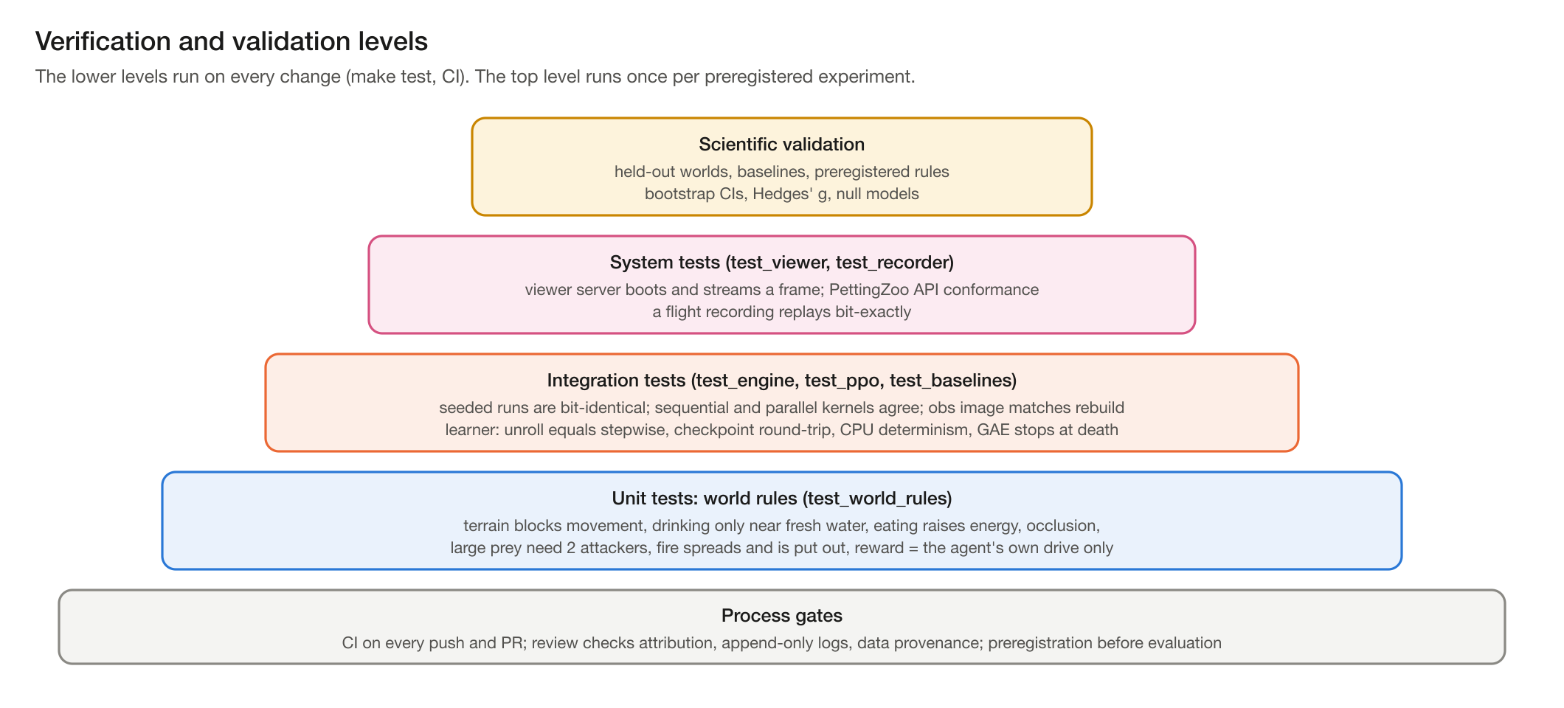
Figure 1. Verification and validation levels.

3. Test environments
Environment | Hardware | Used for
Developer laptop A | MacBook Air M4, 10 cores, 16 GB, fanless | unit/integration tests, analysis, short training
Developer laptop B | MacBook Pro M3 Pro, 11 cores, 18 GB | long training (H2/H3), viewer frame-rate tests
CI | GitHub Actions ubuntu-latest, Python 3.11, CPU torch | full suite with coverage on every push and PR

4. Test inventory
File | Level | What it checks
test_world_rules.py | Unit | blocking terrain; drinking only near fresh water; eating raises energy; seasonal plant growth; occlusion; large prey need >= 2 attackers; fire spread and extinction; death causes
test_engine.py | Integration | same seed = identical trajectory hash, different seeds differ; reward is own drive only; observation image matches a full rebuild; sequential and parallel twins agree; PettingZoo API test; spin-up handling
test_ppo.py | Integration | CPU determinism; memory reset at birth; GAE does not bootstrap through death; checkpoint round-trip; unroll equals stepwise forward; recorder hook; repeatable validation
test_baselines.py | Integration | baselines run and the heuristic reproduces its reference number
test_recorder.py | System | a recording replays bit-exactly, including manual disturbances
test_viewer.py | System | server boots, streams a world and a frame, applies and logs a command, writes run files
Total: 59 tests, all passing (27 October 2026; make test, about 40 s on the Air).

5. Requirements traceability
Req. | Requirement | Test / evidence | Status
FR1 | Seeded procedural world (terrain, water, biomes) | test_world_rules, test_engine (same seed = same world) | Met
FR2 | Ecology: vegetation, fruit, 3 fauna species, weather, seasons, fire, flood, famine | test_world_rules; fauna diagnostics report | Met
FR3 | Agent physiology and egocentric occluded perception | test_world_rules (occlusion, eating, drinking) | Met
FR4 | Reward = own homeostasis + death penalty only | test_engine::test_reward_is_own_homeostatic_drive_only | Met
FR5 | Capabilities are switches, off by default | configs/default.yaml; config loader rejects unknown keys | Met
FR6 | Three baselines in every comparison | test_baselines; reports/stage1/baselines.json | Met
FR7 | Learner with memory ablation (GRU vs MLP) | test_ppo (11 tests) | Met
FR8 | Held-out evaluation protocol | eval_policy.py; preregistration | Met
FR9 | Flight recorder with exact replay | test_recorder (bit-exact replay) | Met
FR10 | Live viewer with logged controls | test_viewer (boot, stream, log) | Met
FR11 | PettingZoo ParallelEnv API | pettingzoo parallel_api_test in test_engine | Met
FR12 | Social-behaviour metrics (Stage 3) | planned: unit tests on synthetic data | Planned (Sem VI)
NFR1 | >= 100k env steps/min with observations, 1,000 agents | make bench: 111,992 steps/min (M4 Air) | Met
NFR2 | Bit-identical results for the same seed | test_engine determinism; sequential = parallel twins | Met
NFR3 | Every run reproducible from its folder | manifest (git commit, versions, world hash) + config per run | Met
NFR4 | Runs on laptops without CUDA | Numba CPU + PyTorch MPS; all results produced on two laptops | Met
NFR5 | Viewer >= 60 fps | 75-90 fps at 1,000 agents, 1600x900 (M3 Pro); 1440p unmeasured | Partly met
NFR6 | Long runs resumable | run_h2h3.py: Ctrl-C and crash tests (toy scale) | Met

6. Determinism and regression testing
- Bit-identical trajectories for a fixed seed are the main regression guard: any unintended change to dynamics changes the hash and fails CI.
- The heuristic baseline's mortality on world 0 is pinned (1.3745078259737726 deaths per agent-year); baselines reproduce bit-for-bit across both laptops.
- Training on the Apple GPU is not bit-identical; re-runs are treated as replications and compared within confidence intervals.

7. Performance testing
make bench measures environment steps per minute for several world sizes and populations, with and without observations, reporting medians of repeated runs. Throughput is only compared between interleaved runs on the same machine in the same thermal state. Acceptance: >= 100k steps/min with observations at 1,000 agents (met: 111,992).

8. Coverage
Scope | Line coverage | Note
All measured packages (sim, agents, analysis, viewer) | 55% | Includes Numba-compiled code that coverage.py cannot trace
Python-level code (excluding sim/kernels.py) | 76% | Numba kernels run as machine code; they are exercised by every engine test but report ~9%
Core modules | env 99%, ppo 95%, policy 93%, pz_env 91%, recorder 88%, worldgen 87%, viewer server 82% | baselines 31% (largely compiled), legacy preview server 0%
Run with make coverage. CI uploads coverage.xml as an artifact on every run.

9. Continuous integration
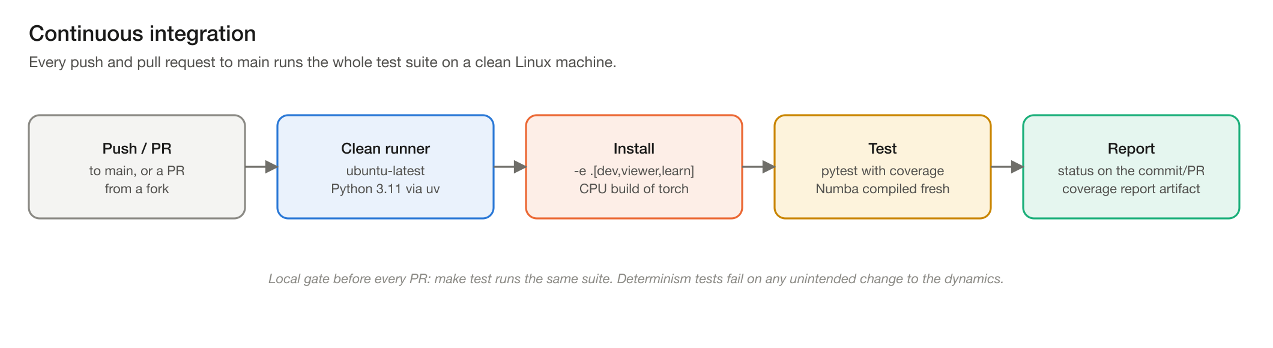
Figure 2. CI pipeline (.github/workflows/tests.yml).

10. Scientific validation protocol
- Worlds: training 1000+, validation 500-502, test 0-4 (never trained on).
- Comparisons: random, greedy and heuristic baselines in every table.
- Statistics: deaths per agent-year (lifetime exposure, spin-up excluded), Kaplan-Meier survival at 1 year, bootstrap 95% CIs, Hedges' g [Efron1993; Hedges1981; Kaplan1958].
- Replication: for H2/H3 the unit is the training seed (n = 3 per arm) [Henderson2018; Agarwal2021].
- Preregistration: hypotheses and decision rules are committed before the runs [Nosek2018]; the H2/H3 driver applies them mechanically.
- Null models for social claims: habitat-matched and place-preference nulls for aggregation; shuffled-timing null for joint attacks; social-blinding ablation.

10.1 Validation results so far
Policy | Deaths / agent-year [95% CI] | Source
Random | 3.83 [3.53, 4.19] | reports/stage1/baselines.json
Greedy | 3.31 [2.92, 3.77] | same
Heuristic | 1.50 [1.04, 2.11] | same
Memoryless learner (replication) | 1.50 [1.30, 1.75] | reports/stage2/eval_ff_s0.json
GRU learner (replication) | 1.67 [1.45, 1.92] | reports/stage2/eval_gru_s0.json
Learners clearly beat random and greedy (H1 supported) but cannot be distinguished from the heuristic at 20M agent-steps (H2 not supported); memory reduced thirst deaths but not overall mortality (H3 not supported). No social coordination was found (H4 held). The 3-seed H2/H3 experiment (make h2h3) is ready to run.

11. Defect log
Real defects found by tests, reviews or analysis, and how each was fixed:
Defect | Found by | Fix / outcome
Survival analysis measured lifetimes from tick 0 although the clock includes a 1-year spin-up: mortality under-stated by about a third | Analysis cross-check | start_tick=env.spinup_ticks; regression test; baselines re-run (2.55 -> 3.83 etc.); erratum logged
Numba twin built with njit(cache=True)(f.py_func) overwrote the parallel kernel's cache entry: misleading benchmarks | Benchmark anomaly | Separate driver functions; rule recorded in CLAUDE.md
Pilot analysis scripts read replication data with the same run names; one figure silently changed | Review of PR #4 | Own run tree + checkpoint-format and recording-fingerprint checks (b248efd)
Resumed training appended duplicate log rows for iterations after the last checkpoint | Building the H2/H3 driver | Rows after the checkpoint dropped on resume; interrupt test
Evaluation defaulted to the Apple GPU and crashed elsewhere | Portability review | Device chosen automatically
A claim that learners rest at night, based on one agent in the viewer | Population-level analysis | Claim corrected in the paper and logs: no night resting

12. Entry and exit criteria
- Entry for a PR: make test passes locally; new behaviour has a test; shared logs only appended.
- Exit for a stage: its acceptance criteria in PLAN.md are met with evidence in reports/; CI green.
- Exit for an experiment: preregistered decision rules applied; results and negative results logged; numbers traceable to files and commands.

13. Planned tests (Semester VI)
- Stage 3 metrics: each tested on synthetic data with a known answer (planted clustering, planted sharing events, planted signal-context information); baselines must produce the expected nulls.
- Viewer at 1440p in a real browser; replay scrubbing.
- A short end-to-end training smoke test in CI.

References
[Agarwal2021] R. Agarwal, M. Schwarzer, P. S. Castro, A. Courville, M. G. Bellemare. Deep reinforcement learning at the edge of the statistical precipice. NeurIPS 2021 (outstanding paper). arXiv:2108.13264.
[Efron1993] B. Efron, R. J. Tibshirani. An Introduction to the Bootstrap. Chapman & Hall, 1993.
[Hedges1981] L. V. Hedges. Distribution theory for Glass's estimator of effect size and related estimators. Journal of Educational Statistics 6(2):107-128, 1981.
[Henderson2018] P. Henderson, R. Islam, P. Bachman, J. Pineau, D. Precup, D. Meger. Deep reinforcement learning that matters. AAAI 2018, 32(1):3207-3214.
[Kaplan1958] E. L. Kaplan, P. Meier. Nonparametric estimation from incomplete observations. Journal of the American Statistical Association 53(282):457-481, 1958.
[Nosek2018] B. A. Nosek, C. R. Ebersole, A. C. DeHaven, D. T. Mellor. The preregistration revolution. PNAS 115(11):2600-2606, 2018. doi:10.1073/pnas.1708274114.

