GENESIS
Emergent social organisation in survival-only learning agents
Sub-team Coordination Report
Work, interfaces, coordination events and feedback per sub-team

Course | Design Experience II (Semester V), VIP vertical
Institute | MPSTME, NMIMS (Vertically Integrated Projects vertical)
Domain | Artificial Intelligence & Data Systems
Team | Heet Ranpura (Sem V), Advik Divekar (Sem V)
Faculty mentor | [to fill]
Repository | github.com/HeetRanpura/Genesis
Version / date | 1.0, 27 October 2026 (covers work up to this date)

Basis
Every event below is taken from the repository: commits, pull requests #1-#4, handoff documents and logs. Use the meeting template for future reports so meetings and attendance are recorded as they happen.
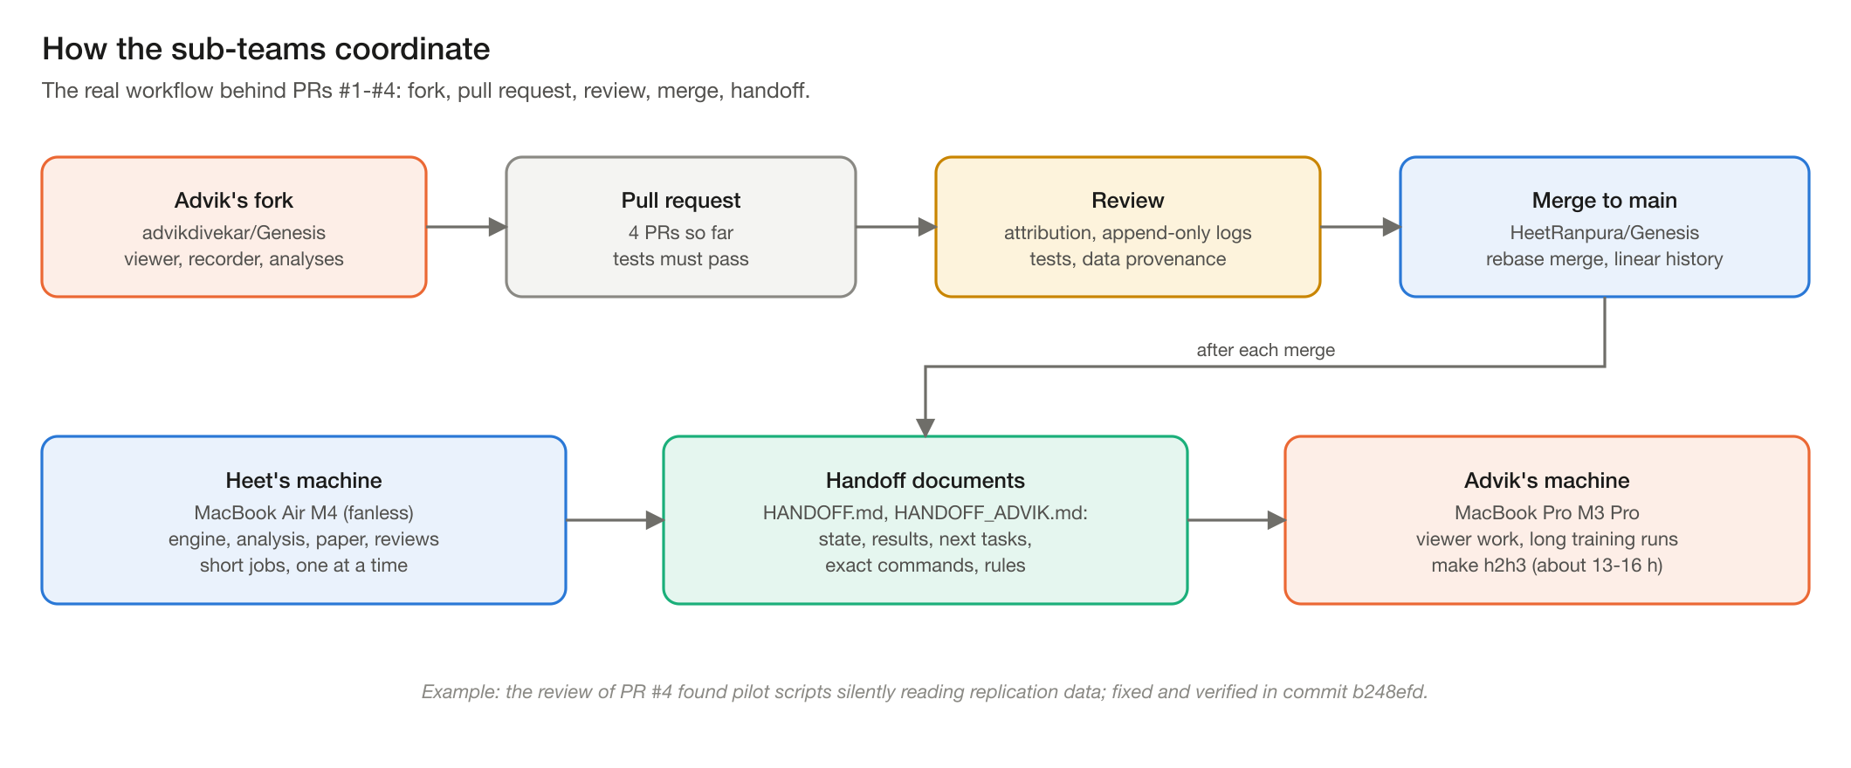
Figure 1. How the sub-teams coordinate.

1. Engine & ecology sub-team
Item | Detail
Members | Heet Ranpura (lead); Advik Divekar (fix to survival analysis, recorder hooks)
Delivered | Stage 1 world engine; Stage 1.1 food-limited fauna, incremental observation image, static line-of-sight masks, fused world tick (>= 100k steps/min with observations at 1,000 agents)
Interfaces | GenesisEnv API to Learning; img and events to Measurement; world state to Visualisation
Coordination | Fauna parameters and the 1-year ecological spin-up were agreed before learners started, so all learner results share one world definition
Issues | Spin-up bug in survival analysis (found and fixed with Measurement); 512 x 512 regression open
Next | Water-congestion test at high density; 512 x 512 refresh optimisation

2. Learning sub-team
Item | Detail
Members | Heet Ranpura (lead); Advik Divekar (designed the rppo variant)
Delivered | PPOTrainer with GRU and memoryless cores; held-out evaluation; replication of the pilot within CIs; energy-economy probe; H2/H3 one-command driver
Coordination event | Two parallel learner implementations existed (Heet's PPOTrainer, Advik's rppo). They were folded into one on 26 Oct 2026: rppo's settings became PPOTrainer's defaults, rppo's tests were ported, original results kept in reports/stage2/rppo_original/
Feedback received | Advik's PR #2 preregistration made the first learner evaluation confirmatory rather than exploratory
Next | Run make h2h3 on the M3 Pro; exploration probes for hunting

3. Visualisation sub-team
Item | Detail
Members | Advik Divekar (lead); Heet Ranpura (learner integration, 2-D preview)
Delivered | three.js live viewer (PR #1), articulated animated characters and chase camera (PR #3), performance work for laptops; learner internals (value, action probabilities) shown in the inspector
Interfaces | Binary WebSocket frames from the server; policies listed as ppo:<run> from Learning
Measured | 85-115 fps (256 agents), 75-90 fps (1,000 agents) at 1600 x 900
Next | Replay scrubbing, side-by-side seeds, 1440p measurement

4. Measurement & analysis sub-team
Item | Detail
Members | Advik Divekar (flight recorder, H6/H7 pipeline); Heet Ranpura (survival, energy, behaviour analysis)
Delivered | Flight recorder with exact replay; survival statistics; behaviour analysis (drinking, space use, value vs drive, clustering vs nulls); pilot preprint with H6/H7 analyses and social-blinding ablation (PR #4)
Coordination event | Review of PR #4 found the pilot scripts silently read replication runs with the same names. Fixed with a separate run tree and fingerprint checks; Advik's handoff explains how to move his files
Open reconciliation | Pilot energy intake (1.31-1.34e-3 per tick) vs replication (~1.7e-3 per tick) differ: different checkpoints and worlds; to be reconciled before a joint paper
Next | Stage 3 social metrics (analysis/social.py) with synthetic-data tests

5. Research operations
Item | Detail
Members | Both
Delivered | Preregistration with dated entries; AGENT_LOG and SESSION_LOG; handoffs; CI; VIP documentation set
Rules kept | Append-only shared logs (verified in every review); no reward terms involving others; negative results logged

6. Cross-team dependencies
From | To | What flows | Agreement
Engine | Learning | observations, rewards, births | GenesisEnv API; any change that alters dynamics invalidates older recordings (hash check)
Learning | Measurement | checkpoints, recordings with value and probabilities | checkpoint format 2; run names prefixed per experiment
Engine + Learning | Visualisation | live state, policy internals | viewer never changes results; controls logged
Measurement | All | results, nulls, verdicts | claims only from held-out worlds, under preregistered rules

7. Feedback given and received (technical review record)
PR | Author | Reviewer | Main feedback | Outcome
#1 Live viewer, recorder, survival fix | Advik | Heet | Re-applied by cherry-pick after main's history was rewritten | Merged into main
#2 Stage 2 results + tooling | Advik | Heet | Learner duplicated PPOTrainer | Merged by rebase; later folded into one learner
#3 Animated viewer | Advik | Heet | Frontend only; no engine impact | Merged
#4 Pilot preprint | Advik | Heet | Run-name collision; non-reproducible figures without local runs; two papers to consolidate; energy numbers to reconcile | Merged; collision fixed in b248efd

