Toilet Rim Segmentation and Measurement Model

This project features a deep learning model for toilet rim detection that can:  
- Segment the rim if the toilet is open  
- Identify the full lid if the toilet is closed  
- Measure distances from the center of the toilet to the bottom and right edge for both:  
 - Inner rim  
 - Outer rim  
  
This model is tailored for applications in smart bathrooms, robotic cleaning, home automation, and object-aware sanitation devices.

# Model Overview

This model is a semantic segmentation model trained using deep learning (e.g., UNet or Segmentation Models) and fine-tuned on toilet datasets marked manually with red overlays.

## Key Features

- Rim Detection (Open Toilet): Segments inner and outer toilet rim as two ring-like structures.  
- Lid Detection (Closed Toilet): Recognizes the full lid as a single object.  
- Distance Measurements: Computes distances from center to:  
 - Midpoint of bottom edge  
 - Midpoint of right edge  
 - For both inner and outer rim  
- Robust to varied toilet shapes (round, oval, square) and lighting conditions.  
- Fine-tuning enabled using red-marked images.

# Visual Examples

## Open Toilet – Inner and Outer Rim Segmentation

Raw Image

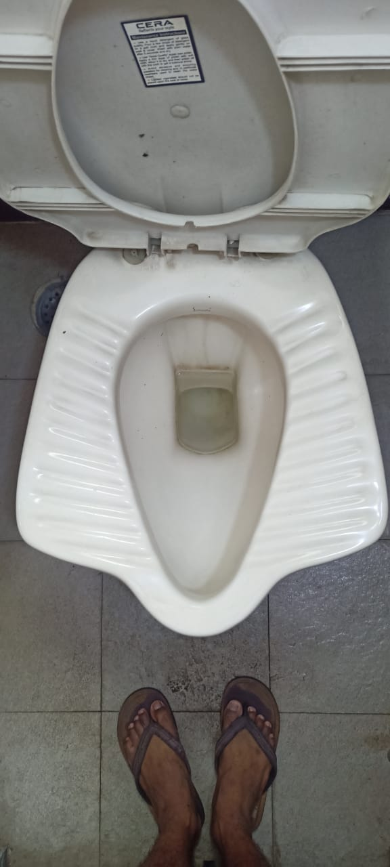

Predicted Mask

## Closed Toilet – Lid Detection

Raw Image

Predicted Mask

## Distance Measurement Output

Visual Output

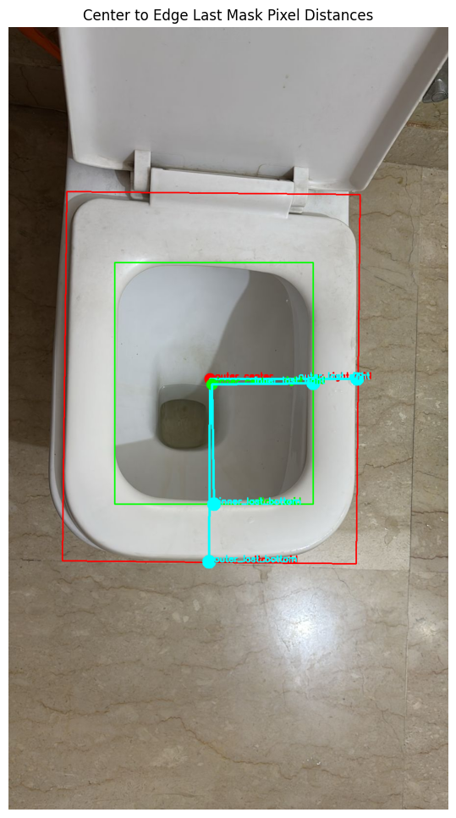

Outer Center: (412, 719)

→ Distance to Last Bottom Pixel: 374.01

→ Distance to Last Right Pixel: 301.00

Inner Center: (416, 730)

→ Distance to Last Bottom Pixel: 245.03

→ Distance to Last Right Pixel: 207.01

# Technical Details

Framework: PyTorch  
Model Type: UNet / DeepLabV3+ / Custom Encoder  
Input Size: 256×256 (resized internally)  
Output: Binary mask  
Inference Speed: ~20ms per image (GPU)  
Distance Logic: cv2.minAreaRect + directional scan

# Training Notes

Model was originally trained on a synthetic and real dataset of toilet images with:  
- Clear rim/lid boundaries  
- Red elliptical markings (for fine-tuning)  
  
Final fine-tuning was done with manually annotated red-marked masks.  
Uses strict HSV thresholds for red mask extraction:

lower_red1 = np.array([0, 150, 150])  
upper_red1 = np.array([5, 255, 255])  
lower_red2 = np.array([175, 150, 150])  
upper_red2 = np.array([180, 255, 255])

# Author

Heet Savaliya  
B.Tech Computer Engineering  
Pandit Deendayal Energy University  
LinkedIn: https://www.linkedin.com/in/heet-savaliya-03b863252/  
Email: savaliyaheet19@gmail.com

# License

MIT License – feel free to use, modify, and build upon this work.